

Module name: Introducing the Modern Workplace
Module code: LCBB4003
Student name: Ceapa Sorina
Student ID:2123039

Table of Contents
Introduction 3
Question 1: The way organisation structure and culture impact its performances 3
Organisational structure and culture of Sainsbury’s 3
Relationship between Sainsbury’s organisational structure and performance 4
Question 2: The way Sainsbury’s employees motivated 6
Hiring and Selection 6
Training and Development 7
Rewards and Recognition 7
Safety and Well Being 7
Role of leadership in motivating employees 7
Clear Goals 8
Effective Collaboration 8
Feedback from managers 8
Autonomy offered by the management 8
Evaluating the factors affecting differences in individual behaviour 9
Religion 9
Personality 9
Employment opportunities 9
Physical facilities 10
Conclusion 10
Reference List 11

Introduction
The chosen organisation Sainsbury’s follows a certain culture in managing its employees and performing better. Here the relationship between organisational structure, culture, people and organisational performance will be depicted along with providing the way this company motivates its employees. The role of leadership in motivating employees, the nature of managerial work and factors affecting the differences in individual behaviour will be discussed as well.

Question 1: The way organisation structure and culture impact its performances

Organisational structure and culture of Sainsbury’s
Organisational structure: Sainsbury’s is a renowned retailer in the United Kingdom and it follows different methods to manage its employees so that they can work efficiently and welcome more profit and productivity to the platform. As a retailer, Sainsbury’s has a hierarchical structure and there are employees designated in different jobs or positions who play their roles properly (Sainsbury’s PLC, 2019). Thus, it is seen that the mentioned organisation follows a clear and understandable structure where every employee works in harmony. The seniors or managing authority of Sainsbury’s direct and guide their employees in a certain way that helps them know the company’s organisational culture well. That is why the employees of the mentioned retailer perform well and the organisation stays in position as a popular retailer in the market of the United Kingdom.
Organisational Culture: Sainsbury’s follows a set of values, ethical norms and other principles to direct its employees in a better way so that they can enhance their professional skills and perform better. The employees of the mentioned company state that it is a great place to work and it shows the satisfaction level of the workers designated in different positions of the organisation. Sainsbury’s is connected with some homeless charity works, creates the “Crisis FareShare” and helps numerous people (Williams. and May, 2022). The mentioned organisation has a vision to be in the top rank in the market in the United Kingdom. Sainsbury’s sets a goal to stay a truncated retailer in the national market and it equips creativity, diversity and talent for their employees (Sainsbury’s, 2023). In this way, the employees can deliver top-quality service to its new and existing customers. Most of the Sainsbury’s employees have depicted that it is rewarding to work there and their work is enjoyable as well. Thus, the mentioned company follows a proper and effective organisational culture to drive sales, satisfy employees and stay in a top position in the market.

Relationship between Sainsbury’s organisational structure and performance
Sainsbury’s is a popular company where workers are satisfied to engage in different types of work and the organisations tend to follow certain methods to increase production, drive more sales, satisfy customers and they do it by appointing workers who are efficient and fast at doing their jobs. Organisational structure plays a vital role in influencing organisational performance and the way the authority motivates and guides its employees show their expertise in managing and retaining workers of different positions. At present, Sainsbury’s implements an idea of “click&collect” operations in grocery and the planning is done for the next 5 years along with having over 100 sites of “click&collect” (Davies, Dolega and Arribas-Bel, 2019). This in turn shows the efficiency of the mentioned retailer and its unique hierarchical structure gets praise for it. The hierarchical structure of Sainsbury’s emphasises its status of being a harmonious, effective, and fast-working organisation that works adeptly to deliver better service and products to the customers (Khayal et al., 2023).
The Bureaucratic Management Theory is applicable in this case as it relates to the way Sainsbury’s company operates and manages its structure. Bureaucratic Management Theory mainly relates to the fact that an organisation is structured into a hierarchy (Toole, 2023). As per this theory, an organisation is governed by its authority and it divides the company into different levels and employees work in those levels. Rational-legal decision-making rules are clearly defined by the company’s authority and its hierarchy helps in managing employees working in different sections of a company.
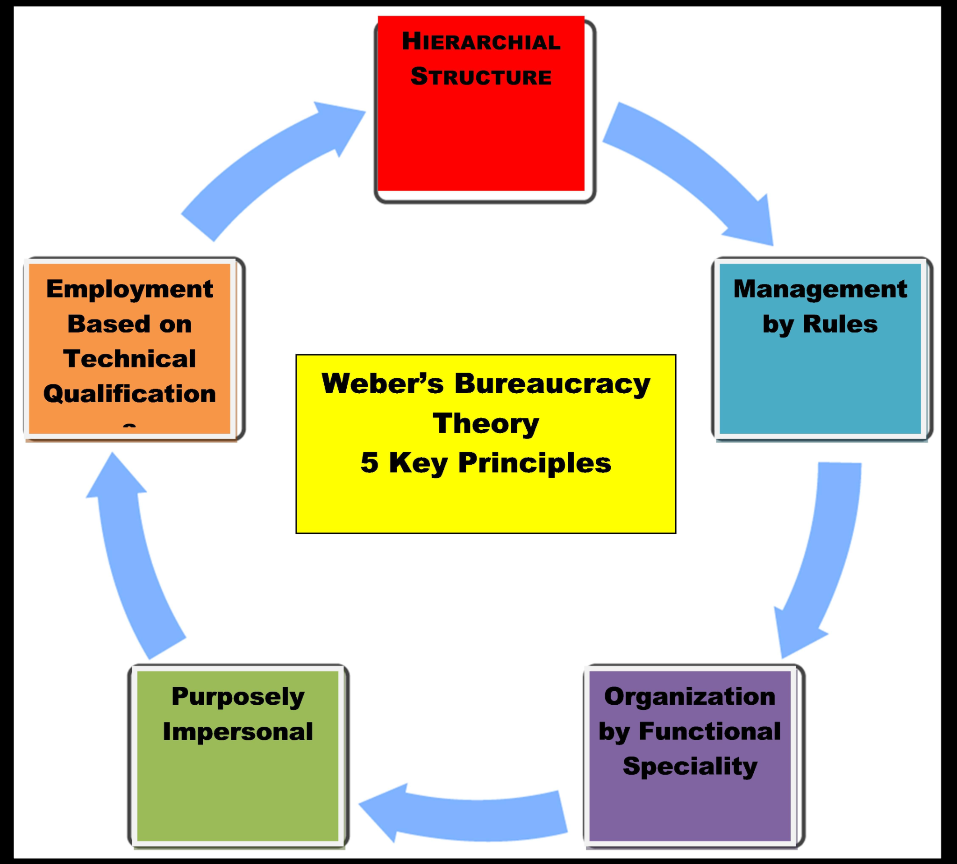
Figure 1: Bureaucratic Management Theory
Source: (Kimmy, 2022)
The above image properly demonstrates The Bureaucratic Management Theory and its 5 key principles developed by Max Weber. Management of rules, employment based on technical qualification, hierarchical structure, functional speciality of the organisation and being purposely impersonal are the main principles of the mentioned theory that help the organisation manage its operations and maintain work in every department or sector. Sainsbury’s is a company that follows a proper hierarchical structure and manages its employees’ performance tactfully (Khayal et al., 2023).
The hierarchical structure and company culture of Sainsbury’s tend to help its employees maintain a balance within the company and deliver better service to customers. The company has become renowned in the United Kingdom for earning the trust of people and maintaining its position as a top-performing retailer in the country. Sainsbury’s motivates its employees well enough and trains them well at the workplace so that they can learn tactfully and perform well with time (Pandey, 2022). Thus, it is seen that employees in the mentioned organisation are encouraged to work and they receive rewards for their work as well. The structure of the company is effective as it helps the employee note their duties positively. The employees at Sainsbury’s abide by their duties regularly and do not show casualties at work. Sainsbury’s works hard to treat every employee with respect and welcomes people from different communities and cultures fairly (Sainsbury’s, 2022). This shows the way the organisation connects with its employees and treats everyone equally. The mentioned company does not discriminate between its workers and tries as much as possible to retain its employees.
Organisations need to pay attention to employee motivation so that they can retain potential workers (Bilderback and Miller, 2023). It is seen that Sainsbury’s deals with different cases of harassment tactfully to avoid any disruptions at the workplace. Sainsbury’s protects its employees from sexual harassment in many ways and it handles such cases tactfully (Colins, and Blodgett, 2021). Thus, it is observed that the mentioned retailer is concerned about its employees and follows proper decorum to continue the workplace traditions and norms. The mentioned company is tactful in guiding its employees through sexual harassment and other adversities. The company is efficient enough to make its workers learn how to handle cases regarding sexual harassment and does not allow any such misdeeds on its platform. This helps the employees to focus on their work and allows employee retention.

Question 2: The way Sainsbury’s employees motivated
Identification of the essential nature of managerial work
The operational activities of the managers of Sainsbury’s are classified into functions such as managerial and operational.

Hiring and Selection
The managers of the brand Sainsbury’s hire and select the right candidates so that they can perform effectively. Through efficient planning concerning human resources, hiring and selection, effective training, placement of jobs and promotion, the brand ensures quality human resource management that results in greater profitability in the future (Moon et al., 2020). Furthermore, the employees of Sainsbury’s brand are excessively talented and skilled concerning the necessary alterations and advanced technologies.

Training and Development
The managers of Sainsbury’s enjoy the responsibility of offering appropriate training to their team members and plan processes of appraisal concerning the performance (Antunes and Pinheiro, 2020). Furthermore, the employees are assisted by their managers in planning their livelihood so that the team members can feel encouraged, motivated and perform well. This leads to the brand’s greater sales and profits in the future.

Rewards and Recognition
Moreover, through organising events where employees are offered rewards and recognition, the managers facilitate employee motivation and retention. Salary arrangements are also planned by the managers. The managers also offer both non-financial and financial incentives to their employees for their effective contribution towards their work. This helps team members in performing in a better way in the long run thereby leading to enhanced productivity and profitability. According to the incentive theory of motivation, employees are encouraged and motivated through the help of incentives. The employees of Sainsbury’s are offered greater incentives for their quality work (Ali and Anwar, 2021). As a result, the team members feel motivated and perform quality work in the future including avoiding such actions that may lead to punishments.

Safety and Well Being
The managers of the organisation also ensure that the needs and requirements of their team members are fulfilled. The well-being of the employees is further safeguarded through the help of effective managerial activities. In addition, through staffing competent and skilled people in the organisation, the brand’s management ensures greater organisation success in the years to come.

Role of leadership in motivating employees
The leaders of the brand Sainsbury’s develop and share a mission and vision that are inspiring and encouraging. Their mission and vision are authentic and easily attainable. As a result, the team members of the organisation get motivated and perform effective operational activities to attain their mission and vision.

Clear Goals
Furthermore, transparent and well-framed goals and objectives are set by the leaders of Sainsbury’s. Such objectives are highly clear and transparent so that the employees are easily able to understand the goals of the project and what the leaders expect from their team members (Demircioglu and Chowdhury, 2021). Appropriate, attainable, time-bound and measurable objectives are created by inspiring leaders. As a result, the employees get motivated to operate smarter and harder by understanding the objectives of the set goals.

Effective Collaboration
The leaders of Sainsbury’s carry out effective collaboration that has resulted in the brand enjoying one of the top positions in the market. Efficient teamwork and collaboration between employees through enhanced links between teamwork and attaining set targets enable employees to feel motivated and engaged. This leads to a healthy work scenario which in turn helps team members in performing better leading to their retention within the organisation.

Feedback from managers
Furthermore, positive feedback is also offered by the managers to the employees so that they feel motivated towards attaining individual objectives as well as organisation objectives (Al-maaitah et al., 2021). Employees are further praised and appreciated for their hard work so that they can offer flexible work to achieve further praise and rewards. Through better and quality communication, transparent information is transmitted. This inspires other employees to effectively communicate thereby resulting in further achievements. Moreover, the leaders of the organisation also listen actively to the ideas, thoughts and queries of their team members so that such queries and thoughts are answered well.

Autonomy offered by the management
The team members of Sainsbury’s are also offered autonomy and opportunities to self-manage their operational activities (Zhang and Yang, 2021). The employees of the organisation have full control over the ways their tasks are completed. This further results in a happier and more productive work environment. The leaders of Sainsbury’s further inspire their employees to consistently establish their skills, talent and knowledge concerning their self-management. Through offering financial rewards to the employees and encouraging and facilitating their self-development, a dynamic workforce is promoted. This helps individuals within the organisation to grow professionally.

Evaluating the factors affecting differences in individual behaviour
Several factors affect behaviour of an individual within the organisation.

Religion
One such factor is religion. Religion and the cultures associated with it play a major role in analysing the aspects of individual behaviour. Furthermore, the attitude of employees towards their work is analysed through religion. Extremely religious employees have better ethics than other employees working within the organisation (López-Cabarcos, Vázquez-Rodríguez and QuinoA-Pineiro, 2022). This may result in effective operational activities leading to greater achievements.

Personality
Moreover, personality is another factor that impacts differences in individual behaviour. Employees with better personalities are considered smart employees. Such dynamics showcase the growth of the psychology of the individual. This factor also showcases traits in employees such as perseverance, aggressiveness, dominance and other major characteristics. Such features are reflected in an individual’s behaviour within the workplace.

Employment opportunities
The behaviour of employees within the organisation is directly influenced by the opportunities for employment that are available to them. Even if the employees are not completely satisfied with their job, they have to stay loyal to their organisation as they have no other options left due to the higher unemployment level. Certain employees stay loyal to the company because of the monetary rewards and wages that are offered to them (Ciobanu, Androniceanu and Lazaroiu, 2019). Wage rates thereby affect behaviour of individuals within the organisation.

Physical facilities
The physical facilities within the organisation also impact the differences in employees' behaviour. Factors that impact an individual’s behaviour include light, cleanliness, level of noise, ventilation, job nature, the number of employees operating within the sector and so on. Furthermore, the design and infrastructure of the company also affect the behaviour of employees. The position at which a team member can appropriately fit within the workplace also influences the behaviour of the individual. In addition, rewards and recognition programs greatly impact an employee’s behaviour within the organisation. Organisation’s concern for the safety and wellbeing of their employees further impacts their behaviour (Riyanto, Endri and Herlisha, 2021).

Conclusion
Concludingly it can be stated that the managers and leaders of Sainsbury’s carry out effective hiring and selection processes to motivate and retain employees. Skilled and competent candidates are selected so that they can contribute better to the organisation. Furthermore, employees are offered rewards and recognition so that team members become highly encouraged and stay loyal to the brand for a longer time. In addition, several factors such as religion and physical facilities impact an employee’s behaviour within the sector.

Reference List
Ali, B.J. and Anwar, G., (2021) An empirical study of employees’ motivation and its influence job satisfaction. Ali, BJ, & Anwar, G.(2021). An Empirical Study of Employees’ Motivation and its Influence Job Satisfaction. International Journal of Engineering, Business and Management, 5(2), pp.21-30. Available at: https://dx.doi.org/10.22161/ijebm.5.2.3
Al-maaitah, D.A., Majali, T.E., Alsoud, M. and Al-maaitah, T.A., (2021) The role of leadership styles on staffs job satisfaction in public organizations. Journal of Contemporary Issues in Business and Government, 27(1), pp.772-783. Available at: https://www.researchgate.net/profile/Dirar-Almaaitah/publication/349320057_The_Role_Of_Leadership_Styles_On_Staffs_Job_Satisfaction_In_Public_Organizations/links/602a9cd94585158939a92e4e/The-Role-Of-Leadership-Styles-On-Staffs-Job-Satisfaction-In-Public-Organizations.pdf
Antunes, H.D.J.G. and Pinheiro, P.G., (2020) Linking knowledge management, organizational learning and memory. Journal of Innovation & Knowledge, 5(2), pp.140-149. Available at: https://doi.org/10.1016/j.jik.2019.04.002
Bilderback, S.L. and Miller, G.J., (2023) Importance of employee development programs in business. Journal of Management Development, 42(4), pp.327-336. Available at:https://www.researchgate.net/profile/Stephanie-Bilderback/publication/372338651_Importance_of_employee_development_programs_in_business/links/64b0664ac41fb852dd6f11dc/Importance-of-employee-development-programs-in-business.pdf?origin=journalDetail&_tp=eyJwYWdlIjoiam91cm5hbERldGFpbCJ9
Ciobanu, A., Androniceanu, A. and Lazaroiu, G., (2019) An integrated psycho-sociological perspective on public employees’ motivation and performance. Frontiers in psychology, 10, p.36. Available at: https://www.frontiersin.org/articles/10.3389/fpsyg.2019.00036/full
Colins, E.G.C. and Blodgett, T.B. (2021) Sexual harassment...some see it...some won’t, Harvard Business Review. Available at: https://hbr.org/1981/03/sexual-harassmentsome-see-itsome-wont (Accessed: 09 December 2023).
Davies, A., Dolega, L. and Arribas-Bel, D., (2019) Buy online collect in-store: exploring grocery click&collect using a national case study. International Journal of Retail & Distribution Management, 47(3), pp.278-291. Available at: https://www.emerald.com/insight/content/doi/10.1108/IJRDM-01-2018-0025/full/pdf
Demircioglu, M.A. and Chowdhury, F., (2021) Entrepreneurship in public organizations: the role of leadership behavior. Small Business Economics, 57, pp.1107-1123. Available at: https://doi.org/10.1007/s11187-020-00328-w
Khayal, I.S., Butcher, R.L., McLeish, C.H., Shentu, Y. and Barnato, A.E., (2023) Organizational Intent, Organizational Structures, and Reviewer Mental Models Influence Mortality Review Processes. Mayo Clinic Proceedings: Innovations, Quality & Outcomes, 7(6), pp.515-523. DOI: https://doi.org/10.1016/j.mayocpiqo.2023.09.004
Kimmy (2022) Bureaucratic Management Theory: Origins Criticism And Influence, Google. Available at: https://www.google.co.in/webhp?ion=1&rct=j (Accessed: 09 December 2023).
López-Cabarcos, M.Á., Vázquez-Rodríguez, P. and QuinoA-Pineiro, L.M., (2022) An approach to employees’ job performance through work environmental variables and leadership behaviours. Journal of Business Research, 140, pp.361-369. Available at: https://www.sciencedirect.com/science/article/pii/S0148296321008110
Moon, T.W., Youn, N., Hur, W.M. and Kim, K.M., (2020) Does employees’ spirituality enhance job performance? The mediating roles of intrinsic motivation and job crafting. Current Psychology, 39, pp.1618-1634. Available at: https://link.springer.com/article/10.1007/s12144-018-9864-0
Pandey, A. (2022) How to drive employee motivation and performance with training, EI Design. Available at: https://www.eidesign.net/how-to-drive-employee-motivation-and-performance-with-training/ (Accessed: 09 December 2023).
Riyanto, S., Endri, E. and Herlisha, N., (2021) Effect of work motivation and job satisfaction on employee performance: Mediating role of employee engagement. Problems and Perspectives in Management, 19(3), p.162. Available at: https://d1wqtxts1xzle7.cloudfront.net/69819906/PPM_2021_03_Riyanto-libre.pdf?1631908840=&response-content-disposition=inline%3B+filename%3DEffect_of_work_motivation_and_job_satisf.pdf&Expires=1702114091&Signature=avjwsL4LGWp1DOn4ZjyXOCkFYvwPxFyvcBZdQ5trb3u6ztSFceFJbSQKE3oDtmrYm9qP~kcjux3jkhdqUTvzhh~HpRYsratKRVevFfjepNd2enBHBtqI0QLG8q4nijgOtwKJ7EUzV2SadunYlG8rEqVI8-3CMPpah1n2Go71A~2xLz8KHa0vrLvsUltubBQWFxcnMqdQtLlC4weF7EMZkAMuPur7~ns9KeRwtmSJCxZBj-JolNdgJq39vhrm27vzDGzO7pcTDF-B1lhbWtZYSNm0xmuFXcJV2DUoIByL8nwRD06kqZttxEqaWCM4OawJ0xW8y3HIfBIDIRB05NicyA__&Key-Pair-Id=APKAJLOHF5GGSLRBV4ZA
Sainsbury’s (2022) Diversity and inclusion – sainsbury’s. Available at: https://www.about.sainsburys.co.uk/sustainability/better-for-everyone/diversity-and-inclusion (Accessed: 09 December 2023).
Sainsbury’s (2023) Values & culture, Sainsbury’s Careers. Available at: https://sainsburys.jobs/working-for-us/values-culture/ (Accessed: 09 December 2023).
Sainsbury’s PLC (2019) Helping everyone eat better - sainsbury’s. Available at: https://www.about.sainsburys.co.uk/~/media/Files/S/Sainsburys/documents/reports-and-presentations/2023/annual-report-2023/annual-report-and-financial-statements-2023.pdf (Accessed: 09 December 2023).
Toole, K. (2023) Quiz & Worksheet - bureaucratic management theory | study.com. Available at: https://study.com/academy/practice/quiz-worksheet-bureaucratic-management-theory.html (Accessed: 09 December 2023).
Williams, A. and May, J., (2022) A genealogy of the food bank: Historicising the rise of food charity in the UK. Transactions of the Institute of British Geographers, 47(3), pp.618-634. Available at: https://rgs-ibg.onlinelibrary.wiley.com/doi/pdf/10.1111/tran.12535
Zhang, Y. and Yang, F., (2021) How and when spiritual leadership enhances employee innovative behavior. Personnel Review, 50(2), pp.596-609. Available at: https://www.researchgate.net/profile/Fu-Yang-3/publication/343264730_How_and_when_spiritual_leadership_enhances_employee_innovative_behavior/links/5f20c4a1a6fdcc9626bc8682/How-and-when-spiritual-leadership-enhances-employee-innovative-behavior.pdf

