

UNIVERSITY OF WALES
TRINITY SAINT DAVID

DIGITAL DEGREE APPRENTICESHIP
SOFTWARE ENGINEERING

COMPUTER ARCITECTURE
&
OPERATING SYSTEMS

ACCA4022

NICHOLAS ALDOUS
2237649

Table of Contents

Introduction 3
General Operating Systems 4
Windows OS CLI Commands 9
Linx OS CLI Commands 15
Windows OS Script 20
Linx OS Script 23
Conclusion 29
Reference List 30
Appendices 32

Introduction

This assignment explores essential aspects of Operating Systems and Command Line Interfaces, focusing on general functions and command operations. It covers key aspects of Windows and Linux environments, exploring their capabilities and scripting languages.
The assignment starts with an overview of Operating System functions such as system management and process handling, which is supported by practical screenshots and references. The next section of the assignment give explanations on the use of Windows and Linux Command Line Interfaces, demonstrating a range of commands with explanations and screenshots.
The assignment demonstrates the scripting capabilities of both Operating System environments, highlighting automation potential and improving efficiency. In conclusion, the assignment provides a comprehensive overview of Operating System functionality, operations and command line utilities.
In addition to the assignment, I have successfully completed an online Cisco certified course to develop a general understanding of Linux Operating Systems and Command Line Interface operations.

General Operating Systems

An Operating System (OS) is an essential type of software which manages all of the applications and resources of a computer system and allows the system hardware and software to communicate. The OS is initiated through a booting-process, where a boot-loader program performs initialisation checks of the system hardware. When completed successfully, the Operating System starts to load. Next, applications interact with the OS through a specific application programming interface (API) to request services from the OS. These requests are then managed by the kernel, which includes the essential components of the OS [1], [2].
The Operating System (OS) manages memory, storage and peripheral devices to allow user interface and program execution. The OS provides a user friendly interface which makes it easy to interact with the system. Applications can only function due to the OS, as it performs as a communication channel between the hardware and software [3], [4].

Key Functions of General Operating Systems
Memory Management is the process which allocates and deallocate memory to multiple processes/programs within a system. It makes sure that each task has enough memory to run and prevents memory from being wasted. It checks how much memory is used and how much is available and prevents programs from interfering with each other. Task Manager can be used to forcefully terminate running applications and to view how much system memory an individual program is using [5-7].

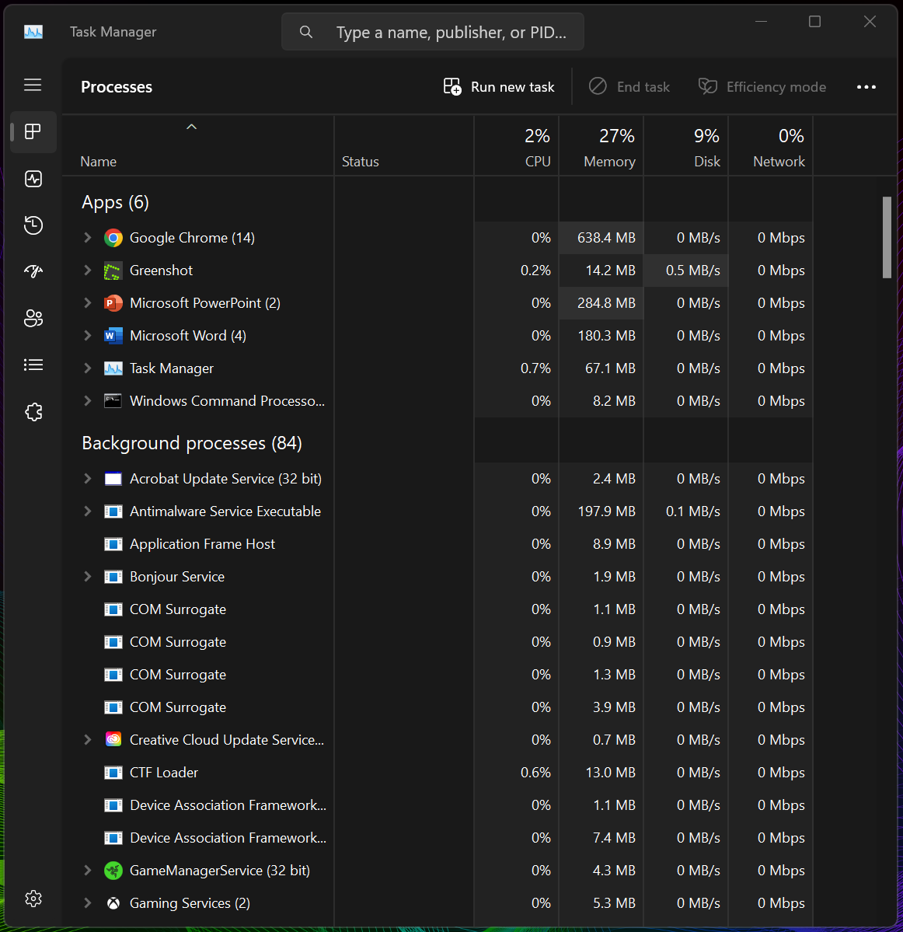

Process Management is the function of creating, monitoring, scheduling and terminating processes within a system. It includes starting/stopping programs, assigning priorities, allocating resources and ensuring that applications on the system are compatible. Performance Monitor and Resource Monitor can be run to view statistics on how the systems and processor are performing in real time [5-7].

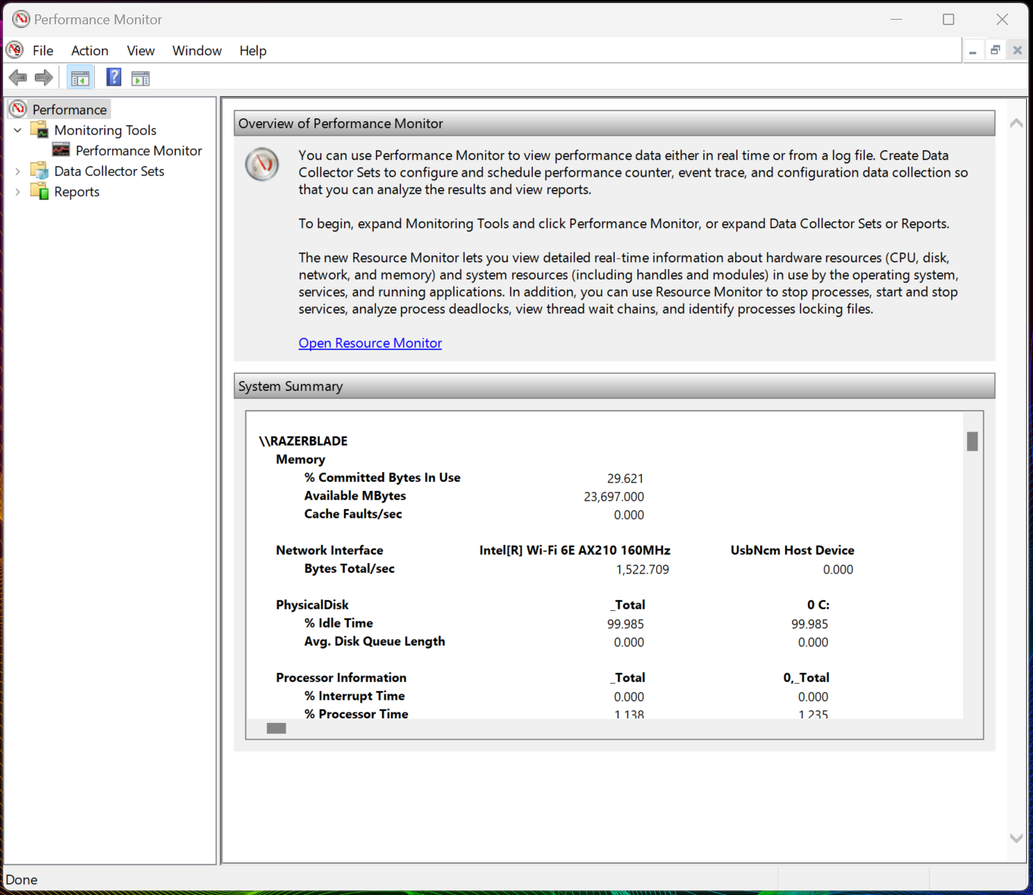
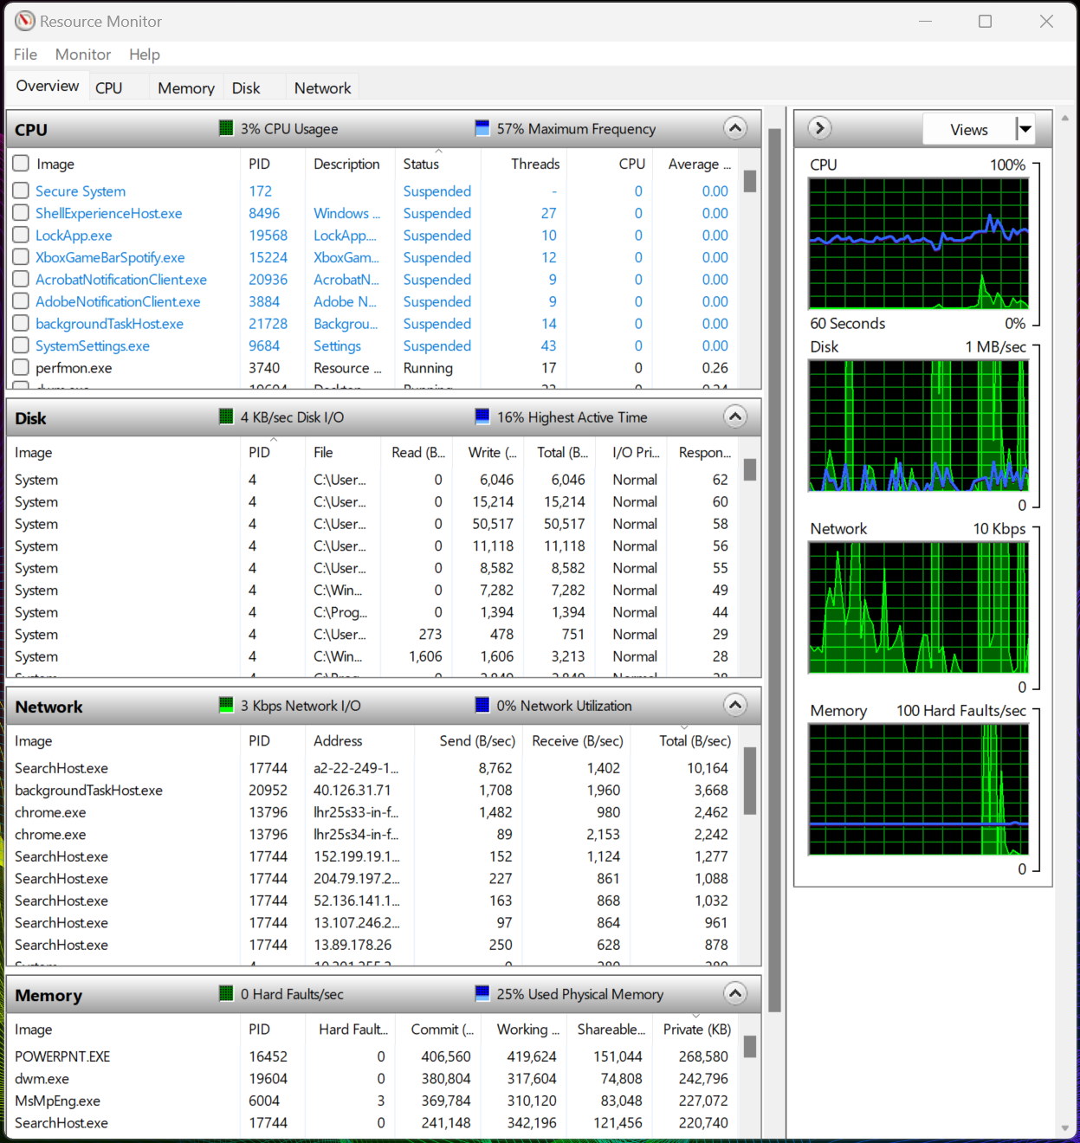
Device Management handles all the input/output hardware devices within a system. It installs, configures and updates drivers and allocates/releases devices when required. It also helps to ensure that devices are up to date, secure and compliant with policies. Event Viewer and Reliability Monitor provide a way to see what driver updates, software installations or hardware crashes might be related to system instability [5-7].

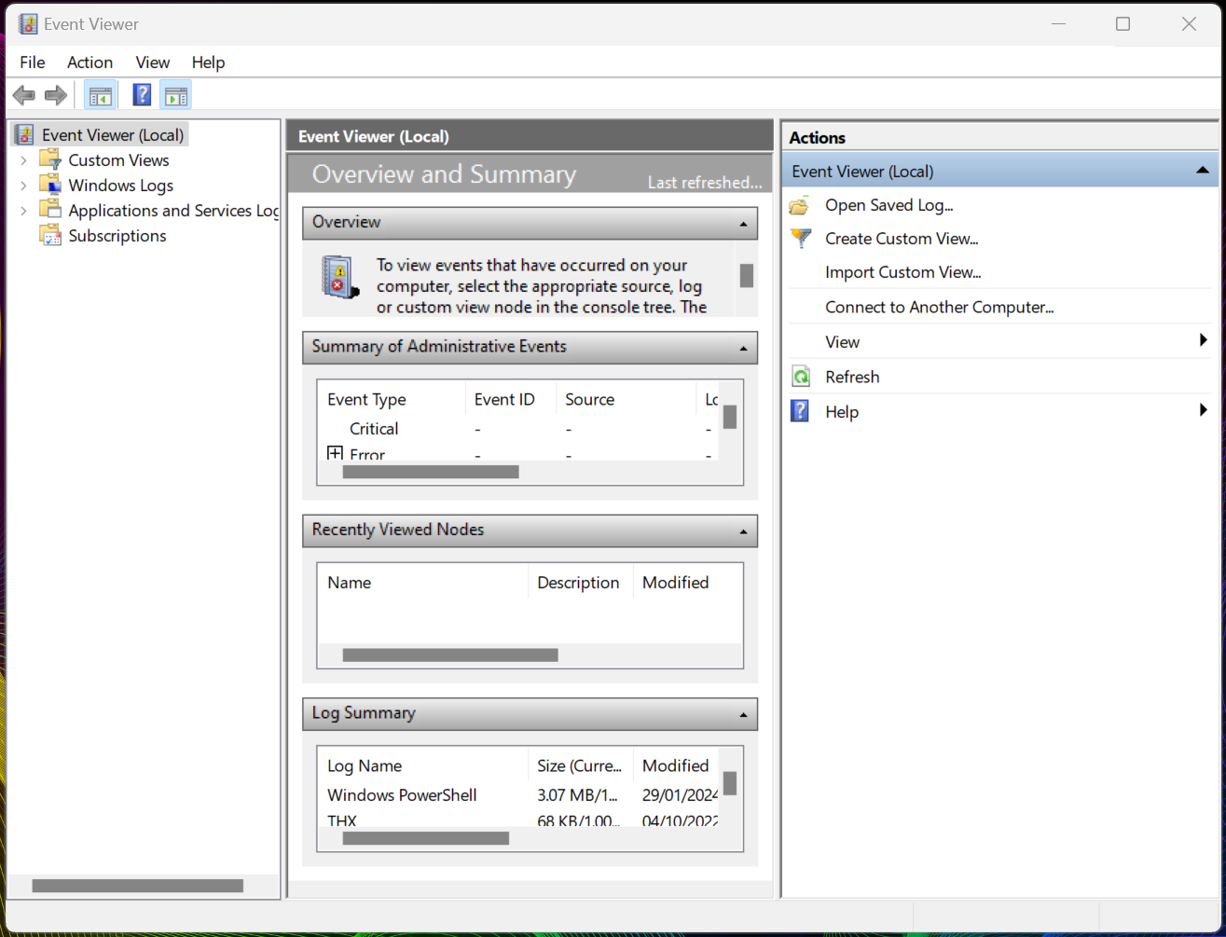
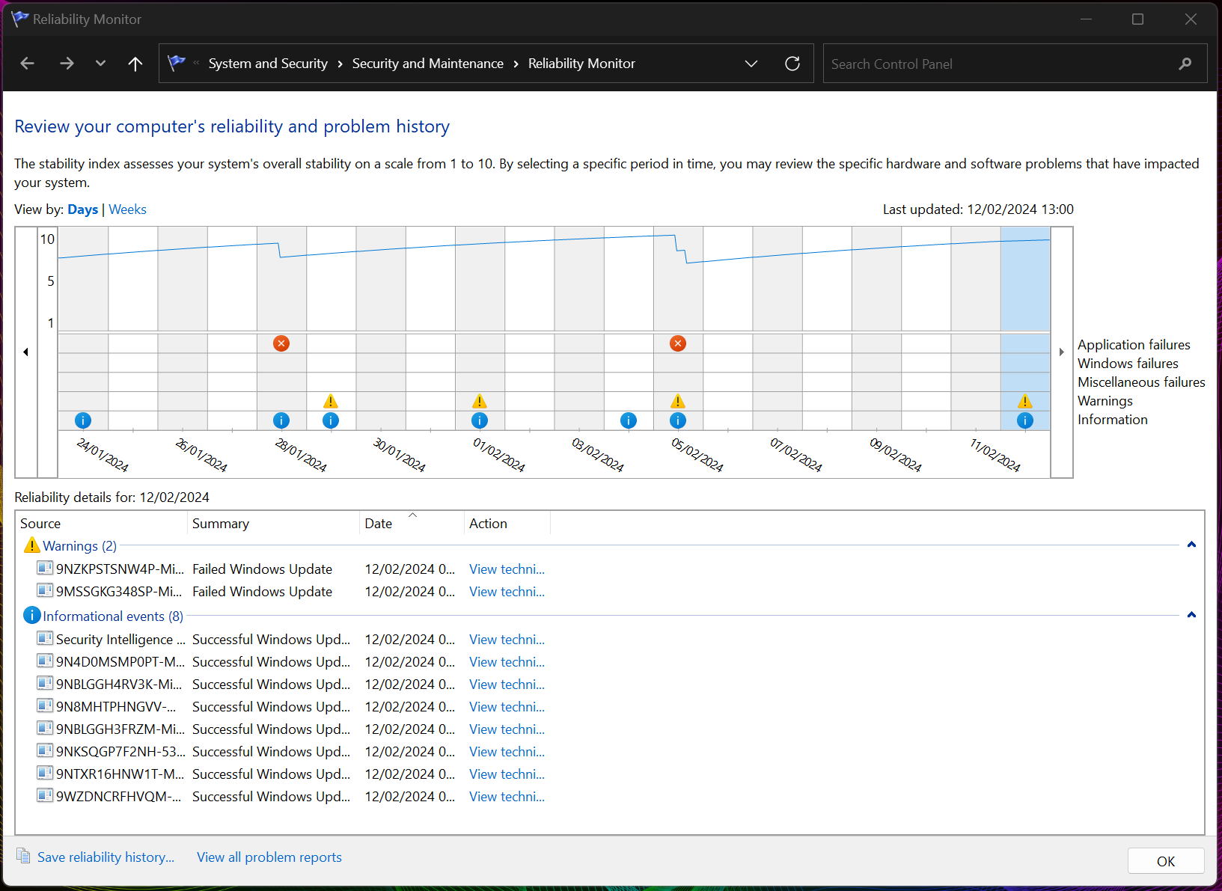
File Management is responsible for managing the files on a system. It allows navigation and provides the functions that can create, delete and modify files. It also handles file attributes, permissions and ownership [5-7].

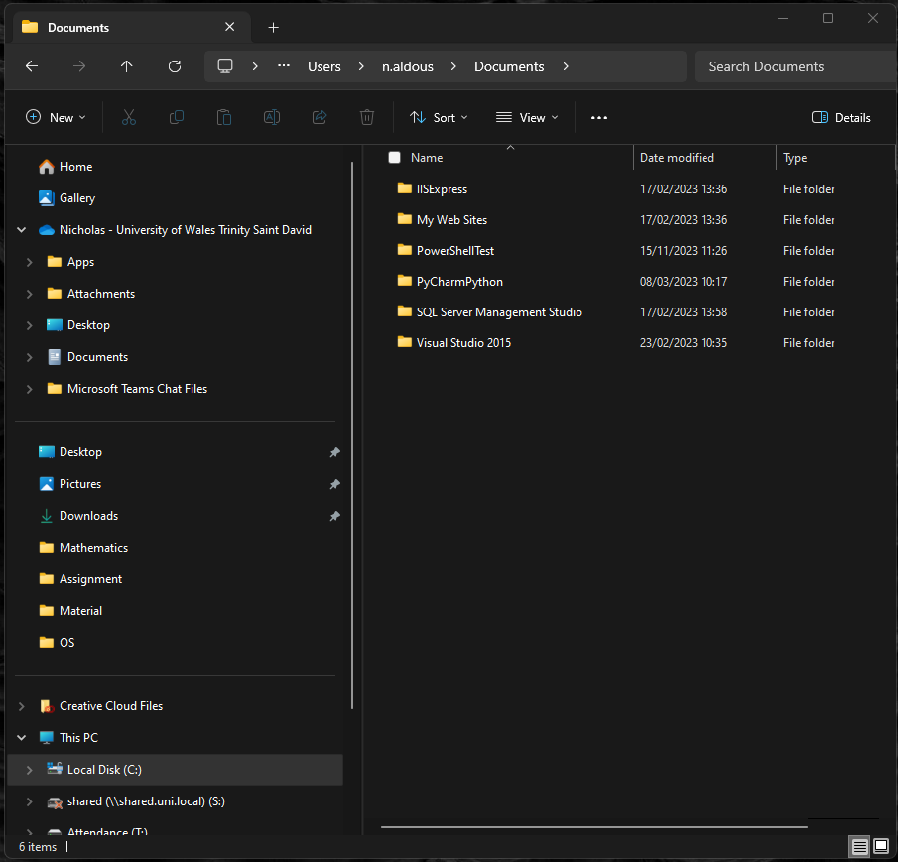

Network Management enables communication and data exchange between different systems over a computer network. It implements network protocols, standards and architecture and can provide services such as DHCP, DNS, FTP and HTTP. It allows the user to manage network devices e.g. routers, hubs and switches and monitor network security and performance [5, 6, 8].

System Security protects the system from unauthorised access, modification or damage and ensures system integrity and availability. It includes protection measures such as authentication, authorisation, encryption and firewall mechanisms to prevent attacks [5, 6, 9].

Windows OS CLI Commands

Windows batch commands provide direct communication between the Operating System and the User. They enable commands to be executed and can allow software developers to automate repetitive or routine tasks [9], [10].

The “title” batch command can be executed to change the title of the console window [11], [12].
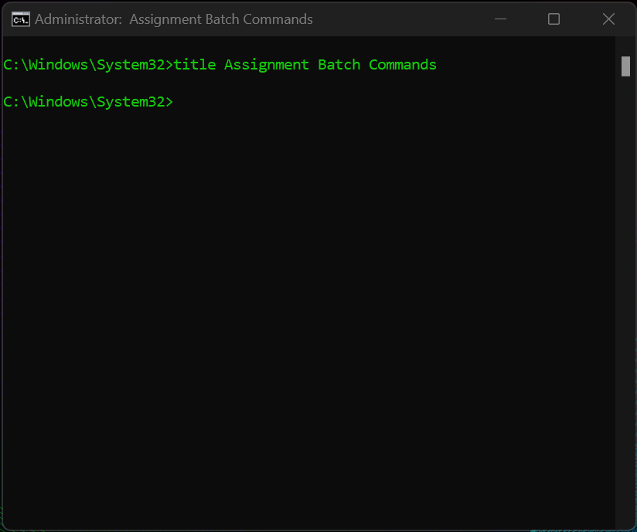

The “echo” batch command can be executed to turn echoing on/off and print messages/text in the console [11], [12].
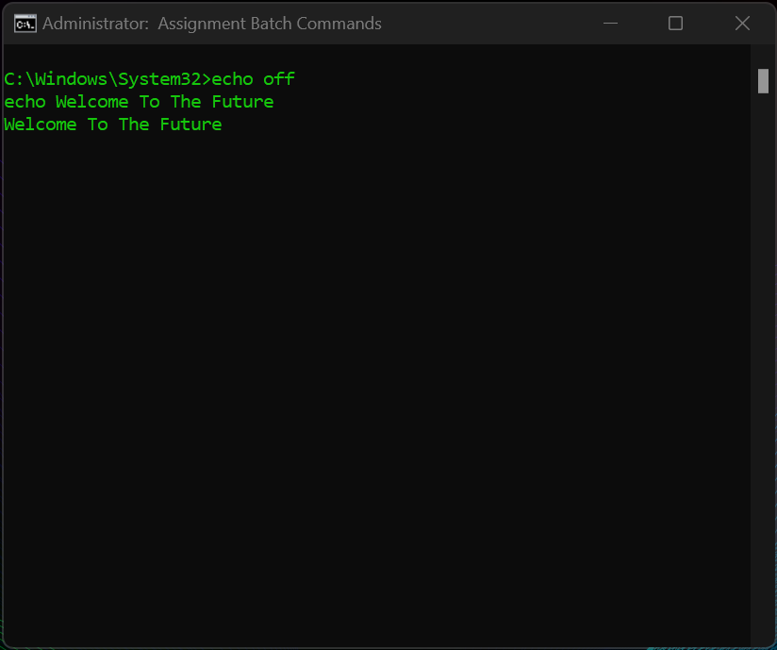
The “ver” batch command can be executed to display the current version of the Operating System [11], [12].
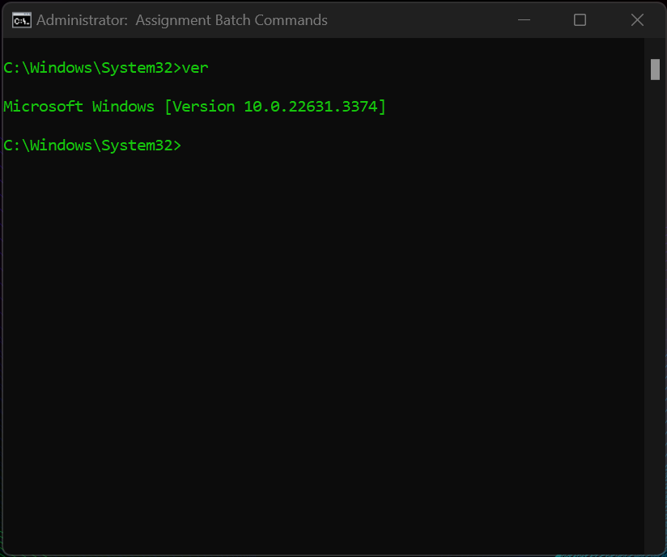

The “cd” batch command can be executed to select another directory or folder [11], [12].
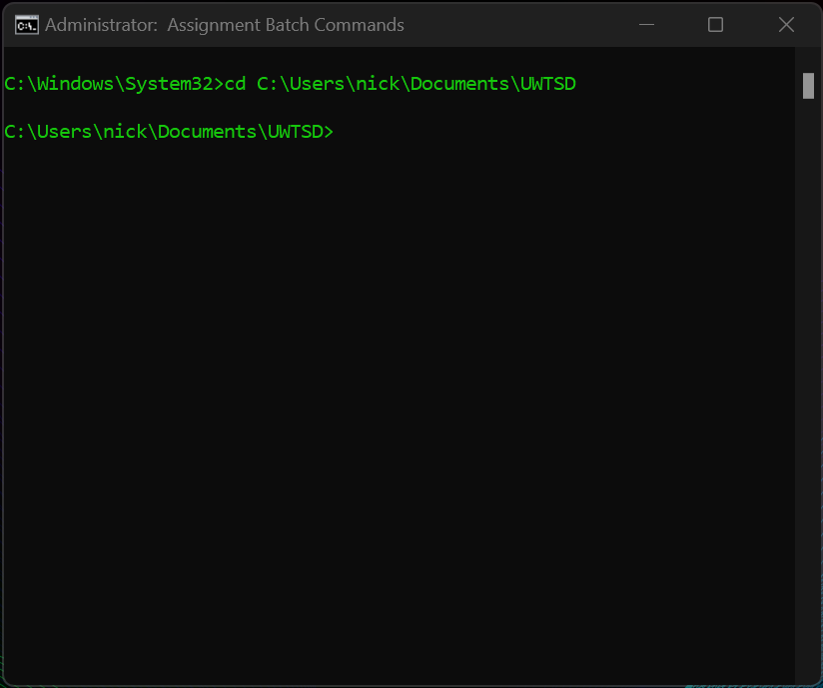

The “mkdir” batch command can be executed to create a directory or subdirectory [11], [12].
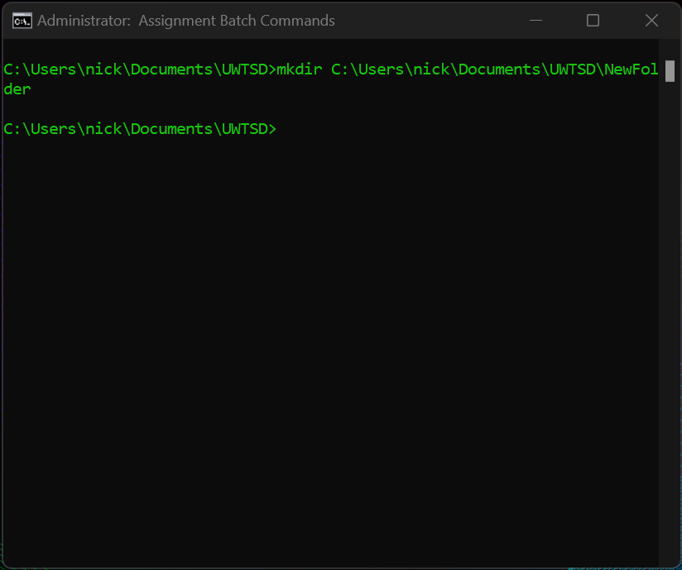

The “find” batch command can be executed to search for a string in a specific directory/file and output the matching lines [11], [12].
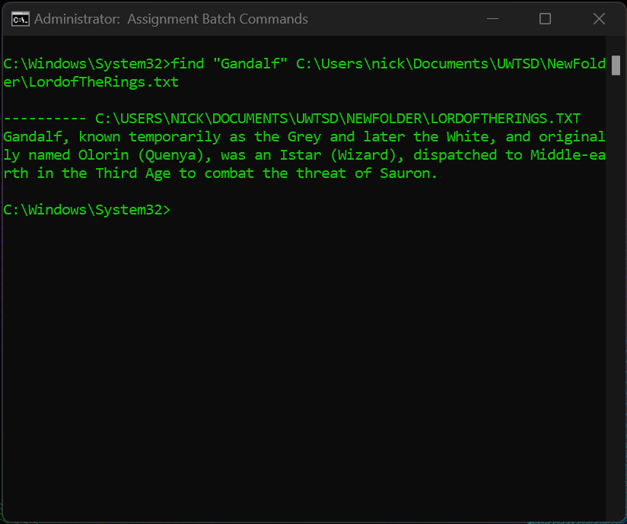

The “ipconfig” batch command can be executed to display/configure the system IP network information [11], [12].
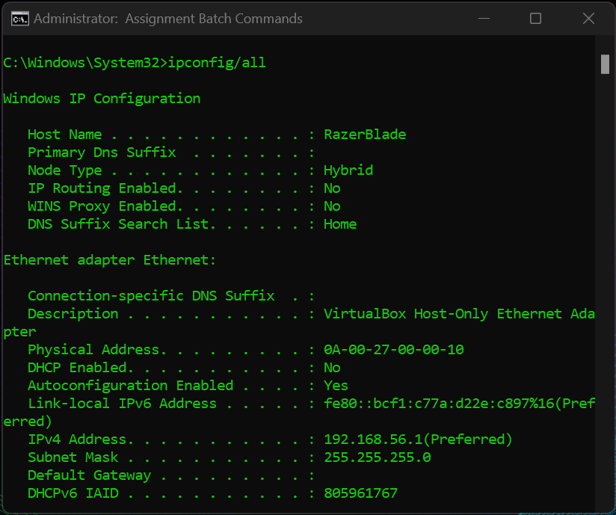

The “ping” batch command can be executed to test the connection with another destination by sending packets over the network [11], [12].
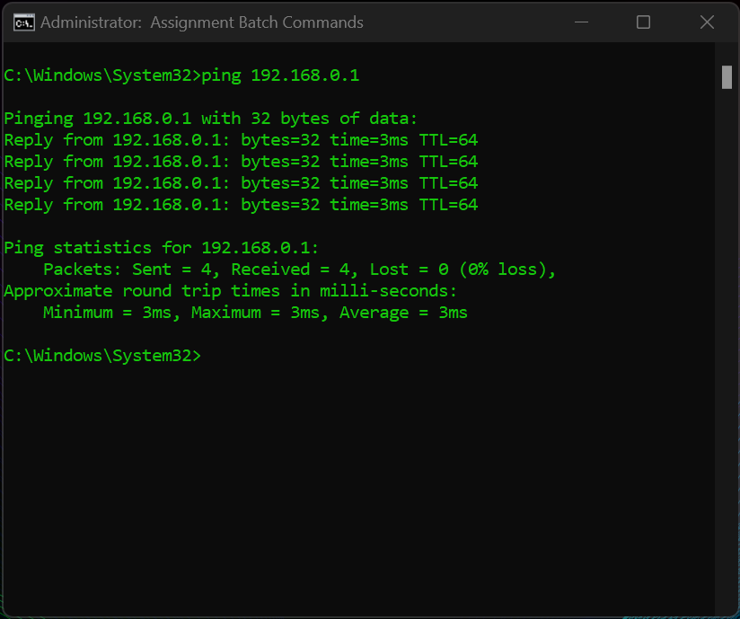

The “tasklist” batch command can be executed to display the active tasks and processes of the system. The command can include options which can be used to customise the output of the command. The options are defined using a forward slash or a hyphen, followed by a letter word [11-13].
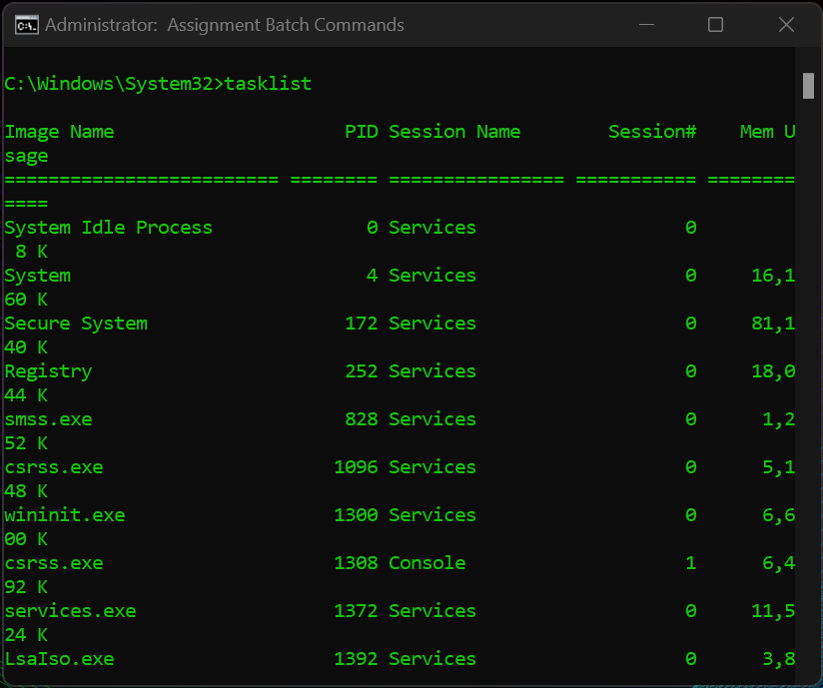

The additional option ‘/FI "STATUS eq RUNNING"’ filters the processes based on their status, specifically looking for processes that are ‘RUNNING’. The additional option ‘/v’ provides verbose output which brings in additional information about each process.
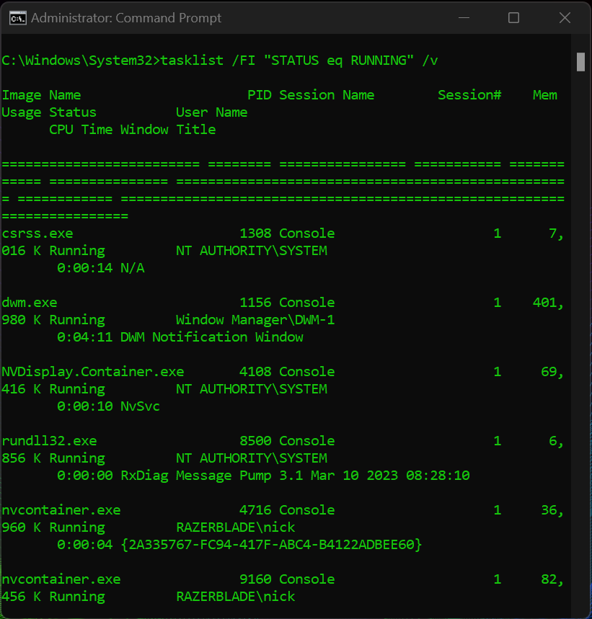

The “dir” batch command can be executed to display the contents of a file directory. The command can include options which refer to parameters which can customise the output of the command [11, 12, 14].
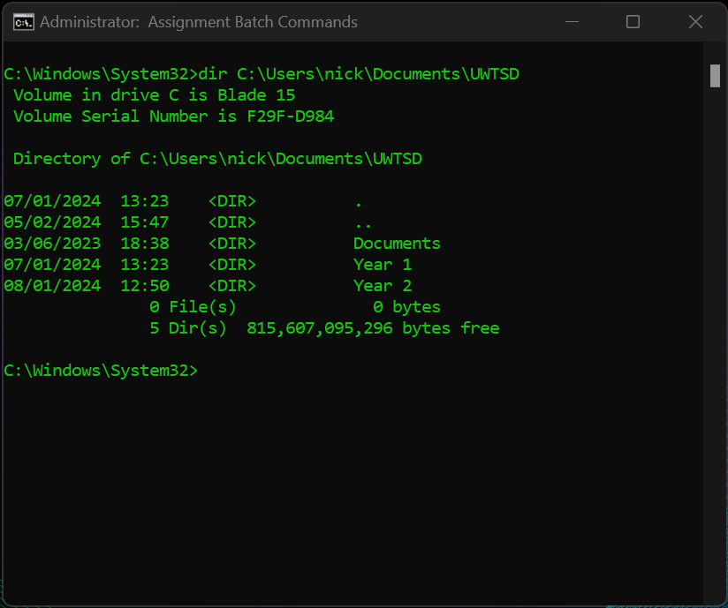

The additional option ‘/s’ displays information regarding the subdirectories in the file directory, and the ‘/p’ option pauses after each screen of information.
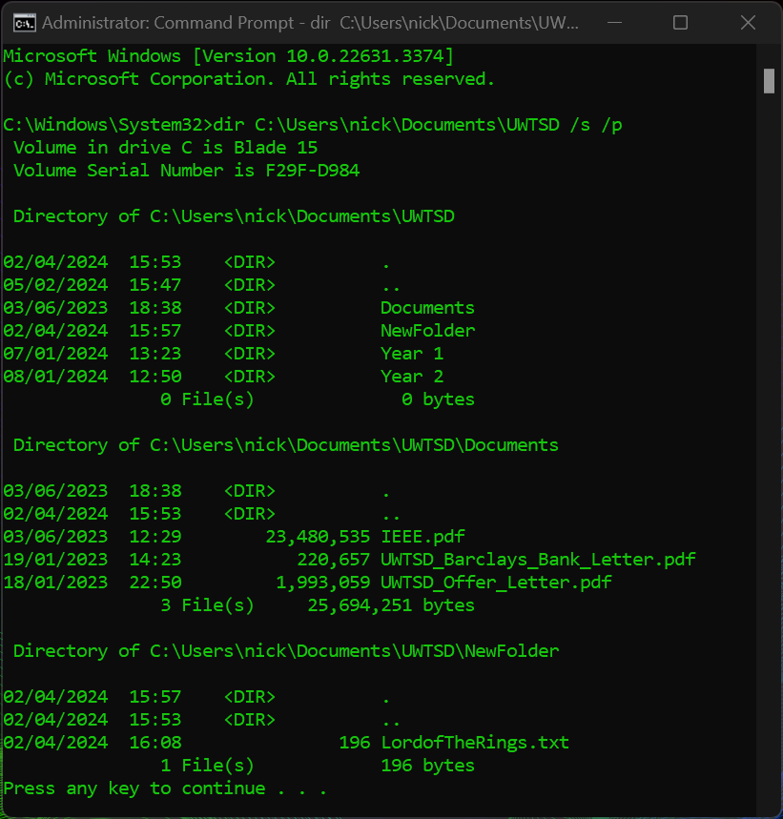

Linx OS CLI Commands

Bash is a Unix shell and command language which is the default interface for most Linux Operating System distributions. Bash commands provide users with a set of tools for managing tasks. They facilitate system navigation and effectively management of files and directories [15].

The “cat” bash command is short for Concatenate. The command displays the contents of a file within the terminal without having to manually open the file [16].
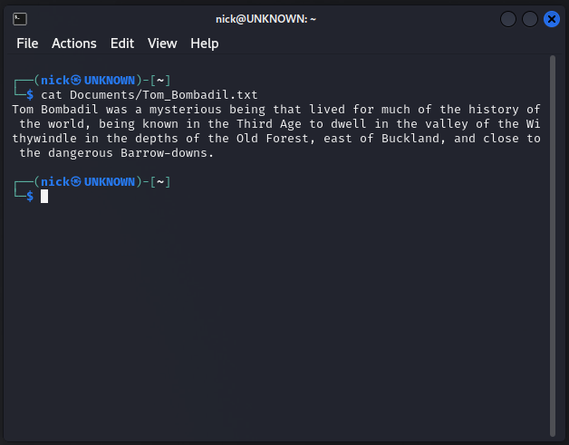

The “cp” bash command is short for Copy. When executed the command can copy directories and/or files in the same location or to a different location, while preserving their attributes and content [16].
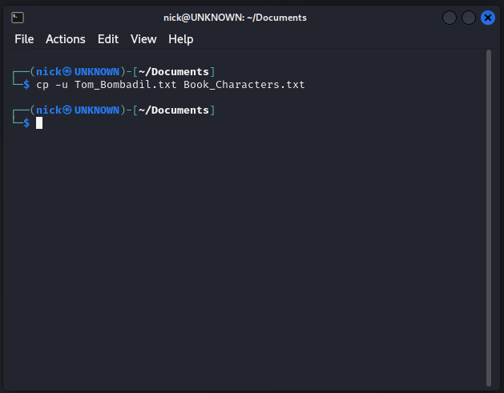
The “df” bash command is short for Disk Free. It allows users to view the available disk space on a filesystem and can be executed with additional options to increase functionality [17].
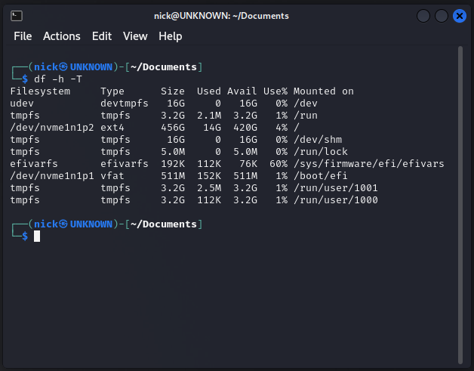

The “du” bash command is short for Disk Usage. It estimates and displays the disk space that is being used by the directories or files on the system printed in kilobytes [16].
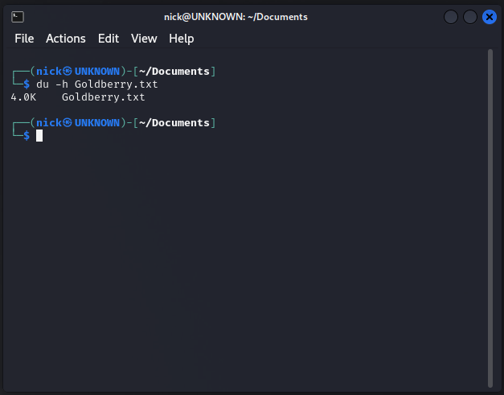

The “gpg” bash command is short for GNU Privacy Guard. The utility can encrypt data by creating digital signatures and is an implementation of the OpenPGP standard which provides advanced key management solutions [18].
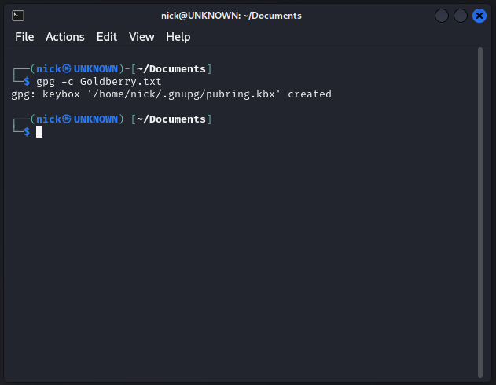.

The “history” bash command utility can be performed to view a list of commands that have recently been executed within a terminal session and are displayed in chronological [16].
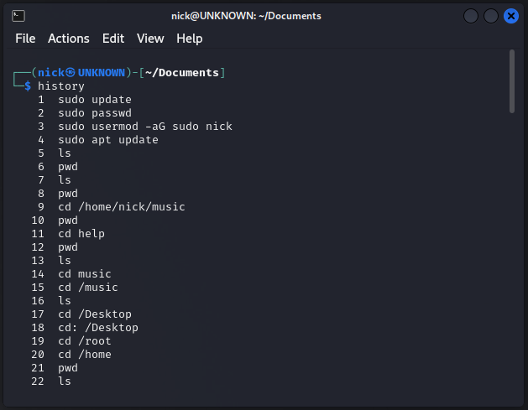

The “pwd” bash command is short for Print Working Directory. The command displays the path of the current directory and can be used to pass the working directory within a script [16].
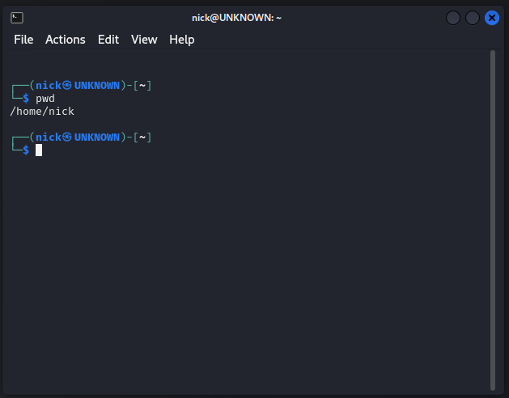

The “ls” bash command is short for List Files. The command lists files which are in the current directory and can provide optional information such as permissions [16].
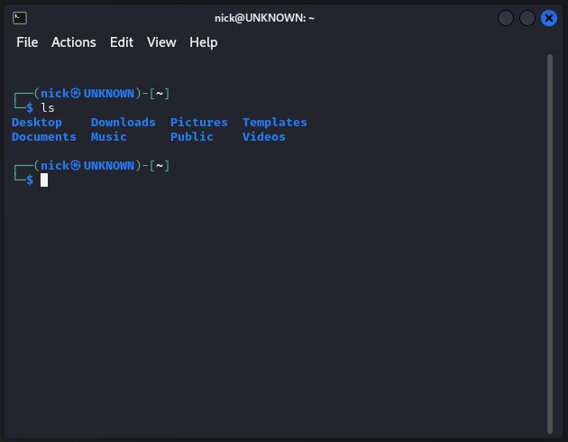

The “touch” bash command utility can be performed to create a new file or empty a file. The command can also be executed to change the file timestamp [16].
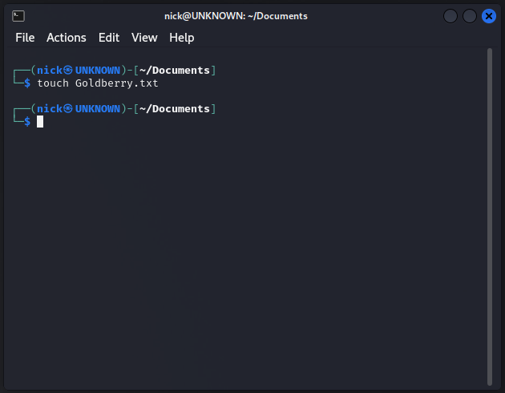

The “which” bash command utility can be executed to located the executable file or location of an application and display the path where the item is located on the filesystem [19].
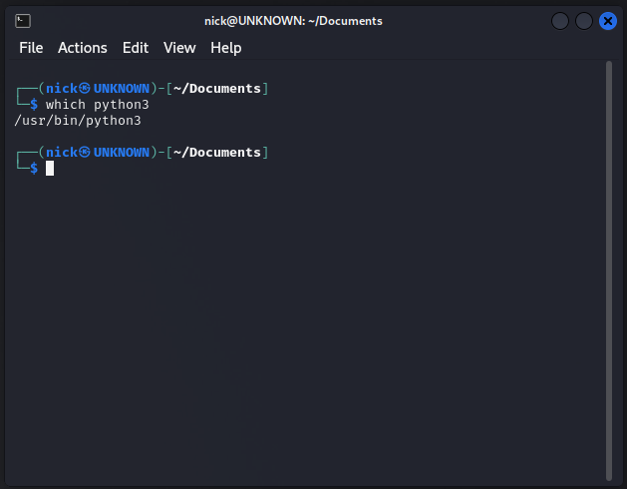

Windows OS Script

This program is a simple search engine selector which has been developed using Windows Batch commands to create an executable script file (.bat). It begins by setting up arrays (engines and URLS) to store the names and corresponding URLs of different search engines. The arrays are accessed using numerical indices.
The program starts with a label (:top) and clears the screen (cls) to display a menu for selecting a search engine. It repeats over the indices 1 to 5 using a for loop, which display each search engine name and it’s index. The user is prompted to enter a number corresponding to their desired search engine and advised that they can enter 'E' to exit.
After user input (userinput), an if statement checks if the input corresponds to a valid index. If accepted, it sets the engineName and URL variables based on the choice. A loading message is then displayed which features a delay using timeout, then the script opens the systems default browser and loads the search engine URL. To finish, the program is automatically terminated (goto :exit).
If the user inputs 'E' to exit, the program terminates using the Exit /b command. Otherwise, if the input is invalid an error message is displayed and the program returns to the :top label using goto top after a short pause where the user can attempt input.
The :exit label is initiated after a search engine is successfully launched or when the user chooses to exit. It displays a message informing the user that the program will close and uses another for loop to display a countdown from 5 to 1, then the program automatically exits (exit /b)
In summary, this program demonstrates the use of arrays (engines and urls) to store data, user input handling (set /p), conditional statements (if and else if), looping (for /l), variables (set), screen clearing (cls), and program control (goto statements) to create a basic interactive menu driven application [20-22].

Search Engine Selector Source Code
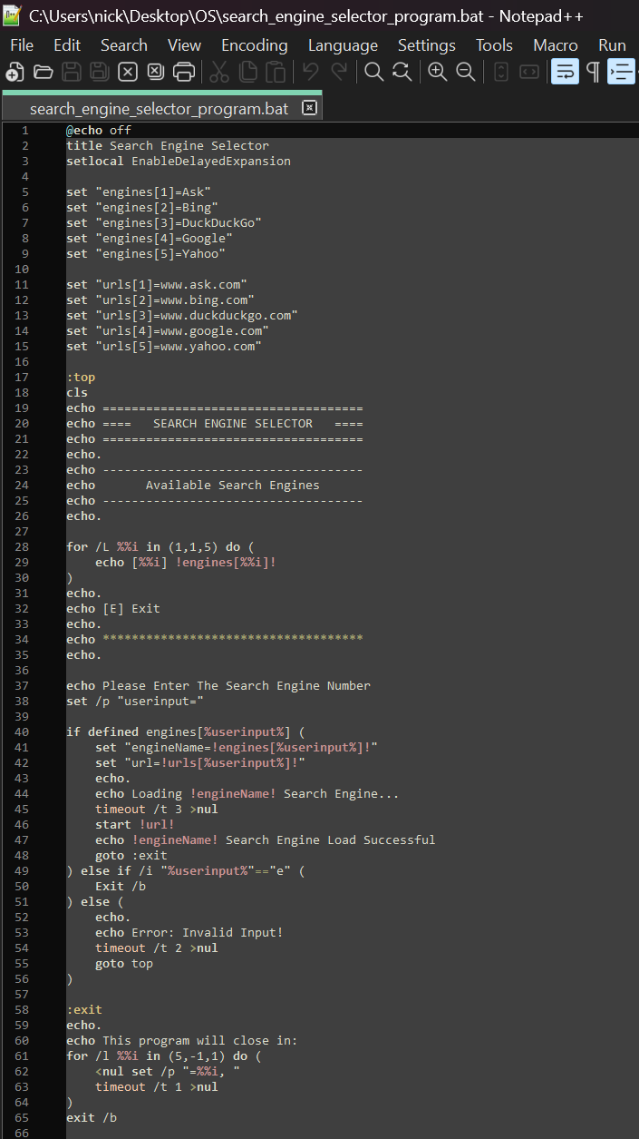
Valid Input
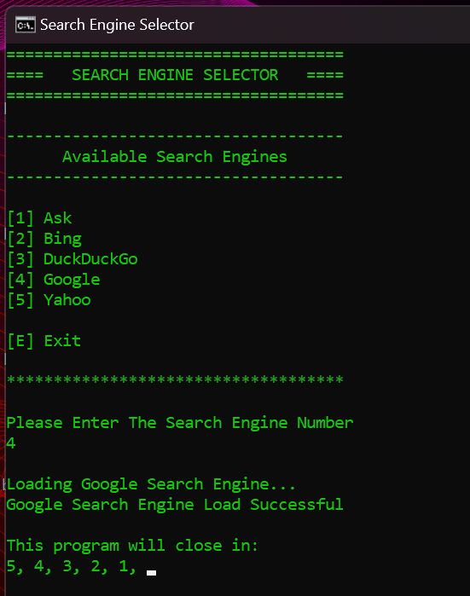

Invalid Input
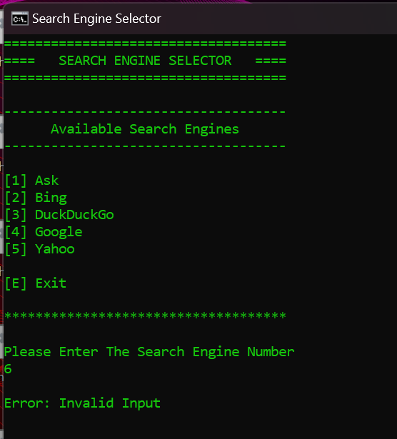

Linx OS Script

This program "Lord of The Rings Dictionary", allows users to select a characters and displays their description, traits and a famous quote. It uses several features to achieve faultless interactive functionality.
Firstly, the program defines an associative array (characters) to store information about a range of characters from The Lord of The Rings. Each key value pair in the array represents a character's name which connects to their description, traits and quote.
Then the profile() function is defined to display information about the selected character which is built from the input name parameter. In this function the character's information is retrieved from the array using parameters to extract their description, traits and quote.
The program then displays a menu to the user using the menu() function, this starts a while loop until the user executes the exit command. The menu displays numbered options for each character and prompts the user for input using the read utility. Depending on the user's selection, a case statement is used to match the input with corresponding actions.
If the user enters a number (1-10), the profile() function is called with the character's name. If the user enters 'e' or 'E', the program exits. If the user inputs anything other than these options, an error message is displayed and prompts the user to enter a command. The menu() function continuously loops, allowing the user to explore different characters until they choose to exit.
This program demonstrates the use of variables (arrays and local variables within functions), user input handling (read), conditional statements (case), looping (while loop), function definitions (profile()) and error handling for invalid inputs. It provides an interactive way to explore a number of characters from The Lord of The Rings through a simple command line interface [23, 24].

Source Code [1/2]
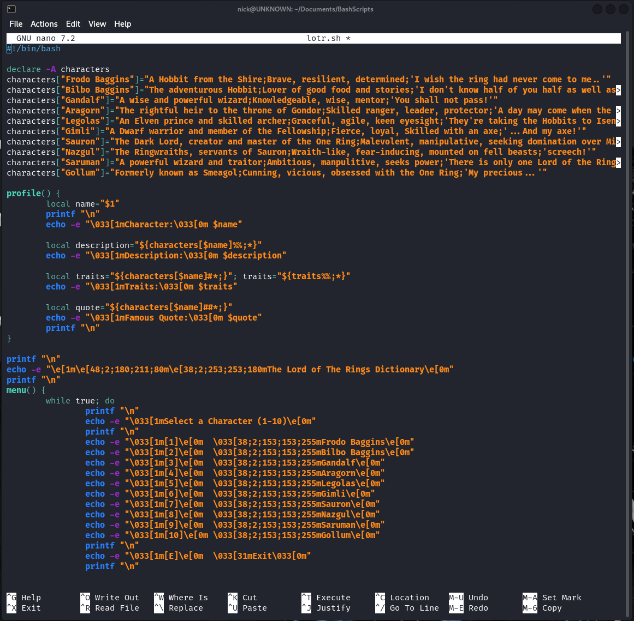

Source Code [2/2]
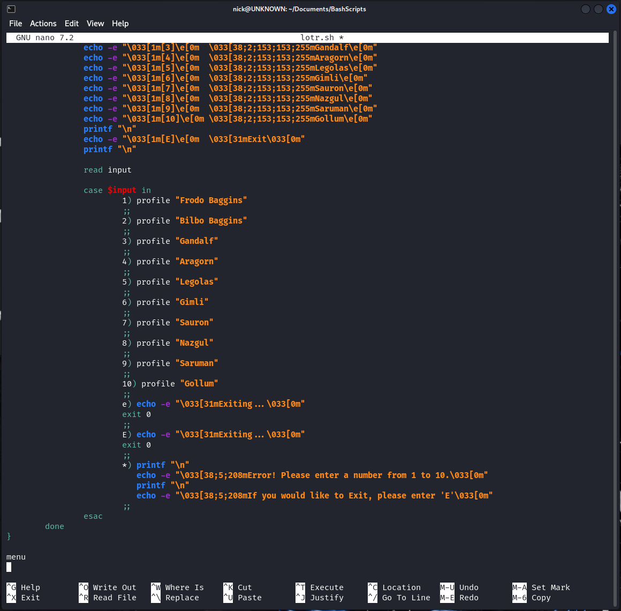

Lord of The Rings Bash Script Program
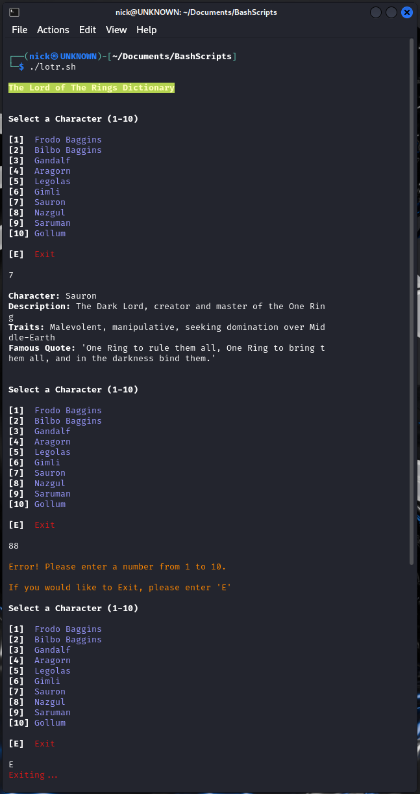
Start of Bash Script
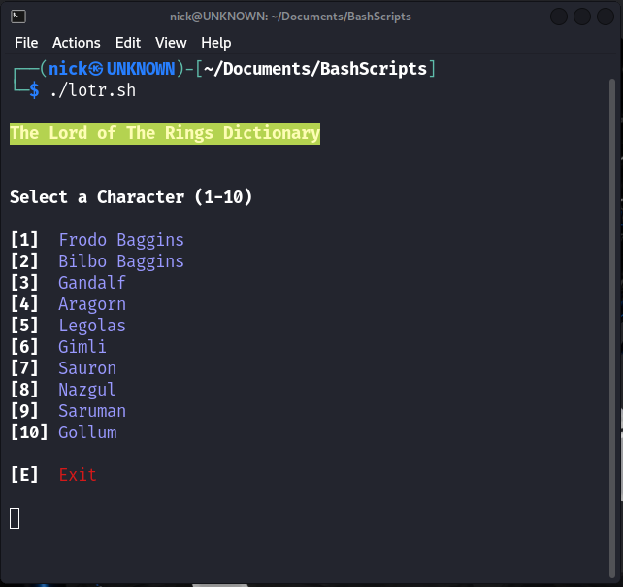

Exit of Bash Script
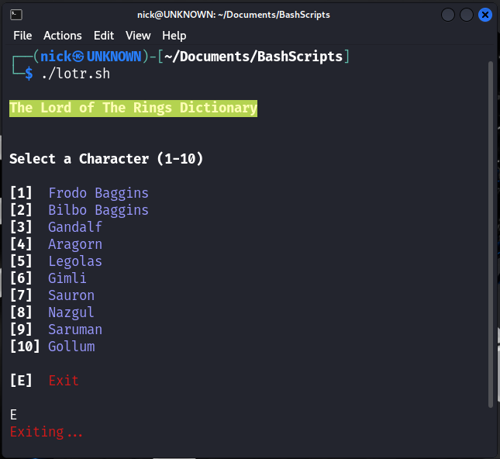
Valid Input
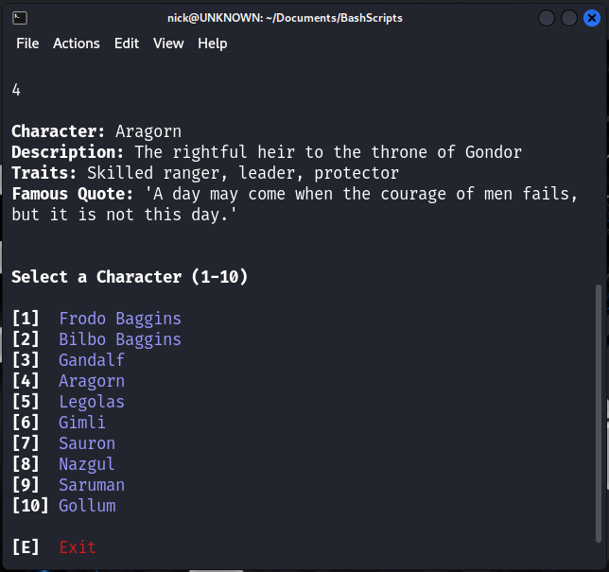

Invalid Input
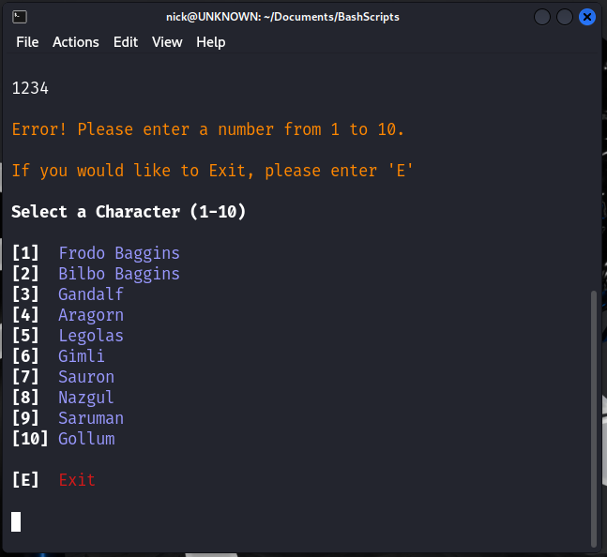

Conclusion

In conclusion, this assignment has explored the fundamental aspects of Windows and Linux Operating Systems and their Command Line Interfaces, focusing on key functions and command operations. The assignment explains the core functions, with practical demonstrations and references to provide insight into system management and process handling. It demonstrates the practical use of Windows and Linux CLI commands, highlighting scripting capabilities and automation potential offered by these tools. Overall, this assignment has developed my understanding of different Operating Systems and their functions and Command Line utilities by integrating research, explanations, practical demonstrations and the completion of a certified online course.

Reference List

[1] (Apr 1,). What is an Operating System (OS)? Definition, Types and Examples. Available: https://www.techtarget.com/whatis/definition/operating-system-OS.
[2] (Apr 12,). Booting an Operating System. Available: https://people.cs.rutgers.edu/~pxk/416/notes/02-boot.html.
[3] (June 11,). What is an Operating System?. Available: https://www.geeksforgeeks.org/what-is-an-operating-system/.
[4] (May 31,). What is Operating System. Available: https://cloudfoundation.com/blog/what-is-operating-system/.
[5] (Dec 27,). What is Operating System? Core Functions and Features. Available: https://www.theknowledgeacademy.com/blog/what-is-operating-system/.
[6] (Jan 23,). Functions of Operating System - Shiksha Online. Available: https://www.shiksha.com/online-courses/articles/functions-of-operating-system/.
[7] (Sep 22,). Task Manager: What It Is & How to Use It. Available: https://www.lifewire.com/task-manager-2626025.
[8] (Feb 10,). What Is Network Management? Definition, Key Components, and Best Practices. Available: https://www.spiceworks.com/tech/networking/articles/what-is-network-management/.
[9] (Jun 17,). Operating System Security. Available: https://www.techopedia.com/definition/24774/operating-system-security-os-security.
[10] (). What is Batch Scripting and how does it work? - Seobility Wiki. Available: https://www.seobility.net/en/wiki/Batch_Scripting.
[11] (). Batch Script - Commands. Available: https://www.tutorialspoint.com/batch_script/batch_script_commands.htm.
[12] (Mar 7,). Batch file commands at a glance. Available: https://www.ionos.co.uk/digitalguide/server/tools/batch-commands/.
[13] (Dec 11,). Tasklist command. Available: https://www.computerhope.com/tasklist.htm.
[14] (Jan 28,). Dir Command (Examples, switches, options, & more). Available: https://www.lifewire.com/dir-command-4050018.

[15] (Aug 27, 0). Bash cheat sheet: Top 25 commands and creating custom commands. Available: https://www.educative.io/blog/bash-shell-command-cheat-sheet.
[16] (Aug 24,). 30 Bash Commands Cheat Sheet. Available: https://phoenixnap.com/kb/bash-commands.
[17] (Mar 23,). Check your disk space use with the Linux df command. Available: https://www.redhat.com/sysadmin/linux-df-command.
[18] (May 3,). How to Encrypt and Decrypt Files Using GPG in Linux. Available: https://www.tecmint.com/gpg-encrypt-decrypt-files/.
[19] (Jan 1,). Linux which command. Available: https://www.javatpoint.com/linux-which-command#:~:text=The%20Linux%20which%20command%20is,file%20or%20command%20is%20stored.
[20] (Sep 12,). How to Create and Run a Batch File in Windows 10 and 11. Available: https://www.makeuseof.com/tag/write-simple-batch-bat-file/.
[21] (May 26,). How to create batch script files on Windows 11. Available: https://www.windowscentral.com/software-apps/windows-11/how-to-create-batch-script-files-on-windows-11.
[22] (Sep 6,). How to Write a Batch Script on Windows. Available: https://www.howtogeek.com/263177/how-to-write-a-batch-script-on-windows/.
[23] (Mar 19,). How To Write Bash Scripts in Linux. Available: https://www.tomshardware.com/how-to/write-bash-scripts-linux.
[24] (Mar 16,). Shell Scripting Tutorial: How to Create Shell Script in Linux/Unix. Available: https://www.guru99.com/introduction-to-shell-scripting.html.
[25] (Oct 15,). Types of Operating Systems (With OS Functions and Examples) | Indeed.com. Available: https://www.indeed.com/career-advice/career-development/types-of-operating-systems.
[26] (Mar 8,). Types of Operating System, Advantages, Disadvantages And More // Unstop. Available: https://unstop.com/blog/types-of-operating-systems.
[27] (Jan 2,). What is Linux?. Available: https://www.redhat.com/en/topics/linux/what-is-linux.
[28] (Nov 14,). A Complete Guide to Understanding Linux File System Tree. Available: https://www.cherryservers.com/blog/a-complete-guide-to-understanding-linux-file-system-tree#:~:text=The%20%2Fbin%20directory%20contains%20binary,just%20to%20mention%20a%20few.
[29] (Sep 13,). Bash for Beginners Part 33: Creating New Users and Groups on Linux. Available: https://medium.com/@rldsn/bash-for-beginners-part-33-creating-new-users-and-groups-on-linux-b070a6b2d99c.

Appendices

Types of General Operating Systems
Multi Programming OS allow a number of applications to run simultaneously and effectively on a single processor system. They maintain multiple running programs and arranging them depending on their priority and the resources that they require. Windows, Linux and MacOS are all examples of this type of OS. Multi Programming OS increase the performance of a system by allowing multiple applications to run on one machine but they can lead to issues if multiple tasks try to access shared resources causing conflicts and resulting in slower response times.
Batch OS are the most suitable system to use in lengthy and timely tasks. They help to group similar tasks and executing the tasks without the requirement of human interaction. The user manually adds the job and submits it with the help of a device to the computer system. Batch OS allow the management of large workloads and accurately estimate how long a task will take to complete but they can be complex to debug and system failures can create large backlogs.
Time Sharing OS, also known as Multi-Tasking OS work by allocating a set time to a number of tasks and frequently shift between the tasks. They allow multiple users to simultaneously interact with the same computer system and feature an increased response time between jobs. Time Sharing OS increase system performance as they minimise the idle time of the processor but system failure can have a knock on effect and lead to more widespread failures.
Network OS are commonly installed on servers and provide features and services which are specifically designed for network environments. They allow the users to manage applications, data and groups. They also facilitates the sharing of resources such as applications, files and printers. Network OS allow security issue to be handled more effectively but they can be expensive to purchase and maintain.
Real Time OS are designed to manage time critical applications which require precise execution of tasks. They are commonly used within organisations such as robotics and aerospace and their processes can include medical imaging and missile system operation. They feature a small response time between input, processing and response which is crucial for highly sensitive processes that require high accuracy execution. Real Time OS have mechanisms that maintain error handling and system failures but feature constraints which make them less flexible to adaptation.
Mobile OS are specifically developed for devices such as smartphones, wearables and tablets. They include features for mobile use such as application integration, touch screen support and wireless network connectivity. Some examples of this type of OS are Android Windows Mobile Operating System and Apple iOS. Mobile OS are easy for users to operate but can have hardware limitations compared to computers or laptops [25], [26].

Linx Operating Systems
Linux is an open source operating system, which is centred around the Linux kernel family. The OS kernel was released on the 17th September 1991 by Linus Torvalds. The OS is presented as the Linux Distribution and includes the supporting libraries, system software and kernel. There are many Linux distributions which are developed by different organisations, some of these include Ubuntu, Mint and Kali [27].

The Linux file system features a hierarchical tree layout which is governed by the Filesystem Hierarchy Standard (FHS) and is a standard which is managed by the Linux Foundation. Some of the directories within a Linx system are as follows:

- /root directory sits at the top of the directory within the hierarchy formation. All folders and files on the system are stored and referenced from here.
- /home directory contains users' personal folders and files and is the entry point for any logged-in user on the system.
- /boot directory includes essential files which are essential to successfully boot the system.
- /bin directory contains binary executables which are programs that include common commands such as ls and ping.
- /dev directory includes files that are representative of devices that are connected to the system, such as hard drives.
- /mnt directory is a temporary mount point for removable devices, such as USB sticks.
- /sbin directory contains command line tools and executables for the root user.
- /temp directory is where temporary files are stored.
[28].

NDG Linux Unhatched Course

During Completion [1/2]
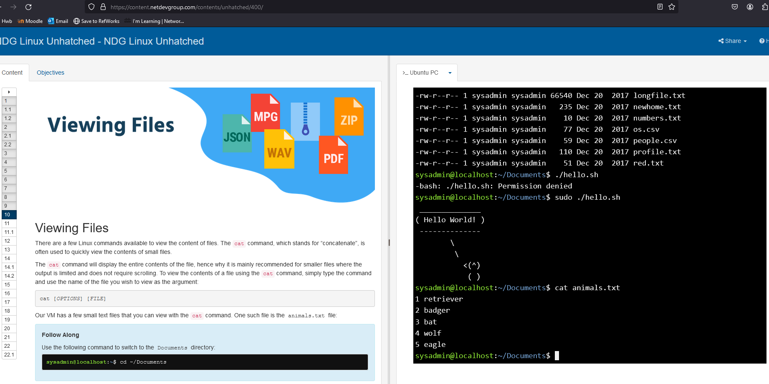

During Completion [2/2]
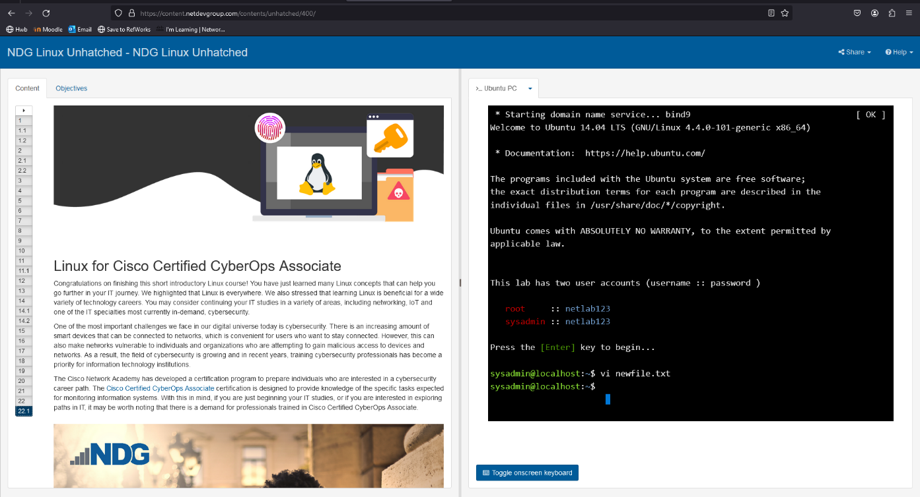

Exam Evidence
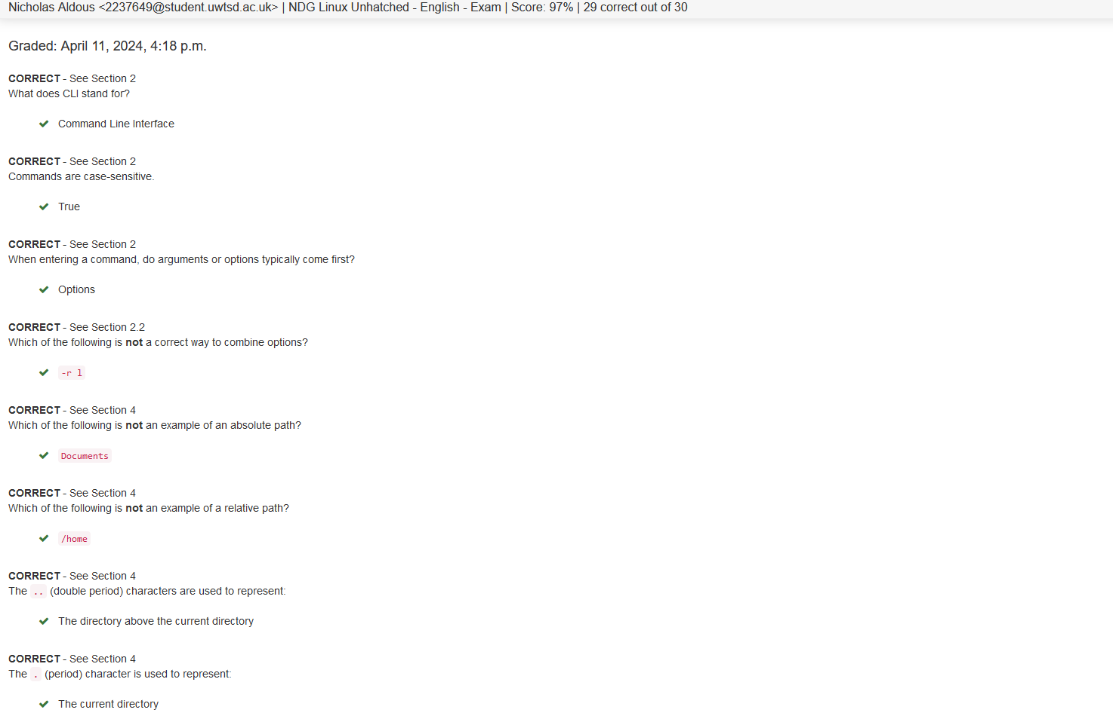

Exam Result
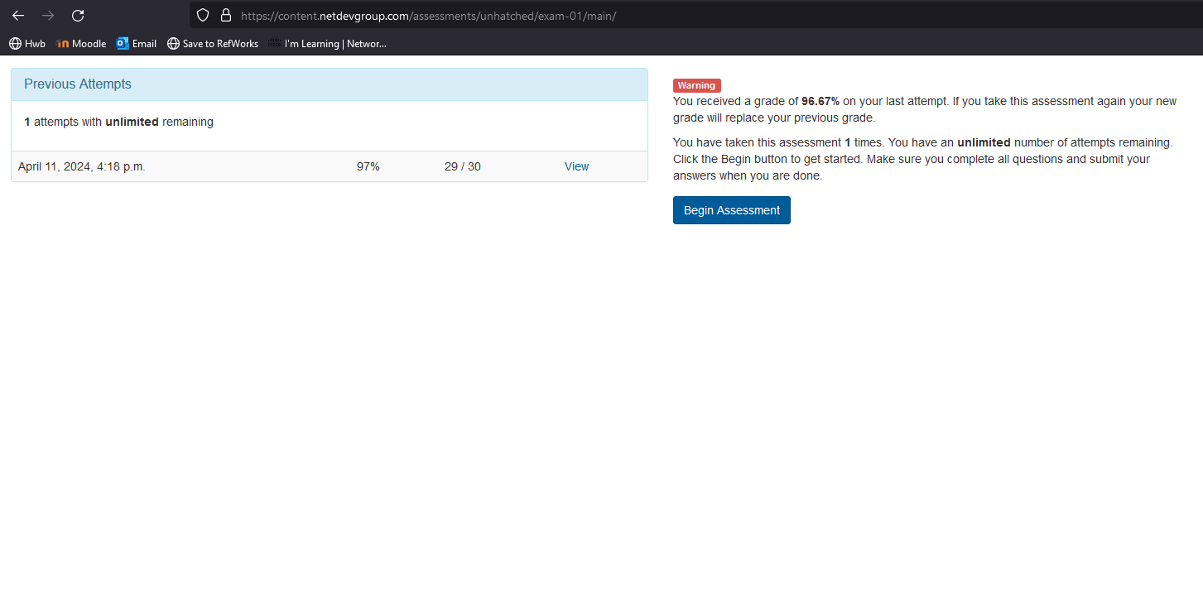

Users & Groups in Bash

Creating a New User Using Bash
The command sudo adduser can be executed on Linx to create a new user, followed by the name of the user to be assigned. A number of prompts for additional information will appear and then finally a confirmation request [29].
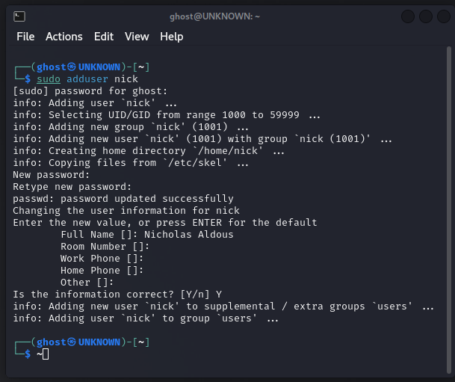

Creating a Group Using Bash
The command sudo groupadd can be executed on Linx to create a new group, followed by the name of the group to be assigned. To verify that the group has been added successfully the command tail /etc/group can be executed [29].
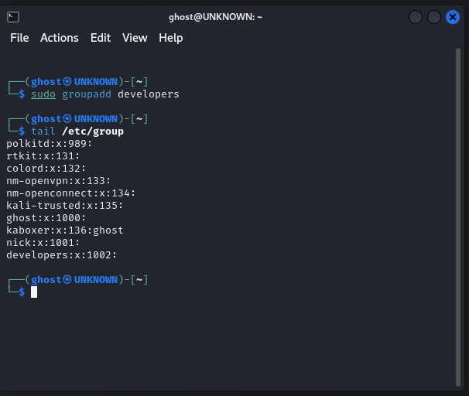
Adding a User to a Group Using Bash
The command sudo usermod -a -G can be executed on Linx to create a add a user to a group, followed by the name of the group to be assigned. To verify that the user has been added successfully the command tail /etc/group | grep, followed by the name of the group can be executed [29].


