
business plan and individual presentation
Kevin Adams 1913062

November 4, 2020

Kwik E Kart Go Kart Centre.
Managing director: - Mr Kevin Adams
Kwik E Kart. Bringing you speed spins and frills with zero emissions.
Aim of the business.
In the forever changing world there has been a concern about the amount of carbon emissions released into the air. The idea of this business is to use electric powered go karts instead of the more tradition petroleum powered go karts to offer a carbon free service. The authorities have come to terms that there will be more need for electric powered vehicles. They set themselves goals to tackle environmental problems and electric vehicles contribute to lower emissions. Electric vehicles also have the potential to be more cost effective to run than petrol/diesel powered engines. (Jensen and Mabit, 2017) The overall objective is to offer a service which could reduce costs which could be passed onto the customer and help the environment.
Introduction.
In the United Kingdom there is a huge interest in motorsport and many champions such as Lewis Hamilton who is set to become the most successful formula 1 driver of all time. With more wins than Michael Schumacher and is also set to equal 7 world championships in 2020. With this much success there will be a younger generation inspired by his achievements. He is also the first ever black man in formula 1 and this will also inspire younger African orientated kids to follow in his footsteps. (Duodu, 2007)
With the history and success that has been achieved in the United Kingdom there will be more popularity and karting is the grass roots to motorsport as its fun safe and easiest vehicle to drive. The business will only use electric go karts as this will offer a more environmentally friendly way to drive. Most karting circuits in the UK only offer petrol powered karts, so the use of electric will be a unique idea to the business.
There are many cheap versions of karts available on the market, but we will be using the well renown Sodi brand. The karts that will be used will be the Sodi RSX and these karts follow the guidance of regulatory provisions of directive machinery 2006/42/CE and also complies with the standards of documents.
- NFS52-002
- FFSA technical and safety rules for karting
- CIK-FIA recommendations for leisure karting (Simply the best electric go kart, electric go kart - SODIKART, 2020)
With the current trend of wetter winters in the UK and this year February 2020 was the wettest winter on record and the latest data shows this is going to continue. With the business support of electric vehicles, which will help emissions which will help with the impact of climate change. It is not fully proven that climate change has made the winters wetter in the U.K. Studies have shown climate change has had impact on singular extreme patterns. Storm Dennis in 2015 which led to extreme flooding in the UK was most likely cause by a 59% impact from climate change. (Record breaking rainfall, 2020)
With the state of the UK weather the business has decided to operate in a warehouse. This will provide us with more cover from weather conditions that will put customers off. This will also benefit us rather than operating outside as it will reduce a chance of a security breach.
The main idea of the business is to hire out these karts on arrive and drive basis. Customers will be able to turn up, but I would advise customers to book to avoid disappointment. Group parties and organised leagues will be able to book large groups as the aim is to purchase 20 Karts. Private owner kart drivers will be able to book for the day but when there is hire kart customers, they will receive priority for their time on the circuit. The business will provide overalls and helmets to the hire drivers and vending machines will be provided for snacks and drinks.
Apart from providing a karting service Kwik E Kart will also provide products relating to karting. These will include brand named overalls, helmets, gloves, sewn on patches and Kwik E Kart branded products. This will include mugs, key rings and apparel.
How will I market the business?
To make the general public be more aware of a business you need to invest in many materials to gain awareness. The most effective way to promote in the modern world is to create a website. With this you can update the website as often as you like. It also verry cost effective and by using services such as godaddy.com which only charge you £16.14 annually. This online provider means you don’t need to run your own server which will mean your website will be more efficient. The website wont have problems with network issues and power cuts.
Another advantage of a website is you can use search engines to find your business. Potential customers out there may have an interest in the business, but they can’t just guess the website. Using keywords and phrases that are on the website and uploading them up onto search engines that are relevant to the business will help these potential customers find the business. The right keywords will help make it to the top of the list on the search engine. (Ellis, 2015) Apart from websites there are more local ways to promote. These include local radio, local newspaper and leaflets. This way is more restricted as you can’t edit as often as you like and only advertising to the local area, but a website is international.
To analyse more on how to market my business there is the thing called the marketing mix. This is also known as the 7 P’s. These are: -
- Product- What are you offering as a service/product.
- Price- How much will it cost for the product/service to keep the business running.
- Place- Is the business easily accessible, are there any barriers or competition.
- Promotion- How will you make the business stand out, what sources of media is most optimal.
- Physical- What type of environment is needed, what training will the employees need.
- People- What individuals are needed and what is their background.
- Partners- Will you need to team up with someone, if so what kind of people are you looking for. (Hanlon, 2020)
To find out if the business is sustainable in the area, I conducted a questionnaire and posted it on a local forum. Data has been collected as shown in sources 1-5 and been analysed.

Source 1
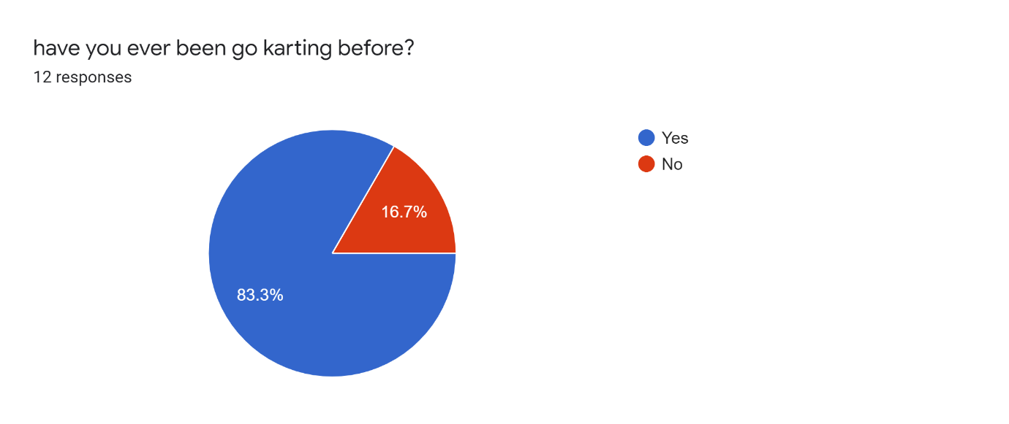
Looking at this data collected it shows the more than three quarters have participated in go karting before. This is positive showing that there is a potential to gain regular customers.
Source 2
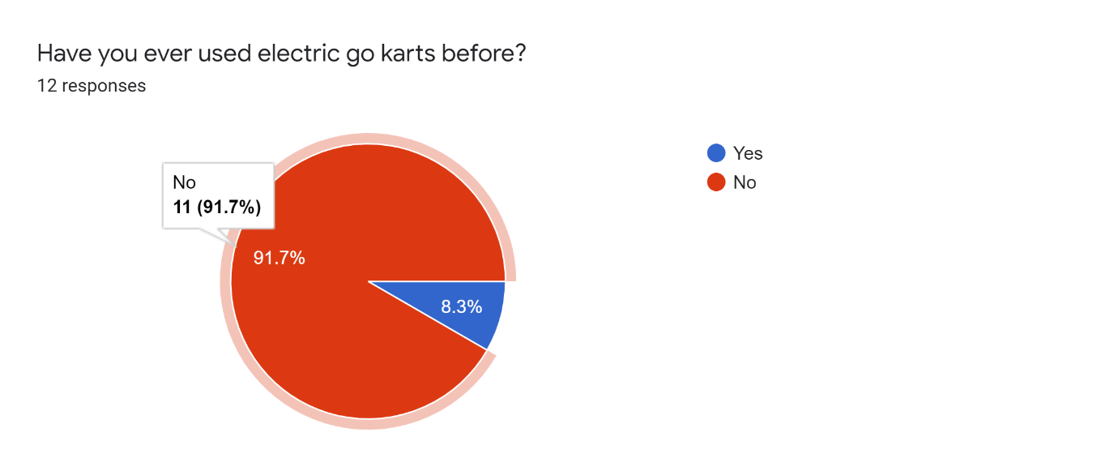
Out of the data collected not surprisingly only one person has used an electric kart before. This benefits the business as it shows a unique selling point. This technology is new with the inaugural formula e championship only starting in china in 2014. (History | FIA Formula E, 2020)

Source 3
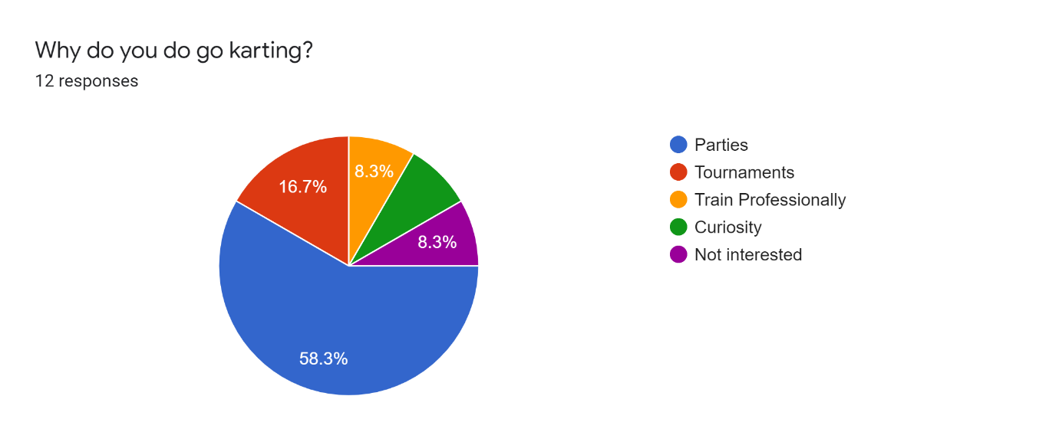
Source 3 shows that most participants go as a party. The business can target this market by offering discounts to larger groups. More people means more cashflow coming into the business.
Source 4
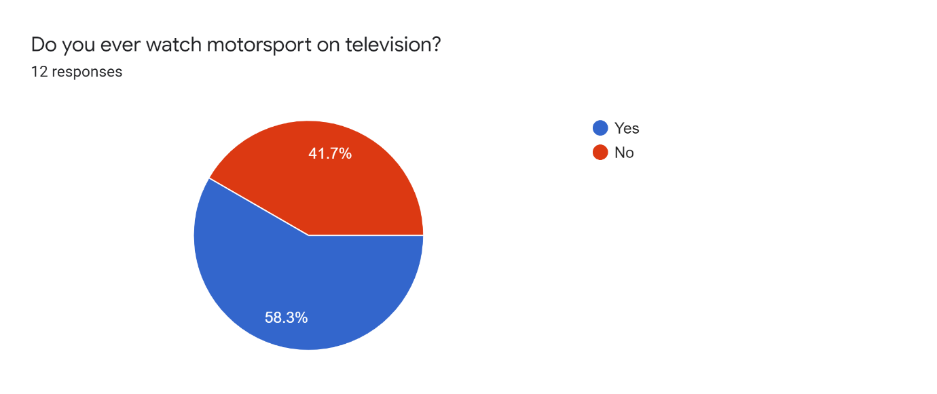
There is a nearly split decision in the data in source 4. Some have an interest in some form or motor which means there is potential to rectify their interest into karting if the business can offer a quality service.

Source 5
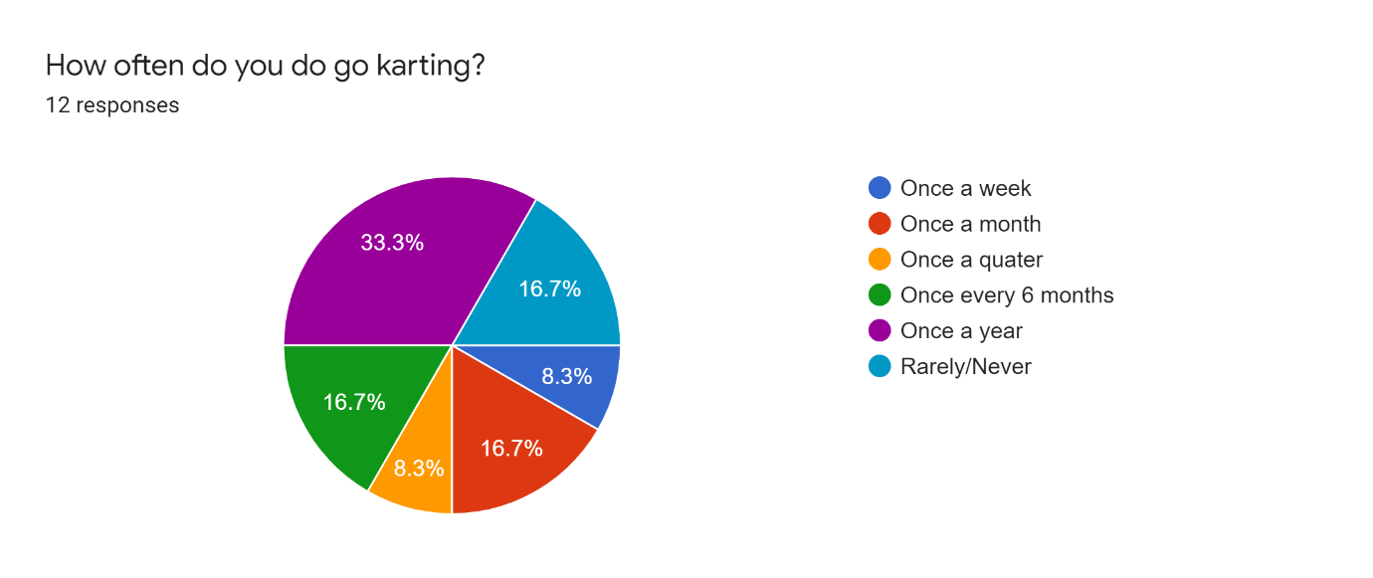
Source 5 shows important data on how we can calculate how much cash flow coming into the business and, also adjust how much we need to spend to offer a reliable service. The business could expect at least half the customers to come back at least once a year.
Physical resources.
The sole purpose of the business is to offer the service within a warehouse. This will be known as a bricks business venture and, the point I will need to look at is the cost and location. Location is paramount when it comes to a business and looking at appendices 1.1 it shows the exact location where the business plans to be. The reason this is planned here because its transport infrastructure allows for a steady flow of traffic with high speed on the highways leading to the business. This is proven as it is near the M4 motorway and 1.8 miles near the city centre train station. (Zhu and Diao, 2020)
Looking at appendices 1.2 the annual rent will be £30,000 pa with 8000 square feet which will be ample of space to fit all essentials into the building. Another reason this site is suitable is there are no steps or stairwells to restrict disabled access. This will help comply with the equality act so, preventing adjusting access to fit within the guidelines. (Duty to make reasonable adjustments for disabled people, 2020) The main expenditure for starting the business is the go karts. Appendices 2.3.1 shows the price list of available karts and I chose the LRX kart at $7400 which is cheapest of the 2 available electric karts available. The business will need 10 karts to keep with demand which the overall cost will be £55700 in total. On top the business will need to supply helmets with a minimum of 10 (1 for each kart) with 3 different sizes which totals to £1220 as shown in 2.2.
The business will employ less than 10 people. We will not expect to turnover 2 million euros annually so the business will fall into the micro business category. (Micro business consumer, 2020) By going by the calculations shown in 2.5 the maximum bill for electricity should not be past £1800. On top of the basic electricity needs such as lights and equipment the karts are powered by electric so there will be additional costs. If a kart can cover 100 miles in a week and 100 miles on weekends, then 2.6 shows a cost of £8.40 per kart per week with £4368 per year for 10 karts in theory. 2.3 shows the cost of the desk to present customers and store files at £1500 and 2.1 is an advert showing scrap tyres are free to collect. Circuits on the formula 1 calendar use this basic technology today showing that tyres are suitable for less powerful go karts. (Guégan et al., 2017)
Financial Resources
Calculating all the start-up costs to run the business it equals to £87000 the most straight forward way to raise this money is to get a secured business loan. Looking at 2.4 the interest is only 5.95% but there is a risk to my property while taking out this loan. The positives of this loan is that the business can have a sole trader leading to no conflict with stake holders. Ideally a partner with some disposable income will help start up and in the long run. A close friend or relative can buy into the business at 20% with the current value close to £90000 the business will look for £18000 to secure the share of 20%. This will reduce the monthly repayment towards the loan, but the investor would be looking for a return on their investment. Having this investment angel would benefit in the long run as having extra knowledge and finance to support the business.
Human Resources.
The owner/manager of the business will have to be comfortable with the main aspects of the business which is to maintain the go karts, market the business and making sure they are customer focused. The owner/manager will have knowledge of go karts as they have been racing competitively from a young age. This means they can service parts linked to go karts. The owner/manager will also have experience in marketing as they have done their level 4 in business.
The business will need to pass on these skills to another person as the manager may want to investigate other ventures. The best way to go forward with this is to employ and apprentice. There is mostly hands-on work to learn the skills to help run the business. In most countries it is proven that this way of learning helps them gain the vocational skills that are needed. (Ünlühisarcikli, 2001) There will be a requirement of 3 people to assists full time and plus 1 person to work on the weekends part time. The reason to have at least 3 staff is to help marshal the track and assist with any karts that get stuck. Looking at appendices 3.1 it shows the job advert and what is required to be suited to fit the role. This also includes the wage and how many hours are required to work.
Swot Analysis
This is a more in-depth analysis of where the businesses is at and where there is areas for improvement.
Strengths
New technology- The use of electricity allows a more unique experience, provides cleaner air and mores cost effective to run.
Central city location- With the building being close to city centre and M4 motorway this makes it easily accessible.
Indoor circuit- There is no chance of weather interruptions and no water damage to the karts. Also customers will remain warm and dry.
Experienced owner. – Having raced karts since a young age has gave him knowledge on the upkeep of karting circuits
Safer. – There is no need to handle hazardous material like petroleum, reducing the risk of fires and burns.
Weaknesses
Easily copied. – Any competitor can add or replace their fleet with electric go karts.
Close to sports stadium. – If there is an event on near the stadium then their could be high amount of traffic which will restrict accessibility.
Slightly dangerous. – Even though karting is normally safe we must still remind ourselves that motorsport can still be dangerous such as loose clothing can get caught. (Girl nearly asphyxiated in go-karting incident, 2009)
High maintenance. – The business is buying karts from a well known kart builder and are verry reliable but, the customers are hiring the karts and have less respect for the karts. Plus the karts will be running every day all day. So time may be consumed on wear and tare repairs.

Opportunities
Expansion. – The equipment is easily moved around so and upgrade to a bigger building is possible. There is also the option of extending the circuit into the car park.
More speed. – As the business chose the less powerful option of e karts there is also the option to buy the more powerful karts, which will attract people who want more speed and adrenaline.
Tournaments/events. – Creating a weekend league or endurance racing events can make new customers and help with customer retention.
Junior karts. – Smaller and less powerful karts will help gain more customers of a younger age.
Driving simulator. – Adding a virtual experience takes up little room and gives another option to the customers.
Threats
Competition. – There is another company named Skidz located in Swansea that offer indoor petrol karting.
Tradition. – Customers may want a more traditional petrol karting experience with high revving loud engines and the smell of petrol and oil.
Hazards. – Employees are expected to go on track to move karts that are stuck. This means they are exposed to getting hit by a kart resulting in injury
Price. – The karting industry prices are around £20-£30 for a 20-minute session while other leisure activities are cheaper and last longer.

Cashflow
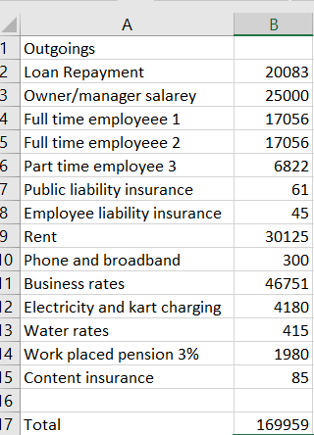
Here is the data gathered to calculate the outgoings of the business on a annual bases. The manager will be on a set salary. The employees are all on the same wage as shown in 3.1 but this could change do to sickness and overtime. The insurances are rough estimates taken from the AXA website as shown in 3.2, 3.3 and 3.4 but the costs are so low compared to the other outgoings.
The rent is shown as taken form 1.2 and could be expected to change on an annual basis. The direct gov website 3.5 shows the value of the property to help calculate the business rate at 50.4p per pound. A loan calculator was used for a 5-year period 2.7 to help understand how much to pay towards the loan. The work placed pension is a legal requirement and the business will pay the minimum of 3% towards that pension. The electricity is calculated using 2.5 showing that as a micro business that only has 4 employees, giving us indication. The karts will need to be recharged often and if they cover 200 miles a week each then 2.6 can indicate how much those 200 miles can cost.
To break even for the year the karts must earn £467 a day. The business will go on at £25 for 20 minutes per kart which the target for 1 day is 19 sessions. Other prices like large groups mean more sessions may be required as there will be a discounted sale. On the positive this will make the business more attractive.

Bibliography
Borehamwood: UBM Information Ltd, 2009. Girl nearly asphyxiated in go-karting incident. 27(6), p.12.
Citizensadvice.org.uk. 2020. Duty To Make Reasonable Adjustments For Disabled People. [online] Available at: <https://www.citizensadvice.org.uk/law-and-courts/discrimination/what-are-the-different-types-of-discrimination/duty-to-make-reasonable-adjustments-for-disabled-people/> [Accessed 20 November 2020].
Duodu, C., 2007. Lewis Hamilton Is Top Class. New African, (463), pp.70-71.
Ellis, K., 2015. Message from the ASLO Communications Office: The Lazy Person's Guide to Using Search Engine Optimization to Promote YOUR Research. Limnology and Oceanography Bulletin, 24(4), pp.114-114.
Fiaformulae.com. 2020. History | FIA Formula E. [online] Available at: <https://www.fiaformulae.com/en/discover/history> [Accessed 16 November 2020].
Guégan, P., Lebreton, D., Pasco, F., Othman, R., Le Corre, S. and Poitou, A., 2017. Metallic energy-absorbing inserts for Formula One tyre barriers. Proceedings of the Institution of Mechanical Engineers. Part D, Journal of automobile engineering, 222(5), pp.699-704.
Hanlon, A., 2020. How To Use The 7Ps Marketing Mix Strategy Model?. [online] Smart Insights. Available at: <https://www.smartinsights.com/marketing-planning/marketing-models/how-to-use-the-7ps-marketing-mix/> [Accessed 16 November 2020].
Jensen, A. and Mabit, S., 2017. The use of electric vehicles: A case study on adding an electric car to a household. Transportation Research Part A: Policy and Practice, 106, pp.89-99.
Met Office. 2020. Record Breaking Rainfall. [online] Available at: <https://www.metoffice.gov.uk/about-us/press-office/news/weather-and-climate/2020/2020-winter-february-stats> [Accessed 7 November 2020].
Ofgem. 2020. Micro Business Consumer. [online] Available at: <https://www.ofgem.gov.uk/key-term-explained/micro-business-consumer> [Accessed 20 November 2020].
Sodikart.com. 2020. Simply The Best Electric Go Kart, Electric Gokart - SODIKART. [online] Available at: <https://www.sodikart.com/en-gb/karts/rental/rsx-32.html> [Accessed 7 November 2020].
Ünlühisarcikli, Ö., 2001. Training on the Job in Istanbul: A Study of Skills Acquisition in Carpentry and Car-Repair Workshops. International Review of Education, 47(5), p.446.
Zhu, Y. and Diao, M., 2020. Crowdsourcing-data-based dynamic measures of accessibility to business establishments and individual destination choices. Transportation Research Part D: Transport and Environment, 87(1), p.102382.

Appendices
1.1
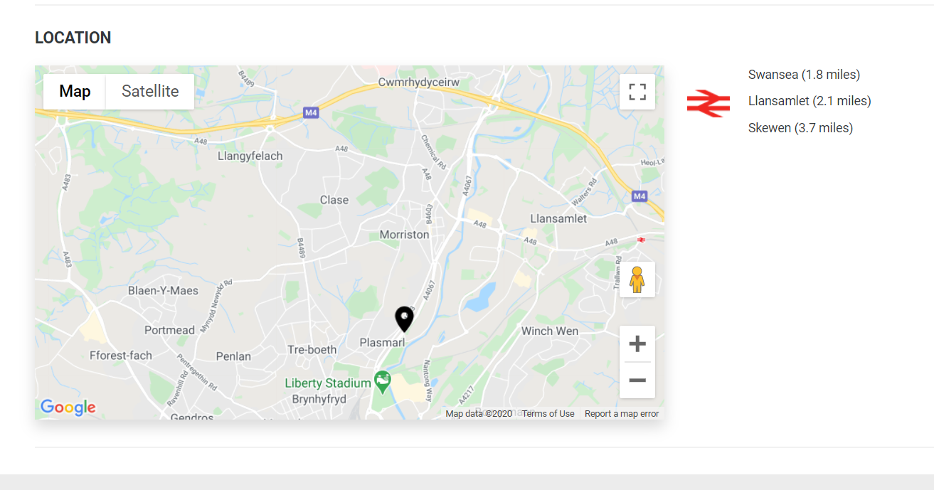
1.2
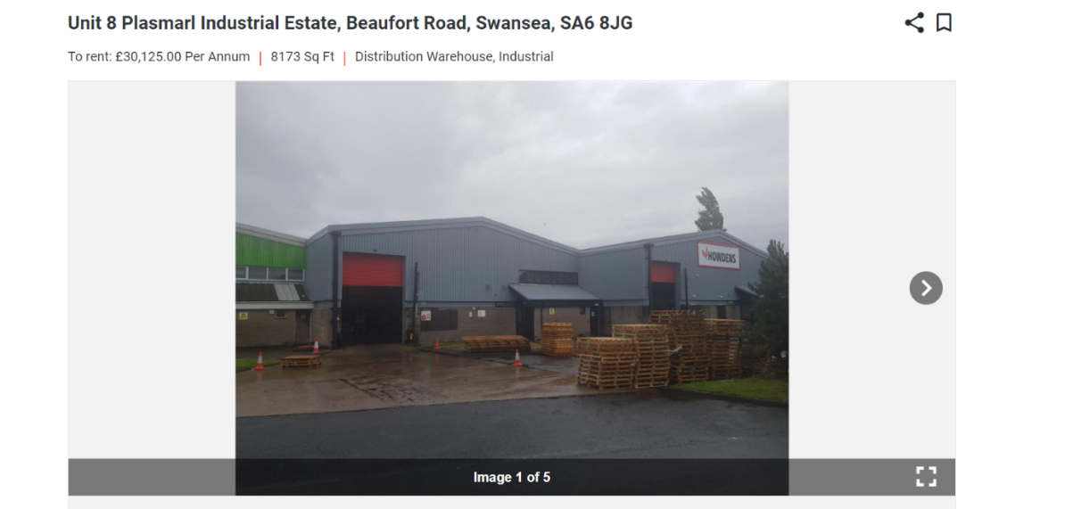

2.1
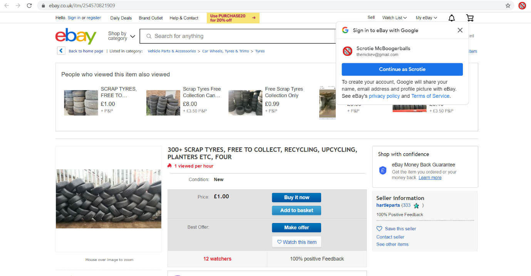
2.2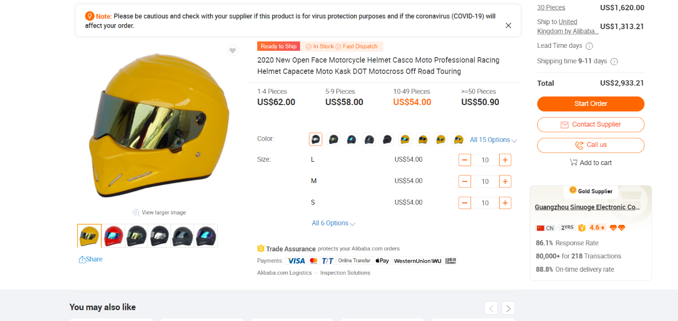

2.3

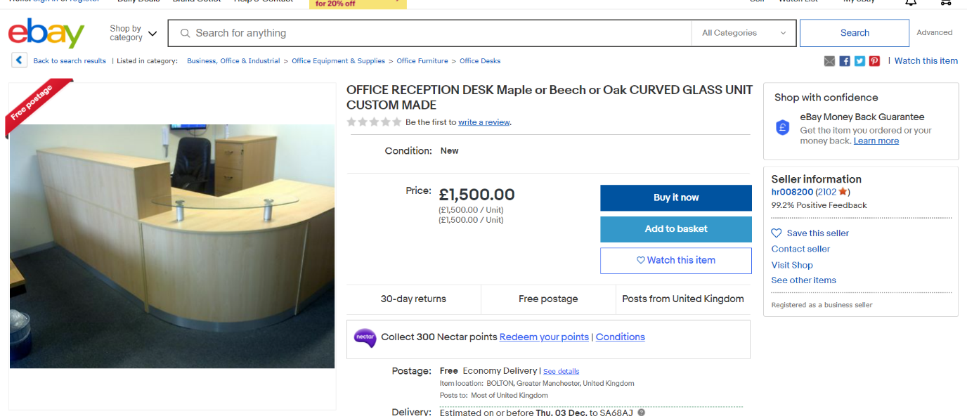

2.3.1
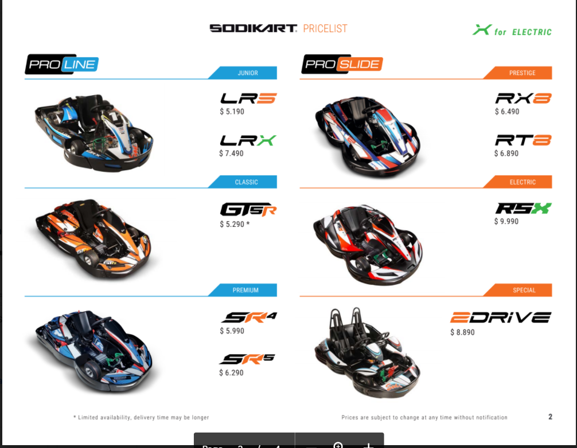
2.4
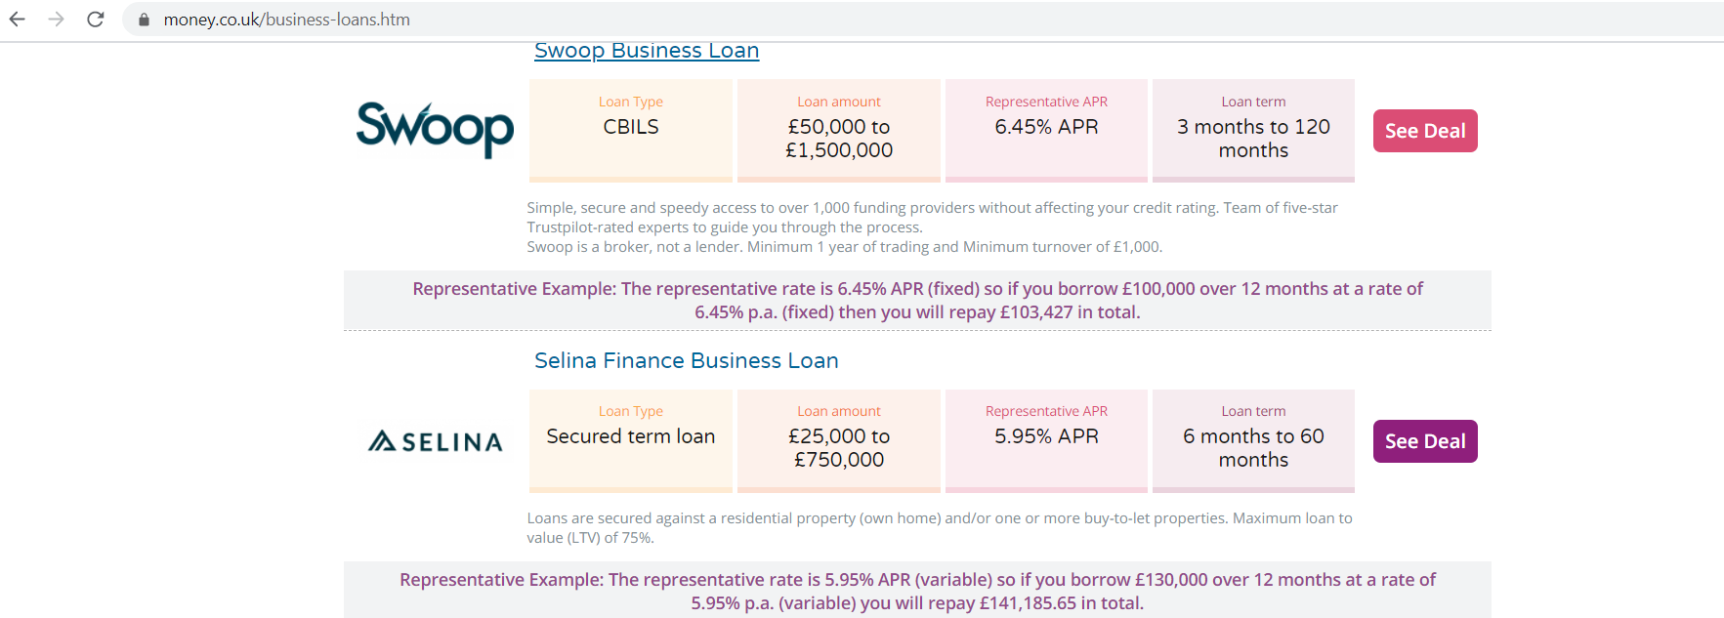
2.5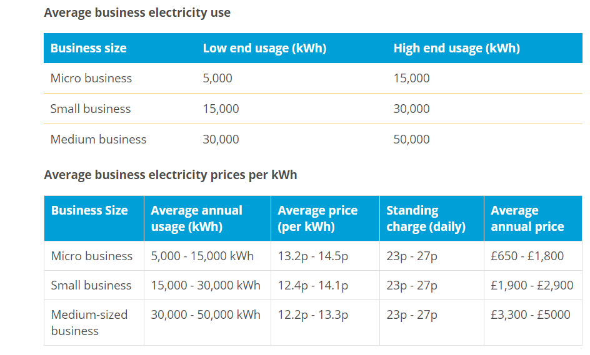
2.6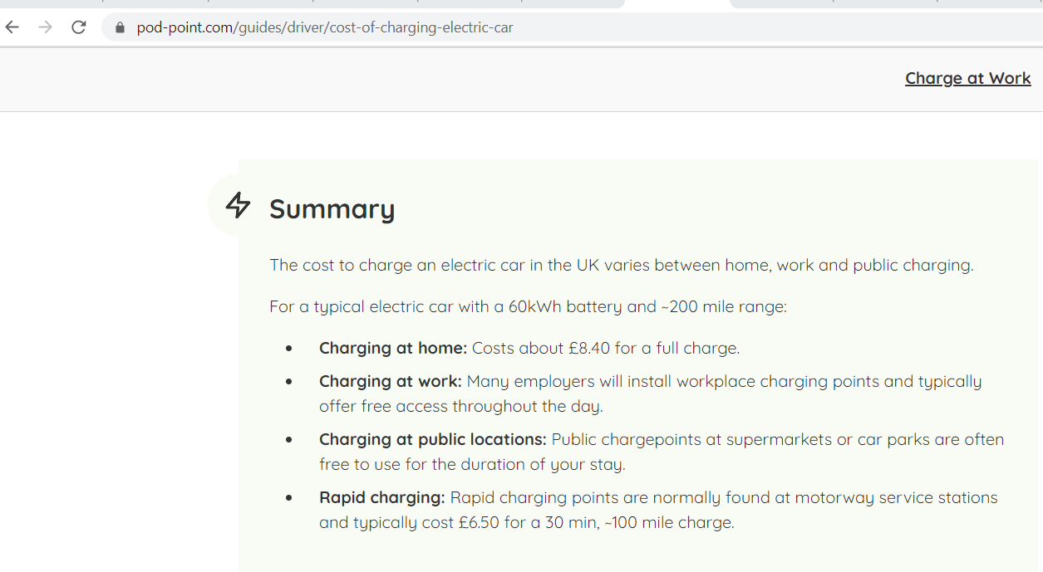

2.7
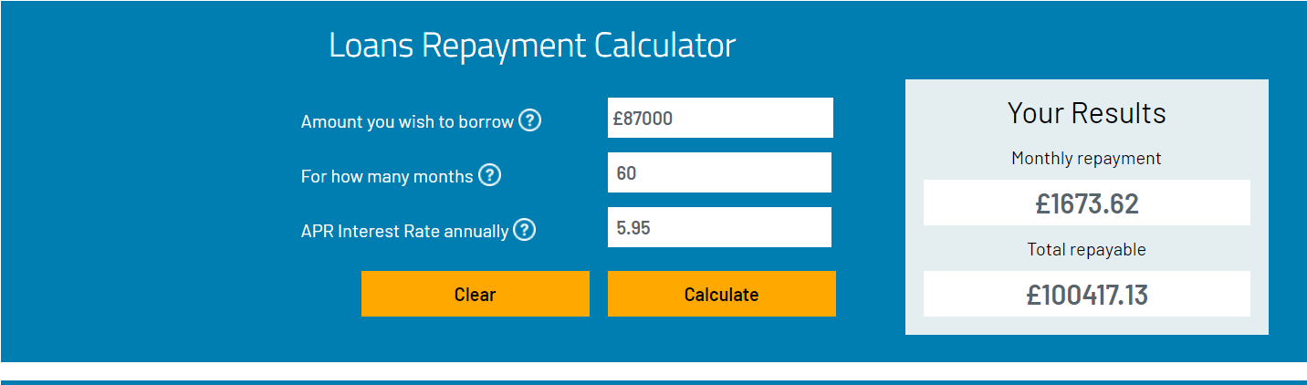

3.1
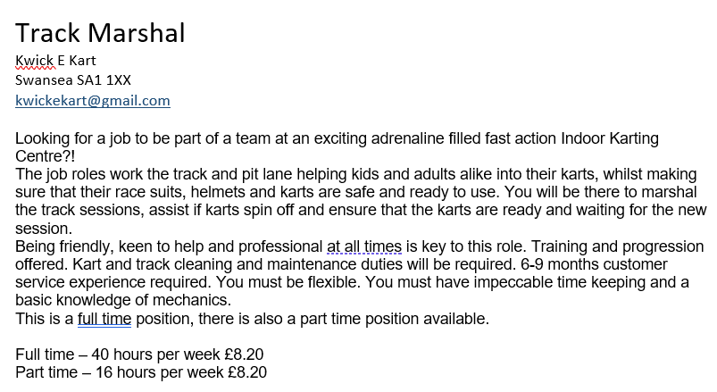
3.2

3.3


3.4

3.5


