ACE PRACTICAL PORTFOLIO

By
Florentina Iancu
2113710

CertHE Skills for the Workplace
Academic And Employability Skills
Sylvia Hoffmann
05/01/2022

Introduction
The paper presents a report concerning my last presentation and how I felt during the presentation. It also offers a reflection on my learning of this module using Gibbs' model of reflection. Furthermore, it discusses time management, paraphrasing, summarizing, and public speaking and presentation proficiency. Appropriate time management becomes essential in effective planning of time to boost overall academic performance. Paraphrasing and summarizing skills improve time-saving and better completion of assignments and research works. In comparison, presentation and public speaking competence help me present ideas effectively in front of the audience with confidence. The paper reflects on how beneficial the topics have been in enhancing my learning process. While developing my future career opportunities due to the enhanced qualities developed.
Report
The week nine presentation that I undertook was extremely stressful since I am not good at public speaking. Initially, when beginning the presentation, I felt extremely confident concerning the task that I had prepared, but after looking around at the audience, I felt lost due to nervousness. After approximately two minutes of straining to overcome the nervousness, I kept convincing myself that nothing could go wrong any further. Later I took a deep breath and continued with the presentation. I had spoken for roughly seven to eight minutes regarding my future career. It was not so challenging speaking concerning H.R.'s career since I have previously read concerning the job description, and I have also observed my friend who works as an H.R. manager. I entirely overlooked all the presentations that I had organized, and I confidently spoke concerning the concepts I already knew concerning the H.R. career. I suppose I could have performed better if only I didn't have a public speaking weakness. Nevertheless, I must enhance my presentation and public speaking competence in the future. My presentation was not as satisfactory as I anticipated, but since it was the beginning, I expect to perform better next time.
Ivanova et al. (2020) postulate that public speaking is a complicated task. During public speaking, physical performance becomes utilized, and practices such as body movements, facial expressions, voicing speech, and gestures are evident. Besides, mental constituents such as speakers' emotions and feelings and intellectual performance like text production become involved. Therefore, the presenter should utilize all the body competencies to enhance the presentation. Furthermore, for an effective presentation, particular knowledge and sufficient preparation become necessitated to boost effectiveness and confidence. Effective communication skills are also necessitated for successful public speaking. All individuals encounter physiological responses during presentations. The most effective technique to conquer anxiety is to sufficiently prepare for public speaking. Therefore, the learning process must effectively prepare the student with suitable public speaking competencies.
I will utilize the Gibbs model of reflection, which is a widely utilized model that entails the investigation of a person's feelings and how they have influenced the situation and the reflection of the occurrence. It entails the utilization of rapid questions at every phase to develop a completely organized investigation. Nevertheless, the model doesn't include many questions like other frameworks. Adeani et al.(2020) pinpoint that the learners must generate reflections to enhance the learning process. Gibbs' model of reflection becomes frequently and successfully utilized by learners in devising reflections on literature works that they are undertaking. The appropriately designed outline of formulating reflections assists learners in comprehending their learning process profoundly. Futhermore, Radovic et al.(2021) highlight that reflection becomes widely utilized in the learning process due to its massive benefits. During reflection, the learners are encouraged to contemplate what they have learned, which boosts the overall academic performance. Encouraging reflection results in enhanced performance assessed through writing.
Reflection is beneficial as it boosts the capability to contemplate my cognitive development. Besides, reflection heightens learning performance management and monitoring, intensifies self-motivation, boosts the emphasis on learning goals and objectives. It also helps me recognize barriers during the learning practice and develop realistic goals and objectives. Furthermore, it empowers me to formulate diverse methods to accomplish the set goals and establishes the gaps in knowledge, competencies, and development. Reflection also permits me to enhance my ability to adjust to novel, unanticipated and complicated situations.
I have learned that time management is an extremely important skill to enhance study organization. Successful time management encompasses the productive utilization of my time, enabling the attainment of all the tasks that I had organized. Besides, the planning and organization of my time between activities that I have to accomplish, such as assignments and extracurricular activities. Suitable time management necessitates the focus on the outcomes I get from various tasks. With appropriate time management, I accomplish my tasks with minimum effort and work smarter rather than harder. It becomes essential to discover the various timewasters and establish accomplishable goals. I will pay close attention to the various distractors that divert my concentration during my assignments and studies. Once I identify the various timewasters, I will refrain from that activity during the entire period that I have devoted to studying. Additionally, I have learned that I must recognize what I require to do and prioritize the various tasks; setting a schedule guarantees that I know what to do and when to do it.
Proper time management has been useful since it has reduced stress and frustration during my studies. It assists me in accomplishing my goals quicker. Razali et al. (2018) emphasize that time management becomes very significant and may influence a person's overall accomplishments and performance. Students frequently complain that they lack adequate time to accomplish all the activities allocated to them. Additionally, the learning institutions' freedom can disrupt learners who lack time management competencies. Appropriate time management boosts my effectiveness helps me concentrate on one task for a particular period which helps me offer the best, which helps attain outcomes quicker. It also helps prioritize the important tasks that demand instantaneous accomplishment. Time allocation to various activities enables me to attain more within a shorter period since it enables me to concentrate more on the activity that I have allocated time. Additionally, time management helps reduce stress since activities are allocated time to reduce stress. It has enabled me to evade procrastination since once I allocate time for a particular activity, I get the motivation to accomplish the task. Good time management also becomes essential in career life since it boosts work quality and overall employee performance. It becomes important in boosting my employee reputation and opening more career opportunities.
Paraphrasing topics have also been useful since it has taught me how to reword some literature exclusive of altering the intended meaning. Fathi and Mahmood (2020) declare that paraphrasing has become extensively applied by researchers to rephrase various concepts that have been researched to ensure that one intellectualizes the concept. The practice saves time that becomes wasted in misunderstanding. It permits placing information from a particular source in one's terms. Paraphrasing is one of the techniques utilized during translation to attain increased accuracy in understanding concepts. It helps to alter the text to ensure that it becomes different from the source while retaining meaning.
The paraphrasing concept has been useful in the production of plagiarism-free work. Most research and assignment tasks encompass information derived from various backgrounds and possess an increased plagiarism risk. Rephrasing offers the influence to an individual to alter the piece and formulate an innovative piece that is devoid of mistakes. Besides, paraphrasing saves time since it empowers me to spare time essential to perform other tasks since it enables the rewording of a piece of literature within seconds. Furthermore, paraphrasing improves the desired content. It enables me to read a particular piece of work, identify the various errors, correct them enhancing the overall quality of the work. While rewording, it comprises developing other people's work and eliminating the unnecessary phrases and sentences that aren't needed to communicate effectively. The topic has assisted me in offering content that makes sense to the students. Paraphrasing also offers me basic writing skills through getting the read thoughts flow and representing them in my own words, which saves much time. Therefore, paraphrasing has been useful in my struggle to complete my research and assignments. It has helped me produce quality work that offers plagiarism-free content. Besides, it has provided me with flexible strategies for developing novel ways of writing concepts and saving time. Paraphrasing becomes significant since it demonstrates that I comprehend the source sufficiently to rewrite it in my terms. Besides, it offers a powerful option to utilize direct quotes, which ought to become occasionally utilized to reduce plagiarism. It is significant since it demonstrates to the reader that I effectively understand the source adequately to put it in my own words.
My learning in this module has also provided knowledge on summarizing. The topic empowers the learners to recognize the most significant ideas within a source, to disregard the irrelevant ideas, and to assimilate the main ideas in a significant manner. Summarising technique has been useful since it empowers me to identify the important concepts and amalgamate significant information backing them. Besides, it helps me focus on the key expressions of a particular source that are important to remember. Summarizing also helps to decrease large volumes of work to the main ideas to enhance understanding. Kirschner et al.(2021) assert that summarizing encompasses a cognitively active practice that students ought to first choose the main message from a particular source. Besides, connect to the preceding knowledge and develop meaning from the message, which assists in acquiring profound comprehension of the context. Summarizing requires editing, shortening, modification, and paraphrasing to attain a concise interpretation.
Conclusion
In conclusion, the module has been very useful in developing various competencies beneficial to my present and future. Proper time management is an essential skill to decrease stress during the learning process. The skill will also become significant in my future career since it will help promote work quality and overall performance, opening greater career opportunities. Paraphrasing skill is also an important skill that I have learned to help accomplish my research and assignments in a plagiarism-free manner. Besides, summarizing skill is a significant skill to assist in reading various sources and only considering the main points to save time. Presentation and public speaking skill is also essential skill that I have studied which has boosted my proficiency in making a better presentation with confidence. Therefore, the module has taught significant concepts to enhance my learning and future career.

References
Adeani, I.S., Febriani, R.B. and Syafryadin, S., 2020. USING GIBBS'REFLECTIVE CYCLE IN MAKING REFLECTIONS OF LITERARY ANALYSIS. Indonesian EFL Journal, 6(2), pp.139-148.
Fathi, S.Y. and Mahmood, M.A., 2020. Paraphrasing as a Technique for Improving the Translation of Undergraduate Students of Translation. Adab AL Rafidayn, 50(82).
Ivanova, T., Gubanova, N., Shakirova, I. and Masitoh, F., 2020. Educational technology as one of the terms for enhancing public speaking skills. Universidad y Sociedad, 12(2), pp.154-159.
Kirschner, P.A., Neelen, M., Hoof, T. and Surma, T., 2021 Let's get to work with productive learning strategies: Summarising.
Radovic, S., Firssova, O., Hummel, H.G.K. and Vermeulen, M., 2021. Improving academic performance in higher education: strengthening the relationship between theory and practice through prompted reflection. Active Learning in Higher Education.
Razali, S.N.A.M., Rusiman, M.S., Gan, W.S. and Arbin, N., 2018, April. The impact of time management on students' academic achievement. In Journal of Physics: Conference Series (Vol. 995, No. 1, p. 012042). IOP Publishing.

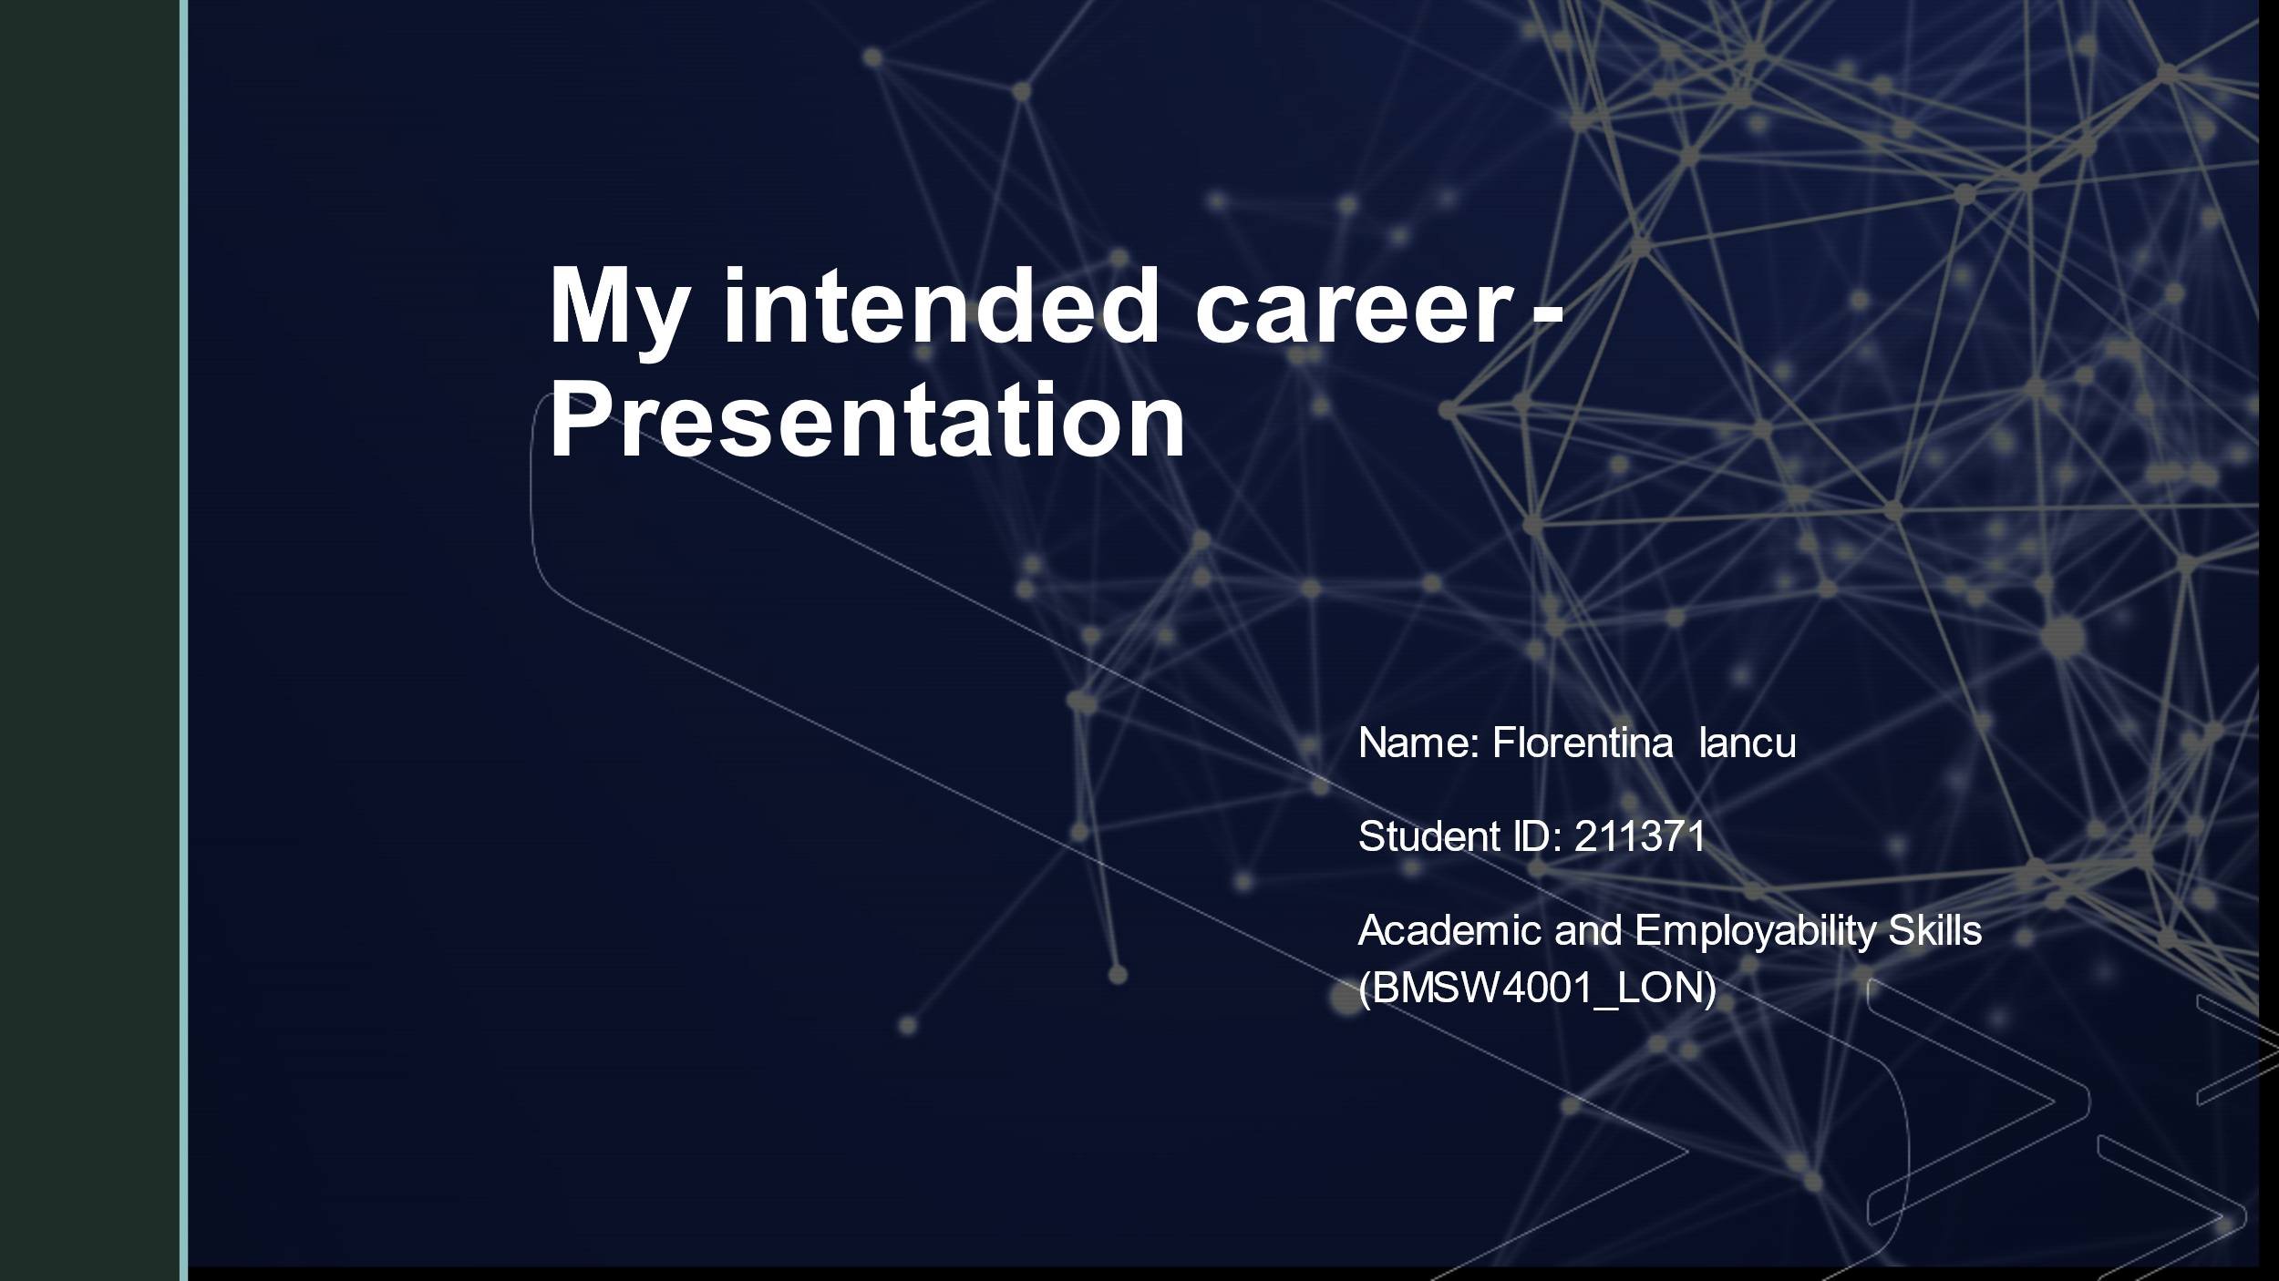
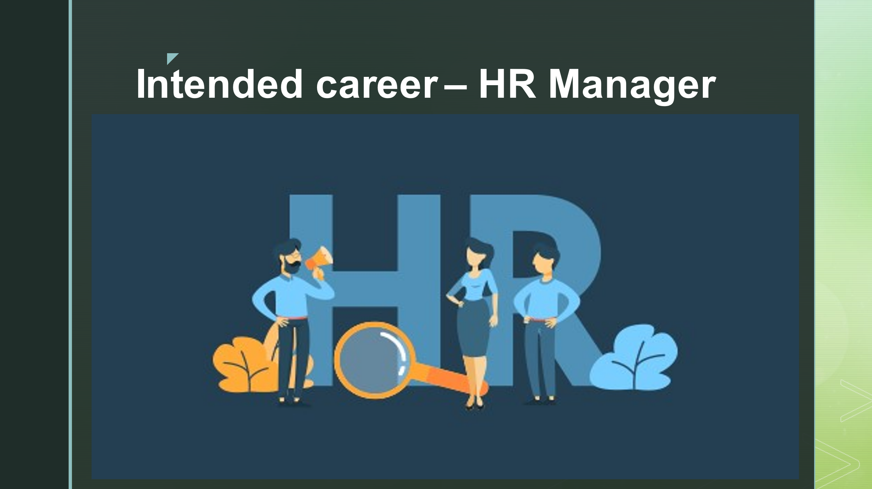
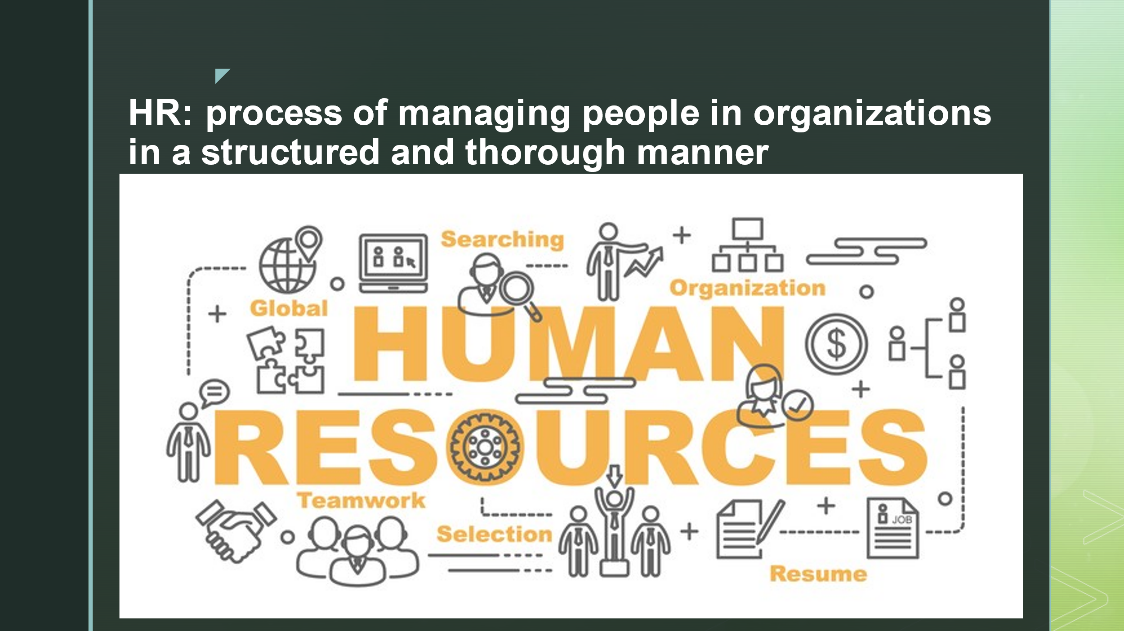
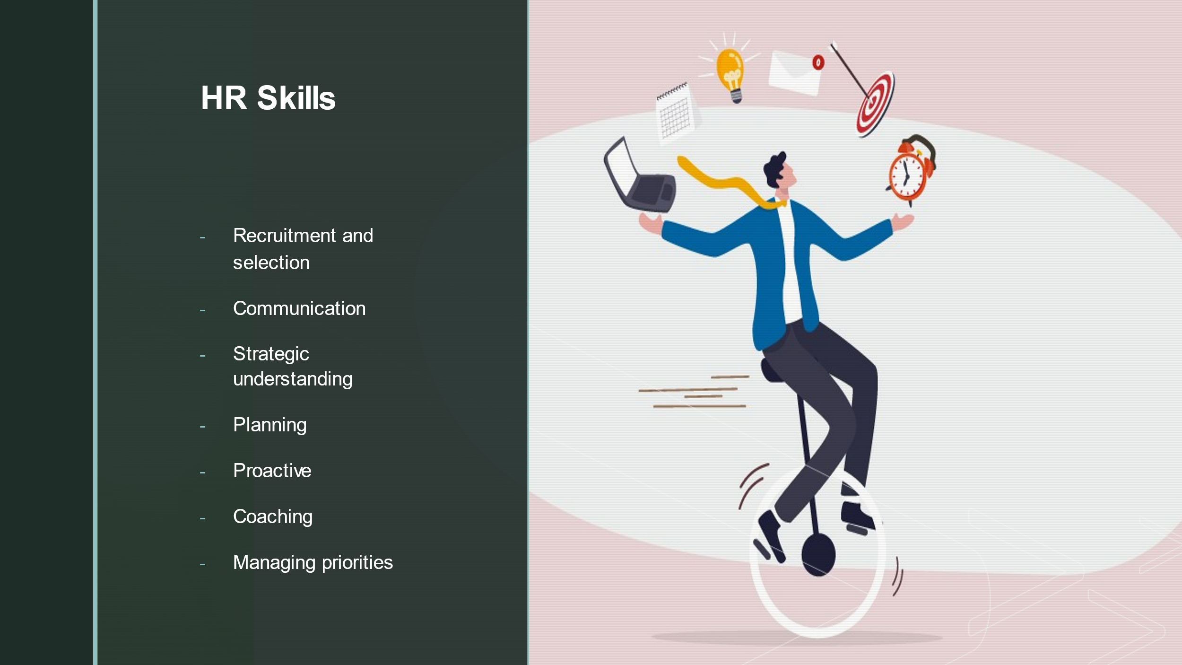
eaaaas

