DS 1 Template

My Screenshots/Photos
- Please add 4–6 screenshots or photos of your digital life.
- You can use your phone or laptop.
- For each screenshot, write one or two sentences explaining what it shows.

Screenshot/Photo 1
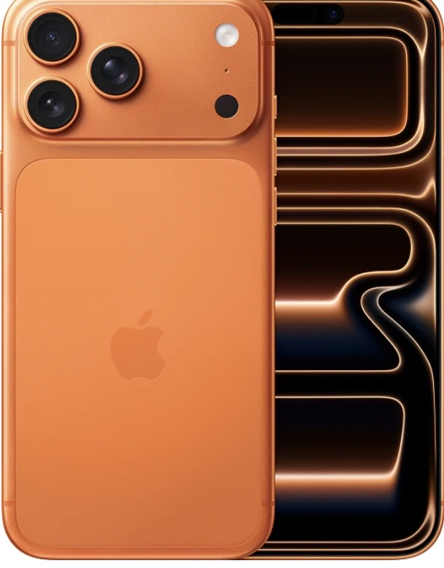
Mobile phones are very important in our daily life. I use it to communicate with my friends and family and work purposes such as food delivery and online shopping. I feel confident to find information and complete my studies.

Screenshot/Photo 2
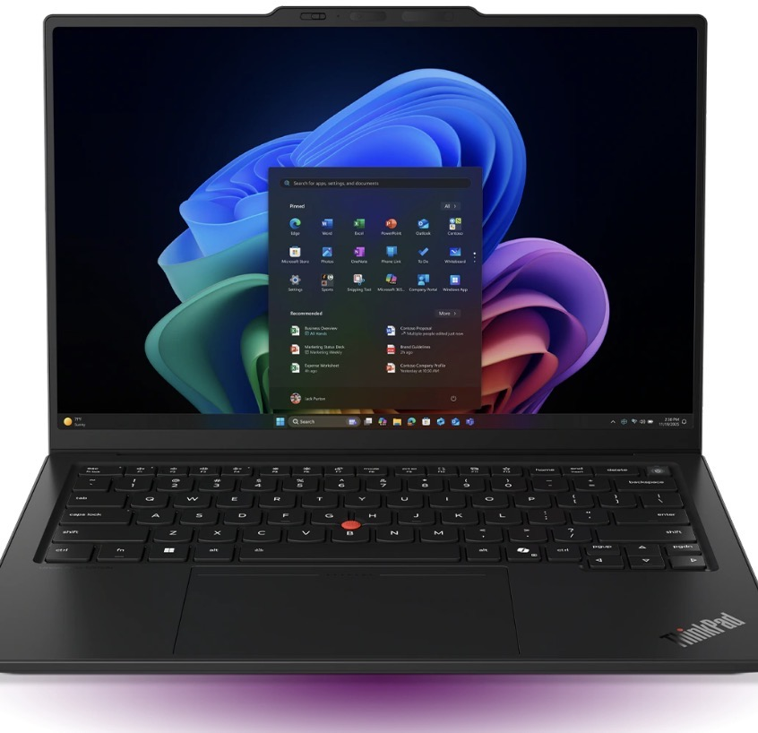
Laptop is useful because it helps me to do business study. I often use it to get information, complete assignments and use module which is helpful.

Screenshot/Photo 3
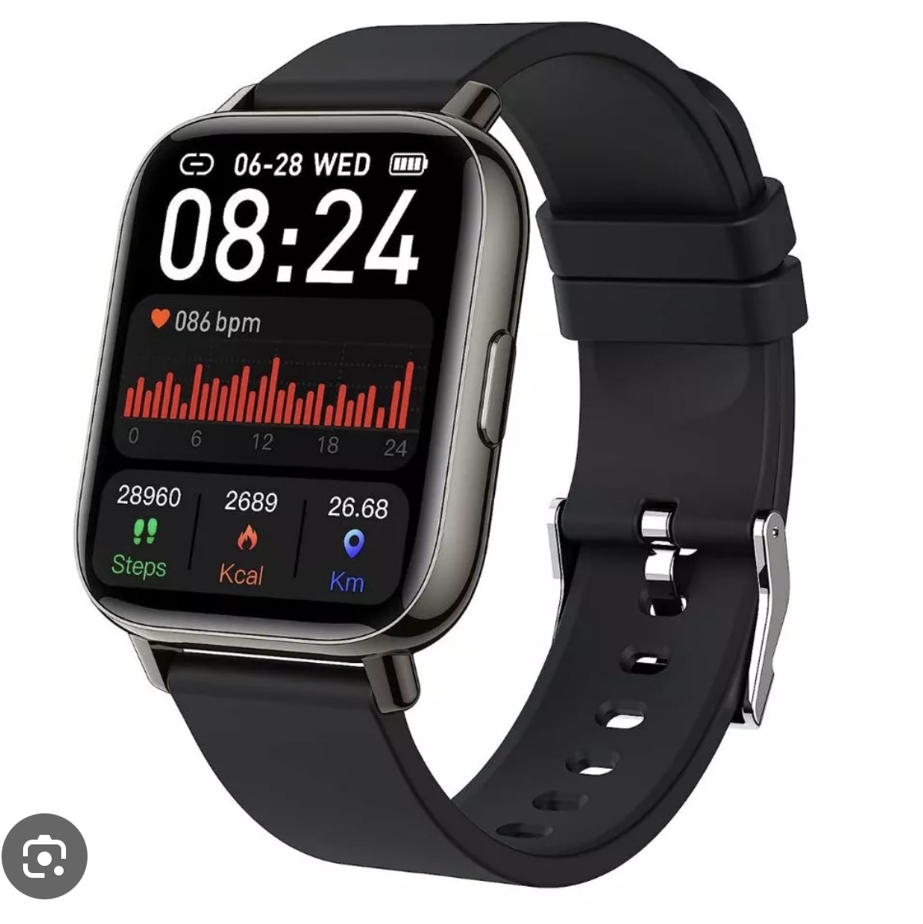
It helps me stay organised in my daily life. I can use it to check time, set reminder when i have classes and deadlines. I can also use for health check such as blood pressure, sugar levels etc.

Screenshot/Photo 4
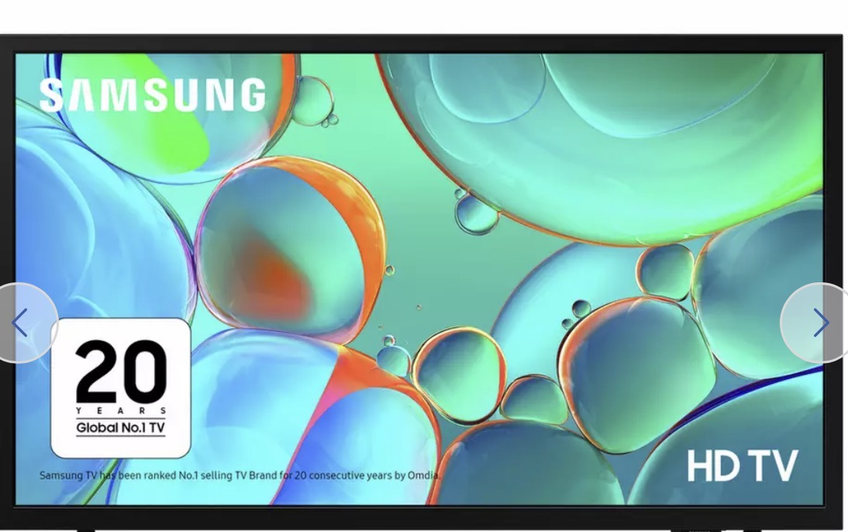
I find it interesting when I use smart tv to watch learning videos because they can make difficult Topics easier to understand. I feel sometimes nervous when I cannot use apps or features.

Screenshot/Photo 5
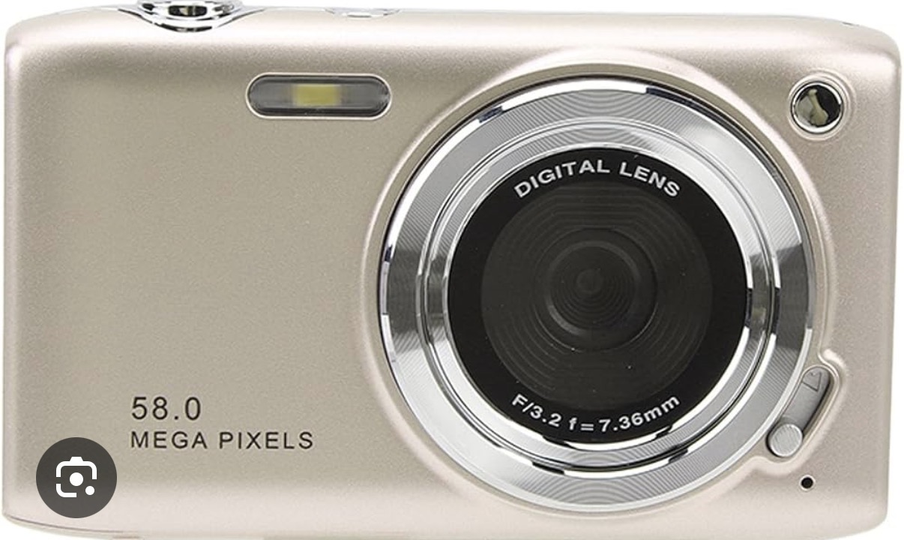
I use digital camera to take photos and videos. I normally use it for my studies to take pictures and videos which I can use it for later. Also, I use it when I travel with my friends and families to take photos and videos which I can use for later

Screenshot/Photo 6

Ai is useful because it saves time and handles things faster or better than we can also help with writing or problem solving. It is good at helping me find information ,learn new thing.

My Short Reflection
- Write 5–8 simple sentences about your digital life.
- You can use the sentence starters below if helpful.
Mobile Phone
Mobile phone is important to me. I feel nervous when using my phone for my work and study, but I am not always sure which apps and features to use. I use it to check Moodle and find information. I need to improve new apps and features I hope this module will help me to overcome all kind of difficulties
Laptop
Laptop is very important and helpful for us. Sometimes I find it difficult to use new programs. I feel nervous when using new features, but I want to improve practising regularly its features or manuals or online instruction. I hope this module will help me to build confidence to use laptop effectively. Digital skills are important for me because they help me to use laptop for different activities.
Smartwatch
Smartwatch is very helpful to me. I feel confident to use smartwatch for studies and other activities. I feel nervous using my smartwatch because of apps and features. I can improve by using my smartwatch until I feel confident. I can check online or a manual to learn how to use it.

Smart tv
I find it interesting when I use smart tv to watch learning videos because they can make difficult Topics easier to understand. I feel sometimes nervous when I cannot use apps or features. I am very much confident by practicing regularly, I will overcome this problem. Digital skills are important for me because they help me to use smart tv confidently for learning activities.
Digital camera
Digital camera is very useful in our daily life. I use it when I travel with my friends and families to take photos and private moments. Sometimes I find it difficult to use the camera setting. I need to improve my camera skills and settings by practicing more.
AI
Ai is useful for my studies. I use it when I do not understand something or need help. Ai can be dangerous, even if you do not know it, so we must be careful to rely on it. I will practise more how to use it properly

Sentence starters
- I use digital tools to …
- I feel confident when I …
- I want to improve …
- I often use these tools: …
- I sometimes feel nervous about …
- I hope this module will help me …
- Digital skills are important for me because …
You can write more if you want.

Submission Checklist
Before you submit, please check:
​​​ ☐ I added 4–6 screenshots
☐ I wrote short sentences for each screenshot
☐ I wrote my short reflection
☐ My work is my own
☐ My file opens correctly
​​☐ My file opens correctly

