

Name: Nyarai O Kanderera
Student: 2243459
Lecturer: Dr Laila
Module name: Empowering the Older Person
Module code: BMHP6027

Acknowledgement: I confirm that I have not used any AI Tools in the research and creation of this assignment
I confirm that I have not presented any AI-generated Materials as my own.
I confirm I have copies of my draft notes and other resources that I used, which I may be asked to provide as evidence.

Information technology solutions
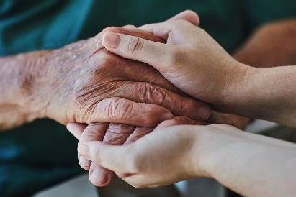
- Independent and personal values, Taylor et al. (2025) argue, older people interpret independence through personal values, autonomy, and control. One person may value physical mobility, another social connection. Care must be tailored, not standardised

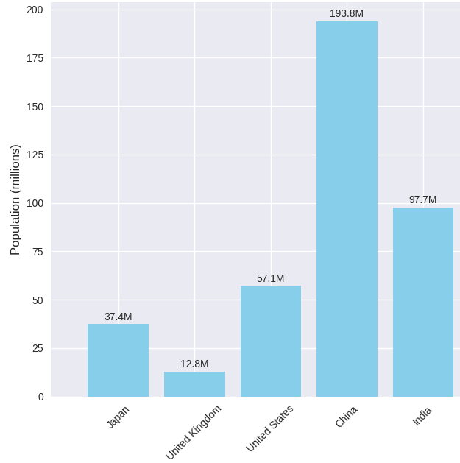
The Ageing Population

“The number of people aged 65 and older globally is projected to grow from 857 million in 2025 to 1.58 billion by 2050”
– WHO, 2024

“In 2025, the United Kingdom had 10 million elderly people aged”
– Centre for Ageing Better, 2024

“Japan’s elderly population, defined as individuals aged 65 and over, stands at approximately 36.19 million”
– Ohtani, 2025

Conclusion
While the UK has introduced various social care policies and innovations for its ageing population, evidence of their effectiveness remains limited due to health inequalities and inconsistent outcomes across integrated care models. Addressing socio-economic disparities is crucial to ensure fair care, through digital inclusion, community engagement, and policy reform that promote advocacy, autonomy, and access to information, as highlighted in the visual framework.

Recommdations
- Expanding digital inclusion initiatives
- Embed co-production in care planning and service design
- Strengthen community networks
- Ensure equitable access to care
Elderly Population by Country in 2025

Challenges
Struggles in maintaining their independence and functional ability, which are influenced by physical, mental, social, and environmental factors. Schwab, et al. (2025). Older people are vulnerable to loneliness and social isolation. Evidently, over 2 million elderly people live alone and are endangered due to a lack of joined care (NHS, 2022).

Theories and Policies for the elderly
The Equality Act 2010 protects individuals from discrimination based on age by ensuring that individuals are treated fairly. GOV.UK (2013).

The Social Model of Disability encourage integrated care by promoting age-friendly communities and inclusive design in public services and infrastructure. Putnam et al (2025)

Genetic theory is determined by genetic programming that controls the life span, and implies that individuals have a genetically determined potential for longevity. Kunizheva, S.S. et al. (2022)

Critical Review
The UK has a fragmented service where different parts of the care system, such as GPs, hospitals, social workers, care homes, and charities, operate independently with minimal communication or shared planning, which results in poor information sharing, leading to missed diagnoses or medication errors Chan et al (2024).

Care Quality Commission (CQC) reports show many services still fail to deliver personalised care, with outdated care plans and a lack of cultural sensitivity. Care Quality Commission (2022).

The UK Health and Social Care Act 2022 aims to improve the delivery of care for elderly individuals by promoting the integration of health and care services was implemented through various community-based and integrated care interventions aimed at addressing key risk factors, including loneliness, social isolation, being a caregiver, and living with long-term health conditions Department of Health and Social Care, (2025).

A Critical Review of the Care of the Ageing Population
References
Bimou, C. et al. (2021) ‘Patterns and predictive factors of loss of the independence trajectory among community-dwelling older adults’, BMC Geriatrics, 21(1). Available at: https://doi.org/10.1186/s12877-021-02063-7.

Baron, C. (2019). Life expectancy in African countries 2019 | Statista. [online] Statista. Available at: https://www.statista.com/statistics/1218173/life-expectancy-in-african-countries/ [Accessed 10 Nov. 2025].

Centre for Ageing Better (2024). Our Ageing Population | the State of Ageing 2023-24 . [online] Centre For Ageing Better. Available at: https://ageing-better.org.uk/our-ageing-population-state-ageing-2023-4 [Accessed 10 Nov. 2025].

Care Quality Commission (2022). Person-centred care: inadequate - Care Quality Commission. [online] www.cqc.org.uk. Available at: https://www.cqc.org.uk/guidance-providers/adult-social-care/person-centred-care-inadequate [Accessed 4 Nov. 2025].

Chan, S. .C.C., Wright, R. and Majeed, A. (2024) ‘The future of NHS primary care should focus on integration not fragmentation’, BMJ (Online), 385, p. q1087. Available at: https://doi.org/10.1136/bmj.q1087

Department of Health and Social Care (2025). Health and Care Act 2022. [online] GOV.UK. Available at: https://www.gov.uk/government/collections/health-and-care-act-2022 [Accessed 4 Nov. 2025].

GOV.UK (2013). Equality Act 2010. [online] GOV.UK. Available at: https://www.gov.uk/guidance/equality-act-2010-guidance [Accessed 28 Oct. 2025].

Kunizheva, S.S. et al. (2022) ‘Current Trends and Approaches to the Search for Genetic Determinants of Ageing and Longevity’, Russian journal of genetics, 58(12), pp. 1427–1443. Available at: https://doi.org/10.1134/S1022795422120067.

Fukuda, S. et al. (2022) ‘Impact of Changing Socioeconomic Conditions on Family Caregiving Norms: Evidence from Japan’, Behavioural Sciences, 12(12), p. 471. Available at: https://doi.org/10.3390/bs12120471.

Ohtani (2025). Japan Average Life Expectancy 2025: Key Insights and Trends for Longevity. [online] THIS IS JAPAN. Available at: https://thisis-japan.com/japan-average-life-expectancy-2025/ [Accessed 3 Nov. 2025].

Mickleburgh, A. (2025) ‘Aging in Sub-Saharan Africa’, African Studies. Oxford University Press. Available at: https://doi.org/10.1093/obo/9780199846733-0243.

NHS (2022). Loneliness in Older People. [online] NHS. Available at: https://www.nhs.uk/mental-health/feelings-symptoms-behaviours/feelings-and-symptoms/loneliness-in-older-people/ [Accessed 28 Oct. 2025].

Putnam, M. and Stark, S.L. (2025) ‘Bridging the Accountability Gap Between Ageing and Disability Research’, The Gerontologist, 65(6), p. 1. Available at: https://doi.org/10.1093/geront/gnaf121.

Schwab, L. et al. (2025) ‘Functional Capacity and Functional Ability in an Ageing Population: A Scoping Review’, The Gerontologist, 65(7). Available at: https://doi.org/10.1093/geront/gnaf141

Taylor, E. et al. (2025) ‘Participation, autonomy and control are shared concepts within older people’s interpretations of independence: a qualitative interview study’, Ageing and society, 45(5), pp. 855–878. Available at: https://doi.org/10.1017/S0144686X23000740.

Worldbank group (2025). Population ages 65 and above, total | Data. [online] data.worldbank.org. Available at: https://data.worldbank.org/indicator/SP.POP.65UP.TO [Accessed 10 Nov. 2025].

World Health Organisation (2024). Ageing and health. [online] World Health Organisation. Available at: https://www.who.int/news-room/fact-sheets/detail/ageing-and-health.

ReferencesRrrefer

