Ensure you have a suitable environment open, and that you have a working instance of Jupyter Notebook.

- Open Anaconda Navigator and ensure you are in the environment that you set up. Click ‘Launch’ on the Jupyter Notebook tab.
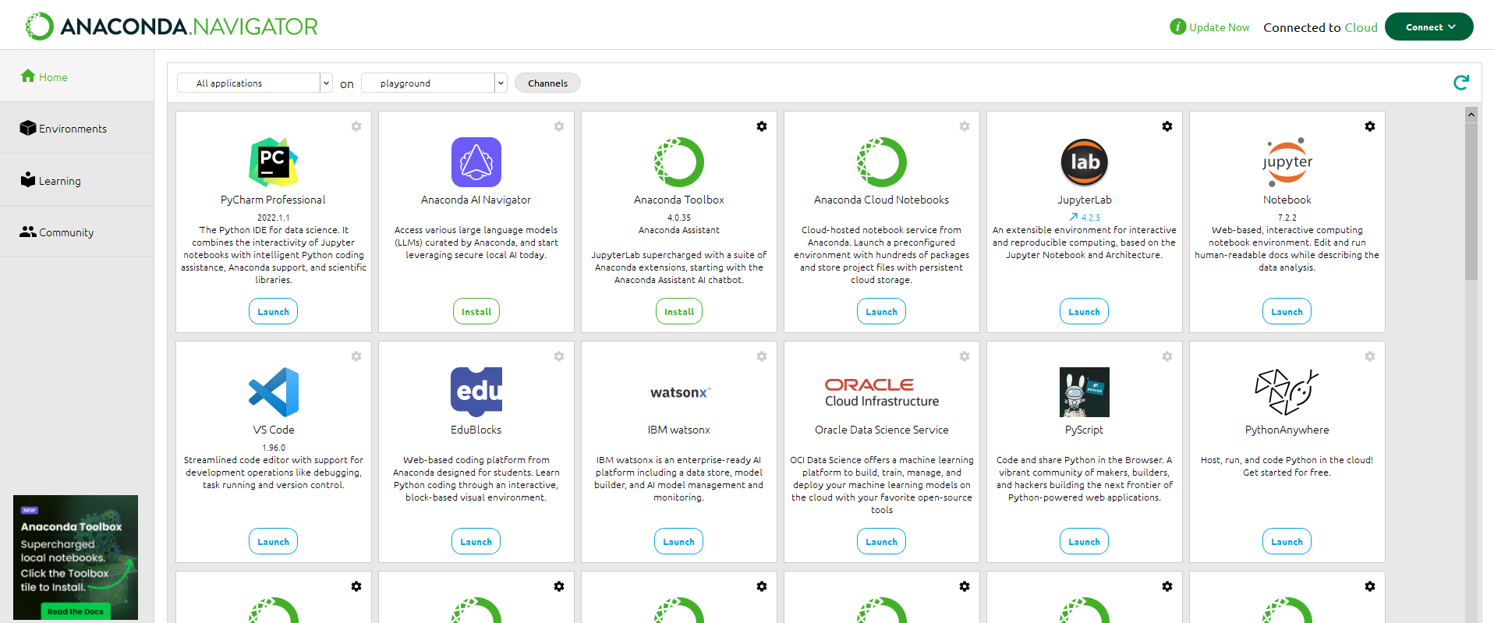

- Once the Jupyter Notebook tab opens in a browser window, choose ‘New’ and in the dropdown menu choose ‘Python 3 (ipykernel)’.
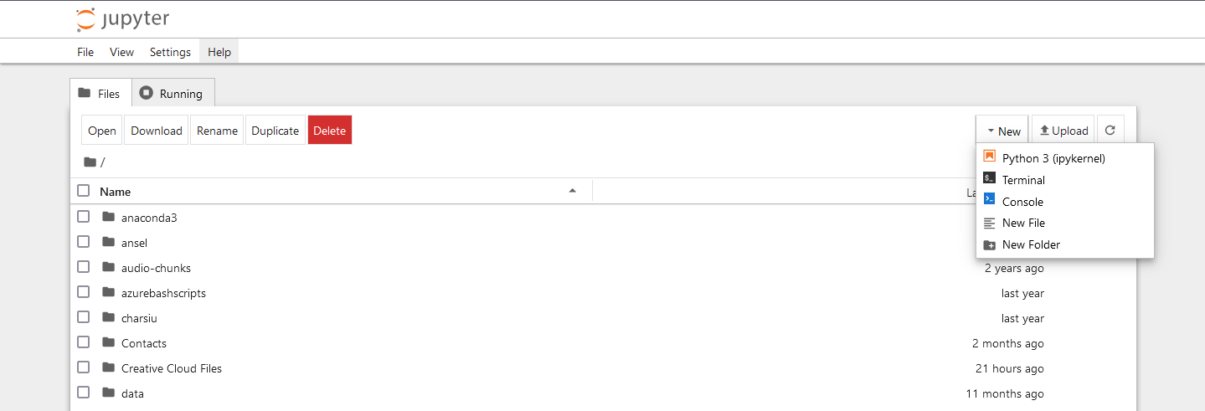

- Once a notebook window is opened, you can start coding. Ensure ALL CODE is typed from the GREYED CELL in the images.
Firstly import the packages you will need. For this tutorial you will need:
  - Numpy
  - Pandas
  - Seaborn
  - Matplotlib.pyplot
  - MLPClassifier and MLPRegressor (from sklearn.neural_network).
  - Metrics (from sklearn)
  - Warnings – we will be filtering out some of the less important warnings so as not to have annoying messages…

Numpy, Pandas, Seaborn and matplotlib.pyplot (see next step) will be imported using an alias (a variable to use in stead of the full name). This will be quite common with several packages. Importing packages will always be the first step. Once you have coded a cell in Notebook, you will need to click the ‘run’ button to run that cell (looks like a play button, see below).

import joblib
from sklearn.neural_network import MLPClassifier, MLPRegressor
from sklearn.model_selection import GridSearchCV
from sklearn import metrics
import numpy as np
import pandas as pd
import seaborn as sn
import matplotlib.pyplot as plt
import warnings
warnings.filterwarnings('ignore', category = FutureWarning)
warnings.filterwarnings('ignore', category = DeprecationWarning)

- As a note, remember you can name your notebook to be saved for later reference.

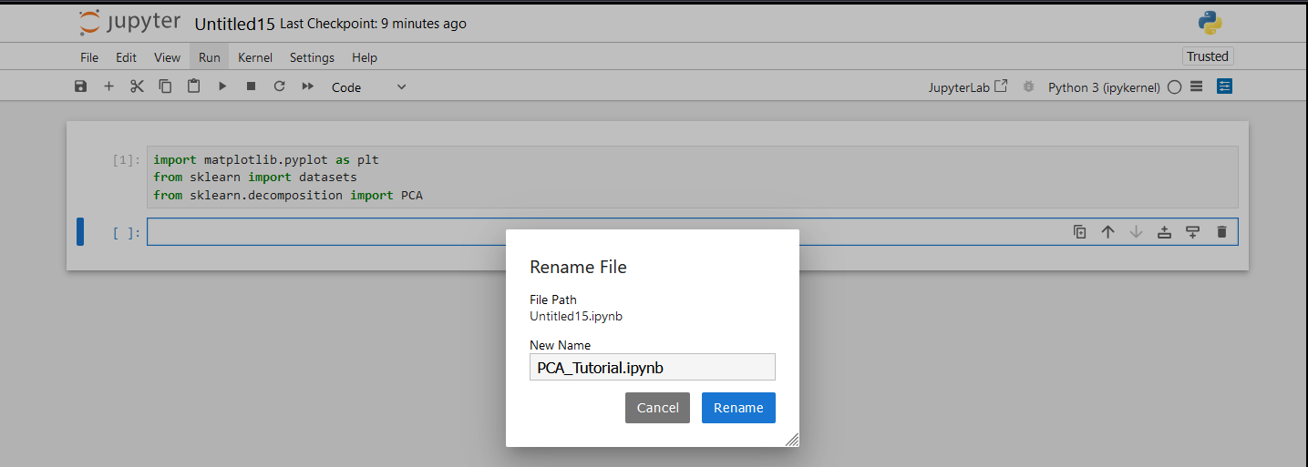

- Let’s look at the parameters that can be fine tuned for both the regressor and the classifier. Run the cell.
# this step is just to demonstrate the adjustable parameters within the algorithm and not a necessary step
print(MLPClassifier().get_params())
print()
print(MLPRegressor().get_params())

From the lectures, which parameters do you recognise?
What do these parameters do?
What are the defaults?

- Load the diabetes dataset that should already be downloaded from a previous tutorial. This can be downloaded from Moodle if you do not have it. Set it to a suitable folder and use that folder for the path (ideally the folder you are in as shown in the example). Check the size and shape of the dataset as we explore it. Run the cell.
# load the dataset (stored in a variable)
diabetes = pd.read_csv('./diabetes.csv', sep=',',header = 0)

print ("The length of the dataset is ", len(diabetes))
print("The shape of the dataset (Number of columns / features) is ", diabetes.shape)

- While we explore the dataset we can look at the data as we did previously with the head() method. Run the cell.
diabetes.head()

Enter 10 or 20 as a parameter within the brackets. What happens?

- Also we will explore the information of the data. The last three steps are just different ways to inspect the data. There will be some information shared across all three outputs. Run the cell.
diabetes.info()
What does this show you?
What does it all mean?
- Now split the dataset into train and test sets using train_test_split() method and set it to a 20 / 80% split and store the datasets in variables, random_state will allow it to randomly split the set as opposed to splitting it in a linear form. We will also print the info of the train set here too. Run the cell.
# split the data into train and test using the SciKitLearn package
train,test=train_test_split(diabetes,test_size=0.20,random_state=42)
# view the information
train.info()

What do you notice different to the last info that you printed?
Try different splits like 25 / 75.

- Now we need to take the labels / classifications and set them to their own variable (y). Then we need to remove them from the main dataset by dropping the column. We will also drop irrelevant columns and set the rest of the dataset to its variable X. We will do this for the train and test set. Lastly we will test the info again, this time on the test set. Run the cell.
# Ensure only labels are saved in y variables
y_train=train['Outcome']
y_test=test['Outcome']
#drop the unwanted / irrelevant columns, features are stored in X variables
X_train=train.drop(['PatientId','Outcome'],axis=1)
X_test=test.drop(['PatientId','Outcome'],axis=1)
# view the information
X_test.info()

- Now we are ready to create a model. We will create a classifier algorithm using the default parameters. This will be stored in a variable. We can then fit the training data to the model to train it using our created variables, ‘values’ (attributes) and ‘mtarget’ (labels). Run the cell.
# Create a model for Support Vector (Machine) Classifier using default parameters
mlp = MLPClassifier()
# fit the data to the model, both features and labels to train it
mlp.fit(X_train, y_train)

- Predict with the model using the test dataset (only the data) and print the predictions. We can then print the length too. Run the cell.
# use the model to classify the datapoints within the test set
y_pred2=mlp.predict(X_test)
# print predicted classifications
y_pred2

- We will now use Pandas to create a dataframe for each model (one code example is shown, figure out what to replace to create the default dataframe). This will allow us to view the predictions and ground truths side by side. It will also allow us to generate a heatmap confusion matrix. Be careful with variable names here for the reasons mentioned above. Run this cell for both dataframes.
# use Pandas to create a dataframe to view the ground truth and classifications side by side
data = {'Actual': y_test,
'Predicted': y_pred_rf }
df = pd.DataFrame(data)
print(df)

Any differences between actual and predicted?

- Now using Seaborn and matplotlib.pyplot, we can generate a heatmap confusion matrix from the dataframe and plot it using matplotlib.pyplot. We will print the classification report too. Run the cell.
# Use Seaborn to create a confusion matrix heatmap and MatPlotLib to display
confusion_matrix = pd.crosstab(df['Actual'], df['Predicted'], rownames=['Actual'], colnames=['Predicted'])
sn.heatmap(confusion_matrix, annot=True)
plt.show()
print(metrics.classification_report(y_test, y_pred2, digits=3))

How does the confusion matrix look?
What can you deduce from this?
How does this compare to the classification report?

- Now let’s figure out the best parameters for classifier. Let’s use the default algorithm and change the n_estimators and max_depth parameters (you can change as many as you want) using cross validation. First create the function for running the results. Run the cell.

def print_results(results):
print('The Best Parameters are: {}\n'.format(results.best_params_))
means = results.cv_results_['mean_test_score']
stds = results.cv_results_['std_test_score']

for mean, std, params in zip(means, stds, results.cv_results_['params']):
print('{} (=/-{}) for {}'.format(round(mean, 3), round(std * 2, 3), params))

- Then create the arrays of parameters we want to change and create the cross validation variable using GridSearchCV. Fit the algorithm with the data and print the results. Run the cell.
mlp_clf = MLPClassifier()
parameters = {
'hidden_layer_sizes': [(10,), (50,), (100,)],
'activation': ['relu', 'tanh', 'logistic', 'sigmoid'],
'learning_rate': ['constant', 'adaptive', 'invscaling'],
}

cv = GridSearchCV(mlp_clf, parameters, cv = 5)
cv.fit(X_train, y_train)

You can use any values you want for the parameters and see how they differ.
What are the best parameters to use?
What is the best accuracy from these parameters?
What do you notice about the output this time?

- Call on the function to print the results. Run the cell.
print_results(cv)

What parameters are the best here?
What do you notice about the results compared to the parameters used?

- Let’s take a look at how the training scores and the cross validation scores compare. For this we will import learning_curve from sklearn.model_selection. We will then create three new variables using the new import for sizes and scores (train and test (validation)). Run the cell.
from sklearn.model_selection import learning_curve
train_sizes, train_scores, test_scores = learning_curve(cv, X_test, y_test, cv=10, scoring='accuracy', n_jobs=-1, train_sizes=np.linspace(0.01, 1.0, 50))

- Then set variables for the mean and standard deviations using numpy arrays. Run the cell.
train_mean = np.mean(train_scores, axis=1)
train_std = np.std(train_scores, axis=1)

test_mean = np.mean(test_scores, axis=1)
test_std = np.std(test_scores, axis=1)

- Create the graph / plot using matplotlib.pyplot (using the alias plt).
plt.subplots(1, figsize=(10,10))
plt.plot(train_sizes, train_mean, '--', color="#111111", label="Training score")
plt.plot(train_sizes, test_mean, color="#111111", label="Cross-validation score")

plt.fill_between(train_sizes, train_mean - train_std, train_mean + train_std, color="#DDDDDD")
plt.fill_between(train_sizes, test_mean - test_std, test_mean + test_std, color="#DDDDDD")

plt.title("Learning Curve")
plt.xlabel("Training Set Size"), plt.ylabel("Accuracy Score"), plt.legend(loc="best")
plt.tight_layout()
plt.show()

What can be seen and diagnosed from this graph?
What do the trends mean in this graph?
How would you interpret this?

