

Module – ACCA4019
Analysing and Solving Problems

Assessment Component 2 – Written Assignment
Lecturer: Dr Abida Perveen

Prepared by:
Bernard Unuigboje Ileogben
Student ID: 2512918

Submission date: 15 March 2026
Table of Contents
Introduction 2
Task 1. Problem Deconstruction Using MoSCoW and Key Variables 3
Task 2. Proposed Flowchart Solution and Detailed Explanation 5
Task 3. Reflection and Justification of the Problem-Solving Approach 9
References 10
Appendix 11

Introduction
Most colleges have overcrowded classrooms and even non-exploited spaces that pose conflicts in the schedules and time wastages as well as poor quality of education. Recent research shows that AI-based optimisation can solve these multi-objective scheduling problems by balancing room capacity, conflicts, and resource use [1]. Lack of coordination of the sizes of the classes, the ability of the rooms and the schedule and arrangement process provokes this issue. The report also discusses the issue of classroom allocation that was put forth by one of the local colleges and proposes a systematic solution which will involve breaking down the problem and drawing a flowchart based on logically fitting out the flowchart. All the problem-solving is done based on an abstract thinking system behind it all, aimed at making the best use of the available space, lowering the movement time of the students and staff, and eliminating any form of scheduling conflict, so the overall learning experience will be enhanced.

Task 1. Problem Deconstruction Using MoSCoW and Key Variables

Problem Components
The classroom allocation problem comprises four interconnected operational failures that undermine educational delivery:

- Capacity Mismatch: Classes assigned to rooms too small cause overcrowding; suitable rooms remain unused simultaneously.

- Schedule Conflicts: Rooms being double-booked create confusion and tardiness.

- Movement Inefficiency: Remote class locations increase transit time and fatigue for students/staff.

- Resource Underutilisation: Available rooms sit empty while others overflow.

MoSCoW Requirements Prioritisation

MUST HAVE (Non-negotiable for basic functionality):

- Classroom capacity ≥ class enrolment size

- No schedule overlaps (one class per room per time slot)

- Minimum seating/chairs available

SHOULD HAVE (significant improvements):

- Minimise distance between consecutive class locations

- Even utilisation across all available rooms

COULD HAVE (desirable enhancements):

- Subject-specific facilities (labs for science, projectors for presentations)

- Pre-employee access to specialist rooms

WON'T HAVE (out of scope):

- Real-time occupancy sensors

- Automated tracking systems (cost/complexity)

- Key Variables and Constraints

Decision Variables:

ClassSize[i] = students in class i
RoomCapacity[j] = maximum seats in room j
TimeSlot[k] = class i scheduled time
RoomLocation[j] = physical coordinates of room j
PreviousRoom[i] = room used by class i-1

Constraints:
- Capacity: ClassSize[i] ≤ RoomCapacity[j] for assigned room j

- Exclusivity: Room j available at TimeSlot[k] (no overlaps)

- Admin Rules: Preferential rooms for specific courses

- Fixed Supply: Limited total rooms available

Optimisation Objectives (prioritised):
Primary: Satisfy capacity + availability constraints

Secondary: Minimise distance (PreviousRoom[i], AssignedRoom[i])

Analytical Framework

MoSCoW establishes clear priorities, while variables/constraints form the mathematical foundation for algorithmic solutions. Capacity matching prevents overcrowding (MUST), distance minimisation reduces fatigue (SHOULD), and conflict elimination ensures operational continuity.

The structured approach reveals interdependencies: poor capacity decisions cascade into availability conflicts, amplifying movement inefficiencies. By prioritising constraints hierarchically, the solution guarantees feasibility before optimisation. This multi-constraint approach matches recent work on smart classroom scheduling that treats allocation as an optimisation problem with competing objectives [1].

Task 2. Proposed Flowchart Solution and Detailed Explanation
Overview of the Flowchart-Based Approach
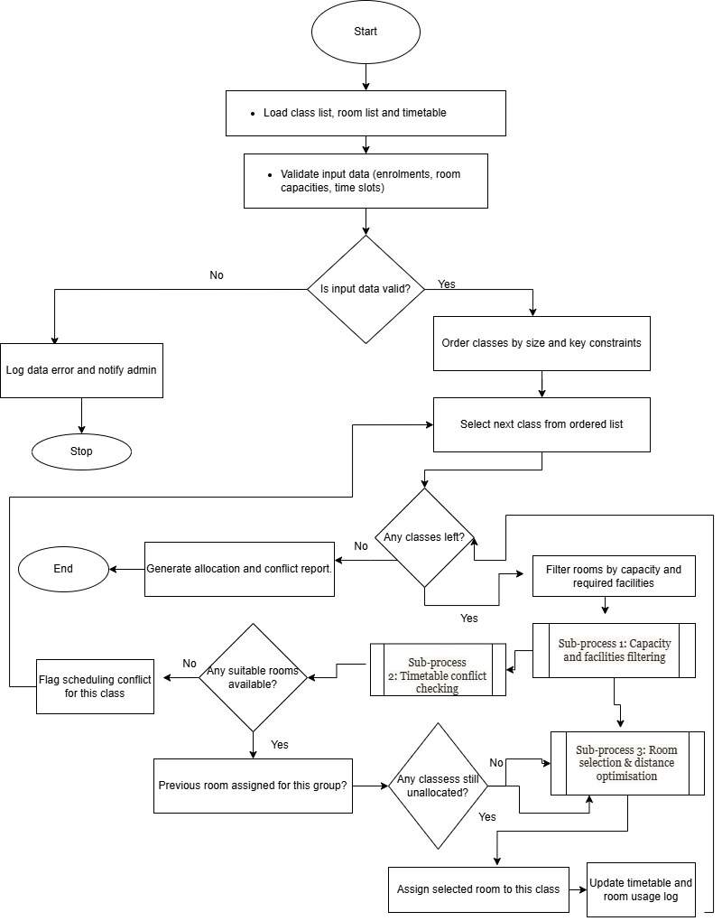
Figure 1. Flowchart

Figure 1. Classroom allocation flowchart. Sub-process 1 (capacity and facilities filtering), Sub-process 2 (timetable conflict checking), and Sub-process 3 (room selection and distance optimisation) are expanded in the pseudocode section.
Figure 1 presents the refined classroom allocation flowchart, showing how data validation, class prioritisation and room selection are structured into a clear sequence of decision points. The system checks room capacity, timetable availability, and movement distance before assigning a classroom. If no room is available, a scheduling conflict is flagged for administrative review. As illustrated in Figure 1, the algorithm first validates input data and orders classes by key constraints, then iteratively filters rooms by capacity, facilities and time slot before applying movement-distance optimisation or flagging unresolved conflicts for manual review.

Algorithm Logic Linked to Flowchart
The three sub-processes highlighted in Figure 1 are expanded below using structured pseudocode.
- Validate input data (class list, rooms, capacities, timetable) and order classes by size and key constraints.
- For each class, filter rooms by capacity, facilities and time‑slot availability.
- If no suitable room exists, flag a scheduling conflict; otherwise, select a room based on either best utilisation or minimum distance from the previous room.
- Assign the room, update the timetable and repeat until all classes are processed.
The proposed solution uses a logical flowchart to organise the systematic allocation of classrooms according to defined constraints and priorities. The flowchart breaks the complex allocation problem into simple, sequential steps that are easy to understand and implement. Çaylı and Yılmaz [1] also used constraint programming and genetic algorithms to create systematic classroom allocation solutions. Similar AI-based scheduling methods have been used in colleges to build automatic timetable generators that avoid clashes and improve use of rooms [2]. The former is the input information required, i.e., classes, student enrolment number, capacity of rooms, time slots of the lesson and the classroom location [2].

Capacity Matching and Initial Room Filtering
The first operational phase is to select the class in the schedule, get the number of students in it and the time. The system compares class size with room capacity. Any other room that does not support the student population is automatically dropped from the list of potential options. This process of filtering ensures that overcrowding is prevented even in the very beginning of the distribution process. The solution is safe, comfortable and productive to learn in and will avoid unnecessary wastage of room by overloading capacities before the rooms are allotted to the students.
Timetable Conflict Checking
The decision point that follows suit after the identification of adequately sized rooms scans the room availability in the identified time slot. The other rooms are examined and verified to determine whether the room has been occupied by another class within the period of time. The rooms with conflicts are removed from the candidate list.
Similar automated timetable systems also use rule-based checks to block any room that is already booked at a given time so that no overlapping classes are allowed [3].
This would be to prevent the sharing of space by two classes at the same time, and the scheduling cleavages that interrupt the delivery of lessons and administration planning would be eliminated.
Movement Distance Optimisation
The system incorporates a second-order optimisation criterion of movement efficiency upon identifying the rooms that fulfil the capacity as well as the availability requirement. The distance between the potential room in the lesson and the one that was used during the previous lesson and the classroom is established. This distance can be determined in terms of walking time, or the location of the building later, or the areas on the campus that have been predetermined. The room with the least distance travelled is selected as the optimal distribution of the rooms is established. This step saves time, reduces fatigue, and simplifies movement for students and staff [3].

Assignment and Iterative Processing
Once a room is selected, it is assigned to that class in the scheduling system. The database is updated to record that this room is now booked for that time slot. The process then moves to the next class in the timetable and repeats the filtering, conflict checking, and optimisation steps. This continues until suitable rooms have been allocated to all classes. If no suitable room can be found for a particular class because of capacity or availability constraints, the system raises an alert so that the administration can check and resolve the issue manually.
Efficiency and Effectiveness of the Approach
This structured flowchart solution offers an effective way to use institutional resources by giving priority to room sizes and better utilisation of space. In congested situations, capacities are matched very strictly, and unused rooms are reduced by considering all available rooms. Scheduling conflicts are reduced through constant availability checking, and movement time is minimised by including distance in the decision-making process instead of using random room allocation. Similar optimisation approaches in course-scheduling research gradually improve timetable quality by satisfying more constraints and reducing conflicts over time [4].
.
Assumptions and System Applicability
The model is based on several assumptions. It assumes that class enrolment numbers do not change a lot during the academic term, that room capacities are correctly recorded, and that lesson schedules are known before the allocation process starts. It also assumes that distances between rooms can always be calculated using campus layout data. These assumptions make the system design easier but depend on real institutional planning conditions. Overall, the flowchart provides a flexible and general solution that can be applied in both small and large colleges. Its step-by-step structure makes it possible to implement using scheduling software, database tools, or spreadsheet automation [4].

Task 3. Reflection and Justification of the Problem-Solving Approach
The issue of classroom allocation was approached using abstract thinking, where a complex real-life problem was broken down into smaller units that were easier to handle. Instead of trying to solve all the inefficiencies at once, the problem was divided into capacity requirements, schedule conflict avoidance, and movement distance optimisation. On one hand, this made it easier to analyse and create logical solutions, and on the other hand, it helped to make sure that all the important operational issues were addressed. The SWOT-style analysis carried out with the MoSCoW priority tool was also useful to identify the most important needs of the system and the less necessary enhancements. This focus on capacity and space use follows recent multi-constraint class scheduling work that aims to use rooms more effectively and avoid overcrowding [5]. This solution did not add unnecessary complexity but improved reliability by first focusing on having enough room capacity and removing scheduling conflicts. The most important capability was achieved first, and then the secondary capability of minimising the distance travelled was added [5]. This step-by-step approach is consistent with recent timetable research, which uses structured algorithms to manage many scheduling constraints at the same time [2]. The use of a flowchart was rational because it shows the decision points and process sequence visually, making the solution easy to follow and check. Flowcharts help to organise thinking and reduce the chance of design errors because they clearly state the conditions and outcomes. This increases transparency for both technical developers and administrative users. Effectiveness, balance, and simplicity are key strengths of the proposed solution. It reduces congestion, prevents time clashes, supports efficient movement, and remains user-friendly. A limitation is that it does not include an automatic option to react immediately to timetable changes. Overall, the problem was divided into capacity matching, conflict detection, and movement optimisation based on the principle of computational thinking.

References

[1] | O. Çayli. A. Yılmaz, “Smart Classroom Scheduling and Resource Optimization for Educational Institutions: Integrating AI and Multi-Objective Decision Support,” The European Journal of Research and Development, vol. 5, pp. 95--112, 2025.
[2] | L. A. a. A. M. Farinola, “Explicit Artificial Intelligence Timetable Generator for Colleges and Universities,” Open Journal of Applied Sciences, vol. 15, pp. 2277--2290, 2025.
[3] | V. a. S. K. B. a. L. X. Shankar, “Enhancing Operating System Performance with AI: Optimized Scheduling and Resource Management,” Journal ID, vol. 9339, p. 1263, 2025.
[4] | S. a. o. Yaasmin, “Automated Timetable Generator,” International Journal of Advances in Engineering and Emerging Technology, vol. 13, pp. 41--43, 2022.
[5] | X. a. W. D. Han, “Gradual optimization of university course scheduling problem using genetic algorithm and dynamic programming,” Algorithms, vol. 18, p. 158, 2025.
[6] | P. Bandyopadhyay, “Optimization of Class Scheduling Problem: A Multi-Constraint Approach for Effective Resource Allocation and Space Utilization,” International Journal of Computer Trends and Technology, vol. 72, pp. 36--42, 2024.

Appendix
MoSCoW Prioritisation Table
Priority | Requirement | Justification
Must Have | Get the room capacity and class size in line. | The main preventive measures against overcrowding are health, safety, and comfort.
Must Have | No schedule conflicts (there can be no room reservation conflicts). | Assures that the lessons will commence on time without the inconvenience of the operations.
Must Have | Maintain records of the availability of rooms. | Had to check on conflict checking and ensure proper scheduling
Must Have | A room should only host one class per time slot | Rudimentary rule of the system to possess a systematic scheduling
Should Have | Make the gap between classes minimal | Reduces the tiredness and time usage by the students and staff
Should Have | Ensure that there is even usage of rooms | Avoids excessive use of space and wastage of resources
Should Have | Use a similar building, preferably | Improves the movement and efficiency of schedules on the campuses
Could Have | Allocate mission-enhanced rooms (ICT room, laboratory and so on). | Enhances the quality of learning, but is not an element of basic allocation
Could Have | Generate issue administrative notifications of ability | Supports decision-making but is not required for the core function.
Won’t Have (for now) | Sensors to track real-time occupancy | High cost and technical complexity;
Won’t Have (for now) | AI-based predictive enrolment forecasting | Advanced feature beyond current system requirements.

Key Variables Table
Variable | Description | Role in Allocation Process
Class size | Number of students enrolled in each class | To find the minimum room capacity required
Room capacity | Maximum number of occupants per classroom | Used to filter suitable rooms
Time slot | Scheduled period for each class | Used to check availability and avoid conflicts
Room availability | If room is available at the time | Stops booking more than once
Distance between rooms | Distance between two classrooms | Minimise time
Number of classrooms | Total number of classrooms | Limits allocation options
Subject requirements | Need for a specialist room | Used for optional prioritisation

System Constraints Table
Constraint | Explanation
Limited number of classrooms | Only existing rooms can be allocated.
Fixed institutional timetable | Class times cannot be arbitrarily changed.
Room capacity limits | Legal and safety restrictions
Administrative scheduling rules | Certain rooms are reserved or restricted.
Campus layout | Physical distance cannot be altered.

System Assumptions Table
Assumption | Reason for Assumption
Student enrolment numbers remain stable. | Simplifies the scheduling process
Room capacities are accurate. | Ensures safe allocation
The timetable is final before allocation. | Prevents constant recalculation
Walking distances are known. | Enables movement optimisation
All rooms are functional. | Avoids unexpected unavailability

