Exercise: Change Appearance of Page

- Download the sample HTML page from Moodle (SevenWorldsOnePlanet.html)

- Open the page in an editor of your choice.

- View the page in a browser to see it in its raw form. It should look something like this:

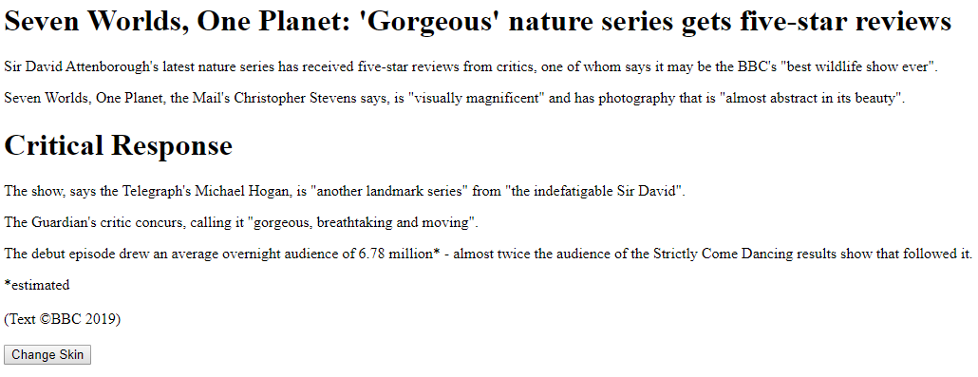

Using the Change Skin button at the bottom to trigger the Javascript, apply the following changes to your page. You will need to use getElementById(), getElementsByClassName() and getElementsByTagName() as required – think carefully about which is most appropriate to each of the below:

- Change the headings to dark blue text
- Change the main text to a larger font size.
- Make all tags marked “special” red.
- Change the background of the entire page to light blue
- Add some text at the bottom “Currently showing blue mode” (note: add your own <div> tag if required)

The final result should look something like the following:



