DS 2 – SCENERIO 2

DIGITAL ARTIFACT
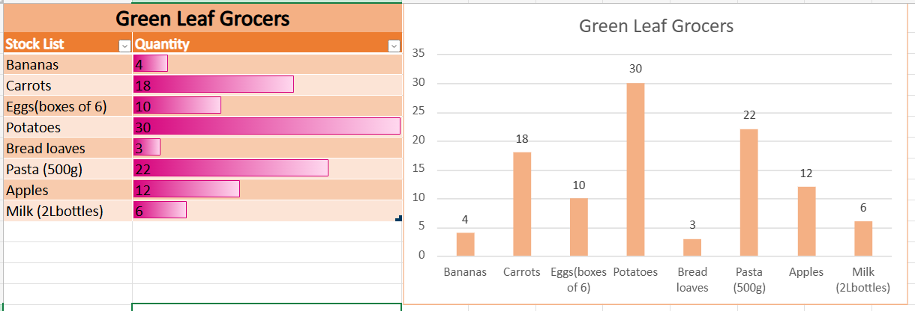
DIGITAL LOGS
Why i chose Excel?
I chose to excel because it’s very clear for me how to make company sales data and it helps me easy to look clearly when making tablet stock lists for the company sales data for me excel is a good choice to use for making any data or bar chart for business. I know there is no perfect choice, but when u use the right tools that help you show clear decisions and improvement, it’s all about how confident you are using the tool.
Why i chose green leaf grocers?
Because food stores are good idea for business because even the economy dips people still buy groceries and of course it is more challenging but depends on how you manage it and for me to have business like food store is worthy because everyone need food so if they need it have to buy from any of food store. Of course is more competition but again it’s all about how to make customer happy with your product to make customer happy with the product first product need to be good quality how to be nicely with the customer so make them more feel confident to give good feedback to the store.
What information i used
I use the green leaf grocer’s sales data to analyses which stock list needs to be added, and which one does not need to add and then i calculate how many products has been sales during this week.
How i created my artifact
- First, I open Excel
- I type product name and number
- Analyses the stock list using the store data
- I make tablet for the sales number so i know which product sells is during this week
- I make bar chart so i can see which product has more sells during this week.
- Add color so make people see it clearly.
- The last one i need to have looked at everything again makes sure the product name and number must be correct.
What changes i made
I don’t know how to make tablet stock list as my first time it’s hard for me, so i ask my tutor explain more how to make the tablet also give the example and then i do by myself but still it’s not clear for people to see so I just add more color and make letter and number a bit more big last i make bar chart so more easy to see and finally they can see my tablet stock list clearly, for me is a big changes I have make.
Feedback I used
My classmate said color is fine, but letter and number to be more clear
i change both based feedback from my classmate.

Final explanation
This artefact now makes me feel more confident to understand how to make stock list data and it’s verry helpfully for green leaf grocers how to manage their stock list every weeks and for me is good for make business grow in the future.

