Data Mining Component 2

University of Wales Trinity Saint David

Programme: BSc Applied Computing Module: Data Warehousing & Data Mining
Module code: ACCA6026
Lecturer: Mobolanle Bello
Student Name: Ionela Alina Marcu
Student ID: 2321713

Contents
Introduction 2
1.1 Purpose and Practice of Data Mining 3
1.2 Dataset Description and Exploration 4
1.3 Data Pre-processing and Post-processing 9
1.4 Sample Runs and Analysis Methods 9
1.5 Business Recommendations 12
1.6 Reflective Commentary 12
Conclusion 13
References 14
Appendix Weka Explorer Output Screenshots 15
Appendix A. Weka EM Clustering Results 15
Appendix B. RandomForest Training-Set Results 16
Appendix C. RandomForest 10-Fold Cross-Validation Results 17
Appendix D. J48 (C4.5) Training-Set Results 18
Appendix E. J48 (C4.5) 10-Fold Cross-Validation Results 18
Appendix F. Logistic Regression Training-Set Results 19
Appendix G. Logistic Regression 10-Fold Cross-Validation Results 20
Appendix H. Source Dataset Sample in Excel 21

Introduction
This report analyses the Online Retail Customer Churn Dataset for the ACCA6026 Data Warehousing & Data Mining module. Using data from 1,000 customers, the study aims to predict customer churn through classification and identify customer groups using clustering. Weka is used for the main analysis, supported by Excel for data preparation and Tableau for visualisation.
The report follows the CRISP-DM framework, covering data exploration, pre-processing, modelling, evaluation, business recommendations, and reflection. The final section summarises the main findings and their relevance to decision-making in online retail.

1.1 Purpose and Practice of Data Mining
Data mining involves examining large datasets to discover meaningful patterns, relationships, and useful insights through statistical, machine-learning, and database techniques [1]. In this study, data mining is applied within the CRISP-DM framework, particularly during the modelling and evaluation stages, which help structure the analytical process [2].
In retail and e-commerce, data mining can turn customer information, such as purchase history, satisfaction scores, support interactions, and responses to promotions, into practical business intelligence. Classification techniques, including decision trees, random forests, and logistic regression, can be used to estimate the likelihood of customer churn and help businesses focus retention efforts on higher-risk customers [3]. Clustering methods, such as Expectation-Maximisation, can also group customers with similar characteristics without using a predefined target variable, supporting customer segmentation and more personalised marketing strategies [4].
The usefulness of data mining also depends on how carefully model performance is evaluated. Measures such as accuracy, precision, recall, and cross-validation help determine whether a model is reliable and whether its results are likely to perform well on new data [5]. For this reason, data mining is not only about building models, but also about producing trustworthy insights that can support customer retention, segmentation, and more effective marketing decisions.

1.2 Dataset Description and Exploration
The analysis uses the Online Retail Customer Churn Dataset [6], which contains 1,000 customer records and 15 demographic, transactional, and behavioural attributes. In Weka’s Preprocess panel, all variables were successfully loaded, and their data types were identified. The dataset contained no missing values across its 15,000 data entries, meaning that no imputation was necessary.
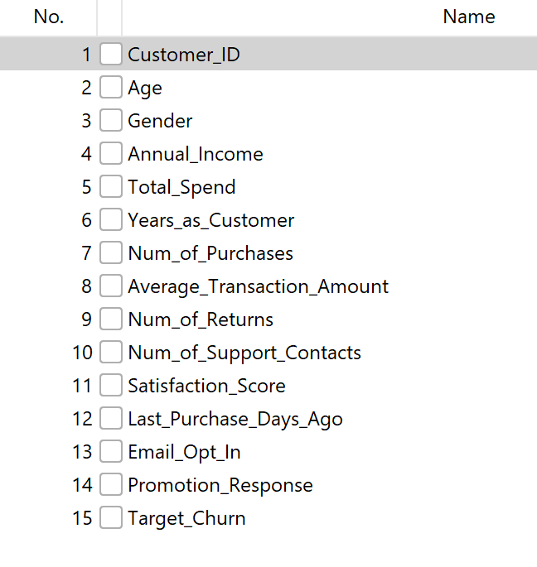

Dataset preview in Weka Explorer showing 15 attributes and 1,000 instances, with no missing values detected.

Table 1. Descriptive Statistics for Numerical Variables (n = 1,000)
Attribute | Mean | Std. Dev. | Min | Max
Age | 43.27 | 15.24 | 18.00 | 69.00
Annual_Income | 111.96 | 52.84 | 20.01 | 199.73
Total_Spend | 5080.79 | 2862.12 | 108.94 | 9999.64
Years_as_Customer | 9.73 | 5.54 | 1.00 | 19.00
Num_of_Purchases | 49.46 | 28.54 | 1.00 | 99.00
Average_Transaction_Amount | 266.88 | 145.87 | 10.46 | 499.57
Num_of_Returns | 4.61 | 2.90 | 0.00 | 9.00
Num_of_Support_Contacts | 1.93 | 1.40 | 0.00 | 4.00
Satisfaction_Score | 2.97 | 1.39 | 1.00 | 5.00
Last_Purchase_Days_Ago | 182.89 | 104.39 | 1.00 | 364.00

Table I presents the descriptive statistics for the ten numeric attributes. Most variables show relatively broad ranges compared with their mean values. Age is distributed evenly between 18 and 69 years (Figure 2), which may suggest that the dataset is synthetically generated rather than based entirely on naturally collected customer data. The target class is also reasonably balanced, with 526 churned customers and 474 retained customers (Figure 1), reducing the likelihood that a majority-class model would achieve misleadingly high accuracy. Gender and Promotion_Response are similarly distributed quite evenly across their categories.

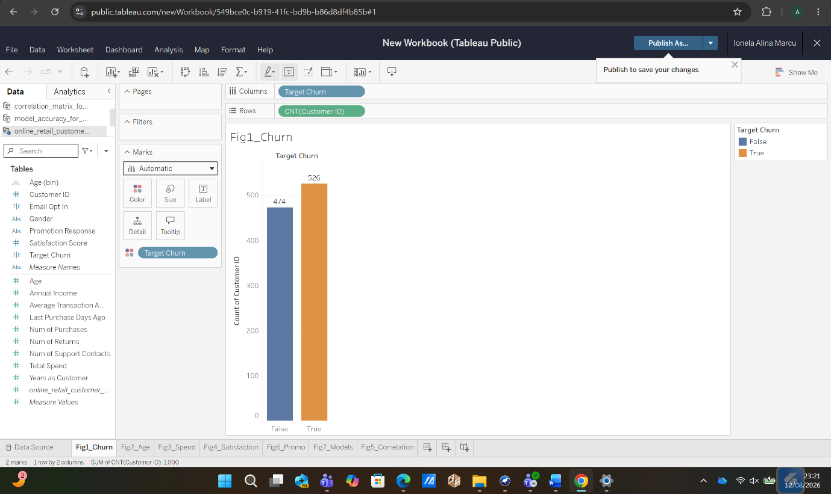
Figure 1. Distribution of the churn classes, showing a near-balanced split between 526 churned and 474 retained customers.

Figure 2. Customer age distribution (18–69 years), showing a relatively even pattern that may indicate a synthetically generated dataset rather than a typical real-world retail population.
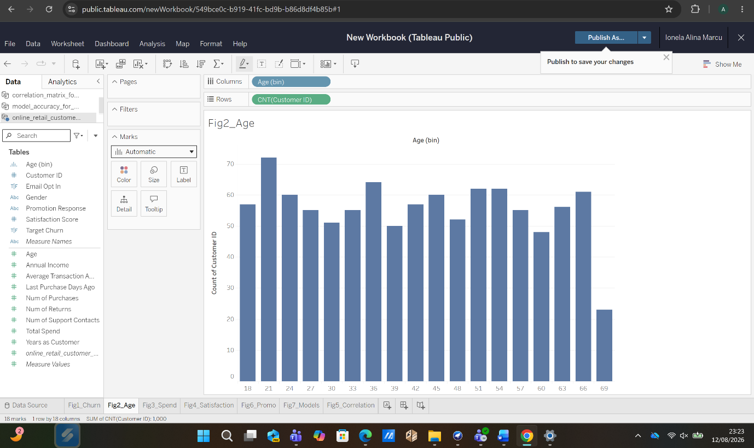
Bivariate analysis shows very little distinction between customers who churned and those who were retained. Median Total_Spend is nearly the same for both groups (Figure 3), while Satisfaction_Score also shows no clear association with churn (Figure 4). This is supported by the Pearson correlation matrix (Figure 5), where correlations between the ten numeric variables and Target_Churn range only from -0.036 to +0.029, indicating extremely weak relationships. Promotion_Response follows a similarly even pattern (Figure 6). These findings provide the basis for the pre-processing and modelling choices discussed in Sections 1.3 and 1.4 and anticipate the main result of the classification analysis.
Figure 3. Comparison of Total_Spend across churn groups, with similar median values and strongly overlapping interquartile ranges.
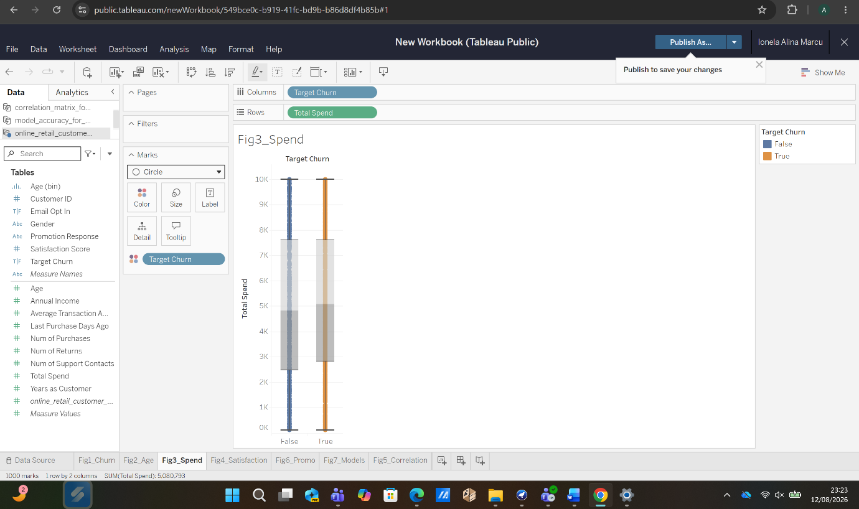

Figure 4. Satisfaction_Score across churn groups, showing very similar patterns for churned and retained customers at all score levels from 1 to 5.

Figure 5. Pearson correlation matrix for the numeric attributes, with Target_Churn showing only very weak correlations, the largest being |r| = 0.036.
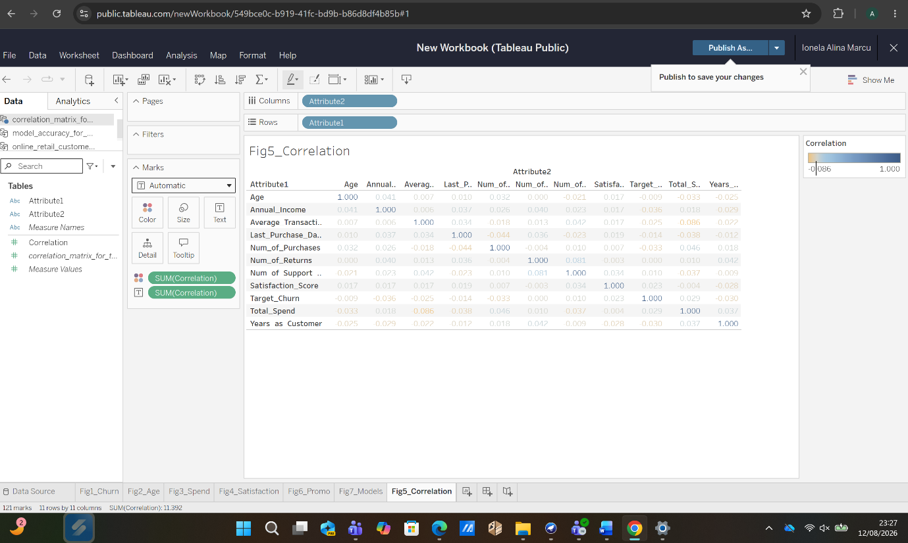
Figure 6. Promotion_Response by churn status, showing a similar churn and retention pattern across all three response categories, despite Unsubscribed being the largest group.
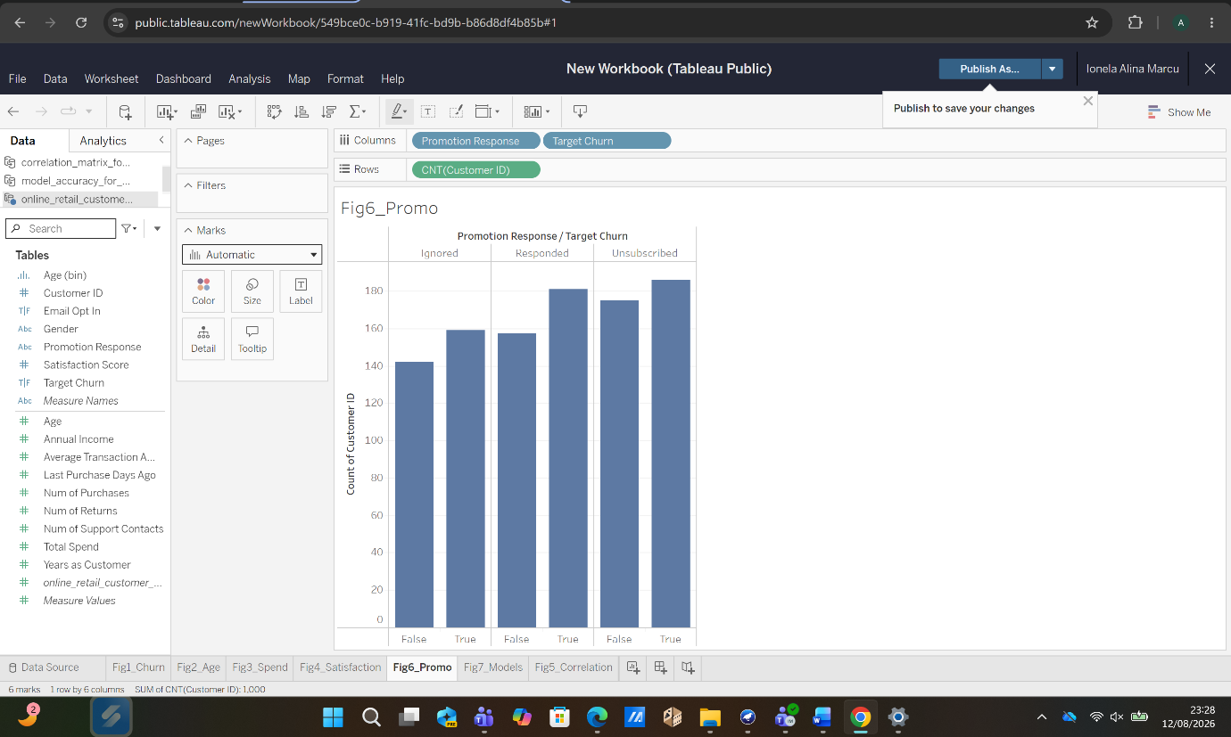

1.3 Data Pre-processing and Post-processing
Data preparation followed the CRISP-DM pre-processing stage [2]. The raw CSV contained no missing or invalid values, as confirmed through programmatic checks and Weka’s attribute summaries. Therefore, no imputation, record removal, or missing-value indicators were required. Although this is unusual in real retail datasets, it was treated as a simplifying characteristic of the dataset. An interquartile-range check also found no numeric values outside the 1.5×IQR threshold, further supporting the view that the data are bounded and likely synthetic.
Weka handled the categorical variables Gender, Promotion_Response, and Email_Opt_In as nominal attributes. Tree-based algorithms processed these categories directly, while Logistic Regression applied Weka’s nominal-to-binary conversion, producing separate indicator variables for category levels. A similar approach was used in the exploratory analysis in Section 1.2 to maintain consistency.
The class distribution was examined before modelling. With 52.6% of customers classified as churned and 47.4% as retained, the dataset was considered sufficiently balanced. As a result, techniques such as SMOTE [7] and under-sampling [8] were not applied, since they were unlikely to improve a dataset where the main issue was limited predictive signal rather than class imbalance.
Feature selection was also considered. Customer_ID was identified as a potential variable for removal because it is an arbitrary identifier with no direct business meaning. High-cardinality identifiers can allow flexible models to memorise individual records rather than learn patterns that generalise to new data [9]. However, Customer_ID was retained in the reported experiments so that its influence on model performance could be examined in Section 1.4 and discussed further in Section 1.6. No additional features were engineered because the earlier correlation analysis suggested that the original variables already had very weak relationships with Target_Churn.
Post-processing focused on evaluating whether model performance reflected genuine predictive ability. Confusion matrices, Kappa statistics, and stratified 10-fold cross-validation were used to assess generalisation and identify possible overfitting [10]. For clustering, the EM cluster profiles were interpreted across their attributes and translated into seven business-oriented customer segments, which form the basis of the recommendations presented in Section 1.5.

1.4 Sample Runs and Analysis Methods
Two types of analysis were carried out in Weka. Expectation-Maximisation (EM) clustering was used to identify customer segments without using the churn label, while RandomForest, J48 (C4.5), and Logistic Regression were applied to predict Target_Churn.
EM works by repeatedly estimating cluster membership probabilities and then updating the parameters of each cluster until the model converges [4]. Using Weka’s automatic cluster selection option (-N -1), the algorithm identified seven clusters after 64 iterations, with a log-likelihood of -55.22. The resulting groups were differentiated mainly by service and engagement characteristics rather than spending behaviour.
Cluster 5, representing 7% of customers, appears to be the highest-risk behavioural segment, with the greatest average Num_of_Returns (8.2) and Num_of_Support_Contacts (3.6), alongside a moderate Satisfaction_Score of 3.0. Cluster 1, accounting for 14% of customers, can be viewed as a highly satisfied loyalty segment, with an average Satisfaction_Score of 5.0. Cluster 4 (14%) contains the most recently active customers, averaging 75 days since their last purchase, while Cluster 6 (15%) is the most inactive, with an average of 271 days. These cluster profiles can support targeted retention and engagement strategies, as discussed in Section 1.5, without relying on Target_Churn.

Table 2. Configuration Settings for Weka Classification Models
Classifier | Weka scheme | Key parameters
RandomForest | Weka. classifiers. trees. Random Forest | -I 100 (100 trees), bagging, unpruned Random Tree base learner
J48 (C4.5) | Weka. classifiers. trees. J48 | -C 0.25 (confidence factor), -M 2 (minimum leaf instances)
Logistic Regression | Weka. classifiers. functions. Logistic | Ridge parameter = 1 × 10⁻⁸
EM Clustering | weka.clusterers.EM | -N -1 (CV-selected number of clusters), -X 10 (10-fold CV for cluster selection), maximum 100 iterations

Table 3. Comparison of Training and 10-Fold Cross-Validation Results
Classifier | Train Acc. (%) | Train Kappa | CV Acc. (%) | CV Kappa
RandomForest | 100.0 | 1.000 | 49.9 | -0.017
J48 (C4.5) | 88.6 | 0.771 | 49.8 | -0.008
Logistic Regression | 55.3 | 0.087 | 49.4 | -0.030

Table 4. Weighted Performance Metrics from 10-Fold Cross-Validation
Classifier | Accuracy (%) | Kappa | Precision | Recall | F-Measure
RandomForest | 49.9 | -0.017 | 0.493 | 0.499 | 0.490
J48 (C4.5) | 49.8 | -0.008 | 0.498 | 0.498 | 0.498
Logistic Regression | 49.4 | -0.030 | 0.485 | 0.494 | 0.479

For the classification analysis, RandomForest, J48 (C4.5), and Logistic Regression were selected because they represent different modelling approaches. RandomForest uses an ensemble of 100 bagged decision trees [11], J48 provides a single pruned and interpretable decision tree [12], while Logistic Regression offers a more stable linear approach with lower variance. Model performance was assessed mainly using accuracy, Kappa, and confusion matrices. Since the churn classes were relatively balanced, accuracy remained informative, while Kappa was particularly useful because it adjusts for agreement that could occur by chance [10].
Figure 7. Comparison of training and 10-fold cross-validated accuracy, showing that all three classifiers fall to approximately 50% accuracy under cross-validation.
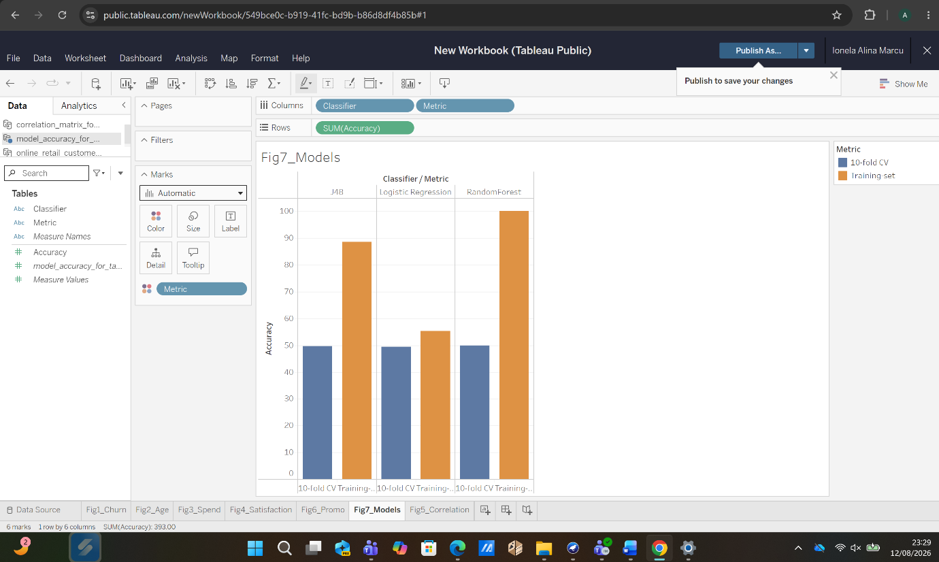
When evaluated on the training data, all three classifiers initially appeared to perform well (Table 3). RandomForest achieved 100% accuracy, J48 reached 88.6%, and Logistic Regression produced 55.3%. However, the results changed substantially under stratified 10-fold cross-validation. Accuracy fell to 49.9% for RandomForest, 49.8% for J48, and 49.4% for Logistic Regression, placing all three models close to chance level (Figure 7). Their Kappa values were also slightly negative, indicating no meaningful agreement beyond chance.
The same pattern appears in the wider performance measures shown in Table IV. Precision, Recall, and F-Measure remain between approximately 0.48 and 0.50 for all three classifiers, suggesting that none provides a meaningful advantage once tested on unseen data. The large difference between training and cross-validated performance is therefore a key finding of the analysis. It is consistent with the very weak relationships identified in Section 1.2, where the strongest correlation with Target_Churn was only |r| = 0.036.
RandomForest shows the clearest signs of overfitting, achieving perfect training accuracy but performing at chance level under cross-validation. J48 also appears to fit noise in the training data, including splits based on Customer_ID, such as Customer_ID <= 591, which supports the leakage concern discussed in Section 1.3. Logistic Regression overfits less strongly, but its performance remains close to random because the available predictors contain little useful signal for churn prediction. Overall, the results suggest that Target_Churn has very limited dependence on the other attributes in this dataset. This should be viewed as a valid analytical result rather than a failure of the modelling process. Full Weka outputs, including confusion matrices and evaluation results, are provided in Appendices A–G.

1.5 Business Recommendations
Two main recommendations emerge from the analysis. First, none of the three classification models should currently be used for operational churn prediction. Although some models performed well on the training data, their 10-fold cross-validation results were close to random, with Kappa values around zero. This suggests that the problem lies mainly in the available data rather than in the choice of algorithm. The current dataset may not include important churn-related indicators identified in previous research, such as browsing activity, use of discount codes, or delivery-related complaints [3], [13]. Retail managers should therefore focus on collecting richer behavioural data before investing further in predictive churn models.
Second, the EM clustering results remain useful because they do not rely on Target_Churn. Cluster 5, representing 7% of customers, has the highest levels of returns and support contacts and could therefore be targeted with proactive customer-service and retention initiatives. Cluster 1, which has very high satisfaction levels, may be suitable for loyalty and referral programmes. Cluster 6, the most inactive group, could be approached through a focused reactivation campaign rather than broad discounting across the entire customer base. In addition, because Unsubscribed is the largest Promotion_Response category, management should review the frequency and channels used for promotions before relying heavily on email-based re-engagement.

1.6 Reflective Commentary
The classification models showed weak predictive performance when evaluated using 10-fold cross-validation. Although training accuracy reached as high as 100%, Kappa values remained close to zero, indicating that none of the models could reliably separate churned from retained customers beyond chance. A key strength of the analysis was the use of both training-set and cross-validated results, supported by the correlation matrix. This comparison helped reveal that the high training accuracy was caused by overfitting rather than genuine predictive ability. The use of Customer_ID by J48 as a splitting variable also demonstrated how an irrelevant identifier can encourage a flexible model to fit noise in the data.
One limitation is that some of these issues were identified only after the modelling stage. A more efficient approach would have examined the relationships between predictors and Target_Churn earlier and removed Customer_ID during pre-processing. The analysis also relied mainly on Weka’s default model settings rather than systematic hyperparameter tuning. If the study were repeated, three improvements would be made: non-informative identifiers would be removed before modelling, recency-frequency-monetary (RFM) features would be created to provide richer behavioural information, and greater emphasis would be placed on clustering and descriptive analysis, which produced more useful insights for this dataset.

Conclusion
This project helped me understand how data mining can be used in a practical retail context and, more importantly, how important it is to evaluate models correctly. Although the classification models did not predict churn successfully, comparing the training results with 10-fold cross-validation showed me how easily high accuracy can be misleading when a model is overfitting.
The clustering analysis was more useful because it identified clear customer groups that could support different marketing and retention strategies. Overall, this investigation helped me improve my understanding of Weka, model evaluation, customer segmentation, and the importance of choosing the right data before building predictive models.

References
[1] J. Han, M. Kamber, and J. Pei, Data Mining: Concepts and Techniques, 3rd ed. Waltham, MA, USA: Morgan Kaufmann, 2011.
[2] C. Shearer, “The CRISP-DM model: The new blueprint for data mining,” Journal of Data Warehousing, vol. 5, no. 4, pp. 13–22, 2000.
[3] A. Amin, S. Anwar, A. Adnan, M. Nawaz, N. Howard, J. Qadir, A. Hawalah, and A. Hussain, “Customer churn prediction in the telecommunication sector using a rough set approach,” Neurocomputing, vol. 237, pp. 242–254, 2017.
[4] I. H. Witten, E. Frank, M. A. Hall, and C. J. Pal, Data Mining: Practical Machine Learning Tools and Techniques, 4th ed. Cambridge, MA, USA: Morgan Kaufmann, 2016.
[5] F. Provost and T. Fawcett, Data Science for Business. Sebastopol, CA, USA: O’Reilly Media, 2013.
[6] Kaggle, Online Retail Customer Churn Dataset, dataset file, online_retail_customer_churn.csv, provided for ACCA6026 coursework assessment, University of Wales Trinity Saint David, 2026.
[7] N. V. Chawla, K. W. Bowyer, L. O. Hall, and W. P. Kegelmeyer, “SMOTE: Synthetic minority over-sampling technique,” Journal of Artificial Intelligence Research, vol. 16, pp. 321–357, 2002.
[8] G. E. A. P. A. Batista, R. C. Prati, and M. C. Monard, “A study of the behavior of several methods for balancing machine learning training data,” ACM SIGKDD Explorations Newsletter, vol. 6, no. 1, pp. 20–29, 2004.
[9] S. Kaufman, S. Rosset, C. Perlich, and O. Stitelman, “Leakage in data mining: Formulation, detection, and avoidance,” ACM Transactions on Knowledge Discovery from Data, vol. 6, no. 4, pp. 1–21, 2012.
[10] R. Kohavi, “A study of cross-validation and bootstrap for accuracy estimation and model selection,” in Proc. 14th Int. Joint Conf. Artificial Intelligence (IJCAI), Montreal, QC, Canada, 1995, pp. 1137–1143.
[11] L. Breiman, “Random forests,” Machine Learning, vol. 45, no. 1, pp. 5–32, 2001.
[12] J. R. Quinlan, C4.5: Programs for Machine Learning. San Mateo, CA, USA: Morgan Kaufmann, 1993.
[13] V. Umayaparvathi and K. Iyakutti, “Applications of machine learning in customer churn prediction,” International Journal of Computer Applications, vol. 71, no. 15, pp. 1–6, 2013.

Appendix Weka Explorer Output Screenshots
This appendix presents the Weka Explorer results for the analyses discussed in Section 1.4 and summarised in Tables 2 and 3. The screenshots provide direct evidence of the model configurations and results produced in Weka. Each image should show the relevant Classifier Output or Cluster Output panel, including the configuration details and the final performance summary or confusion matrix.

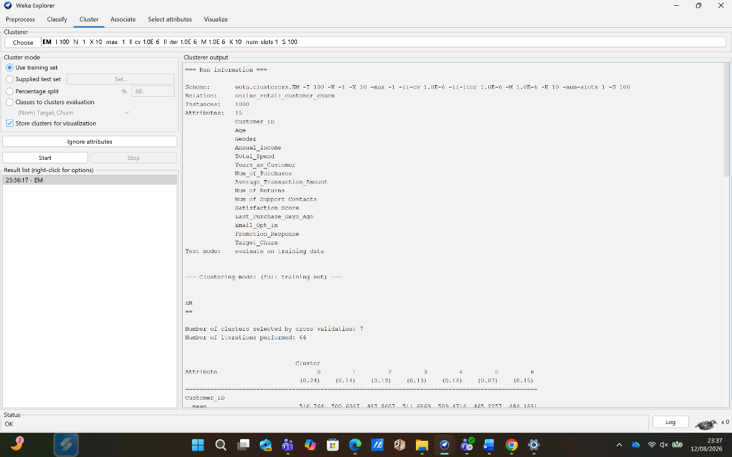
Appendix A. Weka EM Clustering Results
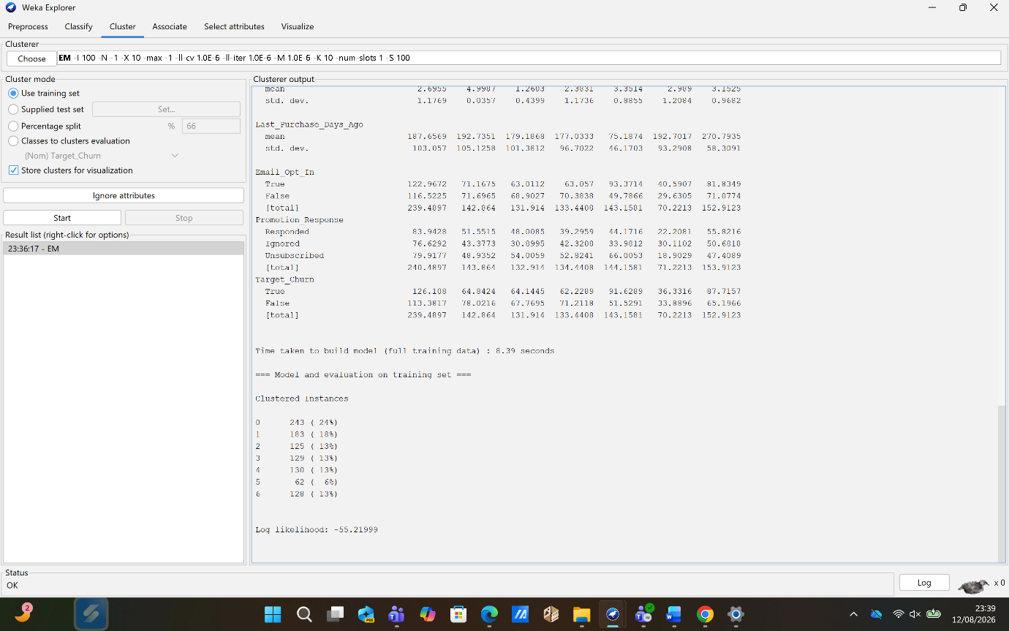

Appendix B. RandomForest Training-Set Results
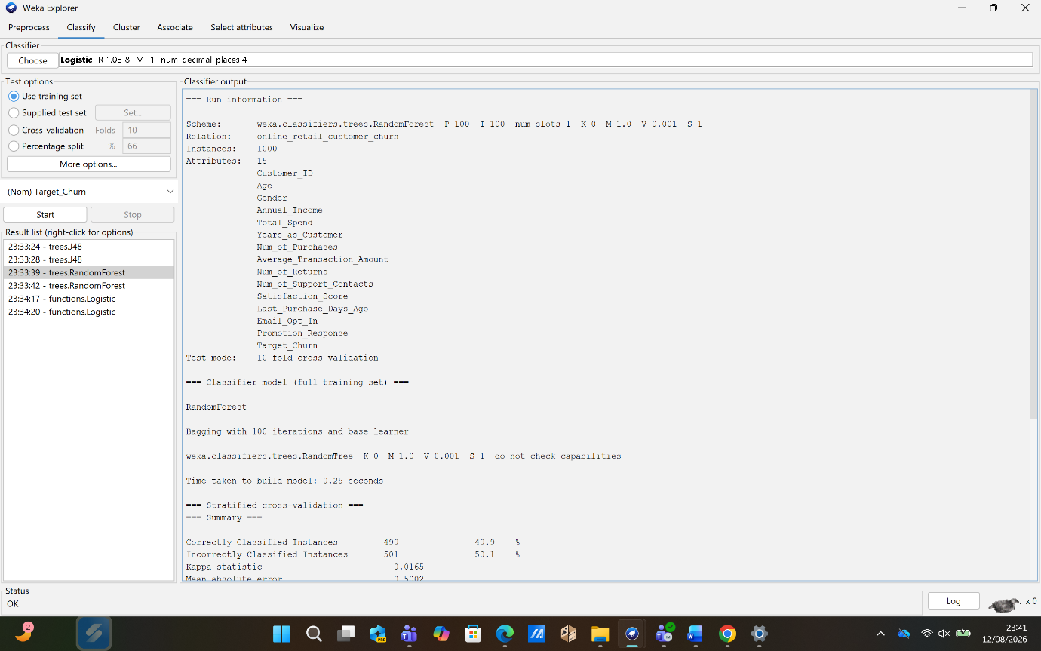
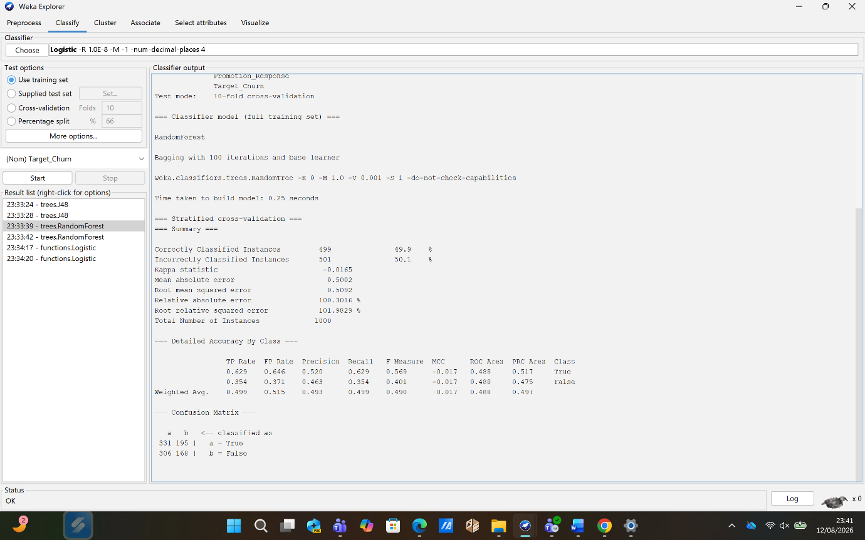

Appendix C. RandomForest 10-Fold Cross-Validation Results
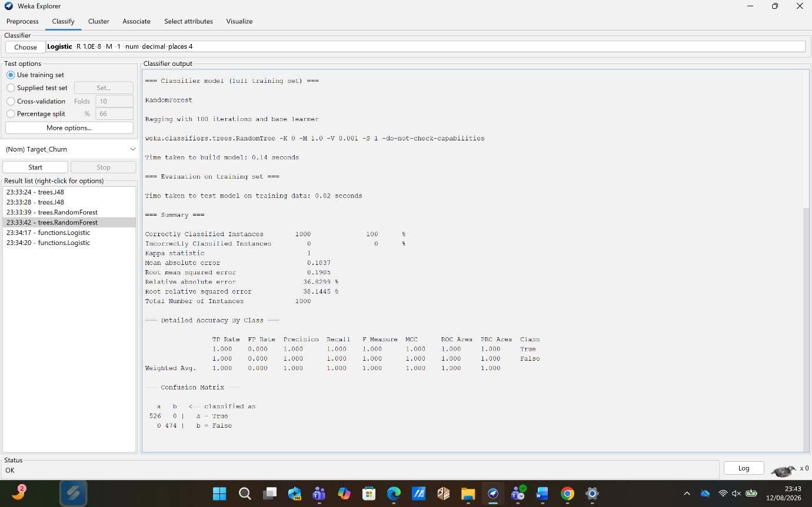
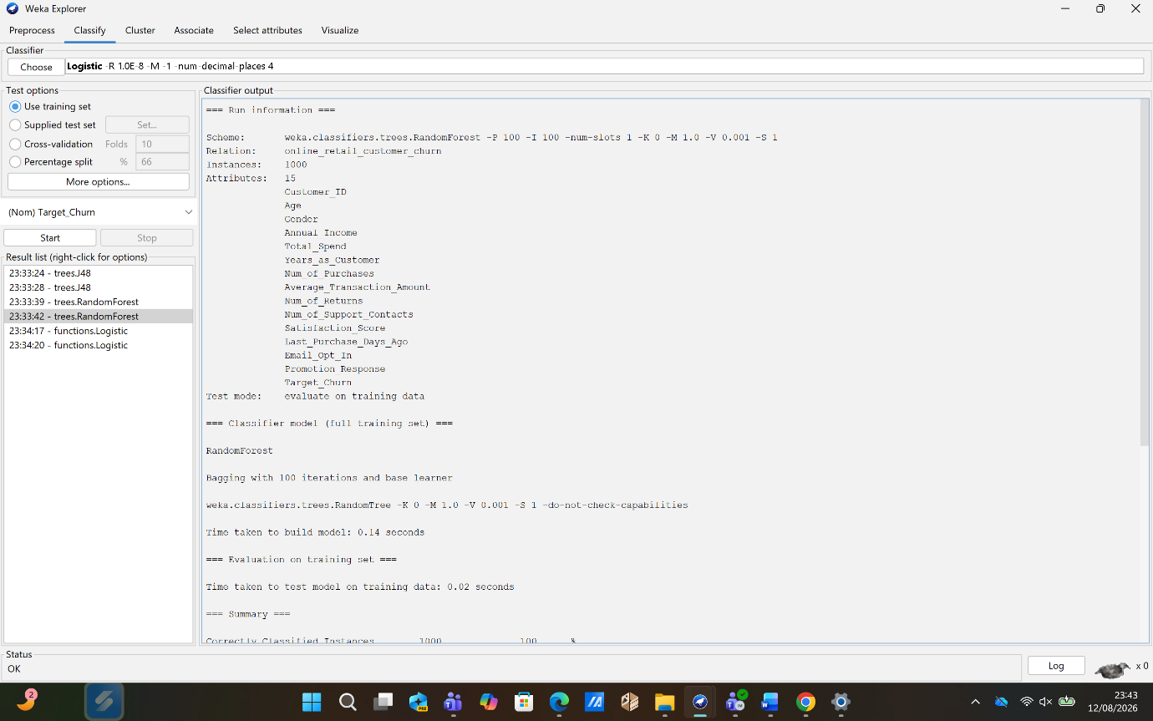

Appendix D. J48 (C4.5) Training-Set Results
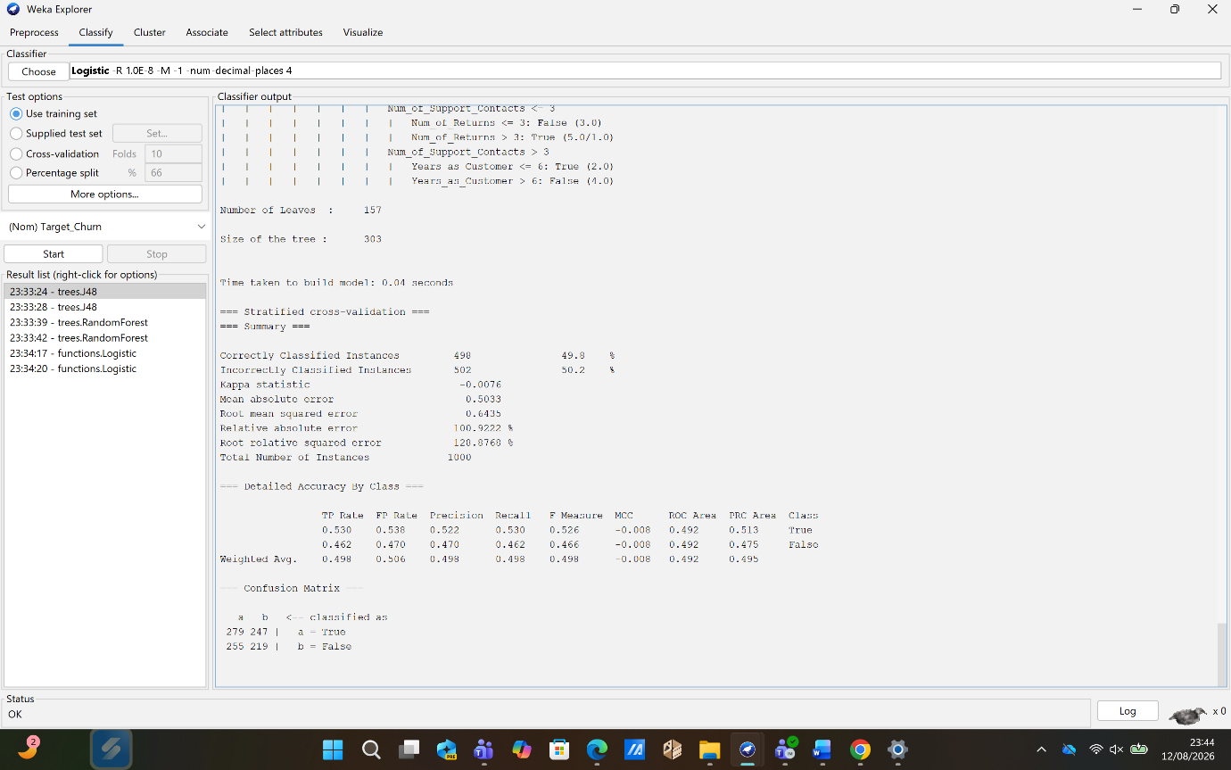

Appendix E. J48 (C4.5) 10-Fold Cross-Validation Results
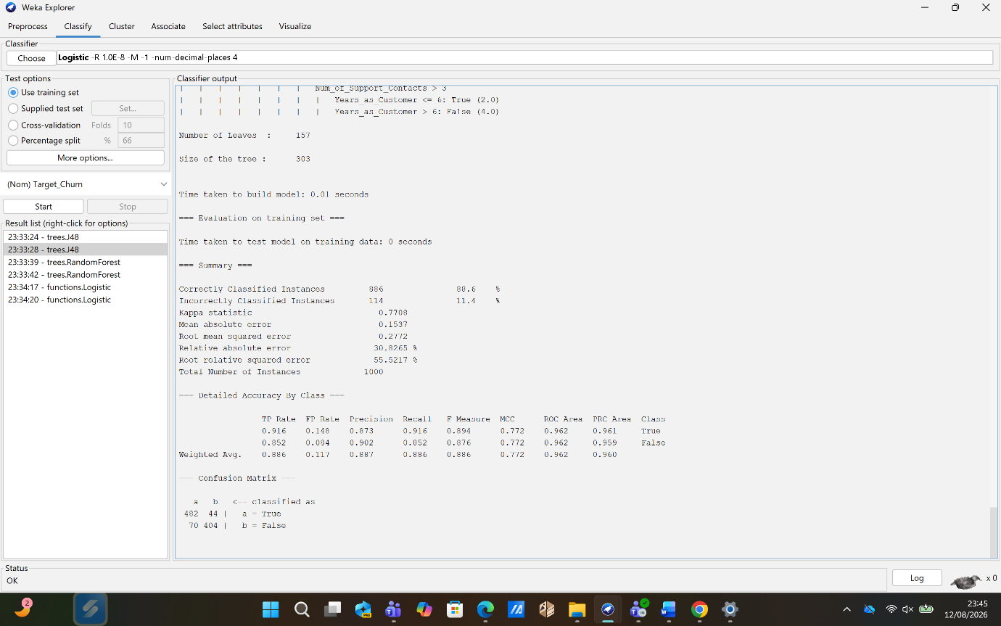

Appendix F. Logistic Regression Training-Set Results
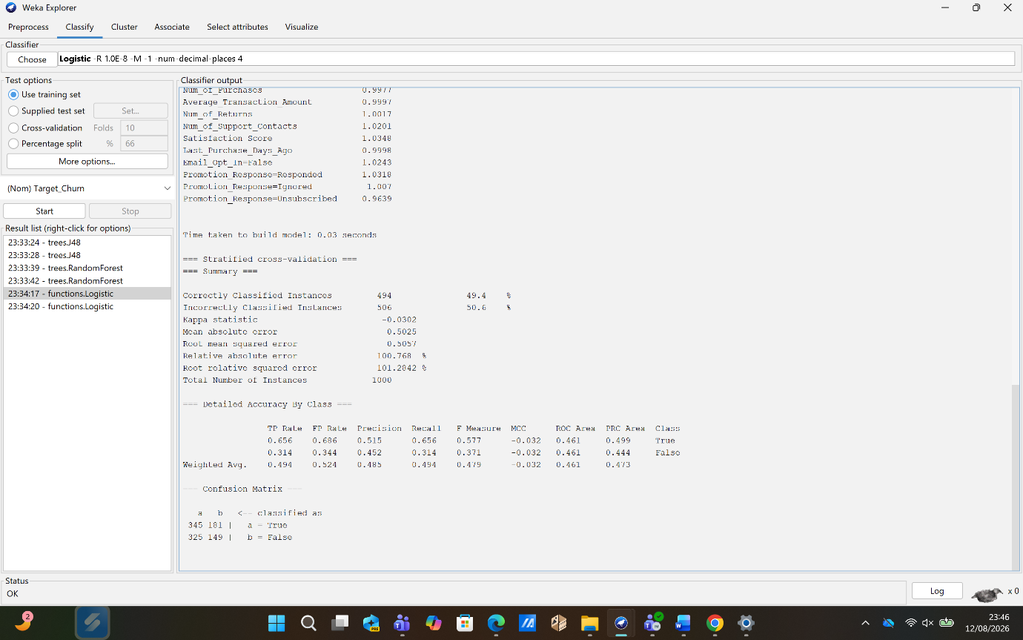

Appendix G. Logistic Regression 10-Fold Cross-Validation Results
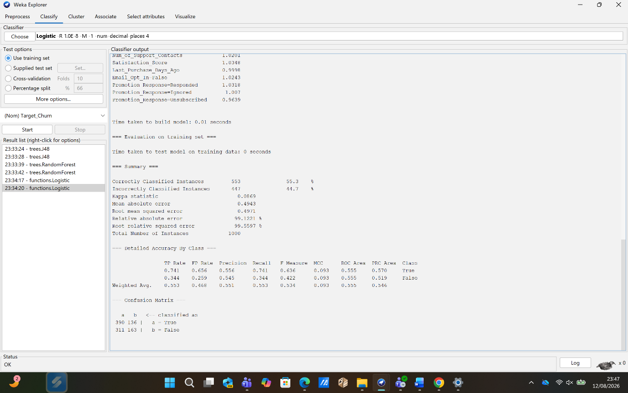
The screenshot below presents a sample of the original dataset as viewed in Excel, showing the raw data structure, attribute formats, and value ranges discussed in Section 1.2.

Appendix H. Source Dataset Sample in Excel


