Learning in the digital era – Assignment 1: E-Portfolio – Timothy David Edwards – 2004445 – BSc Computing (Software Engineering)

Contents
e-Portfolio 2
Task 1 3
Task 2 4
Task 3 5
Task 4 6

e-Portfolio
https://timedwards250.wixsite.com/2004445-assign1
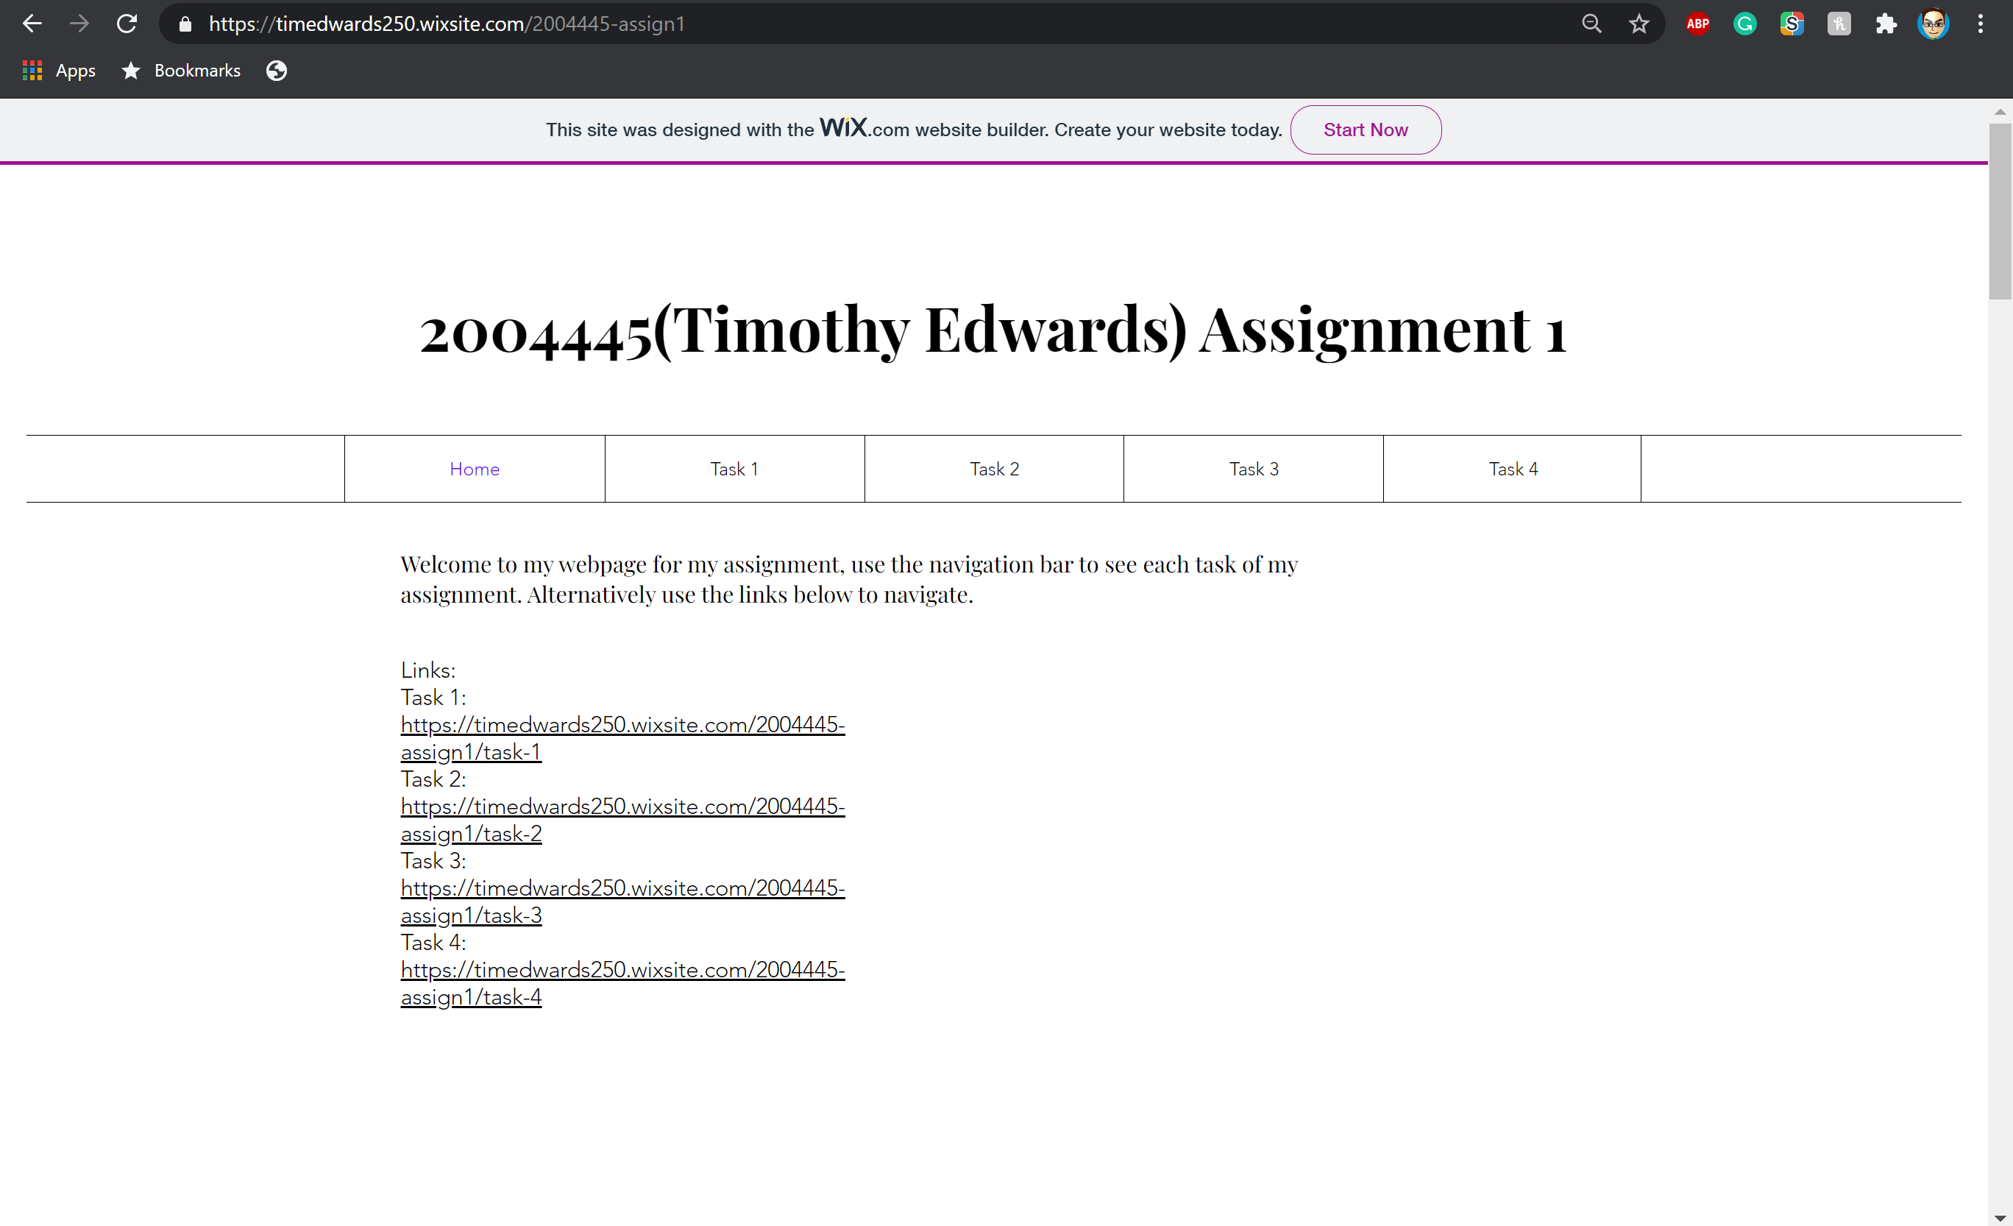

Task 1
https://timedwards250.wixsite.com/2004445-assign1/task-1
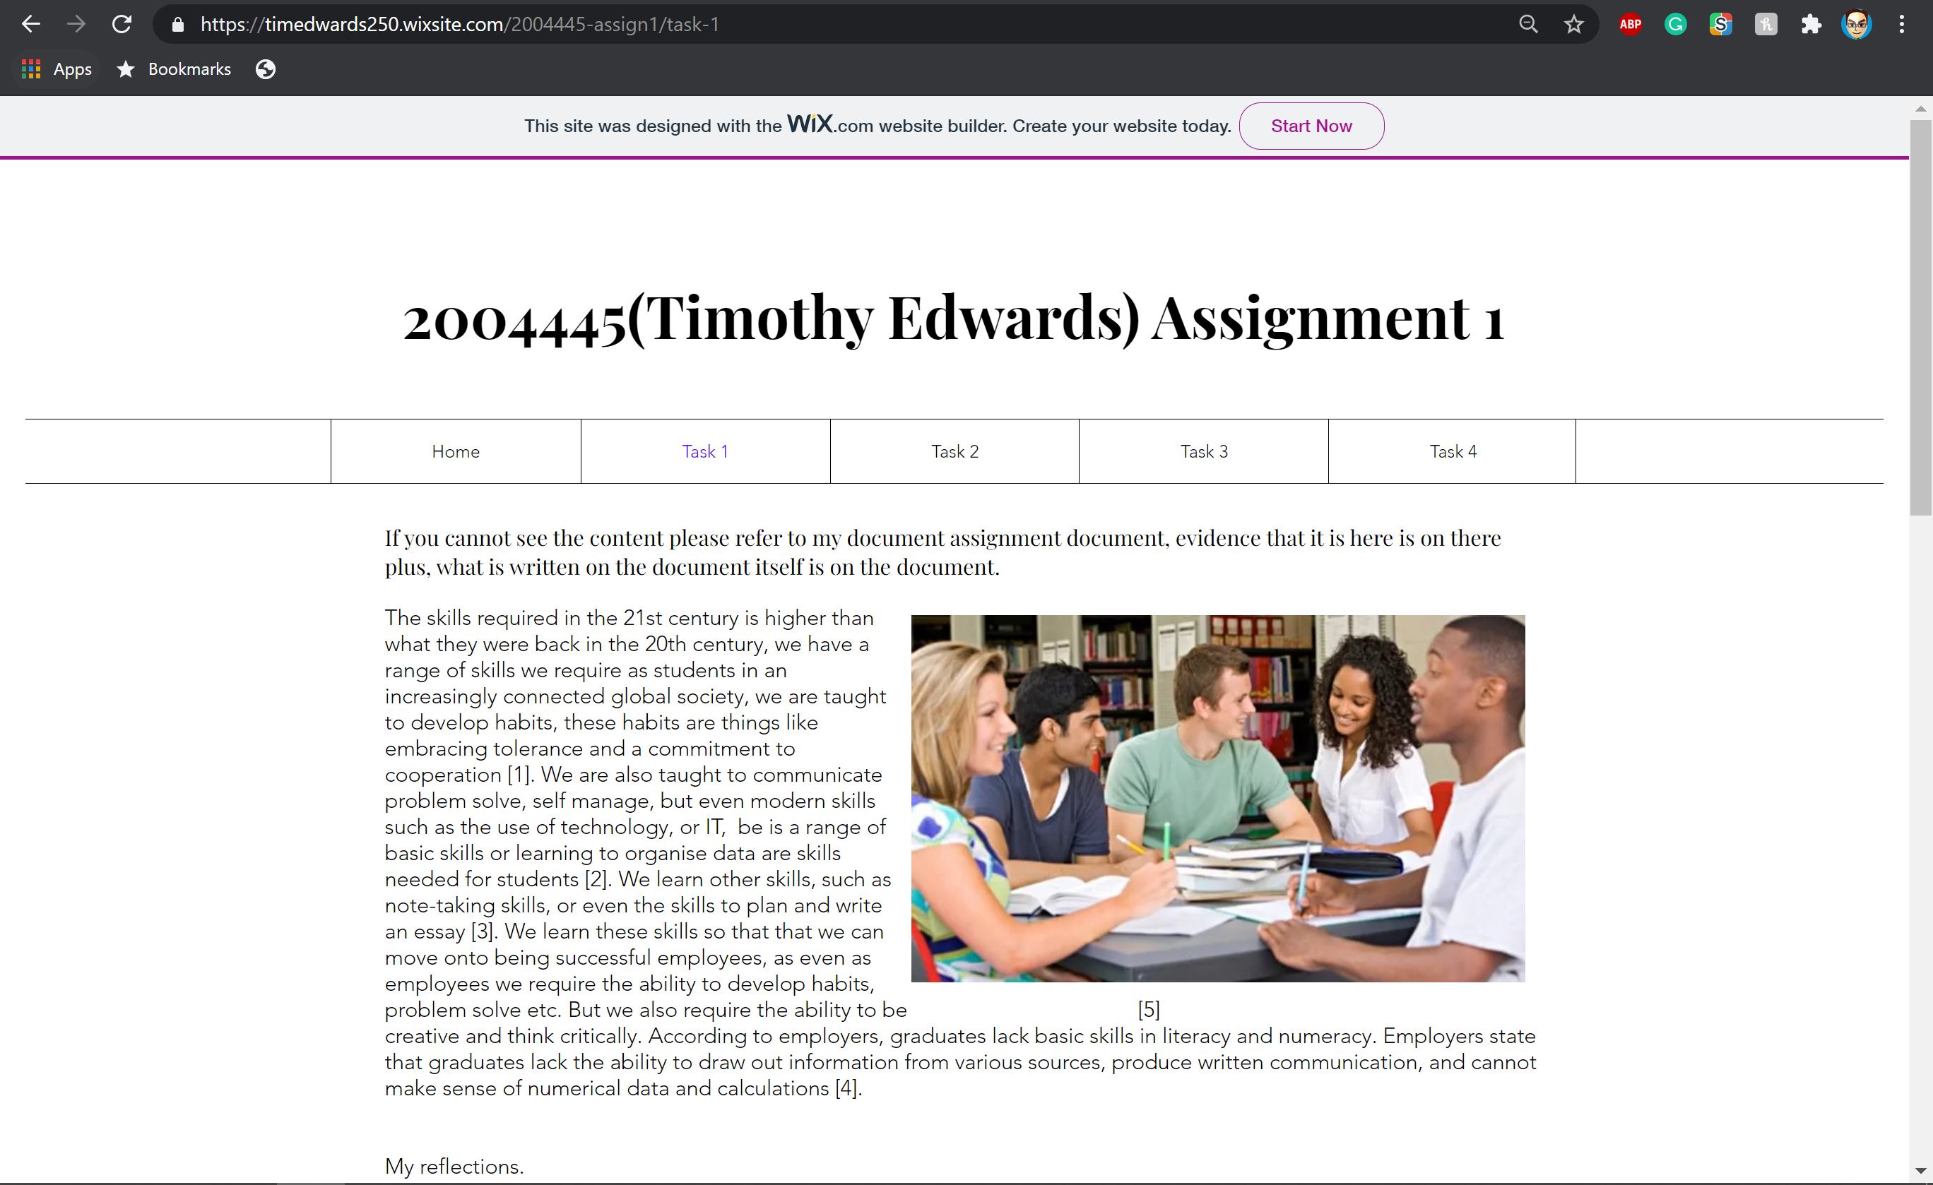
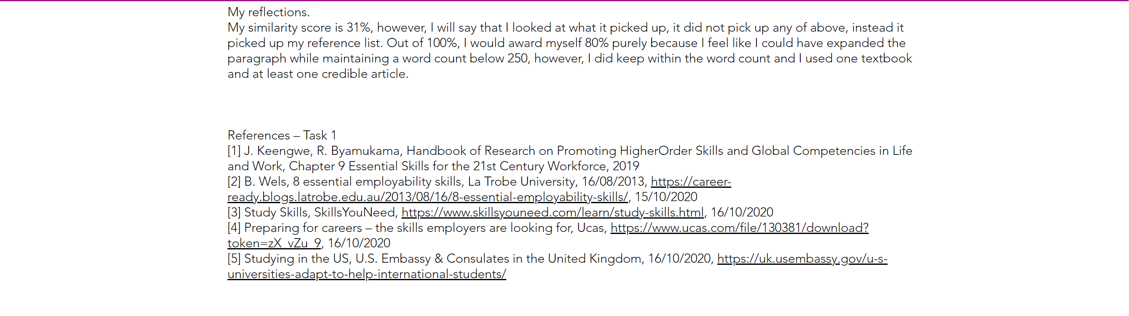

Task 2
https://timedwards250.wixsite.com/2004445-assign1/task-2
https://lucid.app/documents/embeddedchart/3650a96e-2be7-4eb6-ba2f-4de0ce962e2b
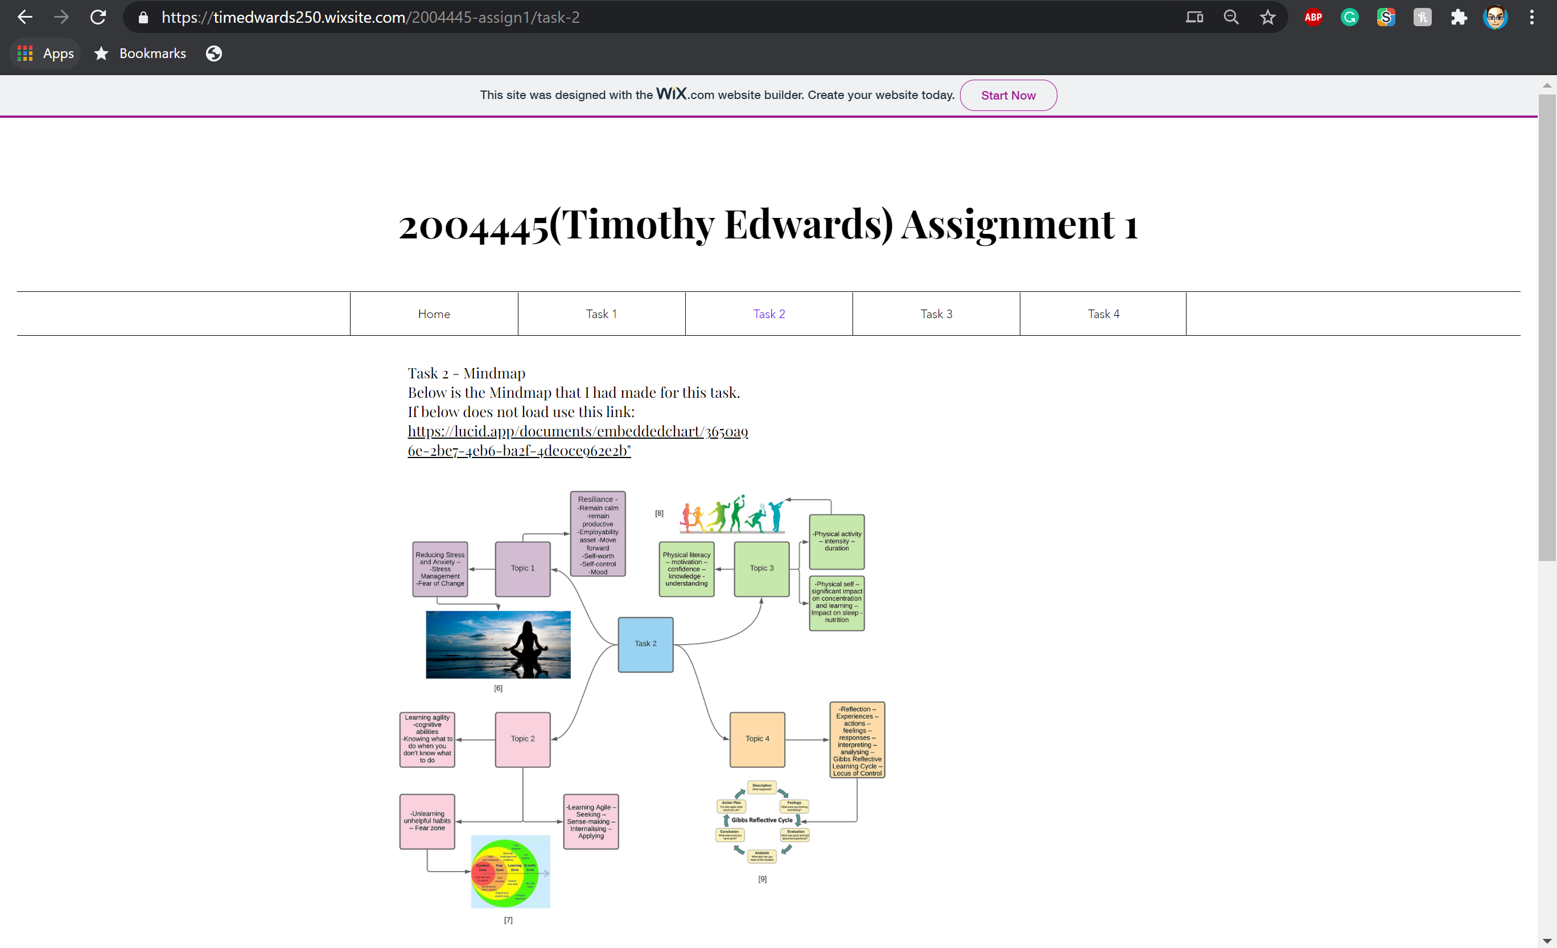


Task 3
https://timedwards250.wixsite.com/2004445-assign1/task-3
https://youtu.be/ymxyB78jvbM
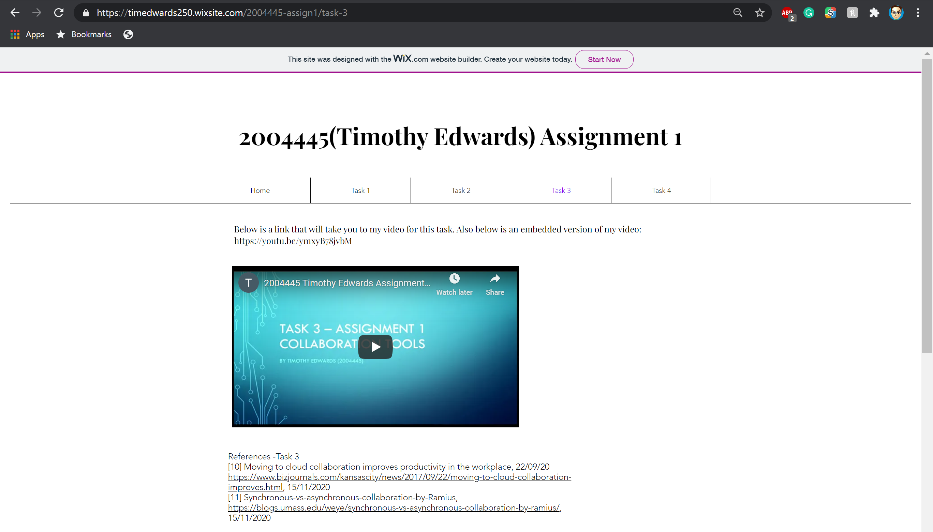

Task 4
https://timedwards250.wixsite.com/2004445-assign1/task-4
https://drive.google.com/file/d/1a4fK-N8QxzbA5Q1lOafRdj-KAA-4Nn1O/view?usp=sharing
https://spark.adobe.com/post/CdJ1xscCZ4QBG/


