

A Case Study of DHCW Onboarding and Training

by
Samantha John

Supervisor: Gaynor Thomas
Second Marker: Michael Dacey
Project submitted as part of the requirements for the award of
BSc (Hons) Computing (Software Engineering)

April 2023

DECLARATION FORM AND FORM OF CONSENT

DECLARATION

I, Samantha Jay John declare that I am the sole author of this Project; that all references cited have been consulted; that I have conducted all work of which this is a record, and that the finished work lies within the prescribed word limits.

This work has not previously been accepted as part of any other degree submission.

FORM OF CONSENT

I Samantha Jay John hereby consent that my Project, submitted in candidature for the B.Sc. (Hons) Computing Software Engineering degree, if successful, may be made available for inter-library loan or photocopying (subject to the law of copyright), and that the title and abstract may be made available to outside organisations.

Abstract

The development of a training and onboarding application for Digital Health and Care Wales Service Desk is intended to provide a comprehensive learning experience for both students and instructors as well as providing one web-based application to improve useability for those accessing training. The application will be built around a user-friendly interface that will enable instructors to create new training modules, access all training material from one central location as well as monitor students’ progress and knowledge retention. In turn this platform will also provide students with a central location in which to access information and training material and test their newly acquired knowledge using quiz questions and call logging scripts. It will also give them the opportunity to familiarise themselves with DHCW Service Desk processes and procedures. This platform is designed to enhance the learning experience of new employees and provide an efficient solution to collate training material relevant to the Service Desk.

The literature review, subsequent case study and constraints identified by Digital Health and Care Wales has highlighted that Visual Studio, ASP.Net framework and C# would be suitable technologies in which to create an onboarding and training platform that offers local user authentication using Microsoft SQL Server to store the users’ details.

From the case study review and information gathered from the Industrial Based Research project three pain points were identified that would later become the focus for the applications development. The first pain point was that the current process is spread across multiple platforms it often leads to lengthy searches for information. Therefore, one of the identified system requirements for the onboarding application was to create a centralised platform in which to house all the onboarding information. The second pain point was that there is a limited amount of quantifiable data available to assess the learner’s progression. To address this, learner quizzes will be integrated into the end of each module. The final pain point identified during the case study review was that the current training booking process is often a lengthy process that should ideally be integrated with the onboarding application and the process automated over time.

In conclusion, future work will need to focus on optimisation of some of the applications existing functionalities. Further work is also required to ensure that this application upholds the organisations data security requirements. A particular focus should be draw to password hashing, to limit the possibility of man in the middle attacks. Additionally, there is great potential to expand this applications functionality to include a reporting platform which will enable to Service Desk to introduce improvements to the training plan which are supported by quantifiable data.

Contents
DECLARATION FORM AND FORM OF CONSENT 2
Abstract 3
Chapter 1 6
Introduction 6
Chapter 2 8
Literature Review 8
2.1 DHCW Training and Onboarding Process Case Study 9
2.2 Comparative Case Study review of other training and learning management systems 15
2.3 Technologies 19
Chapter 3 26
Research Methodology and Development Methodologies 26
3.1 Research Methodologies 26
3.1.1 Findings 27
3.2 Recommendations 30
3.3 Development Methodologies 32
Chapter 4 36
Design, Implementation and Results 36
4.1 Design and Implementation 36
4.2 Results 45
Chapter 5 53
5.1 Conclusion 53
5.2 Future Work 54
Chapter 6 56
6.1 Reflection 56
References 58
Appendices 61
Appendix 0.1 Digital Health and Care Wales Onboarding and Training Application Phased Approach 61
Appendix 0.6 Project Gant Chart 64
Appendix 0.7 Iteration One 65
Appendix 0.7.1 Features 65
Appendix 0.7.3 End User Testing 65
Appendix 0.7.4 Interesting code 65
Appendix 0.8 Iteration Two 66
Appendix 0.8.1 Features 66
Appendix 0.8.2 Developer Testing 66
Appendix 0.8.4 Interesting code 66
Appendix 0.9 Iteration Three 66
Appendix 0.9.3 End User Testing 66
Appendix 0.9.4 Interesting code 67

Chapter 1

Introduction
Digital Health and Care Wales Service Desk provides first line information technology support to 1588 National Health Service users across Wales, employing over 60 Service Desk staff. Each new employees that joins the service desk must undergo training in order to equip them with the technical skills needed to resolve incidents and requests reported to the Service Desk. The training currently integrates staff orientation with technical training which is covered over a six-week period. However, the current process used by the service desk utilises a number of different systems in which to deliver and track employee training. The project is intended to develop a comprehensive training application that could be utilised by Digital Health and Care Wales Information Technology Service Desk during the onboarding of new employees. An initial research project was conducted into the merits of creating such an application for use by the service desk, this project also attempted to identify potential system requirements through the use of a questionnaire and individual interviews with key memebers of the training team. The initial project identified that there is a desire to develop one solution that is capable of housing all of the essential elements of the current onboarding process such as a training session booking system, a competency matrix used to measure understanding and knowledge retention as well as a centralised location to access training material such as presentations and training videos [1].

Aim
- To create a training and onboarding application for use by DHCW Service Desk during the onboarding and training of new starters.
Objectives
- To critically analyse the current DHCW training and onboarding process.
- To compare other learning management systems, training platforms currently in use
- Identify a suitable development methodology for the project
- Identify a suitable software suite in which to develop the project.
- Identify a suitable language in which to develop the project.
- Develop the platform.
- Test the platform and gain feedback from peers and end users.

Organisation of the paper: The remainder of the paper is organised as follows. Chapter 2 which looks to identify a range of suitable development platforms and programming languages that could be used to develop the DHCW Onboarding Training platform. This chapter will also take a detailed look into the current DHCW Onboarding and training platforms comparing it to other learning management platforms. Chapter 3 will describe the research mythologies used to establish the system requirements and discuss the reasoning for the choosen development methodologies, providing justification for their use in this project. Chapter 4 Will describe the design and implementation steps taken in this project and the results from the developer and end-user testing. Chapter 5 will provide an overall conclusion of the project and Chapter 6 will provide a personal reflection of the project.

Chapter 2

Literature Review

In order to conduct a systemic literature review for this project a case study method was adopted. A case study is defined by Yin as a way to explain, explore and describe phenomenon that occur in everyday, within the context they occur [2, Vol. 5]. The case study will focus on the current process adopted by Digital Health and Care Wales Service Desk for their onboarding and training process as well as a review of current learning management systems and training portals offered by other organisations. The literature review will also consider the available technologies and programming languages that could be utilised for the development of a training and onboarding platform. Any supporting literature used for the review will consist of peer reviewed articles, white papers, books, peer reviewed dissertation papers and conference and journal papers. The reasoning for the chosen literature types was to ensure the contents reliability and credibility. In some instances where content or statistical figures were lacking from the prior mentioned sources, credible online material were used. In order to ensure that a wide variety of sources and content were available for this review, a time period of 8 years was set for the content, which included a date range from 2016 to 2023, material outside of this date range were discounted. Additionally, only articles published or available in English were considered.

2.1 DHCW Training and Onboarding Process Case Study

DHCW Service Desk currently enrols each new employee into its onboarding and training process. This process begins shortly before the start date and ends after each module has been covered and a period of observation has occurred. At present, the training is delivered in a hybrid manner, involving a combination of virtual sessions via Microsoft Teams and face-to-face sessions, aligning with the organisations hybrid ways of working.


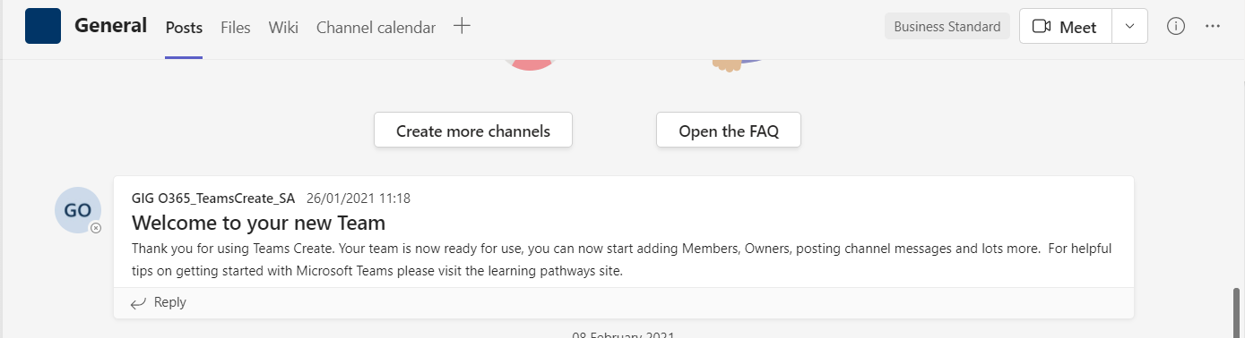
Figure Microsoft Team Onboarding Channel
Source 1 Adapted from Digital Health and Care Wales Service Desk

Presently the Service Desk uses Microsoft SharePoint as a repository for important documentation and links to essential forms, which new employees are required to complete in the initial weeks of employment.
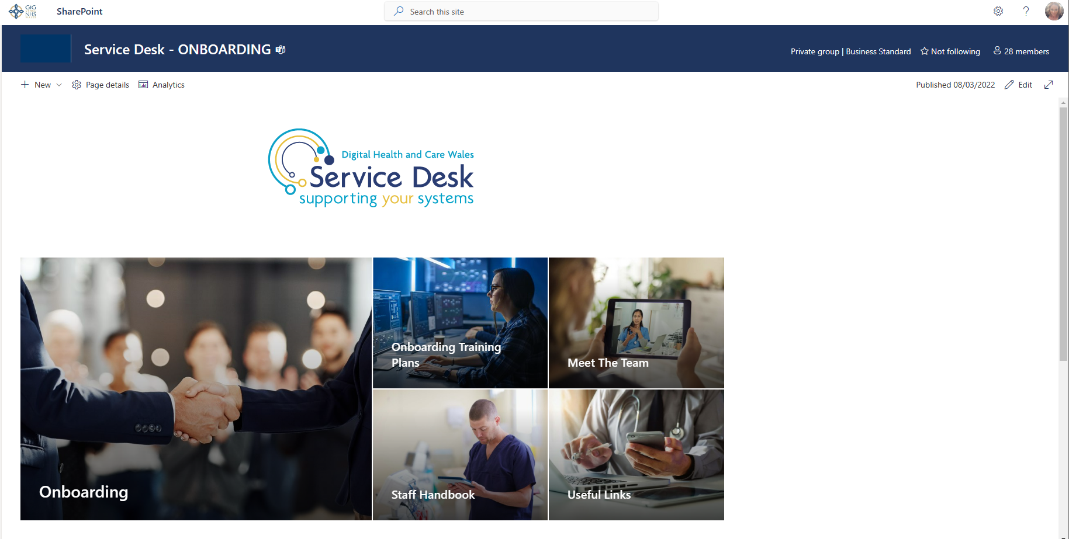
Figure 1 SharePoint onboarding site
Source 2 Digital Health and Care Wales Service Desk

This section of the site is accessible to all staff involved in the onboarding of new staff.

The presentation materials utilised during the onboarding process are currently stored within the Service Desk Knowledge Centre.

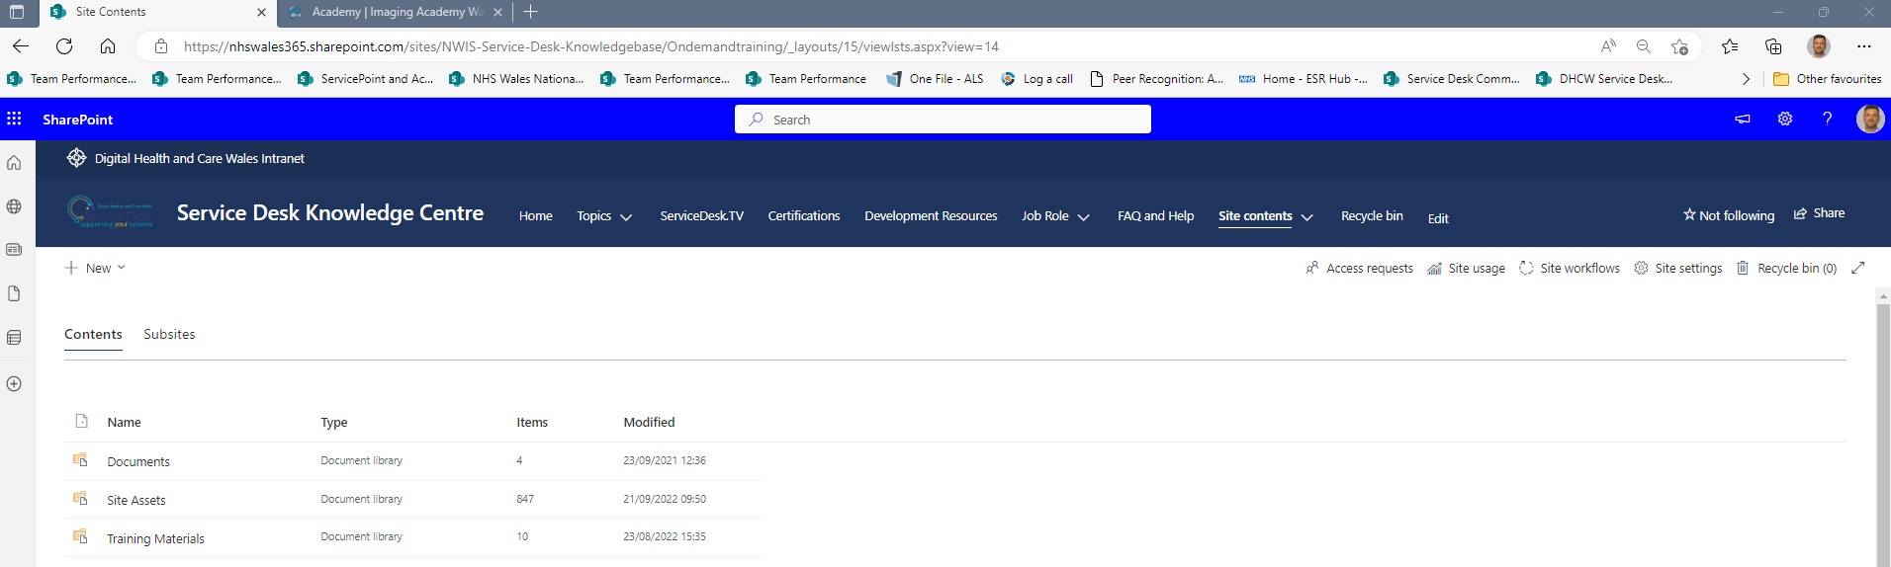
Figure 2 Knowledge Centre training material folder
Source 3 Digital Health and Care Wales Service Desk
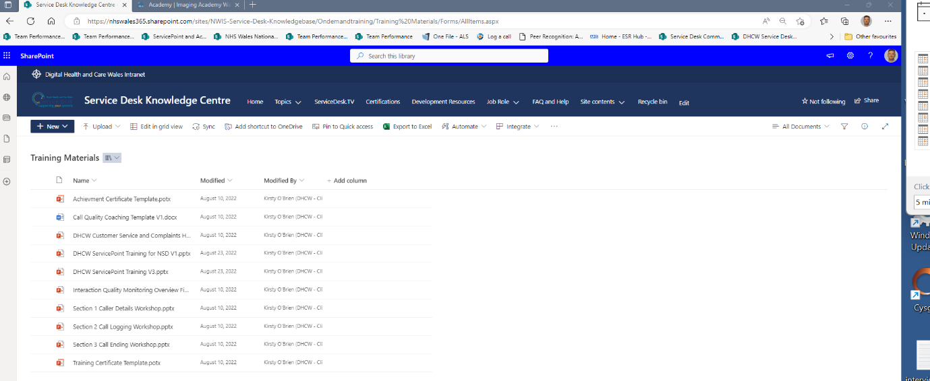
Figure 3 Knowledge Centre training material
Source 4 Digital Health and Care Wales Service Desk

The Service Desk has established a comprehensive Knowledgebase Centre that can be accessed by all staff operating within the Service Desk. The knowledgebase incorporates an extensive range of guidance documents, which staff can use to assist users. During the onboarding process, several guidance documents, videos and service-related information articles are shared with the new employee. Relevant article numbers are stored within Microsoft Planner and the Uniformed Resource Locators (URL) for each document are shared by the instructor via Microsoft Teams chats.

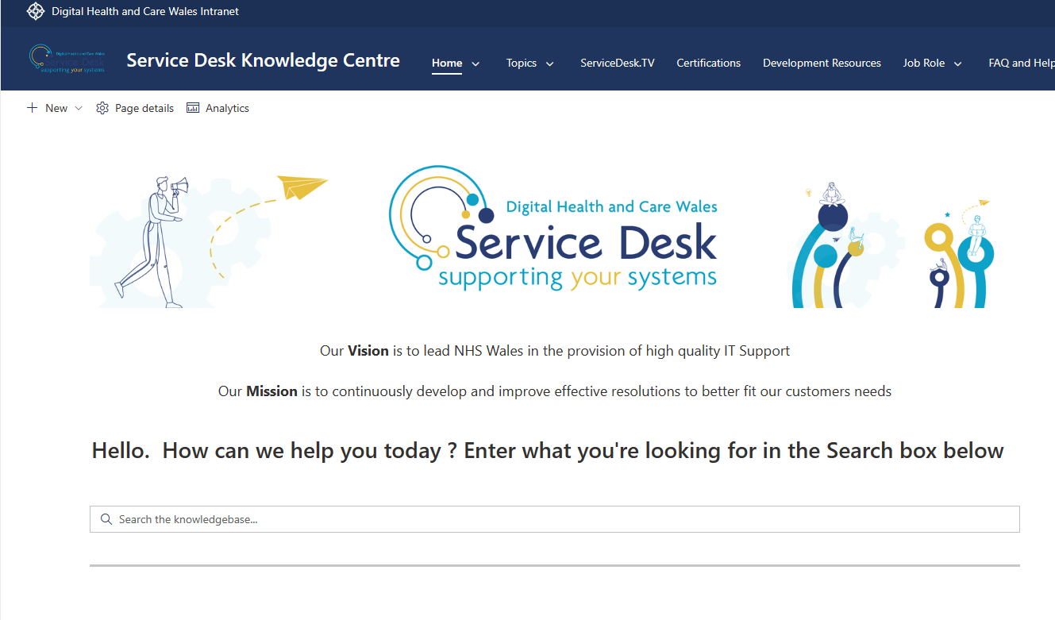
Figure 4 Knowledgebase Centre
Source 5 Digital Health and Care Wales Service Desk

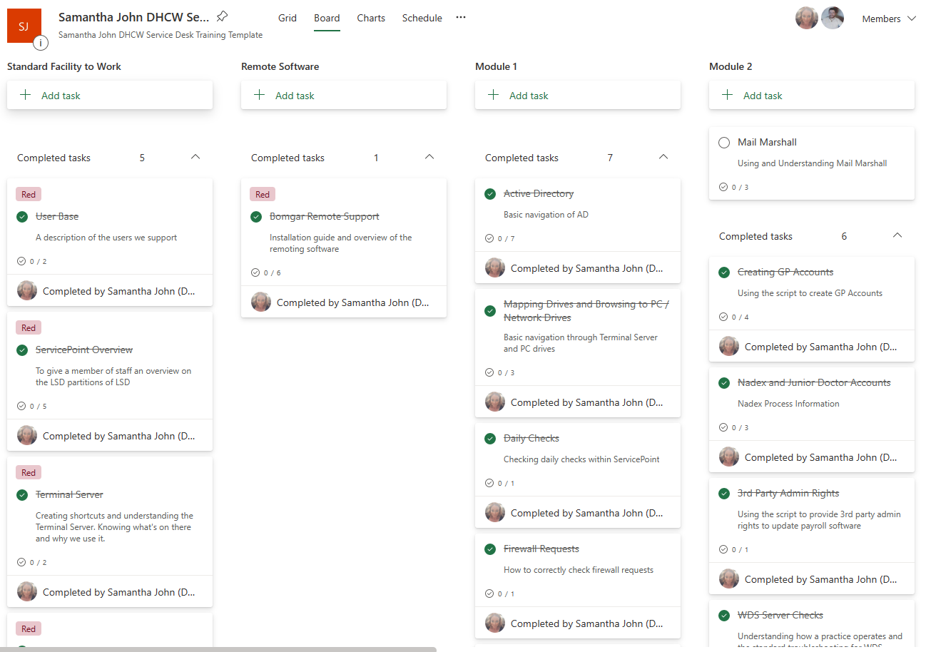
Figure 5 Microsoft Planner
Source 6 Digital Health and Care Wales Service Desk

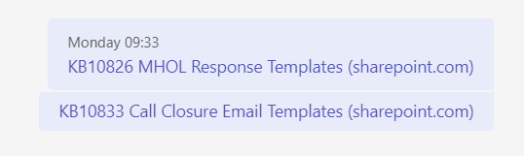
Figure 6 Microsoft Teams chat sharing KB articles.
Source 7 Digital Health and Care Wales Service Desk

Presently, training sessions are currently scheduled using a specialised Microsoft Outlook calendar designed specifically for the onboarding of new staff.

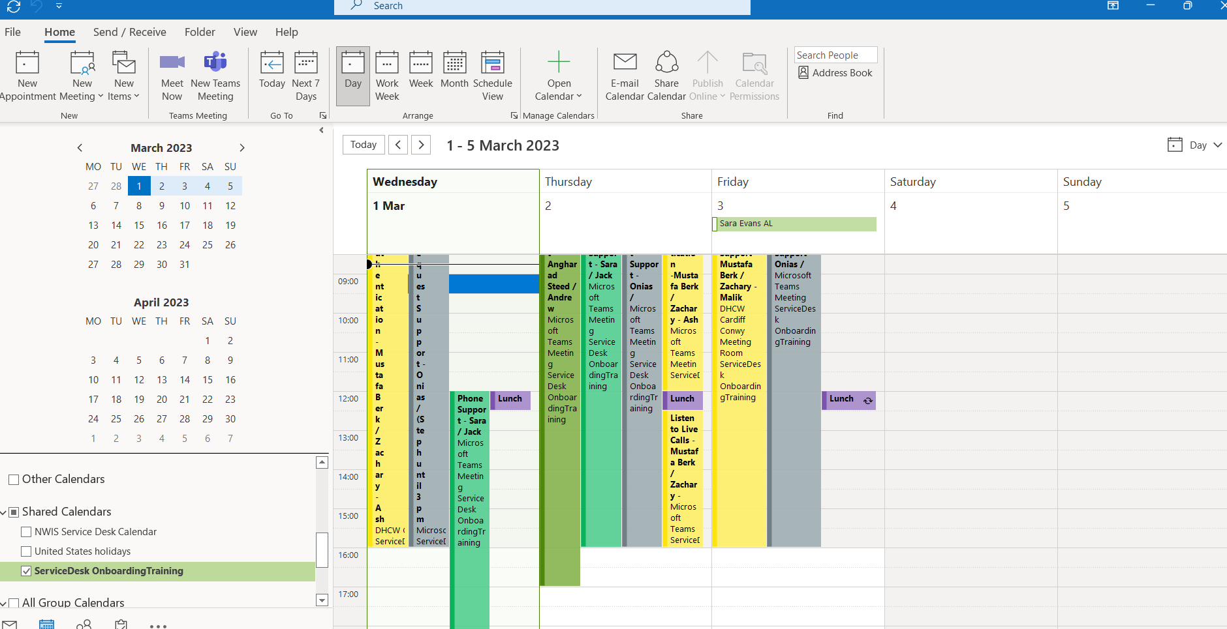
Figure 7 Onboarding training planner and outlook calendar
Source 8 Digital Health and Care Wales Service Desk

The calendar is accessible to all instructors participating in the onboarding of new staff. Those that have access to the calendar possess the capability to edit and generate training slots within the calendar.

A detailed onboarding process is available through the Service Desk SharePoint Onboarding site. This process documents the current steps taken when onboarding new staff to the service desk.

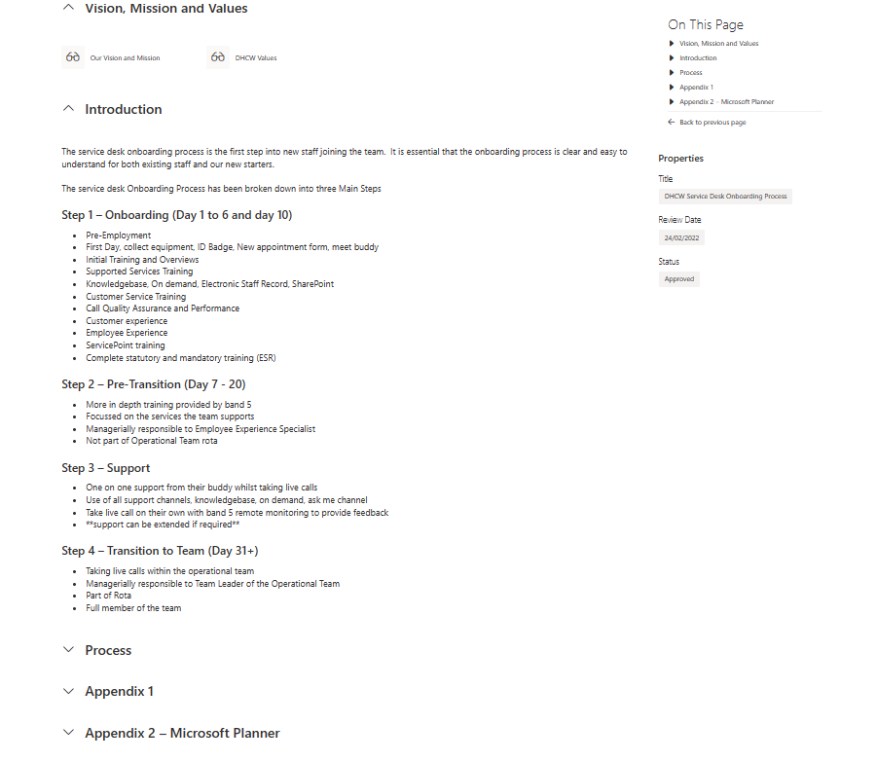
Figure 8 Onboarding process
Source 9 Digital Health and Care Wales Service Desk

2.2 Comparative Case Study review of other training and learning management systems

To perform a comprehensive evaluation of the current training and learning applications used by DHCW an extensive search of comparable platforms was conducted utilising the internet as the primary source. The remainder of this section will analysis the Celtic Leisure Course Progress Swimming application[3].

The aforementioned application was developed by Fitronics, a company known for producing an array of software related to the health and fitness industry [4]. While this application does not provide online training, it does utilise a centralised platform for monitoring the progress against identified criteria.

This application is accessible on both a mobile and tablet device, comprises of an initial log in screen.

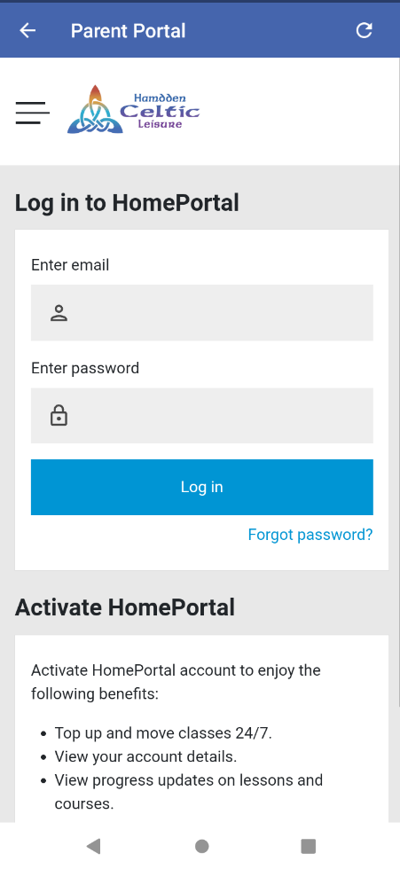

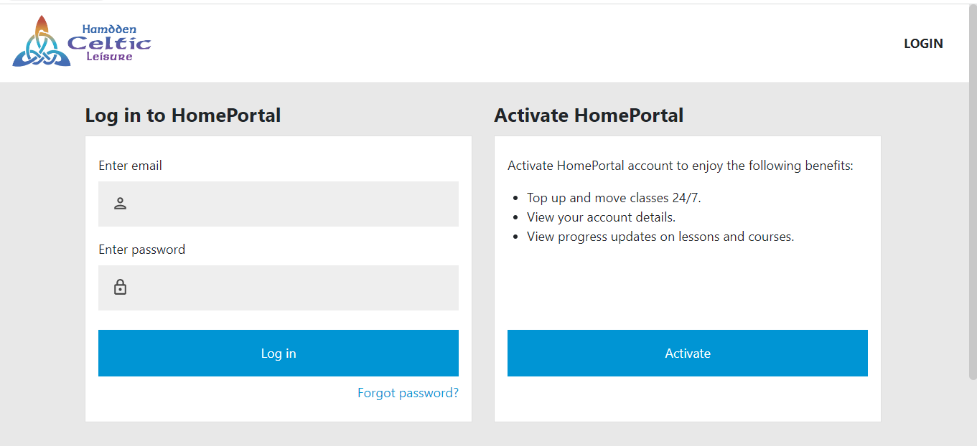
Figure 9 Celtic Leisure Parent Portal Login screen for mobile and tablet devices
Once valid credentials have been entered users are presented with a Home screen. At this point students can see their details as well as their current progress within the class. Competency levels are represented with percentage bars and circular pie charts, with the level of completeness being represented in a darker colour.

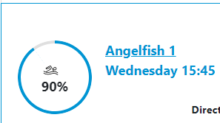
Figure 10 Competency wheel which represents overall competency

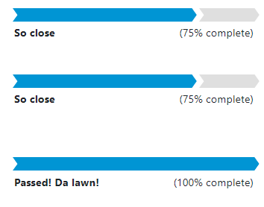
Figure 11 Competency bars which represent individual competencies

The application allows the student to view what competencies they are required to meet in order to progress to the next level. Each competency identifies what observations the instructor needs to observe and on how many occasions before the student is seen as competent. This demonstrates that each competency has a performance indicator in which a student’s competency can be measured.

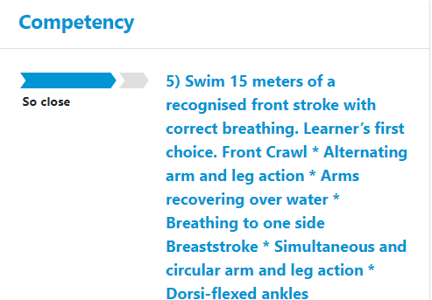
Figure 12 Competency with the advised criteria of assessment
Students are also able to see past course history and access the competency matrix for each of the past courses.

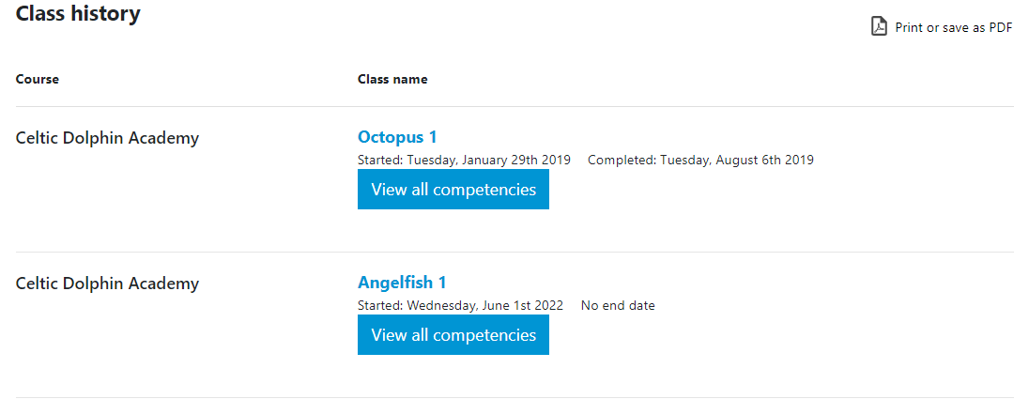
Figure 13 Students class history view

Through the student portal, learners can also access past achievements which is represented in the form of swimming badges in this example.

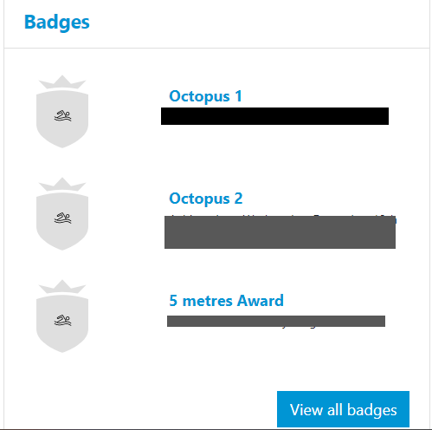
Figure 14 Past achievement view in the form of badges
Source for figures 10 to 15 [3]

To summarise there are a plethora of IDE’s, accompanying web frameworks and programming languages available to developers in the development of web-based applications, each offering a wealth of benefits. However, popular IDE’s such as those discussed in this paper have some similarities such as intelesense code completion and compiler error detection. Similarly, many of the web frameworks discussed in this report offer developers a structured way in which to house the code files. The decision of which IDE and web framework to use in the development of web applications will ultimately come down to constraints such as the developer’s familiarity with these technologies as well as organisation level constraints such as funding and access.

Furthermore, from the case study review of the DHCW Service Desk Onboarding systems several end user pain points have been identified, these pain points will be given further consideration during the requirements and implementation phase of this project. Additionally, the study of Celtic Leisure swimming portal has identified that it is possible to create a competency matrix in which to monitor a students progress through the onboarding and training process, however careful consideration should be given to identify what constitutes as a competency and how that competency can be measured. The comparative study has also highlighted that the proposed DHCW onboarding application could potentially provide their extensive student dashboard which allows the learner to see their progress through there onboarding process and what is expected of them for the duration of the training program.

2.3 Technologies

2.3.1 Development environments

An Integrated Development Environment (IDE) is a software application that provides facilities in which to develop applications. It generally comprises of a code editor, building platform as well as testing elements. Platforms such as this enable developers to create programmes efficiently, providing a structured view for projects through the use of classes and frameworks. Although web-based application projects can be developed in simple source code editors such as notepad++, IDE tools provide developers with a structured way to store multiple project files as well as the ability to compile solutions whilst offering a wide variety of additional plugins, add-on features and web-based frameworks. Additionally, integrated development environments enable teams of developers to work collaboratively on projects through shared file repository. IDE’s also offer an aesthetically pleasing General User Interface in which to work with[5, p. 9].

There are a wide range of IDE’s available to developers. These include various options such as Apache NetBeans, Adobe Flash Builder, Eclipse and Microsoft’s Visual Studio are amongst the most frequently used environments. In the coming section, a comprehensive overview of each of these tools will be presented, whilst identifying each tools strengths and weaknesses.

NetBeans was released as an open-source project in 2000 and was later donated to Apache, becoming known as Apache NetBeans. NetBeans offers developers a wide range of web-based frameworks such as JavaServers, Spring, Struts and Hibernate. It was originally developed to focus on Java languages however, like many of the other IDE platforms it also supports other languages such as C++, PHP as well as HTML and CSS. It has been noted that NetBeans is a mature and powerful IDE, which offers developers the ability to develop, preview, and debug applications easily [6, pp. 17–35]. It provides a highly intuitive development environment for programmers, facilitated by its built-in capabilities including real-time error detection, intelligent code completion to assist the programmer, and the provision of helpful hints and tips to correct and improve code [7]. Another useful feature within the NetBeans platform is the profiler, which facilities the programmer in conducting an in-depth analysis of the CPU and memory utilisation and its capacity to identify memory leaks [7]. However, a potential disadvantage of NetBeans is its comparatively limited selection of plugins in comparison to alternative IDE platforms, such as Eclipse [7].

Eclipse was first launched in 2001 by IBM and like many of the IDE platforms is an open-source programme which predominantly focuses on developing in Java languages. However, programming languages can be extended using plugins and extensions [8]. This IDE offers the added advantage of cross-platform compatibility. It functions in a diverse array of operating systems including Linux, Windows, MacOS and Solaris. Eclipses also offers an extensive plug-in library, with more than 1,600 solutions, 200 application development frameworks and over 100 programming languages, thus providing it with unparalleled versatility[7]. However, despite the extensive range of solutions offered by Eclipse it is documented that some of these solutions do not function as intended and can potentially cause frustration among developers[7]. Like NetBeans the Eclipse environment provides users with an incremental compiler, which enables the developer to identify errors within the code as they are typed. However, every time a new file is loaded, or changes are made to the code, it can slow down the performance of the programe due to increased workload and overheads. Conversely, Eclipse provides numerous exceptional content assistance features, most notably the code completion and recommendation features, which improve efficiency and minimises errors[8][7]. Furthermore, an added advantage of Eclipse is that it is supported by a non-profit foundation that guides the development of the software[9].

Adobe Flash Builder was originally developed by Macromedia and later secured by Adobe Systems in 2005. It utilises ActionScript programming language, which is again an object orientated programming language. During its lifecycle, Adobe Flash Builder has been successfully utilised by a wide range of industry leaders such as Honda’s customise motorbike website [6, pp. 17–35]. However, due to the continued maturity of HyperText Mark Up Language over recent years there has been a decline in Flash Builders popularity and as a result Adobe announced that support for Flash Builder would end in December 2020 [10].

The final IDE for discussion within this literature review is Visual Studio. This IDE provides extensive features that enable developers to edit, debugged, and published solutions with relative ease. It offers many of the features the other IDE tool offer such as a code compiler, as well as extensive intelisense features such as auto code completion. Additionally, it offers an extensive variety of built-in programming languages such as JavaScript, Node.JS and offers extension languages such as C++, C#, Java, Python and .NET. In a recent survey published by GitHub that utilised Google Trends data to establish which IDEs were downloaded the most, Visual Studio was identified as the most searched and downloaded of the IDE’s available, which suggests it’s continued popularity among developers [11]. It provides a wealth of advantages most notably is its licencing cost or lack of. Offering three levels of licence from professional, enterprise and community, the later having no associated licencing costs. Another advantage of visual studio is its ability to integrate with a variety of Microsoft technologies such as Azure and Microsoft SQL Server, which is particular advantageous for a project such as the DHCW onboarding platform which will utilised a database to store course and actor data. However, despite these advantages there are also some associated disadvantages with visual studio. One such disadvantage is its limited cross platform capabilities, primarily designed for Windows based development however, it lacks support for development within Linux. In 2017 Visual Studio released a MacOs version. Another disadvantage of this IDE is that despite it expansive features it can be daunting for a new user to grasp how to use many of the tools and features offered by Visual Studio.

2.3.2 Web Frameworks

In the past, web-based applications were often coded manually resulting in numerous errors and extended development timeframes. With the emergency of web frameworks such as Angular, Ruby on Rails and ASP.Net in the early 21st century, many of these challenges have been overcome[12, p. 12114].

Utilising a web framework for web-based application development offers a whole host of advantages. Aside from the error detection and production time mentioned previously, one other advantage of using a web framework is that it offers the developer a pre-defined codebase and guidelines to ensure seamless web development. Additionally, many web frameworks provide developers with a predefined folder structure that ensure project files are organised in a logical way [13]. There are two forms of web framework, the first focuses on front-end development and the second focuses on server-side development, the following section will discuss some of the more popular server-side development web frameworks.

Ruby on Rails framework is a dynamic server-side, object-oriented programming language used in the development of web-based applications. First established in August 2004, developed by David Heinemeier Hanson, it has reportedly become a popular, standardised tool amongst Agile developers for the development of web-applications. This framework follows the Model View Controller design, separating the application into a model view, business logic and a controller view. The model view is designed to handle the database side, whereas the business logic view is designed to handle the web pages such as HTML with greater focuses on the general user interface and presentation of the application. The final view, the controller view acts as the connector between the application front-end and database back-end [14, No. 9]. RoR offers developers many advantages such as its structured code writing, developers can take advantage of preconfigured file structures, which significantly reduces the application set up timeframe. RoR also supports a variety of operating systems such as Windows, Linus and MacOS, this cross-platform compatibility is likely one of the key driving factors in it’s continued popularity.

Another web framework that can be utilised in the development of web-based applications is Angular. This web framework is an open-source front-end framework which was developed by Google in 2016. There is a great deal of documentation that suggests that Angular is well suited to larger applications that consist of single pages, which lends itself to exceptionally fast load times which utilise less bandwidth proving useful for poor network availability [15]. Like many of the other frameworks Angular offers the ability to create cross-platform applications such as MacOS, Windows and Linux [16, pp. 1–3]. Additionally, much like RoR, Angular adopts MVC however, it only does so in part, by having a controller in the form of a container and a view in the form of a template. The advantage of adopting a structured project such as this makes the project logic easier to understand. One of the core benefits that Angular framework offers is reusability of code, using @Input, @Output properties and the EventEmitter() components are reusable [16, pp. 1–3]. Another documented benefit is the introduction of the Router Module Angular which splits the code segments thereby improving the performance [16, pp. 1–3].

The final web framework that will be discussed in this section of the report is ASP.Net which is a Windows specific web application framework, which is used to build dynamic server-side applications [13]. One of the greatest advantages that is afforded by the ASP.Net framework is that it provides developers with a structured way in which to develop a web application which reduces the amount of code that needs to be written by the developer as much of the code is pre-supplied thereby reducing the development timeframe. Additionally, ASP.Net allows you to build dynamic web applications that can make use of secure features such as user login and authentication. It also offers language independence, whereby a wide variety of programming languages can be utilised such as C# and Java Script as well as fully supporting Cascade Style Sheets and Hyper Text Mark-up Language [13].

2.3.3 Programming languages

With the utilisation of an IDE a project can be created using a web-application framework this gives access to both back-end programming languages such as Java, C# and C++ as well as server-side programming languages such as JavaScript, React and VueJS. The following section will provide context to some of the back-end programming languages available within the aforementioned IDE’s and web frameworks.

Each of the languages described in this section are object-orientated based languages, which as the name suggests focuses on the creation of objects. Due to the object orientated nature of these languages’ objects can be created along with methods and defined with their own properties and attributes plus create object related methods [17].

Java was first developed by Sun Microsystems in 1996 and later acquired by Oracle in 2011.
There are many documented advantages to using Java to develop web-based applications, one such advantage is that it offers cross platform compatibility, meaning a program can be developed in Java and operate within Windows, Linux and MacOS operating systems[18]. Java was developed to be deliberately like C and C++ programming languages, in order to provide a level of similarity for programmers [19]. Over the years there have been many criticisms made in relation to Java programming language for example the verbose nature of code in Java. However, it defends the syntax of code by stating that it was intended to be a highly readable programming language which would aid ease of use and development [19]. Another documented criticism of Java language is that it is not as secure as other programming languages. However, since the implementation of a security manager tool which is used to define class access, ensuring that there is no way to directly address items in memory and coupled with the fact that Java was developed by knowledgeable security experts Java is now seen as highlight secure programming language[19].

Another programming language that can be utilised for web-based application development is C++. This language is a highly prominent programming language and was originally developed in the 1980s by Bjarne Stroustrup [20, pp. 1–11]. Offering developers an array of benefits, among which is its cross-platform compatibility. C++ can be utilised within Windows, Linux and Android operating systems. Another advantage of C++ is that it is identified as a strongly typed language, thereby enabling code verification by the complier rather than at runtime. This feature accelerates the identification of errors and bugs which leads to the production of high-performance code. Additionally due to its ability to adjust programming features without much overhead it is often used in cases where speed is essential[20, pp. 1–11]. Furthermore, as C++ is an Object Orientated Languages it can take advantages of features such as polymorphism, which enables programs to access objects of different types within the same interface. Object Orientated programming languages also facilitate the reuse of code via inheritance, thereby reducing the need to repeatedly write code[21].

Despite the numerous advantages of utilising C++, there exist a few drawbacks associated with this programming language. One such drawback is that C++ is described by many as a complex language, requiring an in depth understanding of OOP style programming and template libraries. Another documented limitation is that this language lacks the ability to automatically deallocate memory, falling to the developer to consider, which therefore adds to the programme complexity. Conversely, a recent study conducted on the efficiency of dynamic memory allocation in C++ identified that this language is far more efficient due to its lack of automatic memory deallocation when compared to languages that provide this functionality[22]. Therefore, it could be argued that incorporating memory deallocation demands extra investment of development time; however, such an investment has the potential to result in a more efficient program.

The final object-orientated programming language that will be discussed as part of this report is C#. This language was designed as a part of the .NET framework to develop Windows applications. C# is a general-purpose language used in backend Web Development and offers cross platform compatibility with several operating systems including Windows, Linux, IOS and Android. According to TIOBE C# is in the top five most popular programming languages and after a short decline in popularity between 2019 it appears to be on the rise again [23]. Aside from its cross-platform compatibility this language also benefits from automatic garbage collection, which as identified earlier with C++ reduces the complexity of the program since the developer need pay little attention to deallocating objects from memory as the language automatically takes care of that [24] [25, pp. 67–76]. This programming language offers several benefits in the development of applications, one such advantage is its reliability. This language supports exception handling, which help the developer to deal with any expected or unexpected that occur [26]. Another benefit of C# is its similarities to other c languages such as C and C++, providing familiar syntax operations this contributes to C#’s ease of use for developers who are familiar with the other C family languages [25, pp. 67–76].

Chapter 3

Research Methodology and Development Methodologies

3.1 Research Methodologies
The aim of the case study is to identify why the current process does not meet the needs of the end-user by critically analyse the current process for training and onboarding within the DHCW Service Desk. Which will then lead to identifying user pain points and focus on how the current process could be improved for the end-user. In order to achieve this aim, a two-pronged approach was taken, the first approach was to conduct a self-reported investigation of the onboarding process which has been documented within the literature review. This approach was choosen for several reasons. A self-reported analysis of a system or process is a relatively simple way to collect data, which also enables project cost to be kept to a minimum. Furthermore, it gives the development team the opportunity to familiarise themselves with the current process in doing so they can identify some of the possible pain points for the user. The second approach was to carry out a further review in the form of a focus group meeting. This methodology was choosen over quantitative research due to the fact that a focus group research approach produces qualitive data which helps developers understand the how’s and why’s of the current process and provides descriptive data, which will further support the aim of the case study review to understand why the current process does not meet the needs of the end-users and get their perspective on how the current process can be improved. The aim of a focus group meeting is to gain feedback before, during, or after a product is developed and is a useful tool that can be used at every stage of the application development [27]. This meeting was held virtually with some of the end users that provide the training for new employees. The minutes for this meeting can be found in appendix item 0.2. Utilizing a multisource approach to the case study is supported by several research papers many of which suggested that this approach ensure the validity of the study. The use of interviews enables developers to gain a deeper insight into the end-user’s experiences [28, p. 100].
This chapter of the report will bring together the findings of the self-reported investigation and the focus group meeting to summaries the pain points and identify possible solutions to the issues. One of the findings identified during the case study was that there are several platforms currently housing the required information used for the onboarding and training of new employees. The second issue identified that the current process contained a limited amount of quantifiable data available to measure a new starters competency level at specific intervals during, after training and the onboarding journey. The third issue identified was that training sessions are currently booked via Microsoft Outlook requiring a large amount of input from the onboarding process owner to remind instructors to book training sessions. From this main issue a sub-issue was identified, which was that the current booking process does not enable the DHCW management team to monitor instructors’ compliance to supply training sessions and as a result there is no way to quantify individuals’ engagement and subsequently monitor their workload in terms of the training program.

3.1.1 Findings
From the case study review conducted as part of the literature review and the initial evidence gathered conducted as part of the industrial based research project, the following three areas were identified as significant pain points for the end users.

3.1.1.1 Centralisation
Since the adoption of an organisation wide hybrid working model DHCW Service Desk has successfully implemented a hybrid training model, which enables them to deliver a mixture of face-to-face teaching sessions alongside remote teaching sessions. However, the Service Desk has yet to adopt a singular platform which brings together all the training material with quantitative means in which to assess a student’s understanding of the subjects during each training module. At present a variety of platforms are used to house the onboarding and training material which was identified as one of the pitfalls of the current process during the industrial based research project. Many of the respondents surveyed during this project identified that a centralised platform would prove easier to access and navigate [1]. Additionally, during the usability study Appendix 0.2, several of the respondents identified that having one location in which to access and share information with students would be useful. In many cases using mutiple systems to store information can cause a system to become ineffective and cumbersome to the user. However, by adopting a single platform would improve the usability and enable users to use their time more effectively. However, one possible alternative to developing an application that provides a centralised location would be to utilise Microsoft SharePoint to create a single landing page that provides links to the various other locations used during the onboarding process.

3.1.1.2 Competency Matrix
A competency matrix enables an organisation to balance an individuals and team’s performance, boosting the development the organisations skills, whilst enabling organisations to align with the company´s objectives. There are several benefits to an organisation defining a competency matrix. One benefit is that team members become aware of the skills they require to successfully carry out their role. Additionally, a well-defined competency matrix will enable organisations to effectively measure performance and identify additional training needs. The DHCW Service Desk has taken the time to develop a competency matrix in which to measure staff performance levels, however this has not yet been integrated into the onboarding process.
From the literature review it was highlighted that other learning management systems and training portals offer the ability to monitor a learner’s level of competence. Additionally, the focus group and survey respondents also highlight that it would be beneficial to the new employee and trainer if they could assess the level of knowledge that has been retained during the module [1].

3.1.1.3 Instructor booking dashboard
The final issue highlighted during the review of the current onboarding system was in relation to the training sessions that are currently booked via Microsoft Outlook using a shared calendar. This requires a large amount of interaction from the onboarding lead and they often have to remind training staff to book into training sessions. Additionally, the training staff must manually edit sessions and assign their name to sessions. Developing the onboarding application to include a booking application would improve efficiency and enable the Service Desk to monitor training staff’s compliance and workload with the training program. Which could potentially be developed to include a reporting element.
An alternative to developing a booking dashboard would be to improve the current application and process. However, due to the limited features available in Microsoft Outlook there are very few developments that could be made to this to improve its efficiency or enable the booking process to be automated in any way.
In order to establish if the three identified pain points would provide value for the DHCW Service Desk onboarding process a Strengths-Weaknesses-Opportunities-Threats analysis (SWOT) was conducted. A SWOT analysis enables organisations to assess internal and external aspects to achieve an identified business goal. Furthermore, it enables developers to identify what is within their control to influence through strengths and opportunities and what is outside of their control through weaknesses and threats [29, pp. 55–73].

Strengths | Weaknesses
- Substantial industry adoption  - Industry acceptance  - Provides a central system that is easier to manage and update.  - Less need for administrators to provide access to multiple sites and areas – access can be provided once to one system.  - Capable of incorporating with a centralised reporting tool that can output qualitative data.  - Provides a means in which to centrally manage course content.  - Provides a means in which to monitor delivery and track progress.  - Capable of initiating talent management and competency levels | - Instructor and Student buy in  - Additional time to train staff to use the new platform.
Opportunities | Threats
- Ability to expand the system through technological advancements.  - Ability to implement a instructor booking system.  - To offer talent management functionality.  - Ability to expand the system on an organisation wide level. | - Technological limitations  - Network compatibility  - Technologically challenging for individuals

From the collective information gathered during the initial Industrial based research project, as well as the case study review of the current DHCW onboarding process and comparative study of a training application it was identified that there are potentially several strengths and opportunities which when compared to the number of weaknesses and potential threats. Therefore, a conclusion can be drawn that the DHCW Onboarding platform would benefit from deployed in a single application that can test a new employees knowledge retention and it would also reduce the workload of the onboarding lead by creating a session booking element.

3.2 Recommendations

The research element of this project has identified three significant pain points for the end users of the system, however each of these pain points is a significant project in it’s own right. Therefore, due to the development time constraints for this project, as well as the limited development resources, it is reasonable to break this project down into phases of development in-line with agile development methodologies. Taking this approach to development will enable segments of the project to be developed relatively quickly. Additionally, following the release of a phase work can continue for the remaining phases. This will improve the development timeframe for this application. Adopting a phased approach will also aid the end user, who will have the opportunity to familiarise themselves with each phase before the next phase is released.

The project has been broken down into five phases with the hopes that phase one and two can be completed and released by the end of this project. Phases one and two are outlined below however a complete breakdown of each phase can be found in appendix 0.1. Additionally, a visual timeline in the form of a Gantt chart to demonstrate the expected development timeframe for the project can be found in appendix 0.2.

Phase one

- Develop a single platform
- This platform should enable instructors and students to register with the platform
  - Instructors will be able to log in and create courses, with quizzes
  - The student will be able to log in and access course material and complete quizzes
- Produce a centralised repository that houses all the training material and information required in the initial onboarding weeks.

Phase two

- Develop a mechanism in which to assess a new employees knowledge and understanding of the modules they have covered.
  - This can be achieved through the creation of:
    - Quiz questions – in the form of end unit assessments
    - Sample call scripts – to assess new employees against quality criteria
    - Integrating the current call quality process to the new starter program.

Appendix 0.6 Gant Chart

3.3 Development Methodologies

3.3.1 Software Development Methodologies

Software Development Methodologies are defined as a structured process or series of processes used during the development life cycle which includes researching, planning,
designing, developing, testing and the implementation of applications. Since the dawn of software development there have been several development models such as Agile, Lean, Waterfall, Rapid Application Development, DevOps and Scrum. All of which have their own advantages and disadvantages and can often be adopted to variety of projects.

For this project an agile development method was adopted. The case study highlighted that this was a large project with multiple aspects involved and as a result several elements that were broken down in to phased for release were identified. Agile development methodology lends itself to this type of phased release approach. They also offer many other benefits such as its ability to remain flexible and adapt quickly to change through the minimal documentation required [30]. Another advantage of adopting an Agile Development Methodology is its stakeholder focus. The customer focus nature of this development methodology supports continuous improvement throughout the life cycle of the project. Furthermore, it allows for regular feature testing which ensures that errors or undesirable actions are identified and addressed early in the project. It is also well documented that Agile Development Methodology speeds up the development to release window for features identified as important by the stakeholder [31, pp. 53–80]. However, it is possible that adopting this model could have the opposite effect. For example, in trying to meet the stakeholders ever changing needs and desires causing release and completion delays. It is therefore important to identify the project deliverables at the outset of the project and build a good relationship with the stakeholder, ensuring that there are regular opportunities for communication, through daily stand-up meetings.

3.3.2 Development Technology Environment

This project will be developed using Visual Studio (2019) with a community licence. There are many justifications for utilising Visual Studio for this project, one of which is the fact that there is not cost associated with a community licencing [32], which will ensure the overall project costs can be kept to a minimum. Which is advantageous to a public sector organisation such as DHCW, where funding for projects is limited. A project constraint was also identified whilst choosing the IDE for this project. Visual studio is widely utilised by DHCW development teams for the development of web-based applications such as this. In order to ensure the continued development of this application beyond this project it would be sensible to utilise a commonly used IDE for the project. This also provides added benefits in that Visual Studio is a development tool that the DHCW web development team are familiar with and therefore this will reduce the projects development timescale as there will be less need for additional training than if a new IDE was used for this project.

Aside from these justifications and project constraints identified as above, Visual Studio also offers many great IntelliSense features such as its ability to provide parameter information, member lists and code completion which makes it an easy platform to work with [33].

3.3.3 Web framework application development.

This project will utilise ASP.NET web framework for the development of this web-based application. The main justification for developing this project in ASP.Net is that the web framework is an identified constraint, in that DHCW currently utilises this framework to produce its web-based applications. By choosing a standard framework currently utilised by the organisation and the fact that the development teams are familiar it, with can reduce the development timeframe due to the familiarity with the framework. Additionally, budget cost can be kept to a minimum as there will be no additional need for training. Choosing this framework for this project would also ensure the projects features and functionalities could continue to advance to meet DHCW business goals to deliver first class IT services through innovation and technological advancements. Another justification for utilising this framework for the DHCW Onboarding and training platform was that this framework offers an authentication feature through local user login, which when paired with an appropriate means to store the users log in details ensures that this application would meet the security needs of the organisation[34]. Authentication services also lend themselves to creating role specific access. For the DHCW Service Desk Onboarding application this will be particular important in defining student and instructor page view specifics as well as user log in view specifics.

3.3.4 Development Language

The main development language that will be utilised for this project is C#, however there will also be a small portion of bootstrap code used as well. The main justification for utilising this programming language is that it is one of the one of the languages of choice withing the .NET framework. However, during the literature review and the research portion of this report a constraint was identified, DHCW software development teams preferred programming language is C#. Using a programming language that the organisation currently support has several advantages. From a technical perspective, using a familiar programming language can result in faster development times. This is because the development team already have a solid understanding of the programming language, its syntax and libraries. Additionally, it can also help to ensure the viability of the software product. Furthermore, it can also ensure that any future development cost is kept to a minimum. This is often since development teams are familiar with the language and therefore it can be assumed that they will be able to identify problems and find resolutions far quicker than if they were using an unfamiliar language.

To summaries the following system requirements have been identified during the self-reported process review, focus group meeting and literature review findings.

- To bring together all the information used for the DHCW Service Desk Onboarding and Training process.
- To develop a means in which to track the new employees progress through the training program.
- To develop a user-friendly means in which to secure training sessions which will also lead to the production of a reporting module that demonstrates workforce utilisation.
- To future proof the application, enabling the Service Desk to provide first class IT support in-line with the DHCW Service Desk Vision and Mission.

Chapter 4

Design, Implementation and Results

4.1 Design and Implementation

To establish the system requirements a focus group meeting was held with the training staff. From this short user stories were created that identify what the stakeholders’ goals are for the application and the expected benefits of these goals. Through each iteration the stories are referred to and can change to meet the users requirements, which follows the agile development methodology. The results of the focus group meeting can be found in full within appendix item 0.7.1. Focus groups are defined as a guided discussion, usually conducted in small groups. These focus group allow application development teams to learn about the users’ experiences in a particular area of interest. This type of research falls within a qualitative research approach, it is well documented that interviews such as those conducted as part of a focus group are often the first steps in a case study project [35]. One of the many advantages to utilising a focus group for a case study project such as this is that it can promote open discussion and encourage stakeholder collaboration. It is also an excellent opportunity to illicit system requirements from the stakeholders.
Following an agile development methodology, the application and key features will undergo regular developer and end-user testing. Which as identified earlier, will ensure that any errors or undesirable results can be addressed prior to further development of the application.

4.1.1 Iteration one

In order to reduce the development timeframe for this project initial usability testing was conducted using wireframes. Thes are a two-dimensional illustration of an application page, that enables a developer to discover the end-users requirements and convey site structure, intended behaviours and functionalities.

https://cloud.protopie.io/p/d338248ce5ef4d731771ecf4

From this activity a standardised layout and navigation features were identified.
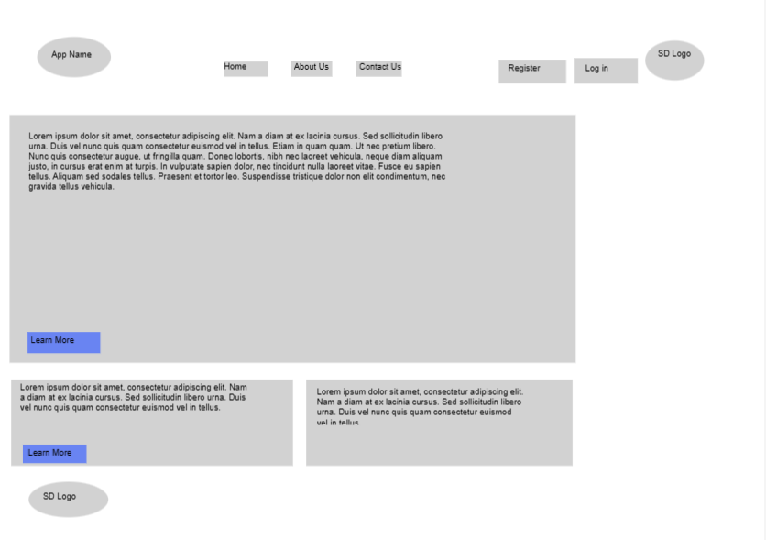
Figure 15 View of application home page

During this exercise it was identified by the end user that the student log in view would benefit from a ‘Useful Information’ section. The purpose of this section would be to enable new employees to access a wide range of helpful information relating to the onboarding process and service desk. The current process has a similar feature which is based on a Microsoft SharePoint page.

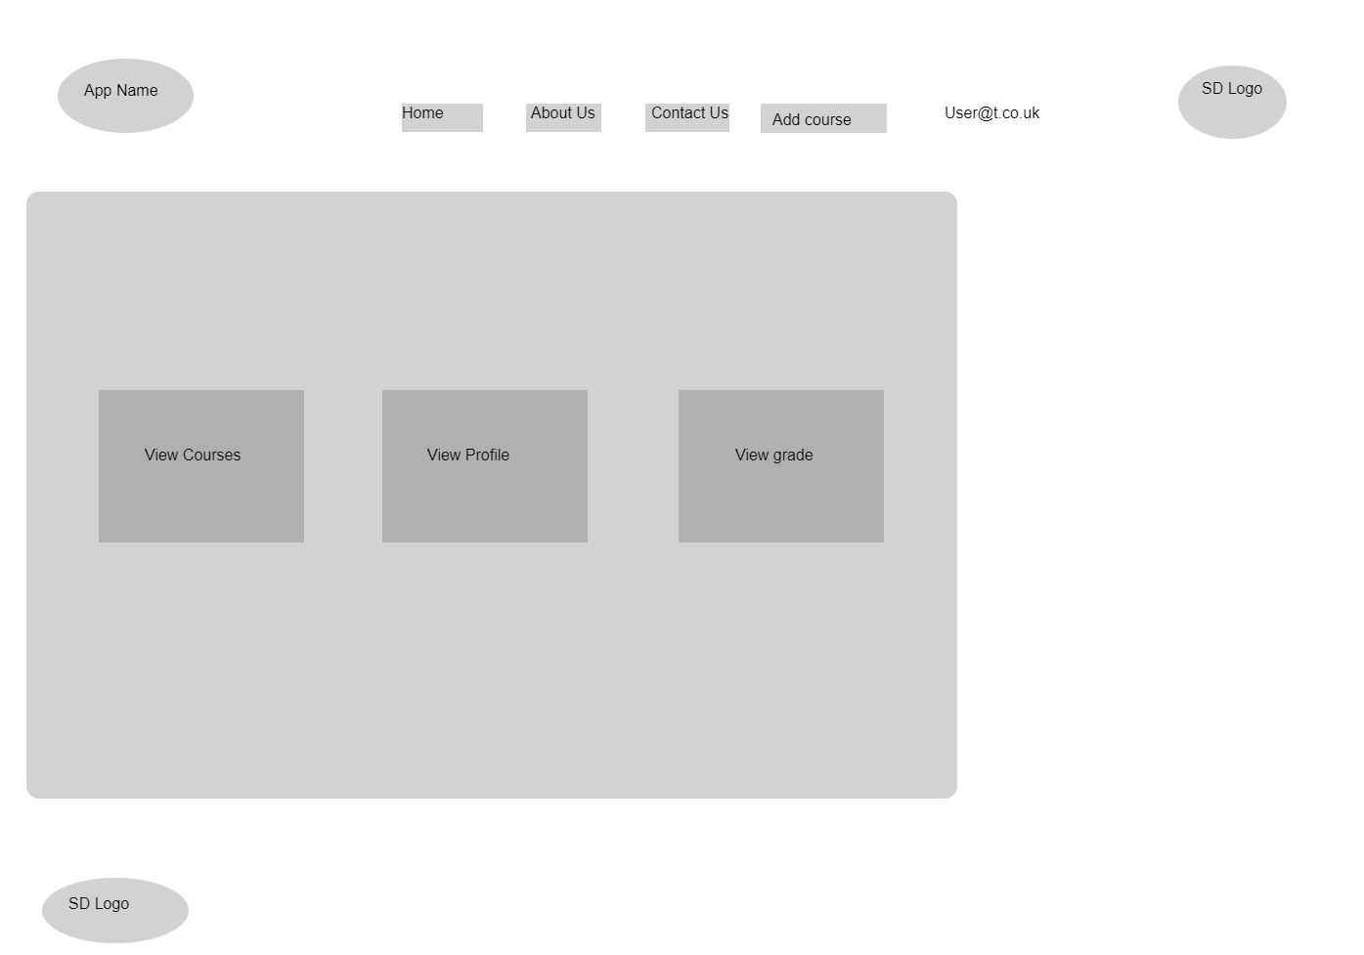
Figure 16 Initial Student log in view

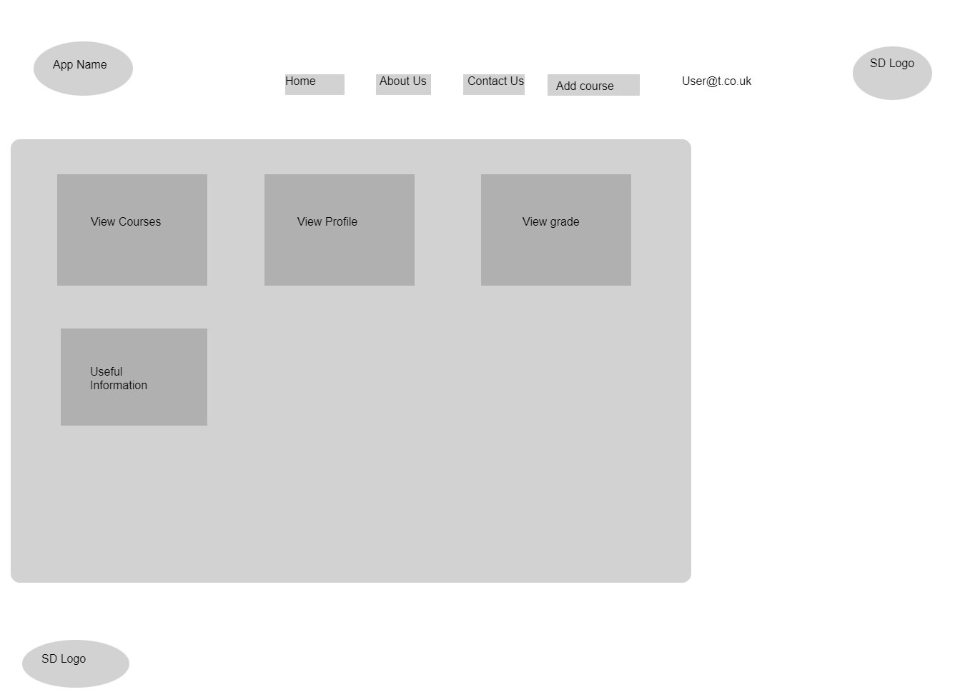
Figure 17 Student log in view with additional tab
As this is a prototype application this area will include basic information using embedded URL links to external content. However, as additional content is identified or becomes available the useful information page can expand.

4.1.2 Iteration Two

Iteration two focuses on the initial development of the application in particular registration and login features. This will be achieved through the creation and connection of a Microsoft SQL local database for the prototype phase. Utilising a local database during the prototype phase will ensure that the application development can progress and have a means in which ensure the system requirements are met. However, once the application is handed over to the end-user the connection can be altered to the organisations sever.

Through the use of ASP.NET the application has been developed with a built-in authentication process which utilizes a registration and login area. This stores users details at the time of registration and then refers to these stored details in order to confirm that the user is entering valid details which then allows authenticates for users to access to different aspects of the application.

In order to ensure that the application is secure and users password meet the DHCW/NHS password standards the code generated by the ASP.NET application was altered from that shown in figure 18 to that shown in figure 20.

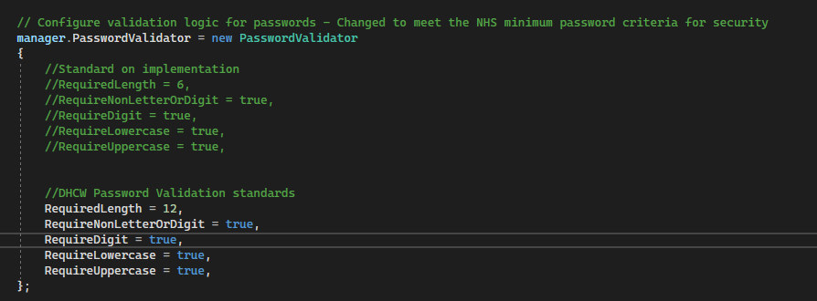
Figure 18 Password validation amended to meet DHCW password requirements
Additionally, to ensure that users can only access the information they are authorised to, this application was developed with various roles. Referring to the user stories developed during iteration one, two roles were identified, an instructor role and a student role.

An instructor should be able to carry out the following tasks
User Story No | User Type | Goal/Objective | Benefit/Result
1 | Instructor | Create new training content | This will keep staff informed of new supported services and the process that should be followed.
2 | Instructor | Amend training content | This will keep staff informed of changes to supported services and the process.
3 | Instructor | Create new quiz questions | This will ensure staff knowledge retention can be tested
4 | Instructor | Amend quiz questions | This will ensure staff knowledge can be kept up to date with changes

Whereas a student should be able to carry out the following tasks
User Story No | User Type | Goal/Objective | Benefit/Result
5 | Student | View training course material as many times as I need to | This will improve my knowledge and enable me to go back over content if needed
6 | Student | View my progress in the training | This will enable me to see how they are doing

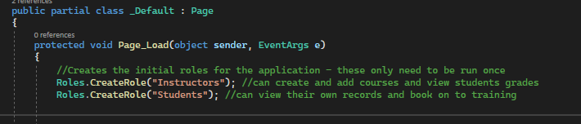
Figure 19 Role creation
The role creation code only needs to be run once on the application and therefore will be commented out after the first run.

4.1.3 Iteration Three

From the results of iteration two, along with developer unit testing plus an end user usability study it was established that in order to ensure the applications security, user registration should be completed by administrators rather than allowing for self-registration. Therefore, an additional onboarding lead role will need to be implemented in order to facilitate user registration. The goals and objectives were adapted into user stories in which to work from.

The onboarding lead should be able to

User Story No | User Type | Goal/Objective | Benefit/Result
8 | Onboarding Lead | Easily see what training has been booked in | I will know that new employees have trainers for each module they need to cover
9 | Onboarding Lead | I would like to be able to create new accounts for new students and make sure they have the correct access | I will be able to make sure the training account for a new staff member is set up and ready to use when they start their role.

The creation of this additional role will also provide additional benefit the booking application is developed. The onboarding lead will also be able to access the training calendar and ensure that the required training slots have been secured.

4.1.4 End User Usability Testing

The second method that has been used to evaluate the success of the application is in the form of a System Usability Scale Test. A SUS test consists of around 10 questions which respondents are given a scaled response from ‘Completely Disagree’ to ‘Completely Agree’. This method is described as being a reliable tool in which to measure a systems usability. This form of usability testing has many advantages, one such advantage is that it is a relatively cheap to conduct, requiring very few resources. Another advantage to SUS testing is that it can be carried out with relatively small samples sizes whilst still producing reliable results. This is particular pertinent due to the small numbers of users this system will generate [36].

The SUS test was carried out in person with seven stakeholders. Each user was provided with a brief description of the application purpose plus basic information for each area of testing. In order to ensure that usability was truly tested the developers were not present during the testing, however users were able to call on them if errors occurred that they could not navigate past. An example of the Test Data and SUS scaling questions can be found in appendix item 0.9.3

The SUS scores were represented in both textual values and numerical values as follows:

Figure 20 Textual and Numerical values for SUS scores

The scores were evaluated using the following formulas:

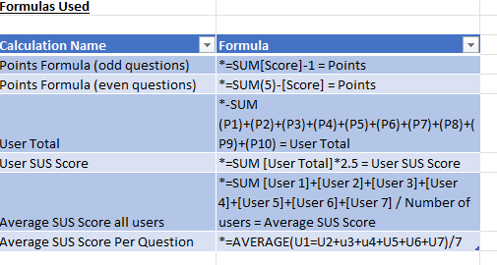
Figure 21 SUS Formulas used to interpret data

The results were evaluated using the following SUS Scale

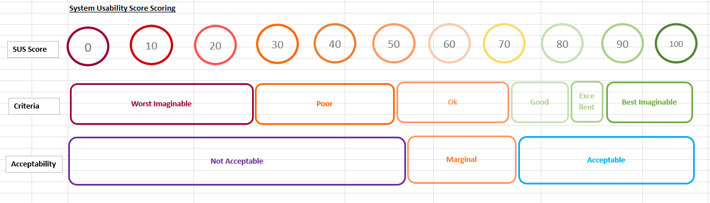
Source: Reference was made to the following site [37]

4.1.5 Iteration Four

From the additional feedback received from the users, several application improvements have been identified. Several respondents identified that the navigation bar text was particularly difficult to see. To resolve this additional code was added throughout the application to display the navigation bar text in white.

Figure 22 Example of user feedback
See Appendix 0.9.3 End User Testing for the full list of user feedback


Figure 23 Updated Navigation Bar Text
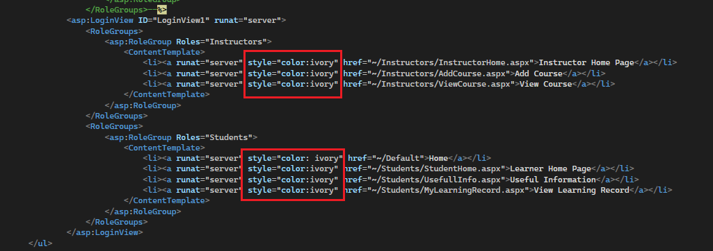
Figure 24 Adjustment to navigation bar code

Another issue that many of the respondents noticed was that one of the registration hyperlinks buttons did not behave in the way it was intended. Therefore, to resolve this issue the hyperlink address was amended to ensure that when the user selected the hyperlink test they were redirected to the registration page.

Figure 25 Example of user feedback
See Appendix 0.9.3 End User Testing for the full list of user feedback

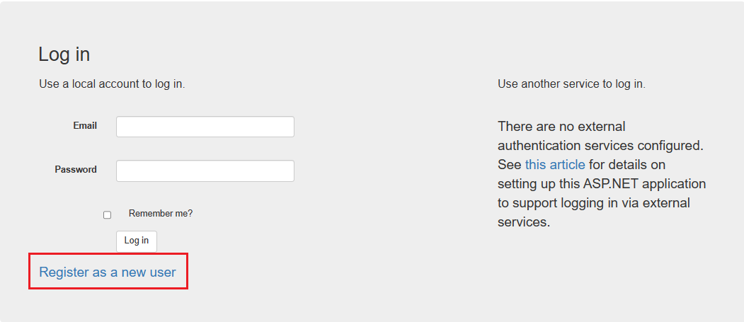
Figure 26 Updated Registration Link

Figure 27Updated Registration Link Code

Aside from these amendments the visual appearance of the application was updated to improve the users experience with the application.

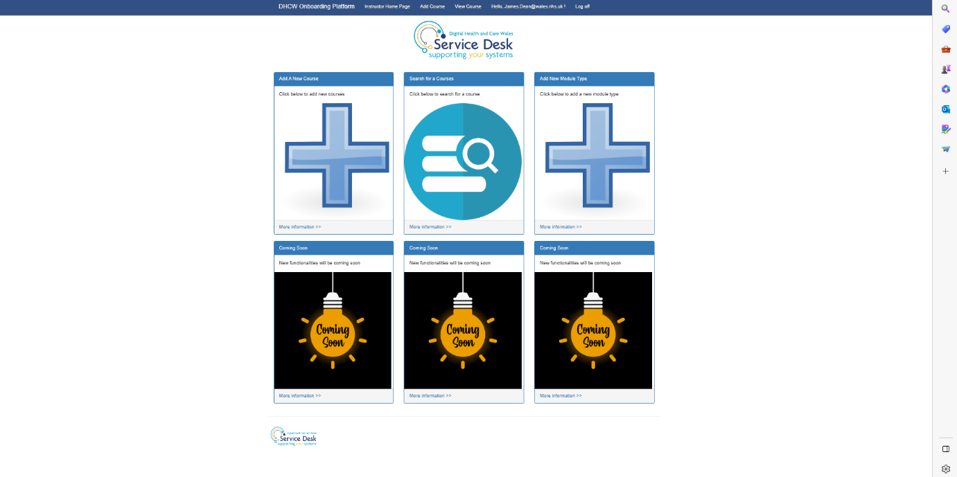
Figure 28 Updates to the visual appearance of the Instructor home page

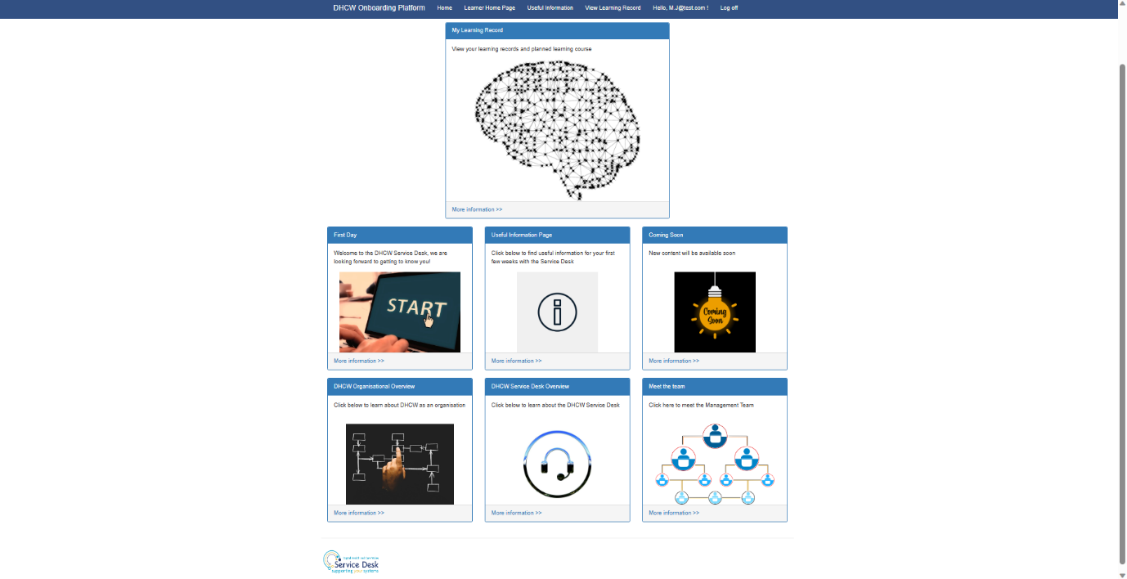
Figure 29 Updates to the visual appearance of the Student home page

4.2 Results

4.2.1 Iteration one

From the initial wireframes, users agreed that the application should have a standardised design throughout and should make use of the DHCW/NHS topology and logo format. Therefore, a site master page was developed, which would include the DHCW Service Desk Logo and utilises a blue colour scheme in line with the organisations branding best practices. This master page will be used as the basis for every page and will promote usability by ensuring users are familiar with the site layout including the navigation features.

Additionally, users felt that the application would benefit from a useful information page. This page should be available to all registered and logged in students. The addition of this page will ensure that new employees are able to access a wide range of useful documents, content and links to third-party websites. This requirement was then adapted into a user story.

User Story No | User Type | Goal/Objective | Benefit/Result
7 | Student | Easily access useful information in one place | I won’t need to go searching for information

4.2.2 Iteration Two

During this iteration several security features were implemented successfully, such as the use of a secure password and role-based user registration. Based on the user stories two roles were created for the application, the first being an instructor role and the second being a student role. Adopting role-based accounts ensures that users are only able to access information and areas they are required to. However, during the end user usability study and end-user testing for iteration two it was highlighted that users should be restricted on which types of roles they can register for. For example, students should not be able to register as an instructor who can create courses. This also falls in line with the industry best practice of the Principle of Least Privilege (PoLP) [38]. In order to address this issue greater research into application and roles-based security is required. This will need to be addressed before the application can advance from a prototype.

There are many potential ways that the account creating process could be developed to ensure the security of the application. One simple option would be to remove the registration features from the application and only allow application admins to create accounts on behalf of the user. This would require an additional administrator role as well as the instructor and student roles. However, careful consideration should be made as to the impact of creating additional roles and how this may impact the application if its use was extended across the organisation. Additionally, a feature to reset or create a new password will need to be implemented when the new users log into the application for the first time.

In order to address the security of the application and the information held within, users will be required to create an account using basic information and protect this account with a local application-based password. From the developer testing (Appendix 0.7.2) it was identified that an exception was thrown when users attempted to login using unmatched credentials. The exception error paused the application but did not communicate to the user why the registration details had not been accepted. In order to address this undesirable effect additional code was written into the application, this code informs the user of the error through and onscreen error message.

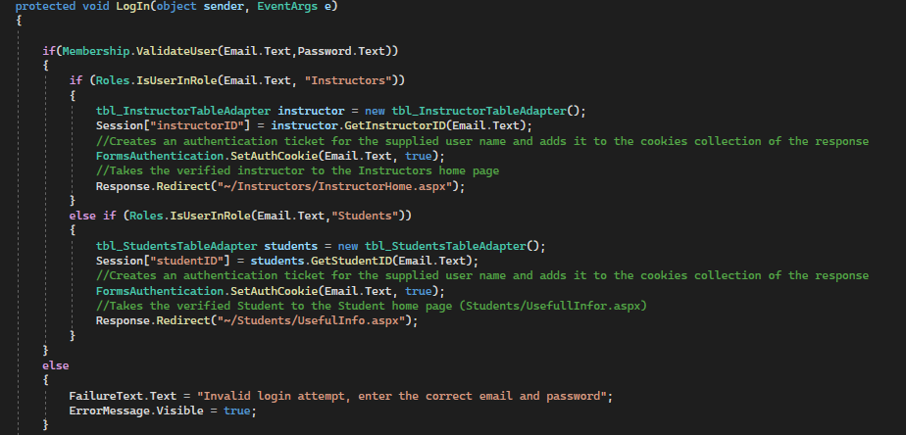
Figure 30 User error message code
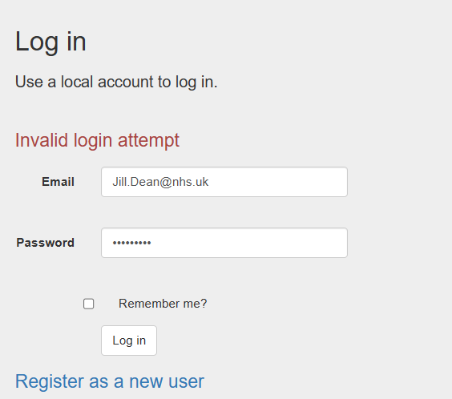
Figure 31 User error message
A similar outcome was identified with the registration process, whereby an exception was thrown when users entered a password that did not meet the applications password requirements, but the user is not made aware of the what the exact issue is. To overcome issue additional code was added to the application which makes use of the regular expression evaluator library to check the password met the requirements of the application.

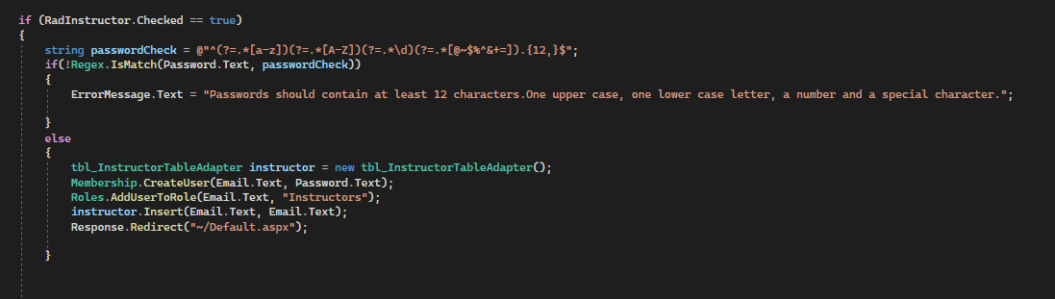
Figure 32 Regular expression added to both registration loops
This was tested as part of iteration one developer testing, test 5.1.

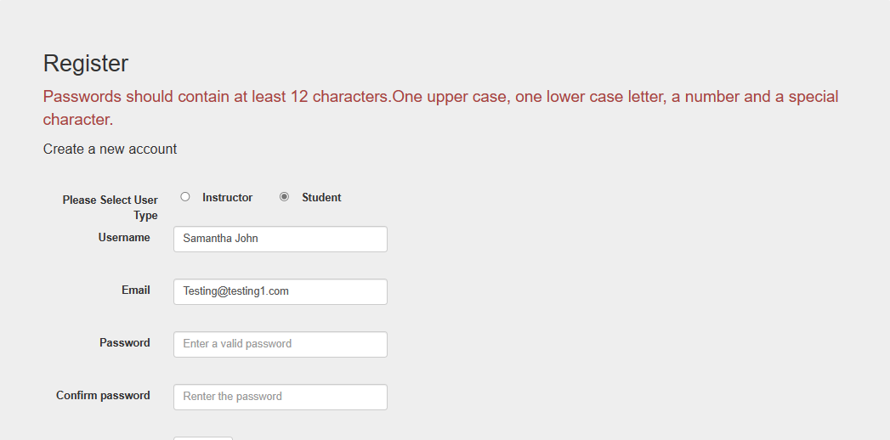
Figure 33 Error message displays to the user

4.2.3 Iteration three

The addition of an administrator role will satisfy the criteria highlighted by the end-user during the initial useability testing. Much as the other roles that were created for the application, the code below will only need to be executed once in order to create a role within the SQL database.

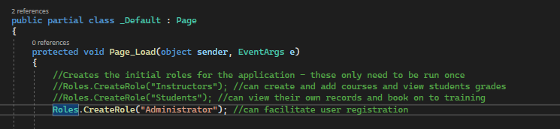
Figure 34 Creation of an additional administrator role

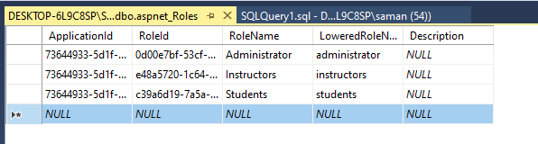
Figure 35 Microsoft SQL SMS Role creation

4.2.4 End User Usability Testing

From the responses collected, six out of the seven users surveyed scored the system usability scale(SUS) as greater than 90, which indicates a high level of usability. Furthermore, the overall system usability score averaged at 94. Which further reinforces that the users preserved the application as highly usable.

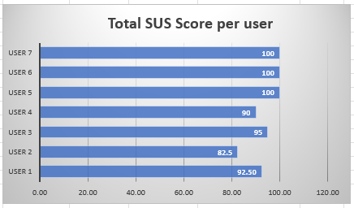
Figure 36 Total System Usability Scores Broken Down Per User

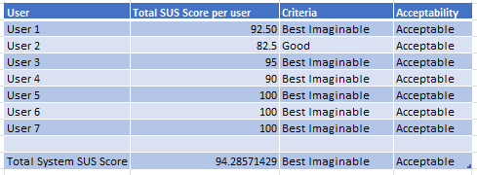
Figure 37 Criteria and Acceptability Outcomes for Individual User and Overall SUS Score

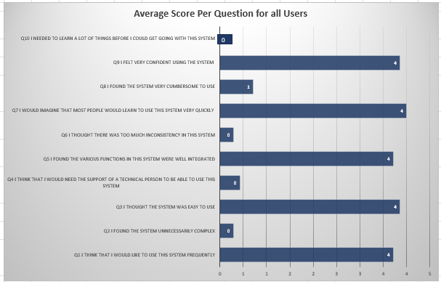
Figure 38 Average Score for Each Question for all Users

The data captured from the average question scores provides valuable insight into the users perceptions of the system. In particular question seven “I would imagine that most people would learn to use the system very quickly” and question three “I thought the system was easy to use” both scored on average 4 which indicates the majority of users strongly agreed that the system was reasonably easy to use and implies a positive user experience.
Additionally, some interesting suggestions were made by the respondents to further improve the accessibility and usability of the application. These findings are further supported by the data collected from question four “I think that I would need the support of a technical person to be able to use this system” where the majority of respondents completely disagreed with the statement, which indicates that users felt this system was relatively easy to use.

With the addition of the additional feedback section within the SUS study, several improvements were identified. One common comment that emerged from the user feedback was that it was difficult to see the text on the navigation.

Figure 39 Image of the current navigation bar

Even though the selected navigation item change colour when users hoover over the text it is particular difficult to see when items are not selected. One potential solution to address this issue would be to modify the colour of the text to make it easier for users to make the correct selection.

Another notable issue highlighted in the user feedback was that the registration buttons did function as it should. On closer inspection the registration button was not set up with the correct URL for the site. To resolve this issue, the code behind this button will need to be adjusted to ensure users are directed to the correct page within the application.


Figure 40 Malfunctioning hyperlink
Figure 41 Incorrect code

Additionally, users suggested that displaying the remaining number of characters in each of the text boxes with the ‘Add Course’ and ‘Edit Course’ forms would enhance the user experience and accessibility of the application. The addition of this feature would provide users with real-time feedback on the acceptable length of the input, allowing them to manage the content. One possible solution to this suggestion would be to incorporate placeholder text within each text box that dynamically decrements as the user types.

The complete copy of the respondents SUS responses including analytical data can be found in appendix items 0.9.3

4.2.5 Iteration Four

Due to the time constraints for this project the amendments that were made during iteration four have as yet not been tested with the end user. However, they have been shared with the end users and DHCW Service Desk Management Team. The amendments to the site navigation bar and the visual appearance of the application were positively received by all. Further end user testing will need to be conducted to ensure that the end users are happy with the application.

Chapter 5

5.1 Conclusion

At the beginning of this project a single aim along with several objectives were identified. The overall aim to create a single application for DHCW Service Desk to house all the information and materials used during the onboarding of new starters was successfully achieved. However, several steps needed to be addressed for this application to be successfully developed which were outlined as project objectives.

From the self-reported investigation, it was evident that the current systems and process used by DHCW for training and onboarding provided new employees with a wealth of information. However, several systems are used to house this information and therefore the process was disjointed. Furthermore, from the focus group study it was also identified that a centralised system to house all the training and onboarding information would aid both the onboarding lead, instructors and students. To further support the need for some of the identified system requirements a self-reported comparative study was conducted, which looked at similar applications used by organisations to track learning experiences. This study identified that several useful features could be developed to support the end-user experience. This includes visual aids to inform them of progress with the programme as well as the ability to view collections of students in one view. From each of these investigations several system requirements were identified that were then taken through to the development phase.

Agile methodology has proven to be exceptionally useful in this project for several reasons. Firstly, it’s iterative and incremental release and testing approach has enabled the project to remain flexible and adapt to the stakeholders needs. Secondly, this development methodology advocates and promotes collaborative work and continuous communication with the stakeholder. Which has again enabled this project to adapt to the stakeholders needs and encourage open communication channels. Overall, choosing to adapt an agile methodology for this project has enabled the project requirements to adapt to the stakeholders needs and ultimately deliver a meaningful and useful prototype project.

From the literature review and subsequent identified project constrains C# was proven to be a suitable development language for a number of reasons including it’s versatility and reliability.

In conclusion, the development of this prototype application has been a success so far. This application has addressed many of the identified pain points highlighted by the end user. Throughout the development process, user feedback has been prioritized and incorporated into each iteration of the application. This is to ensure that the application met the needs of the end user and was easy to use. The overall high scores from the SUS study has provided extensive evidence to support this claim.

One of the key factors in the success of this application was the extensive developer and end user testing and quality checking process. The extensive testing ensured that the application was examined and refined before it was released to the end user. The end user testing provided many valuable insights and ensured the security of the application and user data stored within.

5.2 Future Work

In future work, a key area of focus will be the optimization of the existing functionalities to address many of the highlighted shortcomings of the application which were identified by the end user testing. In particular, the navigation element of the site requires optimising in order to make it more accessible and user friendly.

Looking ahead, there are many possible developments that could be made to the application as it currently stands. One such development would be to create a reporting platform which the Service Desk could draw quantifiable data from to identify future improvements that could be made to the onboarding and training process for new employees. It is evident that the new DHCW Service Desk Onboarding application has great potential and could benefit from the development of enhanced features such as the reporting platform as well as the instructor booking application. However, due to the time constraints associated with this project it was not possible to develop all of the features identified by the end user, as a result the project was broken down into several smaller phases. Further work will need to be carried out to meet the remaining features and requirements identified by the end user. Additionally, it would also be worth considering if other department with DHCW would be able to adopt this system for training and onboarding. This would require additional research into each departments system requirements and further development and usability testing.

Furthermore, there are several security features that will need to be addressed if this application is developed to release stage. One recommendation for this application would be to implement password protection in the form of Hashed passwords [39], currently the browser is set to hide the password from view as it’s typed but the password is sent from the application to the database in plain text format as figure 26 demonstrates. Additionally, it would be advisable to encrypt the connection string with the use of Aspnet_regiis.exe.
Many of these features were not considered during the development of this application due to the fact that this a prototype application to demonstrate proof of the concept and ensure the application is useable.

Chapter 6

6.1 Reflection

Developing this project has been a complex yet enjoyable process. It has involved a wide variety of interrelated activities such as research, analysis, requirements defining along with technical skills such as designing, coding and testing the product. One of the key challenges of this project was prioritising and managing expectations, not just for the customer but also myself. This project has highlighted the importance of ensuring that the application not only meets the needs of the end users but works alongside the organisations current processes and business goals. Another challenge this project presented was ensuring that I effectively communicated and collaborate with the stakeholder to identify the steps involved in the current process were integrated the application and that each element of the application worked for the end users.

This project consisted of many features and although they were not complex features this is the largest application that I have created, coupled with the fact that I was tasked to create this application by myself therefore making it extremely challenging. Not only do I feel I underestimated the level of work required for a project, but there were also points in the project where I found it particularly hard to motivate myself. One of the ways I was able to overcome the challenges of a large project, with mutiple features and short development timeframes was to develop a gantt chart, which ensured I was able to stay on track.

Another challenge I did not foresee was that in choosing to develop this application in an unfamiliar programming language often caused the development process to slow down, whilst I conducted research into errors and problems that arose. On reflection, it would have been better to choose a language I was familiar with. However due to the organisation’s constraints and the requirement for future development the language choice was pre-decided.

Furthermore, this project has also highlighted to me that all application development projects require developers to adopt a continuous learning and improvement process. With ever changing technologies as well as best practices it can often be hard to stay on top of projects and technological advancements. Therefore, I feel that all projects, development teams and stakeholders would benefit from regular knowledge sharing sessions. Adopting this sort of approach will help to identify areas of improvement and foster a culture of continuous learning and improvement within teams.

However, this project has helped me develop several personal skills, such as my communication skills. Due to the agile development methodology used for this project I was required to have regular communication with the stakeholders which gave me the opportunity to develop effective and meaningful methods of communication. Another personal skill that I have been able to develop further is my research skills. Since many of the development technologies used within this project were new to me, I was required to learn and develop research skills.

To summarize, a successful application development project requires a combination of continuous learning, collaboration and communication as well as an extensive range of technical and analytical skills.

(Word Count 11,595 of 10,000)

References
[1]
S. John, “Analyzing the Digital Health and Care Wales Service Desk Onboarding Process in Consideration for a New Delivery Platform.” Aug. 2022.

[2]
R. K. Yin, Case study research: Design and methods, vol. 5. sage, 2009.

[3]
Celtic Leisure Course Progress Swimming Application. https://celticleisure.courseprogress.co.uk/login (accessed 2023).

[4]
“Fitronic.” https://www.fitronics.com/about/ (accessed 2023).

[5]
S. Heredos, Walsh, P. Kim, Walsh, B. Vazzano, and Walsh, “LOOKS DO MATTER: DEVELOPING AN ACCOUNTING SOFTWARE PROGRAM IN JAVA AND NETBEANS,” vol. 18, no. 3, p. 9, 2017, doi: 10.48009/3_iis_2017_9-18.

[6]
G. Alor-Hernández, V. Y. Rosales-Morales, and L. O. Colombo-Mendoza, Frameworks for RIAs Development. United States: IGI Global, 2014, pp. 17–35.

[7]
M. Heller, “Choosing your Java IDE,” Jun. 30, 2022. https://www.infoworld.com/article/3114167/choosing-your-java-ide.html (accessed 2023).

[8]
“Eclipse_becomes_the_dominant_Java_IDE.” (accessed 2023)

[9]
“Eclipse Foundation.” https://www.eclipse.org/ (accessed 2023).

[10]
Adobe, “Adobe Flash Player EOL General Information Page,” 2021. https://www.adobe.com/uk/products/flashplayer/end-of-life.html (accessed 2023).

[11]
Pierre, “Top 10 IDE Index,” Apr. 2023. https://pypl.github.io/IDE.html (accessed 2023).

[12]
D. H. Curie, J. Jaison, J. Yadav, and J. R. Fiona, “Analysis on Web Frameworks,” vol. 1362, no. 1, p. 12114, Nov. 2019, doi: 10.1088/1742-6596/1362/1/012114.

[13]
A. Lock, ASP.NET Core in Action. Simon and Schuster, 2021. (accessed 2023).

[14]
D. Waghare and P. sdkar, “Agile Development Using Ruby on Rails,” vol. 2, no. 9, Mar. 2019.

[15]
Munawar and Shahzaib, “single Page Applications (SPAs). Most Discussed Pros & Cons,” 2022. https://novateus.com/blog/single-page-applications-spas-most-discussed-pros-cons/#:~:text=If%20you%20see%20the%20spinner,is%20a%20single%2Dpage%20application. (accessed 2023).

[16]
L. Bhaskar, R. B. Natak, and R. Ranjith, “Unit Testing for USB Module Using Google Test Framework,” Jul. 2020, pp. 1–3, doi: 10.1109/ICCCNT49239.2020.9225528.

[17]
L. Alexander Sarah Gillis, “object-oriented programming (OOP),” Jul. 2021. https://www.techtarget.com/searchapparchitecture/definition/object-oriented-programming-OOP (accessed 2023).
[18]
J. Farrell, Java Programming. Boston, MA: Cengage, 2023.

[19]
B. J. Evans, J. Clark, and D. Flanagan, Java in a Nutshell: A Desktop Quick Reference. O’Reilly, 2023.

[20]
B. Cyganek, “Introduction To Programming With C++, Introduction.” Wiley-IEEE Press, pp. 1–11, 2020, doi: 10.1002/9781119431152.fmatter.

[21]
E. Doherty, “What is object-oriented programming? OOP explained in depth,” 2020. https://www.educative.io/blog/object-oriented-programming#four (accessed 2023).

[22]
F. Zehra, M. Javed, D. Khan, and M. Pasha, “Comparative Analysis of C++ and Python in Terms of Memory and Time.” MDPI AG, Dec. 21, 2020, doi: 10.20944/preprints202012.0516.v1.

[23]
TIOBE, “TIOBE Index for April 2023,” Apr. 2023. https://www.tiobe.com/tiobe-index/ (accessed 2023).

[24]
S. Samuel, “C# Language advantages and applications,” 2020. https://www.tutorialspoint.com/Chash-Language-advantages-and-applications (accessed 2023).

[25]
R. Turner, Programming Languages. Berlin, Heidelberg: Springer Berlin Heidelberg, 2018, pp. 67–76.

[26]
Microsoft and B. Wagner, “Exceptions and Expection Handling,” 2022. https://learn.microsoft.com/en-us/dotnet/csharp/fundamentals/exceptions/ (accessed 2023).

[27]
U. Government, “Focus group study: qualitative studies,” 2020. https://www.gov.uk/guidance/focus-group-study-qualitative-studies#:~:text=Focus%20groups%20use%20group%20dynamics,(formative%20or%20summative%20evaluations).

[28]
S. Crowe, K. Cresswell, A. Robertson, G. Huby, A. J. Avery, and A. Sheikh, “The case study approach,” vol. 11, no. 1, p. 100, Jun. 2011, doi: 10.1186/1471-2288-11-100.

[29]
M. A. Benzaghta, A. Elwalda, M. Mousa, I. Erkan, and M. Rahman, “SWOT analysis applications: An integrative literature review,” vol. 6, no. 1, pp. 55–73, Mar. 2021, doi: 10.5038/2640-6489.6.1.1148.

[30]
Research anthology on agile software, software development, and testing. Hershey, PA: IGI Global, 2022.

[31]
N. Dzamashvili Fogelström, T. Gorschek, M. Svahnberg, and P. Olsson, “The impact of agile principles on market-driven software product development,” vol. 22, no. 1, pp. 53–80, 2010, doi: 10.1002/spip.420.

[32]
Microsoft, “Visual Studio: IDE and Code Editor for Developers and Teams .” https://visualstudio.microsoft.com/#vs-section (accessed 2023).

[33]
Microsoft, “Visual Studio, User Guide.” https://code.visualstudio.com/docs/editor/intellisense (accessed 2023).

[34]
Microsoft, “Overview of ASP.NET Core authentication.” https://learn.microsoft.com/en-us/aspnet/core/security/authentication/?view=aspnetcore-7.0 (accessed 2023).

[35]
M. Danner, W. Pickering, and T. Paredes, Using Focus Groups to Listen, Learn, and Lead in Higher Education. Routledge: Stylus Publishing. LLC, 2018.

[36]
J. Brooke, “SUS: A quick and dirty usability scale Usable systems View project Fault diagnosis training View project.”

[37]
A. Chinn, “What’s the System Usability Scale (SUS) & How Can You Use It?,” 2018. https://blog.hubspot.com/service/system-usability-scale-sus.

[38]
L. Rosencrance, “Principle of Least Privilege(PoLP),” Apr. 2021. https://www.techtarget.com/searchsecurity/definition/principle-of-least-privilege-POLP (accessed 2023).

[39]
Microsoft, “ASP.NET Web Application Security,” 2014. https://learn.microsoft.com/en-us/previous-versions/aspnet/330a99hc(v=vs.100) (accessed 2023).

