

Mathew George

Reflection on Study Skills

University of Wales Trinity St Davids
Bachelor of Engineering: Electrical & Electronic Engineering

Level 4
2025-2026

Supervisor: Jenni Steen
January 2026

This assignment is submitted in partial fulfilment of the requirements for the degree of HND/Beng Electronic Engineering/Embedded Electronics

Abstract

This report presents a structured reflection and evaluation of the academic, personal and professional skills developed during the course of this module. It covers a detailed reflection of the practical tasks of the module, independent research conducted and self-evaluation undertaken.

Contents
Abstract ii
1.0 Presentation Skills 1
2.0 Research on required skillsets 4
3.0 Self-evaluation and action planning 5
4.0 Application 13
4.1 Looking after your data 13
4.2 Time management and self-organisation 14
5.0 Conclusion 15
6.0 References 17
Bibliography 17
7.0 Appendices 19

Presentation Skills
The purpose of the presentation was to deliver a concise overview on myself in every aspect of life. The topic of the presentation was me, therefore a degree of self reflection was required in order to provide my classmates with the most interesting and relevant details about myself so they can get to know me and build good relationships over the duration of this course. Having covered the skills required for a successful presentation I wanted to make sure that the slides had just the right amount of content, with a mixture of text and images, using a basic fonts and colour scheme to keep the presentation clear and simple. I kept the text brief which gave me the opportunity to talk more in depth on each slide to give a clearer picture of what I wanted to get across to the audience.
In the presentation I covered the following:
My name is Mathew George, and I am 29 years old. I was born in the small town of Haverfordwest, Pembrokeshire and grew up in the town of Pembroke Dock, Pembrokeshire. I spoke about my childhood and how I have always enjoyed spending my time with family and friends. I never found school the easiest and academics never felt like the right fit for myself. Once completing my GCSE’s in Pembroke, I went on to do an electrical apprenticeship at Pembrokeshire College and start my journey in work. I always felt drawn more to a contruction background having helped my dad most of my childhood on renovations to our family homes. I started off self-employed once completing my NVQ Level 3 apprenticeship and worked with a team carrying out domestic rewires for Pembrokeshire County Council. An opportunity came up within the Council which I went for and I started my career as Assistant Electrical Engineer and recently promoted to Electrical Engineer. Outside of work and education I am family man. I have a fiancé and two daughters aged three and one. If all this didn’t keep me busy enough, I am also currently renovating our family home, with the help of my dad. I try to find time for myself to recharge with hobbies such as song writing and playing guitar.
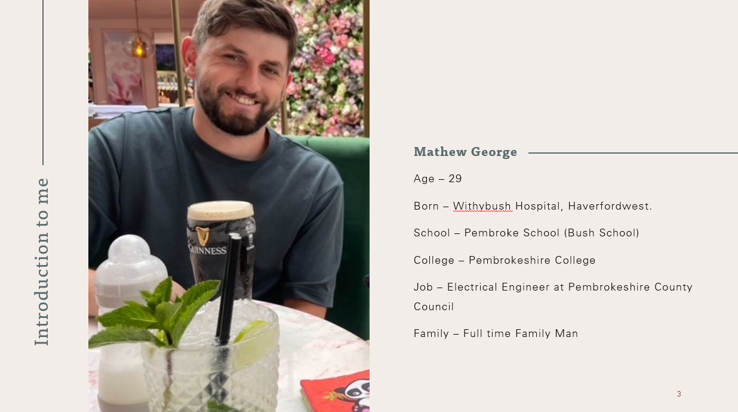
Figure 1: Slide 1 of my presentation
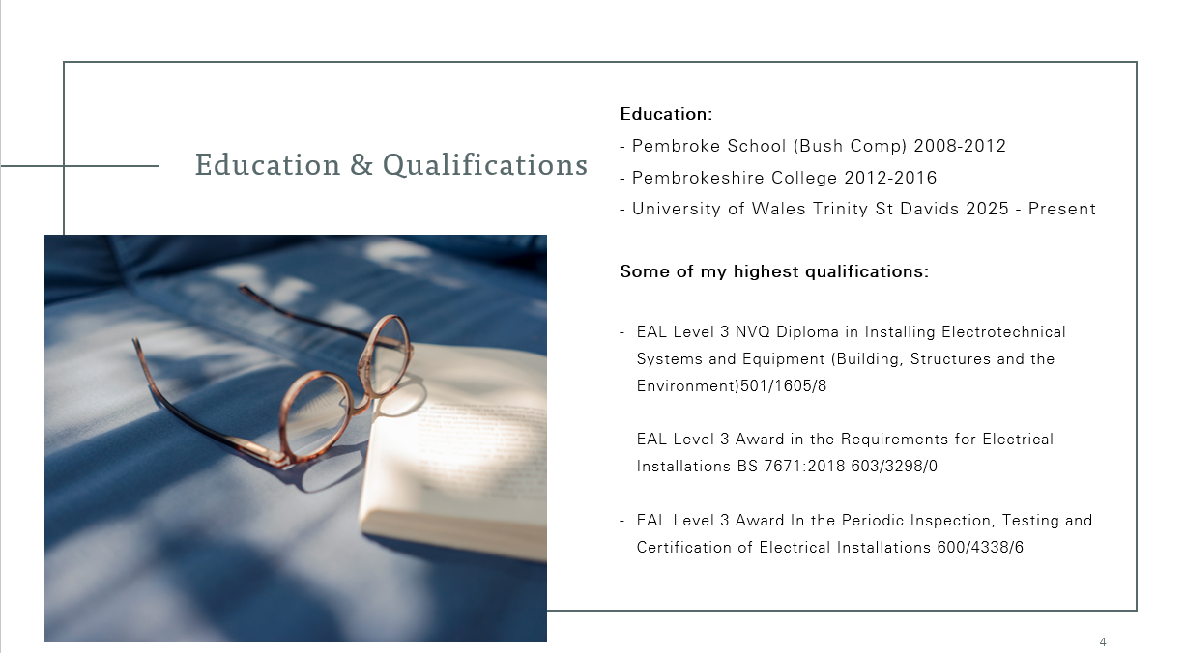
Figure 2: Slide 2 of my presentation

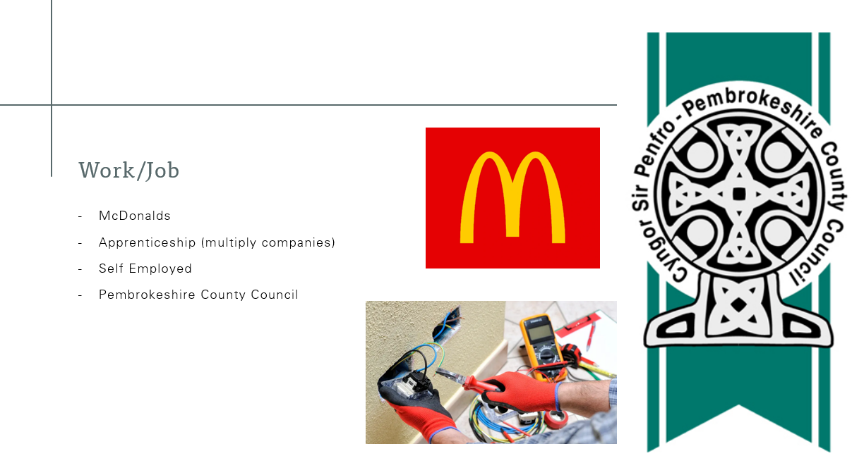
Figure 3: Slide 3 of my presentation
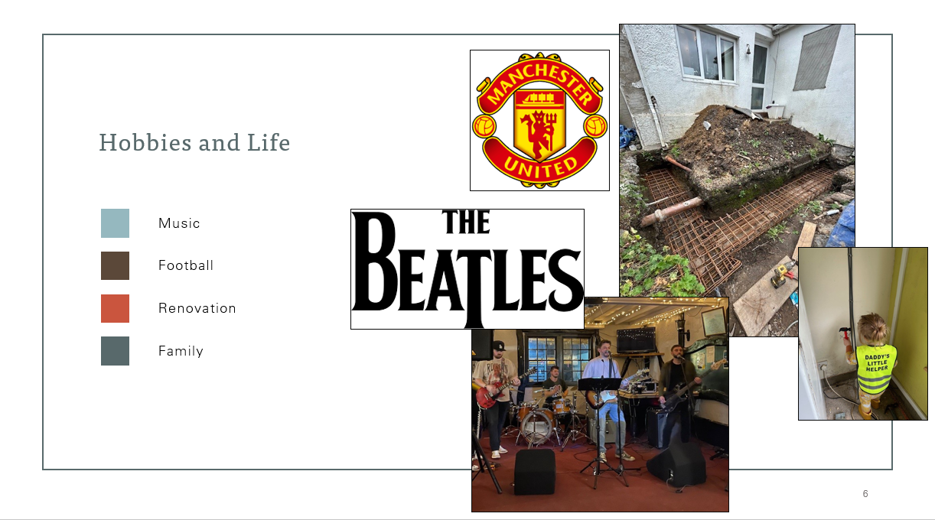
Figure 4: Slide 4 of my presentation
To produce and deliver a successful presentation it's important to consider and incorporate the following key principles. These include, clear and confident communication skills, using effective body language to engage the audience and the integration of multimedia elements to support and enhance the message being delivered. Consideration to the visual clarity and professionalism of the slides is important and can be done through the basics of utilising appropriate fonts and colour schemes. Most importantly, the information presented should be concise, well-structured and communicated with clarity while avoiding unnecessary detail to avoid overwhelming the audience.
With all this in mind, although content and visual presentation hold importance, effective delivery remains an essential presenting skill. Confidence presented a setback and has become an area for development to support successful delivery in future presentations. Going forward preparation for presentations will involve additional practice, including rehearsing in front of a small audience, to build greater comfort with the material. Feedback from classmates reinforced this plan, emphasising the need to improve body language, maintain eye contact rather than focusing on the screen or notes, and adopt a more relaxed and confident overall delivery

2.0 Research on required skillsets
A higher education environment demands a broad set of skills to ensure success. This goes beyond just having knowledge in a chosen subject. Students must develop and finetune skills such as, time management and organisation, digital skills, presentation skills and people skills. These skills form a foundation in which an individual can succeed academically and personally which can be transferred beyond higher education into a work environment.
Time management and organisational skills are key to navigating a higher education setting. It is vital for meeting deadlines, prioritising tasks, setting goals and managing pressures [1]. Time management and organisation will not only contribute to academic success but can also reduce anxiety and stress by using time effectively to find the balance required [1].
Technology is integrated into almost every aspect of life today and crucial for students’ success in today’s world [2]. The importance of teaching digital skills in higher education has become essential to set students up to be better prepared for future careers [3]. Students need digital skills to be able to “access and evaluate information, communicate and create meaningful content” [2].
Teamwork and people skills is required throughout higher education where collaboration is encouraged. A skill that “is essential in virtually any employment situation” [4], it allows people to learn from each other and utilise individual strengths collaboratively [4]. Teamworking is not always straightforward and can involve compromise and dealing with difficulties. Which requires the development of interpersonal skills to excel in a teamworking environment.
Critical thinking and problem solving are core skills for success in higher education [5]. They are skills that allow you as an individual to look beyond the surface level. A skill that is important for analysing information, forming an argument and justifying it [5]. To think critically requires a degree of independence, open-mindedness and being informed [6].
The skills developed in higher education are fundamental and transferrable to the workplace, meaning employers will look for these skills when hiring.
Research shows that “people skills, soft skills and interaction skills are critical” [7] this is due to the fact that these skills are vital to a work environment as they are crucial to adapting to a new work culture, working within a team and communicating effectively.
With technology developing so rapidly it is becoming an increasing priority of employers for prospective candidate to be digitally literate [8], having “a strong understanding of tech-orientated capabilities such as, AI, IT and data analytics” [7]. Most workplaces require digital skills there are five main areas where digital skills are essential for the workforce these are: “communicating, handling information and content, transacting, problem solving and being safe and legal online” [9].
Critical thinking and problem solving creates out the box thinkers that are vital to any workforce, where AI is aimed at low skilled tasked it’s expected that employers will seek individuals with critical thinking skills, a human skill, that cannot be digitalised which contributes to organisational success [8].

3.0 Self-evaluation and action planning
I completed a learning style quiz which followed the Myers Briggs Type Indicator(MBTI); from this quiz I learned that I am a kinesthetic learner. This means I am a physical learner I need to be active and hands on to retain what I am being taught. The more traditional method of teaching has always been a weakness of mine and is partly what lead me to pursue electrics and become an electrician where I could learn by doing. I have always struggled to take in content that is just shown or spoken about. The results from the quiz highlight this and show that the method of learning that is best suited to me is kinesthetic, which an electrician is a match career path for.
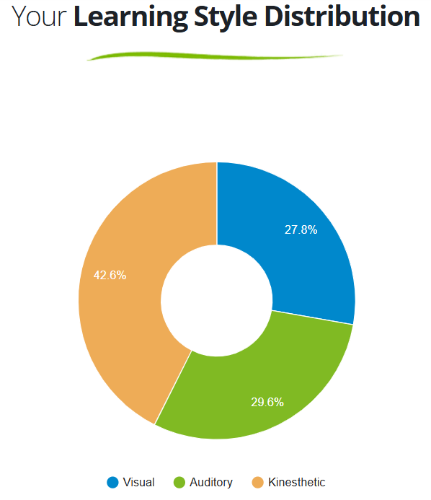
Figure 5: Results of my learning style quiz
The personality quiz below shows I am an Introverted Sensing Thinking Judging personality (ISTJ) type. This suggests that I am reliable and responsible, detail orientated, practical and independent, otherwise known as a logistician [10], deciding logically what to do and approaching it steadily and methodically [11]. All of which fits well with electrical work, where following technique and procedures is vital, and working methodically is key to getting a job done. Equally attention to detail is particularly important within my career and is a strength I poses which I believe assist me in task like fault finding in electrics.
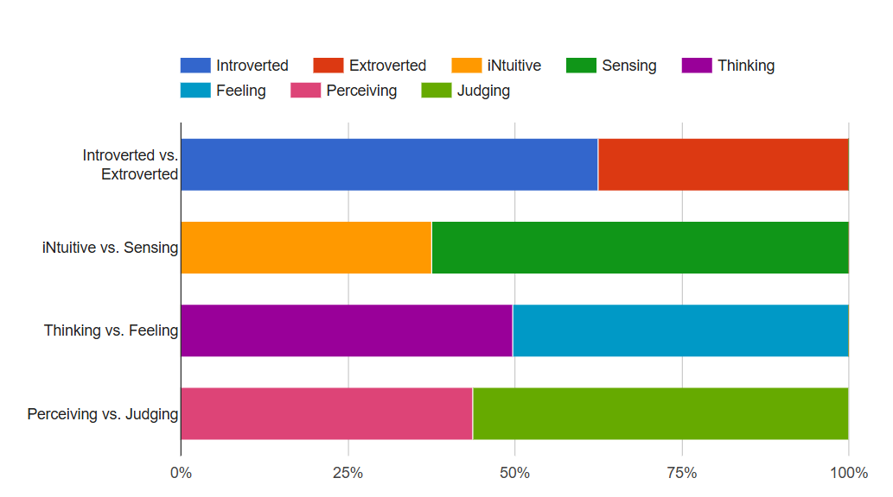
Figure 6: Results of my learning style personality
Another quiz that I have completed follows the Belbin model, this framework looks at team role, whereby each team role is attributed to certain strengths, weaknesses and behaviours. This is a useful tool and result to be mindful of for future teamwork as a successful team is made up of individuals of a diverse mix of team roles [12].
As seen in Figure 7, the results from the Belbin test matches my behaviour to a chairperson/co-ordinator and explorer. Coordinator suggest I have a strong coordinating behaviour, with emphasis on procedures I aim to keep the team focused and on track delegating tasks to individual strengths, it is noted a weakness of this trait is over delegation [12]. While explorer/resource Investigator is outgoing, communicative and explores opportunities [12].
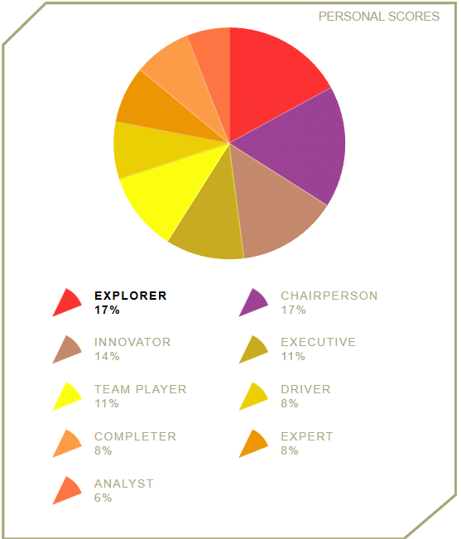
Figure 7: Results of the Belbin Team Role theory quiz
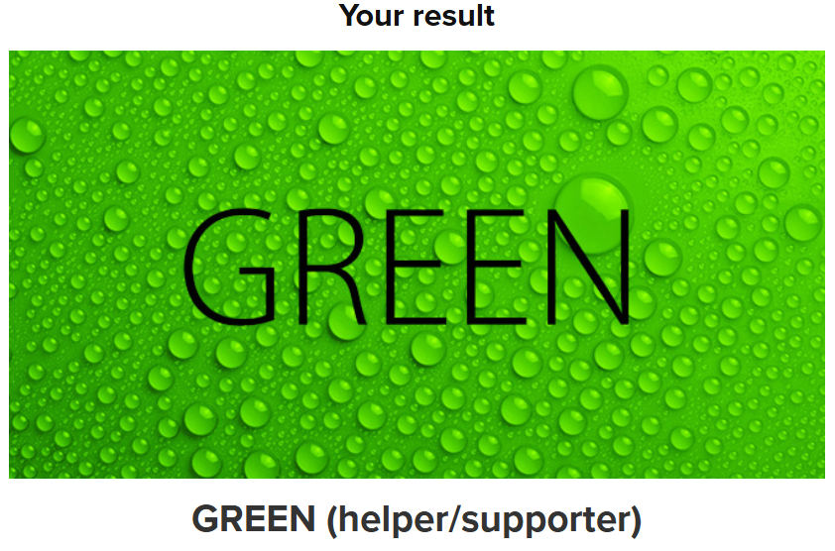
Figure 8: Colour personality test results
Colour personality matches to personality traits that describe the nature of an individual’s behaviour and temperament [13]. The result, as seen in figure 8, was green. This means I have a helper personality. Green personality is attributed with innovative problem solving, valuing perfectionism being analytical and conceptual while being supportive and loyal and good at reading other people’s emotions [13].
I would describe myself as an easy going individual, with a strong work ethic. I am proactive and tend to take initiative rather than waiting around. I enjoy solving problems and will try fix or find a solution for anything. I believe myself to be determined, which helps me follow through with tasks even when difficulties or challenges arise. I also recognise a few areas where I am continuing to develop. My confidence can fluctuate, particularly in new or unfamiliar situations, and I sometimes overthink decisions or outcomes. I have a tendency to take on too many responsibilities at once, which can lead to burnout when I try to manage everything independently. These patterns highlight the importance of improving my confidence, setting clearer boundaries, and managing my workload more effectively.
To conclude, the results of the various assessments present a coherent and consistent profile that aligns closely with both my own self-evaluation and my chosen career as a electrical engineer. The learning style quiz identified me as a kinesthetic learner, confirming that I learn most effectively through practical, hands-on experience. This supports my decision to pursue electrical work, a profession in which physical engagement, active problem-solving, and learning by doing are central to developing competence. The MBTI personality assessment further reinforced this by identifying me as an ISTJ. The traits associated with this personality type are all essential within the electrical industry, where accuracy, adherence to procedures, and tasks like problem solving or fault-finding are critical. These results closely reflect my own understanding of how I work and the strengths I bring to technical tasks. The Belbin Team Role findings suggest that I naturally adopt coordinator and explorer roles within group settings. This indicates that I am capable of organising tasks, maintaining structure, and contributing new ideas, while also highlighting areas for development such as avoiding over-delegation. Similarly, the colour personality test identified traits such as analytical thinking, loyalty, and problem-solving, which again mirror both my self-perception and the qualities required in my profession. When compared with my self-evaluation, the tests point out the strengths I recognise in myself while also highlighting my weaknesses, including confidence and workload management. Overall, the results demonstrate a strong alignment between my normal behaviours, my preferred ways of working, and the demands of my career path. This consistency reinforces that becoming an electrical engineer is not only a suitable choice for my abilities and personality, but also a career in which I am well positioned to continue growing and succeeding
My current long-term goal is completing my university degree. In doing so it enables me to work towards another long-term goal of mine, which is to continue to promote within my professional career. My short-term goal is a personal one and relates to my house renovation which I started in July 2024, I am in the process of building a kitchen extension for my family home and my short-term goal is to have this completed this year. Below I have turned these goals into SMART goals to keep my objective clear and stand a better chance of success [14]. S.M.A.R.T is a framework to keep goals; specific, measurable, achievable, relevant and time bound [14].

What do I want/need to learn or develop?  (Specific & Relevant) | What will I do to achieve this?  (Specific) | What resources or support will I need?  (Achievable) | What will my success criteria be?  (Measurable) | Target dates for review and completion  (Timebound)
After some reflection I would like to complete all 4 years of university and achieving at least a pass over all | I will manage my time well and make time to revise hard. And complete assignments on time. | I will work with my lecturers to make sure that I am going do the right track so do get side tracked on the wrong things. | Finishing my degree and achieving a pass mark which is 40% or above, also having an understanding on what the degree is about. | I have a finish date of July 2029 so I need to have this complete by then.
What do I want/need to learn?  (Specific & Relevant) | What will I do to achieve this?  (Specific) | What resources or support will I need?  (Achievable) | What will my success criteria be?  (Measurable) | Target dates for review and completion  (Timebound)
For my current job role, I would like to develop my knowledge on Construction Design and Management (CDM) | I will attend a training course that my work has put me on and research the regulations | Speak to my works health and safety team for advice and what resources they recommend building my knowledge. | Part of my role is to complete Pre Construction Information for contractors so if this become easier or I understand the task better then I will deem this a success. | The target dates for this will be 3 months to have a basic understanding of CDM and completing the course.
What do I want/need to learn?  (Specific & Relevant) | What will I do to achieve this?  (Specific) | What resources or support will I need?  (Achievable) | What will my success criteria be?  (Measurable) | Target dates for review and completion  (Timebound)
Complete the extension to my kitchen. | I will use any dry weather that we have coming up. Project manage the job by making sure the materials are ordered and on site ready to build. | I will work alongside with my dad who I will assist on the build, using his knowledge and ability to build. Updating myself on building regs and working with building control. | I will have a new extension to my house that we can finally use for a kitchen. | I hope to have this complete but the middle of next year about May 2026
What do I want/need to learn?  (Specific & Relevant) | What will I do to achieve this?  (Specific) | What resources or support will I need?  (Achievable) | What will my success criteria be?  (Measurable) | Target dates for review and completion  (Timebound)
To successfully sit/pass upcoming maths exams | I will manage my time around work, day to day life and other university projects to study/research the relevant maths for the exam | I will utilise the maths lectures and the Moodle portal. I will also use past papers and YouTube clips | A pass mark on the exams | Have the confidence to sit the exams at the start of January 2026 and sit the exams 12th and 19th January 2026
Figure 9: SMART Targets

4.0 Application

4.1 Looking after your data
In the digital world we live in, there a constantly security threats to our personal data and documents as well as technological failures. Hackers utilise different methods to scam and hack digital devices to steal data and unfortunately digital devices do not have an infinite life span and can fail also leading to the loss of documents and data. To combat this and keep my documents and myself safe online I have created the following backup strategy.
My documents are primarily created and saved on my personal computer, with a copy also being saved to my one drive, by doing so this also allows my documents to be accessible elsewhere in the event my laptop is lost or damaged. Less frequently I will also save a copy of my important documents, for example, coursework for university to a portable USB memory stick. This follows the 3-2-1 rule of data backup which provides a robust level of data protection from security threats, technology failures and even human error. The 3-2-1 rules states you should ultimately have 3 copies of data. 2 copies stored in different locations and 1 copy off site, this could mean a hard copy that has been printed or in my example using a cloud-based storage.
“Ransomware is a type of malware that holds a victim’s sensitive data or device hostage, threatening to keep it locked unless the victim pays a ransom to the attacker.” [15]. The most vulnerable data is that saved on a local PC as ransomware typically tries to encrypt these files first, from here attackers can gain further access potentially encrypting synced versions. However, an advantage of using cloud based storage is that ransomware cannot physically attack cloud servers and servers like OneDrive retain older versions of documents for recovery [15] [16]. The most protected from a ransom attack would be the remote USB drive so long as it is not connected at the time of the attack, so keeping this regularly updated with versions of data is paramount to ensuring data protection. The strategy that I have implemented is good and covers the suggest 3-2-1 rule, my use of OneDrive and a remote USB memory stick will help ensure version history of documents is recoverable if my laptop were to become corrupt.

4.2 Time management and self-organisation
To enhance my productivity, improve my organisation, and reduce my stress levels, I implemented the use of a digital calendar using the time-management strategy of time blocking. This approach allows me to allocate specific periods of the day to tasks such as work, study, and personal commitments. By assigning clear time slots, I created a structured routine that helps me stay accountable and prevents tasks from being left until the last minute.
Using a digital calendar also enables me to plan effectively around my busy work life and study commitments. I can visualise my week in advance, identify potential pressures and make adjustments early rather than reacting when I am already overwhelmed. Having a clear plan increases the likelihood that I will follow it, which helps me stay on top of deadlines and reduces the chance of becoming overly stressed.
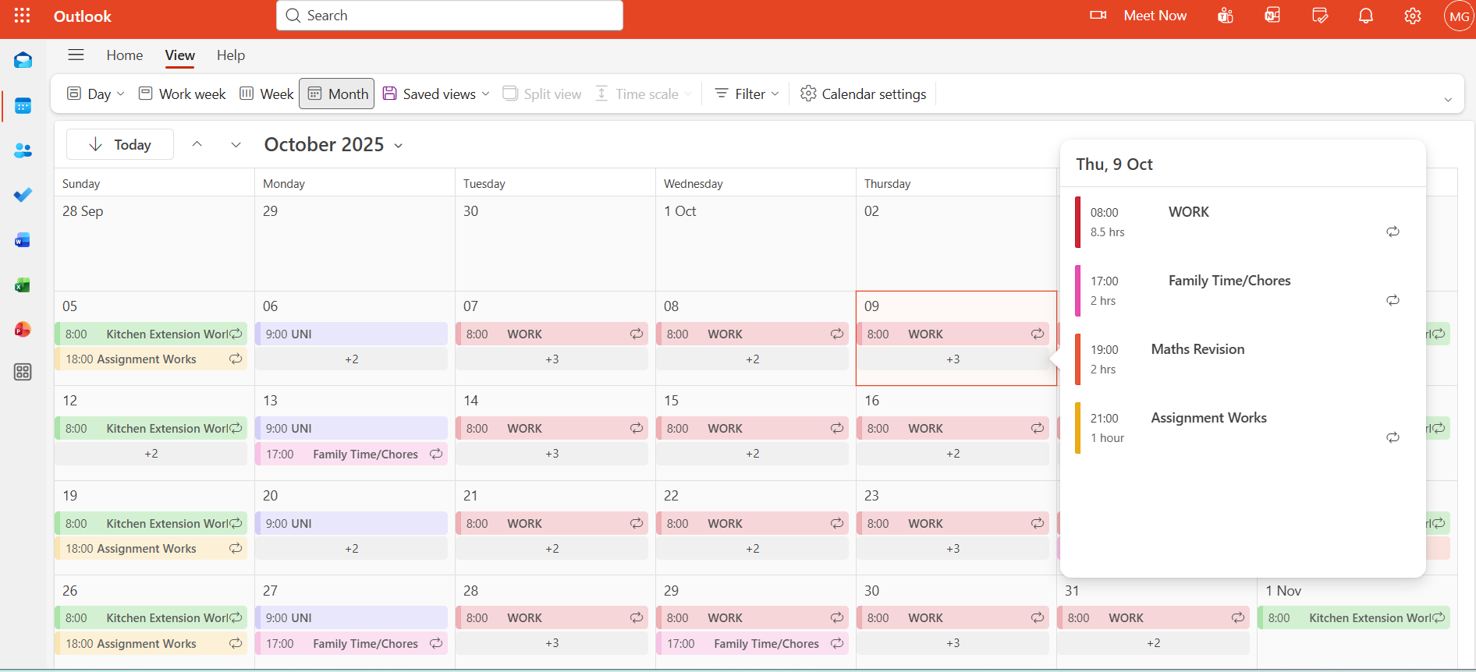
Figure 10: Digital Calendar
As seen in figure 10, a screenshot of my digital calendar. Within my plan was also structured approach to revision for Maths as shown below. Where I tried to implement the 1-2-4-7 method to help with my memory and recall shown in figure 11.
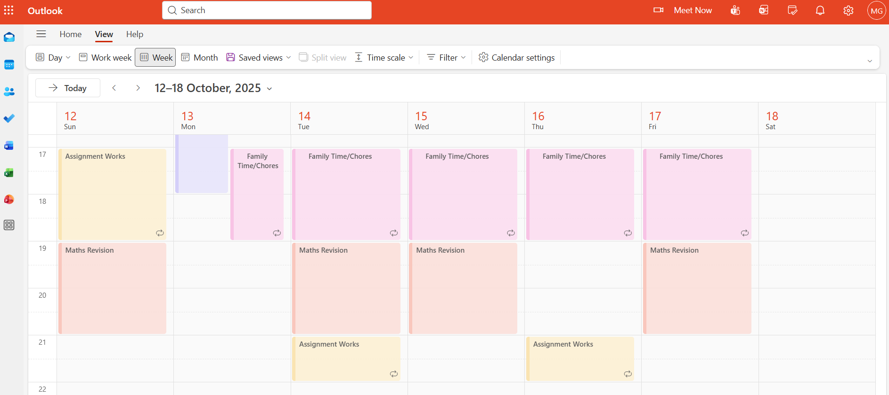
Figure 11: 1247 Rule on Digital Calendar

5.0 Conclusion
The module has highlighted a range of essential academic and professional skills that are fundamental to success in higher education and valuable for future career development. One of the key areas explored was presentation skills, where learning the principles of effective delivery combined with completing a presentation and receiving peer feedback helped identify clear strengths and areas for improvement. This experience reinforced the importance of continuous development, especially as employer expectations evolve alongside the modern workforce.
A significant theme throughout the module was the value of self-awareness. Engaging with personality, behaviour, and learning-style assessments provided meaningful insight into how I work both independently and within teams. Understanding these results will support my ability to adapt, collaborate, and make informed decisions about my personal development. The module also emphasised practical strategies such as time-blocking, which has proven to be an effective approach to managing workload and is a technique I intend to apply consistently across academic, professional, and personal contexts.
In addition, exploring topics such as data security and ransomware has increased my awareness of digital risks and the importance of safeguarding information an area that is increasingly relevant in both study and employment settings.
Overall, the module has encouraged reflective thinking, skill development, and a clearer understanding of the competencies needed for academic success and employability. Areas that would benefit from further study include advanced presentation techniques, deeper exploration of digital security, and continued development of personal effectiveness strategies. These will support ongoing growth and better prepare me for future academic and professional challenges.

6.0 References

Bibliography

[1] | U. o. Wolverhampton, “Skills for Learning - Guide to time management,” 2018. [Online]. Available: https://www.wlv.ac.uk/lib/media/departments/lis/skills/study-guides/LS008-Guide-to-Time-Management.pdf. [Accessed 2026].
[2] | K. Read, “Empowering Higher Education Through Digital Literacies and Digital Literacy Intergration,” UniversityBusiness, July 2025. [Online]. Available: https://universitybusiness.co.uk/digital-literacy-higher-education/. [Accessed January 2026].
[3] | IEEE, “Digital Literacy in Higher Education a Key Area to Close the Digital Divide,” [Online]. Available: https://ctu.ieee.org/blog/2023/01/25/digital-literacy-in-higher-education-a-key-area-to-close-the-digital-divide/. [Accessed 2026].
[4] | S. a. B. R. Drew, “The guide to learning and study skills: for higher education and at work,” Routledge, 2012.
[5] | University of Lincoln, “Critical Thinking and Problem Solving,” [Online]. Available: https://learning.lincoln.ac.uk/academic-skills/critical-thinking-and-problem-solving/. [Accessed January 2026].
[6] | G. a. B. J. Thwaites, in Thinking Skills Critical Thinking and Problem Solving, Cambridge University Press, 2013.
[7] | T. Brower, “5 SKills Students Need From Higher Education To Increase Employability,” Forbes, 02 February 2025. [Online]. Available: https://www.forbes.com/sites/tracybrower/2025/02/02/5-skills-students-need-from-higher-education-to-increase-employability/. [Accessed January 2026].
[8] | S. a. T. I. Montano, “Delivering skills that equip students for future career success,” [Online]. Available: https://www.birmingham.ac.uk/research/perspective/hei-equip-students-for-future-career-success. [Accessed 2026].
[9] | Department for Education, “Essential Digital Skills for work,” [Online]. Available: https://www.skillsforcareers.education.gov.uk/pages/skills-for-life/digital-skills/essential-digital-skills-for-work. [Accessed 2026].
[10] | 16 Personalities, “Logistican ISTJ Personality,” 16 Personalities, [Online]. Available: https://www.16personalities.com/istj-personality. [Accessed 2026].
[11] | I. B. Meyers, “The 16 MBTI Personality Types,” Meyers & Briggs Foundation, [Online]. Available: https://www.myersbriggs.org/my-mbti-personality-type/the-16-mbti-personality-types/. [Accessed 2026].
[12] | M. Belbin, “The Nine Belbin Team Roles,” Belbin, [Online]. Available: https://www.belbin.com/about/belbin-team-roles. [Accessed 2026].
[13] | Color Personality Test, “What is meant by color personality?,” [Online]. Available: https://www.colorpersonalitytest.net/. [Accessed January 2026].
[14] | B. Day, “The Ultimate Guide to SMART Goals,” Forbes, June 2025. [Online]. Available: https://www.forbes.com/advisor/business/smart-goals/. [Accessed January 2026].
[15] | M. Kosinski, “What is Ransomware,” IBM, [Online]. Available: https://www.ibm.com/think/topics/ransomware.
[16] | Kingston Technology, “The 3-2-1 data backup method: your best defence against ransomware attacks,” Kingston Technology, January 2025. [Online]. Available: https://www.kingston.com/unitedkingdom/en/blog/data-security/321-data-backup-method.

7.0 Appendices
Figure 1: Slide 1 of my presentation 2
Figure 2: Slide 2 of my presentation 2
Figure 3: Slide 3 of my presentation 3
Figure 4: Slide 4 of my presentation 3
Figure 5: Results of my learning style quiz 6
Figure 6: Results of my learning style personality 7
Figure 7: Results of the Belbin Team Role theory quiz 8
Figure 8: Colour personality test results 8
Figure 9: SMART Targets 12
Figure 10: Digital Calendar 14
Figure 11: 1247 Rule on Digital Calendar 15

