Guy Miguel Soares Costa- Student Number - 1705978 | Entrepreneurship – SBMA7111D Dr. Louise Emanuel | November 5, 2017

Entrepreneurship
  - Entrepreneurs
Contents
1 Introduction 2
2 Entrepreneurship and Entrepreneur 2
2.1 Entrepreneurship 2
2.2 The Entrepreneur 3
2.2.1 Entrepreneur as risk-taker 3
2.2.2 Entrepreneur as business manager 3
2.2.3 Entrepreneur as exceptional leader 3
2.2.4 Entrepreneur as perceiver/restorer 3
2.2.5 Entrepreneur as innovator 3
3 Motivation 3
3.1 Entrepreneurial Characteristics and Motivation 4
3.2 Selected Entrepreneur Biography 5
3.3 Entrepreneurial Illustrations 5
3.3.1 Need for achievement 6
3.3.2 Locus of control 6
3.3.3 Vision 7
3.3.4 Desire for independence 7
3.3.5 Passion 7
3.3.6 Personal drive 7
3.3.7 Goal set 7
3.3.8 Self-efficacy 8
3.3.9 Cognitive factors 8
4 conclusion 8
Bibliography 9

Introduction
“Entrepreneurship is the base of our economies and dictates the prosperity of a country.” (Carland Jr. and Carland 1997: 33). Entrepreneurship has ramified throughout all business set ups, from the small domestic’s start-ups to the well-known enterprises, becoming fundamentally important to our society.
Recently, in the last few years, researches and scholars demonstrating great interest on this subject, in which there has been a considerate increased amount of literature review. Names such as Bill Gates, Richard Branson, Steve Jobs and Mark Zuckerberg are frequently on tabloids as well as TV programs like Dragon’s Den have positively contributed for the exposure of the entrepreneurship and the entrepreneurs.
These individuals are constantly facing challenges, whereby in order to successful surpass them, they must possess a number of traits including motivation, in which the world benefits greatly economically with their work.
The word “motivation” is derived from the Latin word “movere”, meaning move. If we take into the entrepreneurship context, than the word motivation would be to move from a present situation to a better one. Entrepreneurs’ motivation would vary according to their circumstances they may find themselves in and their desire to achieve their goals.
Therefore, the aim of this assignment is to have a better understanding on the entrepreneurial motivation, considering the various environments such as economic, psychological and social that may determine an entrepreneur behavior, exemplified by a person that has had an impact to my region.

Entrepreneurship and Entrepreneur
Although the word “Entrepreneurship” was created around 1920s, its origins comes from the French word “Entrepreneur” in the 1850s. However only in the early 20th century, entrepreneurs such as Joseph Schumpeter and economist like Carl Menger, Friedrich von Hayek and Ludwig studied entrepreneurship
Joseph Schumpeter view an entrepreneur as “a person keen and prepared to use or change a new creation to a prosperous innovation”. “The entrepreneurs’ existence is to improve or renovate an existing product, by using or develop new or unproven technologies, to produce new goods or services influencing its marketplace.”

Entrepreneurship
Entrepreneurship is normally interpreted as a process of creating, initiating and managing a new business. Similarly it can be define as a person who creates, starts and manages his/her star-up, whereas an entrepreneur is accountable for the entire scope of his own company.

The Entrepreneur
These type of individuals are normally always looking for the next opportunity for business.
Furthermore, entrepreneurs are also associated to be equipped with certain traits that sets them apart from the ordinary people, in which makes them be successful on way they pursue. These characteristics were studied by different scholars and economist and can be seen below:

Entrepreneur as risk-taker
According to Richard Cantillon (1680-1734), these type of individual can anticipate business ventures and are willing to make calculated risks with a view to make a profit.

Entrepreneur as business manager
Frank Knight differentiates entrepreneurship from management. He perceives entrepreneurs as creators looking to be innovative, whereas managers are restricted to fixed salary controlling an enterprise.

Entrepreneur as exceptional leader
Marshall views entrepreneurs as individuals whom takes leadership and accountability and foresees the long term of a business or company, while delegating responsibilities to its employees on a daily, weekly and/or on a monthly basis (short term targets). Entrepreneurial main achievement is creation or development of traits (Hans Karl Emil von Mangoldt, 1824-1868).

Entrepreneur as perceiver/restorer
An entrepreneur has the ability to harmonize the economics markets with their way of thinking by continuously creating or re-designing new product with new technologies (John Bates Clark, 1847-1938).

Entrepreneur as innovator
Entrepreneur needs to be capable to foreseen an opportunity to obtain bargaining power within an economic marketplace. As per Joseph Schumpeter (1883-1950), entrepreneurs are innovators and not merely inventors, whom are not afraid in trying untested technologies to gather new products or services. They possess the desire and drive to accomplish their target, in which are characteristics of successful entrepreneurs.

Motivation
“The word motivation is commonly used on the cultural concept similarly as many other psychological ideologies are.” Maehr and Meyer (1997).
Normally “motivation” is considerate to be an individual’s desires and actions, within a person characteristics. Also it can be seen as a cycle whereby a person’s wish, influences a person’s behavior, in which would impact performance that would drive a person’s desire and so on, noting that at the individual’s attitudes, belief and determination will influence the person’s overall motivation experience.
Hereunder we may find opinions from different researchers on this subject:
According to Berleson and Steiner (1964), motivation is an internal indication that forces, initiates or directs behaviors to objectives.
“Motivation is a process to trigger cultures to initiate and achieve their targets” William G. Scott (1967). Yet, as per Dalton E. McFarland (1974) ideology “Motivation is a human being behavior influenced by its desires, determination and needs.”

Entrepreneurial Characteristics and Motivation
Shane et al (2003), developed a structure with factors, based on possible outcomes that may influence the entrepreneur during a project stage, in which could also enhance his/her knowledge, constituting by: Need for achievement, Locus of control, Vision,
Shane et al outline drivers are; Need for achievement, Locus of control, Vision, Desire for independence, Passion, Drive, Goal setting, Self-efficacy, and the cognitive factors; Vision, Knowledge, Skills and Abilities.
To illustrate better, an entrepreneur will be used so that a better understanding can be reach on the drivers mentioned above.

Selected Entrepreneur Biography
Isabel dos Santos

Birth: April 20, 1973 Born in Baku, Azerbaijan's USSR
Nationality: Angolan
Fortune: Estimated 3 billion dollars
Mother: Tatiana Kukanova
Father: José Eduardo Dos Santos
Spouse: Sindika Dokolo
Occupation: Entrepreneur, Businesswoaman, Investor.

Entrepreneur Isabel dos Santos, daughter of former Angolan president Jose Eduardo Dos Santos, Founder of the Company Unitel International Holdings BV, Santoro Holding; Media, Telecommunications, Financial Services, Oil.

Entrepreneurial Illustrations
Her first employment was at Urbana 2000 Company, in the early 90’s as an engineer and Project Manager, following her completion of a Bachelor of Arts & Science from King’s College in London.
In 1997, Ms. Isabel dos Santos opened her first restaurant, Miami Beach, at ilha de Luanda, at age 24.
FORBES magazine named Isabel José dos Santos, the first female billionaire in the African continent, worth an estimated USD $ 3.7 billion (March 2014). Moreover, by increasing her shares in Portugal’s ZON multimedia (TV and internet company) to 28%, valued at USD $385 million, she is considerate to be within the 40’s richest people in Africa.
She further diversified her business by acquiring 19% in one of the major banks in Portugal, Banco BPI, and a further 25% in Banco BIC estimated at USD $160 million. Also she has 7% on Portugal’s Oil and Gas Company Galp Energy. In June 2016, she was named as a CEO of Sonangol, the Angolan state Oil Company.
Ms. Dos Santos manages her business via two companies: Santoro Finance, in Portugal and Unitel International Holdings BV, in Holland.
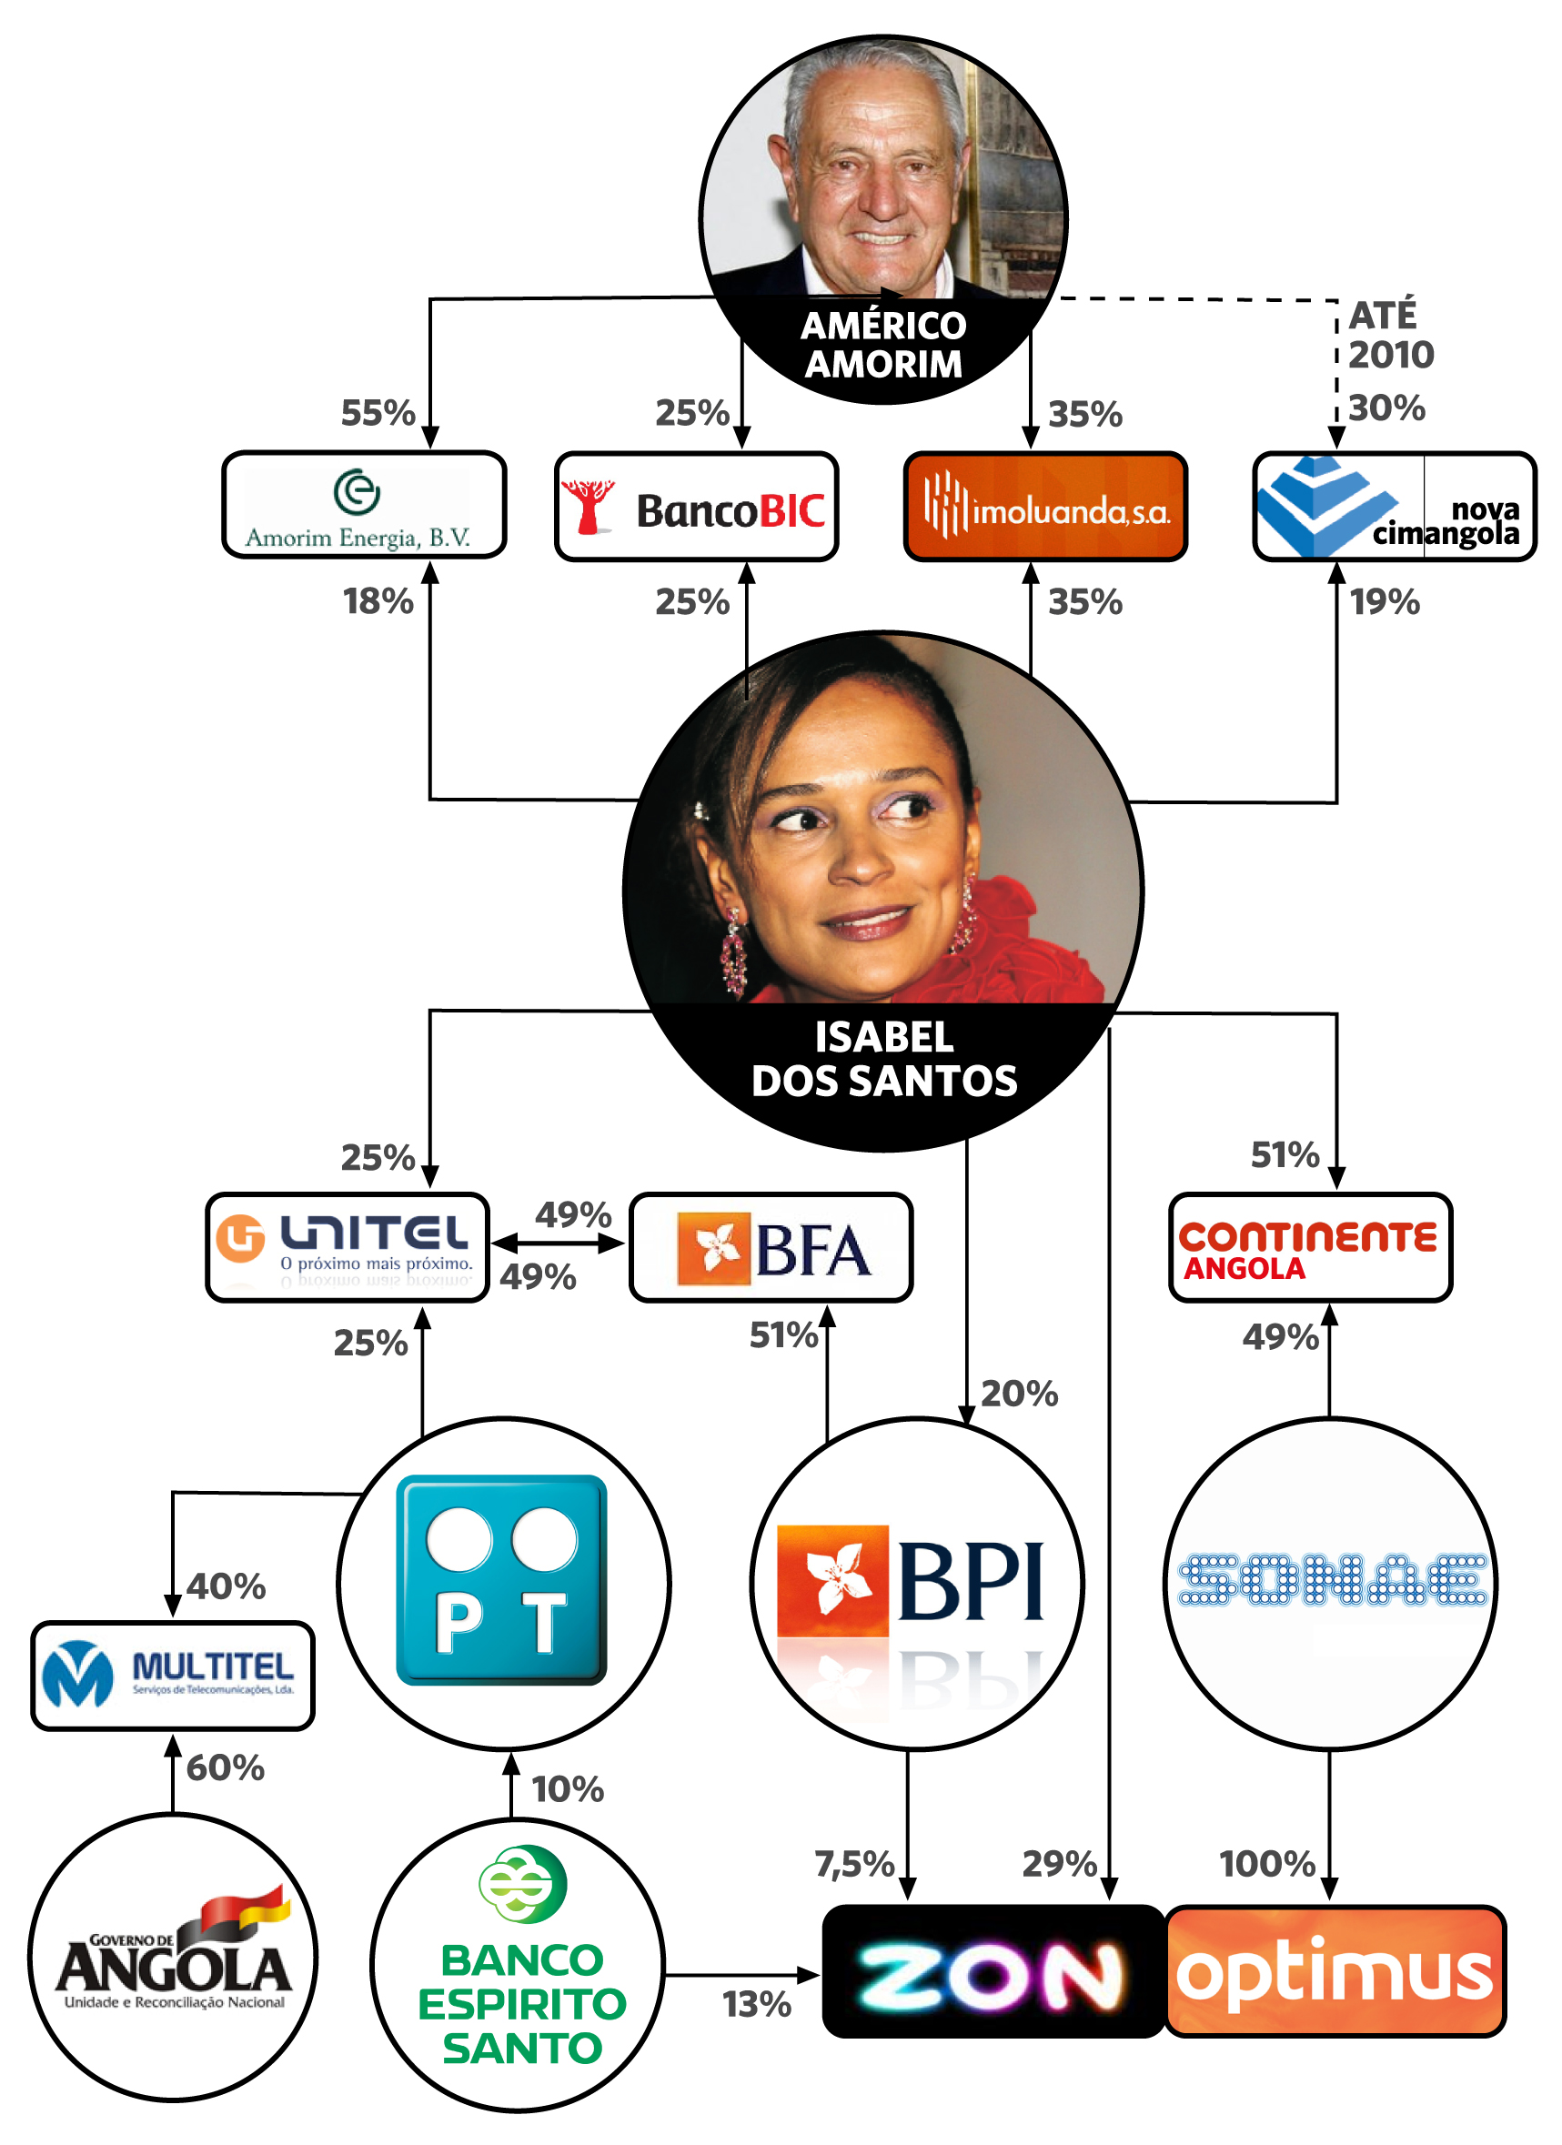
Fig 1 – Illustration on how Isabel dos Santos successfully diversified her business Empire.

Need for achievement
This element is a very influential to an entrepreneur whom strives for excellence. According to Baum & Locke (2004) it is a factor embed in numerous stages of objectives, a method developed by David McClelland in the early 50’s. The concept entails of an individual encountering inward barriers, for supremacy and achievement. Collins et al. (2004) supports the same idea and states that the person is involved in projects in need for meticulous preparation for a long future target advantages. Observing an interview (lunch with Isabel dos Santos, Financial Times), Ms. Dos Santos, recalls the time whereby she initiates the Unitel project (today arguably the biggest telephone Company in Angola) out of a development of a new walkie-talkie system, let to a telecommunications market, in which at the time there was no other company able to provide these services (mobile phone and internet) in the country, apart from the traditional landline.

Locus of control
Locus of control demonstrates whether the person possesses the inner self-believe and control or if the individual is depended on external factors (Rotters, 1966). This view is mutually shared by the other researches such as Shane et al. (2003), agreeing that the individual can either rely on his/her performance, or may be dependable on external factors to be successful.
Considering Ms. Dos Santos background (academically and her development to an inspiring entrepreneur in opening or investing into businesses), it could be argued that she embraces both inner self-believe and external factor, given that according to her interview (lunch with the Financial Times, 2013) indicating her tough upbringing, even though she is one of the former president of Angola’s daughter (led the country for 39 years, until 23rd September 2017), in which may have influenced on her accomplishments.

Vision
A former GE CEO, Jack Welch once stated “employing the right people around you, and give them the opportunity to show their worth, and use a career path as a method of compensation, you would hardly have to manage them. The culture factor will.”
Isabel dos Santos does exactly that, by allowing her company Santoro Finance (a consultancy company whom she employs well experience individuals from various market environments) to conduct various different businesses, nevertheless she remains the main driving force of the company’s targets.

Desire for independence
Many researches acknowledge that entrepreneurs are bound to undertake their own actions and choices illustrating their independency (Shane et al, 2003; Carsrud &Bränback, 2009; Hisrich, 1985).
Ms. Dos Santos demonstrated accountability and responsibility when decided to start-up a new project Unitel. According to the interview she held with the Financial Times (FT), 2003, “He (her father José Eduardo dos Santos) was not aware of the project”.

Passion
As per Shane et al (2003), an entrepreneur would naturally show signs of selfishness, keeping the individual motivated to conclude its targets. Moreover, Baum et al (2001) goes even further stating that it is imperative for the individual to have the passion and the drive to conclude a projects and/or a start-up.
This concept could be seen in the form of businesses MS Dos Santos opened, from her first restaurant at the age of 24, to a more complex ventures such as Unitel enterprise and other known investments mentioned earlier.

Personal drive
Successful entrepreneurs normally strive for excellence, in which they would have to maintain a high willpower, focus, drive and perseverance, to achieve their objectives.
During her interview (Lunch with Isabel dos Santos FT, 2013) there is a part where she states “I do work throughout the week. Seven days per week”. This statement clearly shows her personal drive and why she is so successful.

Goal set
According to Perwin (2003), he summarizes a goal set as ongoing target to be reached in the future, whereby is interlinked between an act and an aim. Nevertheless, setting a goal it is only to have a clear pathway, in which may change depending of the environment or the circumstances. Yet, if an entrepreneur has the drive to reach its goals, there will be an increase in motivation to successful achieve the desire target.
Observing Ms. Dos Santos Empire, it illustrates how her goals did change from when she initiated her entrepreneurship. From a restaurant in ilha de Luanda to owning big enterprise in telecommunications, and huge investments in banks, etc., Ms. Dos Santos continues to look for new opportunities to expand her businesses.

Self-efficacy
Banudra (1977) understands that the entrepreneur success correlates with their level of self-efficacy. In other words, the more confident an entrepreneur is, the higher is the chance for the entrepreneur to be successful.
Given the amount of business and investments in different markets Isabel dos Santos acquired, it is possible to say that she do has a high level of self-efficacy.

Cognitive factors
In line with Locke (2000), motivation is influenced by traits or cognitive factors such as skills, vision, knowledge, abilities, etc. When commencing a new project, the individual would need to be aware as much as possible of the significant information related to the project and its environment. Hence a business opportunity may appear from the entrepreneur’s bargaining power. Furthermore, the individual would need to be able to adapt at any given time to the business environment, in which entrepreneurs would need to perfect this ability to be prosperous (Shane et al, 2003).
As previously mentioned, through hard work, Ms. Dos Santos were attaining skills, enhanced her knowledge and had the vision that made what she is today, a very successful entrepreneur and a businesswoman, according to International newspapers “a very energetic good businesswoman, intelligent, who’s also great professional” (O Público, 2007), “even some critics conceded that Isabel dos Santos’s self-governing abilities as a businesswoman” (Financial Times, 2013).

conclusion
During this assignment, it could be concluded that, motivation is an essential trait on entrepreneurs’ lives. It was also understood that the higher the level of motivation a person may have, the higher are the chances for the same to achieve his/her goals. Overall is an interlinked factor between desire and action to trigger the person’s initiative.
This could be comprehended when an entrepreneur was studied. Based on researches theories, it was possible to have a positive analytical outcome because it matches with real life actions of the person in study.
Therefore, it could be said that an entrepreneur’s behavior in different environments0 is influence according to their entrepreneurial motivation.

Bibliography
Ajzen, I. (2005). Attitudes, personality and behavior (2nd ed.), Berkshire, England: Open University Press.
Aldrich, H. (2000). Organizations evolving. Beverly Hills: Sage.
Aldrich, H., & Zimmer, C. (1986). Entrepreneurship through social networks. In D. Sexton, & R. Smilor (Eds.), the art and science of entrepreneurship (pp. 3–23). Cambridge, MA: Ballinger
Ahmad N. & Hoffmann A. 2008. A Framework for Addressing and Measuring Entrepreneurship. OECD Statistics Working Paper No. 2. Available at SSRN.
Ajzen, I. (1991). Theory of planned behavior, Organizational Behavior and Human Decision Process, 50 (1), 179-211.
B. Berleson and G. A. Steiner, Human Behavior: An Inventory of Scientific finding, P. 240, 1964
Bird, B. (1988). Implementing entrepreneurial ideas: the case for intention. The Academy of Management Review, 13 (3), 442-53.
Carsrud, A., & Brannback, M. (2011). Entrepreneurial motivations: what do we still need to know? Journal of Small Business Management, 49 (1), 9–26.
Carland Jr. and Carland 1997: 33
Caroll Shartle: Executive Performance and Leadership, P. 191, 1956.
Dalton E. McFarland, Management Principles and Practices, New York, p. 537,1974.: 68
Gaglio, C. M. & Winter, S. (2009). Entrepreneurial alertness and opportunity identification: Where are we now? In Carsrud, A.L. & Brännback, M. (eds.), Understanding the entrepreneurial mind, International Studies in Entrepreneurship, 24, 305-325, DOI 10.1007/978-1-4419-0443-0_14.
Hopp, C. & Stephan, U. (2012). The influence of socio-cultural environments on the performance of nascent entrepreneurs: Community culture, motivation, self-efficacy and start-up success.
Entrepreneurship & Regional Development: An International Journal, 24(9-10), 917-945.
Keeble, D., Bryson, J. & Wood, P. (1992). The rise and fall of small service firms in the United Kingdom. International Small Business Journal, 11 (1), 11-22.
King-Kauanui S., Thomas K.D., Waters G.R. & Gilea G. (2010). An exploration of entrepreneurship and play. Journal of Organizational Change Management, 23 (1), 51-70.
McShane, S. L. Glinow M. A. V. (2010). Organizational Behavior. McGraw-Hill/Irwin, 5th Edition.Moorhead Griffin, Organizational Behavior, P. 118, 1999.67:
Morris, M. H. and Lewis, P. S. (1991). Entrepreneurship as a significant factor in social quality of life.
Journal of Business Research,
23(1):21-36. Mueller, S. L. and Thomas, A. S. (2000). A case for comparative entrepreneurship: assessing the relevance of culture.
Journal of International Business Studies. 31(2): 287
Robinson, P. B., Stimpson, D. V., Huefner, J. C., and Hunt, H. K. (1991). An attitude approach to the prediction of entrepreneurship. Entrepreneurship Theory and Practice, 15 (4), 13- 31.
Schumpeter, J. A. (1934). The theory of economic development. Cambridge, MA: Harvard University Press.
Segal, G., Borgia, D. & Schoenfeld, J. (2005). Motivation to become entrepreneur. International Journal of Entrepreneurial Behavior and Research, 11 (1), 42-57.
Shane, S., Locke, E. A., Collins, J. C. (2003). Entrepreneurial motivation. Human Resource Management Review, 13 (2), 257-279.
https://www.ft.com/content/6ffd2edc-955e-11e2-a4fa-00144feabdc0?mhq5j=e6
https://www.forbes.com/profile/isabel-dos-santos/
https://www.blackentrepreneurprofile.com/profile-full/article/isabel-dos-santos/
http://www.dw.com/en/the-growing-empire-of-angolas-first-daughter-isabel-dos-santos/a-36162875
https://successstory.com/people/isabel-dos-santos
https://upclosed.com/people/isabel-dos-santos/
http://www.bbc.com/news/world-africa-36443205

