University of Wales Trinity Saint David



Effective Team Working and Communication
Assignment 1

Student name: Diana Bravo Fernandes
Student number:1912499
Professor name: Afzal Munna
Module code: BMSW4002
Word count: 2075
Date: 4th May 2020

Table of contents

Introduction 2
Definition of communication 3
Verbal and nonverbal communication 3
Verbal communication 3
Types of verbal communication 3
Non-verbal communication 4
The types of non-verbal communication 5
Importance of communication 6
Importance of effective communication 6
Barriers to communicating effectively 7
Importance of listening in effective communication 7
Models of communication 8
Shannon and Weaver model of communication 8
Critical analysis to Shannon-Weaver´s model of communication 9
Berlo’s SMCR model of communication 9
The elements of Berlo´s SMCR model of communication 9
Critical analysis to Berlo´s SMCR model of communication 10
Schramm´s model of communication 10
Critical analysis to Schramm´s model of Communication 11
Communication at my workplace 11
Conclusion 12
References 14

Introduction
Communication is a process of great importance in everyday life. It focuses on the way that humans through a diversity of media and channels use verbal and non-verbal messages to transmit information. The communication models allow a demonstration of how the process occurs based in different models, however with very similar ideas.
Establishing an effective communication is vital to maintain personal and professional relationships. Within the companies, the process must occur in the clearest, most objective and effective way possible, so that the information is properly interpreted, and the work flows correctly.

Definition of communication
Communication is the process of sharing/ exchanging information, knowledge, ideas and feelings through verbal and non-verbal messages, seeking a mutual understanding between two or more individuals or even a mass audience.
The communication process also takes place in the way humans connect with each other creating a relationship. Communication is fundamentally a relational phenomenon (Rodriguez, 2010).

Verbal and nonverbal communication

Verbal communication

Verbal communication is referred to the communication in which messages operate through language. Verbal communication is all communication that is spoken and written (Fujishin, 2000).

Types of verbal communication

Oral: Oral communication is the form of communication mostly used as it consists in exchanging information and thoughts through spoken words. It plays an important role in effective communication as it allows the sender to transmit the information and instantly get a feedback from the receiver. Oral communication can be performed between individuals face to face or through channels like phone calls and text messages.

Negative point on oral communication
- The speaker most of the times surrounds himself in detail, believing that this is the most effective way of transmitting the content. This way, leading to lack of interest on the receiver´s side.

Written: written communication consists in exchanging information and thoughts through writing. It is a safe and decent way of communication because the message is registered and can be used in the future as a proof if needed. It is an accessible way of communication because it is simple and objective. The mediums used in the written communication could be emails, text messages and newspapers.

Negative point on written communication
- Could be a barrier to those who have not had literary education

Examples of verbal communication:
- lady reading the newspaper
- friends having a conversation
- worker emailing his employer
- poster in a school entrance about a science fair for example.

Non-verbal communication

Non-verbal communication is the form of communication that consists in the use of body language and visual signs to be effective. Body language is a set of all expressions and behaviours of the body. In other words, “nonverbal communication is all the communication that is not spoken or written” (Fujishin, 2000, p. 5).
The signs shown through the body language have an influence in the communication process because they could demonstrate confidence, respect or rudeness and lead to misunderstandings.
Non-verbal communication is important because it combines the messages conveyed through the body language together with what is said in words.

The types of non-verbal communication

The different types of non-verbal communication include voice, eye contact; facial expressions; body movement and posture; gestures, touch and space.
Voice: Feelings and emotions can be revealed by the tone of voice. Happiness or in satisfaction can be interpreted by the receiver of the message being transmitted based on how the sender accentuates the voice.
Eye contact: A good visual contact makes the receiver feel attracted and interested in what in speaker is imparting.
Facial expressions: It is possible to transmit feelings like satisfaction, joy, anger and anguish without speaking, only through facial expressions.
Body movement and posture: The way of sitting, walking, positioning hands and how gentle or rough are someone´s movements are factors that can influence a first impression.
Gestures: Making the correct use of gestures is important as some gestures could be considered normal in some cultures and offensive in others.
Touch: Touch can demonstrate affection, support, or agreement in attitudes like hugs, a pat on the shoulder, or a handshake for example.
Space: The proximity between individuals during the process of communication, depending on the culture or circumstance could reveal more about the relationship

Negative point on non-verbal
- Judgemental characteristics of humans that lead to early conclusions

Importance of communication

Communication is a fundamental social component that build relationships, behaviours and personalities.
Different societies across the world have access to international content and are not limited to national knowledge because of the new technologies and the expansion of social medias. In addition to the news on televisions and radios, digital platforms like Facebook and LinkedIn are used by publishers and journals to share sources of information regarding the latest news across the globe.

Importance of effective communication

Communicating effectively goes far beyond the simple process of exchanging information. It can be a lot more complex regarding the skills like listening, body language, posture and the way the messages are transmitted in order to have a proper understanding and feedback.
Having knowledge in communication skills is very important, especially when dealing with different groups of people. The skills used to communicate with children in a primary school is different than the skills used in a university for example. Besides this, having a good communication skill can expand connections among individuals establishing respect, trust, and enhance the efficiency in teamwork, decision making and general social questions.
Effective communication is also important in the maintenance of good relationships in the workplace. It is essential for all employees to be in tune in order to maintain their interest in pursuing the same goals and objectives, this way leading to the success of the organization and the customer satisfaction.
On the other hand, if the communication fails, there are higher chances of having misunderstandings causing disunity between the staff within the company.

Barriers to communicating effectively

Communication has a huge influence in relationships, in the workplace and academic field. Barriers in the communication process include contradictory body language; lack of focus; unfavourable body language; lack of emotion/anxiety control.
Contradictory body language If the non-verbal signs do not match the verbal signs, the sender could pass an image of incredibility. For example, mentioning about being happy while showing an opposite posture.
Lack of focus: The lack of attention during communication can show disinterest. Keeping distance from other distractions such as mobile phones or other worries is important to understand and provide a good feedback.
Unfavourable body language: In case of divergence during a conversation, bad postures like crossing arms and looking away are all ways of showing dissatisfaction in a disrespectful way.
Lack of emotion control: Emotional imbalance can lead to misinterpretation of messages making the whole process of communication more difficult or even lead to major problems.

Importance of listening in effective communication

Listening is a fundamental element for an effective communication. It not only allows the understanding of the message but also the feelings and thoughts of the speaker. During the communication process if the listener is committed to listening attentively, the messages are well understood and the probability of giving a good feedback is higher.
Postures to improve effective communication include:
- demonstrate interest to what is being said
- prevent negative body language
- convey the messages with clear words
- listen attentively
- provide a feedback

Models of communication

Theorists have developed several models of communication. Models provide a concrete way to see how concepts and processes work (Fujishin, 2000).

Shannon and Weaver model of communication

The Shannon and Weaver model of communication is a model of communication created by the mathematics C. E. Shannon and W. Weaver.


Figure 1 - Shannon-Weaver model of communication

The source comes up with an information, then the encoder arranges the information from the source into a form that the audience can interpret. The message is conveyed from the sender to the receiver and is sent through a channel that could be a phone for example. The message is decoded so that the receiver can interpret it. Then the feedback is provided by the receiver to the sender about the correct interpretation of the message. The noise symbolizes an intrusion within the channel that can alter the accuracy in how the message reaches the receiver. The noise could be several people speaking at the same time or a network failure that does not allow messages to be sent.

Critical analysis to Shannon-Weaver´s model of communication

- Feedback was taken as less essential than the message sent by the sender
- The mathematical way the process shown doesn’t apply to the human nature

Berlo’s SMCR model of communication

Berlo´s SMCR model of communication is composed by a source, a message, a channel and a receiver.


Figure 2 - Berlo´s SMCR model of communication

The elements of Berlo´s SMCR model of communication

The elements that characterise Berlo´s model of communication is affected by different factors.
Sender: the messages encoded by the sender are based on factors like communicative skills, knowledge and social values. The sender sends the message in agreement of the receiver´s understanding.
Message: Once the message is encoded by the source and reached the receiver, he/she must precisely interpret the message with the same knowledge as the sender.Videos, documents, texts, or audios represent the content the sender sends to the receiver.
Channel: The channel represents the intermediate by which the messages are sent to the receiver. Mediums like television and internet are used to transmit messages.
Receiver: The receiver decodes and interprets the message sent by the sender. In order to establish an effective communication between the sender and receiver both sides share the same knowledge and understanding.

Critical analysis to Berlo´s SMCR model of communication

- Noise was not taken in consideration
- Feedback was not included in this model, leaving the communication process depending only on the sender.
- Not all cases of individuals with different cultures affects the efficiency and understanding in communication

Schramm´s model of communication

In Schramm´s model of communication, the interaction between the sender and the receiver is the main element to establish an effective communication.

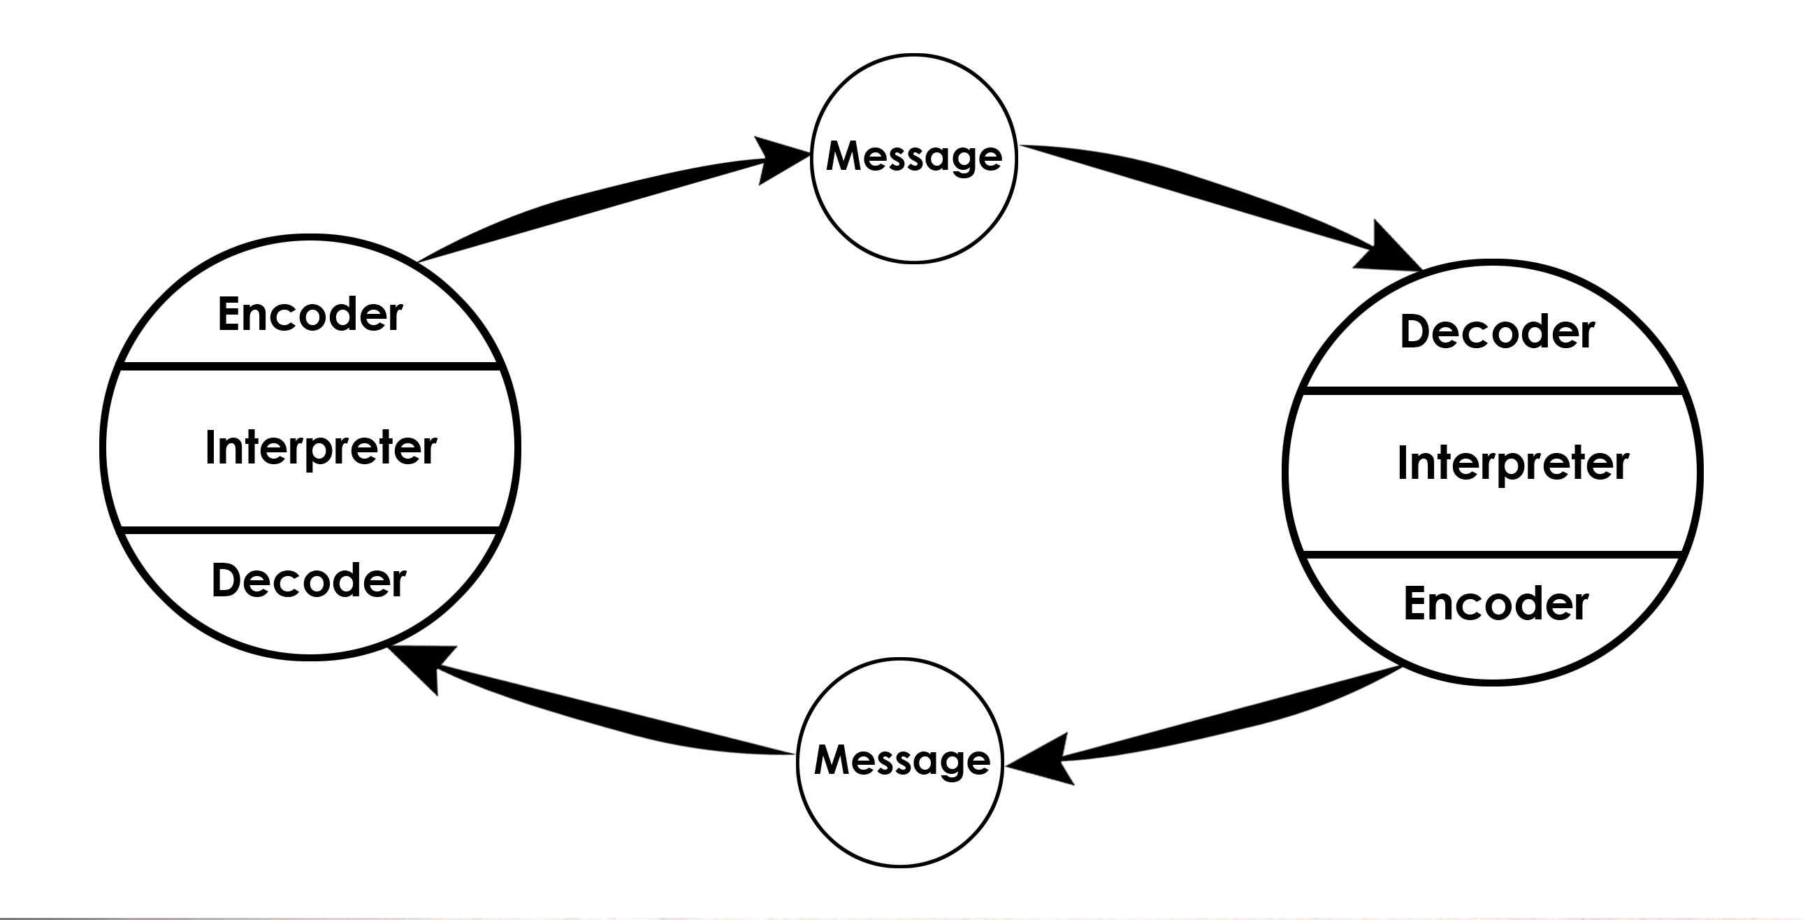
Figure 3 - Schramm´s model of communication

The model of communication created by Schramm centres on the importance of the proper interpretation and feedback from the receiver in response to the message sent by the sender. The receiver of the message is important because the process is only effective if there is a feedback based on a mutual understanding between the sender and the receiver. “In his relational models of 70´s Schramm was concerned about the effects on the communication on the receivers” (Narula, 2006, p.31). According to Schramm´s model of communication, the messages can produce either a positive or negative influence in the receiver, consequently affecting the effectiveness in the process.

Critical analysis to Schramm´s model of Communication

- The existence of noise was not taken in consideration

Communication at my workplace

Communicating effectively at the workplace is important to succeed professionally and personally. It is essential to establish a good relationship between colleagues and managers in order to facilitate the execution of all tasks within the company.
At my workplace, the communication is very effective. As the main tasks are picking and packing products from online orders for delivery, a lot of teamwork is required. We usually communicate face to face, with emails and phone calls. Because the tasks are performed one according to the functionality of the other, all workers stay tuned with all the departments and execute the tasks accordingly. The occurrence of errors or failures resulting from ineffective communication at my workplace is extremely low.

Conclusion

Communication is the process of exchanging information. The process could be expressed through verbal (spoken or written) and non-verbal (body language) communication. Once those two types of communication are combined and used accordingly the efficiency in communication is increased.
Communication has a great importance among humanity. Not only as an informative tool but also as an element responsible for uniting all societies across the globe. It also plays an important role in the workplace as it is the fundamental element for a successful business.
In order to establish an effective communication is crucial to pay attention to skills like body language, listening, understanding and giving a constructive feedback. The different models of communication created by Shannon and weaver, Berlo and Schramm assist in the schematic understanding of how the communication process takes place in different perspectives, however with the same idea.

References

Fujishin R., (2000). Creating Communication. 1st ed. Rowman & Littlefield Publishers, inc., Lanham, Maryland
Janse B., 2018. Berlo's SMCR Model of Communication, [online] toolshero. Available at: <https://www.toolshero.com/communication-skills/berlos-smcr-model-of-communication/> [Accessed 18 April 2020].
Maund A., Schriek M., Tinkler P. K. (2017) Certificate in Higher Education: Skills for the Workplace Student Yearbook. 1st ed. Sage Pub. Ltd., London
Narula U., (2006). Communication Models. Atlantic Publishers and distributors (p) Ltd. New Delhi
Rodriguez A., (2010). Revisioning Diversity in Communication Studies. Troubador Pub., Ltd. Kibworht, Leicester
Robinson L., Segal, J. and Smith, M., (2019). Effective Communication. [online] HelpGuide.org. Available at: <https://www.helpguide.org/articles/relationships-communication/effective-communication.htm> [Accessed 10 April 2020].
Segal J., Smith, M., Robinson, L. and Boose, G., (2019). Nonverbal Communication. [online] HelpGuide.org. Available at:<https://www.helpguide.org/articles/relationships-communication/nonverbal-communication.htm> [Accessed 28 March 2020].
Sen L., (2007). Communication Skills. 2nd ed. PHP Learning Ltd. New Delhi
Thompson N., (2018). Effective Communication. 3rd ed. Red Globe Press, London

