An investigation on how artists use techniques to create hyper realistic creature design.

Sean Ferris
Swansea College of Art, UWTSD
Aloisferris96@gmail.com

Keywords: Creature Design, Hyperrealism, Visual Perception, Horror, Uncanny.

Introduction
This paper is about how artists use different methods to create hyper realistic creature design. This falls into the category of hyperrealism. Hyperrealism is defined as an art style, which involves art characterised by capturing highly realistic lifelike representations. “Hyperrealism can create an atmosphere of Surrealism because nobody sees the world in such detail.” (Rushdie. S.) This style is handled in a method that can be exaggerated, which looks hyper in terms of constructing an art piece.
The intention is to have two final creature designs; however, to create impact on the audience through hyperrealism techniques. The project of these two final creature designs will be referenced for the main project, ‘Cellus’. Horror will be used in the concept art to develop skills and connect artists that will be used as inspiration. To understand what horror is, it is about having the intense feeling of fear, shock or disgust. This also relates to the uncanny affect, which also means something that is mysterious, but in an unsettling way. Hyperrealism is about creating an illusion of realism, by “deceiving the eye”. René Magritte, a surrealist artist says, "Everything we see hides another thing; we always want to see what is hidden by what we see." (Magritte. R. 1964)
The investigation includes a design for a project called ‘Cellus’, where the creature design will be used as concept art. Primary research will be based around a practical digital creature design using digital painting. It will also include analytical areas of the design, with methods that will be used.

Project-specific research
The specifics of this project will be analysing and studying techniques of artists that can engage an audience through hyper realistic detail and how their art pieces relates to hyperrealism. The films will be used to study horror through creature design. The artists are Aaron Sims and H. R. Giger. Their work consists of airbrush painting, biomechanics and digital painting. In terms of how this relates to hyperrealism, these artists have realistic and similar traits to creating conceptual artwork with their techniques.
Aaron Sims is a concept artist, who uses digital painting working in previsualization, developing character designs, environments and key frame shots for films. Throughout his artwork, the designs and realism are relatable to hyperrealism. His work shows hyper realistic detail through the character design, accurate painting, shading and lighting.
H. R. Giger is an artist who uses an air brush method. He suffered from nightmares and drew the horrific designs of monsters for the Alien 1979 film, directed by Ridley Scott. H. R. Giger is well known for his book, Necronomicon, which was published in 1977. He was then hired by Ridley Scott for the Alien 1979 film for producing artwork and conceptual designs. “At its essence, Giger’s art digs down into our psyches and touches our very deepest primal instincts and fears,” Ridley Scott said. Through his artwork he created erotic bio-mechanical mixes of humans and machines. A documentary called Giger’s Alien, 1979 will be used to investigate further into his work. (Scott. R. 1979)
Researching the anatomy of monkeys and humans, will help in developing the creature design. It will be crucial to examine how bipedal and quadrupedal creatures function through movement. Muscle structure and skeletal research, will improve the creature design aspect. Therefore, a variety of animal anatomy will be included in the research.
To explore further, films such as Alien 1979, by Ridley Scott and The Thing 1982, by John Carpenter will be used for observing the type of horror. The methods will be investigated as the horror genre is important to understand and see how this can affect an audience.
Visual perception is an important factor for the study because the audience can be affected by the way they perceive the visual information. Visual perception is described as what a person can see through their eyes.
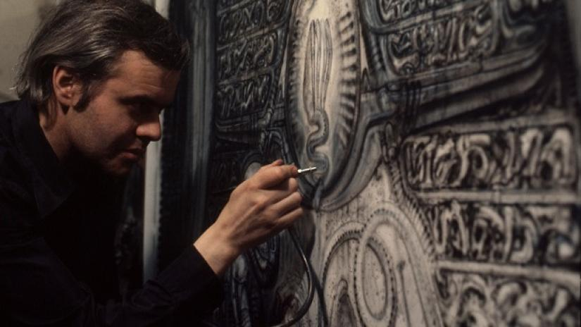
H. R. Giger, Alien (1979)
The creature design should have an impact on people, making them react with fear and anxiety from the horror genre of the creature design. This outlines an ethical issue, where this could have an impact on children, young people and people with a learning disability or cognitive injuries. For example, giving them nightmares, intimidating or overwhelming, causing them to dislike the appearance of the final design. This is important to consider, as it may drive an audience away and affect them in a negative way. The likeliness of the creature design being uncanny can cause an affect.

Proposed Methodology
The methodology will be about deconstructing artist work, analysing and understanding the use of their techniques. Qualitative observation will be used on tutorials, crucial for understanding methods and using them to guide the development as tutorials will be needed for developing the creature design.
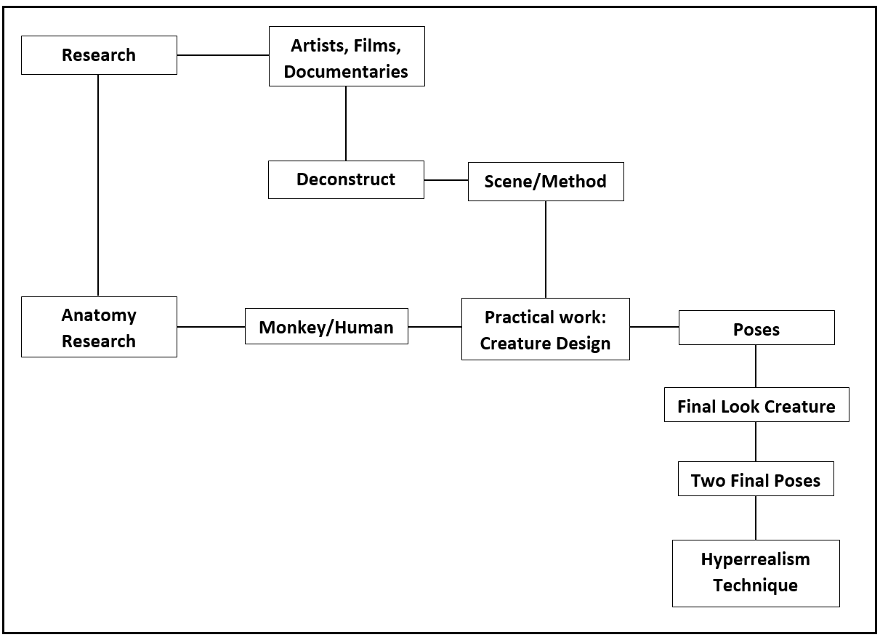
Diagram 1 Project Layout, by Sean Ferris
This diagram shows the layout of the art practise. The diagram shows the specifics of research, deconstruction of the artists’ method, scenes from each film. Falling into the category of producing the creature design, which is categorised with poses, look and two creature designs, then use hyperrealism technique.
The fundamentals of developing the creature design is needed to develop the final. Therefore, the basics need to be addressed such as shading, building layers, texture, poses, perception, perspective and rules of value. All these techniques will be identified throughout the practise and thoroughly explained.
The design of the creature is going to be in a horror and science fiction fashion. The inspiration will be drawn from various areas such as Alien 1979, The Thing 1982 and Stranger Things 2016 by The Duffer Brothers. The designs of their creatures bring horrific and terrifying scenes in the films, which scare a certain audience. The art practice will have different approaches designing the creature, which will include background research into creating a type of horror. For example, the creature will be effective in the visual aspect, however, films help with developing an atmosphere around the creature design. In Alien, the director, Ridley Scott used lighting and shadows to manipulate the atmosphere in the film.
This includes a comparison between hyperrealism and photorealism, discussing how hyperrealism can engage an audience differently. This also tackles the consideration of the viewers’ perception of understanding of a painting, where hyperrealism is used to create a realistic feeling.
During the art practice a graphics tablet will be used along with a software, Photoshop. Learning from these artists, H. R. Giger and Aaron Sims use traditional methods, which can be used by making similar brushes digitally, in the software. As per their paintings, they follow a method to develop their artwork in their own style.
H.R. Giger uses many different techniques of creating his artwork. He creates erotic art pieces with beautifully twisted art. H. R. Giger says “there is hope and a kind of beauty in there somewhere, if you look for it.” His art mixes with modern science fiction, where he features erotic bio-mechanical artwork when he worked for the film Alien.
Aaron Sims uses digital art through 2D and 3D, creating various characters, creatures and environments, using software such as Photoshop and Zbrush. Aaron Sims creates visuals for pre-visualisations for films and games. Working as a concept artist, he immerses with different methods in Photoshop and Zbrush. For example, photo-bashing, building layers, lighting and shading.
Both styles follow similar roots of creating hyper realistic artwork. The techniques follow a set of stages, such as creating a creature design in accurate detail in drawings, then adding tone or value. Use brush strokes, clean thin lines, paint dark and shadows with very light layers.

Proposed Outcomes
The expectation of the dissertation is to have a fully detailed creature design that will affect an audience in a terrifying way. The investigation goes into detail about the techniques from the artists and their artwork, using inspiration from films, artists, tutorials and visual influences. The final two pieces will use hyperrealism as an effect to make an impact on the audience, making the visual of the creature more appealing. The visual of the creature design is meant to give an effect of horror.
The outcome of the project is going to be split into two separate new creature designs, using the methods of the both artists and inspired by them. This will affect the development where basic skills will be developing, creating a certain style through hyperrealism. Also, research based upon learning how to use Photoshop tools will develop various methods to create the final creature design. The focus of the final creature design will be to produce in one outcome, but repeated in two different versions, using various techniques from each artist.
By having to learn and develop new skills, the dissertation will present methods to explain the results of creating various creature designs. This will also show developing artists how to use hyperrealism to improve their own methods of creating conceptual art in creature or character design.
While, it is intended to create two creature designs, if time was interfering with the development, one final image of a creature design would support the context of dissertation. Evidence of using the methods would be needed, as well as presenting the deconstruction of films, documentaries, books and artists.

Bibliography
Books:
Bridgman. G. (1920). Constructive anatomy
Carmarthenshire College. (2012). Beginner's guide to digital painting in Photoshop. Worcestershire: 3DTotal.
Fer, B., Batchelor, D., Wood, P., & Open University. (1993). Realism, rationalism, surrealism: Art between the wars (Modern art, practices and debates). New Haven: Yale University Press, in association with the Open University.
Goldfinger, E. (2004). Animal anatomy for artists: The elements of form. Oxford; New York: Oxford University Press.
Lauridsen, H. et al. (2011) ‘Inside Out: Modern Imaging Techniques to Reveal Animal Anatomy’, PLoS ONE, 6(3), pp. 1–10. doi: 10.1371/journal.pone.0017879.
Mattingly, D. (2011). The digital matte painting handbook. Hoboken, N.J.: Wiley.
Royle, N. (2003). The uncanny. Manchester: Manchester University Press.
Sullivan, G. (2005). Art practice as research: Inquiry in the visual arts. London: SAGE.
Szunyoghy, A. & Fehér, G. (1996). Anatomy drawing school: Animal Anatomy. Köln: Könemann.
Simblet, S. & Davis, J. (2001). Anatomy for the artist. London: Dorling Kindersley.
Films:
Alien. (1979). [Film] Directed by Ridley Scott. Shepperton Studios, Shepperton, Surrey, England, UK.
The Thing. (1982). [Film] Directed by John Carpenter. Juneau, Alaska, USA
Online Videos:
Andrew Tischler, 2018. PAINTING A PORTRAIT in Oils - My favourite Techniques. [Online Video] Available at: https://www.youtube.com/watch?v=4Ib3Pfm1p5Q, [Accessed, October 10th, 2018]
Artists Around The World, 2017. HYPERREALISM Jono Dry and His Best Hyperrealistic Works - Artists Around the World. [Online Video] Available at: https://www.youtube.com/watch?v=JD7IJOP5YuA, [Accessed, October 17th, 2018]
Art and Animation of Chris Scalf, 2018.Digital Painting Hyper-Realism (freehand) in Photoshop. [Online Video] Available at: https://www.youtube.com/watch?v=-oj_q7ybXsk
CineFix, 2015. The Thing's Defibrillator Chest Chomp - Art of the Scene. [Online Video] Available at: https://www.youtube.com/watch?v=OUgNSiwlNeI, [Accessed, October 15th, 2018]
Darkallegiance666, 2011. H R Giger - Interviews on "Alien". [Online Video] Available at: https://www.youtube.com/watch?v=6LkiilI7sEw , [Accessed, October 14th, 2018]
Dean Packwood, 2014. Hyper-Real Digital Speed Painting (Time-lapse) in Photoshop. [Online Video] Available at: https://www.youtube.com/watch?v=DAYivqwyi3c, [Accessed, October 30th, 2018]
Fabiano Millani, 2017. Real-time painting: Hyperrealistic Art – Millani. [Online Video] Available at: https://www.youtube.com/watch?v=YoIq4FifJcA, [Accessed, October 30th, 2018]
Jeffrey Appiatu, 2016. Draw Realistic Skin Texture. [Online Video] Available at: https://www.youtube.com/watch?v=p7e9FmGinb0, [Accessed, October 18th, 2018]
TheDaiwaFoundation, 2013. How Do We Perceive Art-Through Vision or Cognition? Neuro-aesthetics and Tatsuo Miyajima. [Online Video] Available at: https://www.youtube.com/watch?v=R6SBeZ2gqwg, [Accessed, October 11th, 2018]
Documentaries:
‘Alien vs. Predator Galaxy’, 2015. Giger's Alien - 1979 Documentary. [Online Video] Available at: https://www.youtube.com/watch?v=yEf3z1WnVI4, [Accessed, October 15th, 2018]
‘Who Goes There?’, 2015. John Carpenter's The Thing - "Terror Takes Shape" Documentary. [Online Video] Available at: https://www.youtube.com/watch?v=wolVJV5tNqM, [Accessed, October 15th, 2018]
Websites:
Bbccouk, Adams. P. 2016. BBC Arts - Alien monsters: The terrifying visions of HR Giger - BBC Arts. 28th September. BBC. [Online]. [Accessed, 2nd November 2018]. Available from: http://www.bbc.co.uk/programmes/articles/3nnlr6g69pSGmNk30fdgPy/alien-monsters-the-terrifying-visions-of-hr-giger
JALIKER14. 2014. The Son of Man by René Magritte (1964). [ONLINE] Available at: https://thesquirrelreview.com/2014/12/02/the-son-of-man-by-rene-magritte-1964/. [Accessed 3rd November 2018].
Plusonegallerycom. 2015. The difference between Photorealism and Hyperrealism. 25 November. Plus One Gallery. [Online]. [Accessed, 1st November 2018]. Available from: https://www.plusonegallery.com/blog/32/
Mitchell, Mark. M. 2017. What Is The Difference Between Photorealist And Hyperrealist Art? September 8. Mark Mitchell Paintings & Drawings. [Online]. [Accessed, 1st November 2018]. Available from: https://www.markmitchellpaintings.com/blog/what-is-the-difference-between-photorealist-and-hyperrealist-art/
Quoracom, O.N. , 2017. What is the most effective technique for achieving hyperrealism in an oil painting of a still-life study? 13 February, (2016). Quora. [Online]. [Accessed, 1st November 2018]. Available from: https://www.quora.com/What-is-the-most-effective-technique-for-achieving-hyperrealism-in-an-oil-painting-of-a-still-life-study
Jeremy Eden, the Hyper Real Deal. R. Salman. Cultural Flanerie. 16th October. 2016. [Online]. [Accessed, 1st November]. Available from: https://culturalflanerie.com/2016/05/16/jeremy-eden-the-hyper-real-deal/
Images:
HR Giger: From aliens to biomechanical nightmare creatures. (2013). [image] Available at: https://kurier.at/kultur/ars-electronica-hr-giger-von-aliens-zu-biomechanischen-albtraumwesen/25.507.596/slideshow [Accessed, 30 Oct. 2018].

