Targets | How you have worked on this | An example can be found on
Target 1 Revise Harvard referencing protocols https://uwtsd.ac.uk/media/uwtsd-website/content-assets/documents/library-and-learning-resources/infoskills/Harvard-eng_v.1.2.pdf | I have followed the link provided and revised the protocols. I have had the Harvard referencing guide up on my laptop and referred to it throughout. | Throughout my assignment when referencing or paraphrasing and within my reference list.
Target 2 Extend your engagement with literature by engaging further with peer-reviewed journal articles | I have filtered my searches on the library website to only show peer reviewed articles and have used these in my assignment. | This can be seen within my reference list. This is a target that I wish to develop further as I do not feel I have achieved it to the best of my potential within this assignment.
Target 3 Proof-read your work carefully to avoid minor errors | I have proofread my assignment multiple times in attempt to avoid any simple errors. | This should hopefully be evident throughout the assignment.

Supporting your discussion with theory, practice and evidence from literature, critically reflect on how you would support an individual learner whose progress is being affected by specific barriers to his/ her learning during one particular transition period (horizontal or vertical).
Module- ECAD6013
Total word count- 5066
The intensification of the War in Ukraine has resulted in “civilian casualties and destruction of civilian infrastructure” (UNHCR, 2022a), necessitating the movement of Ukrainian nationals, fleeing their homes in the search of safety and protection. For the context of this assignment the learner featured will be referred to by a pseudonym, Dimitri. This adheres to the BERA guidelines (2018) and University’s ethical code of conduct (2022) which similarly call for anonymity of any participants in research. Dimitri is a six-year-old pupil originally from war torn Ukraine, who is now living as a refugee in West Wales with his mother. Dimitri and his mother are now classed as refugees as they have had to flee Ukraine for their own safety (Dwivedi, 2002; Van Oudheusden, 2018). They are two of the 138,400 recorded Ukrainian refugees residing in the United Kingdom (UNHCR, 2022b). Unfortunately, Dimitri’s father was unable to leave Ukraine and has had to remain in the country, fighting for the army. A significant vertical transition is being undertaken, starting a new school and receiving an education in a language he does not know. A vertical transition being a life altering transition that does not happen regularly (The Open University, 2017). As Dimitri would be classed as an individual with English as an Additional Language (EAL), this is presenting as a barrier to his transition. Pre-school education becomes compulsory at the age of five in Ukraine, primary education starting at the age of seven (Ministry of Education and Science of Ukraine, 2022). As a result of the war, Dimitri was unable to receive any schooling whilst still living in Ukraine and consequently, has very little understanding of English, or how to behave within an educational setting. Despite being an individual with EAL, this is not deemed an Additional Learning Need (ALN) by the Welsh Government (2021), detailing that although additional support may be required it must not be considered to limit the child’s potential. The support intervention that has been decided upon for Dimitri focuses on Social and Emotional Learning (SEL). Literature and theory have identified SEL as an essential steppingstone prior to any academic learning for children with EAL. The possibility of supplying a refugee child who cannot speak the language of the school with a full school curriculum is inconceivable (Van Oudheusden, 2018). SEL must be considered at a forefront to develop values such as connection, compassion and most importantly, trust (Vostanis, 2016; Van Oudheusden, 2018).
Due to the fast pace of war and refugee movement, governments are not always prepared for an influx of individuals, especially children in primary schools even more so, those living in rural environments. Consequently, councils do not have the infrastructure in place or immediate funding to support refugees as soon as they start in their primary schools (Vostanis, 2016). Farrell (2009), notes that if children do not have access to an appropriate education and support to achieve their full potential, barriers to learning and participation occur. The Welsh Government are attempting to overcome this idea by ensuring all learners have “access to an appropriate education that affords them the opportunity to achieve their potential” (Welsh Government 2016, p2). Nevertheless, the fast-thinking teacher of today is aware of the resources available to them, via organisations such as UNHCR and their Guide for Teachers (2021). Estyn (2018; 2022) offer in depth examples for schools to follow on the admission and integration of refugees and learners with EAL, and how best to support their families within their Effective Practice publications. There are a number of similarities between the two Effective Practice publications. Firstly, the two feature the importance of supporting the learners’ family even prior to the learner starting at the school. Many adult refugees have undergone severe trauma, they may have little or no understanding of English, and as a result enrolling their child in a school may feel impossible or fall low in their agenda. Estyn (2018; 2022) recommends that once a school is made aware of the families in need, help should be offered to explain and complete any enrolment forms ensuring that the children can access their right to education (UNICEF, 2016). Induction packs are advised for the children to complete prior to joining the class, so they can be passed on to any key stakeholders that the children may encounter (Estyn, 2022). This was not offered to Dimitri prior to entry, however, is an activity that has been included within his support sessions, as it has been viewed as important from research of other effective practice across Wales. In an attempt to reduce the stress of encountering multiple stakeholders, a teaching assistant from his classroom is being utilised during Dimitri’s intervention sessions, prior to his Ukrainian speaking teaching assistant being able to begin. Arshad et al. (2012) suggests that teachers of EAL learners must not only engage with the child as one of their learners, but further as an opportunity to develop their own knowledge and pedagogic approaches including the cultural capital of the learner.
Culture is crucial to human development (Rogoff, 2003; Vélez-Agosto et al., 2017; Watson, 2017) especially to a refugee child who has had to deal with every aspect of life changing. Acknowledging the identity of a refugee is vital to their integration into a new community (Symonds, 2015). The importance of autonomy in a person's psychological wellbeing is recognised by Symonds (2015), if a child is unable to be autonomous due to a barrier, in this instance EAL, then the extent to integration is restricted. In addition to the stresses that affect all children, refugees can further experience stress due to racism and due to a disjointed home life (Dwivedi, 2002). Dimitri’s teacher has delivered lessons to the whole class, educating them about Ukraine and refugees such as Dimitri. This has been in the attempt to exclude racism from the environment and teach them how they can help him integrate into their class. The children suggested he should have a name tag on the spare peg as they all do, they also discussed ideas such as being able to show him where to put his water bottle, where the toilets are and how to line up for and after play time. The lessons have had a positive impact on the whole class attitude and has excited the children to learn more about a country they didn’t know of prior to learning about Dimitri. By including Ukrainian culture within the classroom, the teacher is showing acceptance for Dimitri and allowing him to have points of recognition within his close environment which will in turn offer him a feeling of comfort, allowing him to relax and be at ease (Van Oudheusden, 2018).
Bronfenbrenner’s Ecological Framework and the work of Barbara Rogoff appear to be closely linked to the concept of culture and community shaping learner’s outcomes. Concerning Bronfenbrenner’s Ecological Framework, it is compiled of five systems which all surround the child (Watson, 2017). Dimitri’s microsystem would include his mother, teacher and teaching assistant, having the largest influence on his development. Following that there is the mesosystem, this system demonstrates the connections within the microsystem, be that communication between parents and teachers. Dimitri is not directly involved with the exosystem, which focuses on impacts to others around the child, such as his mothers’ mental health due to what they have encountered. Culture is the focal point of the macrosystem, involving religion, ethnicity and class. Lastly, changes over time are the main feature of the chronosystem (Watson, 2017), for Dimitri, such changes have been momentous in a short period of time. The generalisation of Bronfenbrenner’s theory is that all elements of everyday life are included, inclusive of elements which the child does not even realise is impacting upon them. Vélez-Agosto et al. (2017) however, address the extent to which Bronfenbrenner can be associated with culture, considering how important he deemed it, being so distant from the individual. Rogoff instead saw cultural processes as having relevance in all aspects of life through general socialisation, rather than having indirect involvement with an individual (Vélez- Agosto et al. 2017). Piaget similarly held the view that cultural identities are fundamental to children’s learning. Within their own culture, children gain a feeling of ‘belonging’, which offers a certain autonomy within that environment (Smidt, 2013), for a refugee in a new community, it can take a long period of time to acquire similar senses of belonging and autonomy.
Effective dialogue between stakeholders, in this case the class teacher, parent and teaching assistant, helps to encourage the exchange of ideas and opinions on how best to support the individual (Arshad et al., 2012). Initially, Dimitri’s mother was not supportive of him participating in intervention sessions however, following discussion of the benefits and some adaptations she proposed, the plan in place was agreed. Peer and Reid (2016) highlight the crucial role specialist teachers have in compiling support plans for learners with barriers to learning. However, the views of the child and the views and needs of the parents must also be taken into consideration when achieving an inclusive education for the learner (Welsh Government, 2016; Peer and Reid, 2016). It was agreed that the intervention would take place during the timetabled literacy sessions as Dimitri would be unable to understand the lesson and would be playing with Lego. Some may consider removal from any lesson for an intervention to be exclusion rather than inclusion. In contrast, UNESCO (2005) views inclusion as a process, which involves implementing strategies to achieve a final objective. Meeting Dimitri’s SEL needs and creating a professional relationship with a teaching assistant will help him develop holistically. Holistic development encompassing all areas of development; social, emotional, physical, cognitive and spiritual (Brodie, 2002). Further, literature suggests that there are two main approaches when considering inclusion, a universalist approach and a recognition of difference approach (Peer and Reid, 2016). A universalist approach considers every individual as the same, highlighting common desires for all, initially appearing inclusive. However, this approach lacks any consideration for disadvantaged children due to possible social, economic or impairment barriers. In contrast, a recognition of difference approach requires reasonable adjustment and support for some individuals, to rectify any inequalities they are experiencing so that every individual can achieve their best potential (Peer and Reid, 2016).
Adverse Childhood Experiences (ACEs) can have lifelong substantial impacts on those who they are inflicted on, mentally and physically (CDC, 2021). Dmitri has experienced numerous ACEs due to the war, multiple family members have lost their lives, witnessing bombs exploding and fighting on his doorstep and his family being separated resulting in his father remaining in Ukraine. Public Health Wales (n.d) identify that ACEs not only cause detrimental impacts to an individual’s health but also can result in poor school performance and a cycle of future generations similarly experiencing ACEs. Experiencing multiple ACEs can result in toxic stress and higher cortisol levels within the brain, possibly leading to a child who cannot regulate their thoughts or actions as their brain is overstimulated (Center on the Developing Child, 2022). The Center on the Developing Child (2022) suggests that by meeting an individual’s needs and reducing any additional forms of stress, further significant damage can be prevented. Furthermore, a child can be alleviated from the impact of toxic stress by “fostering strong, responsive relationships” (Center on the Developing Child, 2022). A ‘strong, responsive relationship’ is what is attempting to be achieved by offering Dimitri the support interventions to work closely with a teaching assistant. Following Maslow’s hierarchy of needs, Dimitri would have severe difficulty to progress as he has been and still is lacking many needs to be met. In Ukraine he was often deprived of food due to lack of money and the war preventing food supplies reaching his village. Similarly, the water pipes burst as a result of the bombs thus there was no running water in his house. Another crucial phycological need Dimitri lacked for a prolonged period is safety, as the war got closer to his doorstep. Despite now having somewhere to call home it cannot be ignored that the individual may not consider themselves safe instantly (Van Oudheusden, 2018). “When children’s needs are met, they blossom; when they are not, they suffer. Where there is an anti-racist approach, all children benefit” (Brown, 1989, cited in Alderson, 2008, p58).
Dimitri would be considered a vulnerable learner due to his experiences and label of EAL (NFER, 2018, Dwivedi et al., 2002). It is not uncommon for children to come from single parent families, in 2021 there were approximately 3.6 million children in the United Kingdom who were a member of a separated family (Department for Work and Pensions, 2022). However, it is a trauma for every child to experience a breakup in family dynamic, which is heightened when the child then must travel miles from home to a country where they cannot speak the language. The idea of vulnerability can be categorised into three aspects for refugees, legal, emotional and practical implications. Practical implications may often be dealt with by adults, their parents or guardians and the local authority and cover issues such as housing. Emotionally, refugees undergo significant ordeals, loss, fear and drastic alterations. Legally in many countries refugees lose any rights they held in their home country (Dwivedi et al. 2002). The United Nations Convention on the Rights of the Child (UNCRC) is composed of 54 articles which announce the rights every child should have (UNICEF, 2016). Article 2 is often considered one of the most important articles within the UNCRC as it explains that all children, regardless of their race; sex, religion, language, political stance, nationality, ethnic origin or other statuses (UNICEF, 2016). Despite the Government of the United Kingdom implementing the UNCRC in 1992, they held a reservation on article 22, restricting the intake of refugees, limiting families reuniting and the support provided to refugees. After many campaigns from the public and organisations such as ECPAT UK (2016), the reservation was formally lifted in November 2008 (Parliament, 2009). All articles are of severe importance to children; however, some hold specific relevance to refugee children. Under articles 22 and 39, Dimitri has rights to refugee status, support for recovery as a child victim of war and access to all rights included in the Convention (UNICEF, 2016). Publications including the UNCRC (2016) under article twenty-eight and The Salamanca Statement (1994) similarly consider the fundamental right all children, including those of refugee status, have to education. In addition to having such rights, respect for these rights from those of authority is even more crucial for those greatest in need (Alderson, 2008). An argument against children’s rights considers that rights must be accompanied with obligations and responsibilities and can only be given to those who can exercise such rights independently (Alderson, 2008). However, this argument fails to consider that although children may not be able to use the specific language relating to their rights, they often ask for adults to listen to what they have to say and enjoy having choice (Lansdown and Newell 1944: Save the Children 1999). The school Dimitri has enrolled in is considered a rights respecting school, ensuring that all children are aware of their rights and those of their peers, ensuring that pupil voice is viewed at a forefront to the majority of decisions made about the pupils.
A feature of both effective practice examples is assessment, with regard to assessing the level of English the learner has on entry to the school (Estyn, 2018; 2022). Some studies imply that learning a new language helps a refugee integrate into their new community. Others however argue that this disrupts the family life of the refugee as their language comprehension is better than that of their parents. They also have higher expectations imposed on them, becoming the interpreter for the family which some may enjoy, however can be an added stress for others. (Van Oudheusden, 2018). Lane (1999) suggests that if staff prevent a refugee speaking their native language racism is less prevalent in the classroom. A major drawback of this approach is that it contradicts the UNCRC, article 2 in particular, as it introduces discrimination. Possibly resulting in the child deteriorating further in education due to lack of confidence and a feeling of shame for speaking an additional language. Senker (2017), further develops the understanding that refugee children have lost valuable time in education through no fault of their own and now must be taught in a language they do not necessarily have knowledge of, resulting in taking longer than usual to achieve their full potential. In addition, research indicates that children who are encouraged to speak their native language learn English at a faster pace (Lane, 1999) and develop a “greater wealth of metacognitive and metalinguistic strategies” (Gregory et al., 2004, cited in Smidt, 2013, p94). Arshad et al. (2012) further suggest that if practitioners build upon the complete range of languages a learner with EAL has, the optimal environment for language and academic development is formed. When considering the support intervention for Dimitri, a translation tool will be available for communication between him and the Teaching assistant as the focus will not be on language but rather his social and emotional development.
A notable theory that holds language at the forefront and considers learning through interactions is that of Lev Vygotsky’s. Vygotsky was of the belief that children learnt through talking and listening to other people (MacBlain, 2014). Alderson (2008), is similarly of the view that learners actively learn from their relationships with other individuals, adults and children alike, through feelings, actions and shared experiences. Observation was also key within the ideas of Vygotsky, teachers can be best placed to plan their learner’s curriculum if they spend time observing them and their needs (Mooney, 2013). Unlike the ideas of Piaget, Vygotsky considered that development was not solely affected by the physical environment but further by the social environment learners were exposed to (Mooney, 2013). It could be argued that although Dimitri lacked a formal education, he learnt from conversations witnessed, mundane tasks that he was involved in such as preparing meals and visiting the local community. A significant element of Vygotsky’s theory is his concept of the zone of proximal development (ZPD). The ZPD for a learner is best defined as the distance between the most complex task a learner can complete independently and similarly, that which they can complete with assistance (Mooney, 2013). Teaching practitioners can obtain a learners ZPD through observing them and utilise this information when planning a curriculum for them (MacBlain, 2014; Mooney, 2013). The support provided to learners is often referred to as ‘scaffolding’ which connects with the ideas of Jerome Bruner (Upham et al., 2013). Within Dimitri’s intervention sessions, the teaching assistant will be attempting to offer scaffolding for him to follow, such as completing the booklet and expressing emotions. The theory of Vygotsky cannot be viewed with complete trust, Vasileva and Balyasnikova (2019), identify that during the time Vygotsky published his work, censorship was present adapting any Soviet research papers to comply to the Marxist ideology. A further criticism of Vygotsky’s theory is not the theory but the reliance on translation as Vygotsky wrote only in Russian, thus there are no direct translations of some of his writing (Smidt, 2013; MacBlain, 2014).
Piaget similarly held the view that children learn from experience (Smidt, 2013). As opposed to Vygotsky’s concept of ZPD, Piaget however, was of the impression that infants have the innate ability to learn from and adapt to the environment around them (Smidt, 2013). MacBlain (2014), acknowledged that Piaget believed teachers need to develop tasks which are “stimulating and that are appropriate to their stage of development, as opposed to attempting to accelerate their learning” (MacBlain, 2014, p43). This could be argued however to limit a child achieving their full potential. Although published prior to the new curriculum for Wales, Alderson (2008), features the idea that children have become passive within education, ignoring learners’ powerful capacities. In contrast, Piaget used the term ‘active learner’ to describe infants in his theory, depicting the idea that infants are never passive in their learning and are in fact cognitively pro-active in understanding the world around them (Smidt, 2013). Schemas are a feature of Piaget’s theory, believing that it is through repetition children learn. Although they may not initially understand, repeatedly being exposed to a concept or idea children build schemas leading to cognition developing (Smidt, 2013; MacBlain, 2014). This has influenced the language development approach for Dimitri during his support sessions. Despite not directly teaching Dimitri English during his interventions, it is believed that through the language used in the sessions and classroom, he will begin to gain simple phrases and recognise simple instructions. However, Piaget’s theory must be viewed with criticism as it fails to provide research on any children other than his own, thus this must limit the integrity of his theory and introduce ethical considerations (Babakr et al., 2019).
As a result of evidence from practice and research findings, a SEL focussed intervention must be considered most effective for supporting Dimitri through his transition into his new school. Although not focusing on learning the English language, research suggests that an indirect approach will be successful for a learner with EAL (Arshad et al., 2012; Smidt, 2013; Van Oudheusden, 2018; Alderson, 2008). Dimitri’s social and emotional well-being will remain at the centre of the intervention. This has been discovered to be fundamental prior to any academic learning, as his need for support in this area is strong (Van Oudheusden, 2018). It is often forgotten how prevalent social aspects of transitions are, especially that of moving school (Symonds, 2015), heightened further by moving countries. Through social interactions with the teaching assistant, it is expected that Dimitri will gain confidence and become more comfortable in the school environment allowing him to progress and develop ((Brown, 1989, cited in Alderson, 2008, p58). Play has also been viewed as crucial to a child’s development as it is through such discovery, they identify new facts and piece ideas together, the theories of Piaget, Vygotsky and Bruner all underpinned this idea (Smidt, 2013). Consequently, play materials such as Lego will remain within the environment of the intervention and opportunities for play have also been included within the support plan. A generalised limitation to interventions often not considered is the workload of staff involved. Often staff are assigned an increase in number of roles without an increase in time or pay to complete them. In a survey issued by the National Education Union (2018), 32 percent of teaching assistants only deemed their workload ‘manageable’ sometimes. Not only must teaching a child with EAL be viewed as rewarding as they progress and develop, it must also be seen as a significant professional learning opportunity (Arshad et al., 2012), supporting personal development in line with the QTS standards. Within the changing world and society of the 21st century an active teaching professional must be receptive to new research and information at their disposal. Recognising that there are always opportunities to expand their knowledge and professional development. This is an approach I aim to carry with me throughout my professional career.

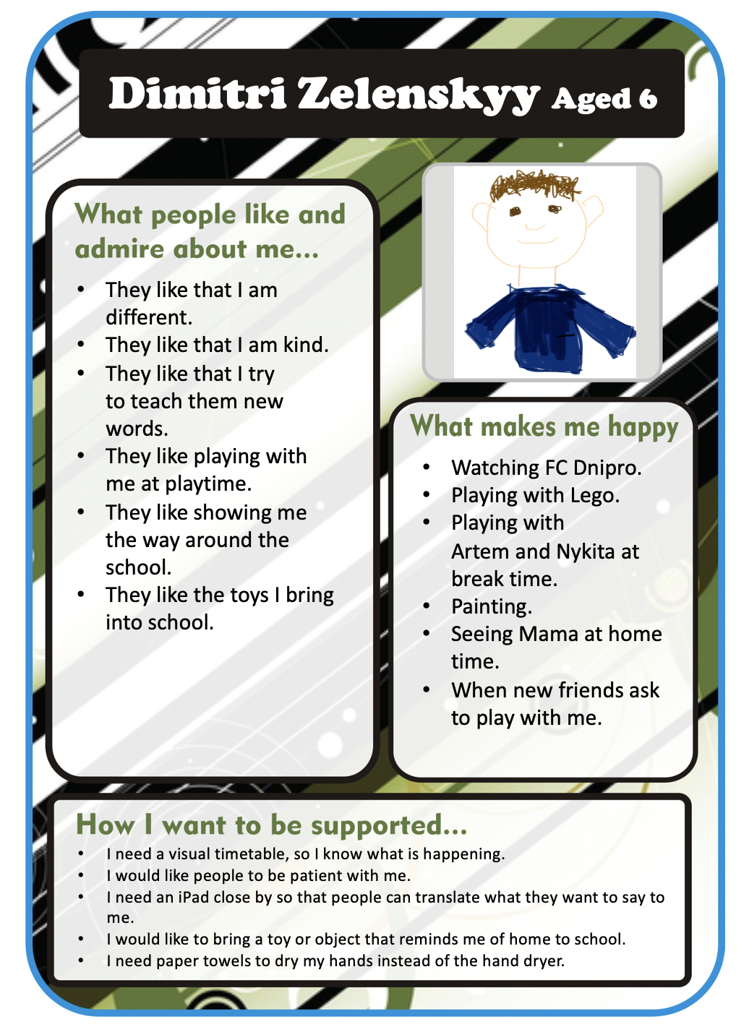

Social and Emotional Focus Intervention-
The intervention will be ongoing in the ‘Cwtch’, once a day whilst the class literacy lessons are taking place. This time has been chosen as it causes the least impact on the natural flow of the classroom, and it is a time where Dimitri is currently just playing with Lego due to the language barrier. Sessions will involve a teaching assistant, Miss Jones, and Dimitri for a period of one half term. This is prior to a Ukrainian speaking practitioner being able to assist Dimitri. Sessions will focus upon the Dimitri’s emotional well-being and basic social skills as research suggests this is required before language development can happen.
Opportunities for Dimitri to play with Lego, paint or colour will also be clearly laid out in the ‘Cwtch’ should he get upset or stressed at any point. Miss Jones will observe what is created each session and take pictures. An iPad will be always available for any translation or communication needs and Miss Jones will be attempting to pick up simple Ukrainian terms that she can use with Dimitri.
This intervention will follow the New Curriculum for Wales’s (CfW) Health and Well-being Area of Learning and Experience (AoLE) which is now being implemented across the country.
Dimitri’s Mum has seen the support plan and agreed to the implementation of the plan. Mum will have access to a Class Dojo where pictures and videos from the intervention sessions will be shared. Communication between the school and Mum will also be possible through this forum.
Week | Lesson Focus | Session activities (30 minutes) | Links to CfW, Health and Well-being AoLE, How we process and respond to our experiences affects our mental health and emotional well-being.
Week 1 | Bonding.  Identifying feelings and emotions. | Prior to the session Mum has explained why Dimitri will be having sessions in the Cwtch with Miss Jones.  The session will start with Miss Jones introducing herself to Dimitri. A translation app will be used if needed on Miss Jones’ iPad. There will be an ‘about me’ pack that Dimitri will complete during the 6 weeks with the help of Miss Jones. This will have a heavy focus on Dimitri’s home life in Ukraine prior to the war. There will be pictures for Dimitri to colour in and opportunities for him to draw what makes him happy, who he has in his family and any other pictures he chooses to draw. Miss Jones will also complete a similar pack, completing who is in her family, what she enjoys doing in her spare time and so on. Simple English terms will be emphasised to Dimitri. Laminated emojis will be used to show different emotions and feelings in English with the possibility of being translated if confusion persists. Simple questions will then be asked including, “How are you feeling today?”, “What makes you happy?” and “What makes you sad?”. The session will end with an activity of Dimitri’s choice. | Progression Step 1- I can notice and communicate how I am feeling.
Week 2 | Emotion bingo | The session will start with a short check in, asking Dimitri how he is feeling. Emotion Bingo will be played, with Miss Jones acting out the emotions as they pop up on the interactive whiteboard. Dimitri will then be invited to act out the emotions too if he wishes. Flash cards will then be produced showing different situations and Dimitri will be asked to show how these would make him feel. Ensuring no pressure is imposed on him answering any questions. Again, the iPad will always be close by for any translation needs. The ‘about me’ booklet will then be used to finish the session, focusing on pages about Dimitri’s favourite foods, colours and activities. | I am beginning to have an awareness of how feelings are communicated through actions.
Week 3 | Mindfulness | A Ukrainian mindfulness video will be played on the interactive whiteboard at the start of the session. Dimitri will have a soft carpeted area that he can lie on to concentrate on the video. After the video, Dimitri will be asked how he feels. At this point Miss Jones will reassess what makes Dimitri happy and sad, identifying any changes in his feelings from the first week. Miss Jones will try to instruct a yoga session with Dimitri to fully relax him after a possibly intense session. | I am beginning to have an awareness that thoughts and feelings change, and I am starting to notice when change happens.
Week 4 | Reflection | This could be an upsetting session for Dimitri so will be approached with caution. Miss Jones will carefully approach the ideas of what Dimitri went through in Ukraine and his journey to West Wales. The concept of safety will be addressed, that Dimitri is now safe, Mum is working in a local salon and has an income to buy them essentials and even treats. This session will end with an activity of Dimitri’s choice to ensure that he is happy returning to class. | Progression Step 2-  I can reflect on my own experiences.
Week 5 | Games | At the start of the session Miss Jones will check in with Dimitri. A variety of games will be set up in the Cwtch, Jenga, Snakes and ladders, dominoes and hungry hippos along with others. The focus for the first half of this session will be for Dimitri to have fun. For the second half of the session Miss Jones will introduce new scenario flash cards, asking Dimitri how he would feel if he was in this situation. Hopefully here some progression would be visible from week 2. | I can notice and communicate my feelings.
Week 6 | About me booklet | During this session the booklet will be looked at, ensuring that it is completed, finishing any gaps that remain. This booklet will be passed on to Dimitri’s teaching assistant during half term so that they aware of his likes and dislikes and can personalise their approach over half term before starting. Miss Jones will ask if there is any other information Dimitri feels his teaching assistant should know, if he would like to draw any pictures or write any messages to her. | I can understand how and why my thoughts, feelings and actions

References-
Alderson, P. (2008). Young Children's Rights. 2nd ed. London: Jessica Kingsley Publishers. p.48.
Amin, HU., Malik, AS., Saad, MNM., and Tyng, CM. (2017). The Influences of Emotion on Learning and Memory. Frontiers of Psychology. 8(1454). [Online]. Available at: https://www.frontiersin.org/articles/10.3389/fpsyg.2017.01454/full [Accessed 3 November 2022].
Arshad, R., Wrigley, T. and Pratt, L. (2012). Social Justice Re-examined. London: UCL Institute of Education Press.
Babakr, Z, H., Mohamedamin, P., and Kakamad, K. (2019), Piaget’s Cognitive Developmental Theory: Critical Review. In: Education Quarterly Reviews, Vol.2, No.3, 517-524. [Online] Available at: https://www.researchgate.net/publication/335219854_Piaget%27s_Cognitive_Developmental_Theory_Critical_Review [Accessed 5 November 2022].
BERA. (2018). Ethical Guidelines for Educational Research. 4th ed. [Online]. Available at: https://www.bera.ac.uk/publication/ethical-guidelines-for-educational-research-2018-online [Accessed 26 October 2022].
Brodie, K. (2002) The Holistic Care and Development of Children from Birth to Three: An Essential Guide for Students and Practitioners. Routledge.
Centres for Disease Control and Prevention. (CDC). (2021). Adverse Childhood Experiences. [Online]. Available at: https://www.cdc.gov/violenceprevention/aces/index.html [Accessed 1 November 2022].
Center on the Developing Child, Harvard University. (2022). ACEs and Toxic Stress: Frequently Asked Questions. [Online]. Available at: https://developingchild.harvard.edu/resources/aces-and-toxic-stress-frequently-asked-questions/ [Accessed 3 November 2022].
Children's Commissioner for Wales. (2021). Universal Children’s Day 2021: A Welsh welcome to child refugees. [Online]. Children's Commissioner for Wales. Last Updated: 2022. Available at: https://www.childcomwales.org.uk/our-work/commissioners-blog/universal-childrens-day-2021-a-welsh-welcome-to-child-refugees/ [Accessed 17 October 2022].
Department for Work and Pensions. (2022). Separated families statistics. GOV.UK. [Online]. Available at: https://www.gov.uk/government/statistics/separated-families-statistics-april-2014-to-march-2021-experimental/separated-families-statistics-april-2014-to-march-2021-experimental#separated-families-and-their-child-maintenance-arrangements
Dwivedi, K, N. et al. (2002). Meeting the Needs of Ethnic Minority Children. 2nd ed. London: Jessica Kingsley Publishers.
Estyn. (2018). Supporting pupils with English as an additional language to help them integrate. Westbourne School. [Online]. Available at: https://www.estyn.gov.wales/effective-practice/supporting-pupils-english-additional-language-help-th [Accessed 26 October 2022].
Estyn. (2022). Supporting the learning of children and young people of asylum-seeking families. Cardiff Council. [Online]. Available at: https://www.estyn.gov.wales/effective-practice/supporting-learning-children-and-young-people-asylum-seeking-families-and [Accessed 26 October 2022].
Every Child Protected Against Trafficking (ECPAT UK). (2016). United Nations Convention on the Rights of the Child. [Online]. Available at: https://www.ecpat.org.uk/united-nations-convention-on-the-rights-of-the-child [Accessed 2 November 2022].
Farrell, M (2009). The Special Educational Handbook. 4th ed. Oxon: Routledge.
Florian, L., Black-Hawkins, K. and Rouse, M. (2017). Achievement and Inclusion in Schools. 2nd ed. London: Routledge.
Greene, R. (2008). Kids do Well if They Can. p162 Available at: https://facultyresources.westerntc.edu/wp-content/uploads/2014/08/Kids-Do-Well-If-They-Can.pdf?fbclid=IwAR09rrZesY48cGDa5CtLyspy2ZnBIWZ1NRjfpxo03ntRbwwdMfh8CZEzJME. [Accessed: 26 October 2022].
Lane, J. (1999). Action for Racial Equality in the Early Years: Understanding the Past, Thinking about the Present, Planning for the Future. London: National Early Years Network.
Lansdown, G and Newell, P. (1994). UK Agenda for Children. London: Children’s Rights Office.
MacBlain, S. (2014). How Children Learn. London: SAGE. P43
Ministry of Education and Science of Ukraine. (2022). EDUCATION SYSTEM IN UKRAINE. [Online]. Available at: https://emergency.mon.gov.ua/educationalsystem/ [Accessed 26 October 2022].
Mooney, C,G. (2013). Theories of Childhood. 2nd ed. St Paul: Redleaf Press.

National Education Union. (2018). Support staff struggling with increasing workloads, says NEU survey. [Online]. Available at: https://neu.org.uk/press-releases/support-staff-struggling-increasing-workloads-says-neu-survey [Accessed 6 November 2022].
National Foundation for Educational Research (NFER). (2018). Vulnerable Groups. [Online]. Available at: https://www.nfer.ac.uk/about-nfer/what-we-do/vulnerable-groups#:~:text=NFER%20has%20a%20strong%20track%20record%20of%20research,Special%20Educational%20Needs%20%28SEN%29%2FLearning%20Difficulties%20an. [Accessed 26 October 2022].
Parliament. (2009). Memorandum submitted by the Department for Children, Schools and Families. [Online]. Available at: https://publications.parliament.uk/pa/jt200809/jtselect/jtrights/157/157we18.htm [Accessed 2 November 2022].
Peer, L & Reid, G. (2016). Special Educational Needs, A Guide for Inclusive Practice. 2nd ed. London: Sage.
Public Health Wales. (n.d). Adverse Childhood Experiences. [Online]. Available at: https://phw.nhs.wales/topics/adverse-childhood-experiences/ [Accessed 2 November 2022].
Rogoff, B. (2003). Orienting Concepts and Ways of Understanding the Cultural Nature of Human Development. [Online]. Oxford University Press. Available at: https://uowtsd-my.sharepoint.com/personal/1505093_student_uwtsd_ac_uk/Documents/ECAD6013/BarbaraRogoff_2003_1OrientingConceptsAnd_TheCulturalNatureOfHu.pdf [Accessed 26 October 2022].
Save the Children. (1999). We Have Rights Okay! London: Save the Children.
Senker, C. (2017). Far From Home, Refugees and migrants fleeing war, persecution and poverty. London: The Watts Publishing Group.
Smidt, S. (2013). The Developing Child in the 21st Century. 2nd ed. Oxon: Routledge. p.94.
Symonds, J. (2015). Understanding School Transition What happens to children and how to help them. London: Routledge. p.
The Open University. (2017). Supporting Children's Development, Children's Transitions. [Online]. Open Learn Create. Available at: https://www.open.edu/openlearncreate/mod/oucontent/view.php?id=79794§ion=3 [Accessed 3 November 2022].
UNICEF. (2016). The United Nations Convention on the Rights of the Child. [Online]. Available at: https://www.unicef.org.uk/wp-content/uploads/2016/08/unicef-convention-rights-child-uncrc.pdf [Accessed 26 October 2022].
United Nations High Commissioner for Refugees, (UNHCR). (2021). Teaching about Refugees, Guide for Teachers. [Online]. UNHCR. Available at: https://www.unhcr.org/uk/publications/brochures/618bc1d64/unhcr-teaching-refugees-2021-guide-teachers.html?query=teaching [Accessed 28 October 2022].
United Nations High Commissioner for Refugees, (UNHCR). (2022a). Ukraine Emergency. [Online]. Available at: https://www.unhcr.org/uk/ukraine-emergency.html [Accessed 24 October 2022].
United Nations High Commissioner for Refugees, (UNHCR). (2022b). Operational Data Portal Ukrainian Refugee Situation. [Online]. Available at: https://data.unhcr.org/en/situations/ukraine#_ga=2.98012895.1141820042.1666635508-2076197324.1666170122 [Accessed 26 October 2022].
University of Wales Trinity Saint David, (UWTSD). (2022). Research Ethics & Integrity Code of Practice. [Online]. Available at: https://www.uwtsd.ac.uk/media/uwtsd-website/content-assets/documents/research/REICoP-July-2022.pdf [Accessed 26 October 2022].
UNCESCO. (1994). THE SALAMANCA STATEMENT AND FRAMEWORK FOR ACTION ON SPECIAL NEEDS EDUCATION. Available at: https://unesdoc.unesco.org/ark:/48223/pf0000098427. [Accessed 26 October 2022].
UNESCO (2005). Guidelines for inclusion: Ensuring access to education for all. Paris: UNESCO.
Upham, P, Carney, S and Klapper, R. (2013). Scaffolding, software and scenarios: applying Bruner's learning theory to energy scenario development with the public. Technological Forecasting and Social Change, 81. 17760. 131 - 142. [Online] Available at: https://eprints.whiterose.ac.uk/78032/18/Upham%20Carney%20Klapper%20TFSCb_with_coversheet.pdf [Accessed 3 November 2022).
Van Oudheusden, H. (2018). Teaching Refugee Children. New York: Apollo Books.
Vasileva, O. and Balyasnikova, N. (2019) (Re)Introducing Vygotsky’s Thought: From Historical Overview to Contemporary Psychology. Front. Psychol. 10:1515. [Online]. Available at: https://www.frontiersin.org/articles/10.3389/fpsyg.2019.01515/full [Accessed 3 November 2022].
Vélez-Agosto, N, M. et al. (2017). Bronfenbrenner’s Bioecological Theory Revision: Moving Culture From the Macro Into the Micro. Vol.12(5) [Online]. SAGE. Available at: https://uowtsd-my.sharepoint.com/personal/1505093_student_uwtsd_ac_uk/Documents/ECAD6013/Bronfenbrenner%20article%20-%20contesting.pdf [Accessed 26 October 2022].
Vostanis, P. (2016). How to help refugee children get through the trauma of what’s happened to them. [Online]. The Conversation. Last Updated: August 25, 2016. Available at: https://theconversation.com/how-to-help-refugee-children-get-through-the-trauma-of-whats-happened-to-them-64335 [Accessed 28 October 2022].
Watson, M. (2017). Exploring the concept of community in relation to Early Years practice. Education in the North,24(2), p.63-71 [Online] University of Aberdeen. Available at: https://uowtsd-my.sharepoint.com/personal/1505093_student_uwtsd_ac_uk/Documents/ECAD6013/EITN_2017_FEATURE_Watson.pdf [Accessed 26 October 2022].
Welsh Government. (2016). Inclusion and Pupil Support. [Online]. Available at: https://gov.wales/sites/default/files/publications/2018-05/guidance-inclusion-and-pupil-support_0.pdf [Accessed 26 October 2022]. P2
Welsh Government. (2019a). Health and Well-being AoLE. [Online]. HWB. Last Updated: 10 January 2022. Available at: https://hwb.gov.wales/curriculum-for-wales/health-and-well-being/statements-of-what-matters/ [Accessed 31 October 2022].
Welsh Government. (2019b). Nation of Sanctuary – Refugee and Asylum Seeker Plan. [Online]. Available at: https://gov.wales/sites/default/files/publications/2019-03/nation-of-sanctuary-refugee-and-asylum-seeker-plan_0.pdf [Accessed 26 October 2022].
Welsh Government. (2021). The Additional Learning Needs Code for Wales, 2021. [Online]. Available: https://gov.wales/sites/default/files/publications/2021-03/the-additional-learning-needs-code-for-wales-2021.pdf. [Accessed 26 October 2022]. P34.
Whitters, H, G. (2020). Adverse Childhood Experiences, Attachments, and the Early Years Learning Environment. Oxon: Routledge.

Appendix
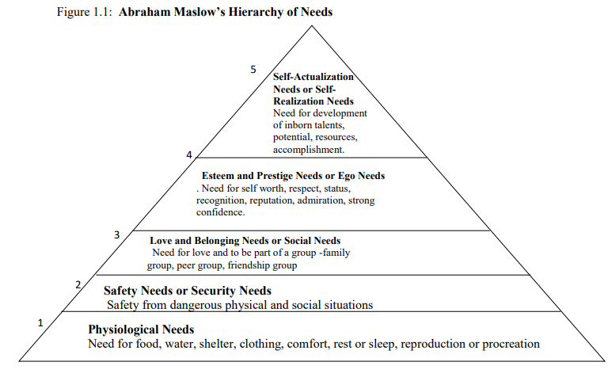
Aruma, E. O. and Hanachor, M. E. (2017). ABRAHAM MASLOW’S HIERARCHY OF NEEDS AND ASSESSMENT OF NEEDS IN COMMUNITY DEVELOPMENT. International Journal of Development and Economic Sustainability. 5 (7), p16.
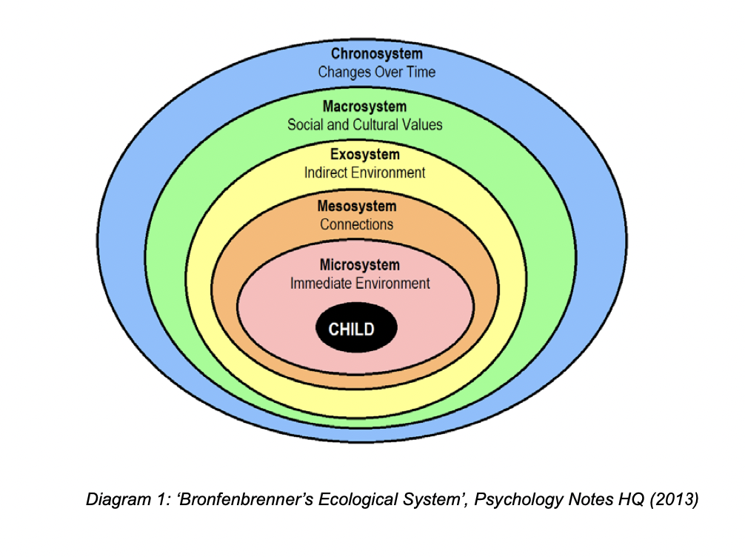
Watson, M. (2017). Exploring the concept of community in relation to Early Years practice. Education in the North,24(2), p.64 [Online]. University of Aberdeen. Available at: https://uowtsd-my.sharepoint.com/personal/1505093_student_uwtsd_ac_uk/Documents/ECAD6013/EITN_2017_FEATURE_Watson.pdf [Accessed 26 October 2022].

