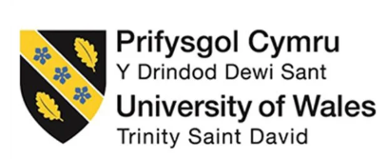

Programme name: Master of Business Administration
Module name: Human Capital Management
Module code: LCMB7023
Lecturer’s name: Dr. Gladius Kulothungan
Student name: Darshan Mukeshbhai Kanani
Student ID: 2532572
Word Count: 2500

Term 1

Table of Contents
TASK A: Socialisation, Identity & Business Activism 3
1.1 Critical evaluation of traditional onboarding versus strategic organisational socialisation 3
1.1.1 Psychological contract theory 3
1.1.2 Identity construction theory 3
1.2 Designing a structured socialisation framework for Helios 4
1.2.1 Pre-boarding 4
1.2.2 First 90 days 4
1.2.3 Year One 5
1.2.4 Proposed mechanisms 5
TASK B: Job Design 7
2.1 Innovative job design strategy 7
2.1.1 Job Characteristics Model 7
2.1.2 Job crafting theory 9
2.1.3 Skills-based architecture 9
2.2 Ways in which the design can stimulate intrinsic motivation and support innovation 10
TASK C: Reflective report 11
3.1 AI as a decision-support tool 11
3.2 Personal capability development plan 12
References 13

TASK A: Socialisation, Identity & Business Activism

1.1 Critical evaluation of traditional onboarding versus strategic organisational socialisation
Traditional onboarding is mainly an administrative process, emphasising completion of documentation, discussion of policies and offering basic job-related information. As stated by Frögéli, Jenner and Gustavsson (2023), traditional onboarding aims to facilitate the socialisation of new professionals by structuring early experiences. In the context of Helios Urban Mobility (HUM), the traditional onboarding approach is insufficient since the new hires must not only learn the tasks, but also internalise organisational values and contribute to innovation. The eight-month ramp-up time indicates that the existing onboarding practices of Helios are not accelerating adjustment.

1.1.1 Psychological contract theory
Psychological contract theory can be applied to evaluate traditional onboarding and strategic organisational socialisation. Psychological contract theory discusses the perceived mutual obligations between the employee and the organisation (Manchia, Bal and Khapova, 2026). The theory neglects the role of previous experiences and is distinct from the formal employment contract with respect to the employer and the employees’ understanding of the employment relationship and their commitment to it (Woodrow, Erdem and Guest, 2024). The employees join an organisation with expectations regarding the development of career, support and meaningful work. When the onboarding focuses only on compliance, the employees may perceive a breach of the psychological contract, resulting in disengagement and turnover. The declining employee engagement score of Helios (54%) indicates that several employees may not be experiencing the developmental opportunities which they expected. Thus, the adoption of a strategic organisational socialisation approach, which emphasises continuous learning and role clarity can strengthen the psychological contract and enhance employee engagement.

1.1.2 Identity construction theory
Identity construction theory adds another vital dimension. Identity construction is a non-linear iterative process, which can be constructed through mundane conversations and stories (Anderson et al., 2022). The employees do not only perform roles; rather, they develop identities, such as innovator and ethical professional. The traditional onboarding process rarely addresses identity formation. Strategic organisational socialisation is a key process for facilitating individuals to enhance their understanding of organisational purpose, goals and desired behaviours (Liao, Zhou and Yin, 2022). This makes the employees begin to see themselves as members of a distinctive community.

1.2 Designing a structured socialisation framework for Helios

1.2.1 Pre-boarding
Helios can introduce a digital pre-boarding programme after the acceptance of the offer. The new hires must receive a personalised welcome portal, containing the CEO video, organisational values, sustainability commitments and a learning roadmap. The managers must also hold an initial conversation about role expectations and career aspirations.

1.2.2 First 90 days
Days 1-30: Orientation and role clarity
The new hires must participate in a structured onboarding academy covering AI-enabled mobility systems, customer impact and ethical use of data. Weekly check-ins with the managers can help clarify the goals and offer feedback. The expected outcome involves faster understanding of roles and improved social integration.
Days 31-60: Cross-functional integration
The employees must join a cross-country project involving colleagues from at least two Helios locations. The expected outcome is stronger collaboration networks and greater appreciation of stakeholders’ needs.
Days 61-90: Contribution and innovation
The employees can complete a small innovation challenge associated with urban mobility and offer recommendations to managers. The formal feedback must assess the performance and cultural integration. The expected outcome involves an early sense of achievement and increased autonomy among employees.

1.2.3 Year One
During the first year, Helios can offer mentoring, different leadership workshops and a personalised development plan to the employees. The high-potential graduates can enter a rotational programme across different functions and locations. This framework is widely justified, since it strengthens the psychological contract through continuous development support and shapes the identity of employees around innovation and sustainability.
Stages | Timeline | Activities
Pre-boarding | After acceptance of offer | Personalised welcome portal, organisational values, learning roadmap
Orientation and role clarity | Days 1-30 | Structured onboarding academy, AI-enabled mobility systems training
Cross-functional integration | Days 31-60 | Participation in cross-country projects from two Helios locations
Contribution and innovation | Days 61-90 | Innovation challenge on urban mobility and presentation of recommendations
Continuous development | Year One | Mentoring and leadership workshops
Table 1: Structured socialisation framework of Helios
(Source: Self-developed)

1.2.4 Proposed mechanisms
Organisational identification
Helios can strengthen organisational identification through a specific narrative, improving urban life through sustainable mobility. Regular town halls, recognition programmes and storytelling about successful city projects can make the employees connect their work to a broader mission. Social identity theory can be applied in this context, which states that individuals form their identity by being associated with social categories or groups (Mittal, Gupta and Motiani, 2022). Through recognition programmes and storytelling, the employees can become more committed as they will perceive membership in a distinctive organisation. For example, Google has introduced peer-to-peer recognition programs, which allows the employees to recognise their peers for doing something big or small (Quinn, 2023). This enhances employee engagement and contributes to organisational identification.
Ethical professionalism
Ethical professionalism can be developed through mandatory ethics training, artificial intelligence (AI)-governance guidelines and transparent decision-making processes. Ethics training has a positive impact on the dimensions of clarity and transparency, since it helps to raise awareness about ethics (Cabana and Kaptein, 2025). The managers must be evaluated on ethical leadership behaviours. This is necessary for Helios since AI-enabled transport systems involve data-privacy considerations.
The business activist mindset
In terms of cultivating a business activist mindset, Helios must encourage the employees to participate in sustainability projects, urban mobility forums and community partnerships. The concept of Ulrich’s HR business partner evolution can be applied in this aspect. The concept involves four roles, which are strategic partners, administrative experts, employee champions and change agents as illustrated in Figure 1 (Cayrat and Boxall, 2023, HRM Handbook, 2021). The business value created by each role is necessary for HR professionals to become business partners who contribute to building a competitive organisation. Another key concept which can be applied is stakeholder capitalism. It indicates the system in which the organisations focus on serving the needs of their stakeholders (Goswami and Bhaduri, 2023). Drawing on the concept of stakeholder capitalism and Ulrich’s HR business partner evolution, the employees of Helios must be encouraged to consider the way business decisions affect governments, citizens, the environment and future generations. This can enable employees to shift beyond narrow job performance towards strategic stewardship and responsible innovation.
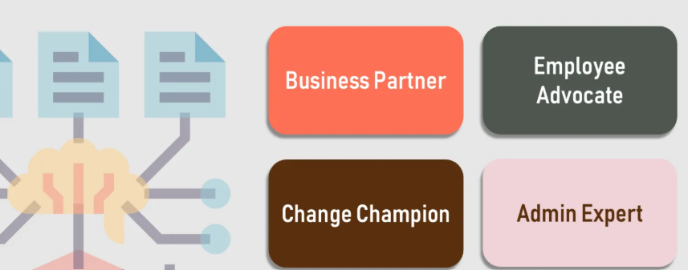
Figure 1: Ulrich’s HR business partner model
(Source: HRM Handbook, 2021)

TASK B: Job Design

2.1 Innovative job design strategy
Helios can incorporate an innovative job design strategy, which combines the Job Characteristics Model, Job crafting theory, and Skills-based architecture. This approach can enhance employee flexibility and align workforce capabilities with the strategic objectives of the organisation.

2.1.1 Job Characteristics Model
The Job Characteristics Model consists of five job characteristics aspects: skill variety, task identity, task significance, autonomy, and feedback (Zhao et al., 2024). At Helios, skill variety can be enhanced by assigning the employees to multidisciplinary project teams instead of restricting them to specialised departmental activities. For example, the software engineers can collaborate with sustainability analysts and AI specialists while developing intelligent mobility solutions. This can broaden their knowledge and reduce repetitive work. Similarly, task identity can be strengthened by enabling employees to contribute throughout the entire project lifecycle, from testing prototypes to post-project evaluation. Rather than completing isolated technical tasks, the employees would experience ownership of complete projects, increasing both responsibility and commitment.
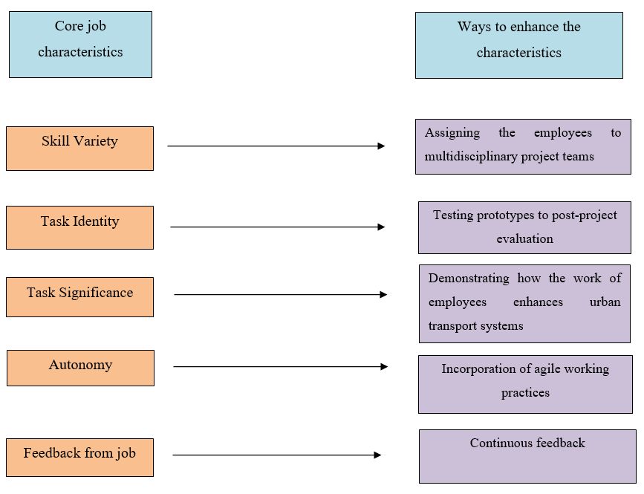
Figure 2: Job characteristics model of Helios
(Source: Self-developed)
Helios can reinforce task significance by demonstrating how the work of employees enhances urban transport systems and environmental sustainability. The reviews of the project can include customer feedback and examples of how AI-enabled mobility solutions of Helios contribute to smarter cities. An enhanced level of understanding about the wider social impact encourages employees to perceive their specific roles as meaningful instead of purely technical. Autonomy can be incorporated through agile working practices to empower project teams for making operational decisions regarding the planning of the project and innovation activities. Agile practices positively influence better job engagement and successful delivery of projects (I Kennedyd et al., 2026). The feedback of the employees must become continuous instead of solely relying on annual performance reviews.

2.1.2 Job crafting theory
The theory identified four categories to craft behaviours through which employees can engage to achieve a balance. The four categories are increasing structural job resources, increasing social job resources, increasing challenge demands and decreasing hindrance demands (Baka, Prusik and Derbis, 2025). In terms of the increasing job structural resources, the employees of Helios can be encouraged to participate in cross-functional innovation projects, digital learning programmes and international assignments across London, Berlin and Singapore. For example, an AI engineer can join sustainability initiatives to increase technical expertise while developing strategic capabilities. These opportunities can strengthen competence and prepare the employees for future leadership roles.
In terms of the category of increasing social job resources, Helios can set up structured mentoring programmes and monthly coaching sessions, where the employees can receive constructive feedback from managers and colleagues. Mentoring supports the employees professionally and psychologically (Yang et al., 2024). Increasing challenge demands encourage the employees to undertake tasks that facilitate personal growth and professional development. The organisation can allow the employees to lead innovation activities and contribute towards strategic sustainability programmes. Helios can achieve the stage of decreasing hindrance demands by automating repetitive administrative activities using AI and clarifying role expectations. Removing these barriers can allow the employees to dedicate time to value-creating activities such as innovation and customer engagement.

2.1.3 Skills-based architecture
A skills-based architecture also offers transparent internal career pathways for high-potential graduates and reduces voluntary turnover. As stated by DeMark and Kozyrev (2021), a skills-based architecture reduces disparities in labour market outcomes. Helios can apply skills-based architecture by crafting a digital skills inventory, which maps employees’ technical expertise, leadership capabilities and career aspirations. Using AI-powered talent analytics, the employees can then be matched to internal projects and mentoring opportunities. For example, Unilever uses AI to analyse job-specific skills and identifies approximately 34 skills per person (Unilever, 2021). Whenever new skills are required, Helios can use existing talent efficiently, while promoting continuous learning and organisational resilience.
Thus, the integration of these three approaches can create a flexible job design system, which balances organisational requirements with the development of employees. The Job Characteristics model offers motivating work design, job crafting theory encourages employee adaptability, and the skills-based architecture ensures workforce agility through continuous learning.

2.2 Ways in which the design can stimulate intrinsic motivation and support innovation
The proposed job design strategy stimulates intrinsic motivation by creating work which is meaningful, autonomous and development-oriented. Self-determination theory can be applied in this context, which states that the employees become intrinsically motivated when their key needs for autonomy, competence and relatedness are fulfilled (Neufeld, 2025). Greater autonomy of the employees can be achieved through agile project teams and job crafting, enabling employees to exercise discretion over the way work is performed. Competence develops through mentoring and continuous feedback, allowing employees to expand their skills, while pursuing personalised career pathways. Relatedness is strengthened through mentoring relationships that connect employees across the global operations of Helios.
The design also supports innovation by encouraging the sharing of knowledge and experimentation. The employees participating in multidisciplinary projects can acquire diverse perspectives, which facilitates the transfer of expertise between departments. Job crafting can encourage proactive behaviour, allowing employees to identify process improvements and contribute necessary innovative ideas beyond their formal responsibilities. Continuous coaching and feedback systems reinforce innovative behaviours by recognising collaboration and learning instead of measuring operational outputs. The managers can also foster psychological safety by encouraging the employees to share ideas and question the existing practices. Psychological safety promotes team learning and increases the effectiveness of the team (Kim, Lee and Connerton, 2020). Such an environment at Helios can promote continuous improvement, which is essential within the evolving smart mobility sector.
Thus, the integrated job design strategy addresses the current organisational challenges of Helios by reducing the level of disengagement, fostering development of the employees and crafting an agile workforce capable of efficiently delivering sustained innovation and long-term organisational success.

TASK C: Reflective report

3.1 AI as a decision-support tool
Artificial intelligence (AI) has become a potent tool in human resource management (HRM), specifically in data analysis, workforce planning and employee engagement. As a future HR professional, I identified that AI can enhance decision-making by processing massive volumes of workforce data and identifying patterns, which may not be visible through manual analysis. At the same time, I also understand that AI must offer support instead of replacing human judgement, specifically when decisions involve ethics, employee well-being and diversity.
I intend to use AI as a decision-support tool for analysing HR metrics, forecasting workforce trends and generating evidence-based recommendations. AI-powered analytics in HR departments allow data-driven decision-making by forecasting the behaviour of employees and enhancing talent management (Căvescu and Popescu, 2025). For example, by applying AI-powered HR analytics, a high rate of employee turnover or declining engagement can be identified, which can allow managers to incorporate timely interventions. Apart from this, AI can also support recruitment by screening applications and matching the skills of the candidates with job requirements. These capabilities can enable HR professionals to emphasise strategic activities, such as employee development and organisational change.
Despite all these benefits, I identified that AI systems may lead to biased recommendations if they rely on poor-quality data. Due to this, instead of accepting AI-generated outputs without question, I will evaluate the reliability of the information and determine whether the recommendations align with ethical principles and organisational values. I also acknowledge the significance of maintaining transparency while using AI as a decision-support tool.

3.2 Personal capability development plan
In terms of strengthening my future employability, I have identified areas of professional development. I aim to improve my data literacy by enhancing practical skills in HR analytics, Microsoft Power BI and data visualisation. Power BI enables turning data into actionable insights (Microsoft, 2026). To achieve this, I will complete a Microsoft Power BI certification within the next 6 months. Enhancing these capabilities can allow me to interpret workforce data, analyse organisational performance and also support evidence-based HR decision-making. Secondly, I will expand my knowledge of AI augmentation in HR by learning how AI supports recruitment, planning of workforce and employee engagement. Instead of relying on AI-generated recommendations, I will focus on understanding its strengths, limitations and key ethical implications, so that I can responsibly incorporate technology into HR practices. To achieve this goal, I will complete an AI in HR online course within four months.
In terms of strengthening my strategic influencing skills, I will enhance my communication, negotiation and stakeholder management abilities by taking part in collaborative projects and leadership development activities. I will participate in at least two leadership workshops and seek opportunities to lead one team-based project within the next 8 months. I will enhance my global mobility awareness by developing cross-cultural communication skills and also understanding labour legislation and talent management. In addition, I also intend to engage with international case studies and professional networks to broaden my understanding of global HR challenges.

References
Anderson, H., Stocker, R., Russell, S., Robinson, L., Hanratty, B., Robinson, L. and Adamson, J. (2022) ‘Identity construction in the very old: A qualitative narrative study’, PloS one, 17(12), pp.1-24. Available at: https://doi.org/10.1371/journal.pone.0279098
Baka, L., Prusik, M. and Derbis, R. (2025) ‘Insight into development of job-related well-being: the role of four job crafting strategies and psychological needs’, Frontiers in Psychology, 16, pp.1-12. Available at: https://doi.org/10.3389/fpsyg.2025.1487043
Cabana, G.C. and Kaptein, M. (2025) ‘Understanding the effectiveness of ethics programs in preventing unethical behaviour by unravelling the dimensions of team ethical culture’, Journal of Business Ethics, pp.1-24. Available at: https://doi.org/10.1007/s10551-025-06115-5
Căvescu, A.M. and Popescu, N. (2025) ‘Predictive analytics in human resources management: Evaluating AIHR’s role in talent retention’, AppliedMath, 5(3), pp.1-30. Available at: https://doi.org/10.3390/appliedmath5030099
Cayrat, C. and Boxall, P. (2023) ‘The roles of the HR function: A systematic review of tensions, continuity and change’, Human Resource Management Review, 33(4), pp.1-26. Available at: https://doi.org/10.1016/j.hrmr.2023.100984
DeMark, S. and Kozyrev, J. (2021) ‘Enabling pathways to opportunity through a skills-based architecture’, The Journal of Competency-Based Education, pp.1-8. Available at: https://doi.org/10.1002/cbe2.1241
Frögéli, E., Jenner, B. and Gustavsson, P. (2023) 'Effectiveness of formal onboarding for facilitating organisational socialisation: A systematic review', PloS one, 18(2), pp.1-17. Available at: https://doi.org/10.1371/journal.pone.0281823
Goswami, S. and Bhaduri, G. (2023) ‘Communicating moral responsibility: stakeholder capitalism, types, and perceptions’, Sustainability, 15(5), pp.1-17. Available at: https://doi.org/10.3390/su15054386
HRM Handbook (2021) Dave Ulrich's HR Model. Available at: https://hrmhandbook.com/hro/model/ulrich/ (Accessed: 7 July 2026)
I Kennedyd, S., Zadeh, A.A., Choi, J. and Alborz, S. (2026) ‘Agile practices and it development team well-being: Unveiling the path to successful project delivery’, Engineering Management Journal, 38(1), pp.16-28. Available at: https://doi.org/10.1080/10429247.2024.2413710
Kim, S., Lee, H. and Connerton, P.T. (2020) ‘How Psychological Safety Affects Team Performance: Mediating Role of Efficacy and Learning Behaviour ', National Library of Medicine, pp.1-15. Available at: https://doi.org/10.3389/fpsyg.2020.01581
Liao, G., Zhou, J. and Yin, J. (2022) 'Effect of organisational socialisation of new employees on team innovation performance: A cross-level model', Psychology Research and Behaviour Management, pp.1017-1031. Available at: https://doi.org/10.2147/PRBM.S359773
Manchia, G.C., Bal, P.M. and Khapova, S.N. (2026) ‘Unveiling the origins of psychological contract perceptions: a systematic review of 30 years of psychological contract antecedents research’, Journal of Managerial Psychology, 41(2), pp.406-433. Available at: https://doi.org/10.1108/JMP-10-2023-0608
Microsoft (2026) What is Power BI? Available at: https://learn.microsoft.com/en-us/power-bi/fundamentals/power-bi-overview (Accessed: 7 July 2026)
Mittal, S., Gupta, V. and Motiani, M. (2022) ‘Examining the linkages between employee brand love, affective commitment, positive word-of-mouth, and turnover intentions: A social identity theory perspective’, IIMB Management Review, 34(1), pp.7-17. Available at: https://doi.org/10.1016/j.iimb.2022.04.002
Neufeld, A. (2025) ‘Putting Self‐Determination Theory Into Practice: A Practical Tool for Supporting Medical Learners’ Motivation’, National Library of Medicine, 22(4), pp.1-5. Available at: https://doi.org/10.1111/tct.70140
Quinn, J. (2023) A Look at Google’s Peer-To-Peer Bonus System. Available at: https://bonusly.com/post/a-look-at-googles-peer-to-peer-bonus-system (Accessed: 7 July 2026)
Unilever (2021) The future of skills: using tech to put people first. Available at: https://www.unilever.com/news/news-search/2021/the-future-of-skills-using-tech-to-put-people-first/ (Accessed: 7 July 2026)
Woodrow, C., Erdem, C. and Guest, D.E. (2024) 'The role of previous experience in the analysis of the psychological contract and its outcomes during the socialisation process: a signalling theory perspective', The InTernaTIonal Journal of human resource managemenT, 35(18), pp.3145-3171. Available at: https://doi.org/10.1080/09585192.2024.2401582
Yang, W., Wang, Y., Choi, M. and Li, Y. (2024) ‘Influence of mentoring on the proactive behaviour of new employees: moderated mediation effect of agreeableness’, Frontiers in psychology, 15, pp.1-12. Available at: https://doi.org/10.3389/fpsyg.2024.1370815
Zhao, S., Ping, J., Zhu, H., Ji, W., Wang, Y. and Wang, Y. (2024) ‘Job characteristics model-based study of the intrinsic motivations for primary care practitioners’, Chinese General Practice Journal, 1(1), pp.3-10. Available at: https://doi.org/10.1016/j.cgpj.2024.03.004

