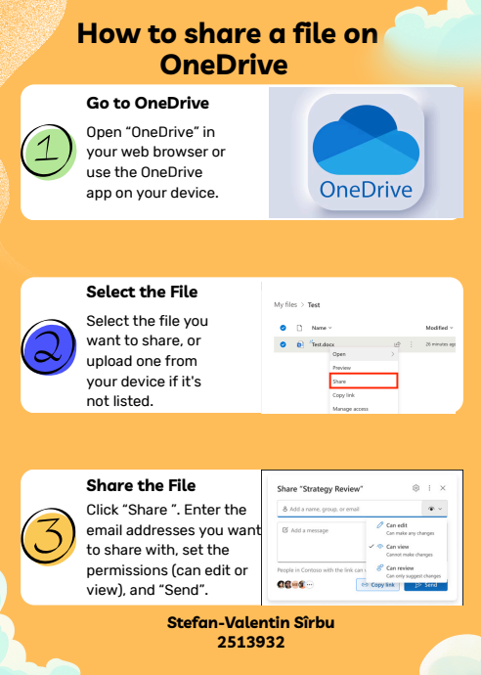
With only three basic steps, sharing a file with OneDrive is simple and quick. You must first launch the internet storage service OneDrive. You may accomplish this by going to the OneDrive website in a browser or by using the app on your computer or phone.
Then, from your file list, select the file you wish to share. To choose that file, click on it. This is crucial since it lets OneDrive know precisely which file you wish to share.
Once you have selected your file, click the "Share" option. You can enter the email addresses of the individuals you wish to share the file with when you click this. Additionally, you determine whether these individuals can only see the file or if they have the ability to edit it. After you click "Send," they get an email invitation.
No matter where they are, users can collaborate by sharing files with OneDrive. Because you have control over who has access, it is secure. This poster helps users transfer files without misunderstanding by clearly and simply outlining each process. In any workplace, it facilitates and expedites cooperation.

