 | Targets | What I have done in this assignment…
Target 1 | a) Ensure an even greater engagement with a wider bank of literature to support all main discussion points. | Used references provided on moodle and used online uwtsd library for further reading
Target 2 | b) Proofread all written expression with care. | Proofread my essay with care to try and avoid further SPAG mistakes
Target 3 | c) Revise and follow all appropriate referencing conventions | Used guide to try and perfect my referencing to ensure that each reference is of the same ‘technique’

This essay will critically analyse the importance of cross-curricular teaching and learning in correlation with the development of in-depth skills and understanding. Cross-curricular teaching and learning is a method of teaching that consists of using all of Areas of Learning and experience to enhance a child’s learning by providing them with resources and tasks that will encourage them to deepen their understanding and develop their critical thinking skills. According to the Curriculum for Wales (Welsh Government, 2024) there are six Areas of Learning and Experience (AoLEs) which were carefully crafted with the sole intention of helping each child to become purposeful learners and great people. The six Areas of Learning and Experience are: Expressive Arts; Health and Well-being; Mathematics and Numeracy; Science and Technology; Humanities; and Languages, Literacy and Communication. Each of these areas have been designed with principles that align with the goal of each pupil achieving the four purposes during their learning journey. The four purposes should be perceived by Welsh Government (2020) a school as the foundation for their curriculum. Welsh Government (2020) Therefore, if cross-curricular teaching and learning occurs then hopefully each pupil will be: Ambitious, capable learners; Ethical, informed citizens; Enterprising, creative contributors; and Healthy, confident individuals. As well as this, cross-curricular teaching and learning has proven to be fundamental in teaching and learning as Donaldson (2015) implies that literacy, numeracy and digital competence should be viewed as one of the main responsibilities of all teachers. It is important to consider how the cross-curricular teaching and learning can be impacted by various contributing factors from within the school which could be either opportunities or challenges. Equally, each factor can have an impact on pupil development and ultimately, pupil outcomes. One opportunity that could influence cross-curricular teaching is the use of outdoor space. For example, at Bridging School X they have vast amounts of outdoor spaces including both tarmacked areas, play areas, and fields. Therefore, by utilising all of the outdoor spaces when planning for cross-curricular learning will help to improve the development of in-depth skills and understanding as if the children were only learning about insects from within the classroom by expanding their learning to outdoor interactive research, they are even more likely to develop these skills, as a result of effective cross-curricular teaching. However, one challenge that could influence cross-curricular teaching is a lack of funding. Often cross curricular learning is most prevalent when projects are established such as learning about St David’s day through making Welsh cakes, visiting a local religious setting, and dressing in traditional Welsh outfits. Whilst each of these tasks would be incredibly beneficial for developing the pupils’ in-depth skills and understanding, they can be costly activities that not all schools have the privilege of being able to organise for the children’s learning. Therefore, whilst a teacher may want to design their lesson plan to include numerous Areas of Learning and Experience it can be incredibly difficult to find the resources to execute these tasks effectively. Therefore, it is important to consider various contributing factors that can affect the teacher’s ability to access cross-curricular resources and the importance of easily accessible frameworks.
Within the Curriculum for Wales, there are three fundamental frameworks: Literacy, Numeracy and Digital Competency. The Literacy framework is divided into five strands: Translanguaging, Listening, Writing, Reading, and Speaking. There are numerous elements and pathways within each strand that align with the progression steps which is important to note as it shows how each framework can be applied to learners cross the primary age range. As stated in the Curriculum for Wales, it is important that there is focus on individual developments. (Welsh Government, 2024) For example, whilst the curriculum and lessons may be the same for each learner, the pace at which they are delivered to each individual will differ, as a way to best support each learners’ abilities and goals. Therefore, progression steps are now introduced at five ages 5,8,11,14,16. The Progression steps begin at Progression Step 1 (Nursery to Reception), Progression Step 2 (Year 1 to Year 3), Progression Step 3 (Year4 to Year 6), Progression Step 4 (Year 7 to Year 9), and Progression Step 5 (Year 10 to 11). One way in which the Literacy framework can be applied to learners across the primary age is that within the Speaking strand and Progression step one the subject is ‘I can produce many speech sounds accurately.’ Welsh Government (2022) Therefore, the Literacy framework shows that it can be applied to the younger primary school age as the children within the Progression Step 1 bracket, are able to be supported through the structured use of phonics into their learning to align with their current stage, progress and capability. Welsh Government (2022) As well as this, both the Numeracy and Digital competency are divided into strands and elements coinciding with pathways and progression steps too. It is evident that each framework targets, supports, and prioritises the needs of each individual learner by separating the overarching aims into phases and stages so that each pupil can reach them when they are able to, often pupils do reach stages of their learning at different ages in comparison to their peers. Welsh Government (2022).
As briefly discussed previously, there are numerous contributing factors that can affect the opportunities and challenges that teachers can face that impact cross-curricular learning. One of the most important aspects of cross-curricular teaching is the use of various resources. For example, Ashbrook (2019) states that a great resource to use is modelling clay. The use of modelling clay in any lesson can allow the children to develop further skills by utilising their fine motor skills and measuring and modelling the clay into their desired shapes. One way in which teachers can plan to use modelling clay in cross-curricular learning was demonstrated on St David’s day at Bridging School X. During parental engagement the children were tasked with modelling a Welsh dragon out of play dough based on their interpretation of the flag and photos provided. This is a great example of cross-curricular teaching and learning as the children are able to learn about the Welsh culture and history through expressive arts. Therefore, the ability to have easily accessible resources readily available for teachers to plan to use across the curriculum is a great opportunity to enhance child development.
Whereas one of the challenges that teachers may face with cross-curricular teaching and learning is any time constraints that may occur. One of the key aspects of cross-curricular teaching and learning is that each of the subjects are taught alongside one another as way of enhancing and deepening subject knowledge. As a result, it can take lots of time and careful planning to construct lesson plans that incorporate numerous subjects from the curriculum. Therefore, teachers who are faced with the constraints of restricted and limited time to plan lessons may feel as though they are not able to accomplish the appropriate amount of time to plan high standard cross-curricular lesson plans. (Kerry, 2015)
As well as this, another challenge that a teacher may face is limited time in the academic year to teach the lessons effectively. For example, a teacher may feel as though they need to rush the teaching of cross curricular lessons as they have lots of information to teach their students, as well as ensuring that the pupils understand the content they are being taught. In Bridging School X, they often use mixed ability groupings for lessons, and if the teacher were to approach cross curricular teaching at a high rate, then the lower ability children may need extra support during these lessons, but the teachers may not recognise this or be able to support them as much as they could if they had the appropriate amount of time. Consequently, there are both numerous opportunities and challenges that teachers may face when cross curricular teaching and learning, and that they may often intertwine with one another. For example, a school’s resources may present as both an opportunity and a challenge for a class teacher when discussing cross curricular teaching and learning. Interestingly, Boyle and Bragg (2008) imply that despite numerous years of work towards curriculum reform there is still ‘work to be done’ but one of the beneficial aspects of cross-curricular learning and curriculum reform is that teachers can feel ‘liberated’ as children feel as though they can discuss their learning with the class teacher and negotiate how and why they have to learn something rather than feel they are obliged to ‘just because’. Therefore, cross-curricular teaching and learning can become an opportunity to resolve some aspects of limited time for teachers to plan effectively.
In regard to cross-curricular teaching and learning within the classroom, it is important to recognise the impacts that effective cross-curricular teaching and learning can have on pupils and what it means for both the teachers and pupils. Therefore, during PTE1 there are many factors to consider when planning and teaching on Placement. One example of cross-curricular learning that would be great to utilise in the classroom is the story stick. Barnes (2015) suggests the use of the story stick which is a method of cross curricular teaching and learning in which the class/small group go outside or on an ‘adventure’ in which each child has the opportunity to collect five items relating to the theme of the task and share them with the group. One example of a theme for Reception could be colour, at Bridging school X they have a wonderful outdoor area in which each pupil could have a stick/double-sided sticky tape to attach their selected items to relating to their chosen colour. (Barnes, 2015). This task is an impactful cross-curricular lesson as there is numerous opportunities for the children to develop their critical thinking skills and by discussing their findings and their individual reasoning they can deepen their previous understanding of the topic as well. This is relevant to the Professional Standards of Teaching and Leadership as one of the strands entitled ‘Cross-curricular themes’ implies that student teachers should be able to know, understand, and engages with the principles of the curriculum with the development of cross-curricular themes. As it I stated previously, the story stick is one of many beneficial cross-curricular activities that is relevant to areas of learning and are relevant to the curriculum design and innovation. Therefore, it is important that each aspect of the Professional standards of Teaching and Leadership are referenced during placement as they justify why student teachers may make decisions regarding cross-curricular teaching and learner and why such behaviours and skills can result in good teaching practices.
Overall, the literacy, numeracy and digital competency framework are very influential in schools as they can impact how lessons are structured, why certain pupils focus on certain areas of learning at different times, and when some pupils may need to be introduced to subjects later or earlier in their academic journey, in comparison to their peers. Also, each framework is divided into elements that can help teachers identify and prioritise areas of progression for reach pupil and how best to help them achieve the four purposes throughout their learning journey. By using the three frameworks above and effective cross-curricular teaching and lesson planning it is clear that every pupil will benefit greatly as their specific needs are being met through varying teaching techniques and high levels of support at each stage of their individual progression. Finally, effective cross-curricular teaching and learning can positively influence developing a pupils in-depth skills and understanding as great examples of cross-curricular teaching and learning, when teachers and pupils both receive the support and resources needed to succeed, then they are more than likely to develop their skillsets and reach each aspect of the four purposes during and by the end of their academic journeys and beyond, into their personal and professional lives.

References

Ashbrook, P. (2019) Yes, and ... Cross-Curricular Planning for Preschool. Science and Children, 57(1), pp. 14-15.

Barnes, J. (2015) An Introduction to Cross-Curricular Learning pp. 267-279.

Boyle, B. and Bragg, J. (2008). Making primary connections: the cross curriculum story. pp. 15-17

Donaldson, G. (2015). Successful Futures.

Kerry, T. (ed.) (2015) Cross-curricular teaching in the primary school : planning and facilitating imaginative lessons. 2nd ed. Abingdon: Routledge.

Welsh Government (2020) ‘Areas of Learning and Experience’ as a central element of the new curriculum. https://educationwales.blog.gov.wales/2020/03/02/areas-of-learning-and-experience-as-a-central-element-of-the-new-curriculum/

Welsh Government (2022) Cross-curricular skills frameworks https://hwb.gov.wales/curriculum-for-wales/cross-curricular-skills-frameworks/#literacy-and-numeracy-framework

Welsh government (2024) Curriculum for Wales https://hwb.gov.wales/curriculum-for-wales/

Appendix
Appendix A – Lesson plan
Student-teacher: | Emily James | Class / Group: | Reception
AoLE or Subject: | Languages, Literacy and communication | Date (please note that this may be a continuous session): | 13/04/2024
Meaningful links to Curriculum (What Matters Statements, Descriptions of learning, ‘previous’ curriculum...) | -Literature fires imaginations and inspires creativity  -Learners who listen and read effectively are prepared to learn throughout their lives
Meaningful links across the curriculum  Links to other AoLEs or the Cross-curricular skills frameworks) | Expressive Arts  -Creating combines skills and knowledge, drawing on the senses, inspiration and imagination.  Mathematics and Numeracy  -Learners will see that statistics represent data, probability models chance, and that both support informed inferences and decisions
Personal Targets (targets and consequent impact on learning - refer to any targets that have been identified in learning journal or weekly reflection meeting and describe the desired impact on learning) Desired impact on learning would be that the children are able to express their interpretations of the story through their story sticks/wands.

Learning Intention
‘This should focus on the pupils’ learning during the lesson, rather than what they will be doing, and should be short, achievable and measurable.’ (Crichton, H., and Mcdaid, A. 2016 p. 196)
After reading the book, the pupils will learn how they can express their understanding of the story and the use of their imagination and creativity.

Success Criteria
What the pupils need to demonstrate to successfully meet the Learning Intention.
-collect items for their story stick/wands
-categorise their items
-cut and stick their items onto the stick
-discuss their choices and potentially justify them
Planning for misconceptions:
Use this section to anticipate pupil errors and misunderstandings and your planned responses to them.
- Unsure what items to choose ( give an example and prepare items in advance to help guide the children who feel unsure)
- If their items aren’t able to be out into categories (could discuss the differences instead)

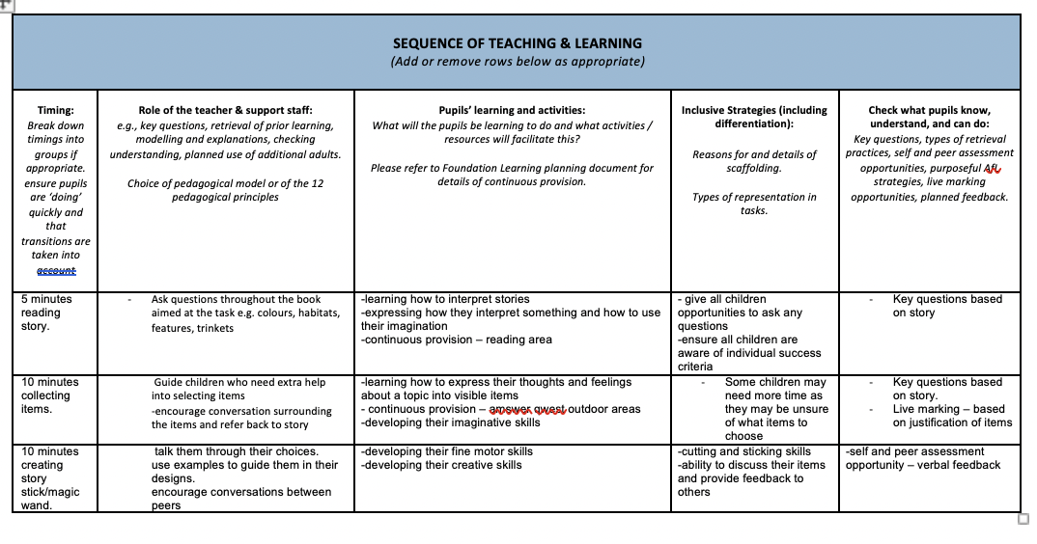

Appendix B – Lesson Resource
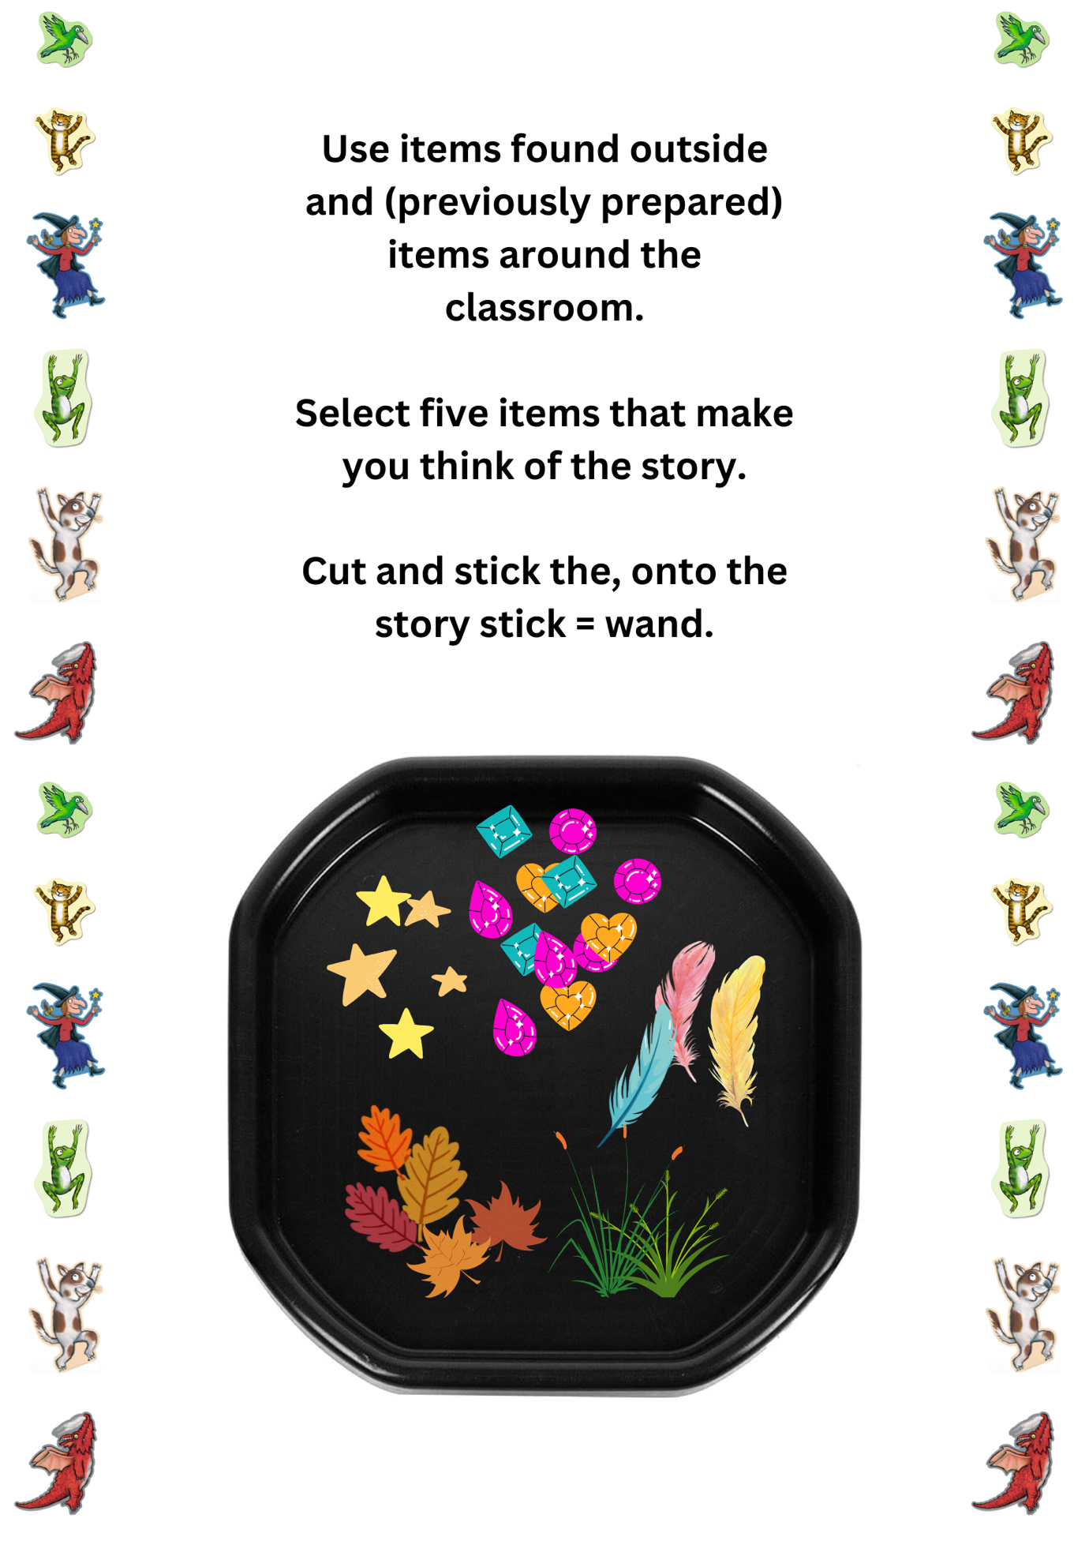
Appendix C – Lesson Resource
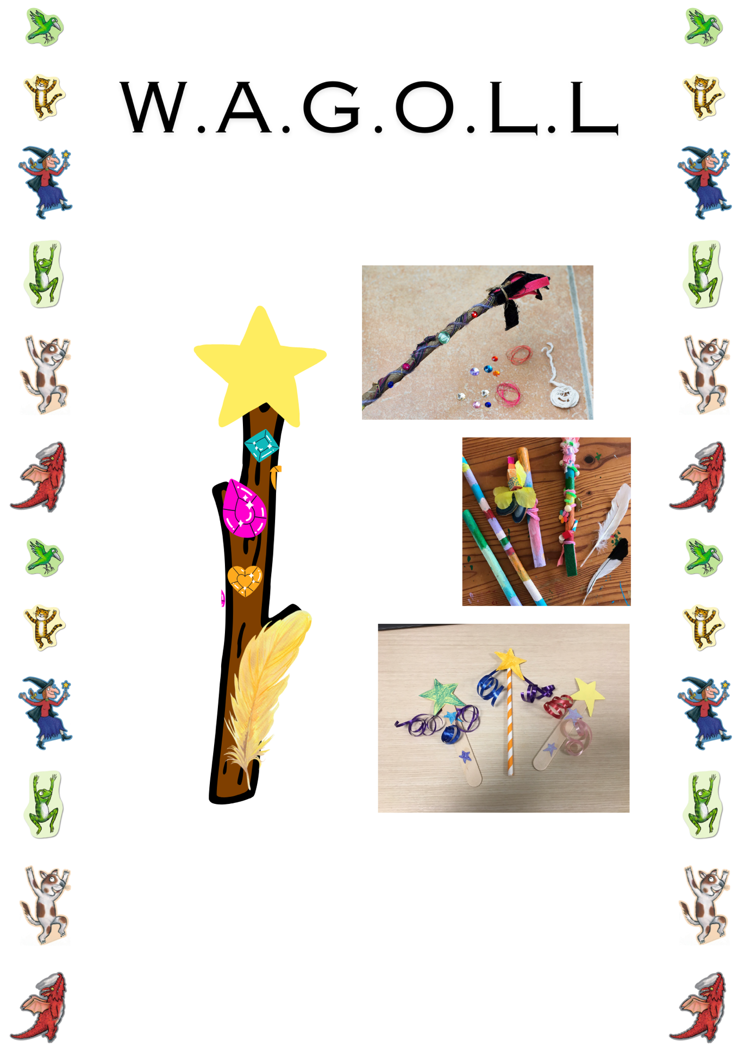

Appendix D – Lesson Resource


