Module Name: Community Engagement
Assignment Title: Coursework - Portfolio
Student Name: Nicolae Botnari
Student ID:2236351

Table of Contents
Introduction 3
Part 1: Discussing the Notion of Community Outreach 4
Concept of Community Outreach 4
Describing the university community from the demographic view 5
Part 2: Commencing the Stakeholder Mapping Exercise 7
Part 3: Describing the Community Engagement Plan 11
Part 4: Practical discussion 19
Evaluating the advantages of engaging the stakeholders in community engagement 19
Representing the personal assessment as a community engagement plan 20
Conclusion 21
References 22

Introduction
The notion of inclusive community engagement is a thing that impacts the lives of all the members positively. It comes with some tasks and a sense of awareness that makes the members of the community responsible execute its positional value. There are different kinds of groups where internal and external stakeholders connect in both active and passive ways. This portfolio will show the abstraction of community outreach by considering a university community which is located in an urban place. The demographic features of the community will be discussed by splitting down that matter into different segments like age, gender, socioeconomic qualities and many more. Then the task of stakeholder mapping will be conducted from the context of various kinds of stakeholders related to that community. The interests and influence of them will be expressed thoroughly. Moreover, the community engagement plan will be evaluated by covering the topics of diversity and inclusion. The positive outcomes of effective community involvement will be assessed here along with a reflective expression of experience.

Part 1: Discussing the Notion of Community Outreach

Concept of Community Outreach
This is a holistic idea to connect with people and entities for the holistic prosperity and well-being of the whole community. The people or groups of people related to a domain directly and indirectly form a group. The process of outreach simply means finding out the issues faced by all in the group and plotting solutions for mitigating them (Broomfield et al., 2021). It should not be fostered to the benefit of a selective section of the community rather it should enrich all individuals in the field. Some steps are related to this methodology and some of them are shown below (Broomfield et al., 2021).
I. Assessment-
The foremost task in this procedure is to rationally point out the key issues and challenges present in the community. It should judge the sides of all people who form the group and then find an inclusive solution (Anthony Jr, 2024). There should be an equilibrium among the sub-segments where the individuals stay satisfied and do not hinder the growth of other people.
II. Relation-
Effective communication among the members of the community should be executed to build trust and develop a sense of cooperation. Understanding the needs and structure of the demography the relation building methods should be conducted. It ensures equal and active engagement of the individual for aggregated growth (Anthony Jr, 2024).
III. Resource allocation-
All the abstract and physical resources should be divided justifiably into different sections of a community. It needs to be ensured that no one or no portion of the group is getting undue advantages where the others are suffering from that. Community outreach solves rigid issues and makes sure that everyone has the essentials like healthcare, education and basic amenities of a balanced life (Taffere et al., 2024).
IV. Collaboration and evaluation-
Connecting with other institutions with similar approaches can positively benefit all of the collaborators. Then, it is also necessary to assess if the measures are working or not by evaluating the extent of growth (Taffere et al., 2024).

Describing the university community from the demographic view
These very types of communities are blended with the components of intellectual things and innovative mindsets. The case of this very university which is located in a proper urban place has access to all modern facilities. This community is made up of so many types of people and the demography is discussed below (Taffere et al., 2024).
Demographic features
I. Age-
The general age range of the students is between 18 to 25 while the age of the faculties majorly comes in the range to 35 to 55. The group has their members too, like the staff whose ages vary start above 30 years of old. The age range of the external stakeholders of this community is diverse and includes people of different ages (Compan et al., 2024).
II. Gender-
The gender gap is minimal in this university and it is a fact of the surroundings there as it resides in an urban place. The number of male students is roughly equal to the number of female students in this college, which is an appreciable thing (Compan et al., 2024). The number of male teachers is slightly higher than the number of female teachers in this institution. In the case of staff and alumni, it can be counted accurately which is again the same for the external members of the community as well. Overall, it can be witnessed that this community has no concerning disbalance in gender in the course (Compan et al., 2024).
III. Social environment-
The surroundings of the university are highly progressive and industrial where the sense and practice of sustainability lack. The influence of modern amenities, specifically the abundant access to the internet makes the students socially inactive. The extent of social communication and links is weak as people stay busy most of the time and interact only for need (Parker, 2024). The social circumstances are quite self-centric where people do not have time for each other.
IV. Economic state-
The financial health of the university and the surrounding areas is in quite a good condition as there are affluent chances for people to earn enough. The pupils of the college come from well-off families and get good monetary support from the government as well. The faculties and staff are also paid handsomely for working in the college (Parker, 2024). It is assessed that most of the alumni of this university have attained good positions in their professional careers and are economically strong.
V. Race and culture-
Diversity can be seen here easily as the students come from different cultural races and geographical divisions in this university. People from various upbringings interact with one another in this community and conduct a fusion of cultures (Parker, 2024).

Part 2: Commencing the Stakeholder Mapping Exercise
This community of the university is associated with internal and external stakeholders whose impact and power are of different exponent. The students, teachers, alumni and staff basically reside under the segment of internal stakeholders. On the other hand, the government, local community, donors and many more come under the branch of the external ones.
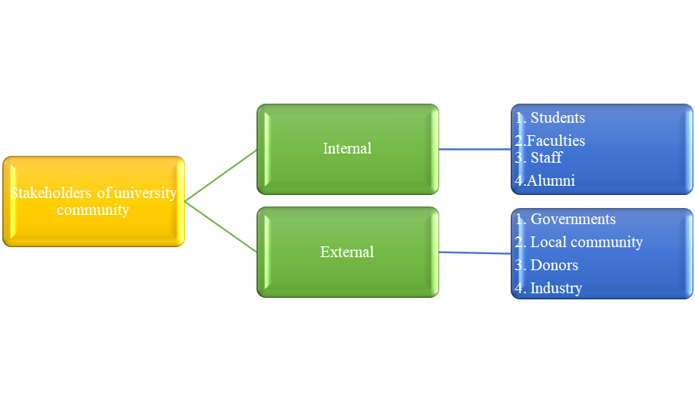
Figure 1- Different stakeholders of the university community
Source: (Self-created)
All of these groups of people have various dimensions of influence and interest in the community. Where the students and the faculties are the most powerful ones who need to be managed closely for the effective movement of the overall group. This is the same for the government and the donors around the university who reside in the high-interest and high-power zone in the stakeholder map (Baines et al., 2024). Then, comes the individual who needs to be kept satisfied and monitored like the alumni and the local communities. Each of the core segments in this domain is showcased below.
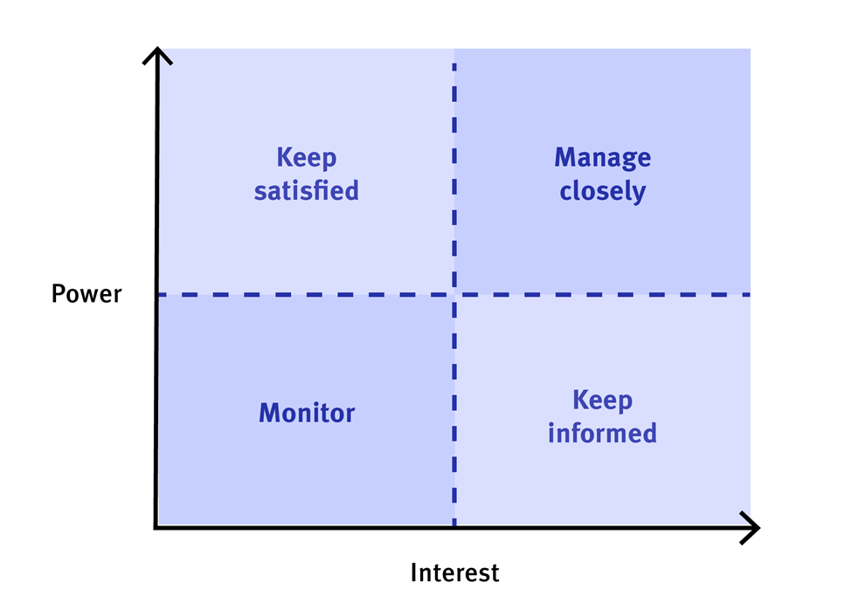
Figure 2- Stakeholder mapping
Source: (Baines et al., 2024)
I. Students-
They are the most important factor in this category as the executions and state of these students reflect the condition of the whole community. They influence others actively and make candid moves for the betterment of themselves and their surroundings as well (Baines et al., 2024).
II. Faculties-
Teachers are the path leaders for the pupils and influence their professional and personal lives. They influence the environment of the college and set the norms to be followed by the students. The advancement and capability of the faculties cast a positive impact on the community. Engaging experienced and highly qualified faculties in the university attracts people to come and study there.
III. Staff-
They are the people related to different kinds of work in the university like management, infrastructure and other working bodies like this. Their activities and dedication strengthen the aggregated group (Crowley et al., 2024).
IV. Alumni-
These are the passed-out students of the college who add charm and a degree of success to the community through their achievements. These people also provide testimonial donations to the university. They encourage the present students of the college to pursue suitable paths and reach the apex of a professional career (Crowley et al., 2024).
V. Governments-
The administrative bodies of the location are among the crucial external stakeholders of the group. They provide financial support and form the infrastructure of education in the whole system. The growth of the education department shows the efficacy of the government and the efforts of this sector.
VI. Local community-
The surroundings of the university and socioeconomic components from the section matter for the aggregate group. The growth of the university and the executions of the local people both have a cyclic relationship with each other. It lets people access the university while staying in their residential locations without moving to far places (Crowley et al., 2024).
VII. Donors-
Non-profit bodies and other donation-giving institutions are important for communal enhancement. Their monetary aid shapes the internal pattern of the university and encourages them to perform better (Broomfield et al., 2021).
VIII. Industry-
The education industry and its framework influence the entire community severely. Even, the fame of the university contributes to making the reputation of the industry better. The whole education industry is fostered to make all the portions in this field advanced for the amelioration of all the people related to the education sector (Anthony Jr, 2024).

Part 3: Describing the Community Engagement Plan
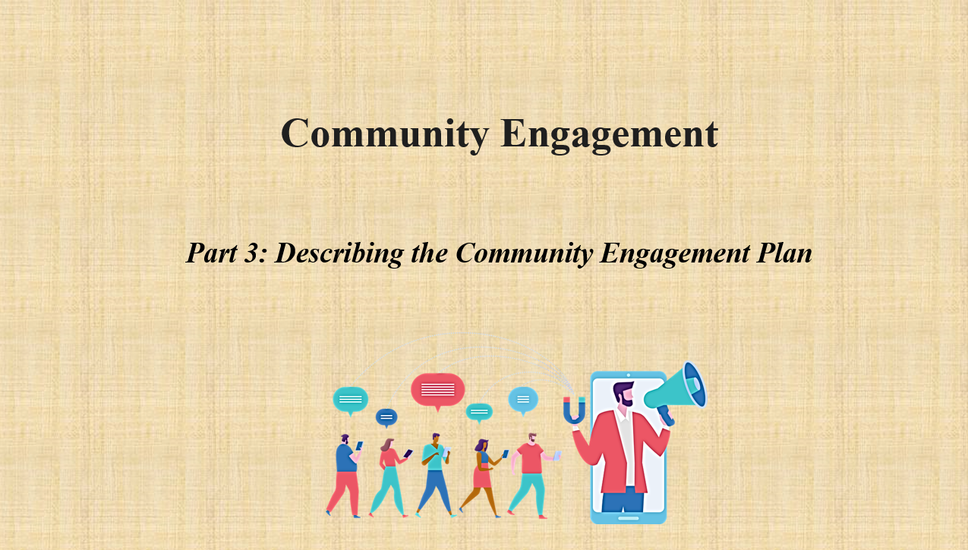

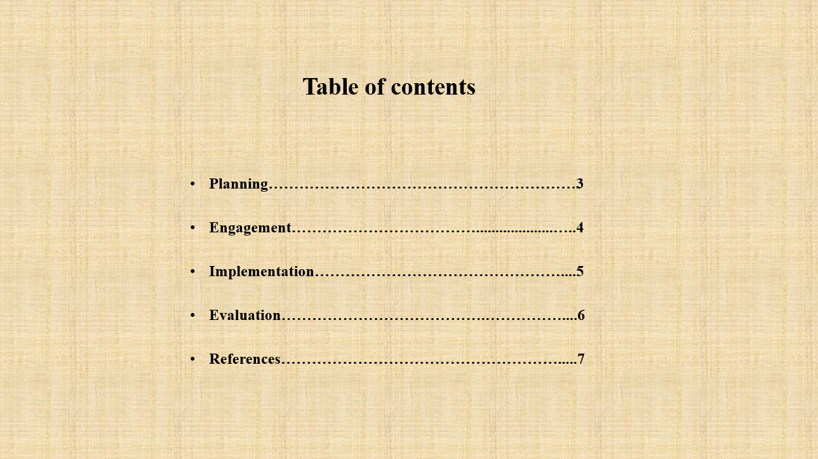

Slides:
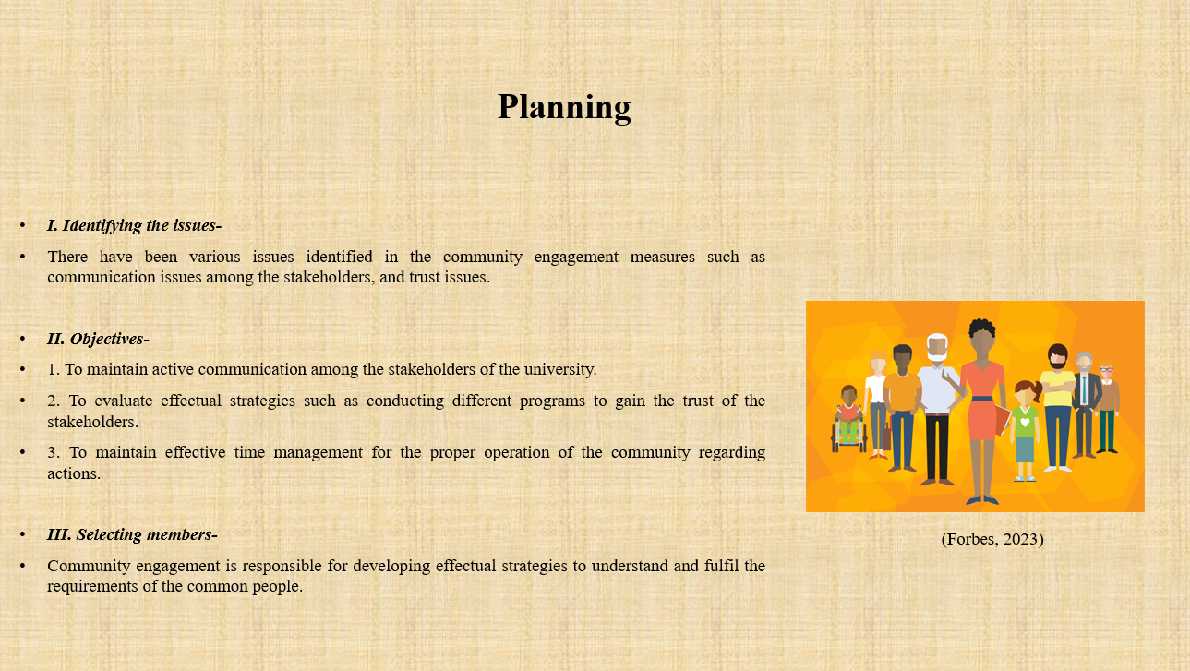
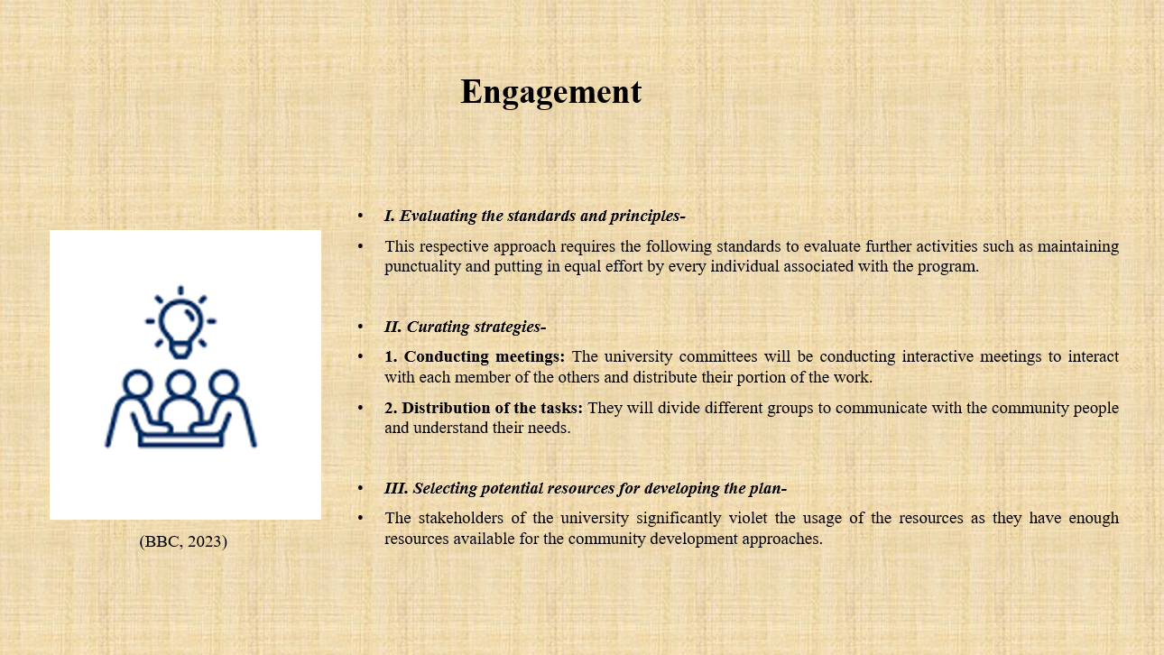
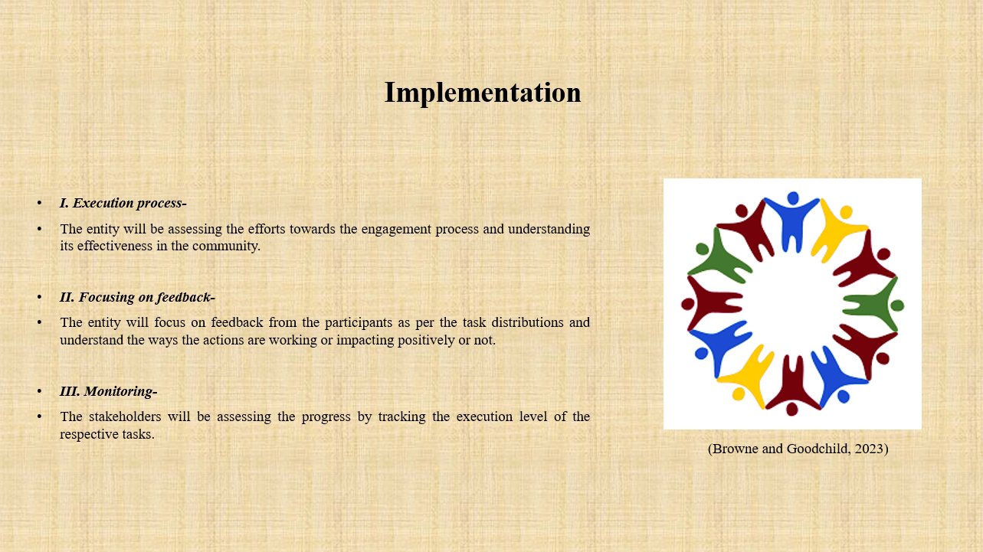
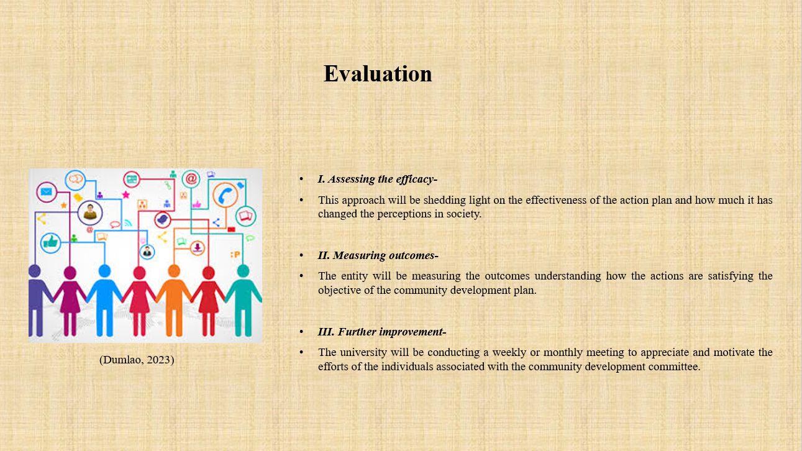
Notes:
Planning
I. Identifying the issues-
There have been various issues identified in the community engagement measures such as communication issues among the stakeholders, and trust issues. Apart from that, there are lack of time engagement towards community activities and some others (Forbes, 2023).
II. Objectives-
1. To maintain active communication among the stakeholders of the university.
2. To evaluate effectual strategies such as conducting different programs to gain the trust of the stakeholders.
3. To maintain effective time management for the proper operation of the community regarding actions.
III. Selecting members-
Community engagement is responsible for developing effectual strategies to understand and fulfil the requirements of the common people. The university must be aware of selecting their stakeholders potentially to form a strong team to serve the community engagement actions (Forbes, 2023). The stakeholders of the community engagement plan will be the faculties associated with the university, students, staff and also the donors to the university.
Engagement
I. Evaluating the standards and principles-
This respective approach requires the following standards to evaluate further activities such as maintaining punctuality and putting in equal effort by every individual associated with the program (Forbes, 2023). This should be an inclusive approach for shedding light on the diverse society. There are different preferences and beliefs in every community and in order to operate a potential community engagement the standards should be followed.
II. Curating strategies-
The issues identified in the respective stakeholders state a lack of communication and interaction among the individuals. The members especially the students and faculties enjoy a potential range of modern amenities that prevent them from socialising (BBC, 2023). As community engagement is a social activity, it requires a lot of potential in the activities to understand the needs of the people. Some strategic approaches for developing the community engagement plan are represented below.
1. Conducting meetings: The university committees will be conducting interactive meetings to interact with each member the others and distribute their portion of the work (BBC, 2023).
2. Distribution of the tasks: They will divide different groups to communicate with the community people and understand their needs. They will divide other groups to potentially manage further activities such as helping the people and designing different facilities (BBC, 2023). The teams will also monitor and assess the progress and further requirements for changes as well.
3. Effectual resource allocation: The students who are in the maximum number as the stakeholders were identified as misusing the resources for ineffective purposes. These respective measures must be controlled and the resources must be used for activities as per the objectives (Renwick et al., 2020).
4. Inclusivity and diversity: There will be an approach for joining the university as a stakeholder to all the interested participants for expanding the teams and groups. This will lead the entity to serve the diverse committee supporting their respective beliefs and preferences (Renwick et al., 2020).
III. Selecting potential resources for developing the plan-
The stakeholders of the university significantly violet the usage of the resources as they have enough resources available for the community development approaches. The above passage has already stated that there is government support, donations from the voluntary institutions and others that significantly reduce the resources (Mosurska and Ford, 2020). Still, the entity lacks in developing the action plan due to the lack of attention to sustainability measures. The community actively focuses on internet usage and does not support social engagement. This is causing the harm in both the social, cultural and economic aspects. However, the university does not require further resources as they have efficient funding still, they require to shed light on the sustainability measures (Mosurska and Ford, 2020).
Implementation
I. Execution process-
The entity will be assessing the efforts towards the engagement process and understanding its effectiveness in the community. It will significantly change the current situation into better aspects by developing social, cultural and economic measures (Browne and Goodchild, 2023).
II. Focusing on feedbacks-
The entity will focus on feedback from the participants as per the task distributions and understand the ways the actions are working or impacting positively or not (Browne and Goodchild, 2023).
III. Monitoring-
The stakeholders will be assessing the progress by tracking the execution level of the respective tasks. It will allow them to track progress and make further adjustments as per the requirements (Browne and Goodchild, 2023).
Evaluation
I. Assessing the efficacy-
This approach will be shedding light on the effectiveness of the action plan and how much it has changed the perceptions in society. It will measure whether the community accept the changes and works effectively or if there are conflicts (Dumlao, 2023).
II. Measuring outcomes-
The entity will be measuring the outcomes understanding how the actions are satisfying the objective of the community development plan. It will lead them to understand the progress of the respective approach (Dumlao, 2023).
III. Further improvement-
The university will be conducting a weekly or monthly meeting to appreciate and motivate the efforts of the individuals associated with the community development committee. There will be a discussion about the experiences gathered by executing the approaches which will be incorporated into further development plans (Dumlao, 2023).

Part 4: Practical discussion

Evaluating the advantages of engaging the stakeholders in community engagement
Stakeholders play a potential role in every business's action by evaluating their potentiality and expertise in business activities. Community engagement is an essential approach that not only develops the community, it also reflects the abilities and skills of the respective individuals associated with the development plans (Gyamera and Debrah, 2023). The advantages of engaging stakeholders in community engagement can be understood through the following.
Benefits of the internal stakeholders
The internal stakeholders of the university in community engagement refer to the students, faculties, staff and alumni. The students enhance their understanding of the ways entities develop community engagement. They can lead the future assessment by the experiences in the current assessment of the community development actions. The faculties uplift their skills through experiencing the actions and execution process of the development processes (Gyamera and Debrah, 2023). These skills will enable them to uprise their position in their further employment aspects. The staffs and the alumni also take the experiences to improve their knowledge about the ways these measures evaluate community standards.
Benefits of the external stakeholders
The external stakeholders of the university are the government authorities, local community, donation centres and industries. The government authorities represented their states or the countries in which they have developed their special, cultural and economic standing through tier donations into the community development plans. The donation centres enjoy tax benefits by showcasing their donations to their universities (Gyamera and Debrah, 2023). The local community and the industry also access the benefits of the community development actions and enhance the living standards. Thus, it is to be said that engaging the stakeholders helps the universities to develop effective strategies with potential resources. Apart from that, it is also effective for the individuals associated with the development processes as well.

Representing the personal assessment as a community engagement plan
I have been associated with the community development committee as a student. I was directed to interact with the people and identify the issues they are facing in living in the society. The university is situated in an urban place and in order to interact with the individuals of the society I faced communication issues as they prefer to stay active on digital platforms (Forbes, 2023). There were difficulties identifying their complications that made them ignore sustainability as they used a lump sum energy in living their lives depending upon the online activities. I have also been a member in the meetings as well where I learned the ways following respective stages the development actions are decided (Forbes, 2023). I have stated the factors I had identified in the social activities by the individuals of the society which reflected engage a potential factor in the development plans. I have identified that different conflicts can happen due to the different preferences of different individuals and in order to resolve such situations listening to both complaints are must. My identification has effectually contributed to the direction of the development plans which has improved the sustainability measures of the society (Forbes, 2023). Thus, it can be said that the monitoring and execution process was successful through the action development process.

Conclusion
The portfolio concludes that community engagement is essential for uplifting the lives of the community through fulfilling their requirements. It has portrayed the community outreach demonstrating the demographic measures such as age, gender and other factors. The context has also highlighted the social, economic and cultural measures as well. There has also been a brief explanation of the various stakeholders that are associated with community engagement measures and also stated different groups and partners. It has reflected appropriate ways to communicate with the stakeholders for developing the respective factors. Apart from that, it has presented a community engagement plan discussing the objective and the strategies. It has also highlighted the inclusivity and diversity approaches to fulfilling all the requirements of the respective individuals in the community. Furthermore, the context has described the advantages of engaging with the stakeholders in the community engagement including a self-assessment.

References
Slide:
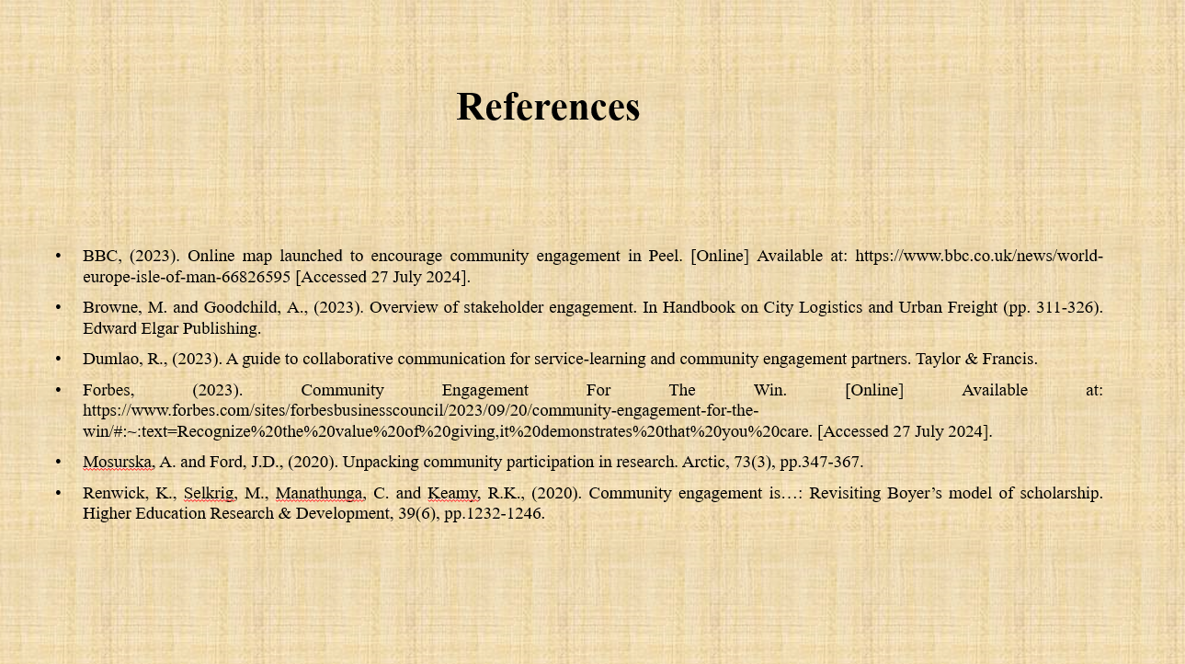
Notes:
Anthony Jr, B., (2024). The role of community engagement in urban innovation towards the co-creation of smart sustainable cities. Journal of the Knowledge Economy, 15(1), pp.1592-1624.
Baines, L., Gooch, D. and Ng-Knight, T., (2024). Do widening participation interventions change university attitudes in UK school children? A systematic review of the efficacy of UK programmes, and quality of evaluation evidence. Educational Review, 76(3), pp.628-647.
BBC, (2023). Online map launched to encourage community engagement in Peel. [Online] Available at: https://www.bbc.co.uk/news/world-europe-isle-of-man-66826595 [Accessed 27 July 2024].
Broomfield, K., Craig, C., Smith, S., Jones, G., Judge, S. and Sage, K., (2021). Creativity in public involvement: supporting authentic collaboration and inclusive research with seldom heard voices. Research Involvement and Engagement, 7, pp.1-14.
Browne, M. and Goodchild, A., (2023). Overview of stakeholder engagement. In Handbook on City Logistics and Urban Freight (pp. 311-326). Edward Elgar Publishing.
Compan, P., Kongyok, C., Prommachan, T., Rodsaard, N. and Socheath, M., (2024). Developing and Validating Sustainability Indicators for Measuring Social Impact of University–Community Engagement Programs. Sustainability, 16(12), p.5232.
Crowley, A., Lloyd, N. and Lindley, R., (2024). How University of Warwick successfully united its development and alumni engagement functions. Journal of Education Advancement & Marketing, 9(2), pp.136-148.
Dumlao, R., (2023). A guide to collaborative communication for service-learning and community engagement partners. Taylor & Francis.
Forbes, (2023). Community Engagement For The Win. [Online] Available at: https://www.forbes.com/sites/forbesbusinesscouncil/2023/09/20/community-engagement-for-the-win/#:~:text=Recognize%20the%20value%20of%20giving,it%20demonstrates%20that%20you%20care. [Accessed 27 July 2024].
Forbes, (2023). Mastering Stakeholder Engagement To Drive Business Success. [Online] Available at: https://www.forbes.com/sites/glebtsipursky/2023/04/23/mastering-stakeholder-engagement-to-drive-business-success/ [Accessed 27 July 2024].
Gyamera, G.O. and Debrah, I., (2023). Utilising university community engagement as a critical tool for global citizenship. Compare: A Journal of Comparative and International Education, 53(3), pp.435-453.
Mosurska, A. and Ford, J.D., (2020). Unpacking community participation in research. Arctic, 73(3), pp.347-367.
Parker, L.D., (2024). Public university research engagement contradictions in a commercialising higher education world. Financial Accountability & Management, 40(1), pp.16-33.
Renwick, K., Selkrig, M., Manathunga, C. and Keamy, R.K., (2020). Community engagement is…: Revisiting Boyer’s model of scholarship. Higher Education Research & Development, 39(6), pp.1232-1246.
Taffere, G.R., Abebe, H.T., Zerihun, Z., Mallen, C., Price, H.P. and Mulugeta, A., (2024). Systematic review of community engagement approach in research: describing partnership approaches, challenges and benefits. Journal of Public Health, 32(2), pp.185-205.

