

BA (Hons) Business Management
Project Management

Student name: Valentin Masala
ID Number :2236548
Module: LCBB6006
Lecturer: Zainab Atta

Table of Contents

1.Introduction…………………………………………………………………………….3
2.Background of Contracts in Project Management…………………….4
3.Turnkey Contracting………………………………………………………………….4
4.Multicontract Contracting…………………………………………………………6
5.Do-It-Yourself (DIY) Contracting…………………………………………………7
6.Multicontract + DIY Contracting………………………………………………..8
7.Conclusion………………………………………………………………………………..9
8.References………………………………………………………………………………..10
9.Appendix…………………………………………………………………………………..12

1.Introduction

According to Kerzner (2022), project management is the coordinated application of processes, expertise, abilities, and resources with the aim of accomplishing project objectives while abiding by constraints like time, money, and scope. Contracting is a crucial part of project execution in modern enterprises since it allows companies to allocate tasks, transfer risk, and have access to outside information (PMI, 2021). The way that work, risks, and resources are distributed among the several project participants is impacted by contract decisions.
Business owners choose to hire outside help for several strategic reasons, such as needing to reduce the strain on their own staff, speed up delivery, save money, or gain technical skills that they may not have internally (Turner, 2020). This is evident in big infrastructure projects, such as, for example, The Elizabeth Line in London, which used many different contractors for digging, signalling, train stock, and station construction. This meant that the customer had to manage a lot of work packages that depended on each other (Megaprojects, 2022). These real-world examples show how the way it chooses to contract influences the risk, coordination demands, and overall performance of a project. These choices are also affected by larger environmental issues, which may be looked at using tools like STEEPLE or PESTEL, and by internal capacity evaluations like SWOT.
The goal of this paper is to look at four important ways to contract in project management: Turnkey, Multicontract, Do-It-Yourself (DIY), and Multicontract + DIY. It will also look at the advantages and disadvantages of each technique and how well they work for different types of projects. The conversation brings together useful project management tools like Gantt charts, risk registers, stakeholder analysis, and the Work Breakdown Structure (WBS) to show how each contracting approach changes how projects are planned and carried out. The essay ends by comparing the strategies and pointing out the best situations for each one to work.

2. Background of Contracts in Project Management (STEEPLE)
Contracts are critical in project management because they define obligations, allocate risks, and establish responsibility among stakeholders (Larson and Gray, 2021). Contracting out work is a common practice for organisations to get access to specific expertise, decrease operational risk, and enhance efficiency, particularly in complex projects such as building, IT systems, and retail growth.
From a societal standpoint, labour shortages and workforce mobility in the UK construction industry have increased reliance on contractors, as organisations are often unable to sustain a fully qualified permanent workforce ( Construction Industry Training Board, 2022). Furthermore, globalisation has contributed to the development of multicultural project teams, requiring external collaboration to manage diverse skills, cultural expectations, and communication styles effectively (Hofstede, 2001).
Economically speaking, external geopolitical events have a huge impact on contracting decisions. Conflicts in the Middle East, for example, have affected global energy supply lines, resulting in higher oil and gas prices, which increases UK construction and logistical costs (Bank of England, 2024). As a result, UK economic development has fluctuated, with slowdowns caused by inflationary pressures, which have a direct impact on project budgets and contracting techniques (IMF, 2024).
From an ecological standpoint, sustainability criteria and environmental regulations have increased project complexity by requiring organizations to meet carbon reduction targets and environmental standards. Contracting professional firms with knowledge in sustainable construction and green technologies is frequently required (UK Green Building Council, 2023).

3.Turnkey Contracting
In turnkey contracting, one contractor oversees the design, procurement, building, and commissioning of a complete, operating facility (PMI, 2006). The customer gives the contractor high-level requirements, and the contractor adopts responsibility for all the technical and management details until the project is finished. Meredith and Mantel (2009) suggest that this method works best when the customer cannot manage complicated technological interfaces on their own since it puts all the responsibility on one person. So, turnkey delivery is often utilised in big infrastructure and industrial projects where it is important to make sure that everything works together and that performance is guaranteed.
One of the best qualities aspects about Turnkey contracting is that there is just one person in charge, which makes communication easier and takes some of the stress of coordinating off the customer (Larson and Grey, 2018). According to Wysocki (2003), the customer receives more predictable costs and schedules since the contractor takes on most of the design and performance risk, particularly when fixed-price contracts are employed. This makes Turnkey arrangements attractive to businesses who want to be less involved in day-to-day operations and have a high level of confidence in the project's results. Also, this method lets customers get customised technical help without having to build it themselves.
Nevertheless, these advantages, turnkey contracting has certain drawbacks. Clients have less authority over design decisions post-contract signing, which may result in misalignment if requirements change over the project length (Meredith and Mantel, 2009). Due to the substantial risk assumed by the contractor, Turnkey projects often include high initial costs, since risk premiums are integrated into the contract price (Larson and Grey, 2018). Wysocki (2003) emphasises that Turnkey delivery lacks flexibility, making scope adjustments hard and expensive to execute.
A notable application of Turnkey contracting is the Dubai Metro, executed by a consortium supervised by Mitsubishi Heavy Industries under a comprehensive Turnkey agreement (Mitsubishi Heavy Industries, Ltd., 2009). The contractor supplied train stock, signalling, power systems, station construction, and testing integrated system. This illustrates the efficacy of Turnkey contracting for large, technically complex transport projects requiring a fully operational solution at the time of handover.
In Turnkey projects, the contractor mostly generates the Work Breakdown Structure (WBS), while the customer just looks at the big picture outcomes (PMI, 2006). The risk register gives the contractor most of the technical and delivery concerns, while the customer keeps the strategic risks, such getting regulatory permissions. Because the contractor oversees most of the outside stakeholders, the stakeholder grid is not as complicated as it is in multicontract projects. The Gantt chart is similarly based on the contractor's job duties, and the customer just keeps monitoring on the progress of milestones and not the details of the schedule(Appendix)
Turnkey contracting works well for projects that are steady, predictable, and need a lot of technical knowledge, such energy installations, industrial facilities, or transit systems. At the same time, it is less appropriate for projects that necessitate iterative design, evolving requirements, or high client involvement. The contractor's skill and the clarity of the project's first specifications are very important to its success (Larson and Grey, 2018).‌

4. Multicontract Contracting
In multicontract contracting, the client engages multiple expert contractors, each of whom oversees a different work package, such tunnelling, signalling, structural construction, or systems integration. The customer is in charge of the whole project and serves as the project integrator, making sure that all of the various workstreams are in sync (PMI, 2006). This is different from Turnkey delivery, and Meredith and Mantel (2009) stress that this method works best for big, complicated projects when various parts need specialised knowledge and the customer can handle a lot of cooperation.
According to Larson and Grey (2018), one major benefit of using multiple contracts is that the customer has a lot of control because they get to choose which contractor is ideal for each job package. Cost savings are a common result of this, as competitive bidding may lower total spending. The approach is versatile since it lets the customer make changes or switch out contractors without impacting the overall project. According to Wysocki (2003), when one contractor cannot meet the technical requirements of a project's components, multicontracting becomes very advantageous.
Multicontracting, however, presents disadvantages as well, where to guarantee that contractors' outputs are timely and technically aligned, the customer must manage complex coordination as Meredith and Mantel (2009) argue. Therefore, there are much more contact risks, such as misaligned designs, mismatched systems, or scheduling problems. According to Larson and Grey (2018), disagreements amongst contractors may occur when duties overlap or when delays in one package have an impact on others. As a result, this method requires thorough planning, effective communication systems, and mature project management.
Multicontract projects need a thorough job Breakdown Structure (WBS) with clearly defined job packages to minimise overlap, where interface hazards dominate the risk register and need constant monitoring and mitigation. The stakeholder matrix is wide since each contractor has stakeholders, subcontractors, and dependents and to minimise cascading delays, the Gantt chart must highlight package interdependencies and critical path analysis (PMI, 2006).
Multicontract contracting works best when the customer has excellent internal project management and the project demands various specialised capabilities. It is less suited for organisations without coordination ability or projects with closely linked technological systems as Larson and Gray (2018) stated that this type of contracting requires precise scope specification, robust interface management, and contractor-wide communication.
A strong example is Heathrow Terminal 5, which required the customer (British Airports Authority -BAA) to serve as the central integrator and entailed over 1500 individual contracts, and it show how multicontracting works well for massive, interdisciplinary infrastructure projects but that also requires extraordinary coordination skills (Flyvbjerg, 2008).

5.D0-IT-Yourself (DIY) Contracting
DIY contracting is a project delivery method where the customer handles most tasks internally utilising their own people, resources, and technical competence, rather than outsourcing significant job packages. Meredith and Mantel (2009) recommend this method for organisations with strong internal competence that want to control important project choices. DIY delivery fits contexts where knowledge retention, intellectual property protection, and internal learning are strategic concerns since the organization owns processes and results, according to PMI (2006).
Client control is a fundamental benefit of DIY contracting. The company can rapidly shift priorities, objectives, and choices without haggling with contractors (Larson and Grey, 2018). DIY delivery helps organisations retain knowledge and utilise it in future initiatives. According to Wysocki (2003), DIY methods may save money by using internal people with the relevant capabilities, eliminating the requirement for external procurement. This flexible strategy allows iterative development and ongoing improvement throughout the project lifespan.
Nevertheless, DIY contracting has limits. It pressures internal teams, which may delay delivery if resources are few (Meredith and Mantel, 2009). The organization's expertise limits the strategy; without it, quality and performance may suffer. When companies overestimate their capacity or underestimate the difficulty of the task, Larson and Grey (2018) believe that DIY delivery increases project risk. Also, internal teams may have difficulties staying objective, which may cause scope creep or poor risk management.‌
The WBS for DIY projects must reflect internal assets and skill distribution (PMI, 2006). Capability gaps, workload constraints, and internal capacity delays are on the risk register. External stakeholders may be engaged for regulatory or compliance reasons, but the stakeholder matrix is mostly internal. Gantt charts must balance internal workloads and schedule carefully to minimise team bottlenecks (Larson and Grey, 2018).
DIY contracting works best when the company has strong inside expertise, consistent resources, and a strategic requirement for control or knowledge retention. This method is less effective for significant, specialist, or time-sensitive projects, since external contractors may deliver more efficiently. Its effectiveness relies on accurate capacity evaluation, good internal coordination, and risk management without external help (Meredith and Mantel, 2009).

6. Multicontract and DIY
The hybrid strategy combines multicontracting and DIY, with the client managing certain aspects internally and outsourcing specific duties (Wysocki, 2019). This method is consistent with modern project management practices, which promote flexibility and resource optimisation.
The fundamental advantage of this strategy is that it strikes a compromise between control and efficiency, as the customer maintains strategic oversight while using external knowledge. For example, in a Tesco Express store development project, the company may handle planning and financing internally while outsourcing construction and technology installation.
However, this strategy adds complexity since coordination between internal teams and external contractors necessitates effective communication and governance systems. Failure to manage this integration may result in delays and performance difficulties (PMI, 2013).

7.Conclusions
The Multicontract + DIY (Hybrid approach) is the finest contracting strategy in today's market, particularly in the UK where inflation, supply chain disruptions, and geopolitical volatility exist.
This strategy is regarded the most effective because current projects are no longer steady or predictable, necessitating both flexibility and control. The hybrid model allows organizations to maintain internal strategic decision-making while outsourcing specialized and technical activities to skilled contractors, which enhances efficiency and quality (PMI, 2013; Larson and Gray, 2021).
8.Reference List
Bank of England (2024) Monetary Policy Report. London: Bank of England.
Construction Industry Training Board (2022) Construction Skills Network Report. CITB
DW Documentary (2023) How the world’s biggest wind turbines are built. YouTube video, 12 June. Available at: https://www.youtube.com/watch?v=MdcNeQD54bQ (Accessed: 16 April 2026).
Flyvbjerg, B. (2008) Learning to manage mega projects. University of Brighton. Available at:https://cris.brighton.ac.uk/ws/portalfiles/portal/188751/Learning_to_Manage_Mega_Projects.pdf (Accessed: 16 April 2026).
Geert Hofstede (2001) Culture’s Consequences: Comparing Values, Behaviours, Institutions and Organizations Across Nations. Sage Publications.
Kerzner, H. (2022) Project Management: A Systems Approach to Planning, Scheduling, and Controlling. 13th edn. Hoboken: Wiley.
Kniberg, H. and Ivarsson, A. (2012). Scaling Agile at Spotify with Tribes, Squads, Chapters & Guilds. [online] Available at: https://blog.crisp.se/wp-content/uploads/2012/11/SpotifyScaling.pdf(Accessed: 18 April 2026).
Larson, E. and Gray, C. (2018) Project Management: The Managerial Process 7th Edition, McGraw Hill.
Megaprojects (2022) How the Elizabeth Line was finally completed. YouTube video, 4 December. Available at: https://www.youtube.com/watch?v=r-q5V6LDxEY (Accessed: 16 April 2026).
Meredith, J. and Mantel, S. (2009) Project Management: A Managerial Approach, Asia: John Wiley and Sons.
Mitsubishi Heavy Industries, Ltd. (2009). Dubai Metro Commences Operation: First Urban Rail System in GCC-- World’s Longest Driverless Rail System -- | Mitsubishi Heavy Industries. [online] Available at: https://www.mhi.com/news/0909101308.html [Accessed 16 Apr. 2026].
PMI (2006) The Guide to the Project Management Body of Knowledge (PMBoK), 5th Edition: PMI
PMI (Project Management Institute) (2021) A Guide to the Project Management Body of Knowledge (PMBOK® Guide). 7th edn. Newtown Square: PMI.
Scribd. (n.d.). Apm Body of Knowledge 7th Edition | PDF | Project Management | Life Cycle Assessment. [online] Available at: https://www.scribd.com/document/507430090/Apm-Body-of-Knowledge-7th-Edition (Accessed 16 April 2026),
Turner, J.R. (2020) Handbook of Project-Based Management. 4th edn. New York: McGraw-Hill.
UK Green Building Council (2023) Sustainability in Construction Report. London: UKGBC.
Vance, A. (2009). Elon Musk; Tesla, SpaceX, and the Quest for a Fantastic Future. Ashlee Vance. [online] Available at: https://www.academia.edu/41363337/Ashlee_Vance_Elon_Musk_Tesla_SpaceX_and_the_Quest_for_a_Fantastic_Future. (Accessed: 17 April 2026).
Wysocki, R.K (2003) Effective Project Management, Traditional, Extreme, Indianapolis: Wiley Publishing Inc.

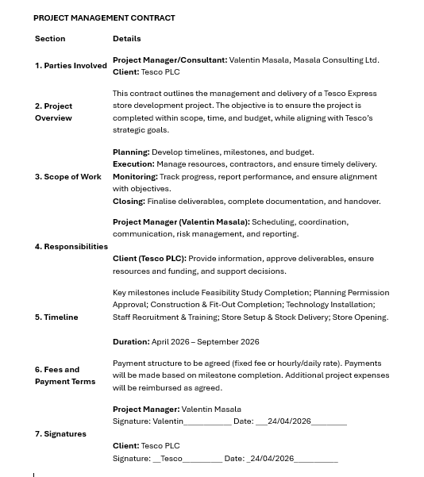
9.Appendix
A. Project management contract

‌

‌

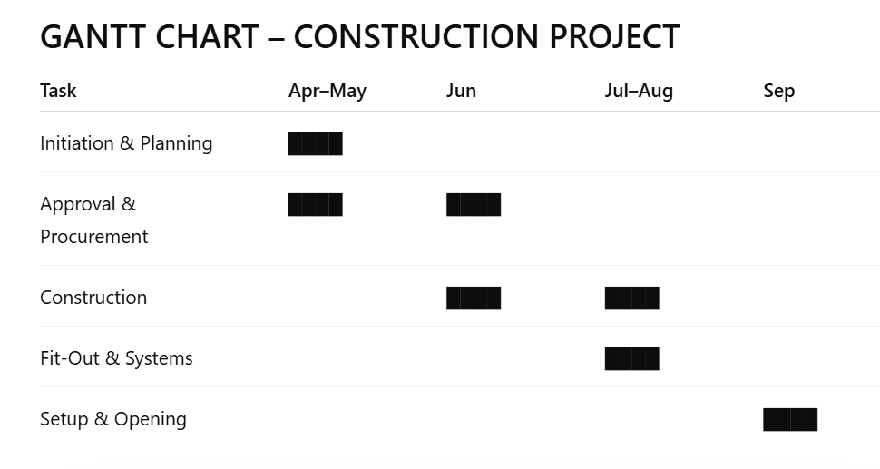

B. GANTT CHART

