INTERNATIONAL MARKETING: PRINCIPLES AND PRACTICES
LCMB7026
ASSESSMENT COMPONENT 1: INDIVIDUAL REPORT
STUDENT NAME:Nicolae Mihai
STUDENT ID:2124103
Lecturer Dian Mayasari

Table of Contents
Section 1: International Marketing Report 3
1. Introduction 3
2. Selection of Countries 4
3. Comparative Market Analysis (PESTEL and Hofstede) 4
3.1. A PESTEL analysis of France 4
3.2 PESTEL Analysis of Japan 6
3.4 Hofstede Cultural Analysis 8
4. Comparative Analysis of STP Strategy 9
4.1 Segmentation 9
4.2 Targeting Strategy 10
4.3 Positioning Strategy 10
5. Comparative Analysis of International Marketing Mix (7Ps) 11
5.1 Product 11
5.2 Price 12
5.3 Place 13
5.4 Promotion 13
5.5 People 14
5.6 Process 14
5.7 Physical Evidence 15
6. Market Entry Strategy in Japan 15
6.1 Chanel's coming to Japan 15
6.2 Entry Mode Analysis 16
6.3 Evaluation of Entry Strategy 16
7. Ethical Issues in Chanel's Marketing Mix 17
8. Recommendations 18
9. Conclusion 18
Section 2: Reflective Account 19
10. Reflection Using Gibbs Reflective Cycle 19
10.1 Description 19
10.2 Feelings 20
10.3 Evaluation 20
10.4 Analysis 20
10.5 Conclusion 21
10.6 Action Plan 21
References 22

Section 1: International Marketing Report

1. Introduction
Chanel is undoubtedly one of the biggest luxury brands, which is globally recognised. Chartered in 1910 in Paris, France, by Gabrielle "Coco" Chanel, it started off as a millinery shop and progressed into haute couture, perfume, cosmetics, jewellery, watches, and luxury accessories (Gross, 2024). Key to Chanel's reputation, this company has earned over 100 years of experience, and its exclusive, hand-made, and classic design. The brand has iconic products like the Chanel No.5 perfume, the Chanel suit and the 2.55 handbag that are helping to make Chanel a global phenomenon (BBC News 2011; Post 2, 2009). Postpone in the luxury industry happened in 2024; nevertheless, Chanel seized revenues of a sum of US$18.7 billion, keeping its standing among the biggest luxury brands in the world (Nair and Blondiaux, 2025). According to industry reports, Chanel is one of the top luxury brands in the world in 2025, along with Louis Vuitton, Hermès and Dior. Chanel's brand value is estimated to be around US$37.9 billion, and the brand holds a commanding market share globally (Chechi, 2024).
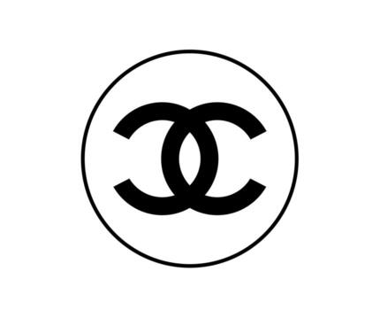
Figure 1: Chanel
Source: (Vecteezy, 2026)
This report presents a case study on the marketing activities of a company, Chanel, that sells its products internationally in France and Japan. France embodies Chanel's heritage and identity, as the brand was founded here and many of the historic elements are rooted here. Japan is known to be one of Chanel's best-performing luxury fashion markets in Asia and is an important host market. The report begins by reviewing the macro-environmental scenario of both nations using PESTEL analysis and considering cultural differences based on Hofstede's cultural dimensions framework. It then examines Chanel's segmentation, targeting and positioning (STP) strategy and its international marketing mix (7Ps) for each market. In addition, the report examines the approach in which Chanel ventured into the Japanese market and also analyses critically the ethical issues surrounding Chanel's marketing.

2. Selection of Countries
France and Japan were chosen for this report for two reasons: firstly, they are two of the most important markets for Chanel to target in their marketing strategy, and secondly, Japan and France are two countries in which Chanel has established outlets, making them easier to compare to international marketing strategies. Chanel's headquarters is in France, and Japan is one of the first and leading host markets in Asia. France is ideal because Chanel began in Paris in 1910 and is still closely linked to the French Luxury industry, French Fashion Heritage and French Craftsmanship. The reputation of the country in the sale of luxury goods helps establish the image of the brand and its competitive advantage. Additionally, France is well endowed with many top luxury brands, making the market all the more competitive, where brand prestige plays a crucial role (Garnier, 2025). While French consumers are focused on purchasing products from a Western European luxury market, which appreciates heritage and the authenticity of brands, Japanese consumers prioritise quality and craftsmanship, as well as service and long-term brand trust. Moreover, Japan has gained significance for luxury brands, with its growth (Noyen, 2024). In spite of the signs of weakness in luxury demand from the rest of the world, the Japanese people themselves have preserved luxury demand by travelling abroad and appreciating high-quality goods, according to industry data.

3. Comparative Market Analysis (PESTEL and Hofstede)

3.1. A PESTEL analysis of France
Political Factors
In France, the political climate is relatively stable, and this helps luxury brands like Chanel invest in the long run. European Union member country with good institutional, IP protection and international trade arrangements. With 71 announcements, €93 billion of investments unveiled and more than 15,600 jobs generated, the ninth edition of "Choose France", organised on June 1, 2026, in Versailles, just outside Paris, set a record, confirming the attractiveness of France to foreign investors (Business France, 2026). France, too, supports the luxury and fashion segment in the country as it makes a major contribution to the national economic output and exports.
Economic Factors
France is the seventh biggest in the world with a GDP of 3162,08 billion US dollars in 2024 (TRADING ECONOMICS, 2026a). The country still has high-income consumers and a robust tourism market, which keeps it as one of the largest luxury markets in the world. The city of Paris is a big shopping hub for luxury products and receives millions of tourists from around the world each year. But recently, consumer spending has been influenced by inflationary tendencies and a decrease in economic growth. This makes it difficult for luxury brands because people might be pickier about shopping.
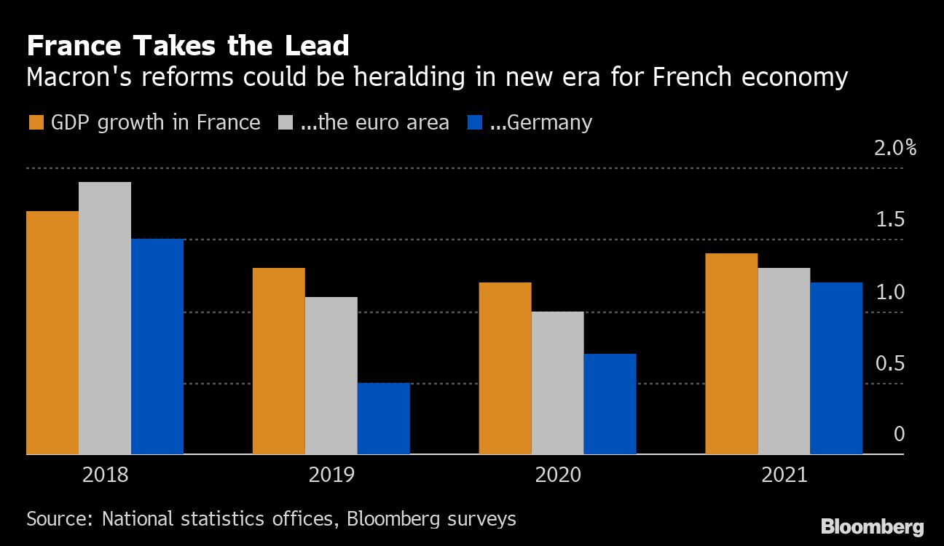
Figure 2: France Economy
Source: (Al Jazeera, 2019)
Social Factors
The French fashion scene is renowned, and France is known as a world-class beauty, design and creativity hub. For consumers, French luxury brands are synonymous with heritage, exclusivity and craftsmanship. Meanwhile, younger consumers are demanding that brands show sustainability and diversity and take responsibility for their actions, which puts pressure on luxury brands to undergo modernisation.
Technological Factors
At the end of 2025, a total of 77.3 million cellular mobile connections were used in France, which corresponds to 116 per cent of the total population (Kemp, 2025b). With the advancement of ecommerce, digital marketing, and artificial intelligence, luxury brands can enhance customer engagement and personalise shopping experiences. Chanel has been investing more in digital customer services to sustain its exclusive brand image.
Environmental Factors
Environmental sustainability is a pressing problem in France. Society is demanding more from companies, urging them to cut down on carbon emissions, to shed light on their supply chains and to find more sustainable manufacturing. In response, Chanel has made investments in sustainable materials and environmental initiatives (Chanel, 2024).
Legal Factors
France has very strict legislation on consumer protection, IP rights, clothing standards in advertising and employment practices. Criminal counterfeiting of luxury products is a major concern in the fashion industry, and robust trademark protection is all the more crucial for Chanel.

3.2 PESTEL Analysis of Japan
Political Factors
Japan became a member of the World Bank in August 1952, with the exception of Japan's year of the signing of the San Francisco Peace Treaty (World Bank Group, 2026). In 1953, a number of projects were introduced, utilising World Bank loans to support Japan's economic structure, including electric power production, basic industries development, transportation, water and infrastructure.
Economic Factors
The official statistic for the Gross Domestic Product (GDP) for Japan in 2024 was 4026.21 billion US dollars (TRADING ECONOMICS, 2026b). As a result, the country continues to be one of the biggest luxury goods markets in the world. The brands, including Chanel, have been capitalising on the Japanese Yen, which has made it more attractive for visitors from overseas to buy luxury goods in Japan.
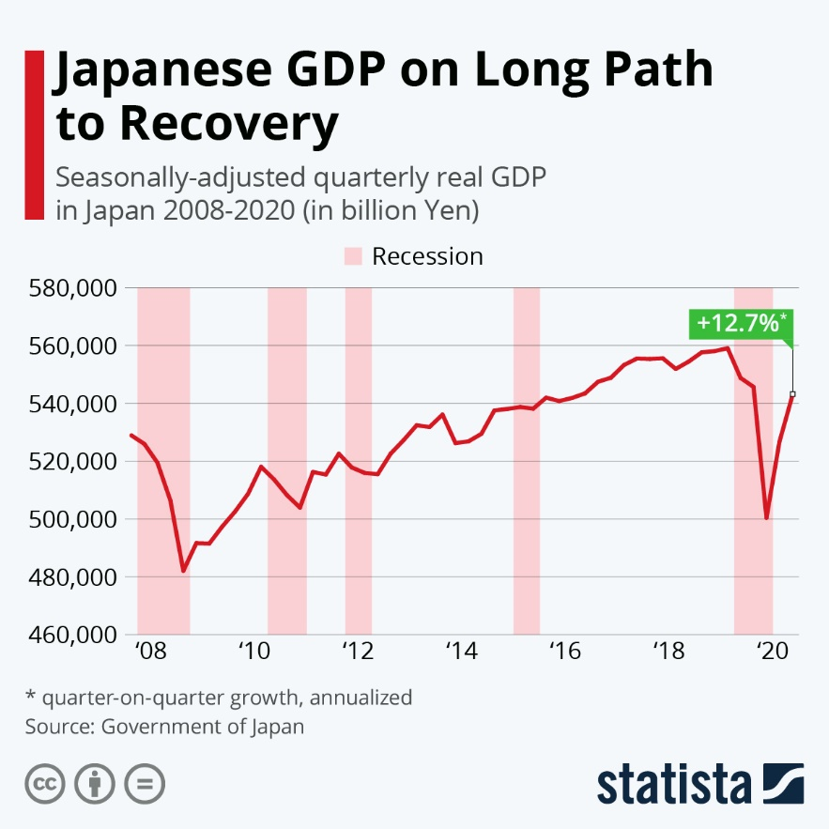
Figure 3: Japanese GDP
Source: (Buchholz, 2021)
Social Factors
The Japanese people are renowned for their emphasis on quality, craftsmanship and service. This is a good fit with Chanel's 'luxury positioning'. While many Western markets give the customer considerable choice, Japanese buyers can eventually come to be loyal to more expensive brands. Often, luxury items can be perceived as luxury investments — or luxury social purchases. This helps to set the stage for Chanel's ability to justify its high prices.
Technological Factors
At the beginning of 2025, 109 million people in Japan used the internet, meaning the penetration rate of Japan's online population was at 88.2 per cent (Kemp, 2025a). Such developments enable Chanel to unify the luxury retail experience and digital communications in a way that is engaging and personal, using marketing, online functions and omnichannel retail approaches to do so.
Environmental Factors
The significance of the environment is growing in Japan. Consumers are demanding that companies cut waste, increase packaging sustainability and ensure they're being responsible with sourcing. There is a compelling need for luxury brands to make changes to their operations to meet the national carbon reduction targets and environmental expectations.
Legal Factors
Japan's laws regarding consumer protection, intellectual property rights, product quality and fair competition are very strict. Firmer I.P. enforcement is especially beneficial for Chanel as it will help to fight against the counterfeits selling under the name Chanel. Moreover, more environmental disclosure obligations promote luxury businesses to improve the sustainability of communications and supply chain transparency.

3.4 Hofstede Cultural Analysis
Hofstede's cultural dimensions offer a valuable tool for understanding the differences in consumer behaviours between France and Japan. These cultural differences have an impact on Chanel's marketing communications, customer experience and brand positioning strategies. France has a score of 68 on Power Distance, showing that the hierarchy and authority are readily accepted in the society (The culture factor, 2023). Japan, which scores 54, is less polarised, indicating somewhat even management-employee dynamics. France ranks 74 in Individualism, whereas Japan ranks 62 (The culture factor, 2023).
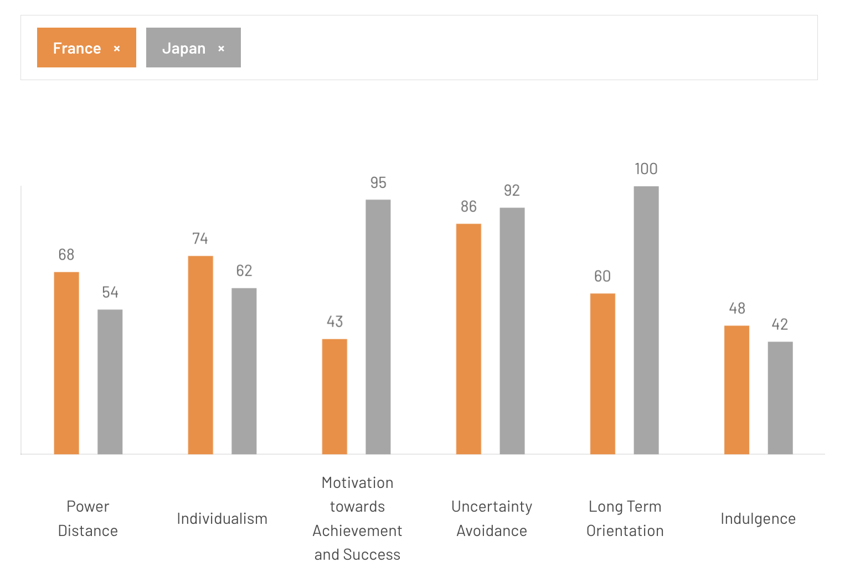
Figure 4: Hofstede’s dimensions
Source: (The culture factor, 2023)
Furthermore, Chanel's marketing strategies in Japan are concentrated on the level of craftsmanship, reputation, and social status instead of individuality. This is, to a large extent, reflected in the cumulative values of the scales, where Japan scores 95 and France scores 43 for Masculinity (The culture factor, 2023). That means a strong focus and competitiveness in Japanese society. As such, luxury spending in Japan is quite common as a way to show success, quality and professional achievements. French shoppers, on the other hand, tend to have a high value for luxury products, based on their aesthetic appeal, lifestyle benefits and personal pleasure. Both countries score highly with respect to Uncertainty Avoidance (86 for France and 92 for Japan). Trusted brands with good reputations are preferred in both markets. This is very good for Chanel, since the brand's history, quality standards and affiliations decrease the threats in purchasing. The Long-Term Orientation score is much higher in Japan (100) than in France (60). This implies that the Japanese consumers are more concerned about long-term value, durability, and quality maintenance of the relationship. The quality of products and customer service is thus crucial in Japan for Chanel.

4. Comparative Analysis of STP Strategy

4.1 Segmentation
France
The key targeted groups of Chanel's business in France are affluent consumers whose ages range from 25 to 60 years and have high disposable income. The brand targets business people, business executives, entrepreneurs and affluent tourists vacationing in Paris. The backbone of Chanel's key consumers is the women who desire to associate themselves with everything that a brand like Chanel represents – elegance, modern simplicity and class (daisyblance19, 2020). Consumed by the French, luxury products can often become a way of expressing themselves or of asserting their style or culture. Chanel is for people who prefer tradition and classic clothing over trends. This matches the high individualism score of 74, which indicates that consumers in France are searching for products to reflect their personal identity and social status.
Japan
Chanel is present to the high-end consumers in the big cities of Japan like Tokyo, Osaka and Kyoto. The brand is popular with the high-earning class, business executives and rich tourists. Younger consumers and visitors from overseas are also more likely to be the ones paying luxury prices, thanks to a strong exchange rate. Quality, perfection, craftsmanship and attention to detail are all very important to the Japanese consumer. Luxury items often carry the significance of accomplishment, recognition and a long-lasting value. This is due to the Japanese high masculinity score (95) and long-term orientation score (100). Japanese consumers have always been placed as one of the most highly loyal consumers in the world who are committed to purchasing certain brands for products in many different industries, such as automobiles, luxury goods, and electronics, to name a few (Amoroso and Ackaradejruangsri, 2026).

4.2 Targeting Strategy
In both markets, Chanel is following a niche marketing strategy. The focus group market is high-income consumers who can afford to shop and buy luxury fashion items frequently. There is a second group of luxury fashion buyers who are interested in buying reputed brands with a heritage and that are exclusive. However, Chanel chooses NOT to target the masses in the name of maintaining its top-shelf position and control over the price paid for its products. The company is also increasingly going after the younger luxury consumers- Millennials and Generation Z.

4.3 Positioning Strategy
France: Heritage Luxury
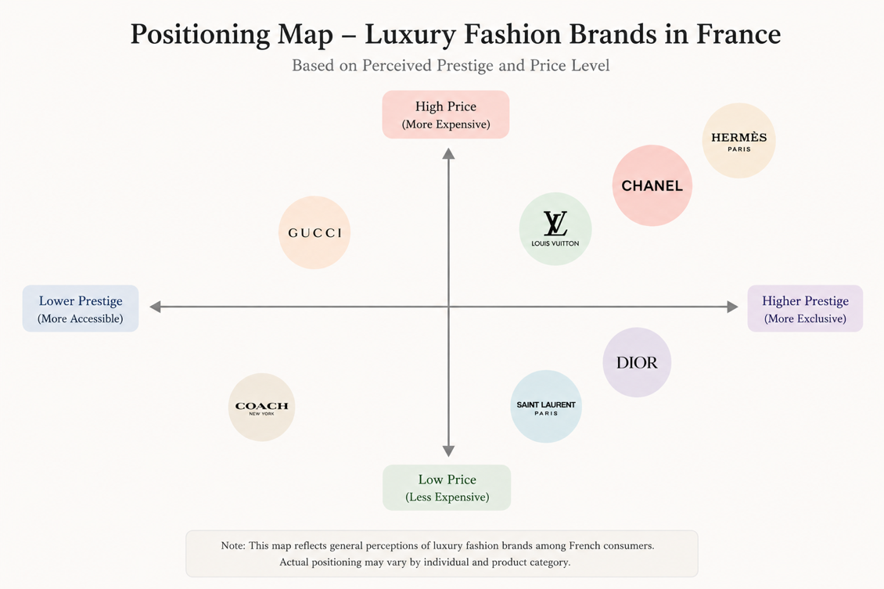
Figure 5: Positioning map of France
Source: (Developed by the author)
For France, Chanel has established itself as an emblem of luxury with roots. The brand emphasises its Parisian heritage, its history and its association with Coco Chanel. Craftsmanship, timeless elegance and contribution to French fashion culture are often the core of marketing messages. Such a position enhances Chanel's authenticity and consolidates Chanel's position as one of the world's most esteemed luxury houses.
Japan: Prestige and Craftsmanship
In Japan, the Chanel brand is more about prestige, quality and craftsmanship. Obedience to detail, product quality and durability are greatly appreciated by the Japanese consumer market. Consequently, Chanel promotes the use of high-quality materials, craftsmanship and excellent customer service. That alignment meets the needs of Japanese customers and enables them to align with Japanese culture.
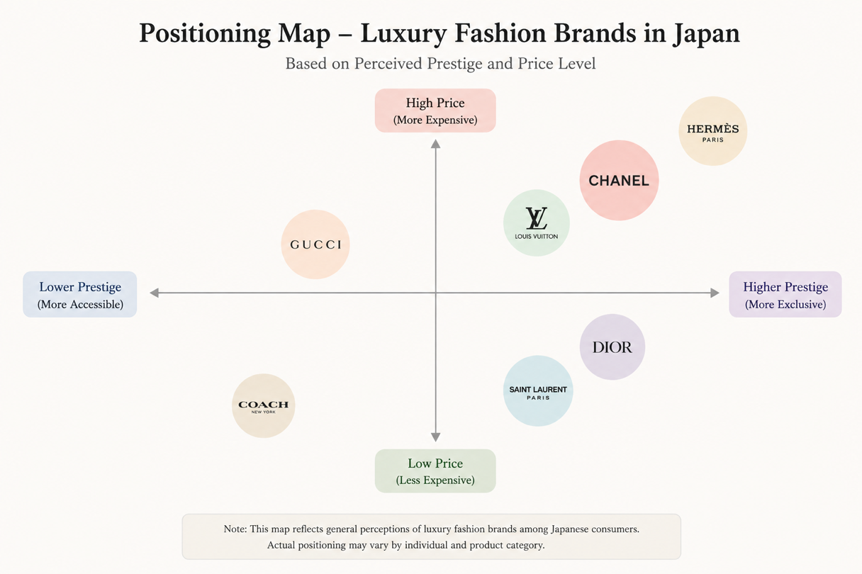
Figure 6: Positioning map Japan
Source: (Developed by the author)

5. Comparative Analysis of International Marketing Mix (7Ps)

5.1 Product
France
The brand strategy of Chanel in France focuses on Heritage, Exclusivity and Timeless Design. The company has a wide range of products which include "haute couture", "ready to wear", handbags, jewellery, watches, fragrances and cosmetics. Items like the Classic Flap Bag, Chanel No.5 perfume and the Chanel Tweed Jacket are sold as emblems of French luxury and artisanal skills. The first CHANEL handbag to feature the double C turn lock clasp and a chain strap laced with leather, the 11.12 handbag has given rise to countless classic versions (CHANEL, 2025).
Japan
chanelon.jp sustains the same base continuous canvas of products with a far bigger focus on craftsmanship, product excellence and the customer experience. Also, Japanese consumers pay a lot of attention to details and to the durability of the product, which is exactly what Chanel is looking for and is specialising in artisanal production. Additionally, Chanel also launches limited edition collections, boutique exclusive items and seasonal products to cater to the high market demand for unique luxury products in Japan.
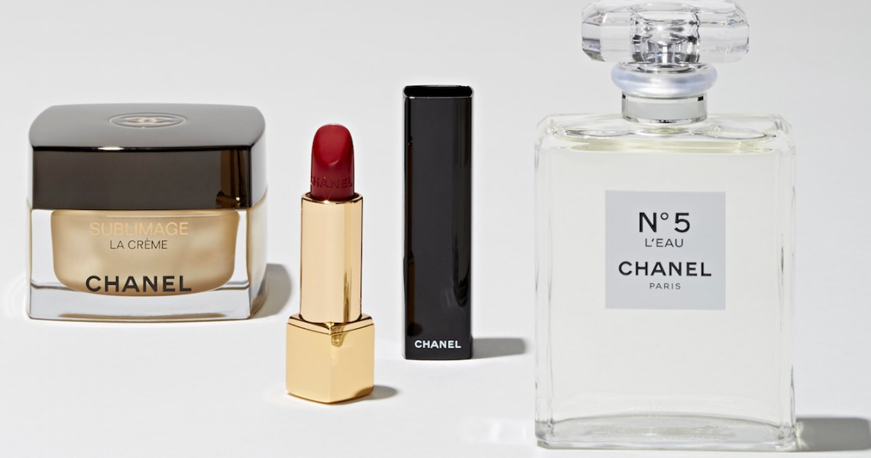
Figure 7: Chanel products
Source: (Sandler, 2019)

5.2 Price
France
In Paris, Chanel follows a policy of selling at a high price to support its exclusivity and illustrate its luxury brand. Compared to mass-market and high-cost fashion labels, products cost much more, because of the company's history, craftsmanship and reputation. This is coupled with regular price hikes, especially for the iconic products like the Classic Flap and 2.55 handbag. The Classic Flap is available to be bought directly from the brand for anywhere between £8000 and £10,000, depending on size, with second-hand versions available for around £5000 or higher. The ultra-mini versions are appreciated at more than £3000 too (Afriyie, 2023).
Japan
Chanel's pricing strategy in Japan is the same, high-priced, but prices are adjusted according to the exchange rate, import costs and local market conditions in Japan. The company has undertaken occasional price hikes throughout the Asia-Pacific area, including Japan, to uphold price uniformity around the planet and keep the exclusivity (Luxus-plus, 2023). Japanese customers will typically pay a higher price if that product is of higher quality, has higher craftsmanship, and offers a greater long-term value. This enables Chanel to maintain profitable margins in an economy with ups and downs.

5.3 Place
France
In France, Chanel has an exclusive distribution network of shops, luxury department stores and beauty outlets. The Chanel retail network is centred around Paris, with the brand's legacy in the form of the historic boutique located at 31 Rue Cambon (Chanel, 2026b). Chanel aims to keep its high-quality customer experience by having many checks and balances on where the stores will be located, what kind of products will be available, and what will keep the exclusivity and reputation of the brand.
Japan
In Japan, Chanel is known for adopting a similar exclusive distribution policy, but with a focus on high-end retail encounters in Ginza, Shinjuku and Osaka, famed in Japan for their luxury shopping. Expecting Japan's famous appetite for luxury to be as voracious as ever, Chanel will bank on the Japanese market with its biggest boutique in the world, housed in a 10-floor high-rise glass building in Tokyo (FashionUnited, 2021).

5.4 Promotion
France
Instead of tackling marketing with blatant advertising, Chanel's promotion in France is all about history, brand, mythology and exclusivity. High-profile fashion shows, luxurious magazines, celebrity ambassadors and artistic campaigns are a strong part of the company's investments, to sustain the image of Paris. During Paris Fashion Week, Chanel's runway shows draw international attention and reinforce its brand as a luxury icon of France.
Japan
Chanel marries its international luxury campaigns with locally relevant activities in Japan. The company engages consumers through its digital marketing, social media, exclusive product launches and high-profile events. The Ginza store has been hosting exhibitions, cultural events and brand experiences to foster connections with customers.

5.5 People
France
Chanel's people strategy is aimed at providing an extremely personalised luxury experience via the well-trained staff at the boutique shops, fashion advisors and beauty consultants in France. Staff will have a wide knowledge of products and represent the heritage, elegance and exclusivity of the brand. Staff is carefully put together to embody Chanel's French luxury brand and to deliver a world-class shopping experience, which in turn enhances brand attachment. The company also focuses on training the artisans in craftsmanship, with programs like le19M, which helps specialised artisans and the conservation of the luxury skills of the tradition (le19M, 2026).
Japan
But Chanel puts even more emphasis on the quality of its customer service in Japan. Japanese consumers have a very high expectation of professionalism, levels of attention to detail and highly personalised service. Hence, Chanel makes huge efforts in training its employees to guarantee the quality of services at each of their stores. Educating employees to develop long-term customer relationships and make personalised suggestions that add value to the luxury shopping experience.

5.6 Process
France
In France, the way Chanel operates their services is to ensure that they uphold the status of exclusiveness and luxury. In boutique settings, customers are treated to personal consultations and appointment-only services while getting product recommendations for their needs. Chanel has introduced Lipscanner, a new innovative mobile app that combines computer vision, augmented reality and machine learning for immediate shade accuracy and interactive lip try-on. Following a quick calibration scan, users can take a picture of any material, such as a magazine clipping, a fabric swatch, or their favourite lip influencer, and Lipscanner identifies the closest matching shade from Chanel's Rouge Allure, Rouge Coco, and Rouge Velvet ranges (DigitalDefynd, 2025).
Japan
Chanel's luxury service processes are the same in Japan, but with more attention to precision, efficiency and customer care. The Japanese appreciate top-notch service, which is where Chanel has detailed information about the products, special after-sales service, and great in-store experiences.

5.7 Physical Evidence
France
Chanel's tangible signs of evidence are so tied to its heritage and luxury that they can be traced in France. The brand's boutiques are marked by simple and elegant decoration of a minimalist layout and a unique black and white design with the high-quality materials dictated by Chanel's identity. Packaging, shopping bags, and visual merchandising are thoughtfully developed for a luxurious experience and to emphasise the sense of exclusiveness.
Japan
While maintaining the worldwide visual identity, Chanel delivers a mandate level of detail and comfort in the shop interior in Japan. The product of luxury retailing is integrated into buildings that take a more contemporary approach, such as Flagship boutiques like the Chanel Ginza building, offering luxury stores and premium customer service facilities.

6. Market Entry Strategy in Japan

6.1 Chanel's coming to Japan
Starting in 1998, in the early days of the expansion of luxury consumption among Japanese consumers, Chanel set up in the Japanese market. To further bolster its presence, the company launched Chanel Japan, thereby gaining better brand management, retail and customer experience. Chanel inserted itself between the distributor companies and thus ensured that the quality standards were always met and the luxury brand image was not compromised. The retail expansion strategy of the company was to open 'boutiques' in high-end shopping areas like Ginza, Omotesando, Shinjuku and Osaka.

6.2 Entry Mode Analysis
Direct Investment
Chanel's main investment strategy in Japan was Foreign Direct Investment (FDI). This meant investing in boutiques and retail infrastructure, as well as employee preparation and customer service models. Without having the restrictive control of direct investment, Chanel had no way of controlling the aspects of product presentation, pricing, and brand communication.
Subsidiary Approach
When Chanel Japan was formed as a 100% subsidiary, the company was able to operate autonomously and react to the market conditions in Japan. This allowed for less reliance on external parties and allowed for global brand standards to be maintained throughout Japan.
Boutique Expansion
Chanel did not seek to develop quickly, instead adopting a small store approach. Retailers were only opened in top-end retail locations suitable for the brand's upscale offering. This allowed the customers to achieve exclusivity and a consistent customer experience. The tactic additionally matched the inclination of Japanese consumers for a top-quality in-store shopping experience.

6.3 Evaluation of Entry Strategy
Advantages
Chanel's entry strategy resulted in good control over the brand image, prices and customer experience. The brand was not diluted, and as a result, a long-term relationship with customers could be developed because of direct ownership. The strategy also facilitated premium pricing and increased confidence in the authenticity of the product.
Challenges
Capital was a large part of the strategy, and it also had to cost more to operate. Long-term challenges include Japan's high retail property prices and an ageing population. Also, it is important to keep up with innovation and the customer's interaction in a growing market.

7. Ethical Issues in Chanel's Marketing Mix
One of the biggest ethical concerns of the luxury fashion sector is sustainability. While luxury brands are synonymous with high quality, long product life cycles are accused of seeing no end to carbon emissions, and the sourcing of raw materials, packaging wastage and supply chain transparency are all points of criticism. The demand from consumers, as well as investors and regulators, on Chanel to prove their product is "made responsibly" while still performing to luxurious standards has been on the rise. Without proper sustainability measures, companies can suffer damage to their reputation and the loss of consumer faith. Chanel's Sustainability Report cites a company goal to limit its greenhouse gas impact throughout the value chain as well as increase its investments in sustainable materials and innovation (Chanel, 2024).
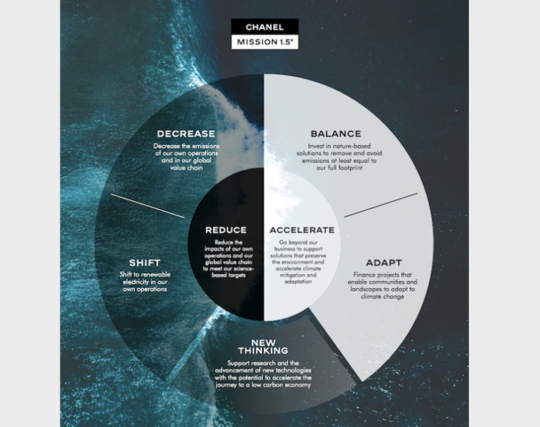
Figure 8: Chanel sustainability
Source: (WeAr Global Network, 2020)

8. Recommendations
- Chanel needs to bolster its Japanese digital luxury offering with the launch of virtual consultations, personalised mobile apps and online-only events. Japanese shoppers are highly online and value premium customer experiences. Pacifying the technology with customised service can increase customer engagement without reducing the level of exclusiveness.
- While Chanel has set itself challenging sustainability goals with Mission 1.5° and its net-zero strategy, more transparency is needed (Chanel, 2026a). The company ought to make its solutions more transparent to consumers and investors in terms of sustainability results. Different platforms, such as social media and e-mail, can be used to offer personalised omnichannel services.
- Chanel should keep building up seamless integration between the online and offline channels. In both France and Japan, personalised recommendations and appointment reservations would enhance customer relationships and long-term customer loyalty.
- Chanel's global brand is preserved but needs more culturally relevant campaigns. Therefore, the well-developed campaigns in France should keep on stressing heritage and leadership of fashion, whereas in Japan, the art of craftsmanship, quality, and long-lasting value should be highlighted to better cater to local consumption tastes.

9. Conclusion
In this report, Chanel's international marketing strategy in France and Japan was explored. The PESTEL analysis has indicated that both countries are conducive to political and economic stability, but Japan has a better chance of enhancing the luxury market growth opportunities, and France has a more positive influence on Chanel's heritage and global reputation. Some of the cultural differences identified by Hofstede were very significant, namely masculinity, long-term orientation and consumer motivations. This study concluded that the STP and marketing mix analysis show that Chanel has a mostly standard international luxury strategy, with several elements being adapted to meet local market expectations. While Heritage, Exclusivity and Fashion Leadership are the brand's values in France, Craftsmanship, Service and Customer are more important in Japan.

Section 2: Reflective Account

10. Reflection Using Gibbs Reflective Cycle
Gibbs' Reflective Cycle was created by Graham Gibbs in 1988 to help provide structure to learning from experiences. It provides a way of analysing the experience, and because it is cyclical, it is good for repeated experiences so that you can take something from what went well or not well athe nd Learning Toolkit (Reflection Toolkit, 2024).
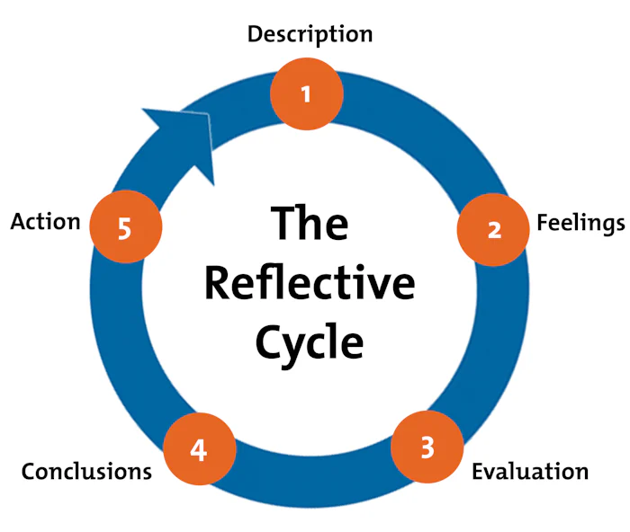
Figure 9: Gibbs’ reflective cycle
Source: (Mind Tools 2026)

10.1 Description
For analysis on this assessment, I compared the Chanel business in France and Japan to look at Chanel's international marketing strategy. The purpose was to gain an insight into the adaptation of a global luxury brand for its marketing activities in different international markets without losing brand identity. For this, I used some marketing concepts such as PESTEL Analysis, Hofstede's Cultural Dimensions, STP analysis and the 7Ps marketing mix. I did research on the history of Chanel, its market position, and its presence in both countries. I then delved into the various parameters and their effects in the luxury fashion industry, such as political, economic, social, technological, environmental and legal. This was followed by a study of the cultural aspects they differed in, as well as how these differences impact consumer behaviours and marketing decisions.

10.2 Feelings
Initially, I was interested and motivated to do this assessment, since Chanel is one of the most well-known luxury brands worldwide. I was convinced that studying an internationally established company would assist me in gaining insight into the application of marketing theory. But some of the time, I was also worried about how much evidence I would be able to provide to compare the markets of France and Japan, as opposed to merely describing them. I had grown increasingly confident as I went along. One aspect I found interesting was the cultural differences and their impact on consumer behaviour and marketing itself. Through the Hofstede analysis, I came to understand the reasons behind the nuanced difference in Chanel's French identity as characterised by heritage and individuality versus service quality and craftsmanship in the Japanese market.

10.3 Evaluation
I feel that the assessment was a success as I could apply the theories of International Marketing to an actual organisation working in a different cultural and economic environment. I feel like one of the best things that I did in my work was using several frameworks, specifically PESTEL, Hofstede, STP and the Marketing Mix, to develop the understanding of Chanel's strategy. This enabled me to go beyond just describing things and assessing the impact of external influences on business decision-making. I was also able to set clear and distinct differences between France and Japan, as well as explain how one differs from the other in relation to the way in which Chanel conducts its marketing. The research process enabled me to interpret information from both academic and industrial sources and to use information as evidence to support my interpretations.

10.4 Analysis
This evaluation helped me to gain an insight into how vital it is to modify marketing strategies according to different international environments. During my analysis, I came to know that the successful global brands are not necessarily nationalising all marketing activities. This was clear in comparing France and Japan. Chanel's marketing mix, customer service and communication approach are adapted to local tastes and preferences, although they retain their luxury image. This adds to the idea that culture is an important variable that drives consumers' behaviour and decision-making. Another thing I took away from there was that sustainability is becoming more of a strategic issue in the luxury fashion industry. My initial impressions before this evaluation were mainly of luxury brands equating with exclusivity and prestige. My own research found, however, that stakeholders now have environmental responsibility and transparency as part of their expectations for luxury companies, as well as product quality.

10.5 Conclusion
Completing this assessment really helped me understand a lot more about global marketing and the issues that international luxury brands encounter. The research brought to my attention that international marketing isn't successful just by selling an identical product into multi-country markets. I got to know that a company needs to be aware of the cultural values, consumer behaviour, economic situations and ethical expectations that would help them in developing their marketing strategies. The shock of France and Japan taught me more about how Chanel understands how to keep a brand consistent across multiple markets and adapt to local markets. I also gained a better understanding of the significance of sustainability and the expectations of stakeholders for the luxury fashion industry. Most of all, I came to the insight that good business analysis is not just describing facts; it's a critical evaluation of the facts.

10.6 Action Plan
From this experience, I have found some things that I want to do better in school in the future. The first being at a much earlier stage of research, so that more time could be given to the analysis of academic journals and industry reports. This will facilitate the sharpening of my evidence-based arguments and critical analyses. Second, I hope to become a little more knowledgeable on different theories related to international marketing, going beyond the required content of the marketing core module. This will enhance the skills of the analysis of business strategy from various angles. Third, I will work on using a greater breadth of peer-reviewed research material in tandem with data from industry. Lastly, I will be developing my reflective practice and using feedback from forthcoming assessments to identify areas for development. Through these actions, I believe I will improve my academic writing quality, sharpen my critical thinking skills, and increase my knowledge and confidence in doing more in-depth analysis of complex business situations for future assignments. The reflective models are characterised as prioritising the concept of learning to practical improvement and future action.

References
Afriyie, A. (2023) Experts agree—this iconic French handbag will always be a good investment. Available at: https://www.whowhatwear.com/chanel-classic-flap-bag (Accessed: 15 June 2026).
Al Jazeera (2019) France is outpacing Germany as Europe's economic growth engine. Available at: https://www.aljazeera.com/economy/2019/11/6/france-is-outpacing-germany-as-europes-economic-growth-engine (Accessed: 15 June 2026).
Amoroso, D.L. and Ackaradejruangsri, P. (2026) ‘Brand commitment as predecessor to the factors of continuance intention’, Journal of Marketing Analytics, 14(1), pp. 158–172.
BBC News (2011) Chanel No 5: the story behind the classic perfume. Available at: https://www.bbc.com/news/world-13565155 (Accessed: 15 June 2026).
Buchholz, K. (2021). Japanese economy grows again after the coronavirus low. Available at: https://www.statista.com/chart/22583/japan-gdp-quarter-on-quarter-annualised/ (Accessed: 15 June 2026).
Business France (2026) Choose France 2026: France confirms its ability to attract foreign investment. Available at: https://en.media.businessfrance.fr/news/choose-france-2026-france-confirms-its-ability-to-attract-foreign-investment-c94e6-aba4d-1.html (Accessed: 15 June 2026).
CHANEL (2024) Chanel’s sustainability ambition. Available at: https://www.chanel.com/us/sustainability/ (Accessed: 15 June 2026).
CHANEL (2025) Classic handbags - handbags. Available at: https://www.chanel.com/in/fashion/handbags/classic/ (Accessed: 15 June 2026).
CHANEL (2026a) Climate transition plan. Available at: https://www.chanel.com/puls-img/1765449310899-climate-transition-plan.pdf (Accessed: 15 June 2026).
CHANEL (2026b) 31 Cambon – Boutique CHANEL. Available at: https://www.chanel.com/fr/mode/services/boutique-31-cambon/ (Accessed: 15 June 2026).
Chechi, H. (2024). Top 10 luxury brands in the world. Available at: https://www.glion.edu/magazine/top-luxury-brands-in-the-world/ (Accessed: 15 June 2026).
daisyblance19 (2020) Chanel’s target consumer tribe and their visual identity. Available at: https://daisyblance19.wixsite.com/mysite-2/post/chanel-s-target-consumer-tribe-and-their-visual-identity (Accessed: 15 June 2026).
DigitalDefynd (2025) 9 ways Chanel is using AI [case study] [2026]. Available at: https://digitaldefynd.com/IQ/ways-chanel-use-ai/ (Accessed: 15 June 2026).
FashionUnited (2021) Bigger is better at Chanel. Available at: https://fashionunited.uk/news/fashion/bigger-is-better-at-chanel/2005031436673 (Accessed: 15 June 2026).
Garnier, J. (2025). Hermès takes on Chanel and Dior in the high fashion market. Available at: https://www.lemonde.fr/en/economy/article/2025/02/15/hermes-takes-on-chanel-and-dior-in-the-high-fashion-market_6738183_19.html (Accessed: 15 June 2026).
Gross, R.E. (2024). A brief history of the House of Chanel: Coco Chanel to Virginie Viard. Available at: https://www.forbes.com/sites/rachelelspethgross/2024/07/31/a-brief-history-of-the-house-of-chanel-coco-chanel-to-virginie-viard/ (Accessed: 15 June 2026).
Kemp, S. (2025a) Digital 2025: Japan. Available at: https://datareportal.com/reports/digital-2025-japan (Accessed: 15 June 2026).
Kemp, S. (2025b) Digital 2026: France. Available at: https://datareportal.com/reports/digital-2026-france (Accessed: 15 June 2026).
Le19M (2026) Le19M. Available at: https://www.le19m.com/en (Accessed: 15 June 2026).
Luxus Plus (2023) Chanel raises prices in China and Asia-Pacific. Available at: https://luxus-plus.com/en/chanel-raises-prices-in-china-and-asia-pacific/ (Accessed: 15 June 2026).
Mind Tools (2026) Gibbs’ reflective cycle. Available at: https://www.mindtools.com/ano9qiu/gibbs-reflective-cycle/ (Accessed: 15 June 2026).
Nair, L. and Blondiaux, P. (2025) CHANEL limited financial results for the year ended 31 December 2024. Available at: https://www.chanel.com/puls-img/1747810519727-20250520fy24resultspressreleasefinalwwpdf.pdf (Accessed: 15 June 2026).
Noyen, M. (2024). Japanese shoppers are being less frugal, good news for the luxury industry. Available at: https://www.businessinsider.com/japanese-shoppers-being-less-frugal-good-news-for-luxury-industry-2024-11 (Accessed: 15 June 2026).
Post #2 (2009) Chanel 2.55 is one of the top five status handbags - well, according to this article. Available at: https://forum.purseblog.com/threads/chanel-2-55-is-one-of-the-top-five-status-handbags-well-according-to-this-article.431561/ (Accessed: 15 June 2026).
Reflection Toolkit (2024) Gibbs’ reflective cycle. Available at: https://reflection.ed.ac.uk/reflectors-toolkit/reflecting-on-experience/gibbs-reflective-cycle (Accessed: 15 June 2026).
Sandler, E. (2019). How Chanel’s beauty products propel its continued growth. Available at: https://www.glossy.co/beauty/how-chanels-beauty-products-propel-its-continued-growth/ (Accessed: 15 June 2026).
The Culture Factor (2023) Country comparison tool. Available at: https://www.theculturefactor.com/country-comparison-tool?countries=france%2Cjapan (Accessed: 15 June 2026).
Trading Economics (2026a) France GDP. Available at: https://tradingeconomics.com/france/gdp (Accessed: 15 June 2026).
Trading Economics (2026b) Japan GDP. Available at: https://tradingeconomics.com/japan/gdp (Accessed: 15 June 2026).
Vecteezy (2026) Chanel logo vector art, icons, and graphics for free download. Available at: https://www.vecteezy.com/free-vector/chanel-logo (Accessed: 15 June 2026).
WeAr Global Network (2020) CHANEL publishes new sustainability plan. Available at: https://www.wearglobalnetwork.com/news/chanel-publishes-new-sustainability-plan/ (Accessed: 15 June 2026).
World Bank Group (2026) Japan. Available at: https://www.worldbank.org/ext/en/country/japan (Accessed: 15 June 2026).

