Group project Guardian Trace (AirTag)

Table of Contents
Introduction 3
Project Aim 3
Project Objectives 3
Team Organisation and Role Explanation 4
Research into relevant technologies and potential solutions: 5
What is App Development? 6
Planned material, components 7
Cost & Budget planning 7
Design consideration(reliability, safety, simplicity) 7
Appendix 8
Group Contract 8
References 10

Introduction
Guardian Trace is an assistive technology project designed to support disabled users by improving their safety, independence, and daily communication. Many existing assistive devices only focus on one function, such as basic tracking or sending a simple alert. This often leaves caregivers without important information when the user is in danger or in need of help. To solve this problem, our project aims to create a multifunctional device that combines real-time location tracking, two-way audio communication, and an easy-to-use mobile application.
The project brings together both hardware and software to create a complete safety system. The device will contain a tracking module, microphone, speaker, and supporting sensors, while the mobile application will allow caregivers to monitor the user, receive updates, and communicate when needed. By combining these technologies, Guardian Trace aims to offer a more reliable, accessible, and user-friendly solution than many current assistive devices.
As the Software Developer and Collaboration Lead, I am responsible for ensuring effective communication between the hardware device and the mobile application. My key duties include designing and programming the Guardian Trace app, developing a clear and functional user interface, and ensuring the accurate display of tracking data and communication features. I also coordinate the team’s collaboration by organising documentation, maintaining version control, and ensuring all project files remain accessible and up to date. In addition, I support integration testing to confirm that the hardware and software operate smoothly together. Through these tasks, I help maintain clear communication, reduce errors, and sustain an efficient workflow across the project.

Project Aim
The aim of this project is to design and develop an integrated assistive device that improves the safety, communication, and independence of disabled individuals.

Project Objectives
To achieve this aim, the project will focus on creating a fully functional device that includes a tracker, microphone, and speaker as its core components. Alongside the hardware, an easy-to-use mobile application will be developed to display the user’s location and support smooth communication. The design will be kept simple and accessible to ensure that individuals with different disabilities can operate it confidently. The project also prioritises safety and reliability, ensuring that all features work consistently in real-life situations. In addition, existing assistive technologies will be studied to identify what is currently lacking and how the new device can offer improvements. Finally, cost-effective components will be selected to make the final product affordable and practical for real users.

Team Organisation and Role Explanation
The Guardian Trace project team is organised into three key roles to ensure efficient workflow, balanced responsibilities, and successful completion of all project tasks. Each role has been assigned according to team members’ strengths, technical interests, and previous experience. While each member has specific responsibilities, collaboration remains an essential aspect of the project, with shared duties in research, presentation development, and final report completion.
Yacob Alkarim – Project Manager & Hardware Development
Yacob is responsible for overseeing the overall direction of the project and ensuring that key milestones are achieved on time. His duties include coordinating team meetings, managing the project timeline, and developing the hardware components required for the device. He also maintains the Gantt chart and monitors team performance to keep the project on schedule.
Amani Mohsin – Software Developer & Collaboration Lead
As the Software Developer, I am responsible for designing, programming, and maintaining the Guardian Trace application. My work includes developing the user interface, integrating software with the hardware system, and organising all project documentation. I also manage version control to ensure files remain updated and accessible to the team. Additionally, I support testing and assist in coordinating collaboration between hardware and software components to maintain smooth integration.
Nariman Ramadhan – Health & Safety Officer & Product Design
Nariman ensures that all project activities comply with relevant health and safety standards, reducing risks throughout development. She also contributes to the design of the physical product, helping shape a solution that is safe, user-friendly, and appropriate for disabled users.
Across all roles, the team works collaboratively to share research tasks, produce presentations, and refine the final report, ensuring a cohesive and well-rounded project outcome.
For the Group Contract see Appendix 1:
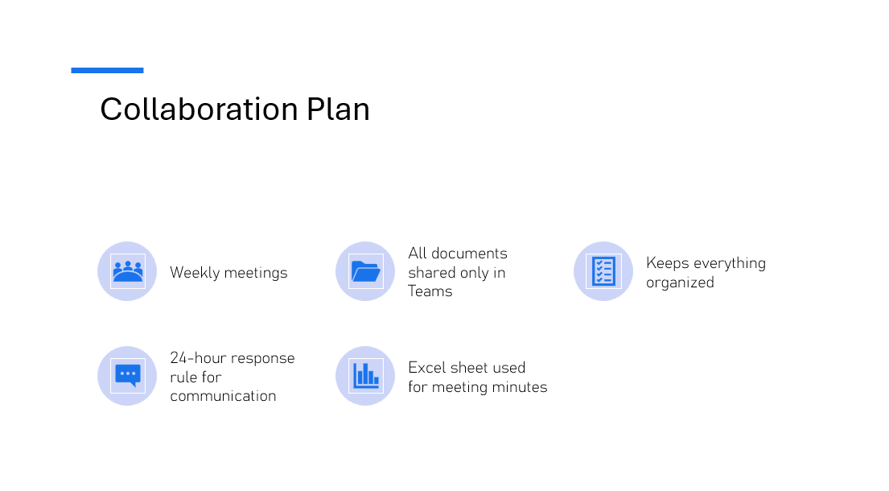

This collaboration plan aims to support clear and organized teamwork. It includes weekly meetings, a 24-hour response time for communication, and the use of Microsoft Teams for all shared documents. An Excel sheet will also be used to record meeting minutes, helping maintain accurate and accessible documentation.

The red line is a hard deadline.
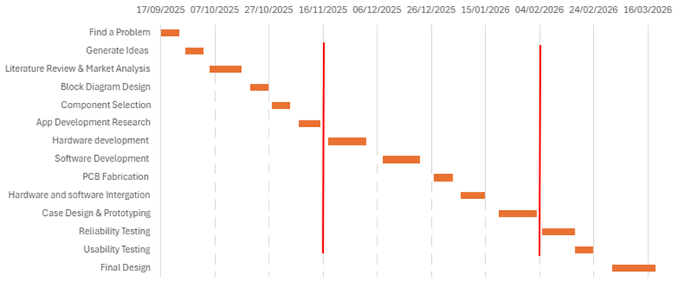

Research into relevant technologies and potential solutions:
Research shows that modern tracking systems often combine GPS, LoRa, and IoT to improve accuracy. GPS is very accurate outdoors but becomes unreliable indoors because it relies on satellite signals. LoRa offers long-range, low-power communication, making it better for indoor or weak-signal areas. The study also explains that many devices use only one technology, which reduces reliability. By using both LoRa for indoor tracking and GPS for outdoor tracking, the system can switch automatically based on the environment, improving accuracy and reducing power use. (Haider1, June 2025)

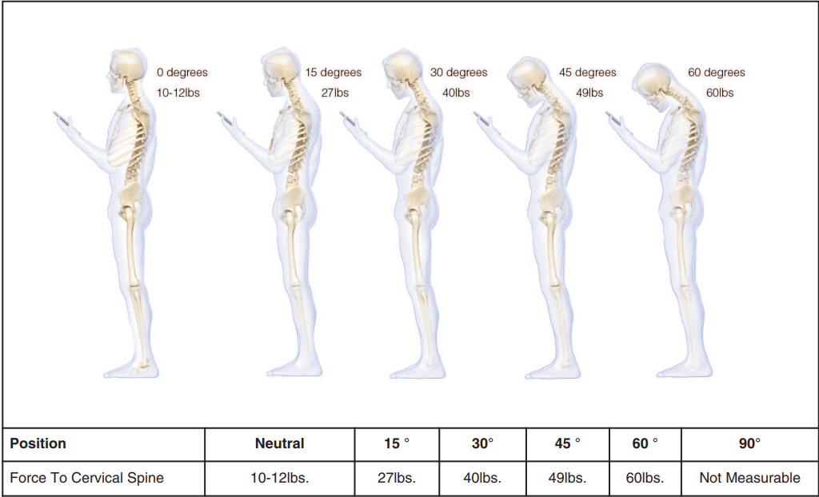Figures 1.
This figure 1 shows the the amount of weight the spine supports increases as the neck bends forward. In a neutral position, an adult head weighs about 10–12 pounds. When the head tilts forward, the pressure on the neck rises significantly reaching 27 pounds at 15 degrees, 40 pounds at 30 degrees, 49 pounds at 45 degrees, and 60 pounds at 60 degrees. (KENNETH K. HANSRAJ, 2013)

What is App Development?
app development is the process of creating software applications specifically designed to run on mobile devices such as smartphones and tablets. These apps are developed to provide users with various functionalities and serve different purposes, ranging from entertainment and social networking to productivity and e-commerce. (K. Crowston, 2010)
There are three types of mobile apps:

Native Apps
Native apps are developed for a specific operating system, such as iOS or Android, using platform-specific programming languages (Swift/Objective-C for iOS, Java/Kotlin for Android). They offer the best performance and access to device-specific features but require separate development for each platform.

Web Apps
Web apps are essentially websites optimized for mobile devices and are accessed through a web browser. They do not require installation from an app store. Web apps are platform-independent but may have limited access to device features.

Hybrid Apps
As the name suggests, hybrid apps combine elements of both native and web apps. They are developed using web technologies like HTML, CSS, and JavaScript, and then wrapped in a native container that allows them to be installed and run on multiple platforms. The plus of hybrid apps is that they offer a balance between cross-platform compatibility and access to device features. (Technologies, 2024)

I chose native app development because it works best for both iOS and Android. Native apps are built using the official languages for each platform, which makes them faster, more reliable, and better at using device features like the camera, GPS, and notifications. Even though native apps must be developed separately for each system, they provide the highest quality experience for users. This makes native development a strong choice when performance and smooth operation are important.

Planned material, components (Done by Yacob)

Cost & Budget planning (Done by Yacob) Appendix 2

Design consideration(reliability, safety, simplicity) (Done by Nariman).

Gibbs’ Reflective Cycle: Reflection on Managing Team Meeting Minutes
While preparing the Excel sheet for our team meeting minutes, I made a mistake in understanding what information needed to be recorded. I assumed that the task was to create a schedule of upcoming meetings, so I added dates and times for several months ahead, including the fixed meeting time from 2 PM to 4 PM. Later, I realised that the actual requirement was to document what we had completed in previous meetings, not to list future meeting dates. As a result, the table did not serve its intended purpose and did not help the team track progress.
At first, I felt confident because I believed I had completed the task correctly and neatly. However, once I realised my mistake, I felt embarrassed and disappointed. I also felt concerned that my misunderstanding could cause confusion within the team or delay our documentation process.
Although the table was well-organised in terms of layout, it did not include the information that was actually needed. This experience highlighted the importance of understanding the task requirements clearly before starting the work. Despite the mistake, it provided a valuable opportunity for learning and improvement.
I learned that completing a task correctly depends on fully understanding its goals, not just producing a neat or organised result. Clear communication within the team is essential for avoiding errors.

Appendix
Appendix 1

Group Contract
Project Title: Guardian Trace (AirTag)
Team Members: Yacob Alkarim, Amani Mohsin, Nariman Ramadhan

Purpose
This contract defines how the Guardian Trace project team will work together effectively, maintain professional conduct, and ensure accountability. It provides clear expectations about communication, deadlines, responsibilities, and quality of work.
The project focuses on developing an assistive device ('Guardian Trace') designed to help individuals with disabilities through tracking, microphone, and speaker-based assistive technology.

Group Goals
- Successfully design, develop, and test the Guardian Trace prototype.
- Submit all project milestones, reports, and documentation on time.
- Ensure the final deliverables meet academic, ethical, and technical standards.
- Maintain effective teamwork, inclusivity, and problem-solving throughout the project.

Meeting Schedule and Communication
- The team will meet weekly (in person or online) to review progress and assign new tasks.
- If a member cannot attend, they must notify the group at least 24 hours in advance.
- The team will maintain communication through a group chat (e.g., WhatsApp or Teams).
- Meeting minutes will be recorded to track progress, decisions, and upcoming tasks.
- Each member must check messages daily and respond within 24 hours to maintain workflow.

Roles and Responsibilities
Yacob Alkarim – Project Manager & Hardware Development - Coordinate project timeline, meetings, and deliverables.1
- Develop the hardware components and integration.
- Create and maintain the Gantt chart and project plan.
- Monitor team performance and ensure milestones are met.
Amani Mohsin – Software Developer & Documentation Lead - Design and program the Guardian Trace application.
- Write and organize project documentation, including this contract.
- Maintain version control and ensure all files are up to date.
- Support testing and integration between software and hardware.
Nariman Ramadhan – Health & Safety Officer & product design
- Ensure all project activities follow health and safety guidelines.
- Product design
All members will share responsibility for research, presentation preparation, and final report editing.

Group Rules and Expectations
- Respect: Treat all members fairly and courteously; allow equal input and ideas.
- Accountability: Each member is responsible for their tasks and deadlines.
- Quality: Work must meet high academic and technical standards.
- Punctuality: Meetings and deadlines must be attended or communicated promptly.
- Participation: Each member must contribute actively to discussions and tasks.
- Decision-Making: Decisions will be made by consensus; if unresolved, majority vote will apply.
- Academic Integrity: All work must be original; plagiarism or fabrication will not be tolerated.
- Support: Members will assist one another when technical or academic difficulties arise.

Conflict Resolution
- Minor conflicts should be discussed privately and respectfully within the group.
- If an issue continues, it will be addressed during a scheduled team meeting.
- Persistent unresolved issues will be escalated to the project supervisor for mediation.

Accountability and Consequences
- Missed deadlines without communication will result in a warning from the team leader.
- Repeated failures to contribute or attend meetings will be documented and shared with theinstructor.
- Tasks may be reassigned to ensure project progress.
- Peer assessment scores may reflect unequal participation.

Agreement and Signatures
Initial Agreement (Start of Project)
Name | Signature | Date
Yacob Alkarim | ___________________ | ___________
Amani Mohsin | ___________________ | ___________
Nariman Ramadhan | ___________________ | ___________
Completion Sign-Off (End of Project)
Name | Signature | Date
Yacob Alkarim | ___________________ | ___________
Amani Mohsin | ___________________ | ___________
Nariman Ramadhan | ___________________ | ___________

Appendix 2
This project has a baseline budget of £100.
What we plan for this project is that there is to be going an app that works in unison with Guardian Trace. To get the app on the play store there is a onetime fee, of £25,
this is for android user. However, for ISO users, we would need to spend £79 to get the app on the play store. This will go over our baseline budget. So, we will design the app for android and refer that we can use the same code for ISO.
With the cost of all the components and putting the app on the app store the total cost comes to around £92 pounds.

References
Best Practices for Mobile App Development in 2025. (2025, 07 23). Retrieved from geeksforgeeks.org: https://www.geeksforgeeks.org/android/best-practices-for-mobile-app-development/?utm_source
Haider1, N. S. (June 2025). Design and Implementation of a Smart Tracking . India: Ramaiah Institute of Technology. Retrieved from https://d1wqtxts1xzle7.cloudfront.net/123339329/Design_and_Implementation_of_a_Smart_Tracking_System_for_People_Pets_and_Assets_Using_LoRa_and_GPS-libre.pdf?1750226134=&response-content-disposition=inline%3B+filename%3DDesign_and_Implementation_of_a_Smart
K. Crowston, K. W. (2010). Libre Open Source Software Development. Syracuse: Syracuse University.
KENNETH K. HANSRAJ. (2013, 09 19). SURGICAL TECHNOLOGY INTERNATIONAL . Retrieved from pingeprii.ee: https://pingeprii.ee/wp-content/uploads/2016/09/Hansray-K.K.-Assessment-of-Stresses-in-the-Cervical-Spine-Caused-by-Posture-and-Position-of-the-Head.pdf
Technologies, O. S. (2024, 01 02). Mobile App Development — A Complete Guide. Retrieved from medium.com.

