

Electronic Circuits Testing and Applications

Electronic Control Systems (ACHA4010)

Emily Dawes
2303927
24/03/2024
Contents
1 Task 2 1
1.1 Scope Time Division Calculations (4) 1
1.2 Function Generator output sine wave (3) 1
1.3 Unsmoothed Rectifier Wave (3) 1
1.4 Smoothed Rectifier Wave with capacitor (3) 1
1.5 Drop in Voltage Question (4) 1
1.6 Different Voltage Readings Question (5) 1
1.7 Rectifiers use in Automotive applications Question. (4) 1
1.8 Probing Question (4) 1
2 Task 3 2
2.1 Scope Time Division Calculations (4) 2
2.2 Function Generator output square wave (3) 2
2.3 Capacitor charge and discharge wave marked at correct points. (3) 2
2.4 Basic Capacitor Calculations (3) 2
2.5 Capacitor discharge table (4) 2
2.6 Gradient Plot and calculations (4) 2
2.7 Capacitor Uses (5) 2
2.8 Inaccuracies Question (4) 2
3 References 3

Task 2

Scope Time Division Calculations (4)
When finding the scope’s time division, you firstly need to know how many divisions the scope is displaying for one period. Once looking at the sine wave you can see that there are 4 divisions for one period.
Given that the frequency is 10Hz.
f = 1/period
Period = 1/f
Period = 1/10 = 0.1 seconds.
For 1 period we know there are 4 divisions so,
0.1/4 = 0.025s/division.
25ms/division.
Total scope time of one period = 25ms/division 4 divisions = 100ms

Function Generator output sine wave (3)
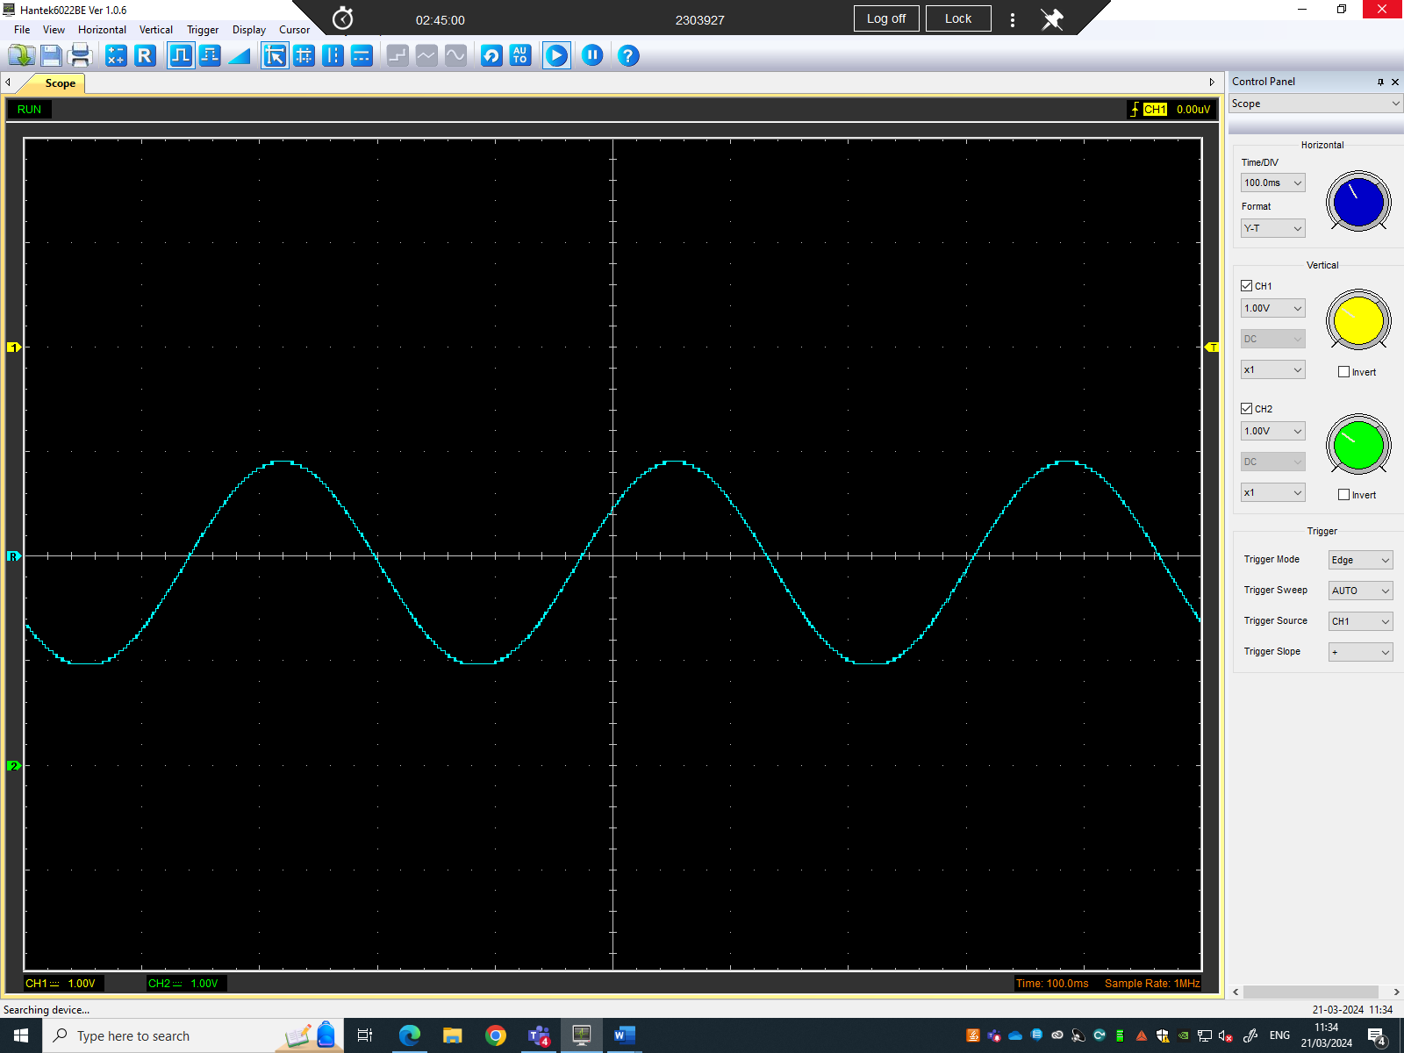
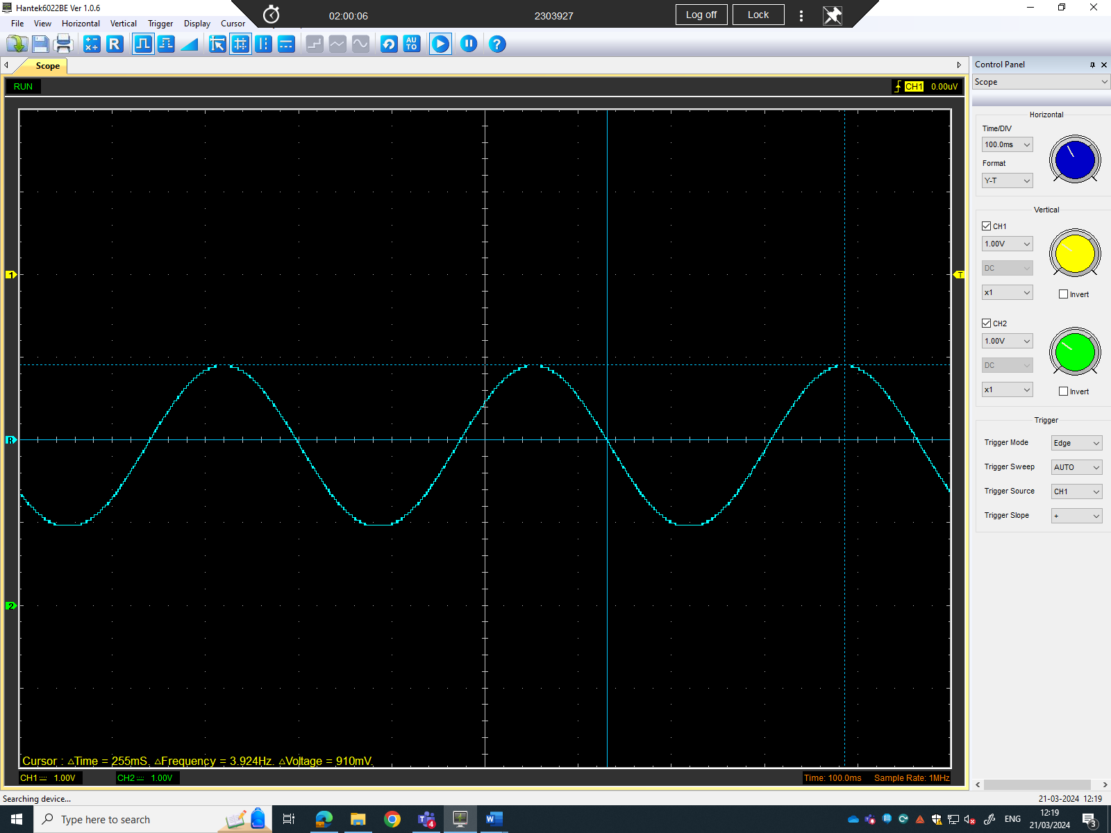
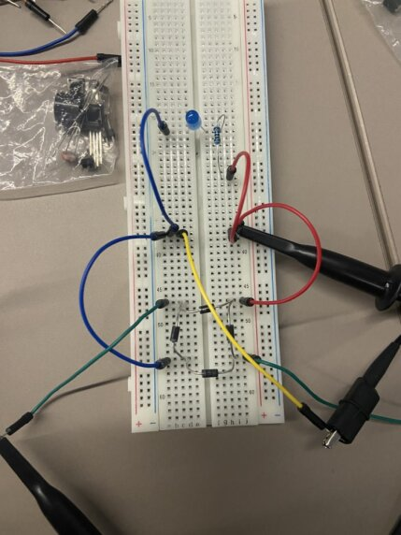

Unsmoothed Rectifier Wave (3)
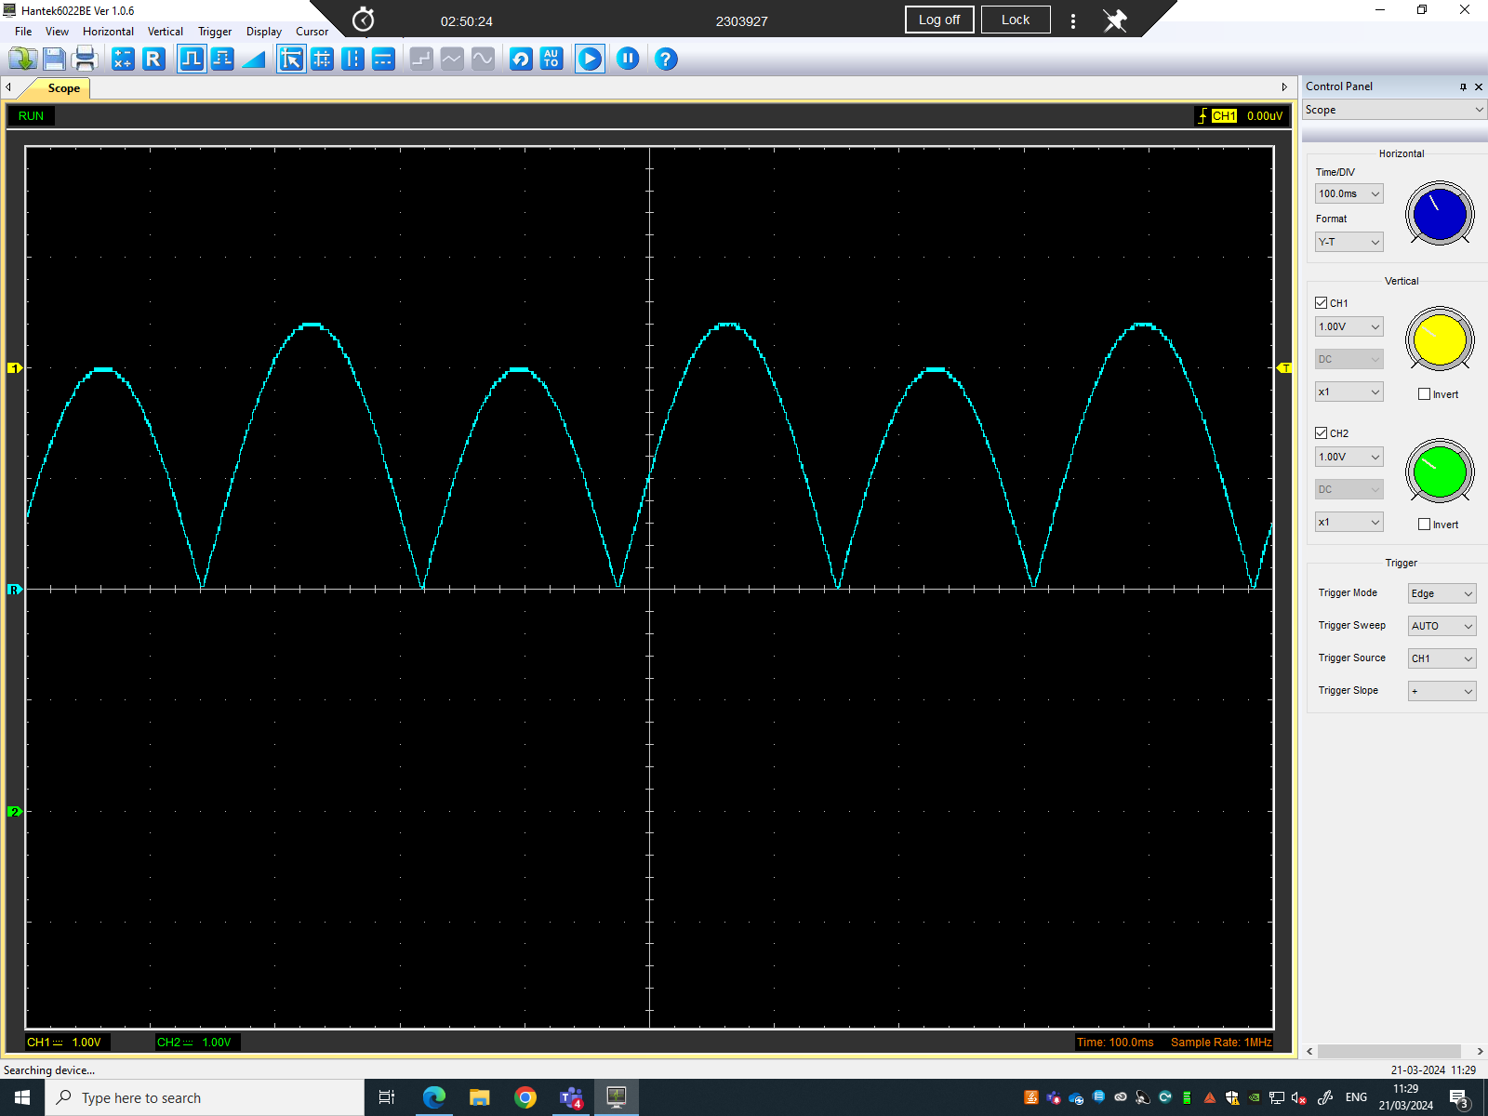
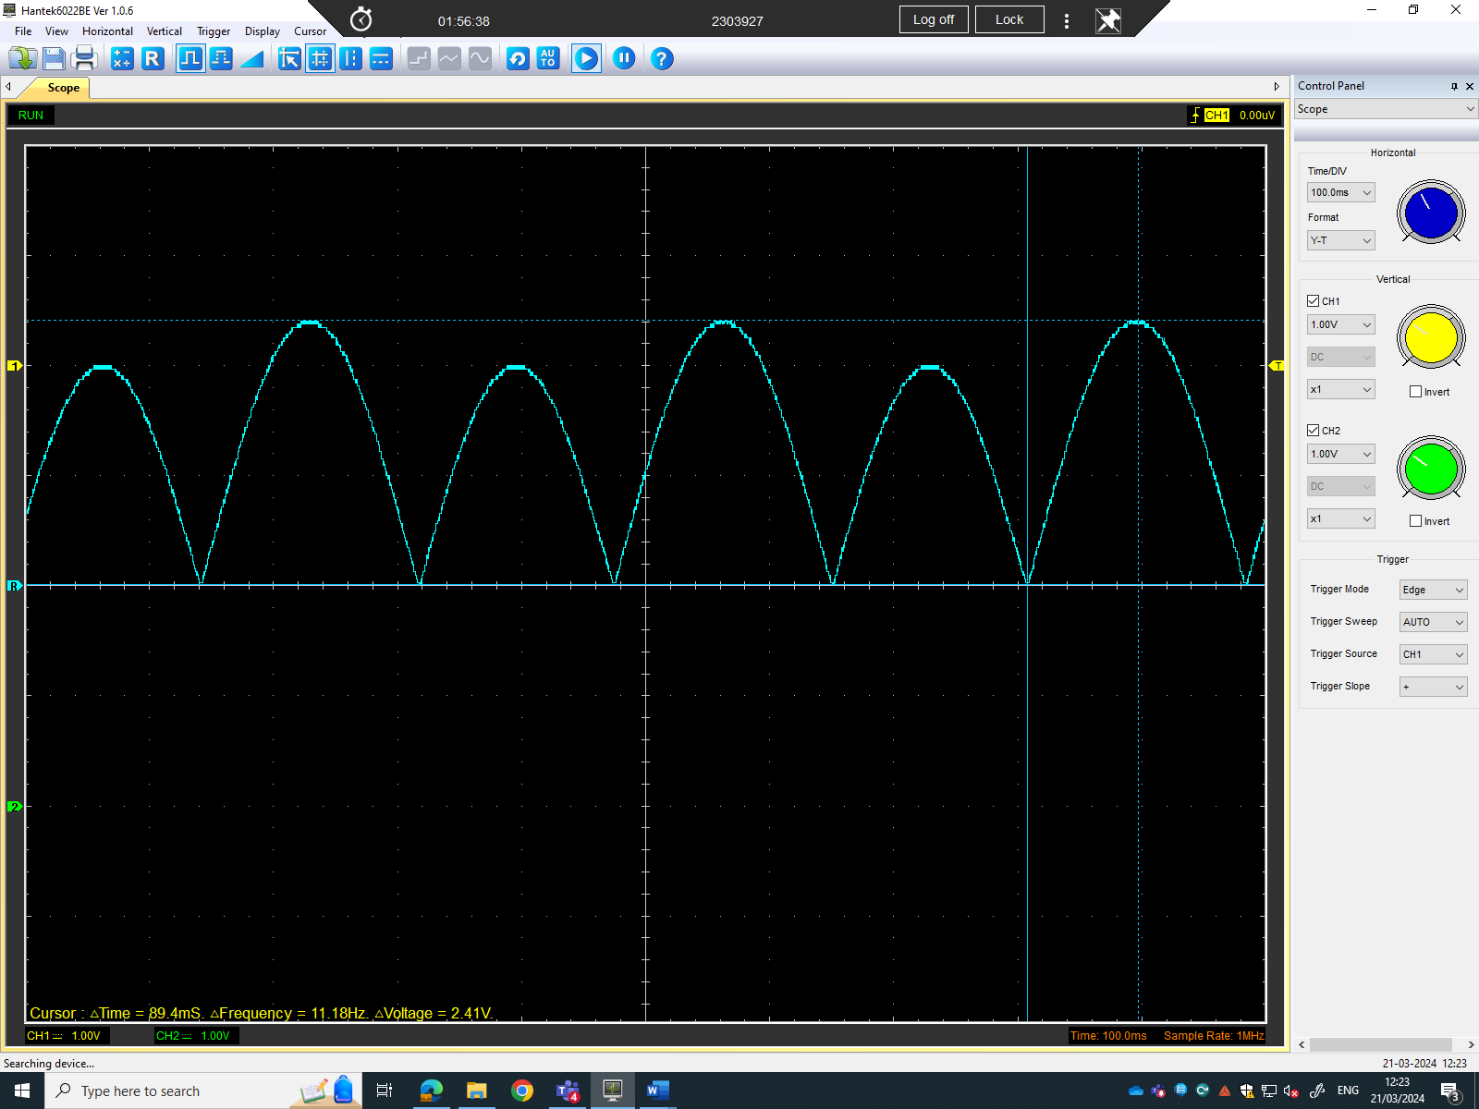

Smoothed Rectifier Wave with capacitor (3)
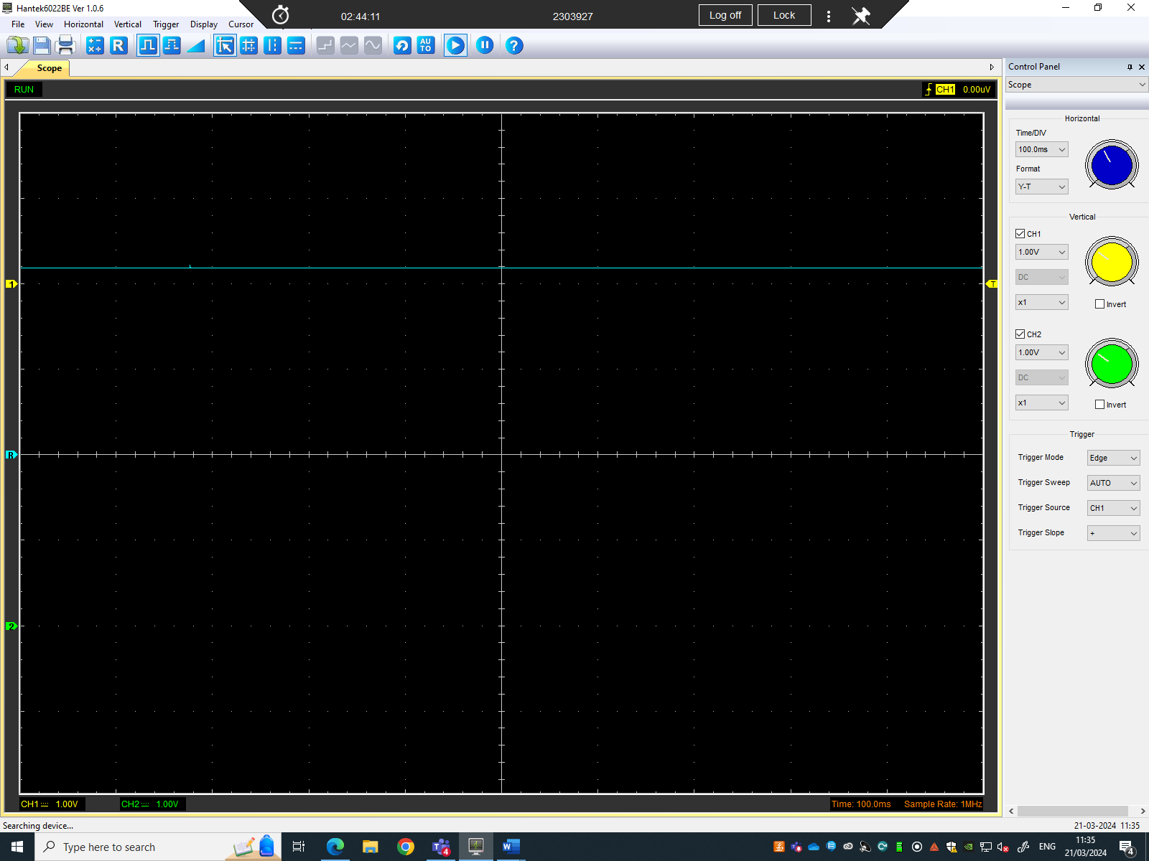
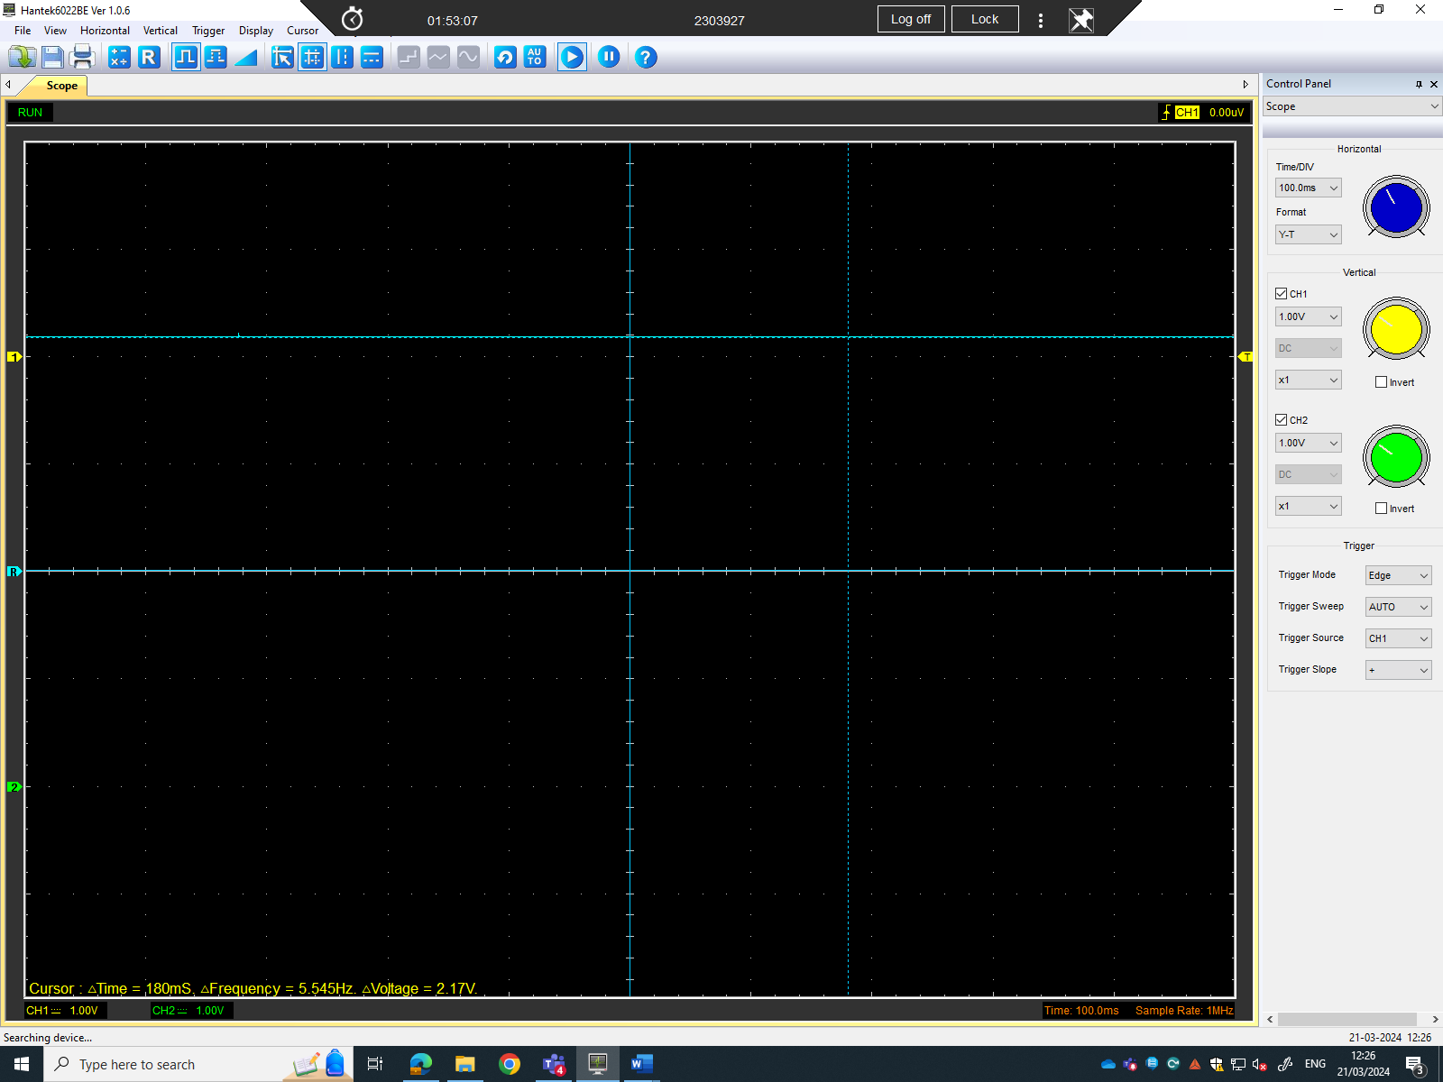
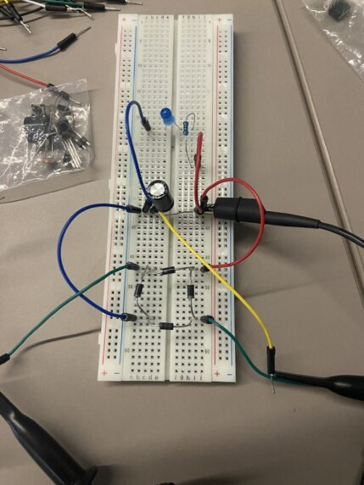

Drop in Voltage Question (4)
Reasons why a voltage drop could have occurred could be due to:
- Diode forward voltage drop
- Transformer imperfections
- Load resistance
- Filter capacitor
- Peak inverse voltage limitation
These factors collectively contribute to the drop in the rectifier DC output compared to the peak of the sine wave input.

Different Voltage Readings Question (5)

Rectifiers use in Automotive applications Question. (4)
Rectification, the process of converting alternating current (AC) to direct current (DC), finds various applications in different vehicles, playing crucial roles in their electrical systems.

Probing Question (4)

Task 3

Scope Time Division Calculations (4)
The formula for T is, Time constant = Resistance x Capacitance (T = RC).
The resistor used during this test was 10KOhms and the capacitor was 10uf.
Therefore, T = 10,000 x 10 x 10⁻⁶ = 0.1s or 100ms.
Frequency formula, F = 1/T
1/0.1 = 10Hz.
Given that we have 20T, time division = 20 x 0.1 = 2s
This then means that the time division for the scope to display 1 full period/wave with the duration of 20 seconds would be 2 seconds per division.

Function Generator output square wave (3)
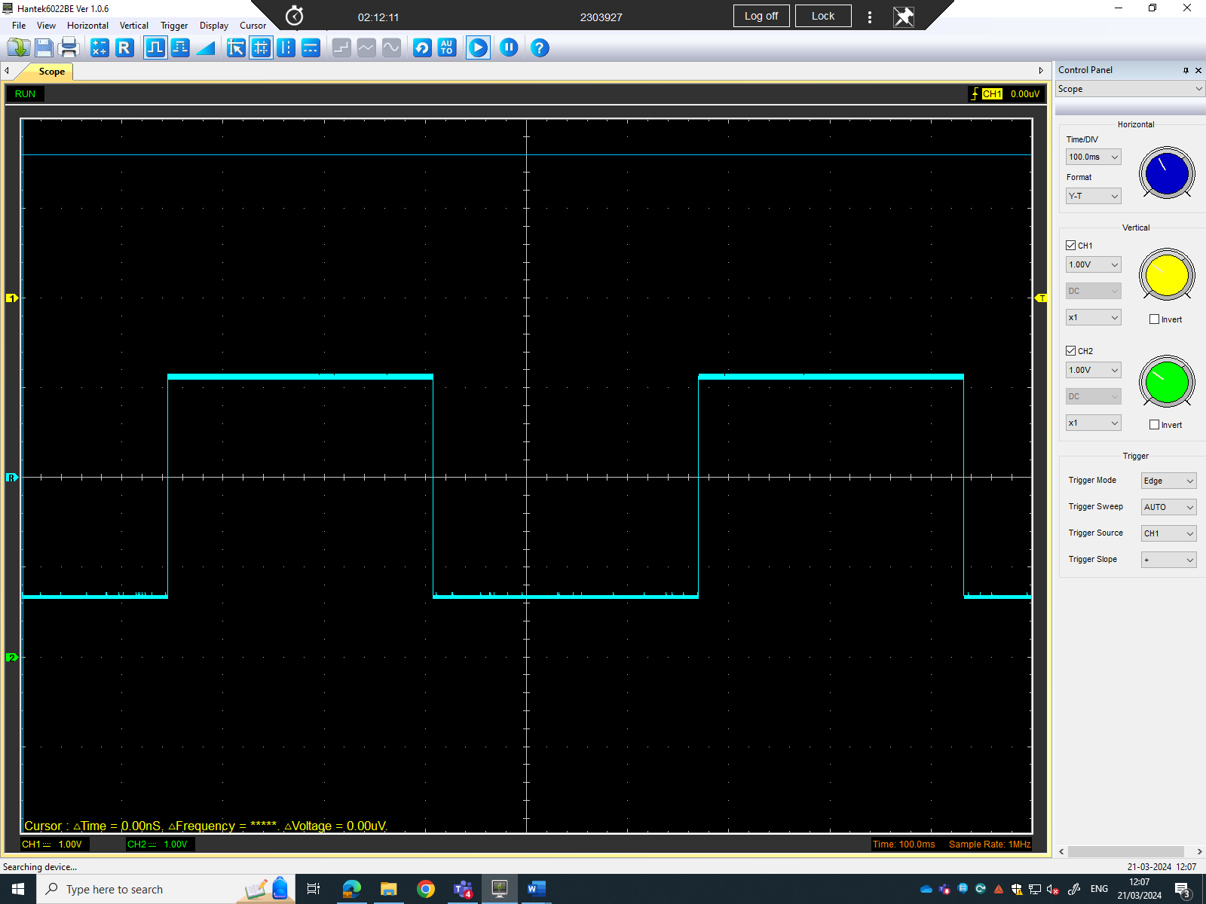

Capacitor charge and discharge wave marked at correct points. (3)
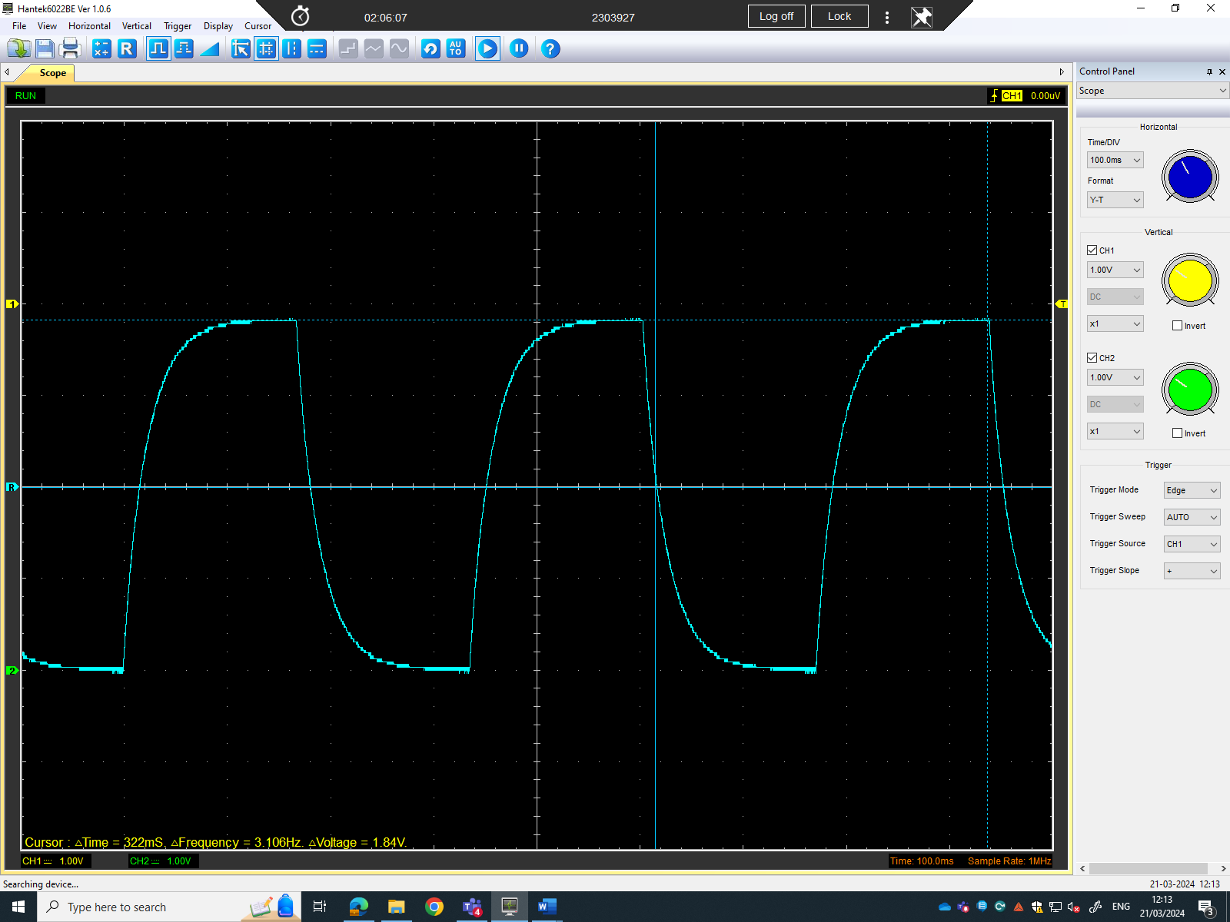
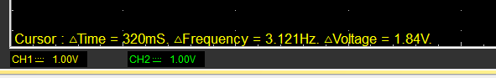

Basic Capacitor Calculations (3)

Peak = 1.84V
(1.84 – 0) *0.632 + 0 = 1.16V
T = RC
C = T/R

Capacitor discharge table (4)
Time (s) | Voltage (V) | V+ | In (V) | dy = y2 – y1  dy = ln(V)2-ln(V)1 | dx = x2- x1  dx = Time2 – Time1 | dy/dx
0.002078 | 1.0667 | 2.0667 | 0.725953 | x | x | x
0.002291 | 0.5961 | 1.5961 | 0.467563 | - 0.25839 | 0.000213 | -1213.1
0.002504 | 0.2353 | 1.2353 | 0.211314 | - 0.25625 | 0.000213 | -1203.05
0.002717 | - 0.0471 | 0.9529 | - 0.04825 | - 0.25956 | 0.000213 | -1218.61
0.00293 | - 0.2353 | 0.7647 | - 0.26827 | - 0.22002 | 0.000213 | -1032.96
0.003143 | - 0.4392 | 0.5608 | - 0.57839 | - 0.31012 | 0.000213 | -1455.96
0.003356 | - 0.5961 | 0.4039 | - 0.90659 | - 0.3282 | 0.000213 | -1540.85
0.003569 | - 0.7216 | 0.2784 | - 1.2787 | - 0.37211 | 0.000213 | -1747
0.003782 | - 0.8 | 0.2 | - 1.60944 | - 0.33074 | 0.000213 | -1552.77
0.003995 | - 0.8784 | 0.1216 | - 2.10702 | - 0.49758 | 0.000213 | -2336.06

Gradient Plot and calculations (4)

Capacitor Uses (5)

Inaccuracies Question (4)

References
(Format to Harvard style as per handbook)

