AHHI5017 Contesting Conflict: Representations of War, 1789–Present
Week 4: The Spanish-American War
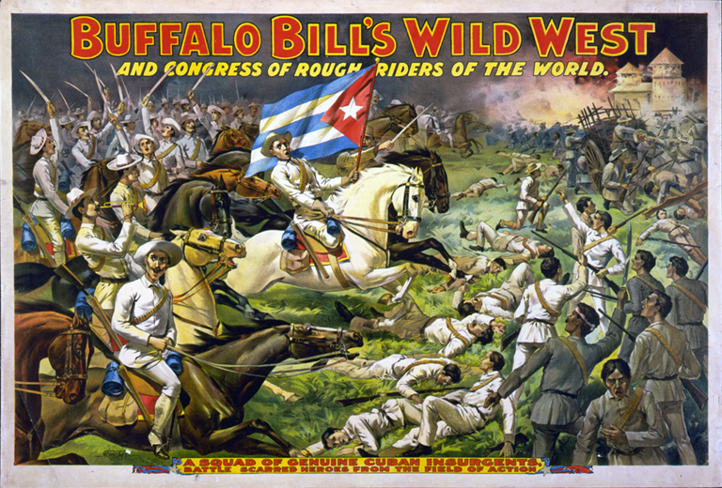
Advert for Buffalo Bill’s Wild West, circa 1898
Lectures summary:
This week consolidates several themes already explored on the module. It continues the previous week’s discussion of American history by exploring the United States’ 1898 war with Spain; likewise, where Week 3 focused on the advent of photography, students will be introduced to how another key technological innovation – the cinema – shaped perceptions of the conflict. We shall also consider the role of popular culture (Buffalo Bill’s Wild West) and international expositions (the 1904 St Louis World’s Fair) in disseminating knowledge about the war and the United States’ newly-acquired colonial possessions – the Philippines in particular.
The lecture will begin by highlighting an interesting problematic. Whereas the legacies of Week 3’s topic – the American Civil War – loom omnipresent in contemporary US society, politics and culture, this week’s focus, the Spanish-American War is largely forgotten by comparison. Because of this relatively obscure status, the first part of the lecture will explain some of the basic chronological details relating to the war, as well as some of the scholarly debates which it has engendered – especially with regards to post-Civil War sectional reconciliation. Class and group discussions will service the goal of highlighting the Spanish-American War as a media and cultural ‘event.’ Two key cultural phenomena – early cinema and World’s Fairs/International Expositions – will be foregrounded.
The second part of the lecture will gravitate around assigned readings on the intertwined themes of spectatorship and the Spanish-American War. Our conversations will contemplate cinema’s status as a new medium for representing war, and the manner in which the nascent mass culture of the fin-de-siècle period facilitated new ways of staging, restaging international conflicts and their consequences before audiences of hitherto unprecedented size. Here, we will discuss representations of combat made before, during and in the immediate aftermath the United States’ war with the Spanish Empire in the Caribbean and Southeast Asia. Special attention will be afforded to repercussions the United States’ acquisition and annexation of territories within former colonies of Spain (Cuba, Guam, Puerto Rico, the Philippines). In particular, we will examine representations of and reactions to the United States’ war with nationalist movements in the Philippines, plus the political exigencies behind how the Philippine archipelago and indigenous Filipinos were represented at the 1904 Louisiana Purchase Exposition in St Louis, Missouri.

Required reading and other preparation:
- Sarah J. Blackstone, ‘Cody, William (“Buffalo Bill”),’ in Paul S Boyer ed. The Oxford Companion to United States History (Oxford: Oxford University, 2001 [online ed. 2004]).
- David F Trask, ‘The Spanish-American War,’ in Paul S Boyer ed., The Oxford Companion to United States History (Oxford: Oxford University, [online ed. 2004]). A basic introduction to the topic.
- Kristen Whissel, ‘Placing the Spectator on the Scene of History: The Battle Re-enactment at the Turn of the Century, from Buffalo Bill’s Wild West to the Early Cinema,’ Historical Journal of Film, Radio and Television, Vol. 22, No. 3 (2002), pp.225–243.

Preparing for the lectures:
In the first instance, the immediate goal is for students to develop some understanding of what the Spanish-American War was, and why it has (albeit sometimes ignored) historical significance. To this end, students are simply requested to read a scholarly encyclopaedia entry on the conflict. The Kristen Whissel’s essay ‘Placing the Spectator on the Scene of History’ starts out by thinking about the types of battle re-enactments which constituted part of the mass appeal of Buffalo Bill’s Wild West (see relevant encyclopaedia entry) to American and European audiences, before linking it to how the Spanish-American War was extensively documented by new motion picture technologies.

Questions to consider:
- What was the Spanish-American War, and what are the historical significances of the conflict?
- What were the causes of the war?
- Who were the key belligerents in the war?
- What sort of combat did the war involve?
- What were its key outcomes and consequences?
- How was the war interpreted by the American public?

- What role did media coverage play in the war?
- Is there anything significant about the manner in which the war was reported on by newspapers?
- How did motion pictures document the war?

Whissel, ‘Placing the Spectator on the Scene of History’
- Who was William ‘Buffalo Bill’ Cody and what made his Wild West so popular?
- What was the appeal of the Buffalo Bill persona?
- What were notable and attractive features of his Wild West?

- How were the Spanish-American War and other conflicts represented in Buffalo Bill’s Wild West?
- Besides the Spanish-American War, what other conflicts did the Wild West enterprise focus on?
- Is there anything significant about the particular conflicts which were selected?
- What sociocultural ‘messages’ or presumptions were conveyed by the Wild West performances?

- What were the key features and characteristics of battle re-enactments staged as part of the Wild West, and how were the re-enactments received by audiences?
- Were the re-enactments understood as escapism or as having educational value?
- Were the re-enactment understood as fictitious or as having historical, documentary value?
- According to Whissel, how did the demands placed upon re-enactment spectators compare and contrast with the sorts of audience interaction and responses engendered by PT Barnum’s show?

- What were some of the key features and characteristics of Spanish-American War-themed motion pictures?
- Were there uniform or varying ways of representing the war on film?
- What cinematic ‘genres’ emerged for representing the war on film?
- What sort of audience reaction do you think motion pictures of the war might have engendered?

Background reading:
- Tom Gunning, ‘The World as Object Lesson: Cinema Audiences, Visual Culture and the St Louis World’s Fair,’ Film History, Vol. 6, No. 4 (1994), pp. 422–444.
- Nancy J Parezo and Don D Fowler, ‘The Philippine Reservation,’ Anthropology Goes to the Fair: The 1904 Louisiana Purchase Exposition (Lincoln, Nebraska: University of Nebraska, 2007), pp. 164–193.

Gunning, ‘The World as Object Lesson’
- Gunning stakes much of his analysis on the concept of ‘object lessons.’ What do you understand by this phrase, and why is it important to the points Gunning wished to get across to readers?
- What was significant and novel about the ‘object lesson’ concept in relation to the new mass culture of the late 19th/early 20th centuries?
- According to Gunning, what different cultural institutions and phenomena purported to offer ‘object lessons,’ and to what end(s)?

- What were some of the outstanding features of World’s Fairs (aka International/Universal Expositions)?
- What went on display at World’s Fairs?
- What was the relationship between World’s Fairs and new forms of technology?
- What sort of architecture was used at World’s Fairs, and why might this be significant?
- What was the appeal of World’s Fairs to those stakeholders involved in organising them?
- What was the appeal of World’s Fairs to the audiences of millions who attended them?

- Gunning makes particular reference to the Midway Plaisance of the Chicago World’s Columbian Exposition (1893) and the Rake at the St Louis Louisiana Purchase Exposition (1904). What were the key features of Midway and the Rake, and how did they relate to the rest of the fairs which they were part of?

- In what ways does Gunning compare and contrast early cinema’s spectacular appeal with that of the various mechanical amusements available at the Louisiana Purchase Exposition and other such World’s Fairs?

Parezo and Fowler
- What were some of the important motivations for having a Philippine Reservation at the Louisiana Purchase Exposition?
- What did festival organisers, the Federal government and colonial administrators hope to achieve by staging the reservation?
- What messages did they hope to impress upon visitors to the reservation?
- In what ways were academic scholars involved in organising the reservation?

- What concepts and ideas was the Philippine Reservation supposed to represent?
- What image(s) of the Philippine archipelago did the reservation convey?
- What image(s) of indigenous Filipinos did the reservation convey?
- Were the various Filipino groups present at the Fair represented in a uniform manner, or were the important differences in the specific ideas and concepts which they were supposed to embody?

- What images and ideas did the Philippine Reservation convey about the Spanish-American War and the American-Philippine War?
- Did the military or martial iconography feature in the reservation in any way?

Further reading:
- Louisiana Purchase Exposition Company, The Greatest of Expositions Completely Illustrated (Louisiana Purchase Exposition Company: St Louis, 1904). Available at archive.org: https://archive.org/stream/cu31924096211382#page/n285/mode/2up
- Missouri Historical Society, ‘1904 World’s Fair Looking Back at Looking Forward’: http://www.mohistory.org/Fair/WF/HTML/index_flash.html

Even more background reading for Louisiana Purchase Exposition diehards:
Archive.org (a wonderful repository for all manner of historical research) has numerous further books on the Louisiana Purchase Exposition. These are listed below:
- Austria Ministerium für Cultus und Unterricht, Universal Exhibition St. Louis 1904 [http://archive.org/details/universalexhibit00aust]
- Belgium Ministère de l’Industrie et du Travail, Belgium: Its Institutions, Industries and Commerce [http://archive.org/details/belgiumitsinsti01travgoog]
- Brazil Commissão, Louisiana Purchase Exposição, 1904, Brazil at the Louisiana Purchase Exposition [http://archive.org/details/brazilatlouisian00braz]
- Canada Dept. of Agriculture, Canada: Its History, Productions and Natural Resources [http://archive.org/details/canadaitshistor00johngoog]
- Ceylon Commission, Official Handbook of the Ceylon Court [http://archive.org/details/officialhandboo00unkngoog]
- Yow Tong Chang , To Universal Peace These Poems Are Dedicated: Human Progress as Shown at the World’s Fair in St. Louis, 1904 [http://archive.org/details/touniversalpeace00chanrich]
- China Imperial Commission, China: Catalogue of the Collection of Chinese exhibits at the Louisiana Purchase Exposition, St. Louis, 1904 [http://archive.org/details/chinacatalogueof00chin]
- WW Ellis, The Piker and World’s Fair Guide: An Accurate Account of the Exposition, Preliminary Programme, Olympic Games and World’s Championship Contests [http://archive.org/details/pikerworldsfairg00elli]
- Everett, Marshall, The Book of the Fair: The Greatest Exposition the World has Ever Seen Photographed and Explained [http://archive.org/details/bookoffairgreate00ever]
- Germany Reichskommission, Weltansstellung in St. Louis, 1904, Descriptive Catalogue of the German Arts and Crafts at the Universal Exposition [http://archive.org/details/descriptivecata00germgoog]
- Germany Reichskommission, Weltansstellung in St. Louis, 1904, International Exposition St. Louis 1904: Official catalogue - Exhibition of the German Empire [http://archive.org/details/internationalexp00germrich]
- Hoshi, Hajime, Handbook of Japan and Japanese Exhibits at World’s Fair, St. Louis, 1904 [http://archive.org/details/handbookjapanan00unkngoog]
- Imperial Japanese Commission to the Louisiana Purchase Exposition, Japan in the Beginning of the 20th Century [http://archive.org/details/japaninbeginnin00yamagoog]
- Kingdom of Siam Ministry for Agriculture, The Kingdom of Siam Ministry of Agriculture, Louisiana Purchase Exposition, St. Louis, U.S.A., 1904: Siamese Section [http://archive.org/details/kingdomofsiammin00cart]
- Mason, Augustus Lynch, Our Pioneers: The Heroic Deeds and Devoted Lives of the Fathers and Mothers of America, Embracing the Principal Episodes in the Struggle of the White Race with the Red Men for the Possession of the New World [http://archive.org/details/ourpioneersheroi00masorich]
- Philippines Exposition Board, Official Handbook of the Philippine and Catalogue of the Philippine Exhibit [http://archive.org/details/officialhandboo00niedgoog]
- William Taft, Circular Letter of Governor Taft and Information and Instructions for the Preparation of the Philippine Exhibit for the Louisiana Purchase Exposition to be held at St. Louis, Mo., U.S.A., 1904 [http://archive.org/details/cu31924074368006]
- Coming Down the Pike [http://archive.org/details/comingdownpike00viss]
- Jackson’s Famous Photographs of the Louisiana Purchase Exposition [http://archive.org/details/jacksonsfamousph00jack]
- Official Handbook of the Philippines and Catalogue of the Philippine Exhibit [http://archive.org/details/afj2120.0001.001.umich.edu]

