

Christopher Scrine

BEng (Hons) Engineering Portfolio

Level 6 – Control Technology

Contents

1 – Introduction Page 3
2 – Control System Page 4
3 – MATLAB Code Page 8
4 – Graphs Page 12
5 - Conclusion Page 17
6 – References Page 18
7 – Appendix Page 19

Introduction
In the world of control systems engineering, the Proportional-Integral-Derivative (PID) controller is a widely used tool for regulating dynamic systems. Its versatile applicability spans across various industries, from manufacturing and industrial automation to automotive engineering. This report investigates the understanding of PID controllers, with a specific focus on their implementation in an industrial control system, looking into the systems inputs, outputs and settings.
The analysis further extends to investigating a vehicles cruise control system and how the control system can influence the user's experience, in this case the driver. In the context of a cruise control system, altering the setpoint can lead to changes in the vehicle's behaviour and driver comfort. The assignment will explore how PID controller parameters influence the responsiveness and stability of the cruise control system, thereby impacting the driver's perception of the system's performance.
To investigate the concepts discussed, MATLAB will be used as the analytical tool. MATLAB's capabilities to simulate dynamic systems, tune PID controller parameters, and visualize system responses make it an ideal platform for this analysis. The report will highlight MATLAB-based simulations, offering insights into the effects of PID controller adjustments on the drivers’ experience.

Control System
A Proportional-Integral-Derivative (PID) controller is a widely used feedback control system in industrial applications. It is designed to regulate a system's output by adjusting its control inputs based on the error between the desired setpoint and the actual process variable. PID controllers have evolved alongside technology and are often found in digital form rather than pneumatic and electrical components (Visioli, 2006).
Proportional (P) Term: The controller calculates an output signal based on the current error, which is the difference between the setpoint and the current process variable. The proportional term generates a control signal that is directly proportional to the magnitude of the error. A higher error results in a larger control action, helping to reduce the error quickly.
Integral (I) Term: The integral term considers the accumulated past errors over time. It aims to eliminate any steady-state error that might remain due to the proportional term alone. The integral term produces a control signal proportional to the integral of the error, which helps to counteract long-term deviations from the setpoint.
Derivative (D) Term: The derivative term anticipates the future trend of the error by measuring its rate of change. This component helps dampen the system's response and prevent overshooting or oscillations. The derivative term contributes to stabilizing the control system and reducing transient responses.
By tuning the coefficients of the proportional, integral, and derivative terms, engineers can adjust the controller's behaviour to match the specific characteristics of the controlled process. The choice of tuning parameters depends on factors like the system's dynamics, desired speed of response, and noise levels.
PID controllers are commonly used in various applications, one of which being vessel level control. At Vale, Foxboro digital integrated PIDA controllers are used as part of the I/A system to control vessel levels at the PGP such as the Benfield Absorber level. These controllers are used to maintain steady vessel levels and react to flow changes in the systems, these vessel levels play a critical part in purifying gases for refinery to use in their processes. As part of the system, input and output components are used for the PIDA controller to operate efficiently, these are level sensors and level control valves.
The level sensor that is used for vessel level indication is a Vegaflex 81, which are designed for continuous level and interface measurements of liquids (Vega, 2023). The Vegaflex 81 obtains measurements using guided wave radar technology and converts the measurement into a 4-20mA signal, this instrument is then connected to an AI(Analogue Input) block which then sends the signal to the PIDA control block(Appendix 1). This signal obtained is used to determine the level percentage of the vessel, that percentage is then displayed on the process screens for operators to see. Depending on the measured value, the PIDA control block will then send a signal via an AOUT(Analogue Out) block to the control valve which will then operate accordingly to achieve the set point. The level control valve used in the system is a Fisher DVC2000 controller. The DVC2000 controller is an intrinsically safe, integral mounted controller which communicates using 4-20mA signal, “the performance and simplicity of the Fisher FIELDVUE DVC2000 instrument allows for your operation to run closer to setpoint, improving product quality with more accurate control” (Emerson, 2023).

Sampling time, which refers to the intervals in which the PID controller evaluates and applies actions to the system it is controlling. Sampling time is a factor that can affect the performance of a PID controller, the correct choice of sampling time will impact the effectiveness of the controller’s ability to control a system. This can affect the system in several ways such as stability, responsiveness and the systems parameters.
The stability of the system will be altered depending on the sampling time, this occurs if the sampling time is too large as the controller may not be able to respond quick enough to changes which may have happened in the system since the last time a sample was taken, this can lead to instability within the system and an inaccurate control system. Similarly, if a sample time is too small this can also cause issues such as noise and again instability. Short sampling times will be more susceptible to noise from measurements and may therefore require filtering.
Responsiveness of a system is also affected by the sampling time; a shorter sampling time allows the system to respond to deviations from the set point quickly which can be beneficial in some systems and can help achieve a tight control. However, this can also add stress to the system as it creates more wear on components.
As mentioned previous, the PID control system at Vale uses analogue signals as its communication protocol, however there are many different methods of communication PID systems can use. Some of these could be serial communication (Profibus, modbus etc) which are often used to connect PID controllers to PLCs and computer systems. Fieldbus is another form of communication which could be used and is very common in industrial automation as it enables devices such as sensors, actuators, controllers etc to exchange data and control signals over a common communication network.
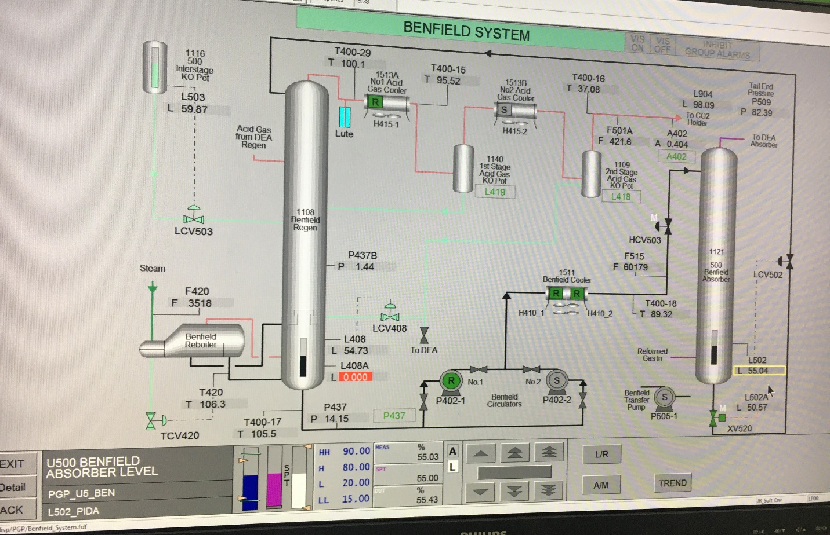

Figure 1: Benfield System, Vale (2023)

Figure 1 image is showing the Benfield system which is displayed on the IA process screens in the control room, the right hand column highlighted is the absorber vessel which has a PIDA control system to control its level. The second highlight box displays the alarm setpoints for the system, the current setpoint, the current actual value and the valve position. Here you can see the setpoint(spt) is set to 55%, the measured value(meas) is 55.03% and the valve position(Out) is 55.43%. Theses are also shown in Figure 2 below which displays the trend screen for the system which allows users to look back at previous conditions.

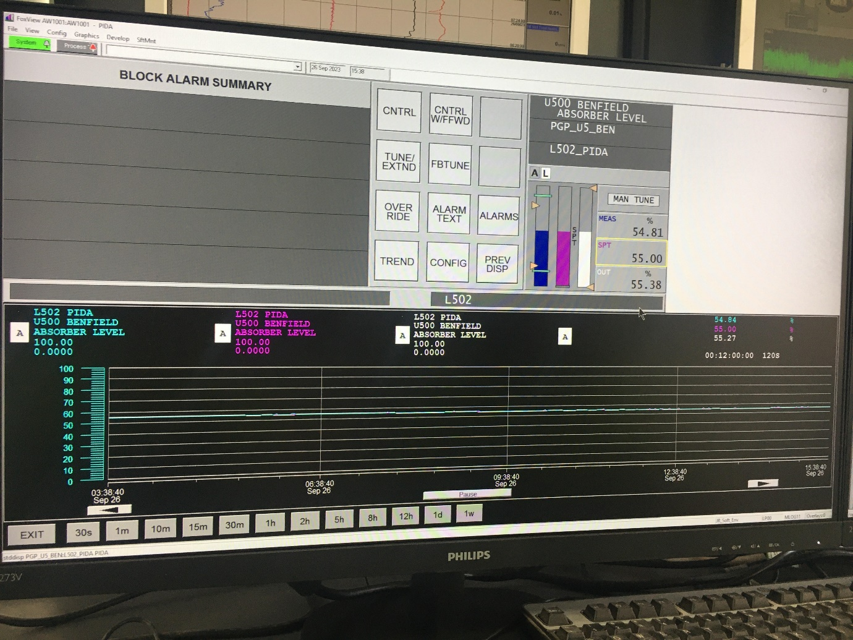
Figure 2: Benfield System Trends, Vale (2023)
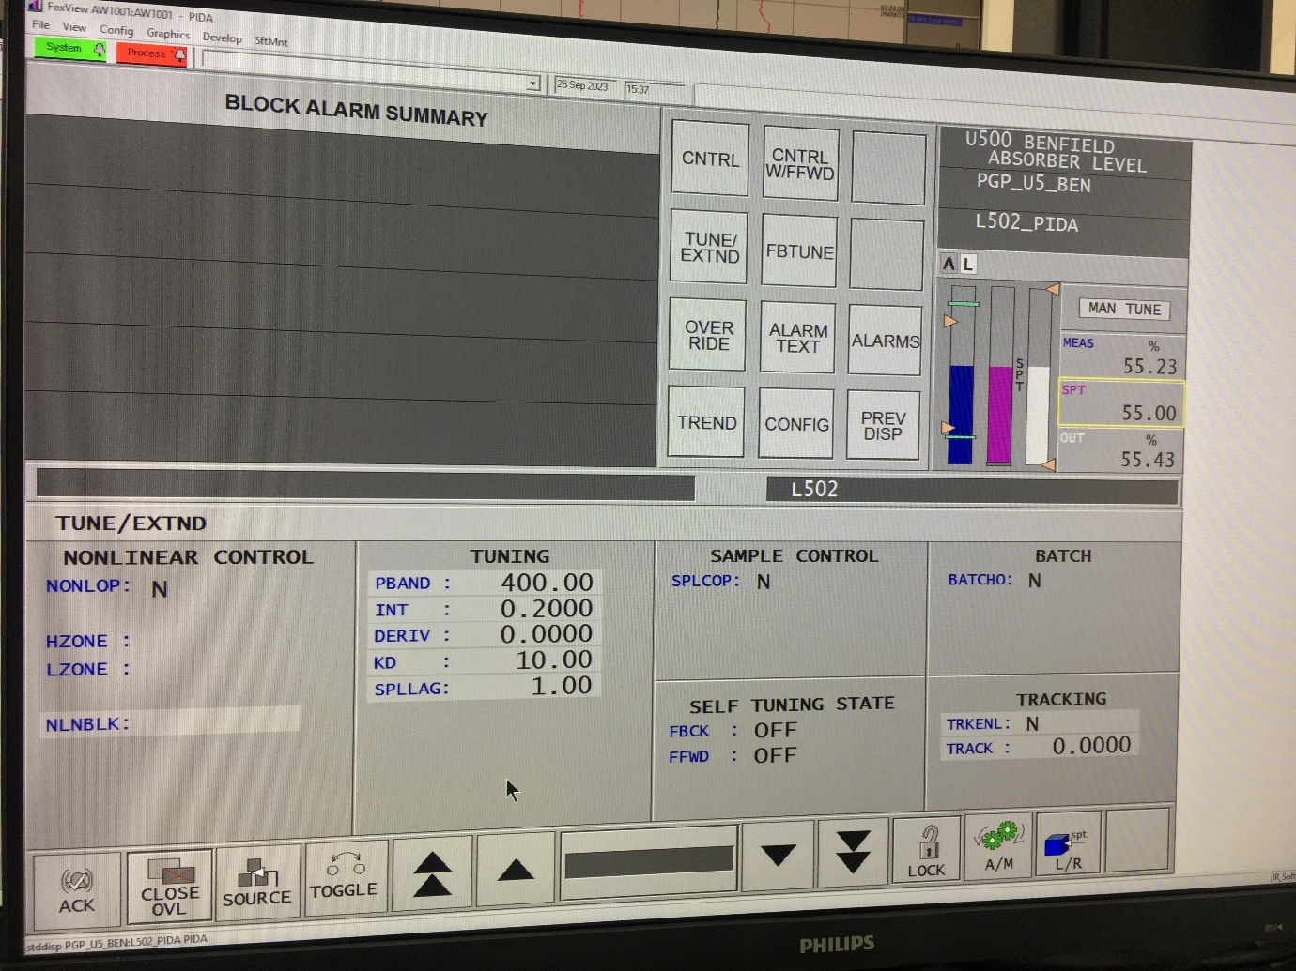

Figure 3: Benfield System PIDA Tuning, Vale (2023)
Figure 3 above is displaying the tuning parameters which are used to maintain the Benfield Absorber level using the PIDA controller. It shows the user how each aspect of the PID part of the controller is tuned, for this controller only P and I are used. This page also allows for other settings to be changed on the controller such as self-tuning, which in this case is switched off.
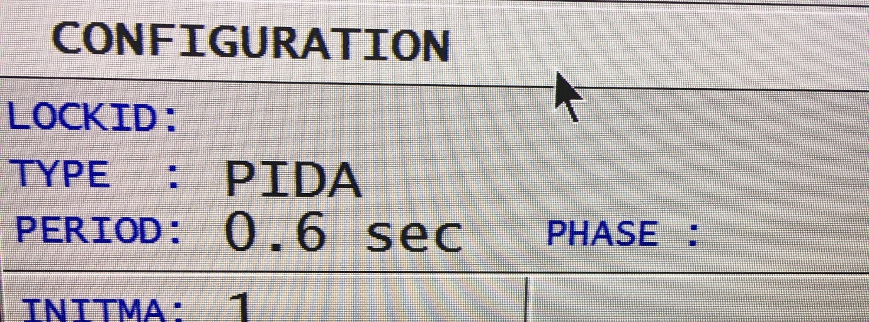
Figure 4 below then shows the sampling time setting for this controller, the sampling time is set to 0.6seconds and phase set to 1.
Figure 4: Benfield System PIDA Sampling time, Vale (2023)

Matlab Code
Matlab will be used to simulate a cruise control system in a vehicle and how a PID controller is used in this system to maintain a steady stead for the driver. Tuning alterations will be made to the PID controller, and the effects of these changes will be seen via graphs, the effects shown in the graphs due to the changes will be discussed and optimum settings will be recommended for the cruise control system to provide a smooth system for the driver.
The Matlab code is split in to separate sections, the main script will run the simulation and be used to plot the graphs. Separate function codes are then used to perform operations outside of the main script, but their results are utilised within the main script.

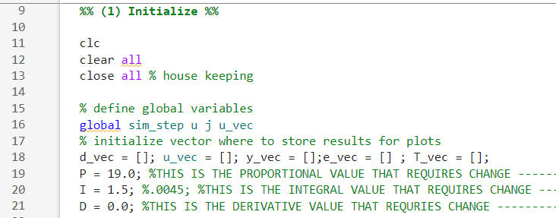

Figure 5: MATLAB Main Script, MATLAB (2023)

Figure 5 above shows the start of the main script, here the script starts by clearing all variables from previous runs and ‘close all’ will also close any currently open figures/graphs.
Global variables which are set to be used in the code are then defined, here we can see global variables ‘Sim_step’, ‘u’, ‘j’ and ‘u_vec’.
From there, the parameter settings for the PID controller are set, there is a separate setting for each aspect of the controller. These parameters are what will be altered when trying to define the optimum for a smooth cruise control system. Modifying P will alter the throttle travel and make the system more responsive to velocity changes, the higher this parameter is the quicker the velocity of the car will change to reach the driver’s demand. This will result in lowering the settling time, however, could likely lead to overshooting and therefore exceeding the drivers demand speed. Modifying I will help to eliminate the steady state errors, but this could also make the system slow to respond to speed changes, for this simulation this will be kept at 1.0. Modifying D will dampen the response to speed changes and try to eliminate overshooting.

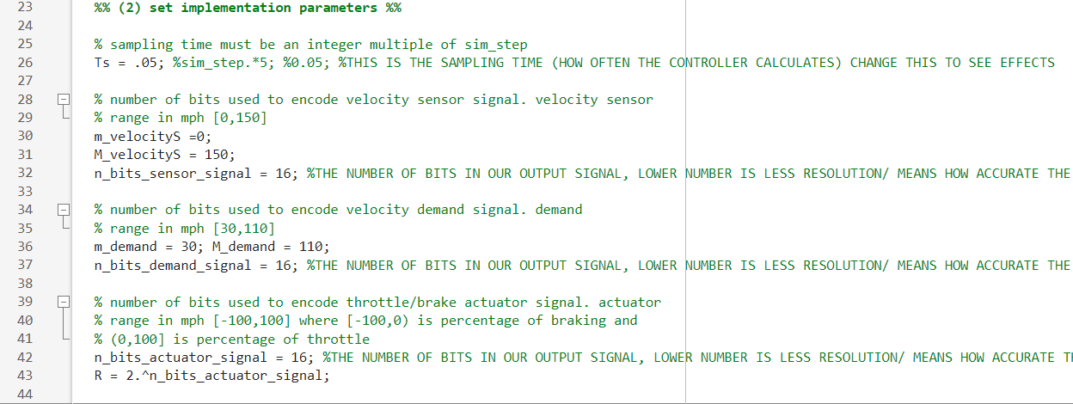

Figure 6: MATLAB Main Script, MATLAB (2023)
Figure 6 shows implementation parameters for the main script. Here the sampling time for the simulation is set, for the script shown this is set at 0.05s, this sampling time is how often the controller calculates required adjustments to reach desired output.
Also, in this section of code the number of bits used to encode various signals for the system simulation, altering these bit resolutions will influence the results obtained, as shown above for this script they are each currently set to 16bits. It defines the bit resolutions for the velocity sensor signal, the velocity demand signal, and the throttle/brake actuator signal. Parameters are given for the velocity sensor, which will range from 0 to 150mph. Parameters for the velocity demand signal are set at 30mph minimum to 110mph maximum.
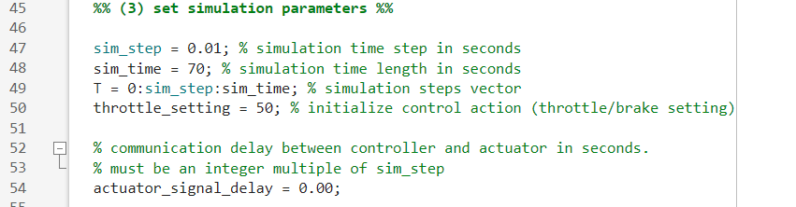

Figure 7: MATLAB Main Script, MATLAB (2023)
Figure 7 show the section of code that establishes the fundamental parameters for the simulation, including the time step(0.01), simulation duration(70), Throttle setting (50%), and communication delay between the controller and actuator(0). The ‘Sim_step’ parameter will determine how frequently the simulation will update and calculate control response. ‘Sim_Time’ parameter will set the duration of the simulation and the ‘Throttle_setting’ will determine the output of the throttle at the simulation start.

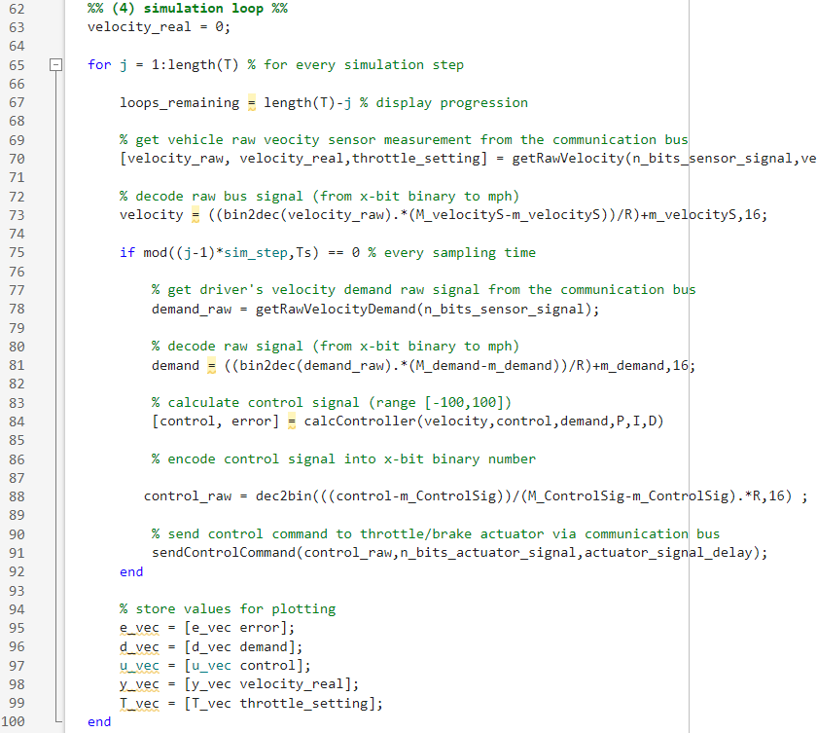

Figure 8: MATLAB Main Script, MATLAB (2023)

Figure 8 shows the section of the main script which represents the heart of the control system simulation. It iterates through time steps, calculates control actions based on the driver's demand and sensor measurements, and updates the system's state. Lastly, it then stores values which will be used for plotting the graph for visual representation.
Here, ‘Velocity_real’ is set to 0, this is the starting velocity of the vehicle during the simulation. From there the loops remaining is calculated, which is essentially counting how many simulation steps remain. The code then moves on to collecting and using data to run the simulation, ‘getRawVelocity’ function is called which collects a raw velocity sensor measurement. The measurement obtained is the decoded from an x-bit binary unit to mph.
The raw velocity is then used to calculate the error between the current velocity and the demand velocity, depending on the error, a control command is then sent to the throttle/brake to reduce the error and achieve the speed required.
Values for error, demand, control, real velocity and throttle setting are then stored so they can be plotted using the graph to provide a visual representation of the simulation to the user.
As mentioned, there are several functions which are used within the main script to retrieve data to use within the simulation. These functions are ‘GetRawVelocity’, ‘GetRawVelocityDemand’, ‘CalcController’ and ‘SendControlCommand’.
‘GetRawVelocityDemand’ function is used to simulate the drivers speed demand for the cruise control. This will alter during the simulation to simulate the driver altering the desired speed output from the cruise control. Elseif statements are used here for different speed ranges and the values from each of these statements is then converted from decimal to binary using dec2bin.
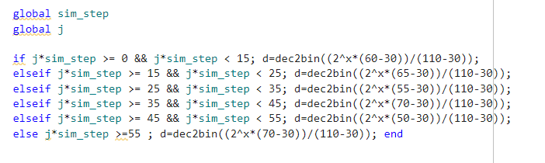

Figure 9: GetRawVelocityDemand Function, MATLAB (2023)

‘CalcController’ function, as shown in Figure 10, implements the PID control for the system to generate a control signal based on the error between the demand and the actual velocity. Firstly, in this function the error is calculated by using the formula error = demand – velocity. From there the distance to look back at integer value is set at 6, an IfElse statement is used to determine whether or not that is possible, if u_vec is less than 6 then it uses the control value to set the value of variable ‘prev’, if u_vec is greater than 6 it assigns the 6th value from the end of u_vec to ‘prev’. The following lines then calculate the proportional, integral and derivative control requirements and provide an output signal – ‘Contout’.
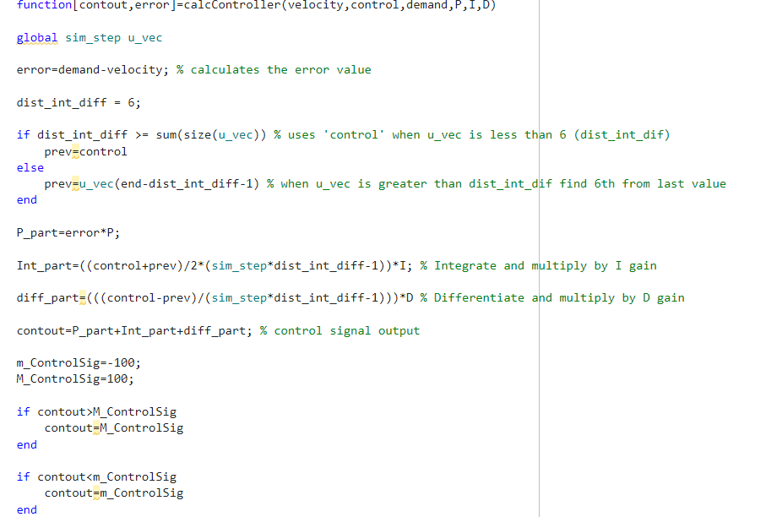

Figure 10: CalcController Function, MATLAB (2023)

Graphs
Here the simulation will be executed with settings altered for the PID controller to witness the effect if has on the cruise control system and try to obtain optimum settings for the system.
Figure 11 shows the first run of the simulation with PID parameters set at P=50, I=1 and D=0.8, these paraments can also be seen on the top line of the graph. From analysing the graph it is clear that the cruise control struggles at maintaining the desired speed with the real velocity of the car constantly either over or undershooting the drivers demand speed, this would result in an uncomfortable ride for the driver as the car would be constantly altering between accelerating and breaking. The lower graph shows the control of the system, here you can see that the throttle position is altering frequently and the control % of the system is very often at its maximum.
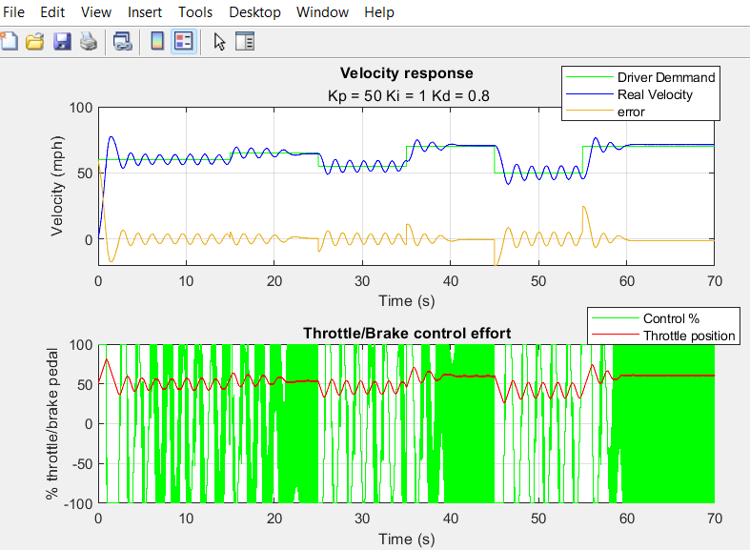

Figure 11: Simulation Graph, MATLAB (2023)

Figure 12 below shows the results of the simulation with P parameter being reduced to achieve a smoother system. It is evident that the throttle control is now much smoother than the previous simulation as is the real velocity of the car. This would provide a smoother driving experience however the real velocity of the car rarely achieves the drivers speed demand and has some large over and undershooting. Also, from looking at the lower graph it is evident that the control of the system is working tirelessly to try and achieve the drivers demand speed which would be putting a lot of stress on the system and would likely lead to part failures. Ideally, the control system will operate smoothly and well within its constraints, further parameter changes will be made to try and achieve this.
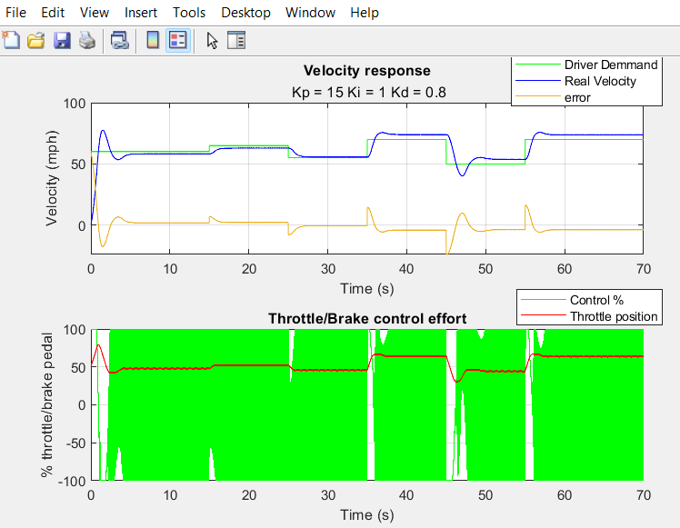

Figure 12: Simulation Graph, MATLAB (2023)

Figure 13 shows the results after halving parameter D’s figure from 0.8 in the previous simulation to 0.4. Here it can be seen that the result of this has drastically reduced the strain on the control system with only a couple of peaks where the system must operate at 100% of its capacity to try and achieve setpoint. This simulation also manages to achieve the drivers demand speed at every speed change with no error after a small settling time. The throttle position stays relatively smooth also and therefore these parameters would provide the driver with a reasonably smooth cruise control system, however there is still some room for improvement.

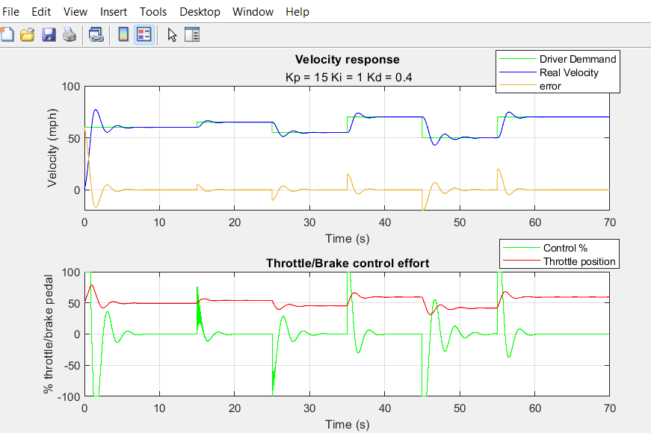

Figure 13: Simulation Graph, MATLAB (2023)
Figure 14 displays the results with further parameter changes, here P has been reduced to 4.0. This has had a positive effect on the system, it is clear that the control strain on the system has reduced with the system never having to operate at 100% of its capacity. Also, the throttle position is much smoother than previous simulations and therefore providing the driver and passengers with a smooth driving experience. This parameter change has also resulted in no over or undershooting of the drivers demand speed, there is a slight delay in achieving the demand speed when changes are made however these are only a few seconds and would be realistic in real world cruise control systems and would be required to achieve a smooth drive. These parameters of P=4.0, I=1.0 and D=0.4 would be the recommended parameters for the cruise control system to achieve a smooth ride for the driver.
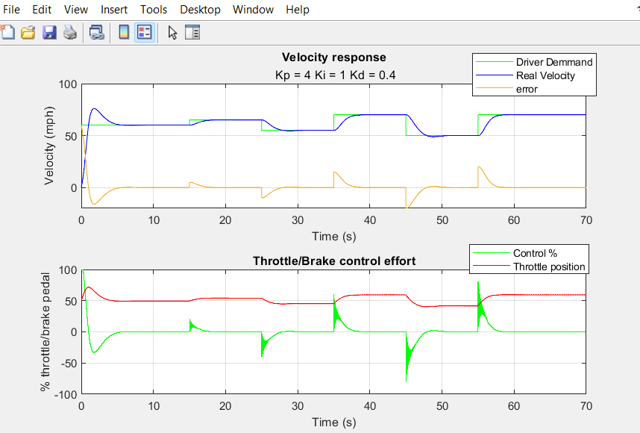

Figure 14: Simulation Graph, MATLAB (2023)

Now that parameters have been selected for the system, the sampling time will be altered to see what effect that has on the system and if it could further enhance the drivers experience. The sampling time for the previous results was set at 0.05s. This will be reduced and increased to monitor the affects.
Due to simstep and simtime limitations of MATLAB the sampling time can only be altered so much as this will cause errors on the system. 0.04s was the lowest the sampling time could be taken to successfully run the code, this had little to no effect on the results of the simulation due to such a small change. The sampling time was then changed to 0.5s, the results of which are shown in Figure 15. It is evident that increasing the sample time has a dramatic effect on the system, the driver would not have felt too much of a difference as the car would manage to reasonably maintain the drivers demand speed. However, when looking at the lower graph the effects changing the sampling time has on the control % is the greatest. This increase in sampling time has cause a lot more stress on the system and would eventually lead to breakdowns in components.

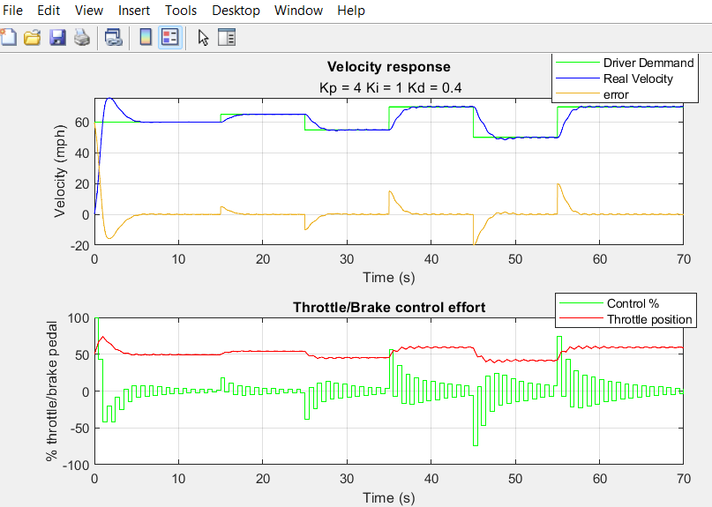

Figure 15: Simulation Graph, MATLAB (2023)

Conclusion
In conclusion, PID controllers have long been a staple in the field of control systems, and their effectiveness in regulating processes, such as vessel level control, is utilised at Vale using Foxboro integrated PIDA control blocks. These control systems have many different settings and parameters which can be controlled to fine tune their systems and in future could possibly use the ever-evolving artificial intelligence(AI) to further enhance their use and effectiveness.
MATLAB has been used to simulation a vehicles cruise control system and how each of the P,I and D aspects of a PID controller can influence its results. From carrying out multiple simulations and recording the parameters for each, it has been concluded that the optimum paraments for the cruise control system to achieve a smooth driving experience would be P=4.0, I=1.0 and D=0.4. Further to these parameter changes, simulations were also run whilst altering the sample time of the system to see what effect it has. It is evident from looking at the simulation graphs that although the sample time is restricted using the MATLAB simulation it its clear that increasing the time had a detrimental effect to the system and the optimum sample time for this simulation is 0.05s.
Further experiments could have been completed with altering the number of bits used for signal encoding/decoding which would alter the rate that data and control signals are updated and processed. This simulation was run with a bit rate of 16, increasing the bitrate may have increased the systems performance as it would have received more frequent updates of the systems performance. However, increasing bit rates too high can lead to noise and oscillations within a system.

References
Emerson, 2023. Fisher™ FIELDVUE™ DVC2000 Digital Valve Controller. [Online]
Available at: https://www.emerson.com/en-gb/catalog/fisher-dvc2000-en-gb
[Accessed 18 08 2023].
Johnson, M. & Moradi, M., 2005. PID Control - New Identification and Design Methods. London: Springer-Verlag.
Vega, 2023. VEGAFLEX 81. [Online]
Available at: https://www.vega.com/en-uk/products/product-catalog/level/guided-wave-radar/vegaflex-81
[Accessed 19 08 2023].
Visioli, A., 2006. Practical PID Control. London: Springer-Verlag .

Appendix


