Teaching Plan
Title of the lesson:
Travel arrangement
---Talking about sequences of activities (GCSE Edexcel 116-117)
Date (day/month/year): 29/09/2019

Reference to scheme of work:  4thweek of GCSE  Notes: As GCSE is a new class restructured after 13th August 2019, they are using the same learning material. |  | Reference to assessment objectives/ specification:  GCSE Specifications (Edexcel)  By referencing to the GCSE specifications
Learning objectives (with targeted students in mind):
- Learn how to make travel arrangements, which include preparations for travel items, making queries on travel information, asking for support and planning itinerary
- Learn phrases and new words that fulfil the above functions
- Learn the grammatical point: how to express the sequence of activities

Timing: | Lesson structure: | Teacher notes:
10:00-10:10 | Revision  Read the text and new words and expressions in Lesson 5.  Dictation.
10:10-10:25 | Introduction  After we have decided when and where to spend our holiday. We will need to plan our travel. The first step is to think about your itinerary, then book hotel and flight/train, and prepare the staff you need. Today you learned phrases and new words that fulfil the functions.  Development  Listen to the recording on P116 and complete the table printed out on pupils’ worksheets.  Pre-listening: Ask pupils to guess  (1) where those places given on the maps are,  (2) how pupils in the text reach there.  (3) remind pupils of what they focus on.  Listening  Post-listening:  (1) pass around the answer sheets and check other pupils’ answers and see where pupils’ difficulties are.  (2) *Ask students to reflect on how they’ve listened to the material. Highlight the significance of reading comprehension before listening comprehension and focus on key information in listening.  Listening 1& Listening 2  答案（1）  飞机票照相机手机身份证信用卡护照地图钱包  答案(2)  1. a.博物馆 b. 购物中心 c.海滩  2. a.购物中心 b.厕所 c.出租车  3. a.他妻子/太太的 b.他自己的 c.出租汽车司机的
10: 25-10:35 | Reading passage on p110.  Introduction: When people travel, they need various types of help, for unexpected things may happen.  Step 1 Scan for information  Go through the text quickly and tell what questions were asked and answered between Zhao Yang and his teacher.  [When, where, with whom, how, where to live, what to do, how long, weather, the feeling]  Q: which question do you want to know most? Why?  Step 2 Read the passage with new words covered and answer questions in English. When you come across new words, guess the meaning. Record the time you use to read the passage.  Step 3 Check your answers in pairs. Answers are then displayed on PPT slides.  1.谁不需要匆忙赶车？  赵悦。  2. 谁要去青岛旅行？  李海。  3. 谁要去昆明？  赵悦。  4.谁要从四号站台出发？  王丽。  5.谁需要车站接车？  李华。  Step 4 Ask pupils to write those words/expressions after writing demos.  【阅读1】  Chen Hong: 妈妈，我们的火车在一站台，快点儿，我们的火车要出发了！  Li Hai: 爸爸，我们晚上八点半到，我们有很多行李，请到火车站接我们！  Wang Li: 我们的火车快要出发了，我们去四站台吧。  Zhao Yue: 姐姐，我们的车晚上七点一刻出发，我们可以先吃饭，在买点东西，然后回来等车，好吗？  【生词1】  车次  T特快 K 客车 G 高铁 D 动车    - 目的地  - 出发：  出发时间、出发地点  你几点从家里出发？  - 到达  达到北京、到达天津  你到达北京了吗？  - 站台  - 接：  接人、接站、接机、接待处、接住  - 先…..再……然后…...  在哪个登机口/站台上车: board  【生词2】  - 介意  我很介意你的话。  - 游学  在北京游学  - 联系  请联系我。联系方式、联系人  10．行程: itinerary  行程单  Step 6 Take turns to read the text.  Step 7 Q: Understand and use adverbials to express the sequences of activities.  先…..再……然后…... | Take down each student’s reading time.
10:35-10:45 | Role play  A station/airport employee +tourist to talk about a series of actions | Application
11:00-11:30 | Reading 2  【阅读2】  排序的原则  排序的线索  Social behaviour: take turns  c. 小东，去年你英国游学回去以后，就没有联系了。你还在北京吗？我下个月要去北京参加夏令营，要是你还在北京的话，我想再见见你。Lily.  f. Lily! 太高兴了！是的，我还在北京。现在读高中了，一直太忙，没有联系你，对不起！你来北京要呆几天呢？  e. 一个星期，从七月十日到十六日，但我还不知道行程安排。你那几天都在北京吗？晚上有空吗？  d. 那个星期是我们的考试周，星期五下午考完试以后，我要去郊区看奶奶。你不介意的话，跟我一起去？奶奶过七十岁生日。  b. 拿到行程安排后，给我发微信，我们计划先去哪儿接你再一起去我奶奶家。奶奶知道了一个英国女孩要去看她一定很高兴。  a. 太好了。我不介意。参加一个中国老人的生日会，一定很有意思。  [生字2]  再: 再见，再来一次。
11:30-11:50 | Plenary  After we have decided when and where to spend our holiday. We will need to plan our travel. The first step is to think about your itinerary, then book hotel and flight/train, and prepare the staff you need. Today you learned phrases and new words that fulfil the functions.
11:55-12:00 | Homework  (1) Memorise new words  (2) Writing on P117.  Requirement: Be interactive in writing  (3)Interview your parents on how they made arrangements for your recent family trip. Report your conversation.
Differentiation:

Pupils with low Chinese proficiency will get scripts with pinyin.
Method that assesses the progress of all students
Dictation and Q and As.
LIL strategies:
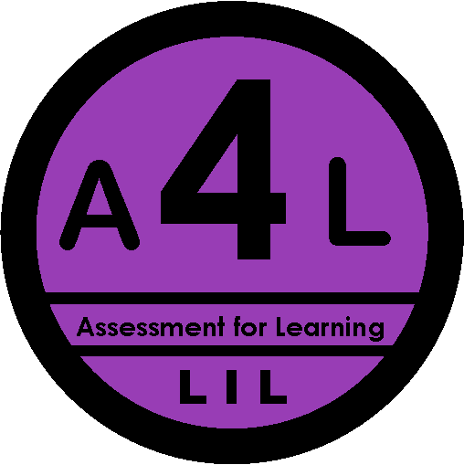

Analytical and evaluative skills.

Resources:
Online resources: travel information and google pictures

