

Improving Supply chain Performance
Module – Procurement and Supply Chain Management (ACEA7011) Lecturer – Andrew Thorn
Shaun Farthing - 1708439

Contents
Abstract 2
Introduction 3
Supply chain management 3
FMEA introduction 4
FMEA tables 5
FMEA Analysis 7
Steps to make the supply chain more resilient. 11
Diverse suppliers. 11
Multiple transportation modes. 11
Inventory management. 12
Strong supplier relationships. 12
Contingency planning. 12
Investment in technology. 12
Conclusions and suggestions for further work/research 13
Bibliography 14

Table of figures
Figure 1 - Basic supply chain (Chopra & Meindl, 2001) 3
Figure 2 - Severity rating scale 5
Figure 3 - Occurrence rating scale 6
Figure 4 - Detection rating scale 6
Figure 5 - FMEA 10

Abstract
This paper investigates failure mode and effect analysis (FMEA) and its use in the electrical wire supply chain.
Firstly, an overview of supply chain and supply chain management is detailed. This is followed by a brief overview of FMEA, including a history of where FMEA was first deployed, the steps required when carrying out an FMEA, followed by the desired outputs of the FMEA. The actions required because of the outputs are then discussed.
Following the introduction, an overview of the severity, occurrence and detection tables are listed. These list the failure degree rankings, effects, and criteria for each ranking.
The paper then documents an FMEA of an electrical wire manufacturer and distributor. This includes a full FMEA including corrective actions and the department responsible for fulfilling those actions.
The steps that would ensure a more resilient supply chain are then discussed. Although there are many other steps of the supply chain that could be improved upon to increase resilience, the six detailed within this paper are particularly relevant to the electrical wire supply chain.
Finally, the paper ends with a conclusion and potential future research opportunities.

Introduction

Supply chain management
A supply chain is a network of organisations that are involved through upstream and downstream linkages contributing to the different processes that are involved in the production of value in the manufacturing of goods or the provision of services (Habib, 2011)
A basic supply chain is picture below.
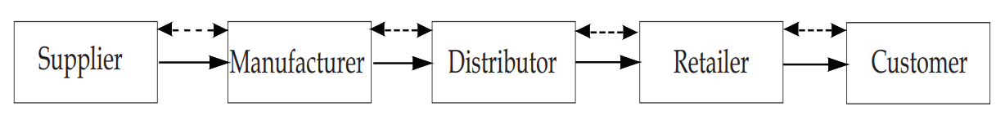
Figure 1 - Basic supply chain (Chopra & Meindl, 2001)

Supply chain management (SCM) is the process of managing the flow of these materials, goods, services and information through the various suppliers, manufacturers, distributors, retailers, and customers to ensure the production and delivery of products and services to the end user.
The primary focus of SCM is to ensure that the process from raw material through to the delivery of the finished product or service to the customer is efficient, cost effective and to the customers satisfaction.
SCM involves multiple activities, these include procurement, manufacturing, production planning, inventory management, logistics, transportation, and distribution. The process begins with determining the demand for the product/ service by the customer and ends with the delivery of the finished product or service. SCM amalgamates all these elements to ensure the right products are provided to the right customers at the right price at the right time (Lee, 2004)
Effective SCM requires close collaborations with all stakeholders. It also requires data analytics and other tools to optimise the supply chain and improve visibility, efficiency, and responsiveness. With proper SCM, businesses can reduce costs, increase revenue, improve customer satisfaction, and gain competitive advantage within their operating market. FMEA is one of the tools that can be used to assist with effective supply chain management (Mentzer, et al., 2008).

FMEA introduction
FMEA is Failure Mode and Effects analysis, it is a structured and systematic method of identifying and preventing potential issues or failures within a system or process before they occur. FMEA was introduced in the late 1940s by the US military, in the 1960s, FMEA was used by the aerospace industry as a design methodology for reliability and safety requirements and in the 1970s, Ford motor company introduced FMEA to the automotive sector for safety and regulatory consideration (Sharma & Srivastava, 2018). FMEA is now widely used across multiple sectors including manufacturing, healthcare, and engineering to proactively identify and address potential failures with processes and products.
FMEA consists of the following steps:
- Identifying the system or process to be analysed.
- Breaking down the system or process into its individual components or steps.
- Identify potential failure modes for each component or step.
- Assessing the severity, frequency occurrence, and detection probability of each failure mode.
- Assigning a risk priority number (RPN) to each failure mode based on the severity, frequency/ occurrence, and detection scores.
- Identify actions that can be taken to reduce the RPN for each failure mode.
- Implement the recommended actions and re-evaluate the RPN for each failure mode.
An FMEA uses three criteria to assess a problem, 1, the severity of the effect on the customer, 2, the frequency in which the problem is likely to occur, and 3, how easily the problem can be detected. Each criterion is scored between 1 and 10, 1 being low and 10 being high. When all three elements have been scored, the risk priority number (RPN) can be calculated. The formula for calculating the RPN is, RPN = severity x occurrence x detection (Dendera-Gruszka & Kulińska, 2020)
There is no definitive threshold for determining which RPN output requires most attention, this requires further input from other elements, such as whether the problem is safety, legal or regulatory related. A starting point for prioritising corrective actions could be to review the Pareto principle. The Pareto principle states that 80% of issues are caused by 20% of the problems, which are the vital few (Forrest, 2010).
The actions to be implemented to reduce the RPN will be specific to each process, but typically to reduce the severity, a more robust product or process could be implemented to be able to be able to tolerate and withstand a failure without effecting the end user. To reduce the chance of occurrence, steps can be taken to understand the root cause of the issue and eliminating it, this could be achieved through root cause analysis and implementing control through training or reliable equipment and processes. Detecting the failure before it causes a problem to the end user may be achieved by introducing more quality control procedures, implementing more frequent inspections, and improving communications between the different teams proving the product or service (Hartwell, 2022)

FMEA tables
The three elements, severity, occurrence, and detection used to determine the risk priority number are shown in the tables below. The numerical values assigned to each element dependent on the severity of failure, probability of occurrence and likelihood of detection respectively are detailed (Díaz & Soares, 2020).
Figure 2 - Severity rating scale

Figure 3 - Occurrence rating scale

Figure 4 - Detection rating scale

FMEA Analysis
This paper and FMEA looks at the global supply chain of electrical cable. International supply chains can be vulnerable for many reasons. Some of the more prevalent reasons are.
- Transportation disruption: Supply chains, particularly international are heavily reliant on transportation of varying types. Disruption of these systems through natural disasters, geopolitical conflict and pandemics can cause delays and stoppages of the movement of goods.
- Unstable political and economical conditions: Unstable politics and economic downturns can cause disruption in supply chains though import/ export restrictions, currency fluctuations and changes in trade policies.
- Single supplier dependency: If a business relies too heavily on a single supplier, any disruption to that supplier will have a knock-on effect on the entire supply chain.
- Cybersecurity threats: With the increase of digitalisation and automation of processes, the risk of cyber attacks is a growing concern.
- Environmental risk: Extreme weather, natural disaster and resource scarcity can be a disruption for supply chains, this is particularly difficult where suppliers must rely on certain regions for a particular product.
The below FMEA looks at the failure modes and effects of the supply chain of electrical cable.

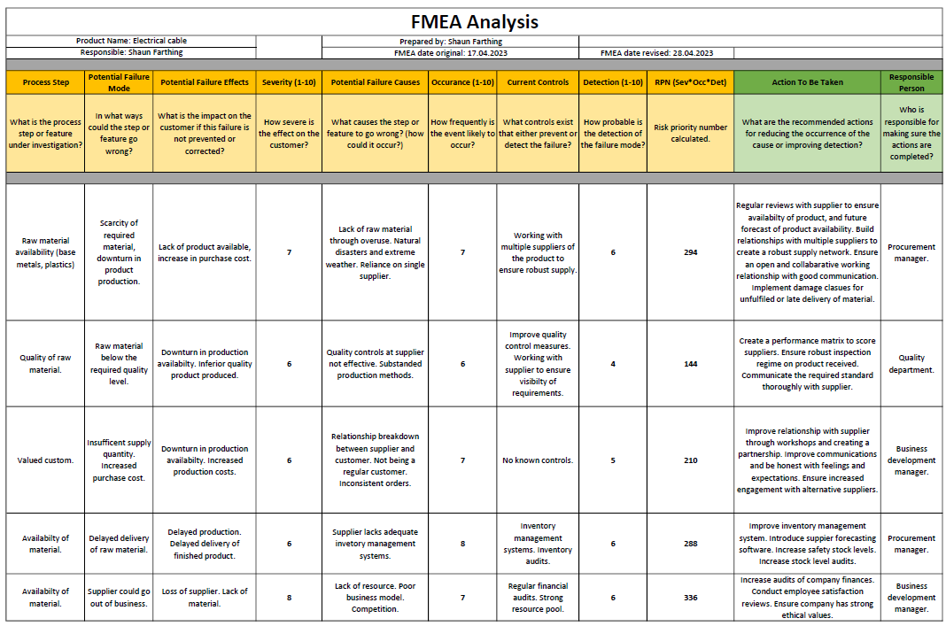
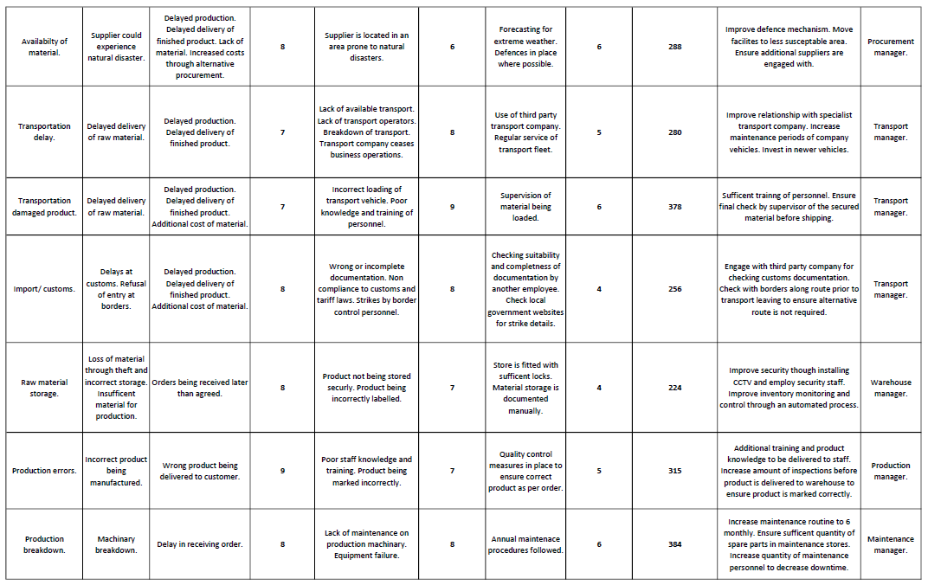
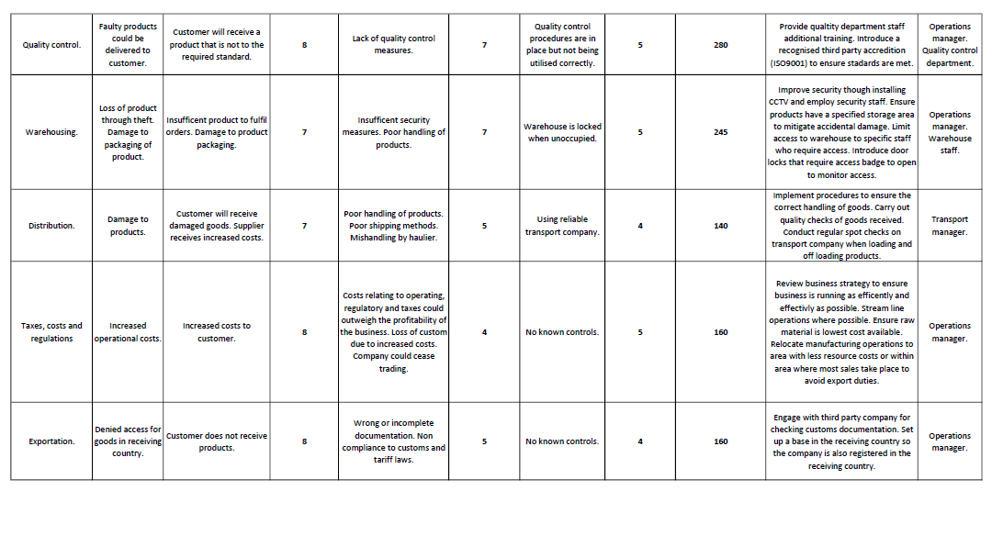
Figure 5 - FMEA

Steps to make the supply chain more resilient.
The supply chain is a fundamental part of the running of a business. Without an efficient and effective supply chain, businesses will not operate. The importance of having a trusted supply chain is key to successful operations. The steps detailed below help create a more resilient supply chain regarding the electrical wire supply chain.

Diverse suppliers.
The use of diverse suppliers reduces the risk of disruption of supply. The primary supplier may encounter a natural disaster, labour strikes or financial issues and may not be able to deliver on the agreed material. Having a diverse supplier base ensures continuity of supply should any of the above happen. In the case of the electrical wire industry, raw materials, particularly base metals are mined, this industry is particularly challenging, having options of suppliers ensures that production can continue through multiple supply routes.
Having a diverse supplier base also ensures that the material the company is purchasing is at a competitive price. A comparison can be made considering the cost and lead time for the material to be supplied. This is particularly important in the case of copper and aluminium, the cost of these products changes frequently.
Including multiple suppliers in the procurement process also provides insight into innovative products. Although, within the electrical wire industry, copper and aluminium are industry standards for conductor material, the insulation parts of the cable are developing. Purchasing products with better fire rating properties and less environmentally impacting products ensure that the company is trading ethically and is environmentally conscious.

Multiple transportation modes.
Multiple transportation modes offer many benefits. Cost savings can be achieved by evaluating which method of transport is most suitable. As an example, with electrical wire transportation, it may be more cost effective to fill a container on a ship rather than use multiple road lorries. This may improve the delivery time, reduce cost and be more environmentally beneficial. This may not always be the case; transport will require review dependant on where the product may need to be sent. Often, multiple transportation modes may be used during a delivery.
Utilising various modes of transport also reduces the risk of reliance on one mode of transport. Weather, labour strikes or other disruptions may be an issue with a particular transport mode but not on another, having the flexibility to choose another will improve efficiency and reduce the likelihood of delayed deliveries.
The electrical wire industry from raw material to finished product spans the globe, having the availability of a diverse transportation network is imperative for effective and efficient operations.

Inventory management.
Inventory management is an important aspect of supply chain management. Holding enough stock to ensure customer demands can be met whilst not holding excessive stock levels that ties up capital and creates storage costs is a balance. This is particularly important in the electrical wire supply chain, as with larger cables, the costs can be quite extensive. Only carrying required stock levels also reduces the storage costs, handling costs and insurances.
Although, having stock available allows the company to be able to react to customer needs, being reactive when they require the product is important. This allows the customer to build confidence in the company and increase the chances of return custom. Stockouts are also less likely to occur when inventory is managed effectively. Having an accurate picture of available product also allows for better forecasting and reduces bottlenecks in the manufacturing and distribution processes.

Strong supplier relationships.
A strong relationship with suppliers is critical to the business. A strong supplier relationship ensures consistency of supply, the company can rely on the supplier to provide the goods and service required, at the right time and to the correct standard. This aids in the reliability of the companies’ operations.
Building a strong relationship with suppliers also ensures quality standards are consistently being met though feedback and review. Having this element consistent reduces the likelihood of defective and substandard products or services, which reduces the chances of downtime, revenue loss, and penalties.
Working with specific suppliers and placing most orders with one supplier strengthens the opportunity to negotiate costs of material. This can decrease manufacturing costs and increase the potential profit. This will give the business a competitive market advantage. This is particularly true within the electrical wire sector as the raw material costs tend to fluctuate quite rapidly.

Contingency planning.
Contingency planning is useful for highlighting potential risks in the supply chain and creating strategies to overcome these disruptions. Creating a contingency plan allows businesses to overcome issues in raw material supply, manufacturing, storge and distribution by being aware of other options if these issues were to arise. Having a contingency plan allows the business to avoid delays and fulfil customer expectations, therefore maintaining reputation. Having a contingency plan also helps with avoiding financial loss through having to procure additional material or receiving penalties through loss of product delivery. Raw material supply for electrical wire manufacture is a difficult process, a contingency plan is vital to ensure no delay in production.

Investment in technology.
Investing in technology is a crucial part of the supply chain, technology allows for processes to be improved for efficiency and productivity. The electrical wire making process can be automated to allow for increased output, less chance of error, and a faster safer, and more reliable manufacturing process.
Improved technology can also aid with raw material order and product delivery. Having real time tracking and up to date material and product levels can help in optimising inventory levels, optimise logistics and reduce operating costs. This will give visibility to the business requirements.
Utilising available technology can help streamline a business, reduce operating costs, and create a more reliable service. This will in turn improve customer experience and satisfaction.

Conclusions and suggestions for further work/research
The supply chain and its management are ever-evolving fields. The key areas requiring further work and research are:
- Sustainability and ethical practices. There is more focus than ever on sustainability and social and environmental responsibility. The supply chain must evolve in a way where harm to the environment is limited, waste must be reduced and recycled, and ethical practices must be developed and implemented. This area of the supply chain is of particular importance to ensure the longevity of natural resources.

- Digitalisation. Although there is risk through cyber security, the future of efficient supply chains is utilising technology. Artificial intelligence, advanced analytics and IoT are key drivers to the future supply chains. Further research into the utilisation of these technologies will create an optimised, efficient, reliable, and robust supply chain.

- Circular economy. The circular economy model states that waste should be minimised, and products should be reused and recycled. The supply chains of the future must adapt this approach and develop systems that are durable and recycles and reduces waste through the network. Further research into this field will be beneficial for supply chains.

- Automated transportation. With the limitations around driving hours for hauliers. Automated transportation could be a worthy avenue of research. Automation of transportation could improve delivery time and reduce the risk of accidents through tiredness and other human factors.

I feel that the points documented above are some of the most important factors for the future of supply chains.

Bibliography
Chopra, S. & Meindl, P., 2001. Supply Chain Management: Strategy, Planning, and Operation. 5th ed. New Jersey: Prentice Hall.
Dendera-Gruszka, M. & Kulińska, E., 2020. Supply Chain FMEA Risk Analysis for the Heavy Industry Sector. In: C. Capinha, J. Rocha & S. Oliveira, eds. Risk Management and Assessment. London: Intech, pp. 27-40.
Díaz, H. & Soares, C. G., 2020. Failure mode identification and effect analysis of offshore wind turbines and substations. In: G. S. Carlos, ed. Developments in Renewable Energies Offshore. London: Taylor and Francis, pp. 444-460.
Forrest, G., 2010. isixsigma. [Online]
Available at: https://www.isixsigma.com/uncategorized/fmea-quick-guide/
[Accessed 23 April 2023].
Habib, M., 2011. Supply Chain Management (SCM): Theory and Evolution. 1st ed. Rijeka: Intech.
Hartwell, J., 2022. iQA system. [Online]
Available at: https://www.iqasystem.com/news/risk-priority-number/
[Accessed 29 April 2023].
Lee, H. L., 2004. Harvard Business Review. [Online]
Available at: https://hbr.org/2004/10/the-triple-a-supply-chain
[Accessed 29 April 2023].
Mentzer, J. T., Stank, T. P. & Esper, T. L., 2008. SUPPLY CHAIN MANAGEMENT AND ITS RELATIONSHIP TO LOGISTICS, MARKETING, PRODUCTION, AND OPERATIONS MANAGEMENT. Journal of Business Logistics, 29(1), pp. 31-VII.
Sharma, K. D. & Srivastava, S., 2018. Failure Mode and Effect Analysis (FMEA) Implementation: A Literature Review. Journal of Advanced Research in Aeronautics and Space Science, 5(1&2), pp. 1-17.

