Ataur Rahman 1806512

Understanding and Engaging in the Customer Experience

Executive Summary
This report looks at the aspects of Customer Relationship Management (CRM) in references to how it is impacted upon by the policies of Sustainability, Ethics and Quality Management. These policies are examined to help the supermarket ASDA to identify and improve its CRM model as well as its performance and compare them to its two nearest rivals.

Contents
Executive Summary 1
Introduction 2
Findings 3
Customer Relationship Management 3
Ethics 4
Sustainability 4
Quality systems 5
Conclusion 7
Recommendations 8
The recommendations need to be based around the report topic areas of : 8
Appendices 9
References 12
Acknowledgements 14

Introduction
This report is part of an assignment set by the University of Wales Trinity Saint David for the BA Management and Leadership course in February 2020. The report aims to highlight how by understanding and engaging Customer Experience and establishing a well-founded Customer Relationship Management policy, the supermarket organisation Asda can improve its customer loyalty and performance. Customer Relationship Management (CRM) is a rudimentary model that operates on the root of the idea that utilises the consumer and marketing mixture to form a relationship (Kotler, 2003).
To achieve this CRM policies will be analysed to seek how the UK supermarket ASDA has managed its strategies on Ethics and Sustainability as well as examining ASDA’s Quality Management System and seek improvements in its CRM policy. It is essential to study ASDA’s policies on these subjects as well as compare them with two of its most competitive rivals to get a better idea on how ASDA can expand its CRM strategy thus lead it to help increase its sales as well as improve its brand reputation.
Ethically-oriented practices by supermarkets can have a huge difference in customer loyalty as well as growth of customer preference for the supermarket brand, motivation in spending more and not oppose an increase in product prices (Bhattacharya et al., 2020, but also lead to a much better general sales for the organisation (Kang et al. 2016). Therefore it is crucial for supermarkets today to have an ethics policy that can help their CRM strategy.
Consumers nowadays are progressively intent in purchasing green or sustainable merchandises, practicing responsible spending and getting much more involved with green issues (Hu et al., 2019). These vital components of sustainability are critical in retailer policies for consumer responsible purchasing of environmentally friendly products, schemes incorporating both message and well thought-out deals on greener products to expand its loyal customer base as well as acclimatise them on their conduct towards the environment (Mintel, 2018; Young et al., 2017).
This report will provide an insight into how strategies in ethics and sustainability aid the CRM policy within one of the most competitive markets in the UK. The report will critically examine ‘customer experience’ of ASDA in reference to the above subjects to seek appropriate recommendations on improving Asda’s outlook in respect to its competitors.

Findings

Customer Relationship Management
The achievement and endurance of business is highly contingent on continuing relationship of consumers and their loyalty (Tait and Roberts-Lombard, 2018). Keeping customers happy and satisfied will generate more profits as well as improve brand image and reputation of the organisation as these customers will act as references to the organisation’s products (Kotler, 2003). There are many definitions of Customer Relationship Management (CRM), one such description described from a different point of view, by (Parvatiyar and Sheth, 2004) contains the four elements of CMR defined as:
"a comprehensive strategy and process of acquiring, retaining, and partnering with selective customers to create superior value for the company and the customers".
CRM is a strategy utilised by organisations to improve their market aspiration using customer information to gain loyalty as a starting point. Appendix Table 1 shows the three most popular CMR models used by organisations to achieve a sustainable working system.
“Creating the right mix of investments for effective use of limited resources while providing the maximum business benefit is the ultimate challenge for business organisations” (Gabas-Varini, 2003).
By analysing customer insights organisations can grow and understand the benefit of individual customer relationship and thereby enabling them to segment customers into “portfolios of relationships” that they can then better target for marketing purpose (Johnson & Selnes, 2004). Extending throughout a company CRM strategy is planned to increase marketing to improve revenue and identify their best customers to win them over by fulfilling their demands for future retention (Frow and Payne, 2009; Heller, 2004). Furthermore Bielski (2007) believes that data mining customers can lead to recognising consumer spending behaviour that can help to design a plan of action targeted marketing strategy that would encourage additional sales.
Although the initial instalment and maintenance of CRM strategy can be extremely high (Nguyen, 2007), it is has been shown that using CRM with technology to quickly process customer data, an organisation can ease customer concerns much more quickly and efficiently as well as manage additional customers all at once (Marlin, 2003). Furthermore there is evidence to suggest that revenue is increased as CRM assist better marketing opportunities nurturing customers to spend more than they would have initially if no CRM strategy was implemented in the organisation (Zineldin, 2006). All this is only possible if there is well-defined exchange among business and consumers since customers will not tolerate dishonest marketing (Liljander and Roos, 2002). Also it is very important to keep the CRM strategy continuously updated throughout the customer relationship or this could affect their retention rate as the customer may feel overlooked (Mattlia, 2004).
Lastly according to Fletcher (2003) many observers have stated that CRM policies may likelihood intrude upon consumer privacy rights. Since CRM requires the collection of customer information such as address, telephone number and even the monitoring of their shopping behaviour, this can be construed as a violation of the consumer’s private life. With this in mind corporations must balance their CRM strategies with their ethical policy as this can have a detrimental effect on the very relationships they are trying to secure.
As a result of heavy competition in the UK supermarket sector (see Appendix Fig.1) the ‘Big Four’ traditional supermarket brands (Tesco, Sainsbury, ASDA and Morrison) have been squeezed by the pricing strategies and expanding product range of the German discount brands (Aldi and Lidl) in recent times, resulting in a greater emphasis on CRM policy (Sturley et al., 2017; Kumar, 2018). These policies have now lead to the gathering of customer information from a wide variety of source, not only collecting information from store-based loyalty cards but also information gathered from till transaction and as well as social media (He et al., 2015).

ASDA supermarket in the UK has always rejected customer loyalty cards instead concentrating on pricing strategy and as a result it had for many years fallen behind both Tesco and Sainsbury on the development of a CRM strategy. This gave Tesco and Sainsbury a head start in the development of CRM policy as they both utilised the immense knowledge gained from their loyalty card programs. Information about consumers is a major advantage, fuelling their capabilities for business achievement and believing that by gaining sufficient consumer knowledge is a resource that will increase with time and aid the companies the ability to constantly improve and modernise (Gupta et al., 2000).
Tesco’s CRM policy was primarily established from the data mining of its loyalty card “Tesco Club Card”. This card was launched in 1995 and at the time helped Tesco to overtake Sainsbury to become UK’s largest supermarket retailer. Sainsbury has one of the largest loyalty card, its “Nectar Card” established 2002 that provides it with a wealth of customer information that helps to build its CRM system. Asda uses the money saved from not developing a loyalty program towards it main policy of price reductions, but has managed to use social media and till transaction along with its scan and go system to develop its CRM policy. It also in 2011 established what it calls “Expert Panel” a group of 20,000 regular customers that it relates using questionnaires and other communication channels to get a wealth of information.

Ethics
Ethics can have many definitions and meanings in general, but this report will focus on organisational ethics in the context of corporate social responsibility (CSR). The connection between ethics and social responsibility is fundamental in understanding the relationships of customer to an organisation’s behaviour (Kumar & Reinartz, 2016). At a fundamental level ethics regulates the behaviour, values and principles of basic human actions concerning whether it is acceptable or unacceptable within a society, therefore in organisational circumstances ethics sets ideals to what is wrong or right in their routine and judgement (Sexty, 2011). It deals with core values that share the organisation’s culture and forms its behaviour regarding accountability towards the external environment.
Over the years supermarkets have made life much more comfortable for consumers, bringing convenience as well as cheaper pricing but at a cost to their ethical behaviour. For example the supermarket industry have been accused of environmental damage which consists of excessive use of energy, water, waste etc. Even pollution and traffic jams due to extra traffic generated due to their warehouse distribution facilities (Shaw, 2010).
As corporations endeavour to generate and grow lasting relationships with their consumers and retain satisfied customers, it is very important to strive for ethical behaviour and high moral values all together. As well as consumers, societies, are becoming more challenging, well-informed, and vigilant, advancing ethical predicaments for businesses. This has led to corporate social responsibility (CSR) positively influencing relationships between organisations and consumers making investment in CSR well worth it, as it shows consumers that the organisation is dedicated to its customers and offers high quality products and services (Bhattacharya et al., 2020).
Tesco, Sainsbury and Asda are all members of the Ethical Trading Initiative (ETI), which monitors member companies’ supply chains in accordance with an ethical code. Although both Tesco and Sainsbury have in the past many ethical issues, Asda, and its proprietor Walmart, have only recently been the attention of numerous news exposés, from slavery in the Walmart prawn supply chain, to accusations of discrimination by Asda employees (Ethical Consumer, 2019). In recent years ASDA was named the worst supermarket for the treatment of its suppliers by the industry watchdog (Butler, 2017) as well as only lately losing a High Court case on gender pay equality (Davies, 2019).
Ethical matters endure at the centre of relationship marketing, as the building of longstanding consumer relationships cannot be prolonged without an honest unease for ethics (Murphy et al., 2007). This implies that it is fundamental for organisations to have good ethics to maintain and expand their CRM policy as well as have good continued CSR.

Sustainability
There are many definitions of sustainability (Johnston et al., 2007), but the one most usually used comes from the Brundtland Commission and defines sustainability as a “development that meets the needs of the present without compromising the ability of future generations to meet their own needs” (WCED 1987). Therefore applying this to customer relationship management represents forming and preserving longstanding lucrative consumer contacts on the basis of economic, ecological and social objectives. This means sustainability-oriented CRM can be utilised to expand and retain consumers that have an appreciation for community sustainability issues. Having to understand customers at such a level requires a strong and effective CRM system in place and organisations have to follow a high sustainability policy for them to be able to outperform their rivals in terms of lasting business performance (Eccles et al., 2014).
Increase concerns for environmental issues such as depletion of natural resources, poverty and damage to the environment have preceded customers to become more aware of the impact of some organisational policies having on future sustainability (Silvius and Schipper 2010). This has led to corporations having to counter these events by acquiring ways to deliberate productivity with conservational and social accountability (Graham and Havlick 1999). All three supermarkets ASDA, Tesco and Sainsbury take sustainability policy currently very seriously, enough to include in their annual reports.

Triple Bottom Line
The triple bottom line (TBL) is a framework that businesses declare attention on social and environmental concerns just as they do on profits. This differs from traditional frameworks as it includes environmental and social dimensions (Henriques and Richardson, 2004). The TBL dimensions are also frequently known as the three Ps (3Ps): people, planet and profits. Both Tesco and Sainsbury along with ASDA have all incorporated sustainability into their approach to measuring their profits.
One example of TBL is ASDA’s sustainability policy in dealing with “food waste”, Appendices Fig.2 shows the issues that can impact food waste. It is suggested that the best way to deal with this is by engaging and partnering with the consumers using communication channels through their CRM system as well as social media thus influencing their customer’s behaviour towards food waste (Young et al., 2017). This also points to how CRM systems can be improved by having sustainability policies that consumers appreciate (Müller, 2014). Other examples of Asda’s TBL is that they will continue to reduce unnecessary plastic packaging, building on the 6,500 tonnes removed in 2018/19 (Babbs, 2019).

Quality systems
In the last ten years quality management has been noted by many people as becoming a reform in the theory of organisational management (Foley, 2004). Three very popular ideas of quality models that have been put forward are:
- Total Quality Management (TQM) – occasionally defined as a “continuously evolving management system consisting of values, methodologies and tools, the aim of which is to increase external and internal customer satisfaction with a reduced amount of resources” (Hellsten and Klefsjo, 2000).

Figure 1 TQM
6 Cs of
TQM

- Six Sigma – is defined as a “business process that allows companies to drastically improve their bottom line by designing and monitoring everyday business activities in ways that minimise waste and resources while increasing customer satisfaction by some of its proponents” (Magnusson et al., 2003).

Figure 2 Six Sigma

- Lean – is defined as a “systematic approach to identifying and eliminating waste through continuous improvement, flowing the product at the pull of the customer in pursuit of perfection” (NIST, 2000).

Figure 3 Lean

Although the definitions of TQM, six sigma and lean vary, the purpose of the varied ideas appears to be alike; basically increase minimising waste and resources at the same time refining customer satisfaction and production outcomes.
TQM is often blamed for being confusing and old and therefore mostly been replaced by six sigma and lean in today’s organisations to produce significant development in the discipline of quality management. Recently many researchers have agreed upon combining lean and six sigma stating that this helps new industries that need to thrive in a fast moving world that does not accept mistakes and defects but wants quick solutions to quality manufacturing practices (George et al., 2004).
ASDA as well as both Tesco and Sainsbury employ quality control managers at all levels of production and services using both combination of Lean Six Sigma quality models to establish a consistent quality control across all their services. To do this ASDA especially recently marketed a new cloud-based QmS (quality management system) to improve output, efficiency as well as inspire modernisation across its private label range. QmS was developed by Solutions 4 Retail Brands (S4RB) and enables the observing of product quality and performance (Lemmon, 2016). Employees must have a working familiarity of the stock and demands of each store. Observing inventory and acquisitions are categorically vital. Consumers are never pleased to discover their preferred produce out of stock. Customer loyalty is crucial – so the quality control of your stock and store is absolutely imperative. If consumers have a bad issue due to quality control they will tend to go to your competitor resulting in a loss of a loyal customer which will impact badly on your CRM policy.

Conclusion
By following a pricing strategy ASDA supermarket has been squeezed by the quality and CRM policies of both Tesco and Sainsbury. Although they have fallen behind both Tesco and Sainsbury in terms of their attitudes towards some of the mentioned policies in this report, they none the least recently have made great strides to catch up to their nearest rival Sainsbury and sometime even overtaking them in sales.
While Sainsbury focuses on quality ASDA has focused on value, this has given ASDA the challenge of improving its quality so that it can have the winning formula of both quality and value. As can be seen from this report ASDA has much improved its sustainability and ethics policies recently, where its lacking is having a robust CRM frame work in place so it can match both Tesco and Sainsbury who have both a strong loyalty program advantage that enormously helps to drive their CRM policy.
Regardless of the reasons why ASDA should whole heartedly implements CRM, through a CRM policy corporations like ASDA can gain an enormous advantage in consumer marketing. ASDA still must increase its quality perception, and even though it is labouring hard to attain this, much persists to be still achieved. For the time being, with price continuing to be the principal focus, ASDA is still clearly evolving its success. However, this is only one campaign, to gain advantage in the competitive war ASDA must stay attentive on improving quality, chiefly if it is to retain its newly found consumers once their spending capacity permits them to return to their primary preferred supermarket.

Recommendations
Using the SWOT analysis shown on appendices fig.3 as a guide the following recommendation has been concluded from this report and will help ASDA to improve its CRM policy as well as its performance.

1. It is very important for ASDA to completely observe with the ETI Code and other such regulations pursuing improved conducts for suppliers and workers, not just paying lip service to them. Also, ASDA’s low price philosophy must be scrutinized closely so as not to sacrifice quality.

2. They need to take up more environmental accountabilities in decreasing the impact of water usage; increase recycling and waste managements, etc.

3. They need to change their policy towards gender pay differential and be more transparent to all their employees and consumers on the matter of pay as well as customer data.

Appendices

Fig.1 (Grocery Market Share - Kantar, 2020)
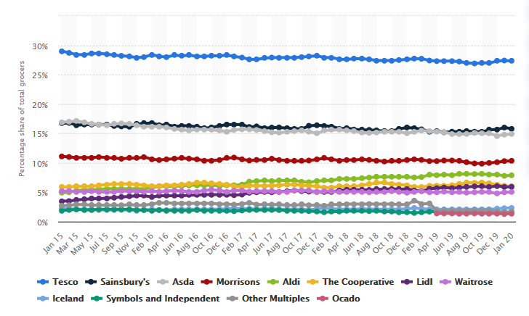

Fig.2 Influences on food waste (Quested et al., p. 45)
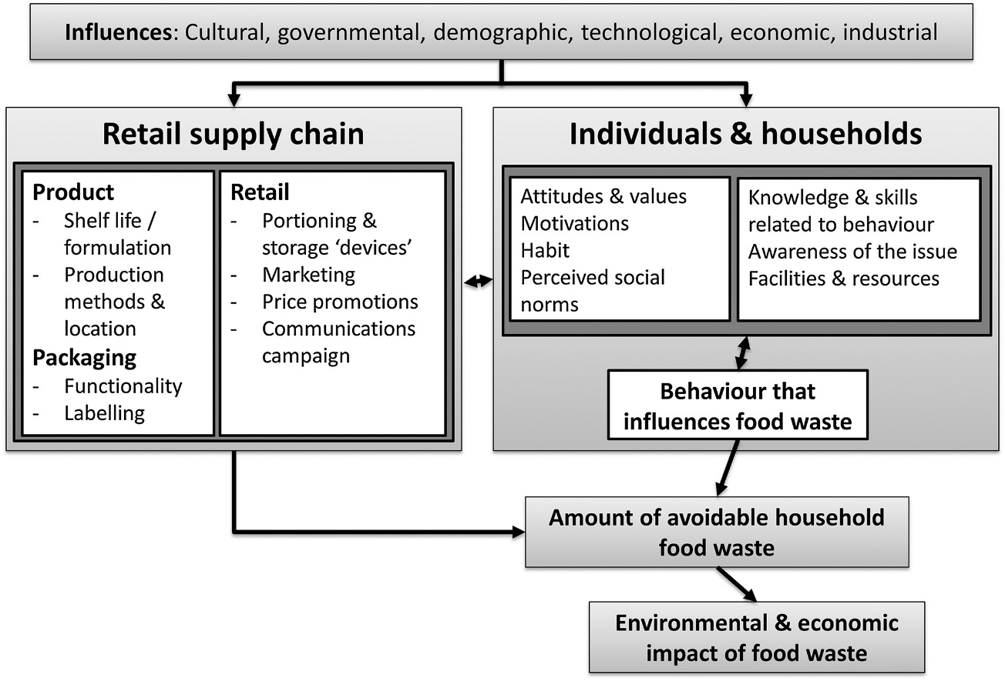
Table 1 Customer Relationship Management (CRM) (Schneider, 2016)
IDIC Model

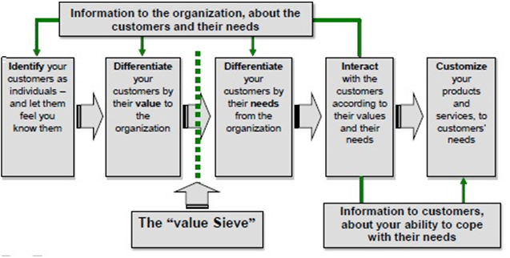
QCI MODEL

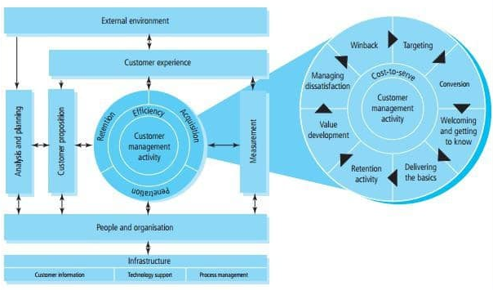
CRM Value Chain Model

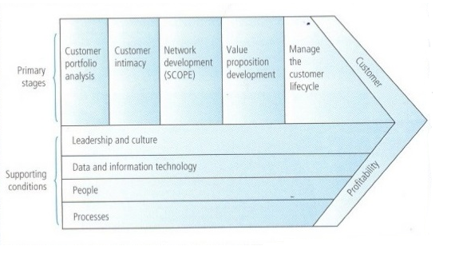

Fig, 3 ASDA SWOT analysis

 | BENEFICIAL | DETRIMENTAL
I  N  T  E  R  N  A  L | Strengths (Current)  - ASDA is the third largest retailer in the UK  - It has a strong management hired from big names such as Carrefour  - It has many stores all over the UK  - It was declared Retailer of the Year 2019. It was also crowned the Chilled Retailer of the Year, Bakery Retailer of the Year, and Drinks Retailer of the Year 2019  - It is owned by Walmart, the world’s largest retailer | Weaknesses (Current)  - ASDA has positioning problems weather to be cheap at the same time have high quality products.  - It has suffered some scandals engaged with price fixing as well as bad treatment of its suppliers  - It has no loyalty programs
E  X  T  E  R  N  A  L | Opportunities (Future)  - As more shoppers use online shopping it can expand this enormously as it is just the beginning  - The business can grow further by opening new stores and taking over smaller companies such as it did with Focus DIY  - Explore expansion beyond the UK | Threats (Future)  - ASDA faces a number of competitors in the UK. Tesco is the market leader, while Sainsbury’s is ASDA’s nearest rival. It is also squeezed by the discounters Aldi and Lidl

References
Bhattacharya, Abhi & Good, Valerie & Sardashti, Hanieh & Peloza, John. (2020). Beyond Warm Glow: The Risk-Mitigating Effect of Corporate Social Responsibility (CSR). Journal of Business Ethics.
Bielski, L (2007). The art and craft of cross-selling. American Bankers Association. Vol. 99, Iss. 9, Pg.46
Fletcher, K. (2003). Consumer power and privacy: The changing nature of CRM. International Journal of Advertising. Vol. 22, Iss. 2, Pg. 249
Frow, P.E. and Payne, A.F. (2009) ‘Customer relationship management: a strategic perspective’, Journal of Business Market Management, Vol. 3, No. 1, pp.7–27
Gupta, B., Lakshmi, S.I. and Aronson, J.E. (2000) ‘Knowledge management: Practices and challenges’, Industrial Management & Data Systems, Vol. 100, No. 1, 17–21.
He, W., Shen, J., Tian, X., Li, Y., Akula, V., Yan, G. and Tao, R., 2015. Gaining competitive intelligence from social media data. Industrial Management & Data Systems, 115(9), pp.1622-1636.
Heller (2004), "Keep asking the customer: Dagbladet Børsen increase customer loyalty through relationship marketing", Strategic Direction, Vol. 20 No. 9, pp. 24-26
Hu, J., Liu, Y.L., Yuen, T.W.W., Lim, M.K. and Hu, J., 2019. Do green practices really attract customers? The sharing economy from the sustainable supply chain management perspective. Resources, Conservation and Recycling, 149, pp.177-187.
Johnson, M. D., & Selnes, F. (2004). Customer portfolio management: Toward a dynamic theory of exchange relationships. Journal of Marketing, 68(2), 1–17.
Kang, C., Germann, F., & Grewal, R. (2016). Washing away your sins? corporate social responsibility, corporate social irresponsibility, and ﬁrm performance. Journal of Marketing, 80(2), 59–79.
Kantarworldpanel.com. 2020. Grocery Market Share - Kantar. [online] Available at: <https://www.kantarworldpanel.com/en/grocery-market-share/great-britain/snapshot> [Accessed 20 March 2020].
Kotler, P. 2003. Marketing management (7th Ed.). Englewood Cliffs, Prentice-Hall, 2003
Kumar, S., 2018. Food and Grocery Retail Analytics Solutions -2018 – The New Age Realities | Manthan. [online] Manthan.com. Available at: <https://www.manthan.com/blogs/food-and-grocery-analytics-in-2018-the-new-age-realities/> [Accessed 12 March 2020].
Kumar, V., & Reinartz, W. (2016). Creating enduring customer value. Journal of Marketing, 80(6), 36–68.
Liljander, V & Roos, I (2002) Customer-relationship levels: from spurious to true relationships. Journal of Service Marketing. Vol. 16, Iss. 7, Pg. 593-614
Marlin, S. (2003) Cost reductions lead IT priorities. Bank Systems and Technology. Vol. 40, Iss.2, Pg.10
Mattlia, A.S. (2004) The impact of service failures on customer loyalty: The moderating of affective commitment. International Journal of Service Industry Management. Vol. 15, Iss. 2, Pg.134-149
Mintel, 2018. Europe Consumer Trend. Available from: (Accessed on 07, March 2019). http://reports.mintel.com/static/trends/documents/European_Consumer_Trends.pdf.
Murphy, P.E., Laczniak, G.R. and Wood, G. (2007), “An ethical basis for relationship marketing: a virtue ethics perspective”, European Journal of Marketing, Vol. 41 Nos 1/2, pp. 37-57.
Nguyen, T.H., Sherif, J & Newby, M. (2007). Strategies for successful CRM implementation. Information Management & Computer Security Information Management. Vol. 15, Iss. 2, Pg. 102-115
Schneider, D., 2016. CRM Models (Customer Relationship Management Model) - Ninjaoutreach. [online] NinjaOutreach. Available at: <https://ninjaoutreach.com/crm-models/> [Accessed 13 March 2020].
Sexty, R. (2011). Canadian business and society: Ethics and responsibilities (2ndEd.). Toronto. McGraw-Hill Ryerson.
Shaw, W.H., 2010. Cengage Advantage Books: Business Ethics: A Textbook with Cases 7th ed., Belmont, CA: Wadsworth Pub.
Sturley, C., Newing, A. and Heppenstall, A., 2017. Evaluating the potential of agent-based modelling to capture consumer grocery retail store choice behaviours. The International Review of Retail, Distribution and Consumer Research, 28(1), pp.27-46.
Young, C., Russell, S., Robinson, C. and Chintakayala, P. (2017). Sustainable Retailing – Influencing Consumer Behaviour on Food Waste. Business Strategy and the Environment, 27(1), pp.1-15.
Zineldin, M (2006). The royalty of loyalty: CRM, quality and retention. Journal of Consumer Marketing. Vol. 23, Iss. 7, Pg. 430-437
Blowfield, M., and A. Murray. 2011. Corporate responsibility. 2nd ed. Oxford: Oxford University Press
Ward, H. 2012. ISO 26000 and global governance for Sustainable Development. London: IIED
Fleming, P., and M. T. Jones. 2013. The end of Corporate Social Responsibility: Crisis and critique. London: Sage
Butler, S., 2017. Asda Is Named Worst Supermarket In Treatment Of Suppliers. [online] the Guardian. Available at: <https://www.theguardian.com/business/2017/jun/26/asda-supermarket-suppliers-walmart-morrisons> [Accessed 22 March 2020].
Quested TE, Marsh E, Stunell D, Parry AD. 2013. Spaghetti soup: the complex world of food waste behaviours. Resources, Conservation and Recycling 79: 43– 51.
Eccles, R., Ioannou, I. and Serafeim, G., 2014. The Impact of Corporate Sustainability on Organizational Processes and Performance. Management Science, 60(11), pp.2835-2857.
Graham JW, Havlick WC (1999) Corporate Environmental Policies. Scarecrow Press, London
Silvius GAJ, Schipper Ron (2010) A Maturity Model for Integrating Sustainability in Projects and Project Management, 24th World Congress of the International Project Management Association, Istanbul
WCED - World Commission on Environment and Development (1987) Our Common Future, Oxford University Press, UK and New York
Johnston, P., Everard, M., Santillo, D., Robért, K., 2007. Reclaiming the definition of sustainability. Environ. Sci. Pollut. Res. 14, 60–66
Davies, C., 2019. Asda Shopworkers Win Landmark Ruling In Equal Pay Dispute. [online] the Guardian. Available at: <https://www.theguardian.com/society/2019/jan/31/asda-shopworkers-win-landmark-ruling-equal-pay-dispute> [Accessed 26 March 2020].
Foley, K. (2004), Five Essays on Quality Management, SAI Global Ltd, Sydney
Young, C., Russell, S., Robinson, C. and Chintakayala, P., 2017. Sustainable Retailing – Influencing Consumer Behaviour on Food Waste. Business Strategy and the Environment, 27(1), pp.1-15.
Müller, A., 2014. Sustainability and customer relationship management: current state of research and future research opportunities. Management Review Quarterly, 64(4), pp.201-224.
Ethical Consumer, 2019. How Ethical Is Asda Group Ltd? | Ethical Consumer. [online] Ethical Consumer. Available at: <https://www.ethicalconsumer.org/company-profile/asda-group-ltd> [Accessed 27 March 2020].
Bhattacharya, A., Good, V., Sardashti, H. and Peloza, J., 2020. Beyond Warm Glow: The Risk-Mitigating Effect of Corporate Social Responsibility (CSR). Journal of Business Ethics.
Henriques, A. and Richardson, J., 2004. The Triple Bottom Line, Does It All Add Up?. London: Earthscan.
Babbs, L., 2019. Doing Our Bit To Protect, Restore And Enhance Nature. [online] Corporate - ASDA. Available at: <https://corporate.asda.com/blog/2019/04/04/doing-our-bit-to-protect-restore-and-enhance-nature> [Accessed 27 March 2020].
George, M., Rowlands, D. and Kastle, B. (2003), What is Lean Six Sigma?, McGraw-Hill Companies, New York, NY.
Lemmon, C., 2016. Asda Rolls Out Quality Management System. [online] Retail-systems.com. Available at: <https://www.retail-systems.com/rs/Asda_New_QmS_S4RB.php> [Accessed 27 March 2020].

