John James 2219351
2219351@student.uwtsd.ac.uk
Abstract:

A static structural analysis of an assembled M12 bolt and nut using Ansys software, validated against empirical evidence.
ACDB5007
Application of Computer Aided Engineering Processes

Table of Contents
1.0 Introduction 2
1.1 Background and Concepts 2
1.2 Nut and Bolt Assembly Tensile Failure Modes 4
2.0 Boundary Conditions 5
2.1 Overview 5
3.0 Ansys Modelling & Observations 7
3.1 Overview 7
3.2 Deformation 8
3.3 Maximum Principle Elastic Strain 9
3.4 Meshing of the Nut and Bolt Assembly 10
3.5 Mesh Size 10
4.0 Validation 10
4.1 Validation Overview 10
5.0 Conclusion 12
5.1 Limitations of Computer Aided Modelling 12
Bibliography 13
Annex A 14

1.0 Introduction

1.1 Background and Concepts
1.1.1 The tensile strength of a nut and bolt assembly is crucial to many applications in structural engineering. To investigate the magnitude of tensile forces that can be placed on such assemblies before they fail, computational analysis can be performed. This method of analysis has many benefits, such as:
- Eliminates the need for costly physical experimentation;

- Has the potential to increases the speed at which comparisons can be made between e.g. different materials;

- Highlights points of failure or concern within a product early in its development lifecycle.
1.1.2 However, it is necessary to validate such analysis with empirical i.e. physical tests performed under controlled conditions to confirm whether the computational modelling holds true.
1.1.3 To perform a static structural analysis, it is first worth detailing some basic material concepts.
1.1.4 Stress (SI unit: Pa) is defined as the applied force F (SI unit: N) per unit area, A (SI unit: m),
- $σ= \frac{F}{A}$
1.1.5 Strain (no unit, dimensionless) is the relative ratio of change in length $∆l$ (SI unit: m) to original length, l₀ (SI unit: m),
- $ε=\frac{l_{0 }- l_{f}}{l_{0}}=\frac{∆l}{l_{0}}$
1.1.6 The Young's modulus (E) is an intrinsic property of the material that informs on how easily it can stretch and deform. It is defined as the ratio of tensile stress (σ) to tensile strain (ε).
- $E=\frac{σ}{ε}$
1.1.7 Poisson’s ratio: a material being subjected to tensile forces, where it is pulled in one direction (uniaxial tensile stress is applied), it extends in that direction but contracts in the other two orthogonal directions. This can be expressed as:
- $ν= - \frac{ε_{y}}{ε_{x}}$ $=-\frac{ε_{z}}{ε_{x}}$ $=-$ $\frac{lateral \left(transverse\right)strain}{axial \left(longitudinal\right)strain}$
1.1.8 For most metals this value is around 0.3.
1.1.9 Figure 1 is a Stress-Strain curve which plots the behaviour of two basic material types: brittle and ductile. For the purposes of this analysis, a ductile material had been selected. Below the Yield point, a ductile material passes through a point called the Elastic limit. This is the maximum load which a material body can be subjected to and still regain its original size and shape once the load has been removed: behaves elastically.
1.1.10 At the Yield point there is a marked increase in the material’s extension. This is due to the internal structure of the material being altered and is said to exhibit plastic behaviour: the material will not return to its original dimensions once the load has been removed.
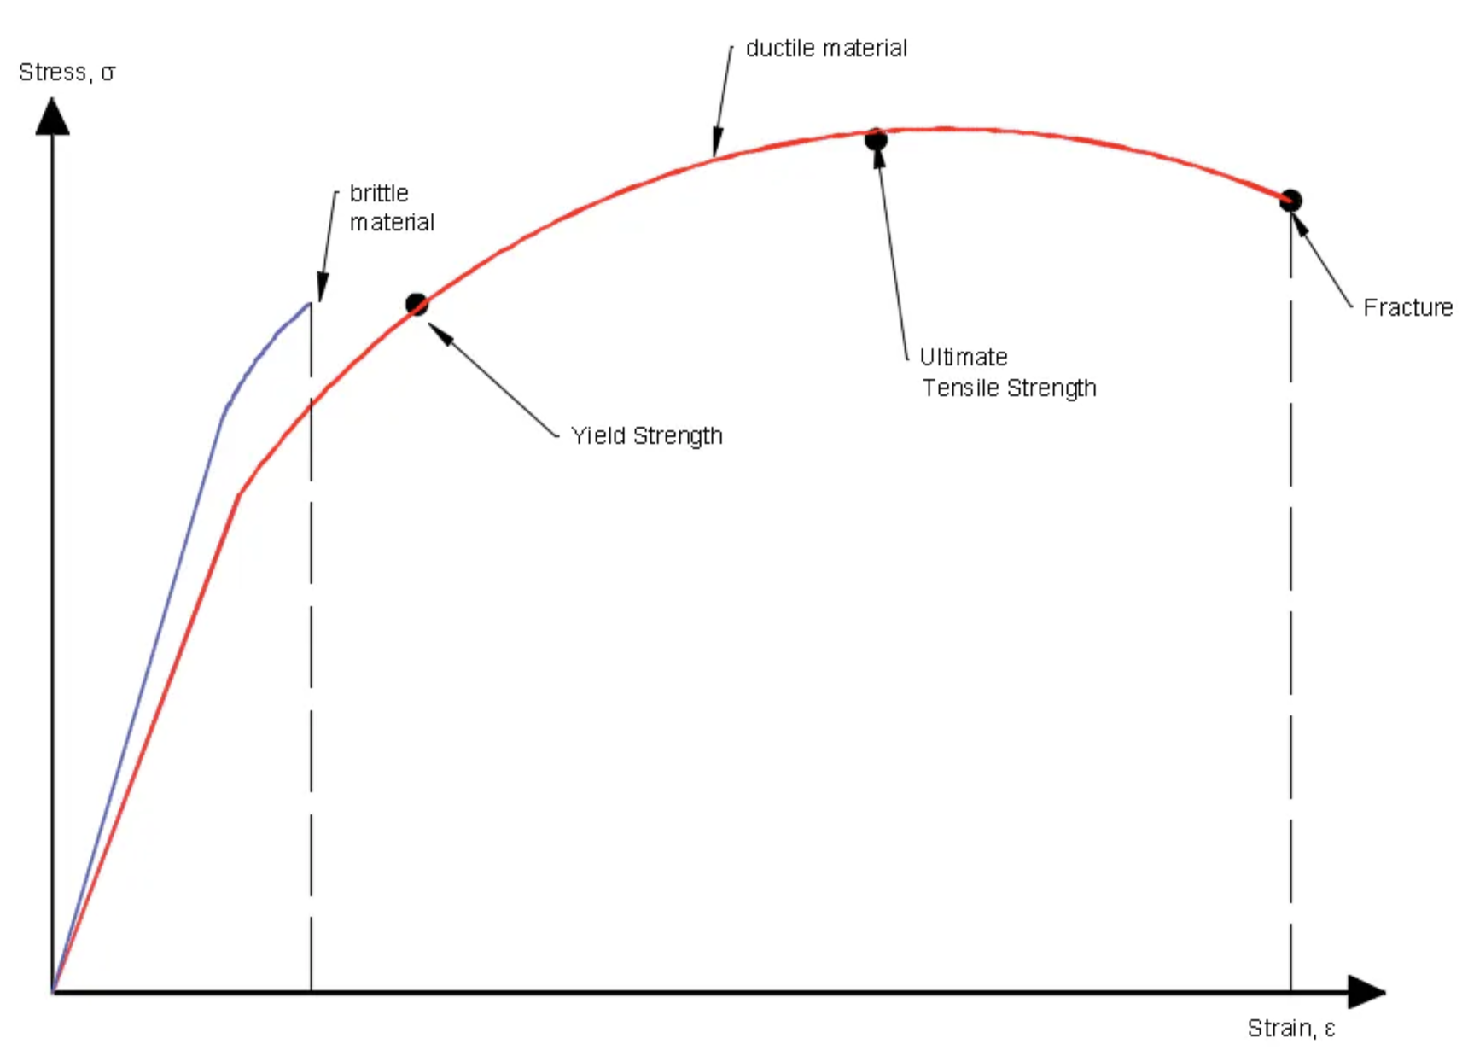
Figure 1 - Stress - Strain Curve [1]
1.1.11 The Ultimate Tensile Strength of a material is a measure of the ultimate stress a material can withstand without breaking under a tensile load. Once this point is reached, it will then fracture.

1.1.12 The following definition has been used to describe Von Mises stress ‘….is an equivalent stress value that is used to determine if a given material will begin to yield, where a given material will not yield as long as the maximum von Mises stress value does not exceed the yield strength of the material’ [2].

- $σ_{v}= \frac{{\left(σ_{1}-σ_{2}\right)}^{2}+{(σ_{2}-σ_{3})}^{2}+{(σ_{3}-σ_{1})}^{2}}{2}$

1.2 Nut and Bolt Assembly Tensile Failure Modes
1.2.1 Taking the basic concepts of how a ductile material behaves under tensile loading, this can then be applied to the modelling of a nut and bolt assembly. There are several failure modes a structural nut and bolt assembly can experience under tensile forces, namely:

- Necking: a ductile failure mode as illustrated in the second and third examples in Figure 2;

- Brittle failure, as illustrated in the fourth example in Figure 2;

- Thread stripping: a form of shear failure as shown in the last example of Figure 2. [3]

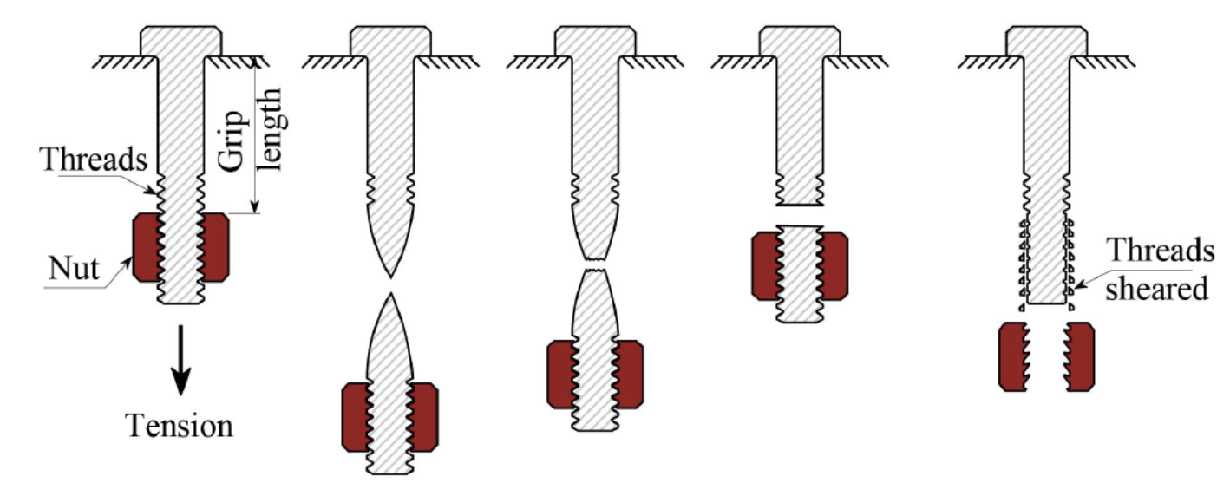
Figure 2 - Tensile Force Failure Modes of a Nut and Bolt Assembly [3]

1.2.2 A ductile material undergoes necking when the ultimate tensile strength of the stress/strain curve is reached. Prior to this point being reached, the plastic deformation occurs throughout the material sample and deforms under constant volume conditions. At the point of ultimate tensile strength, deformation becomes concentrated and localised in the neck region.

1.2.3 The deformation in the neck region is unstable as the true stress continues to increase and the area decreases. This region of the tensile stress/strain curve can only be realized under constant strain-rate test conditions. For a constant load-rate test, the sample fails once the neck forms [4].

1.2.4 Closely linked to neck formation is work hardening. Work hardening acts to suppress necking, Work hardening, also known as Strain hardening, is an intriguing process that occurs in ductile metallic materials when they are mechanically deformed. This deformation essentially increases the dislocation density within the material, thereby significantly boosting its hardness and strength.

1.2.5 Thread stripping failure occurs when the thread engagement experience large shear deformations that will eventually result in the nut disengaging.

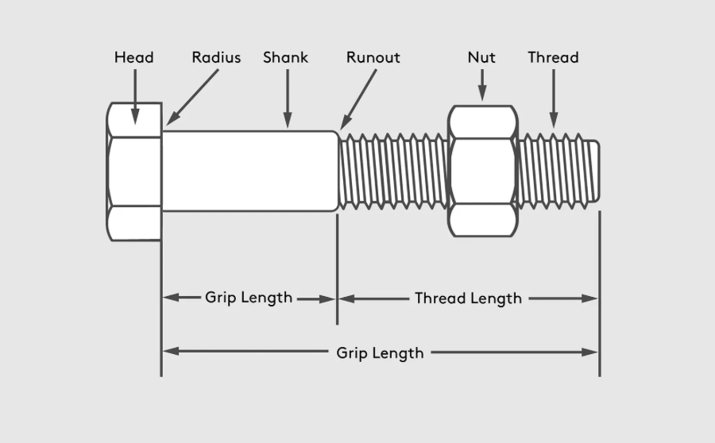
Figure 3 - Constituent Parts of a Nut and Bolt Assembly [5]

2.0 Boundary Conditions

2.1 Overview
2.1.1 The application of boundary conditions is of critical importance in performing a structural analysis. A boundary condition can be described as:
2.1.2 ‘…. a place on a structure where either the external force or the displacement are known at the start of the analysis. In this way, boundary conditions are where the structure interacts with the environment either through the application of an external force or through some restraint that is imposing a displacement. For a structural analysis problem to be solvable, every location on the boundary of our structure must have a known boundary condition, either a known force or a known displacement. The known force or displacement may have some magnitude or it may be zero. For example, we may know that there are locations on our structure that have no external force. This would be a zero force boundary condition. A displacement boundary condition that is zero is equivalent to the structure being held in place at that location.’ [6]
2.1.3 For the purposes of this analysis, two reference points were selected to replicate the constraints and the actions that would be seen under testing conditions, and normal operating conditions. The bolt face had a fixed constraint (Dirichlet condition) placed upon it whilst a load was applied to the nut face.

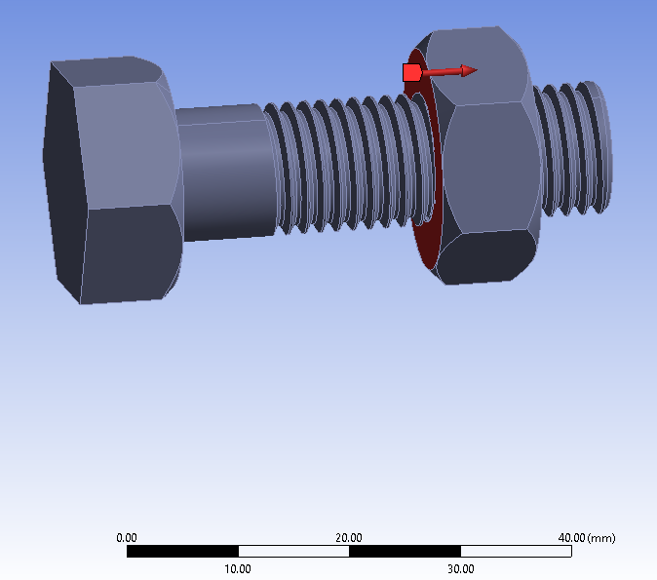
Figure 4 - Loading Applied to the Bolt Face with Load at the Nut Face

2.1.4 To accurately capture the forces experienced by the assembly, it was necessary to ensure the threads between the nut and bolt were engaged. This is shown in Figure 5 and Figure 6.
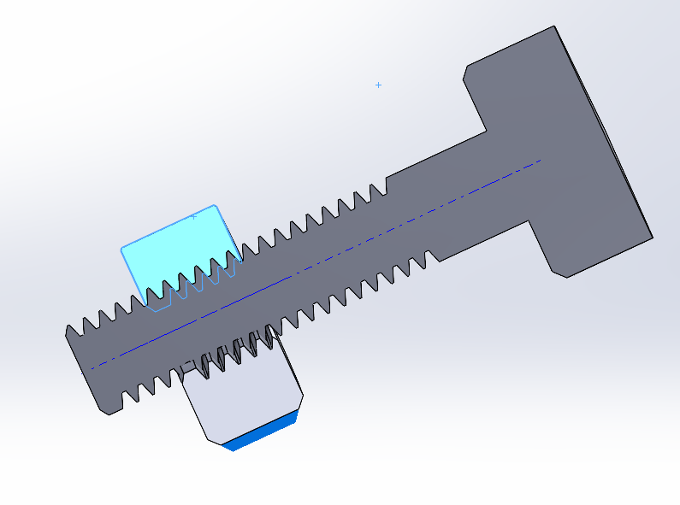
Figure 5 - Thread Interaction Between Nut and Bolt

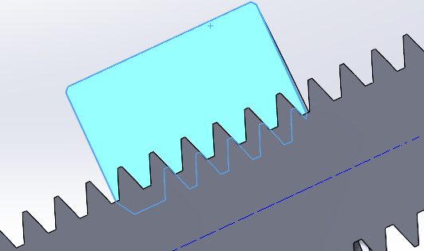
Figure 6 - Thread Interaction

3.0 Ansys Modelling & Observations

3.1 Overview
3.1.1 Ansys software was used to perform a static structural simulation of an assembled M12 bolt and nut assembly as shown in Figure 7.
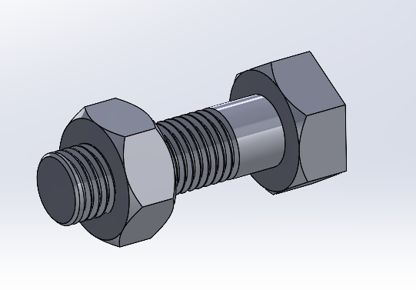
Figure 7 - M12 Bolt and Nut Assembly

3.1.2 The material properties found in Table 1 were used to represent the properties of both the nut and bolt. These were deemed suitably representative of a structural nut and bolt assembly.
Structural Steel Material Properties
Young’s Modulus | 2e+05 MPa
Poisson’s Ratio | 0.3
Bulk Modulus | 1.6667e+05 MPa
Shear Modulus | 76923 MPa
Tensile Ultimate Strength | 460 MPa
Tensile Yield Strength | 250 MPa
Table 1 - Material Properties of Structural Steel
3.1.3 The static structural analysis applied tensile loads of 100 KN, 125 KN and 200 KN to the assembly. The results have been captured at Annex A.
3.1.4 The following parameters were kept constant throughout the analysis, namely:
- Temperature, which affects the test material behaviour;

- The number of threads engaged, which were kept constant when applying different loads.

3.2 Deformation
3.2.1 It was found that the greatest amount of deformation occurred in an uneven, non-linear fashion which peaked across two adjacent flats of the nut face. This can be seen in Figure 9 and Figure 10. It was also found that the least deformation occurred around the circumference of the bolt head, i.e. at the fixed boundary.

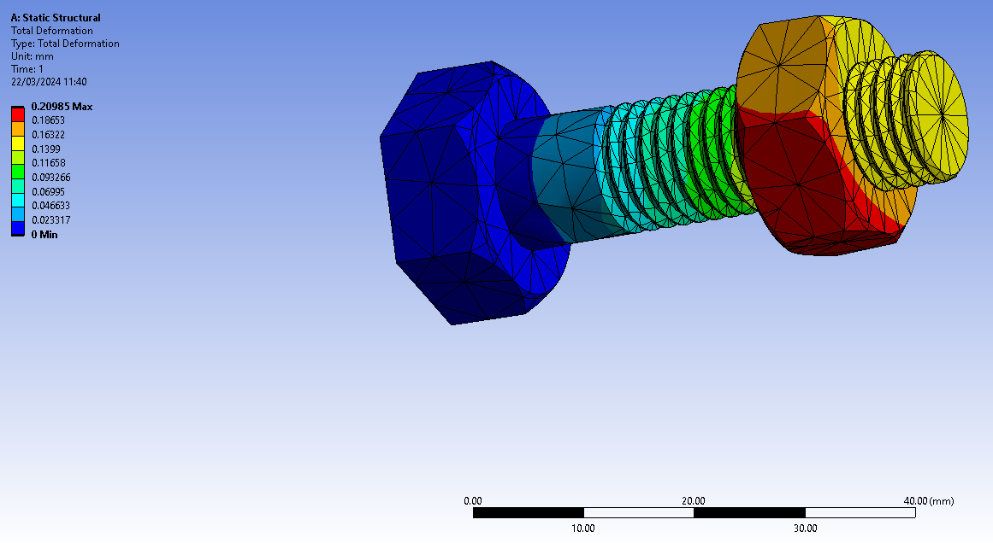
Figure 8 - Deformation at 100 KN with 5mm Mesh.

3.2.2 A possible reason for the uneven deformation is due to the asymmetrical geometry generated by the threads. This is based upon reference to previous computer-based modelling which focussed on aspects such as the effect of thread geometry [7]. The lack of deformation around the fixed bolt face may be due to the greater amount of sample material/volume in that region of the bolt.
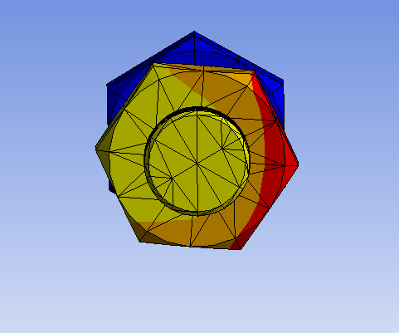
Figure 9 - Deformation at 100 KN
3.2.3 Another possible cause could be due to the misalignment or asymmetry between the flats of the nut and the bolt face, demonstrated in Figure 10.

3.3 Maximum Principle Elastic Strain
3.3.1 Maximum principle elastic strain represents the maximum value of strain experienced in the assembly material. Peak values were found in the thread interfaces and were also heightened where the nodes intersected as depicted in Figure 11.
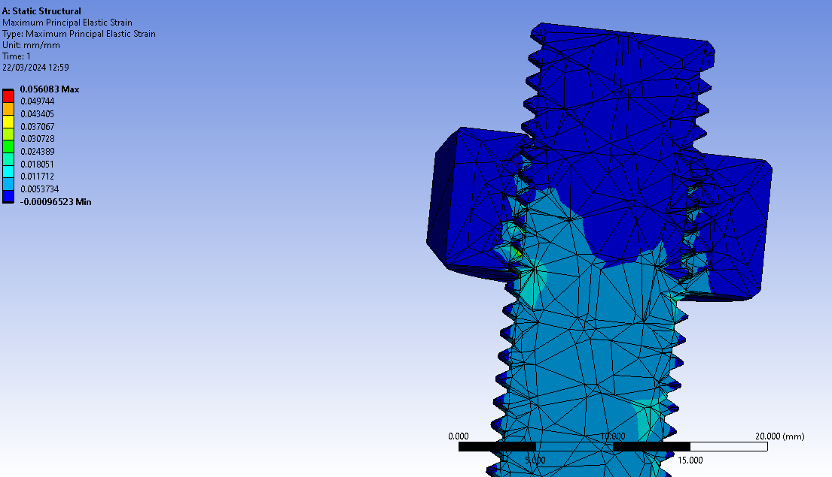
Figure 10 – Maximum Principle Elastic Strain

3.4 Meshing of the Nut and Bolt Assembly
3.4.1 The accuracy of the results generated by computer-based modelling utilising finite element analysis is determined by the mesh size. When a geometric region (domain) is meshed, it is broken down into a finite number of elements. It can be seen from Figure 10, that the elements in the mesh conform to the geometry of the nut and bolt assembly. The assembly in this instance is meshed with 3-dimensional brick elements which contain multiple nodes. Connection between adjacent elements occurs at nodes which are points in space, defined by their respective coordinates, at which degrees of freedom are defined. In finite element analysis a degree of freedom can take many different forms and is dependent upon the type of analysis being performed. In the structural analysis the degrees of freedom were displacements (Ux, Uy and Uz) which are calculated at every node from the governing equation [8].

3.5 Mesh Size
3.5.1 The accuracy of the results generated by computer-based modelling utilising finite element analysis is determined by the mesh size.

Mesh Size | Deformation (mm) | Force (KN)
5.0mm | 0.20985 | 100
10.0mm | 0.20549 | 100
Table 2 - Effect of Mesh Size on Assembly Modelling
3.5.2 Percentage difference between mesh sizes:

- 0.20985 – 0.20549 = 0.00436

- $\frac{0.00436}{(\frac{0.20985+0.20549}{2})}$ x 100% = 1.39 %

3.5.3 The percentage difference between 5.0mm and 10.0mm mesh sizing with respect to displacement was found to be 1.39%. This demonstrates a strong level of independence between the modelling and the mesh sizing i.e., the size of the meshing has little effect on the results regardless of whether 5.0mm or 10.0mm mesh size was utilised.

4.0 Validation

4.1 Validation Overview
4.1.1 Before the process of validation can begin, it first needs to be defined:

- ‘Validation assesses the accuracy of a model’s representation of the real-world system it aims to simulate. It answers the question: Does the model faithfully capture the behaviour of the actual system?’
- ‘Model validation involves comparing numerically simulated data from the model with measured experimental data.’

- ‘Strictly speaking, validation is achieved within the range of experimental conditions investigated. If the model performs well within this range, it is considered validated.’ [8]

4.1.2 To validate the computer-based modelling of the nut and bolt assembly, empirical validation was utilised. This meant utilising the results of experimentation undertaken in a standardised fashion. This required the test samples to be subjected to loading under a constant strain rate within a temperature-controlled environment (standard room temperature) [7].

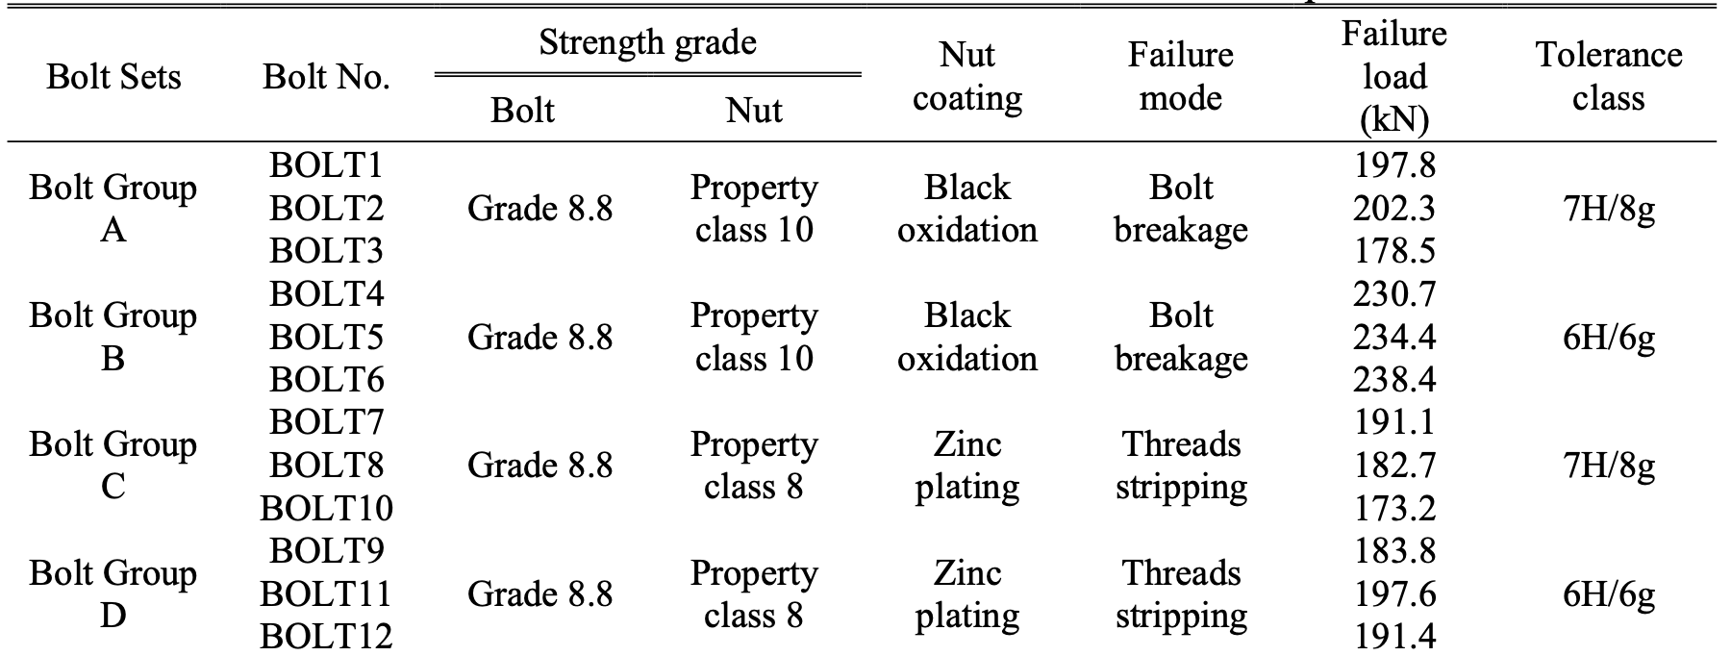
Table 3 - High Strength Bolt Testing at Room Temperature [7]
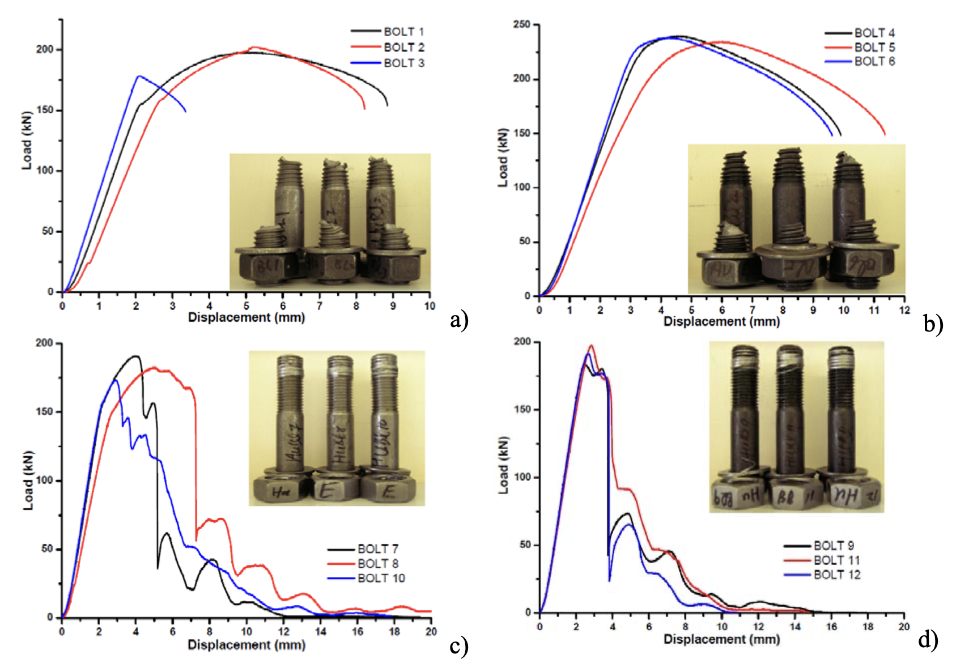
Figure 11 - Displacement Graphs for High Strength Bolts at Room Temperature [7]
4.1.3 It can be seen from Table 3 and Figure 11 that the failure modes of the high strength steel bolts involved thread stripping i.e. high shear failure and, particularly visible in Figure 11 a, the formation of necking. With reference to Annex A, which capture the screenshots of high strength nut and bolt assemblies at equivalent tensile loads in Ansys, there is a clear visual discrepancy between the two different forms of analysis. There is no visual sign of necking being formed nor an indication of the final failure modes i.e. bolt breakage and thread stripping.

4.1.4 It can also be seen from Table 2, the displacement found in Ansys was a fraction of a millimetre (maximum 0.20985mm) at 100 KN; empirical data provided in Figure 11 show that all classes of high strength steel tested resulted in displacement which was greater than 1.0mm at 100 KN.

5.0 Conclusion

5.1 Limitations of Computer Aided Modelling
5.1.1 The limitations of computer aided modelling need to be recognised and taken into account to understand what it can accurately demonstrate, and where other forms of modelling are required in its place.
5.1.2 The static structural analysis applied a load in a linear fashion with the bolt head remaining in a fixed state. However, this fails to take into account the effect of applying torque and the twisting forces/moment induced in the assembly structure. It is assumed that shear forces would be found along the bolt and nut thread interface.
5.1.3 Computer aided engineering and analysis is dependent upon the User. User knowledge and ability to perform the analysis requires a high level of proficiency in computational modelling. This requires specialist training to enable the User to perform such tasks which potentially requires months to years to achieve a suitable level of proficiency.
5.14 It is not clear whether random failure will be captured when utilising computer-based modelling. This would necessitate the inclusion of imperfections in the material as opposed to the uniform material properties applied to the component/assembly in computer-based modelling. This could have implications for e.g. safety critical systems, which may fail to take into account such a failure mode due to the modelling indicating a high level of confidence.
5.1.5 The modelling cannot account for the effect of coatings applied to the nut and bolt structure. For example, zinc coating used in the galvanising of steel, resulting in a non-homogenous material structure. It has been shown that coatings can lower the coefficient of friction between the nut and bolt threads at raised temperatures, increasing the propensity of a stripping failure [3].

Bibliography

[1] | xometry, [Online]. Available: https://www.xometry.com/resources/3d-printing/yield-strength/. [Accessed 30 03 2024].
[2] | Ansys, “What is Equivalent Stress,” Ansys, [Online]. Available: https://www.ansys.com/blog/what-is-equivalent-stress. [Accessed 02 05 2024].
[3] | M. A. Shaheen, “Behaviour of stainless and high strength steel bolt assemblies at elevated temperatures — A review,” Fire safety, p. 46, 2020.
[4] | “Neck, Necking,” Princeton University, [Online]. Available: https://www.princeton.edu/~maelabs/mae324/glos324/neck.htm. [Accessed 29 04 2024].
[5] | “essentra components,” [Online]. Available: https://www.essentracomponents.com/en-us/news/solutions/fastening-components/what-are-the-different-types-of-nuts-and-bolts. [Accessed 24 03 2024].
[6] | J. Erochko, “Learn About Structures,” [Online]. Available: https://learnaboutstructures.com/Boundary-Conditions. [Accessed 29 04 2024].
[7] | Belfast, Queen's University, “FE simulation and experimental tests of high-strength structural bolts under tension,” 2016.
[8] | Microsoft, “Microsoft Bing,” Microsoft. [Online]. [Accessed 02 05 2024].

Annex A

ACDB5007
Application of Computer Aided Engineering Processes

100 KN applied force, deformation with meshing of 10mm.
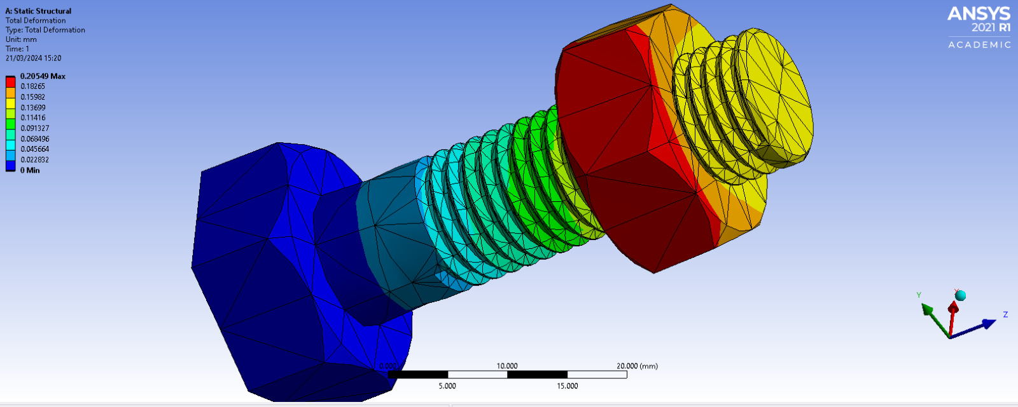

100 KN applied force, equivalent stress with meshing of 10mm.
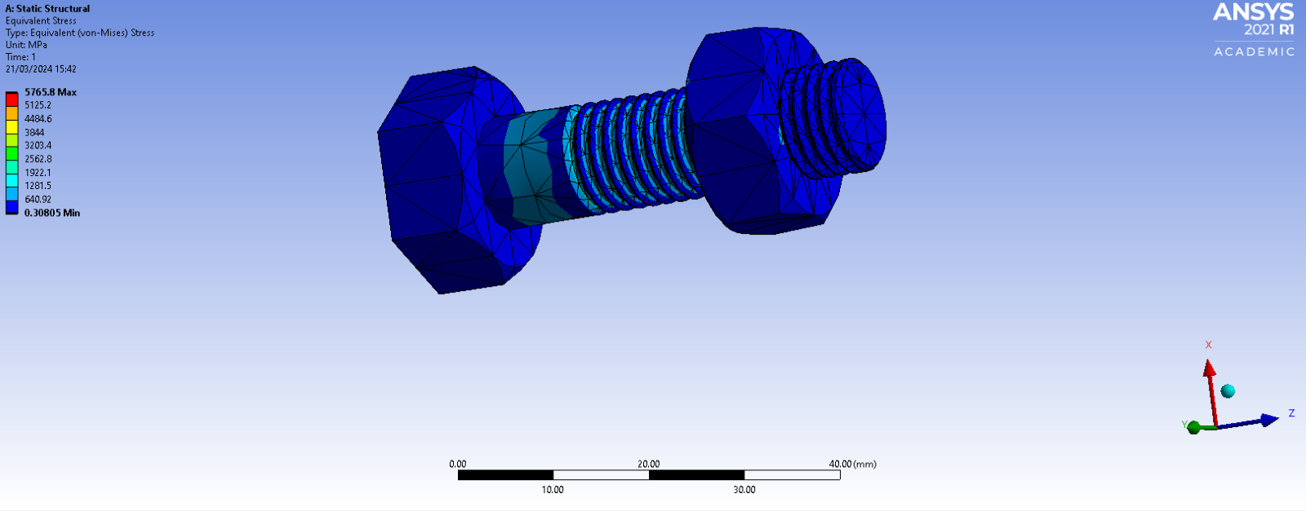

100 KN applied force, maximum principal elastic strain with meshing of 10mm.

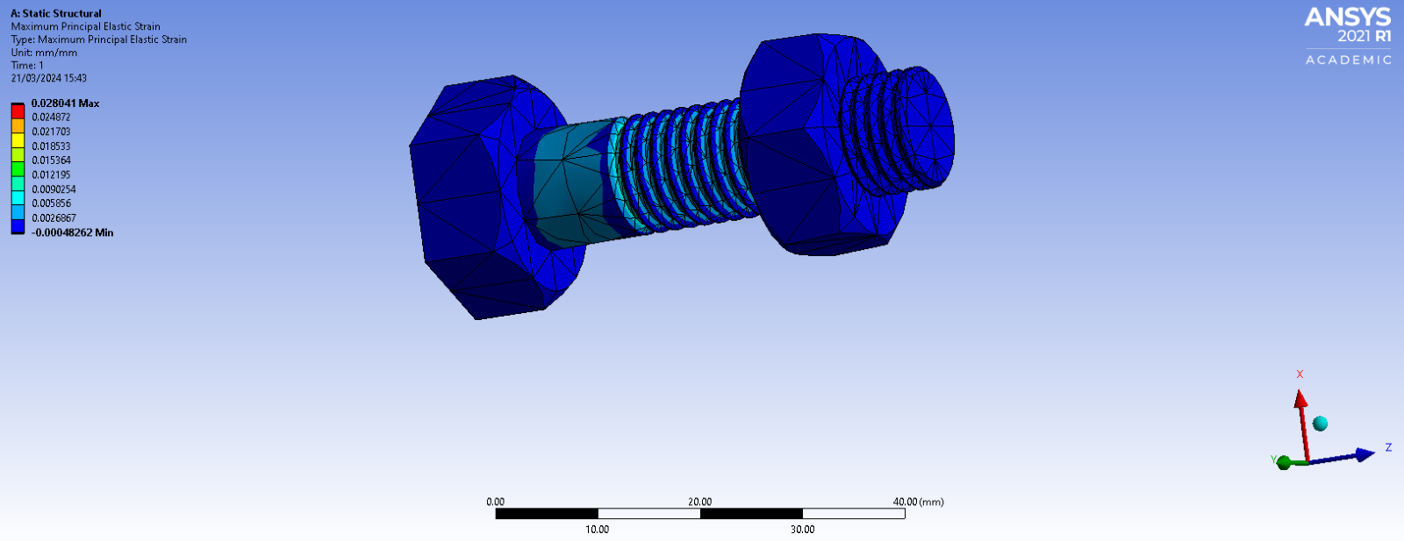

125 KN applied force, deformation with meshing of 10mm.

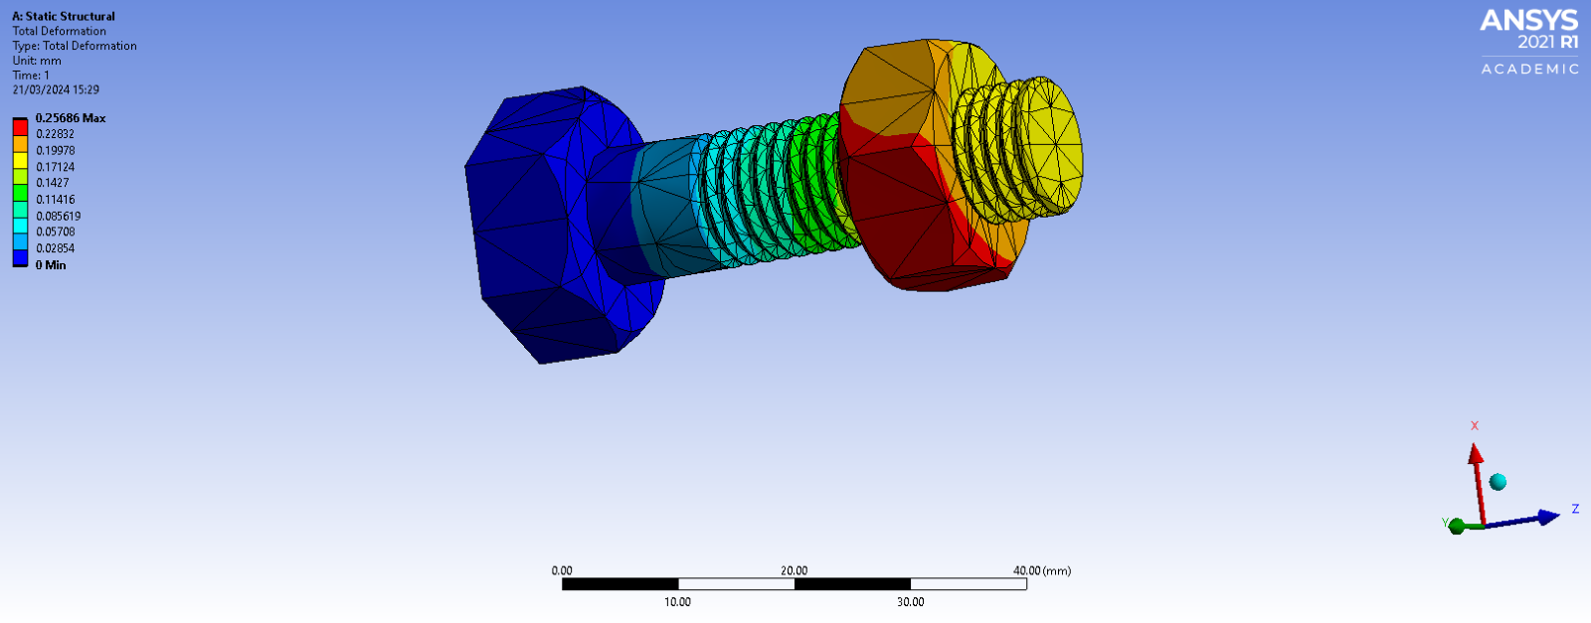

125 KN applied force, equivalent stress with meshing of 10mm.

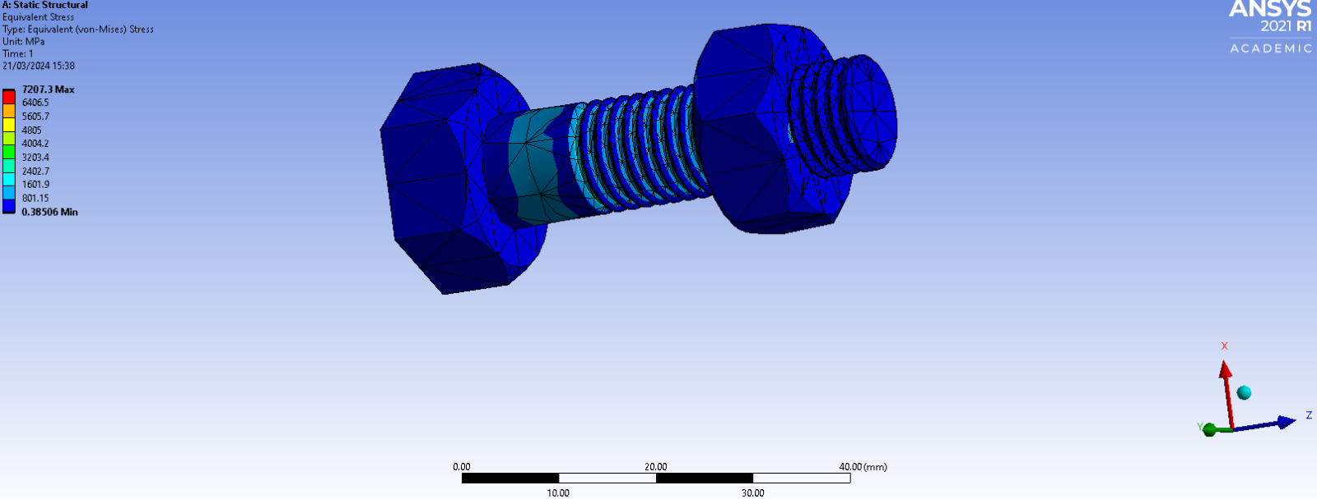

125 KN applied force, maximum principle elastic strain with meshing of 10mm.

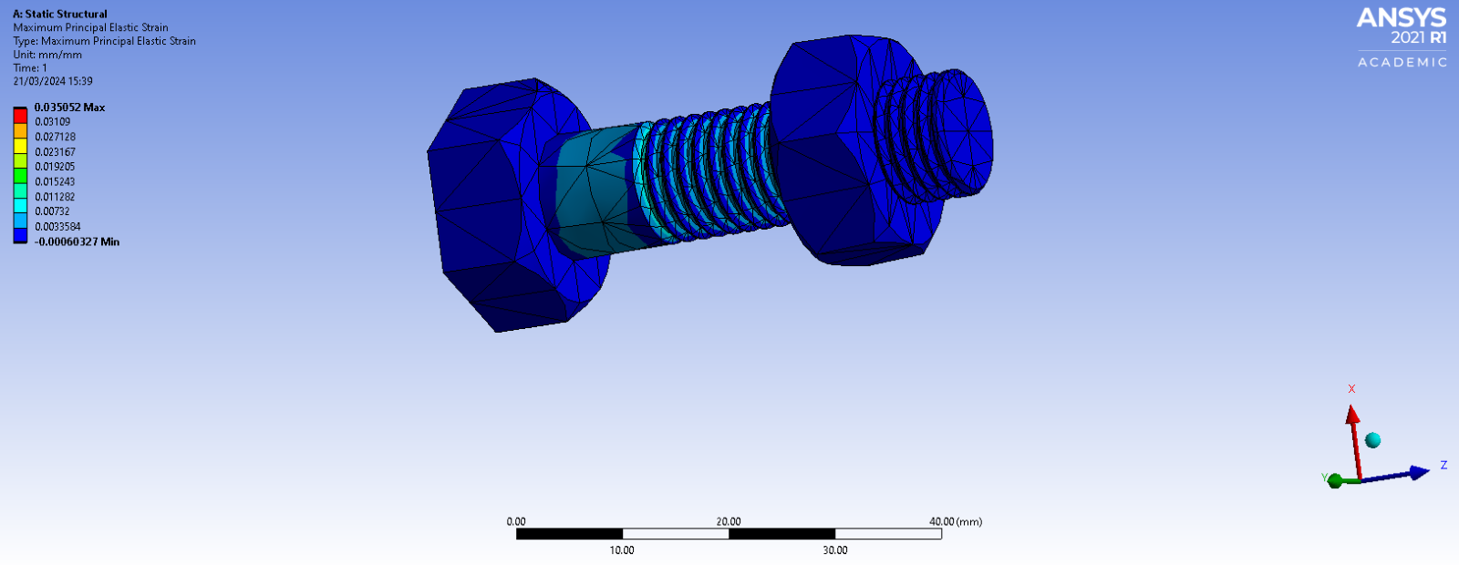

200 KN applied force, deformation with meshing of 10mm.

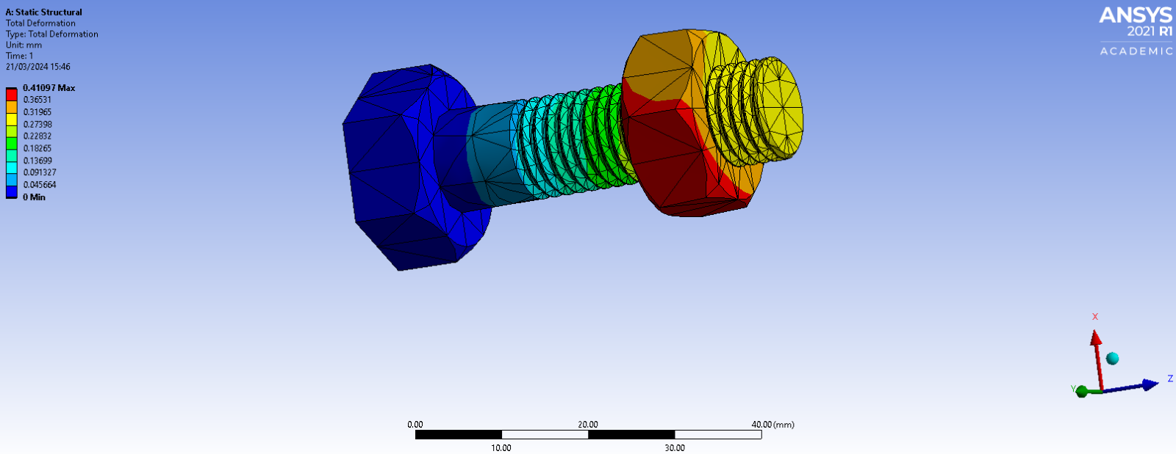

200 KN applied force, equivalent stress with meshing of 10mm.

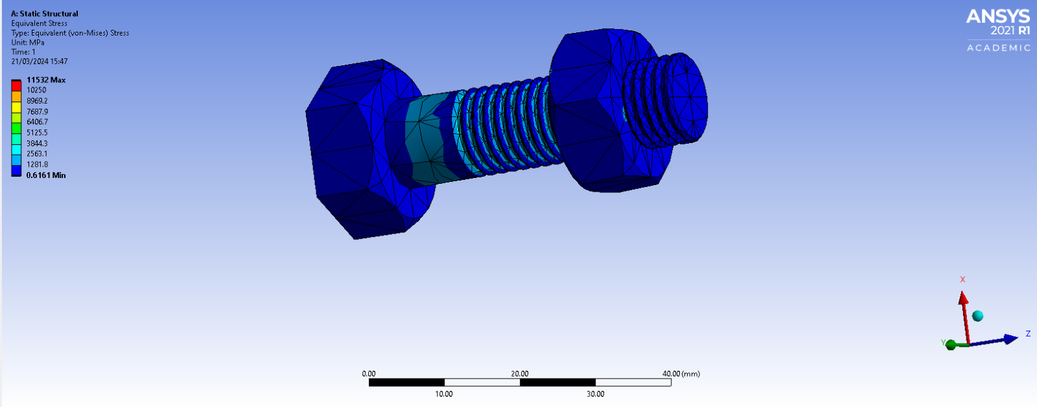

200 KN applied force, maximum principle elastic strain with meshing of 10mm.

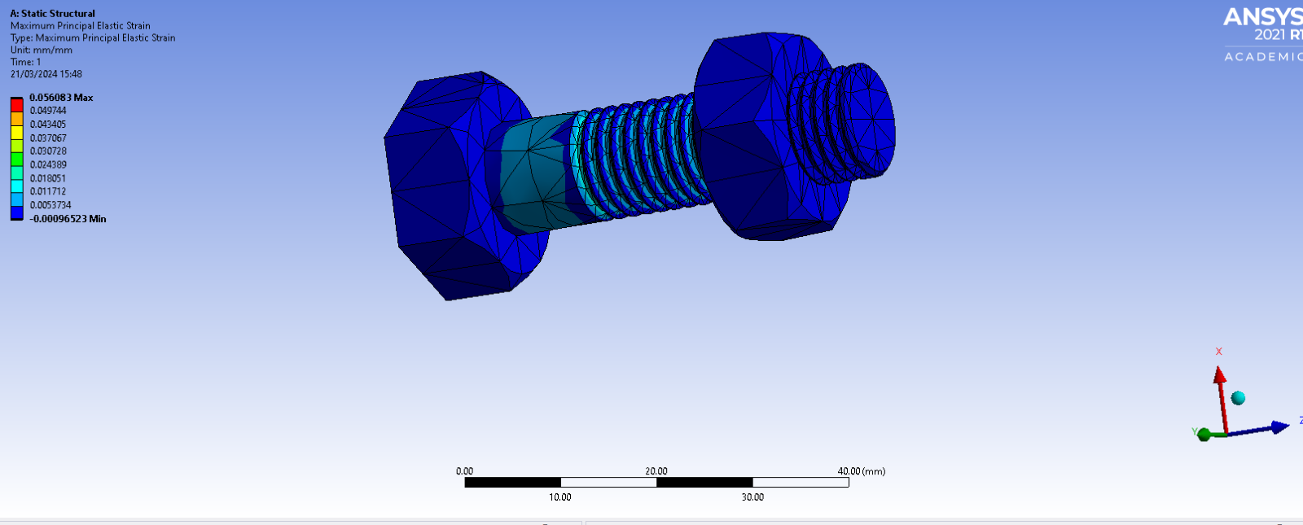
5.0mm meshing at 100KN – max deformation was found to be 0.20985 mm.

True stress is given by the ratio of force to the current cross-sectional area on which it acts.

