Assignment title:
Configure and manage the Virtualised Enterprise network

Dr. Dipo Dunsin & Md. Sadeque Imam Shaikh
MODULE CODE: ACCA5023
BSC Applied Computing
Network Operating Systems and Services


University of Wales Trinity Saint David
London

Jolanta Pacek (2413830)
Table of Contents
Introduction 2
Task 1 3
1.Routing: 1.1 Routing in Swansea Network 3
1.2 Routing in London Network 3
2. Domain Server (Swensea) 10
2.1 Creating a forest named yourname.acca 10
2.2 Creating all records 14
2.3 Creating a reverse lookup zone, PTR records. 18
3.Encrtypted linking among Swansea and London 24
3.1. 24
4.1 28
5.Domain Membership 29
6. DHCP Server 31
6.1 31
6.2 31
6.3 31
7.Test and Troubleshoot 33
7.1. 33
8.1 Mount disk drive. 34
9. IIS Server 38
9.1 38
10. Remote Desktop Services 39
10.1 39
Summary 40

Introduction
This section presents the design and implementation of an enterprise-grade network and domain infrastructure spanning the Swansea and London sites. The implementation encompasses routing and remote access configuration, deployment of Active Directory Domain Services (AD DS), Domain Name System (DNS), and Dynamic Host Configuration Protocol (DHCP), as well as the establishment of protected inter-site connectivity. Centralised domain and user administration was implemented, followed by logical testing and troubleshooting to validate operational integrity.
The primary objective of this structure is to deliver a secure, resilient, and scalable environment that supports centralised authentication, efficient resource establishment, and reliable communication across geographically disseminated networks, in alignment with manufacturing best performs and future scalability requirements.

Task 1

1.Routing:
1.1 Routing in Swansea Network

1.2 Routing in London Network
Configuration of permanent IP Furthering and Routing
Installation Routing and Remote entrance package with modification firewall rules to allow ICMP traffic.

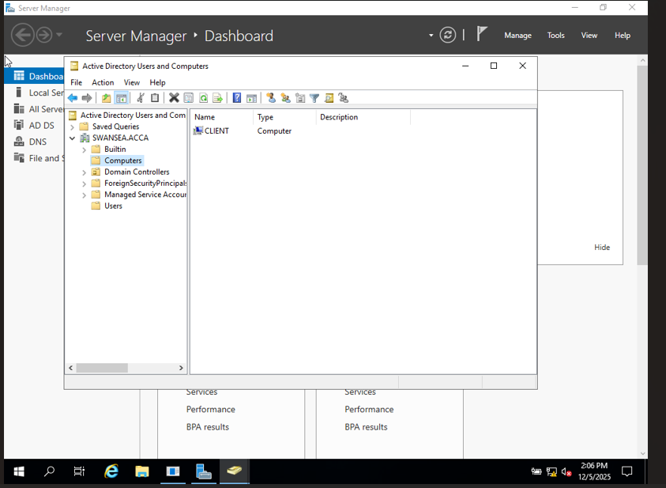
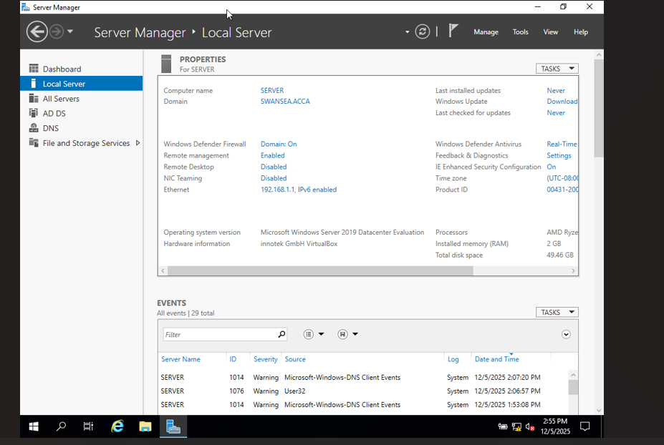
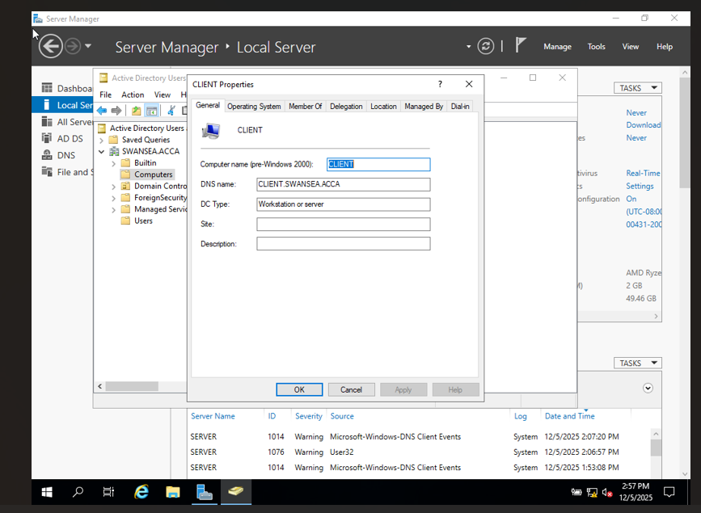
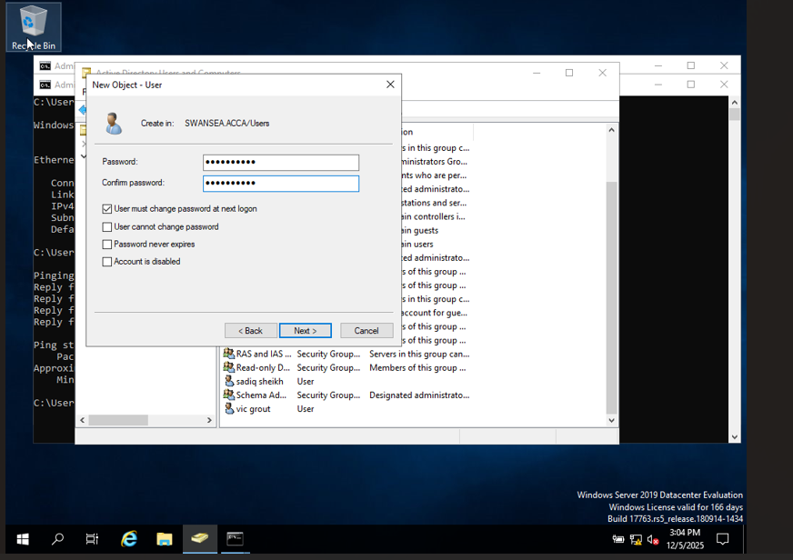
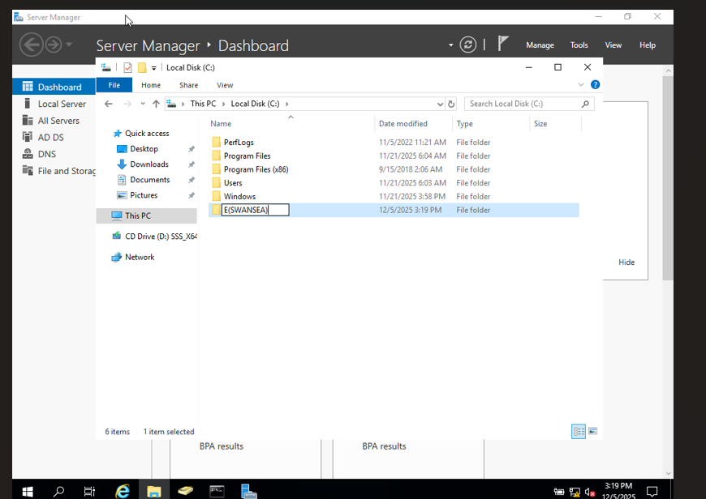
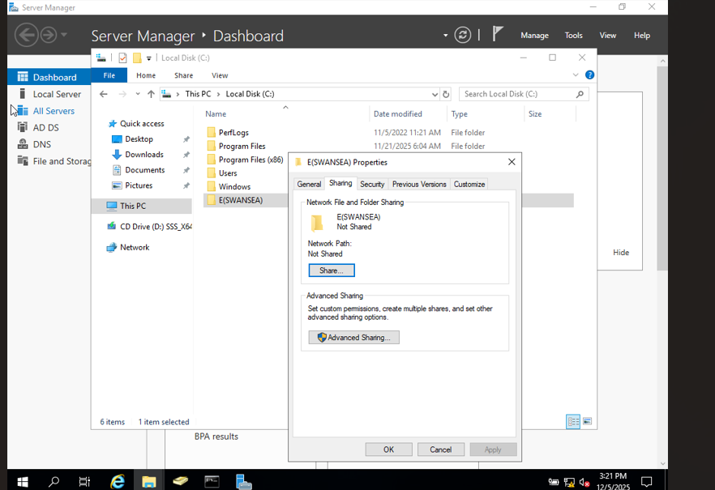
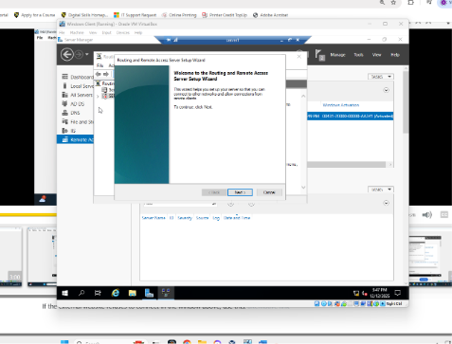
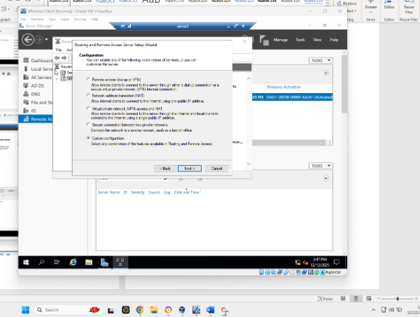
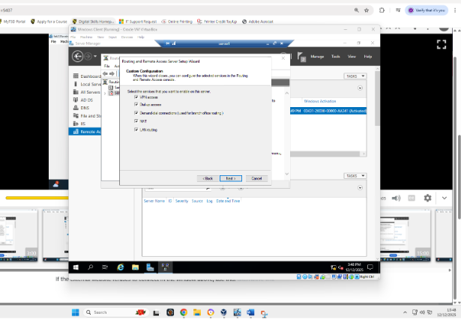
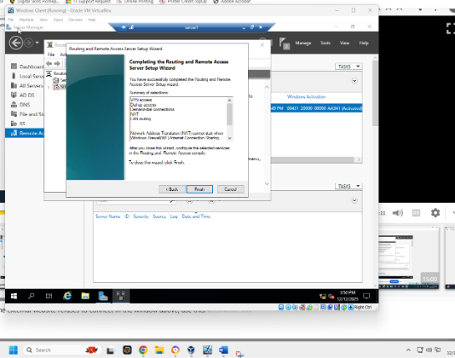
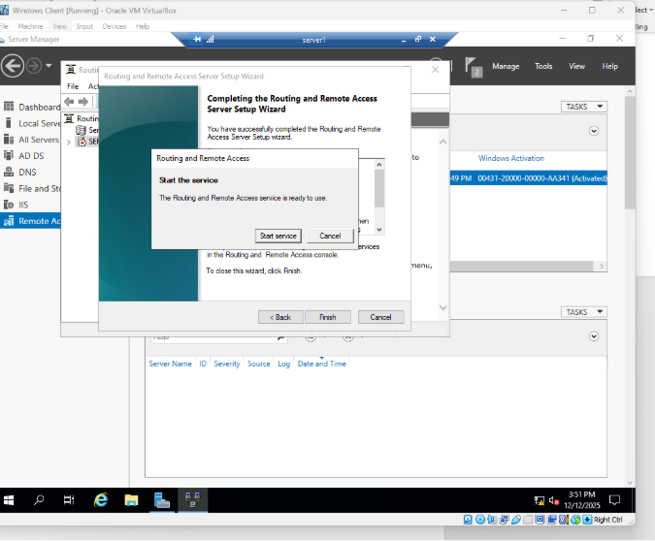
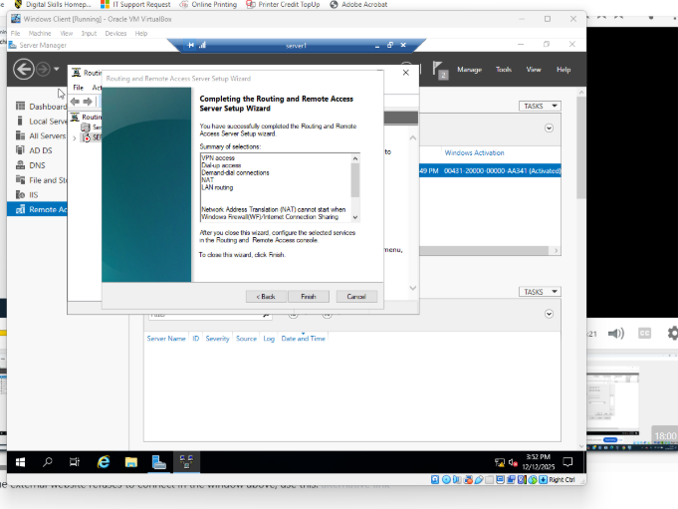
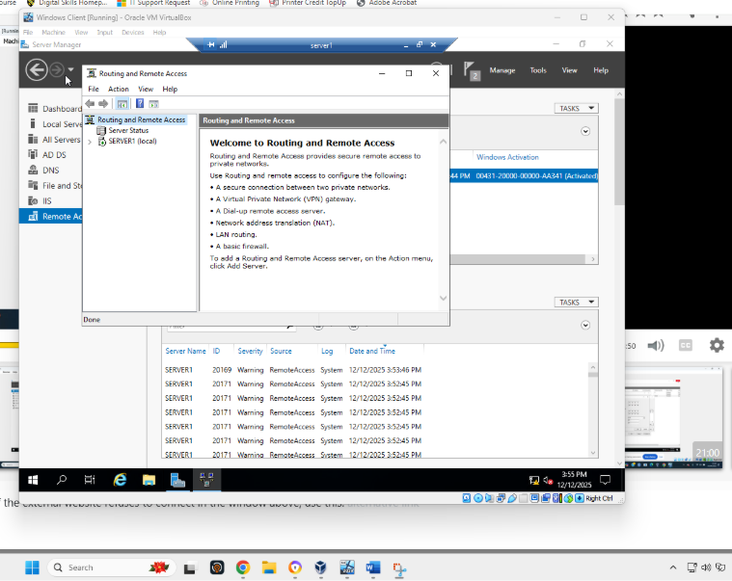
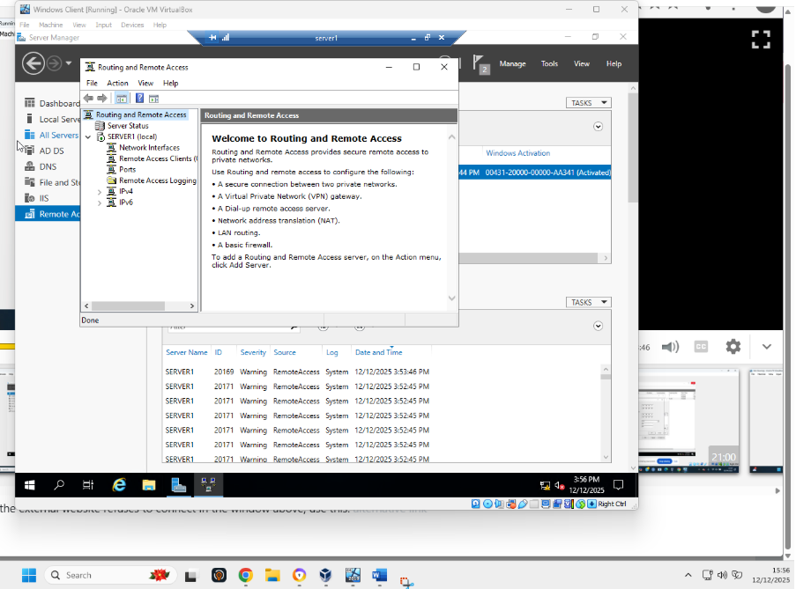
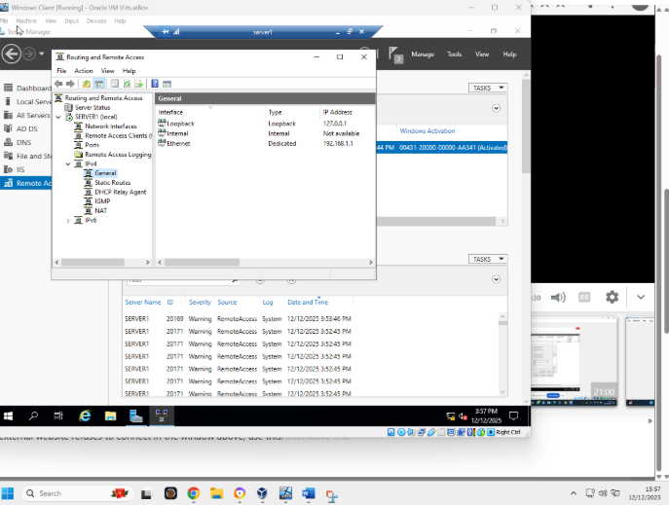
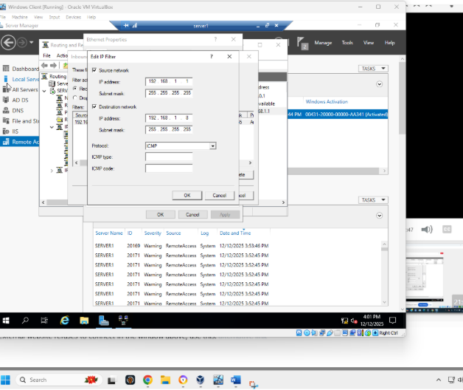
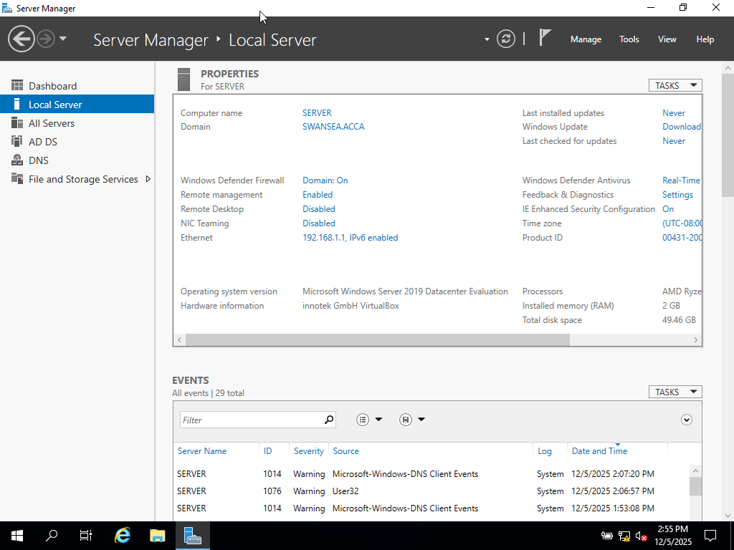
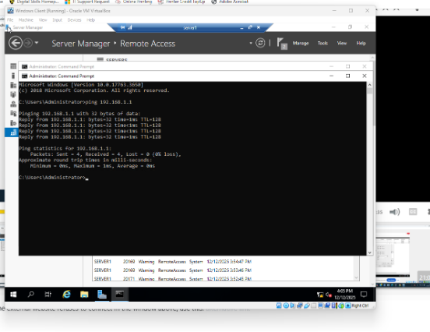

2. Domain Server (Swensea)

2.1 Creating a forest named yourname.acca

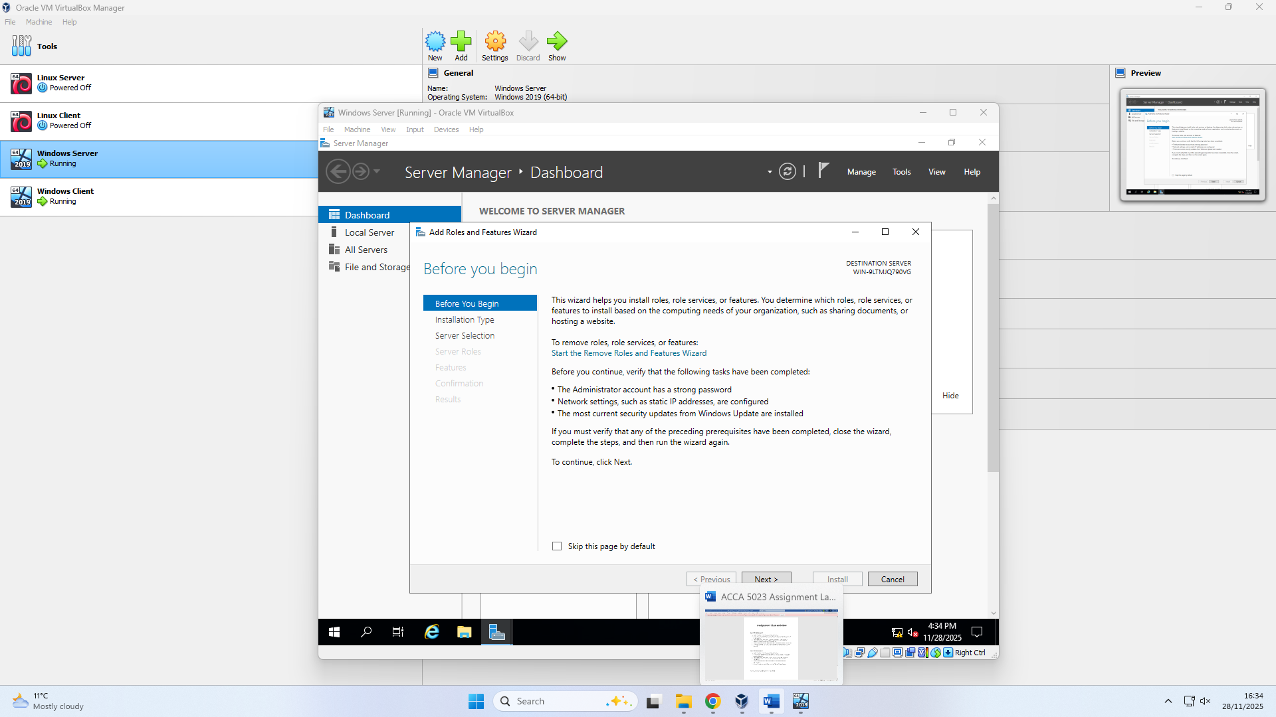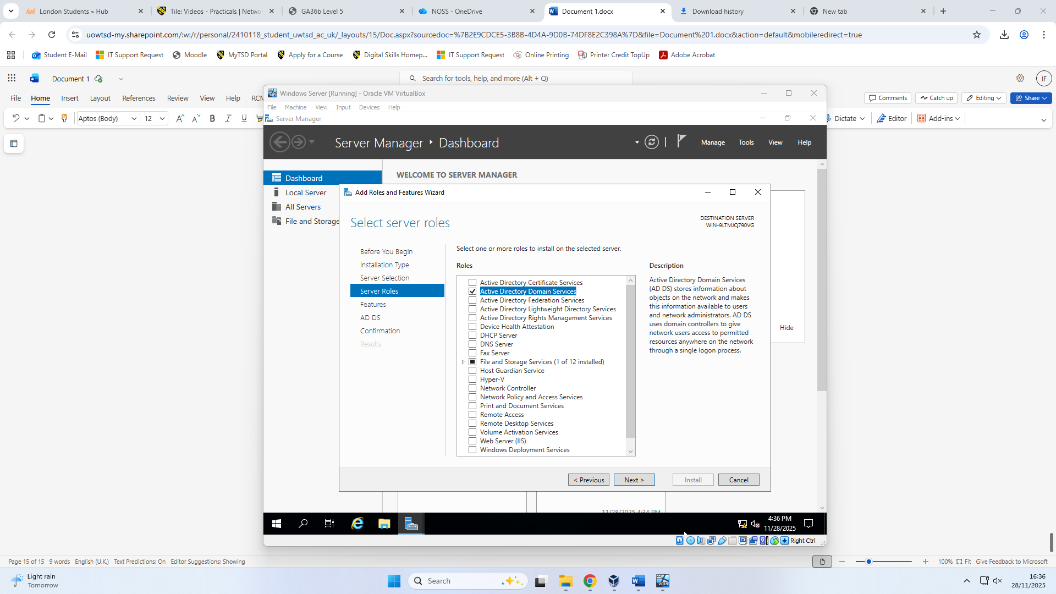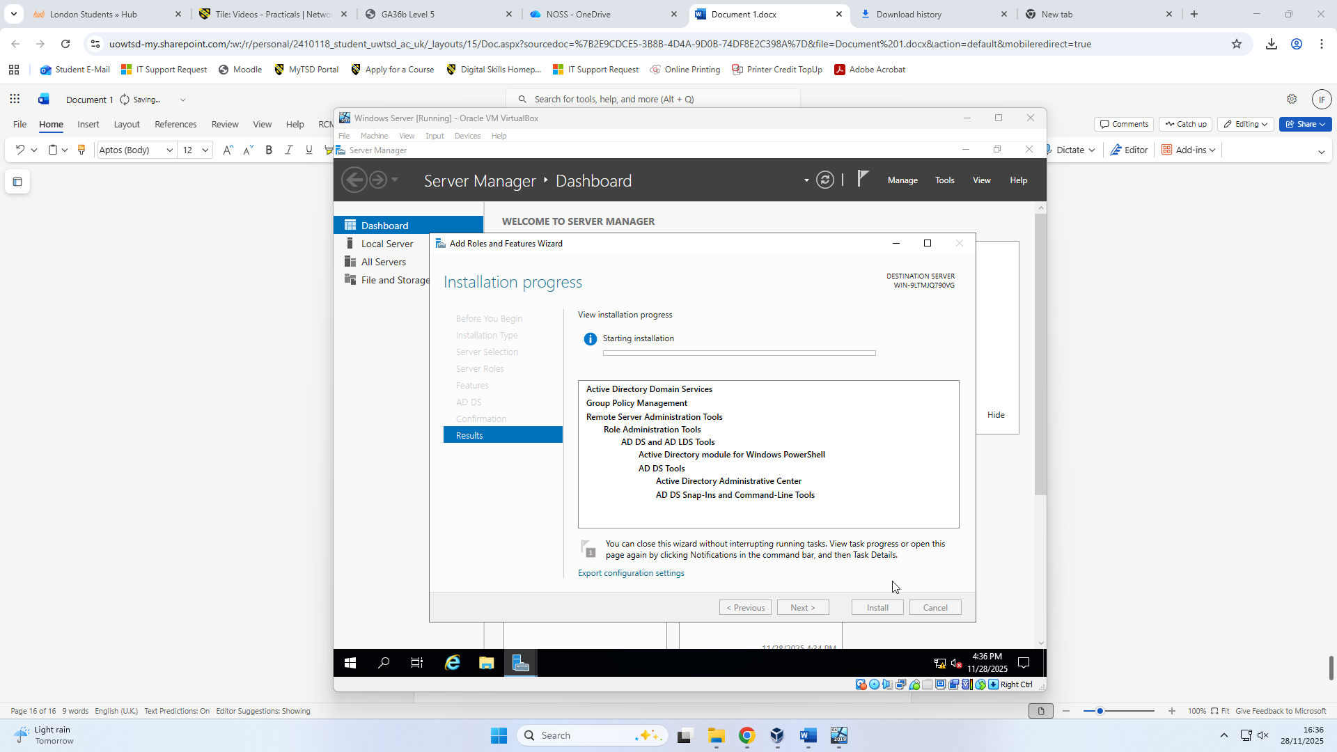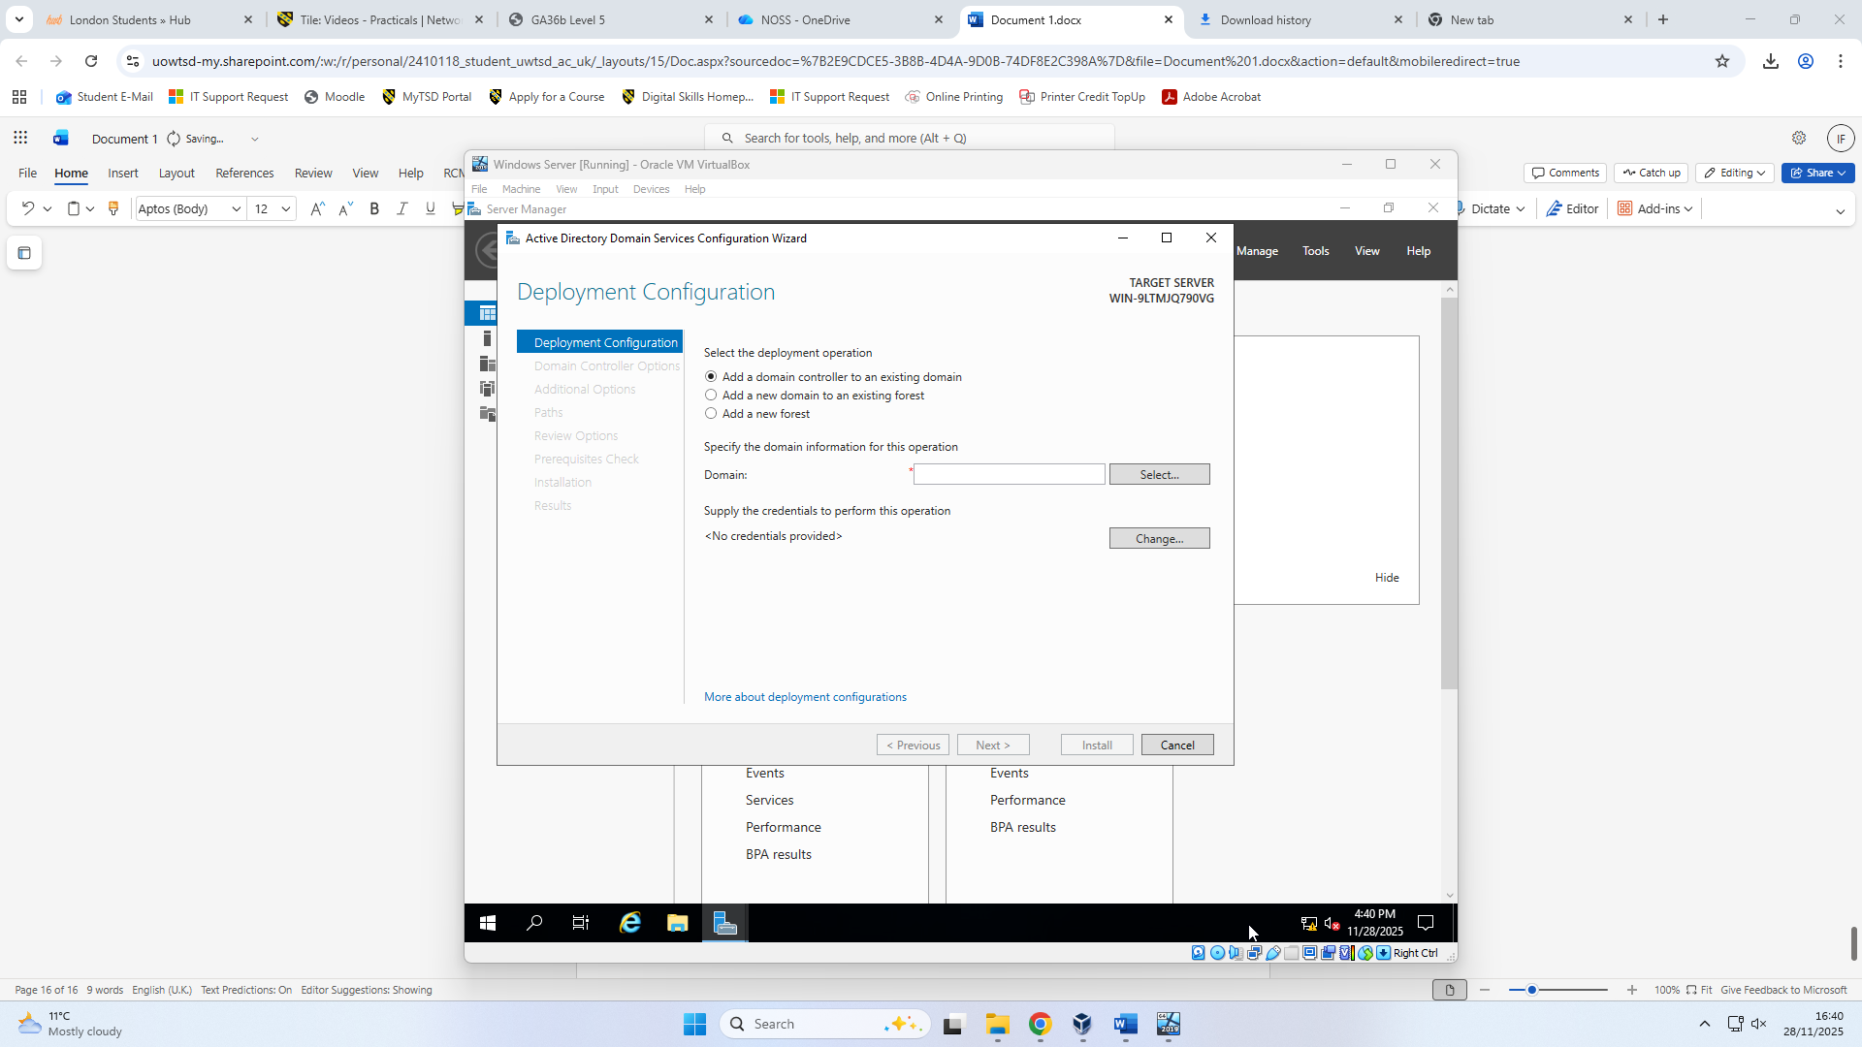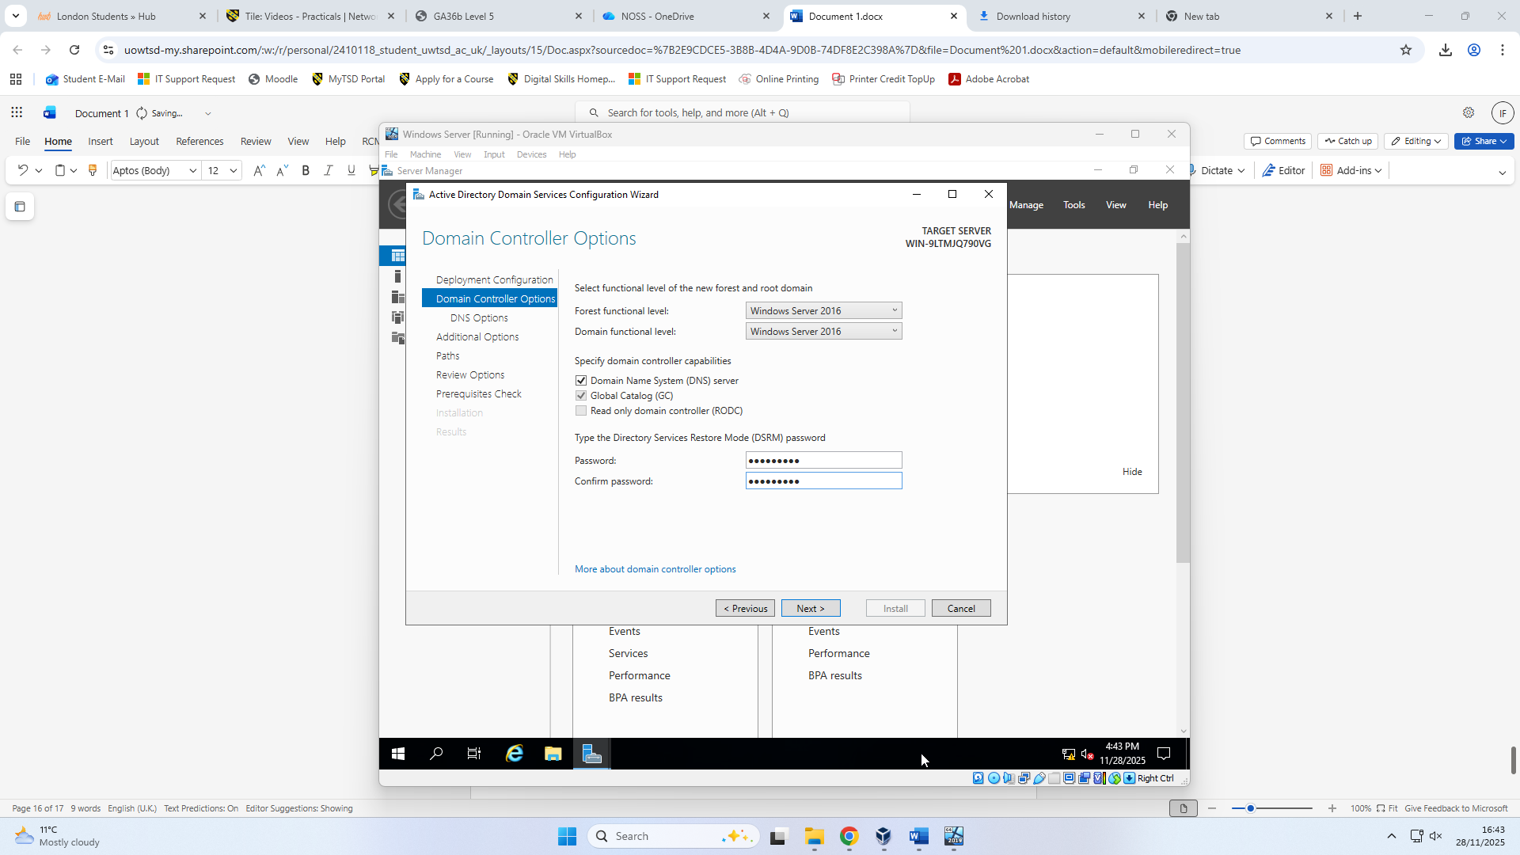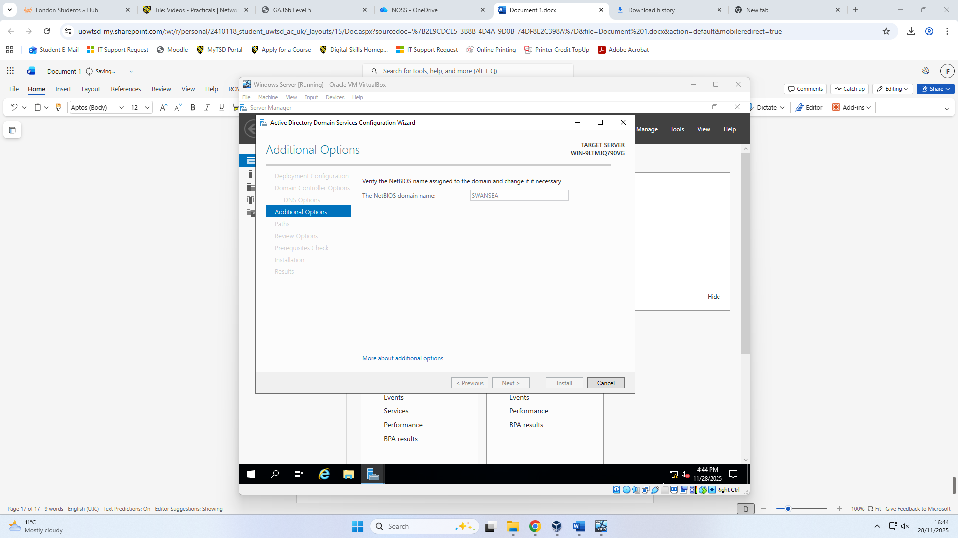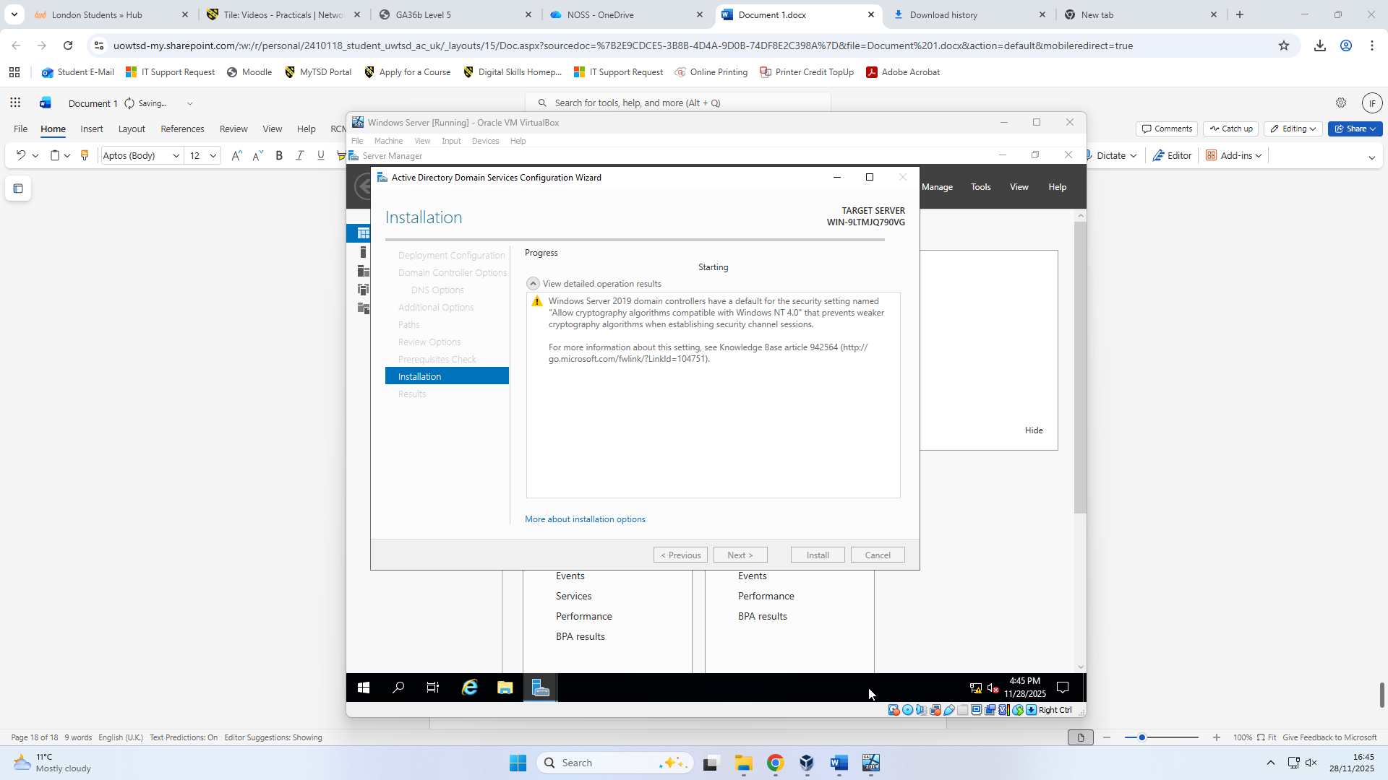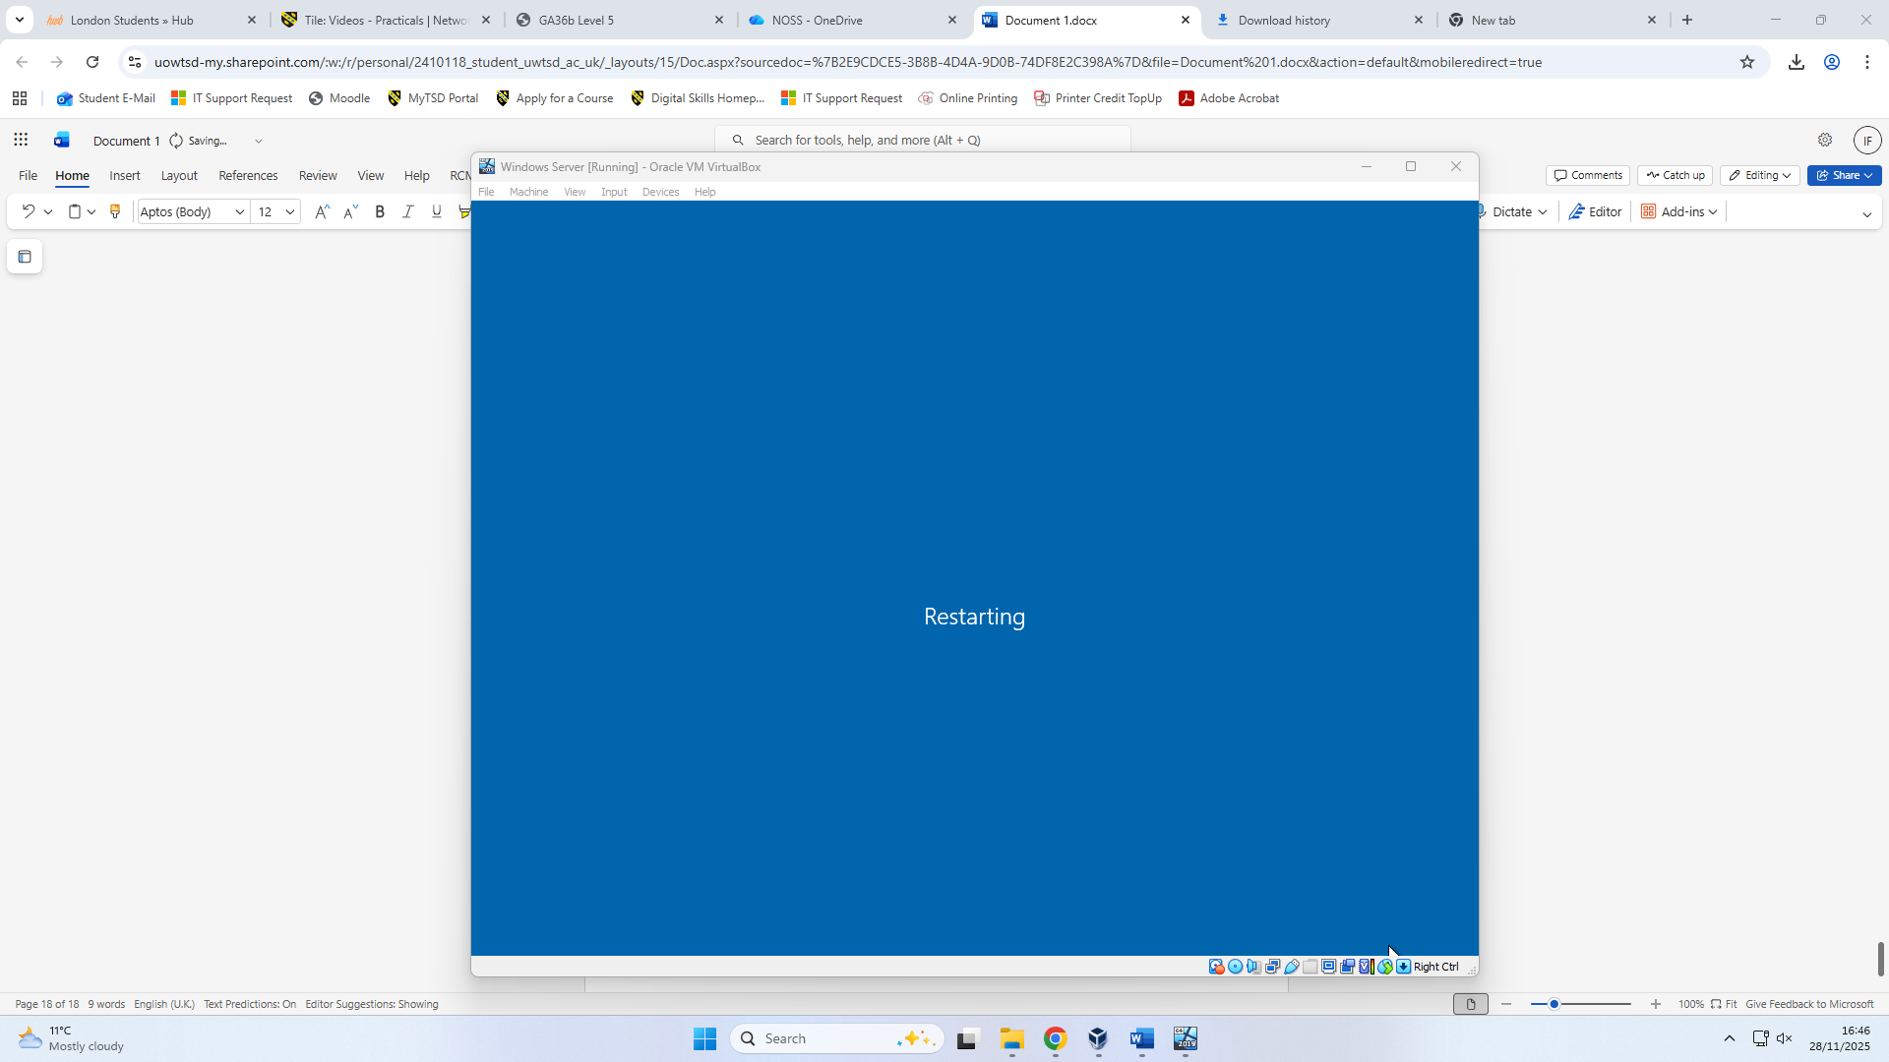

2.2 Creating all records

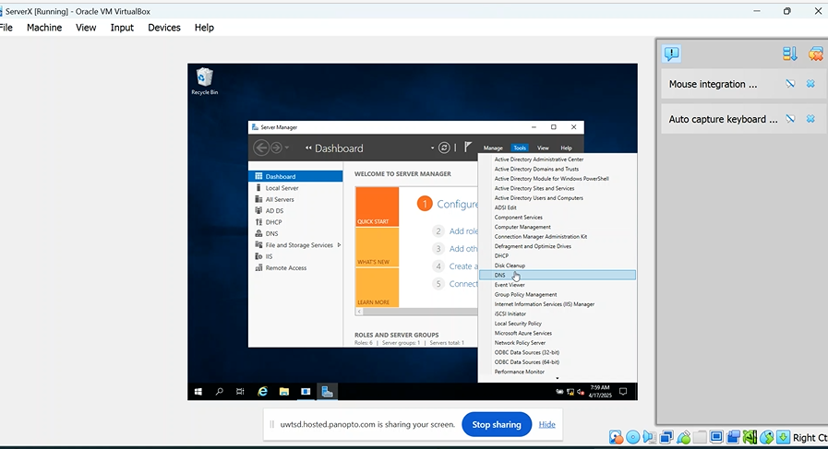
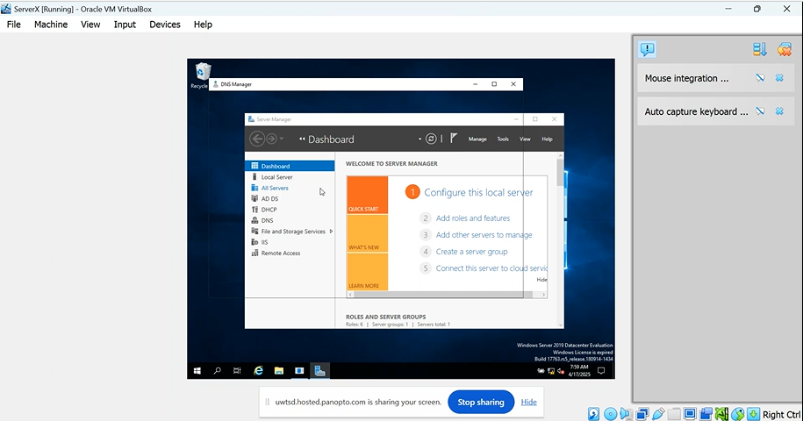
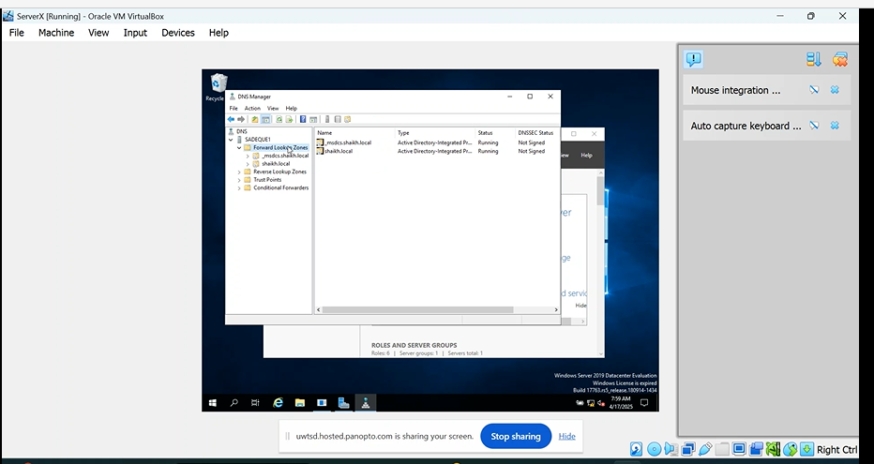
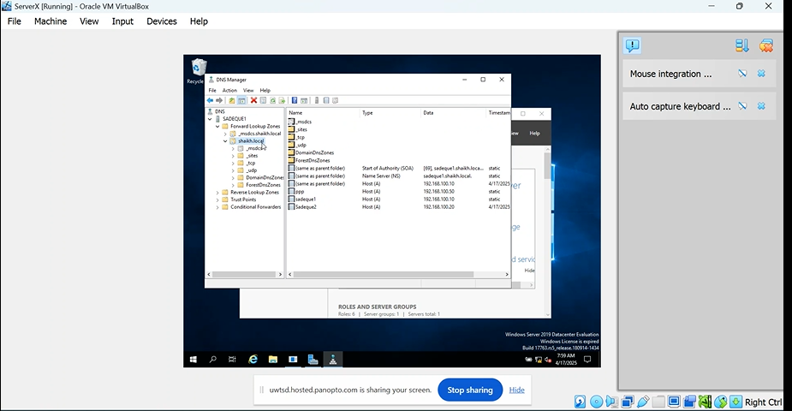
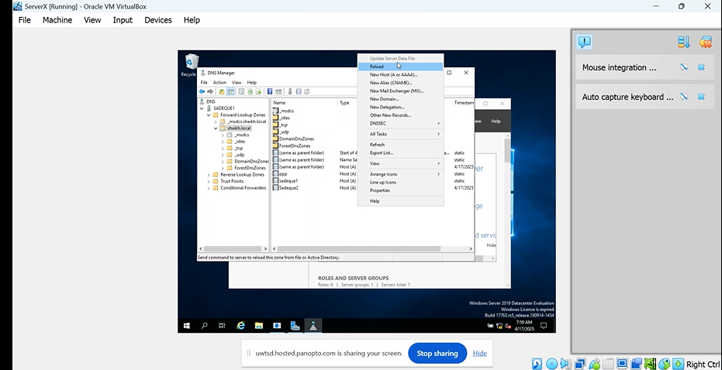
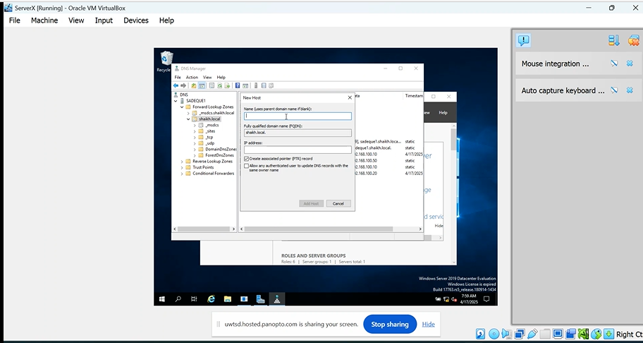
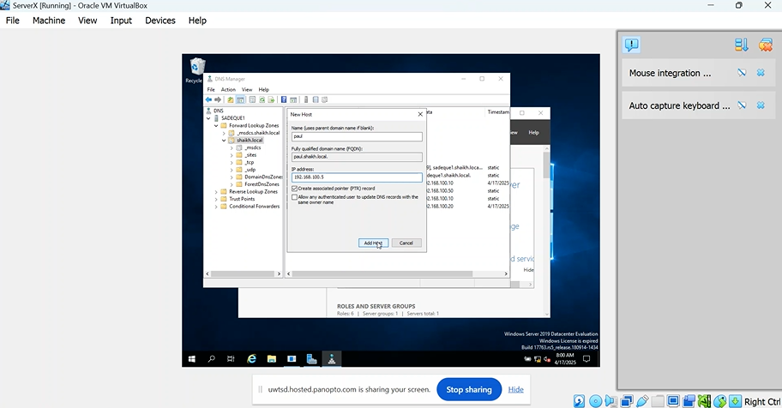
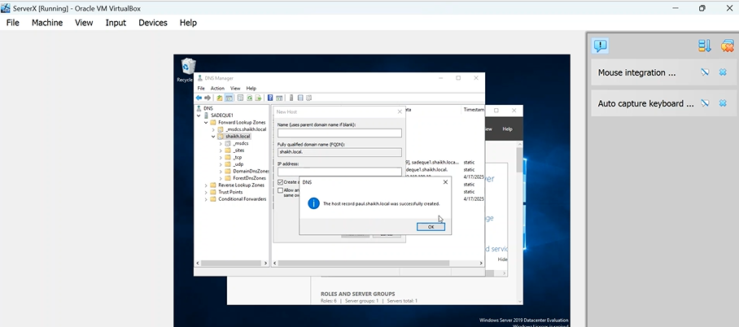
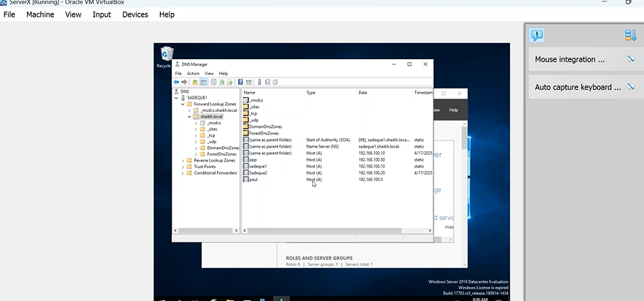
On this picture you can see that person has been added.

2.3 Creating a reverse lookup zone, PTR records.
This shows how the reverse lookup zone is created for all servers to allow IP addresses to be resolved back to their corresponding hostnames.
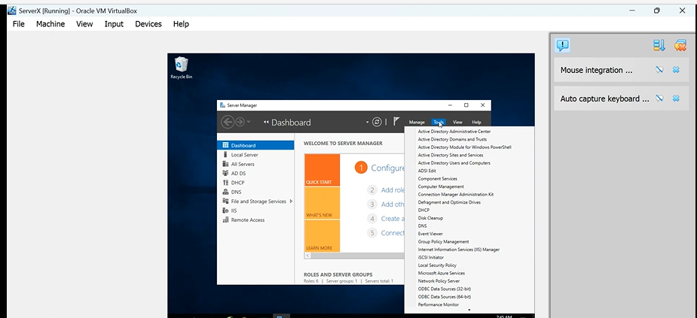

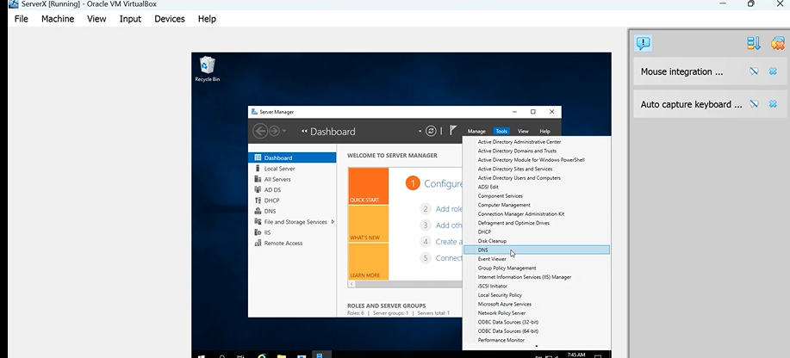

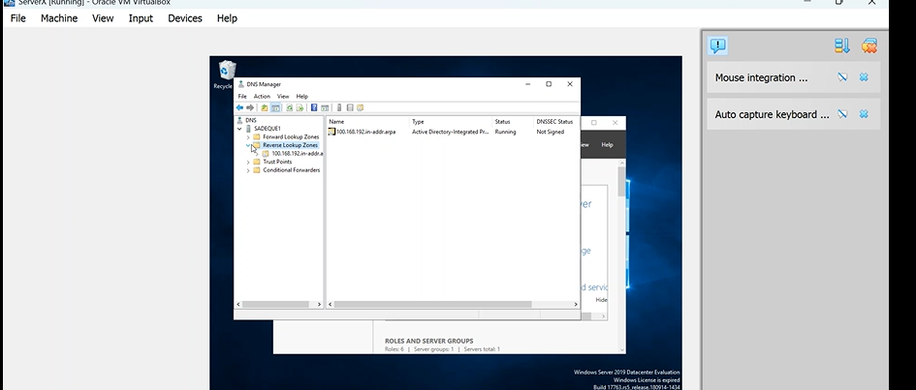

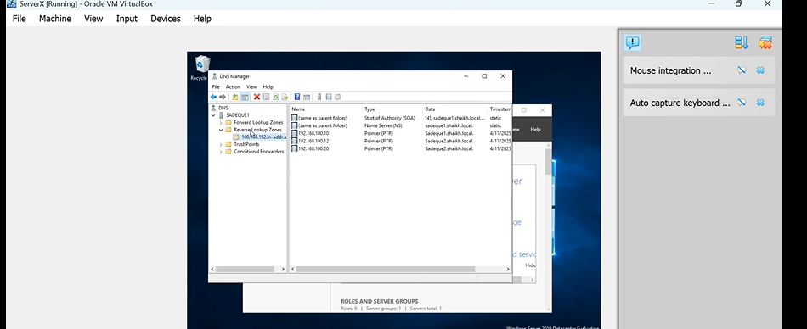
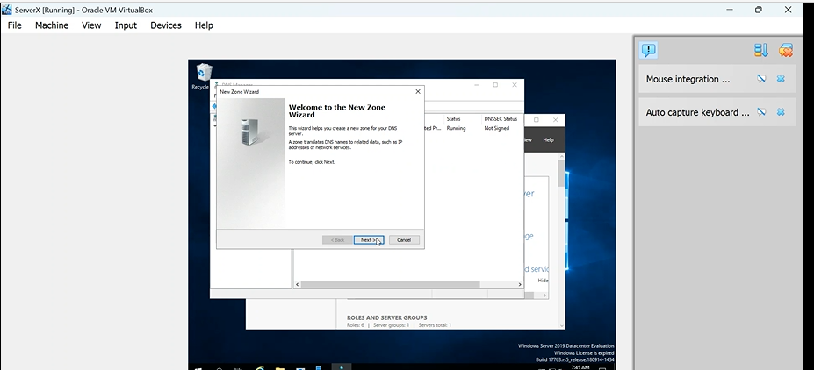
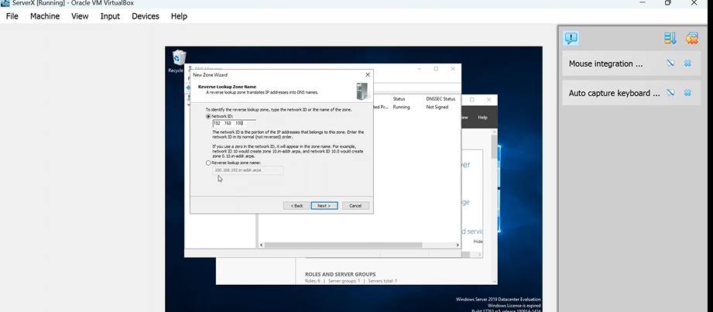
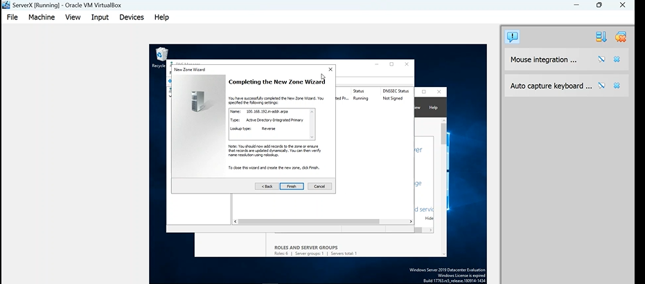
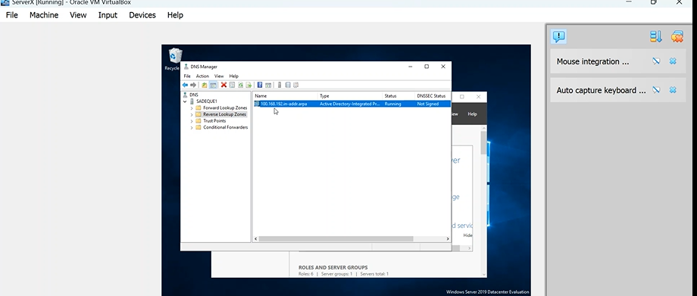

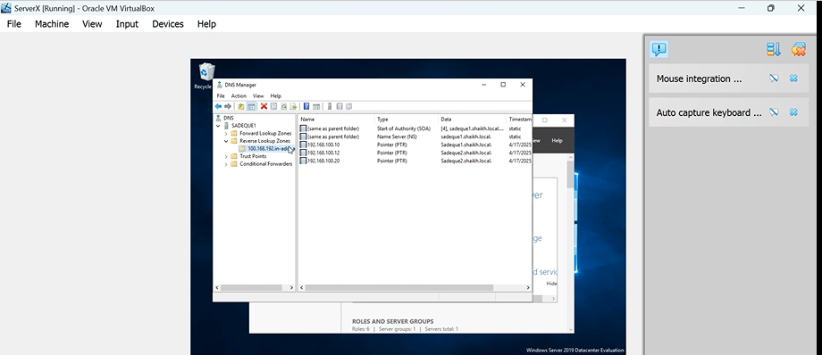

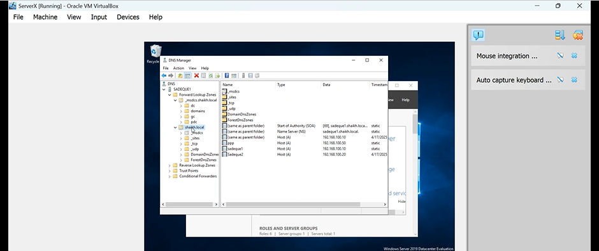
Picture showing the domain that has been created.
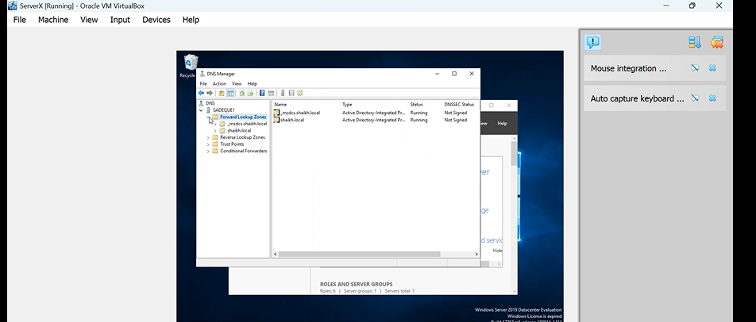
Picture showing to go to forward Lookup Zone.
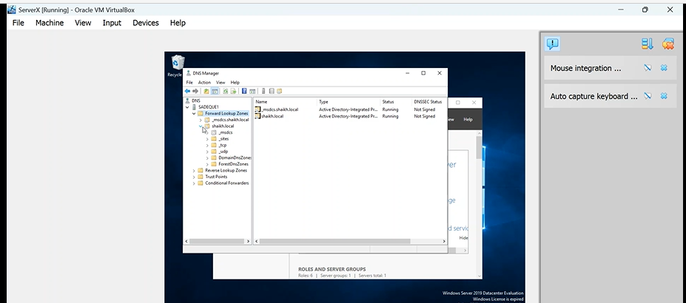
Two domains here are shown on the pictures. Domain and subdomain.

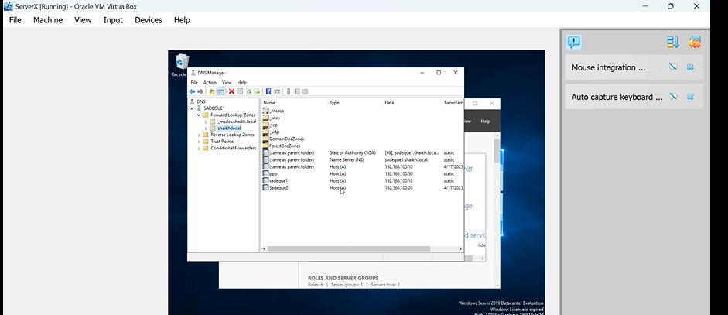
New host -picture.

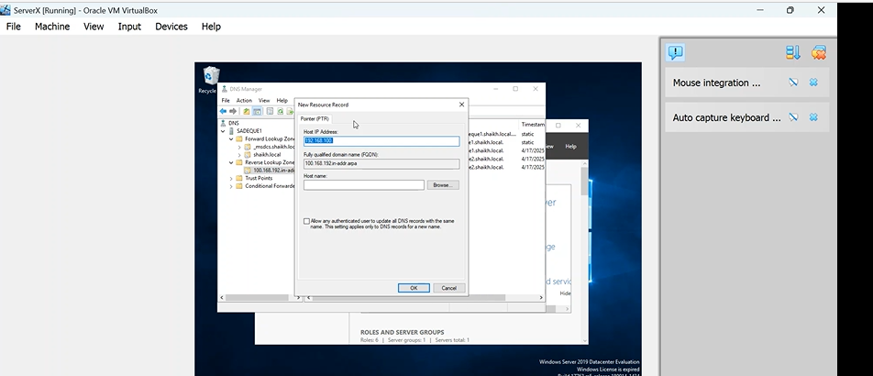
Creating a new pointer
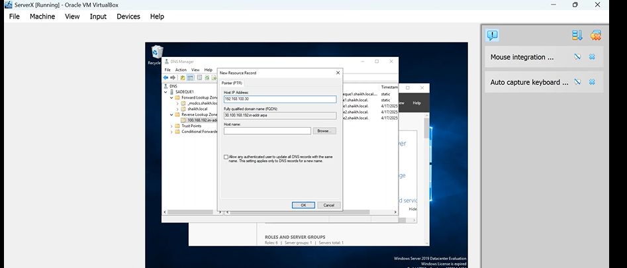Picture of a new host IP address.

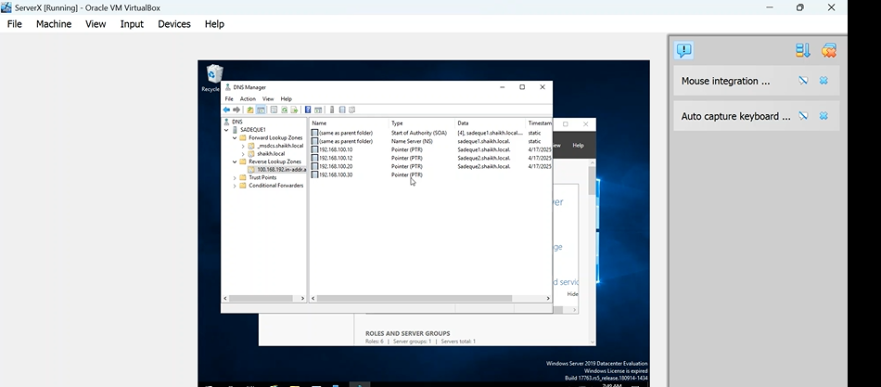
In this picture new domain has been added.

3.Encrtypted linking among Swansea and London

3.1.
Configuration Site -to -Site VPN to London Network.

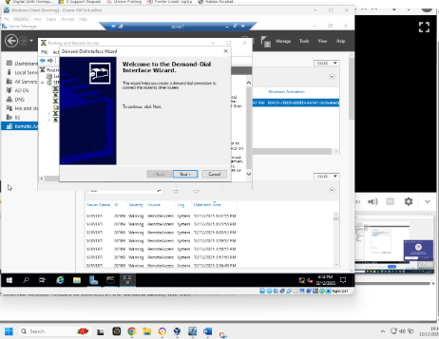
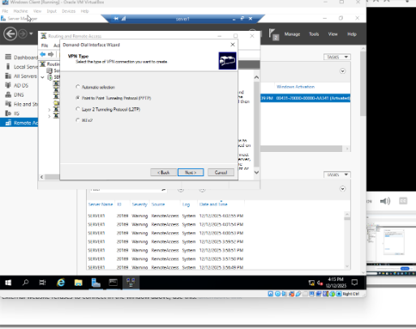
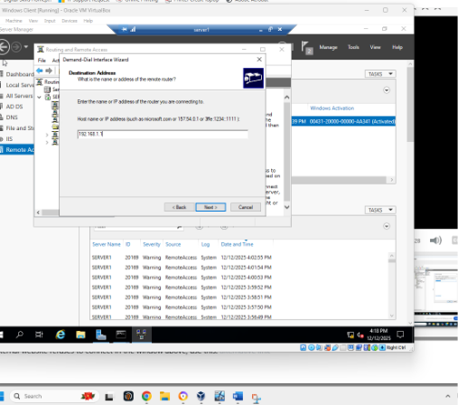
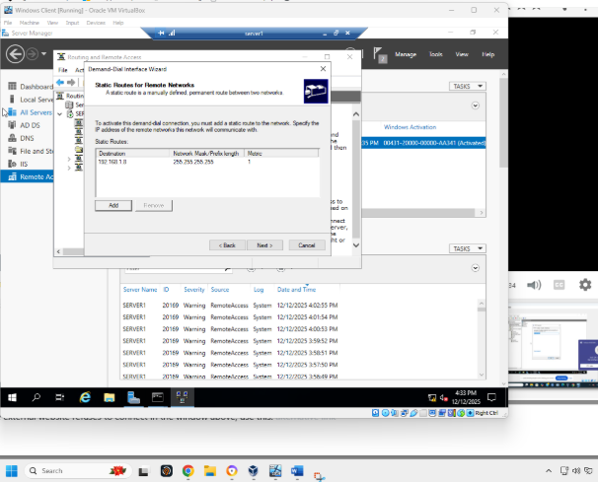
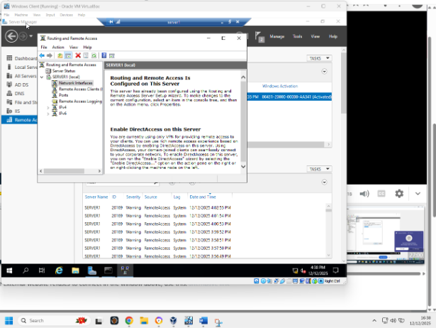
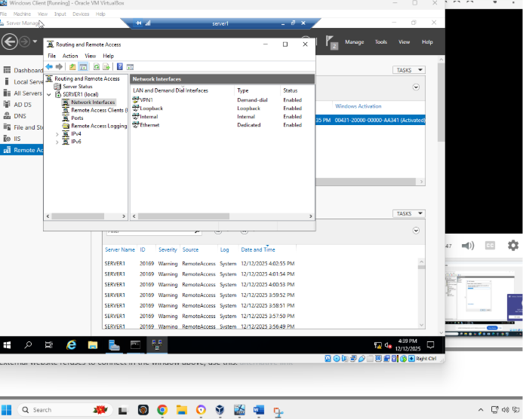
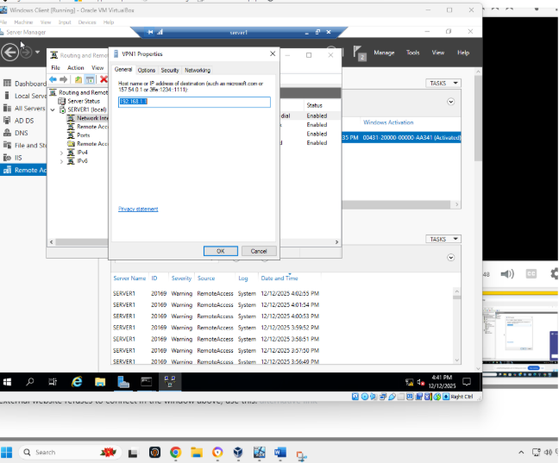
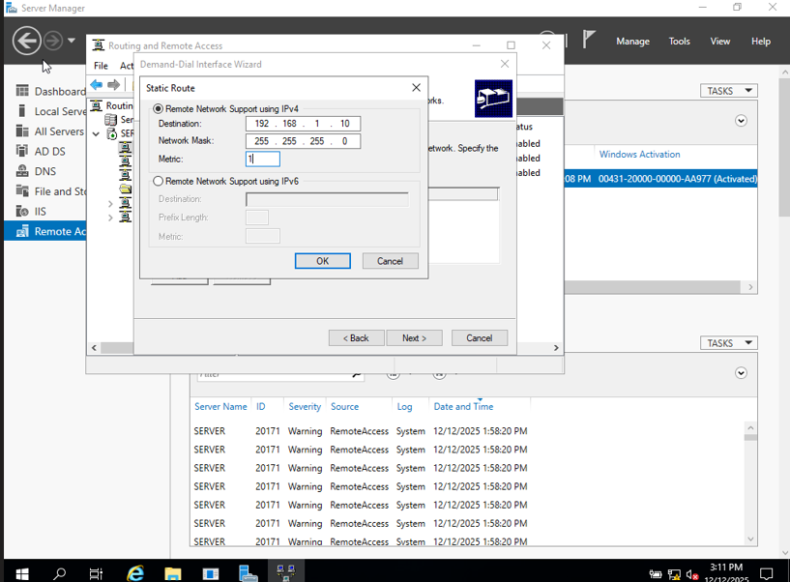

4.1
This demonstrates the creation of user accounts for the yourname.acca domain using the naming convention: first initial, dot, and last name (e.g., n.kaliyamurthy).
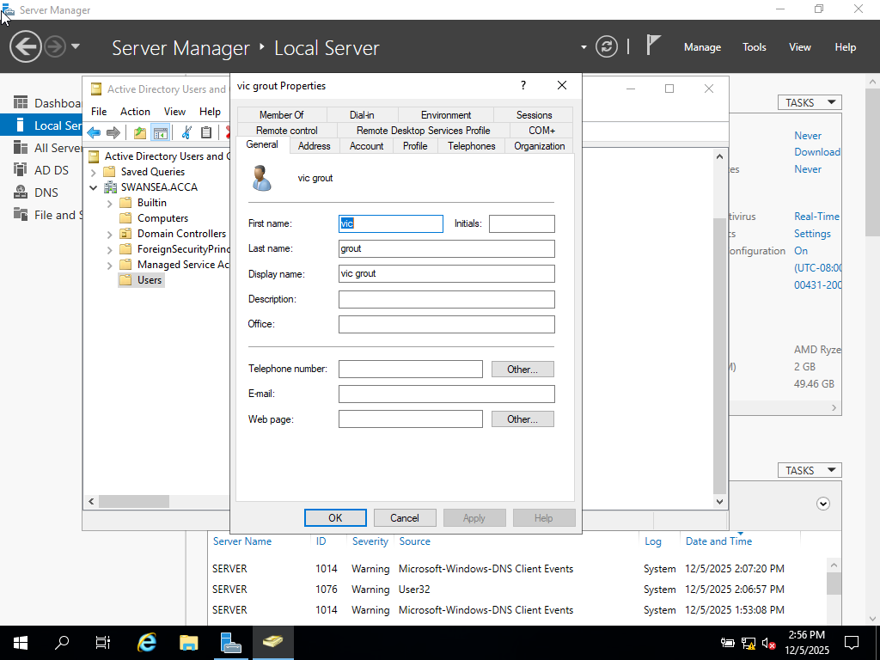
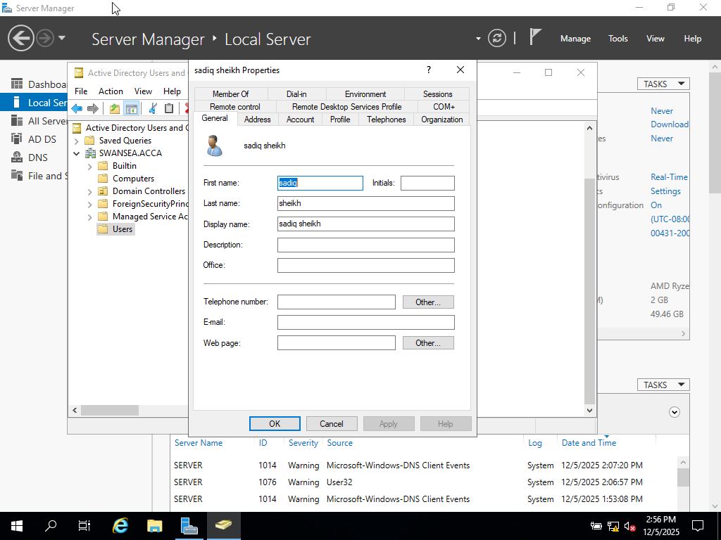

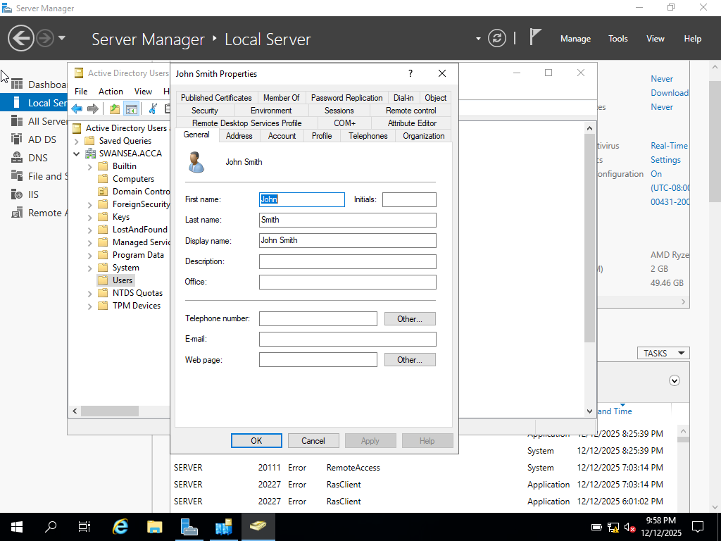

5.Domain Membership
This section presents the configuration shown below.
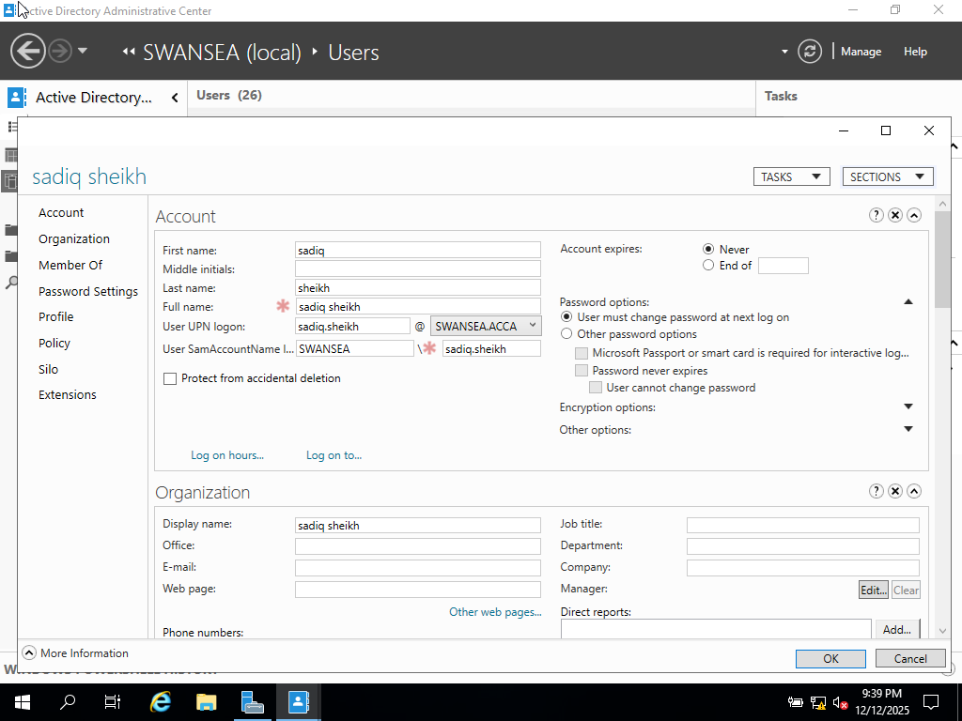
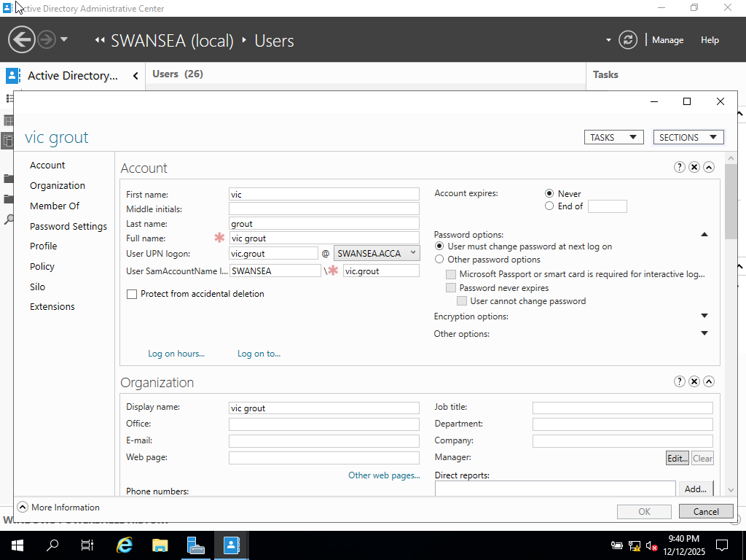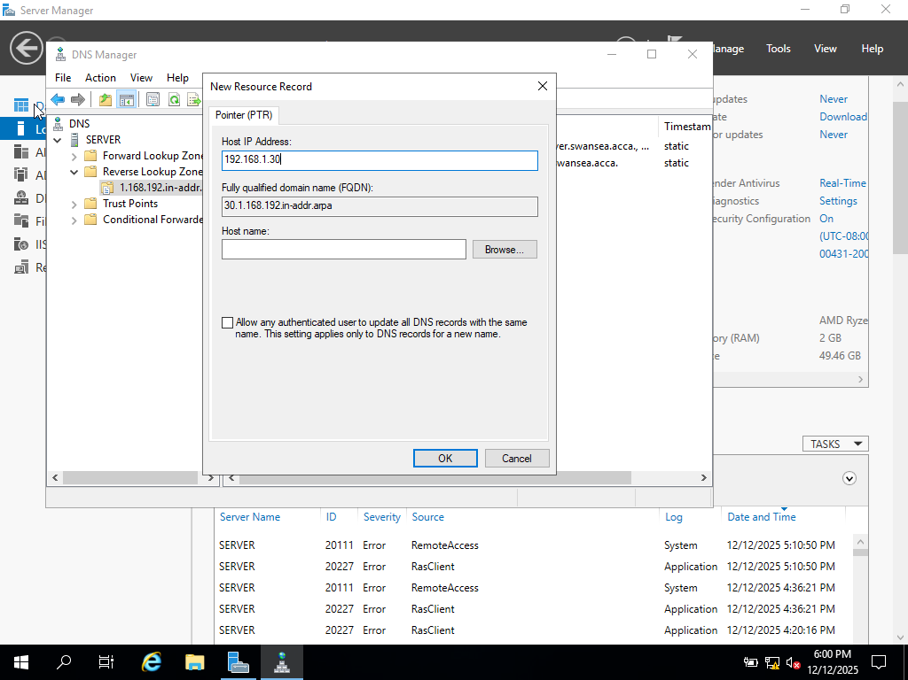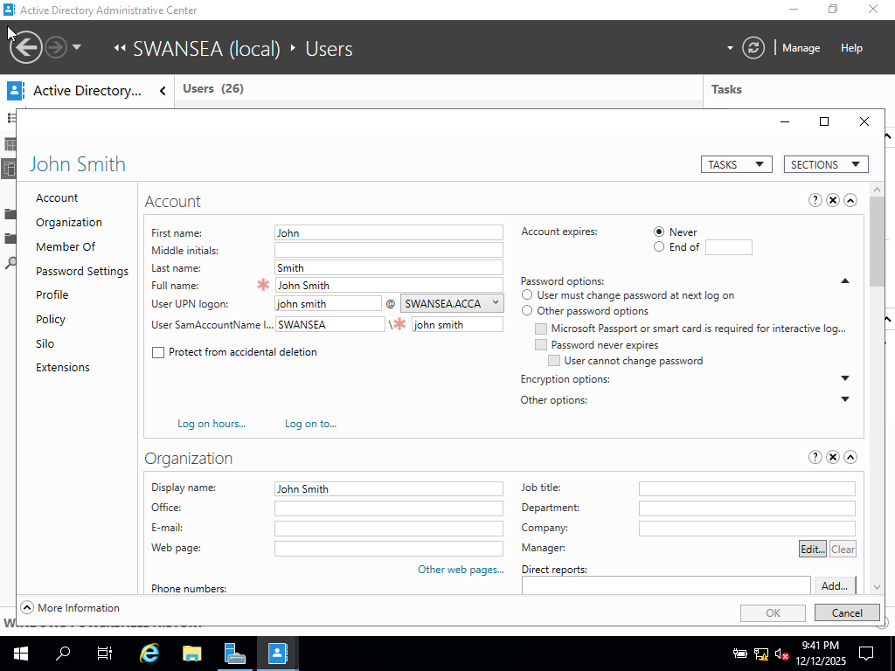

6. DHCP Server

6.1
. This task requires configuring S-DC to function as a DHCP server, assigning IP addresses in the selection for each network, and defining additional DHCP selections in accordance with the structure design.

6.2
Configuration steps are shown below.

6.3
It is demonstrated here that all clients are assigned IP addresses automatically by the DHCP server.
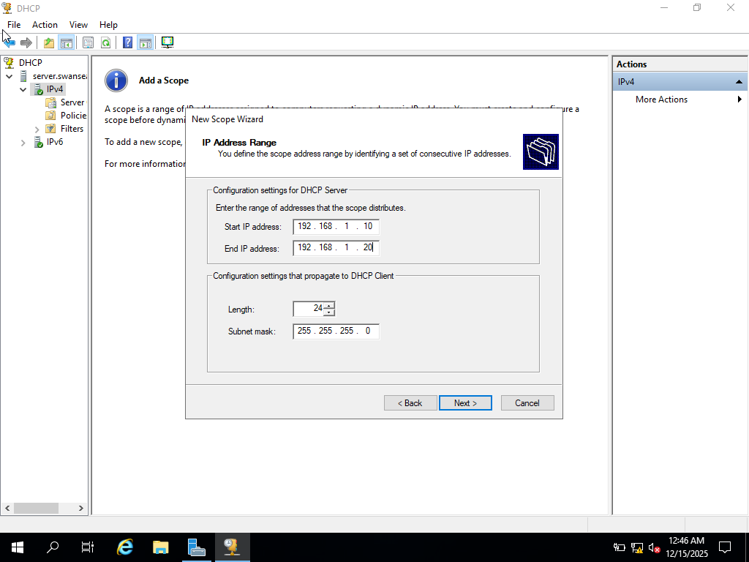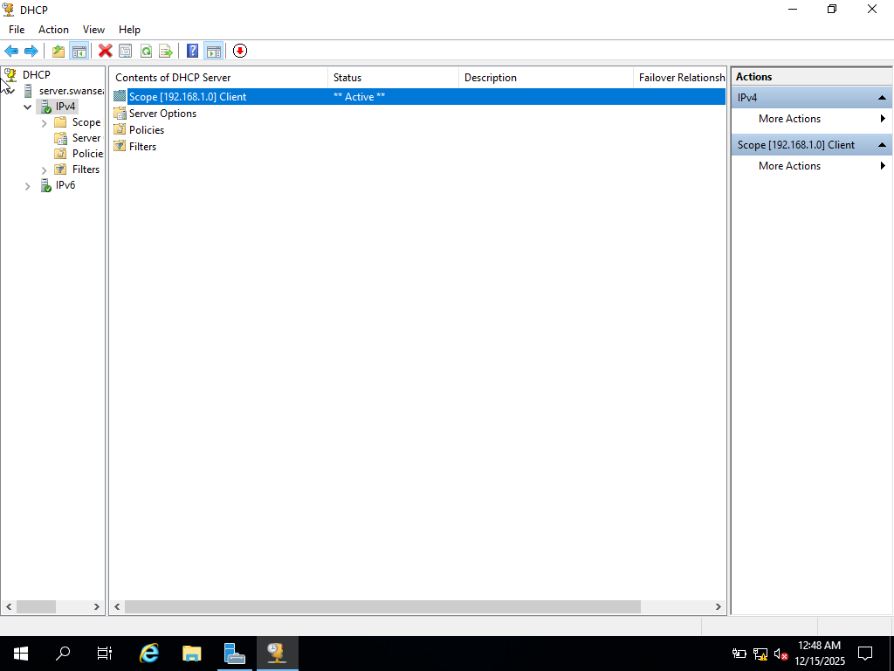

7.Test and Troubleshoot
7.1.
Network connectivity is tested to confirm that the Swansea and London networks are properly connected and fully operational; any issues identified are troubleshot accordingly.
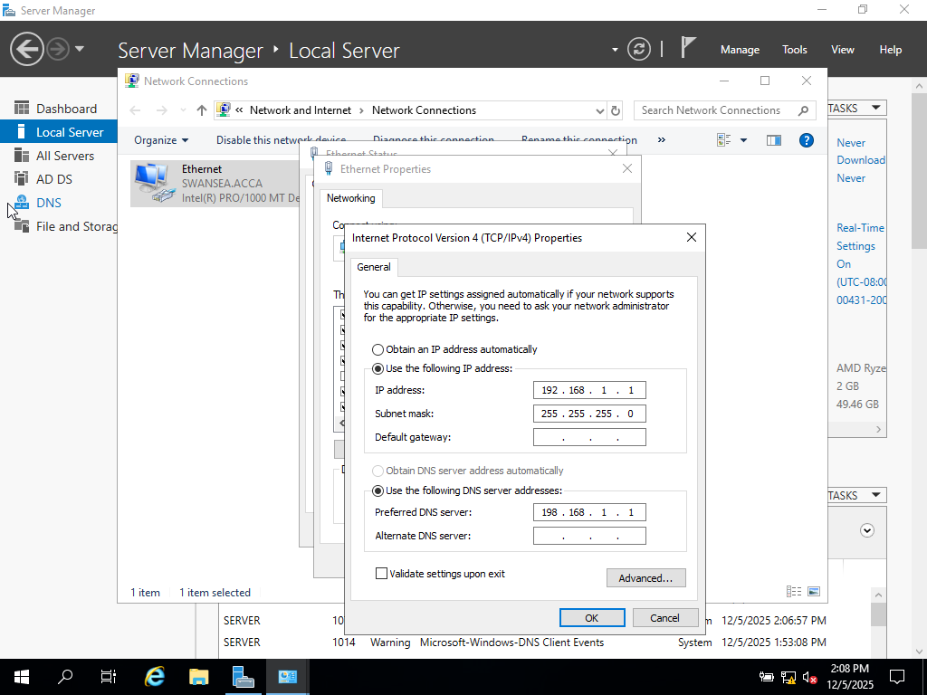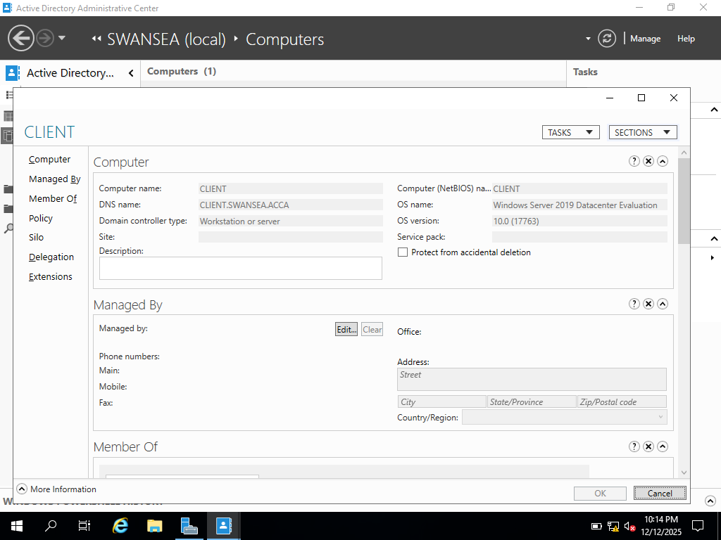

8.1 Mount disk drive.
These screenshots illustrate that Full Control permissions are provided exclusively to Domain Users, whereas other network users are limited to read-only access.
The client drive is created on the C: drive.
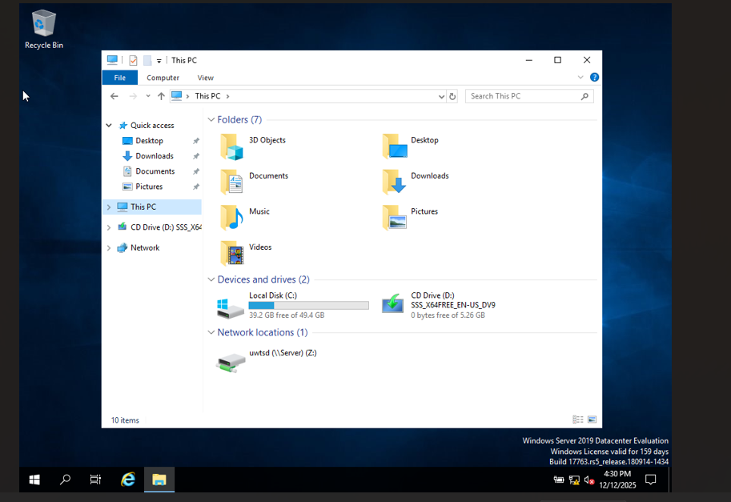

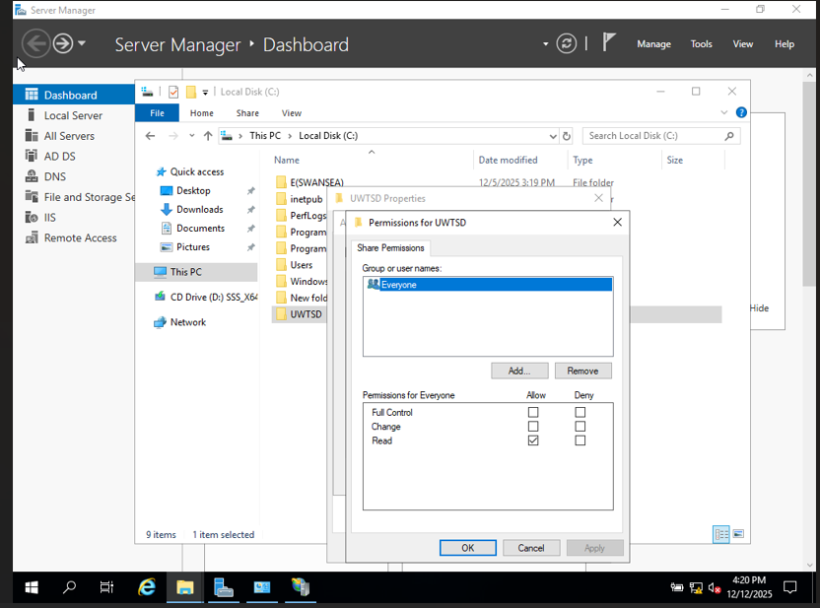
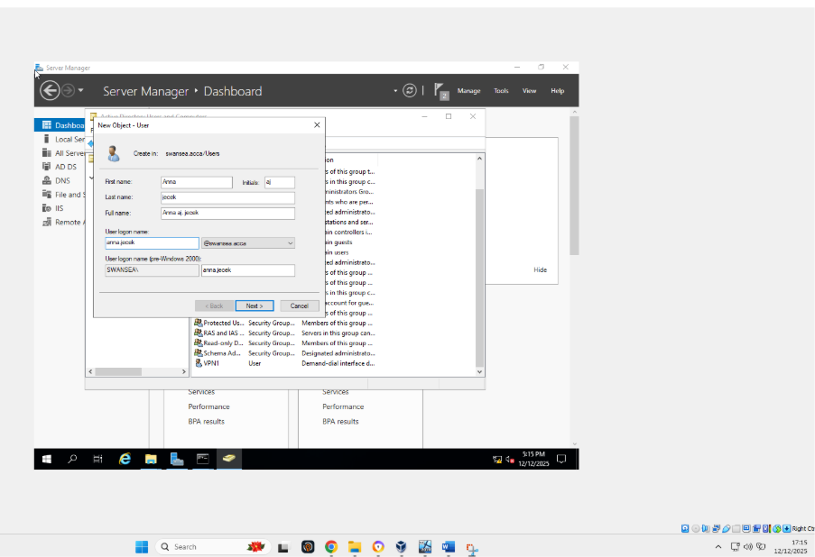

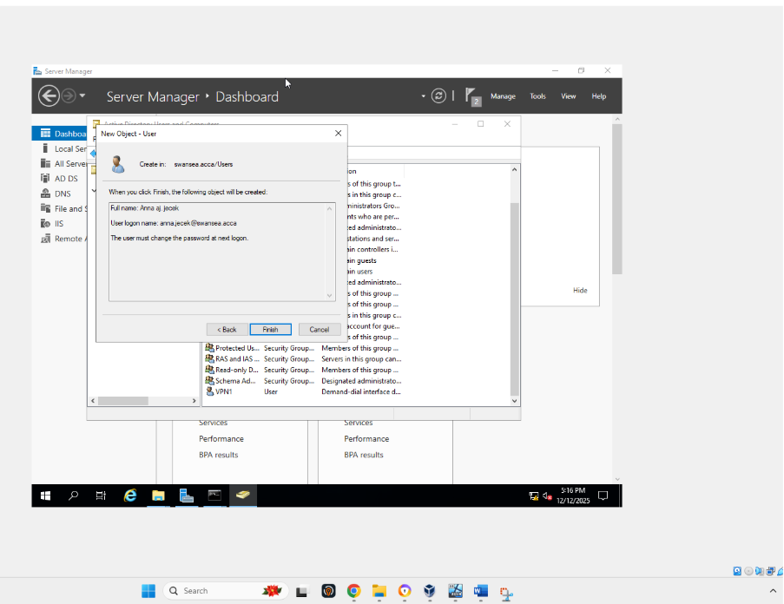
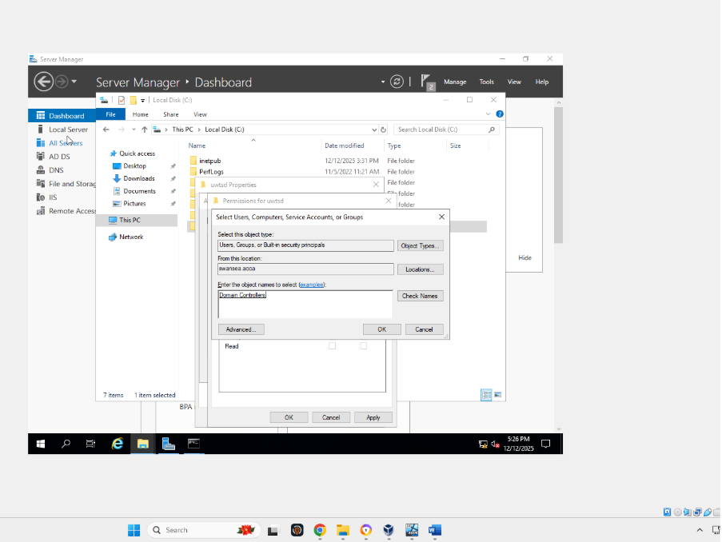

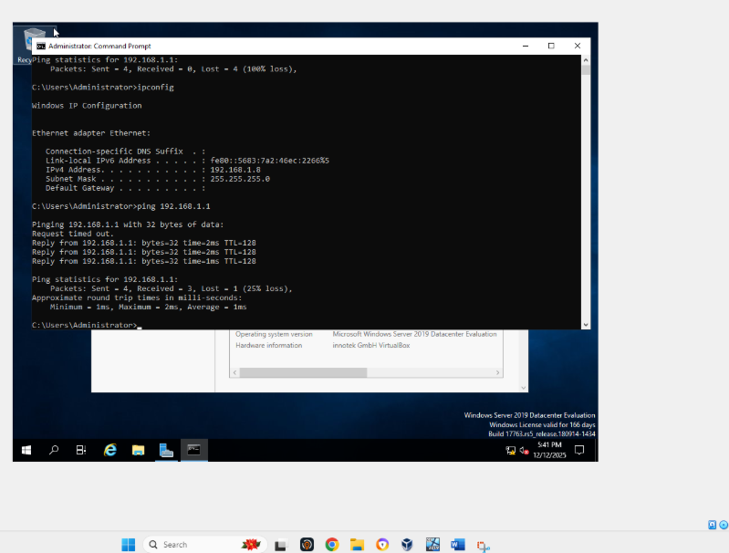

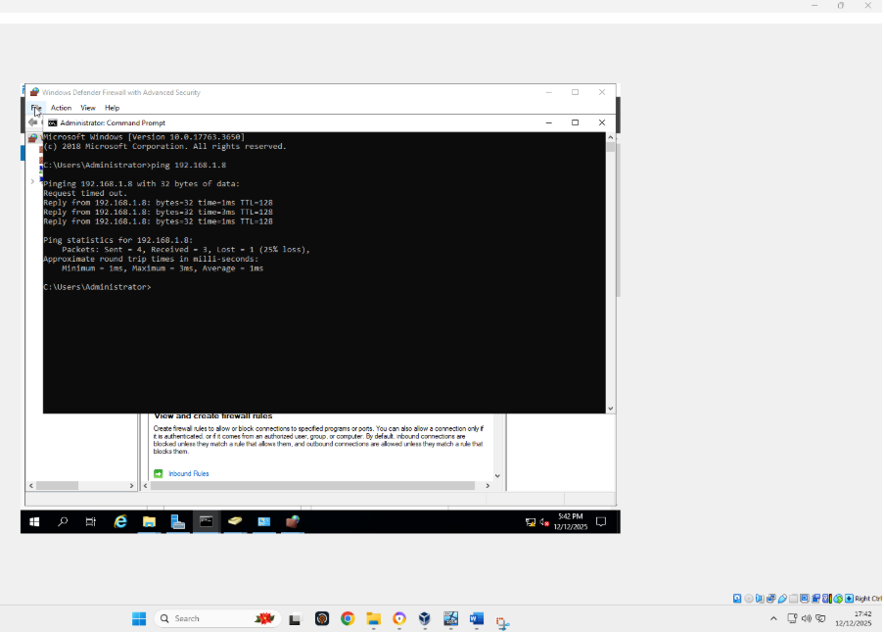
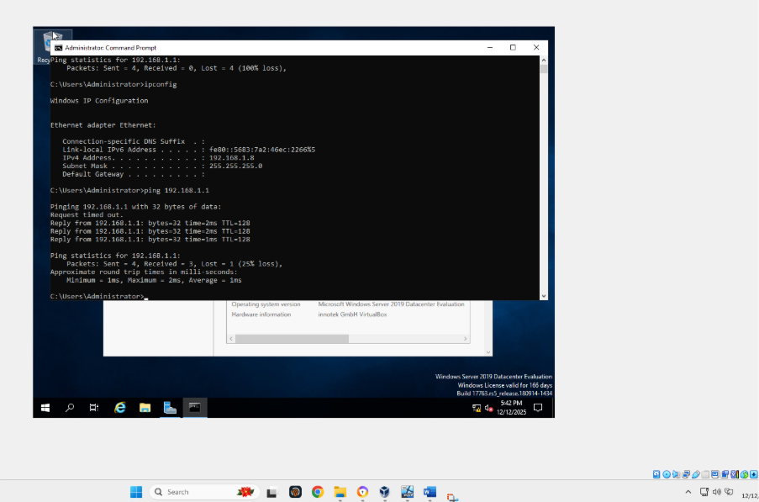
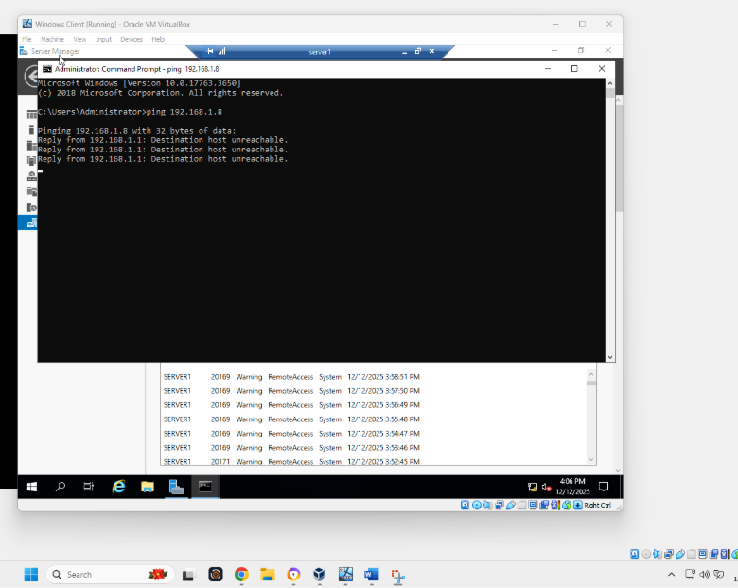
Pic showing not pinging as we have given access only to receive it.

9. IIS Server

9.1
Creating webs. Yourname.acca website and qualify windows inner confirmation.
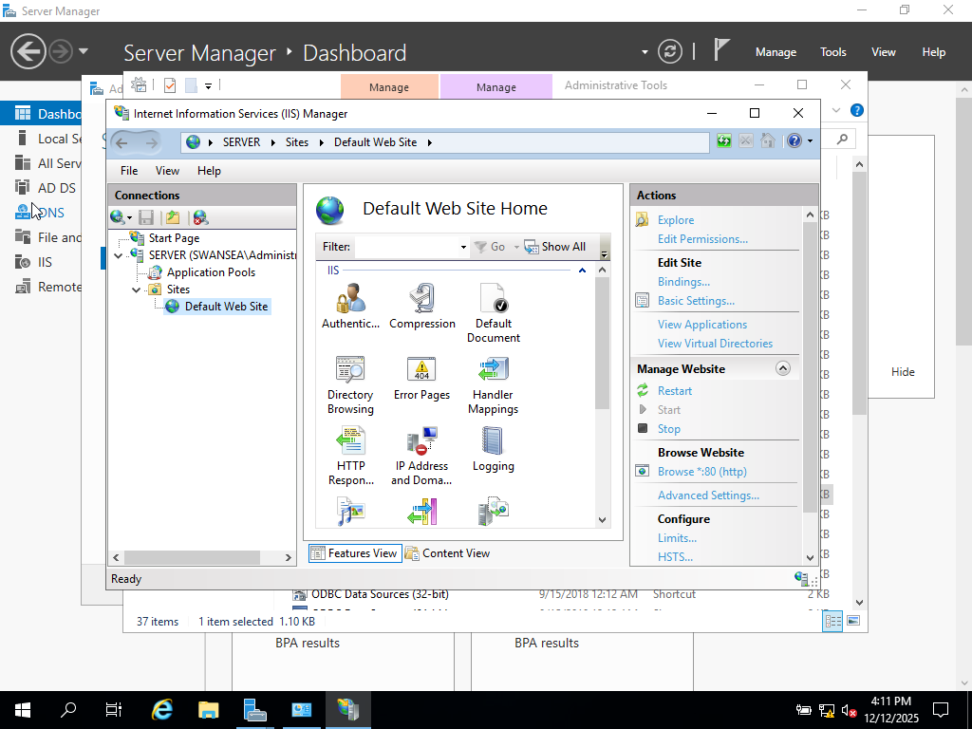

10. Remote Desktop Services

10.1
These illustrations present the configuration of remote access for S-DC from any other machine within the network.

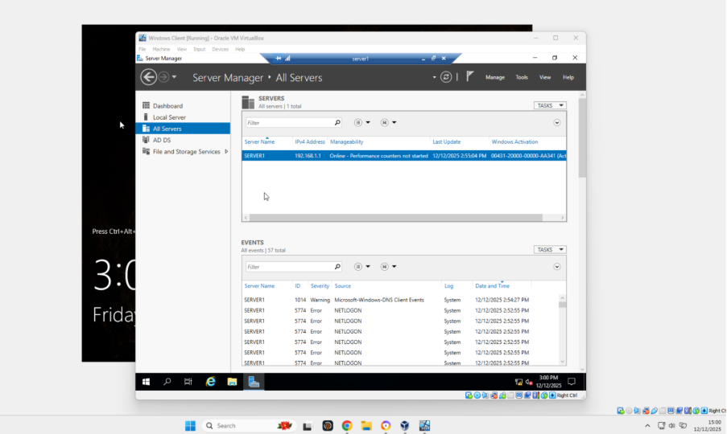

Summary
In conclusion, a secure and fully combined network infrastructure was successfully deployed across the Swansea and London environments. Routing and Remote Access Services enabled controlled inter-site communication through persistent IP forwarding and customised firewall policies. A new Active Directory forest (yourname.acca) was implemented with a comprehensive DNS configuration, including forward and reverse lookup zones, to support accurate name resolution and scalability. A secure site-to-site VPN employing strong encryption confirmed protected data transmission among locations. User provisioning was programmed using PowerShell, and all servers and users were successfully joined to the domain. Centralised DHCP services provided constant and secure IP address allocation, while complete testing confirmed that the solution meets enterprise-level operational, security, and reliability requirements.

