Generating Business Data and Analysing Data
Contents
- Executive summary
- Explanatory of data file’s
- Data analytics
- Data visualization
- Spreadsheet models
- Appendix
- Formulas
- references

Executive summary of the definition of analysis

The meaning of data analysis is to determine identification and measurement on a specific element. Whilst analyzing it is important to understand the purpose of what is being analyzed.
Statistical analysis is collecting and gathering different forms of data, analyzing to interpret results. There are various types of a data analysis such as predictive or casual (Whiting, 2018).

When using excel, there are specific functions to calculate objectives such as the average, min or maximum criteria. Data analysis is a way of understanding and inspection of results, this narrows down the report for example, Scientists use methods comparable to data analysis to find whether data is significant or insignificant.
Performing data is simple, there are mainly three steps. Collecting data, -configuring information and sharing knowledge. For sample, if the weather says it will rain, the television or online broadcasts will alert the public, this relates to the viewers with accurate knowledge of the area. This acknowledges pedestrians to take a suitable jacket or an umbrella. Henceforth leading to data files being useful for daily activities.

At the same time as collecting data, it must be relevant to research as it is most important to ensure the information gathered is accurate, and accountable. Before running an analysis, often Pre – processing data is a simple way to help maintain missing values and irrelevant data, in order to calculate data analysis. Pre-processing requires preparation such as standardizing the data found. However, it can be time consuming especially entering data in manually and can leave room for error, although using a program such as java can help to speed up the process, hereafter it is down for the users on their preference.

Excel illustrates the powerful features particularly with analyzing data. Excel uses continuous formats such as sort: which data can be columnized and sorted into ascending or descending order. On the other hand, formatting enables highlighted cells with a explicit color depending on the cells value. from now, a simple excel chart can speak louder than a sheet full of numbers. Data analysis functions in excel like the what-if analysis allows the user to enter scenarios to try out different values. Excel has progressed extremely since first launch in 1985.

During this task, analysis will be set to identify meanings of formulas and to identify the analysis of different contexts, as well as definitions of multiple data analytics.
A question list has been set per data file, to help configure, locate and solve different formulas. four files have been allocated for a find and answer sheet. Questions have all been created on past lectures and basic knowledge of the subject.
The four files are Prosumer survey, Appliance carbon data list, Weather list file and an Electrical data file.

What is a prosumer file? -Prosumer file is categorical data; this is definite data because it contains mainly characters. The prosumer file is relatively about various businesses and placing them in comparison with one another. This helps to find out who are the largest businesses globally or nationally.

What is an appliance carbon data list? – this is a mixture of categorical and rational data, as it is combined with numbers and characters, the file is based on appliances people own in their home and relays to the usage per year.

What is a weather list file? - Weather data file is constructed on rational data, since most of the information gathered are figures. This file is based on location and the relativity and founded on the actions of the meteorological conditions.

What is an electrical data file? - Electrical file is based on merchandising to determine the brands and quantity of appliances used and acquired by participants.

Appliance file question

- Calculate each recorded sale for all customers. “£286.79”
- on average how many appliances did students own? ‘10’

Prosumer file
- What is the average employee per store? “115091” formula =average (C7:C952)
- How many people said yes for the business having sustainable evidence? “863”
- How many businesses said no for their business being sustainable? “62”
- How many businesses were identified as a small sized company? “36”

Weather file
- What was the minimum amount of rain? “0mm”
- What was the maximum rain fall? “40mm”
- What was the overall amount of rainfall? “198mm”
- What was the average daily wind speed (weather file)? 2.470968

Electrical data file
How much electricity did the university use 17th February 2017? ‘1648.732’ Watts.

Data analytics -
Data analytics is the use of aQuantive methods, by using technology and statistical procedures, this can help business owners to observe business operations to predict future decisions Via past records.

There are various ways to understanding different Analytics, such as the descriptive analytics which helps to better the knowledge of performance and make informal decisions. On the other hand, there are predictive analytics which improves future predictions by examining patterns and data by detecting links between the statistics and exploiting them for better purposes. Although the prescriptive analytics is a stronger way to identify alternatives to min or max of a objective (R.Mullins, 2019). A textbook example of using data analytics, could be reducing the price on a product and predicting how many will sell through, predictive sales data.

Data inputs are used for continuous records for instance accounting, financial profitability analysis or HR measurements, etc. This helps a business by recording accurate data and using the information stored to predict future sales or to prevent errors.
Substitute

Data visualization
Data visualization is a format process of analyzing data and information in a graphical chart. Its regularly used as means to deliver visual reports to participants for the operations and performance statistics of an application or any I.T asset.
Day to day problems often require professional expertise to help solve issues, which data visualization can help improve. although interaction with the digital world seems to be increasing, leading to the use of more data programs, for example social interaction online has a large active perspective on technologies in public areas. Visualization research is apart of the beginning to help expand the focus in and out of the work environment. (Thomas, 2005). Nonetheless, using diverse charts to input data can give a real visualization benefit.

Spreadsheet models
To improve performance, organizations ensure they keep record transactions in and out of the business to evaluate operations, processes or services, to better the use of predictive decisions. Spreadsheet modeling is the use of mathematical data such as sales or budgeting products costs, when originating a business, they will often use spreadsheet application process to perform calculations on data entered in manually or automatically (BITESIZE, 2019).

Spreadsheet models – There are 3 models in a spreadsheet, presentation, data model, logic model. Each file has these logistics .Spreadsheets are a summary of information, there are three main components when using spreadsheet models From this article, the understand of Spreadsheet models is based on a decision modelling is widely used in business today. (Mather, 1999).

Data models are an intellectual organizer program which elements multiple tables of data by structuring relativity to realistic units. For example, this could represent several things for instance, bicycles. The data composed will configure the information, in the color, size or number of bicycles (Oppenheimer, 2012).

Logic model- is a graphical process used to interconnect which describes the theory and assumptions of related activity or solutions a logical model is deciphered through diagrams, or a flow sheet which helps to demonstrate a programs procedure. This type of model is useful because of its possible calculations projecting activities required to attain anticipated goals. Logic model is the construction of constant factors for those with values either constant changing.

Presentation model – this model is a large complex principal model which helps to integrate data from different tables, assisting to build a graph or pivotTables effectively. Also, presentation is configured in the way categorical or numeral information is transmitted into the program. Presentation models have an appealing visual look, with clear order size and immaculate charts.

Appendices
Evidence of additional zip files, putting formulas and functions into action.
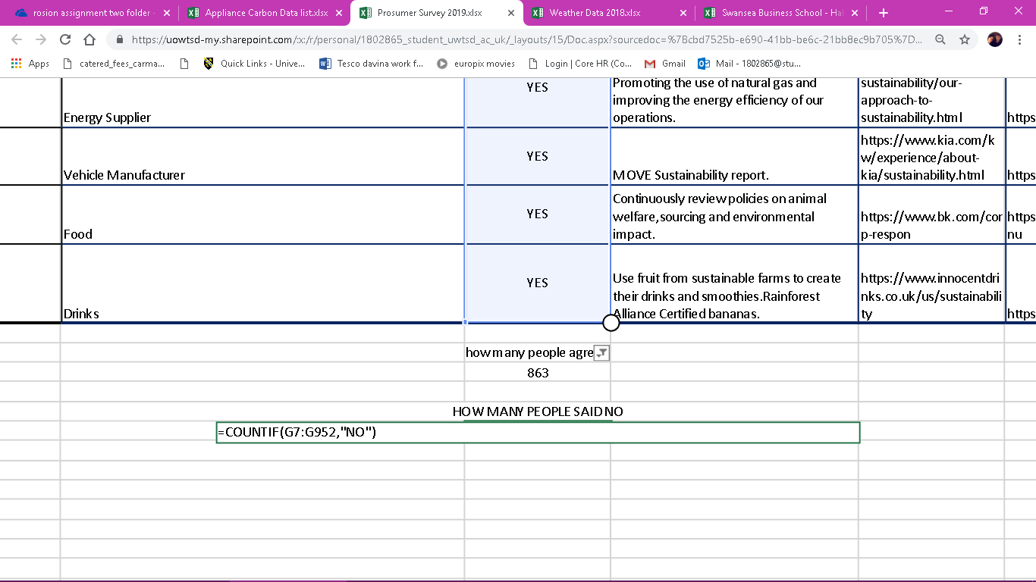
During this screenshot of the prosumer file. The question being asked was “how many people said no” for the subject of evidence of sustainability, the answer was 62. As stated in the highlighted box, the formula used was =countif, this formula is used to hypothesise data to configure the amount of applicants for the question queried.

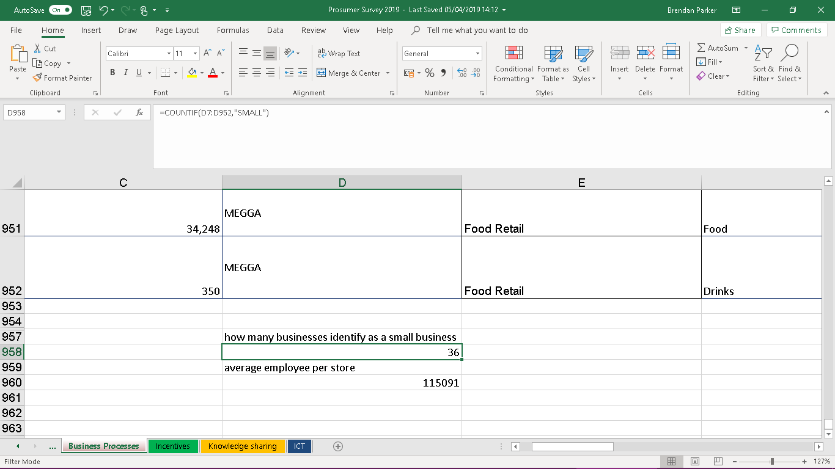
This print screen shot, the question highlighted was “how many businesses identify as a small business?” out of 950 results, is approximately 36. The way this was accounted stood from the formula being =countif” small” however the countif formula is one of the most frequent used formations during excel.

In the above print-screen, the other question related to the “average employee per store?” to get the answer from this question, the =average formula had to be executed. Whilst selecting the average formula, it was important to select the boxes of which I was questioning to get the overall answer in this case the boxes selected were (C7:C952). The results for the formula was 115091

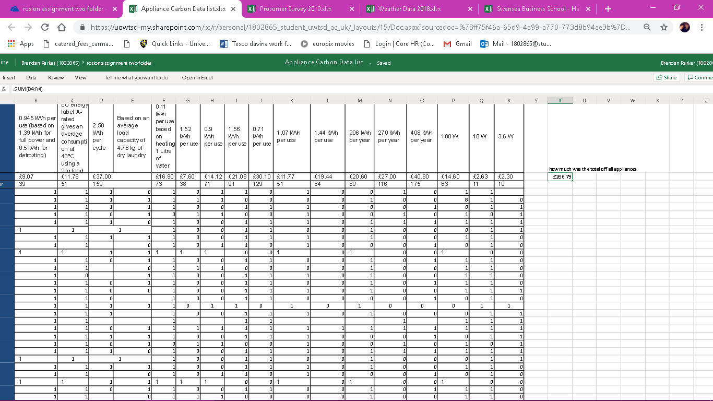
- during the appliance data file, the question asked was, Calculate each recorded sale for all customers. The formula used here was ( = sum)the reason for this formula was to find out the overall payment each appliance costed, for all appliances the result was “£286.79” formula =SUM(B4:R4).

Appliance screenshot evidence; 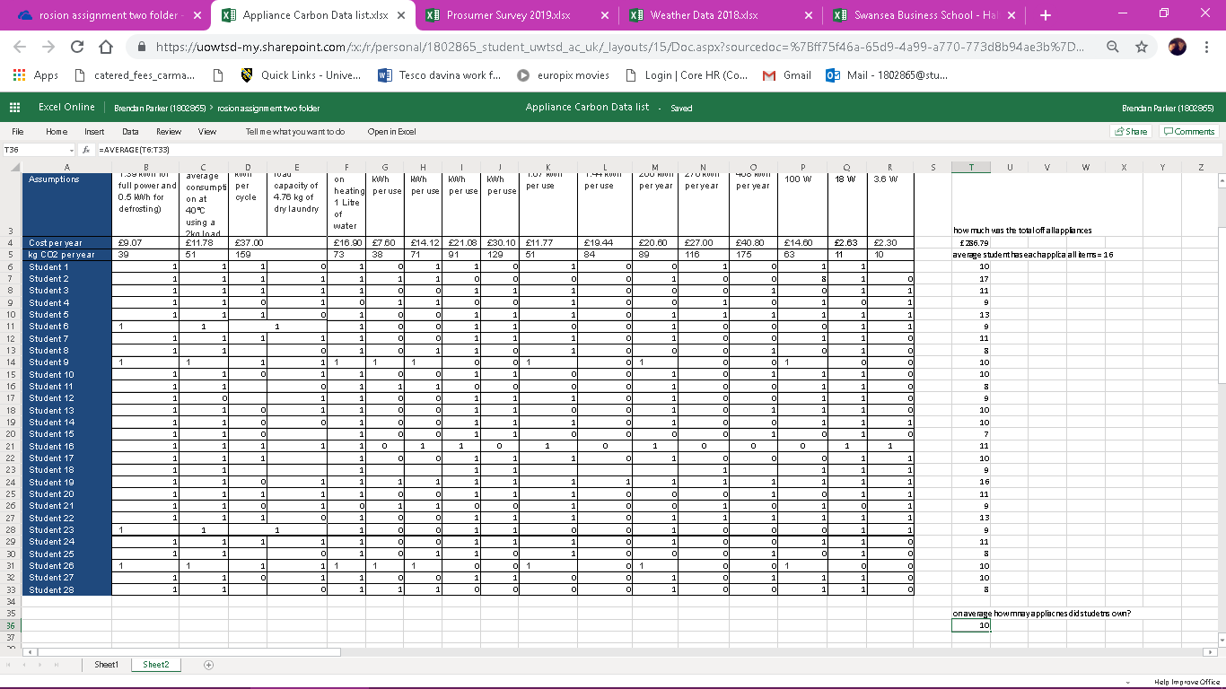
The question asked was a mixture of sum and average, the sum formula was used to calculate how many students owned atleast one of the item. However to determine the average ppliance per student the average formula had to be put into practice, (=average). The overall result was that each student had atleast 10 appliance’s out of the 16 electrical items.

Weather data file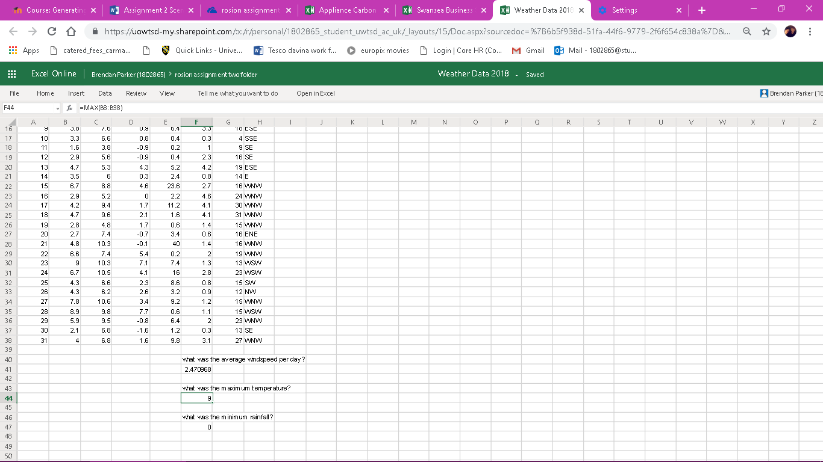
The first question quizzed was the average windspeed per day, through the power formula of =average:F8F38). The result was, 2.470968 mph.

This screenshot is from the weather data file, as shown three questions have been asked via formulas.
The question highlighted, was inquiring about the maximum temperature throughout the days entered.
The way to find out the maximum temperate was through a formula (=max: B8:B38). This formula, assistances to decipher the largest temperature.

Thirdly, the formula used in the excel spreadsheet was (=MIN) this showed the exact minimal rainfall. The outcome was :0

During this shot taken from the weather file, notice that a small amount of data has been combined to create this pivotable. The evidence of a bar chart is based on the sum of rain throughout the period. This is a pivotable and is useful for creating graphs, bar charts or scatter graphs, Etc.

Electrical data file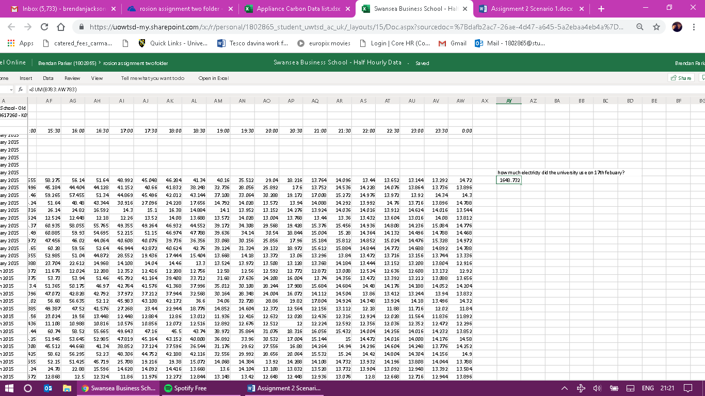
During the last file, the formula used was an average sum to figure out how much electricity the university had used on the 17th February 2017. The exact formulae was =SUM(B783:AW783). This specific function allowed the system to calculate the overall electricity used on this day.

Formulas strengths and explanations
Whilst analysing data on excel there are specific functions which enable precise choices to find out the overall answer to a question. For example, here are a few formulas acquired from lectures thus leading to help towards assignment structure.
- How to find out whether whom said yes, the formula is =countif(B2:B902,"Y") the strength of using this type of formula is to benefit not only the creator of the table, but to benefit people who want to quickly look up any criteria entered, rather than counting manually. (Office, 2019).
- Find out who said no =countif(B2:B902,"N") the same however relates to all ‘countif’ formulas, by using this specific function it peruses categorical data and forms the results to what are being located.

- Formulas vary on the operation at hand, especially when configuring difficult data however finding out a percentage is simpler once taught, henceforth: Working out percentage, For example, open excel data file then click ‘sales’ in the file, in this case the column is f2, then once total of sales once it has been worked out, then divide using the phonetic alphabet which in this case is ‘/’ at that moment press Fix it (f4) formerly go to it again and move the decimals over twice and this will give the result, the formula will look like (=F2/$F$905). Using percentages are vital when calculating sales or revenue, businesses use percentages to determine what products have been sold and what the percentage of profits are being made. In excel this becomes an advantage to researchers.

- =MAX select all discount columns press enter and that is the highest discount offered =MIN(G2:G902). The lowest discount offered is the same with minimum criteria. However just a different term, I.E. MIN (G2:G902) – minimum and maximum formulas hold key for some of the most used in excel, although the minimum and maximum is thought to be easily calculated, using excel formulas, will save time in relation to finding information.

- This formulae allowed the design of regularity within the system, for example ‘How many people on average price on total sales?’ (use this formula) =AVERAGE(F2:F902) The average, is used to regulate the most common number in the fractions.

references
Budget 2013 and 2014 Speeches
https://www.gov.uk/government/speeches/chancellor-george-osbornes-budget-2014-speech
https://www.gov.uk/government/speeches/budget-2013-chancellors-statement
Isenberg, P., Elmqvist, N., Scholtz, J., Cernea, D., Ma, K. L., & Hagen, H. (2011). Collaborative visualization: Definition, challenges, and research agenda. Information Visualization, 10(4), 310-326.

Works Cited
BITESIZE, B. (2019). BITE SIZE. Retrieved from https://www.bbc.com/bitesize/guides/znjmn39/revision/1
Mather, D. (1999). Retrieved from https://moodle.uwtsd.ac.uk/pluginfile.php/231245/mod_resource/content/1/mather.pdf
Office, E. f. (2019). 365 Excel 2019 Excel 2016 Excel 2013. Retrieved from https://support.office.com/en-ie/article/create-a-data-model-in-excel-87e7a54c-87dc-488e-9410-5c75dbcb0f7b
Oppenheimer, D. (2012, august 23). microsoft . Retrieved from https://www.microsoft.com/en-us/microsoft-365/blog/2012/08/23/introduction-to-the-data-model-and-relationships-in-excel-2013/
R.Mullins. (2019). moodle. Retrieved from https://moodle.uwtsd.ac.uk/course/view.php?id=3564
Thomas. ( 2005). The Research and Development Agenda for Visual Analytics. Retrieved from https://journals.sagepub.com/doi/full/10.1177/1473871611412817
Whiting, B. (2018). Retrieved from https://study.com/academy/lesson/types-of-data-analysis.html).

