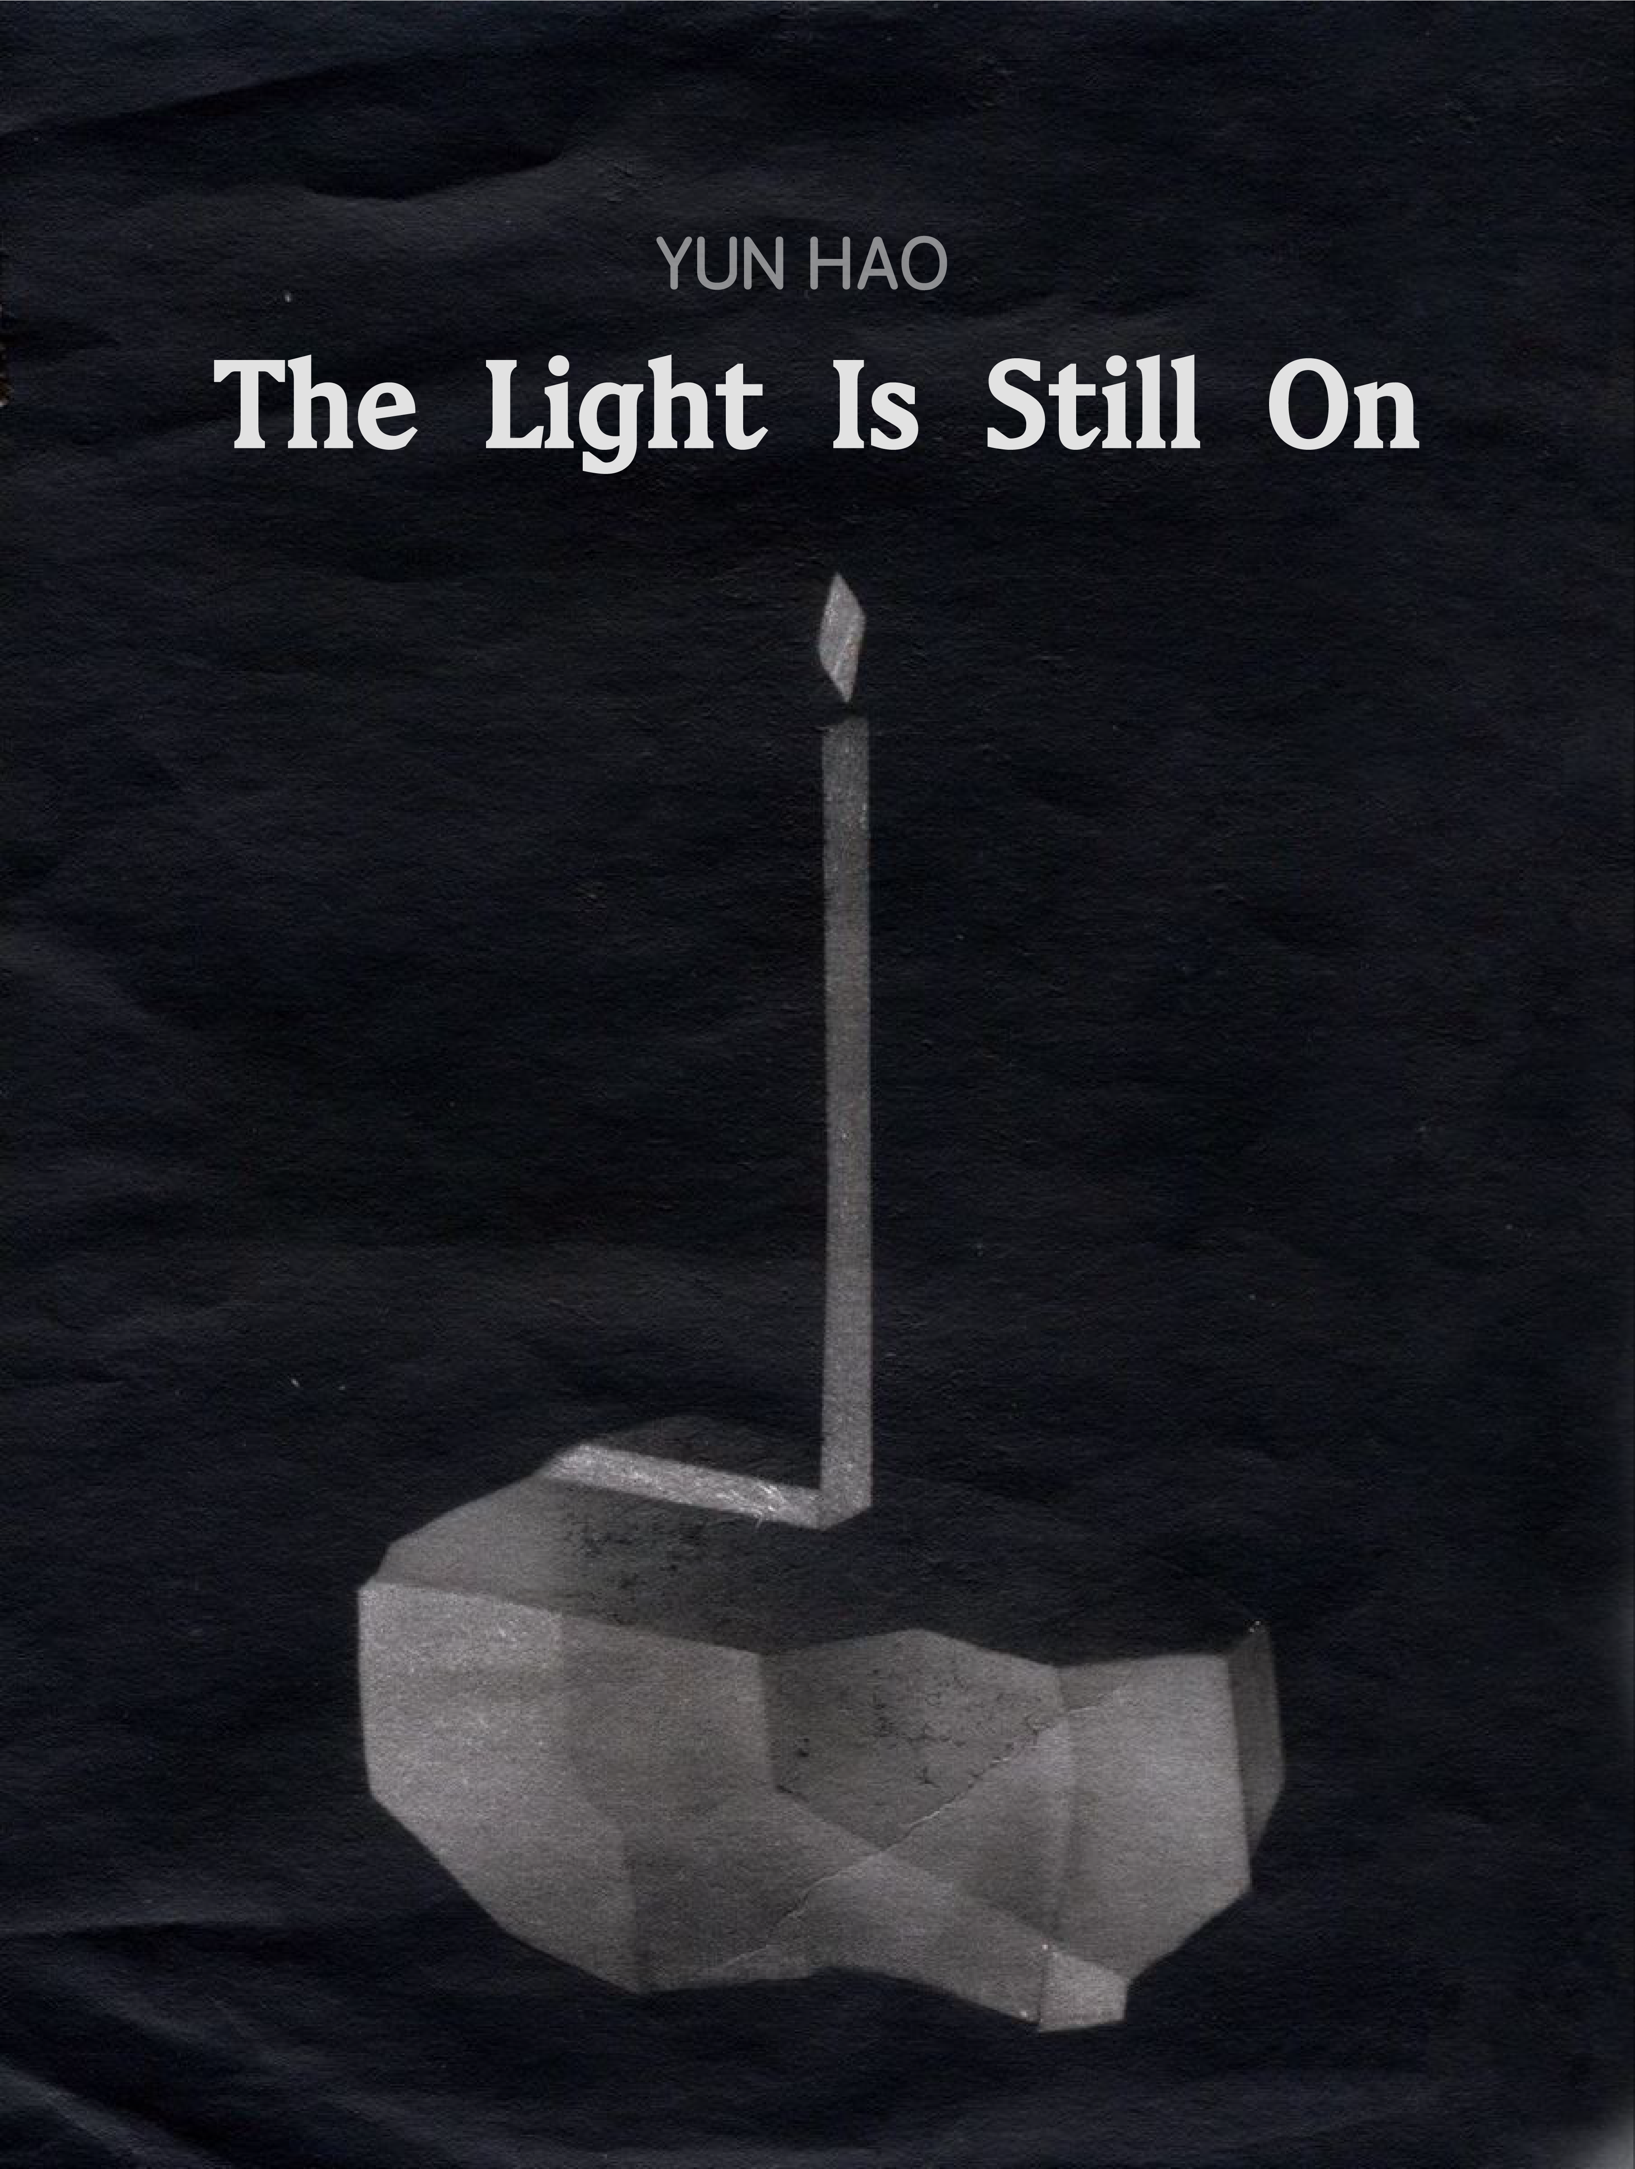

The Light Is Still On

Yun Hao

Chapter One : When the Light Falls
I do not remember when I first began to doubt the world.
This doubt did not begin with a particular philosophy book, nor was it caused by any specific event. It was more like a feeling that had existed somewhere in my body from an early age: every morning I would wake up and see the window, the room, the street; I would see people passing by, talking, working, eating, arguing, and then returning to their own lives. Everything appeared entirely ordinary. Yet, from time to time, I would suddenly wonder—how do I know that any of this is real?
How do I know that what I see before me is not some kind of manufactured illusion? And how can I prove that I, the person watching this world at this very moment, actually exist?
These questions have no answers. Or, more precisely, I have never found an answer that could make me truly believe.
For a long time, I did not consider this feeling a research question. It would simply appear from time to time, only to be covered over again by everyday life. It was not until technology began to enter our lives more and more deeply that I realised that this once vague uncertainty was becoming something concrete.
This became particularly apparent when I began encountering images and moving images generated by artificial intelligence. I see the face of a person. He looks so real that there seems to be no obvious trace of fabrication. He has skin, eyes, an expression, and even a sense of familiarity that I cannot quite explain. Yet I know that he was never born. He exists only in the moment of image generation, and in the fleeting relationship that emerges between the image and the person who looks at it.
I see a city. There are lights along the streets, buildings, and people passing through them. The air seems humid; time appears to have settled somewhere around dusk. It looks like a place that could actually be reached. Yet I also know that this place was never built, and that there was no photographer who once stood there.
I can even see a memory that never existed. It never happened, yet it looks like a memory. For the first time, I began to realise that what technology is changing may not simply be the way we produce images, but the way we understand reality itself.
I began studying photography at university in 2016. Photography once made me believe that, at least in some sense, the thing in the photograph had once existed. This sense of something having once been there may be precisely what fascinates me most about photography. I would sometimes remain still in front of a photograph for a long time, as though trying to enter the moment in which the shutter had been released, to experience as fully as possible that instant.
Today, however, a machine can tell me that it was never there. And strangely, I can still be moved by it. I may feel sadness because of a photograph that never existed. I may feel a sense of closeness towards a person who never existed. I may even feel nostalgia for a moment that never happened, simply because I encountered it through a fictional moving image.
Perhaps, then, the real question is no longer whether the image is real. What truly troubles me is this: why can something virtual give me a real feeling?
I began to realise that what we call reality does not seem to exist only in the physical world. It can also exist in human emotions, memories, desires, and bodily responses. An image of something that never existed cannot prove that its subject was ever real, yet it can nevertheless produce a real transformation in the person who looks at it.
And when this capacity is further amplified by technology, algorithms, and platforms, the question is no longer simply one of art or images. If technology can manufacture a reality that has never existed, and if that reality can nevertheless produce genuine emotions, memories, desires, and even behaviours, then who has the right to decide what should be seen, what should be believed, and what should be recognised as real?

Chapter Two : The Person Standing in the Photograph
Why does a photograph make us believe that something once happened?
The question seems so simple that we rarely stop to consider it. We pick up a photograph and see a person, a street, a room. Usually, we do not first ask whether it is real. Instead, we assume that before the photograph came into being, the object represented in it was already there. The particularity of photography lies not simply in its ability to produce a visual surface resembling reality, but in the fact that it once had a physical contact with a specific reality. Light reflected from an object, entered the lens, and left a trace. In this way, an image and reality became connected through time.
Roland Barthes pushes this experience of photography towards an important level of reflection in Camera Lucida. What he emphasises is not whether a photograph resembles reality, but the almost undeniable evidence of existence that the photograph carries: it was there. Even when the object in the photograph has disappeared, or has died, photography fixes the past within the present. The photograph therefore becomes not only a visual object, but also a kind of testimony to time. It is precisely this relationship that I first felt being disrupted when I encountered AI-generated images.
If the person in a photograph has never existed, then what exactly is the image proving? If the room was never built, if the light never fell across anyone’s face in the physical world, then how should we understand the sense of reality produced by such an image? An AI-generated image does not record an object that already exists in the world. Instead, it produces an object with the appearance of reality without requiring a real-world referent. It can generate a human face without that person ever having been born; it can generate a history without that history ever having taken place; it can generate a space without any body ever having entered it.
Photography once required reality to precede the image. Generative technology now allows the image to precede reality.
At first, this appears to be simply a transformation in the way images are produced. In fact, it touches upon something much more fundamental: the way we understand reality itself. If we once believed an image because it pointed towards an object that had existed, then what happens when the object is removed? Why can an image still make us believe something? More troublingly, why do we continue to respond to it even when we know that it has been artificially generated?
I can know that the person in an image does not exist, and still find myself trying to understand their expression. I can know that an event never happened, and still feel sadness, fear, or nostalgia towards it. Here, a contradiction emerges that cannot be easily explained: the non-existence of reality does not mean the non-existence of experience. Perhaps it is precisely here that the question of photographic reality needs to be reopened.
If the authenticity of traditional photography was grounded in the relationship between the image and a real-world object, then the reality produced by an AI image increasingly occurs between the image and the viewer. It does not need to prove that this person was once there; it only needs to make the viewer psychologically accept that this person could have been there. Reality therefore shifts from being a testimony to past existence towards becoming an experience that takes place in the present. This is precisely where I begin to think about Jean Baudrillard’s discussion of simulation and simulacra.
Within the traditional relationship of representation, an image is generally understood as a copy of reality. Within the logic of simulation, however, this order begins to reverse. The sign no longer simply points towards a reality; it can operate independently of its original reference and even begin to construct our understanding of reality. AI-generated imagery seems to push this condition to an even more extreme point.
It does not even need to conceal the fact that it has no real-world referent. It can simply produce an object without an original and then, through visual detail, give that object a convincing sense of existence. It is not telling me that a particular person once stood here. Instead, it is telling me that a person can be imagined in this way. There is an important difference between the two. The former records the world; the latter produces a possible form of the world.
For this reason, I increasingly resist describing AI-generated images simply as virtual images. The word “virtual” can easily create a misleading sense of distance, as though the virtual were necessarily unreal, unimportant, or incapable of producing consequences in reality. Yet if a person who does not exist can make hundreds of thousands of people feel something, those emotions are real. If a place that does not exist can alter the way people understand an event, that influence is real. If a fictional image can receive millions of views and generate advertising revenue, the economic value it produces is equally real.
The virtual is not necessarily the opposite of reality. It may already have become one of the ways through which reality is produced.
At this point, I am forced to move from the image itself towards the act of looking. No image automatically enters everyone’s field of vision. Whether an image becomes part of my experience depends not only on whether it has been produced, but also on whether it is displayed, circulated, recommended, and repeatedly presented to me. An enormous number of artificial images are produced every day, yet we encounter only a tiny fraction of them. The power of an image therefore lies not only in what it represents, but also in whether it becomes visible.
Michel Foucault’s analysis of power allowed me to approach this question from another direction. In his account of disciplinary society, power does not always appear through violence or prohibition. One of the important characteristics of modern power is its ability to organise space, observation, classification, recording, and norms, gradually encouraging individuals to regulate themselves. The significance of the Panopticon does not lie simply in the fact that everyone is constantly watched by a central authority, but in the possibility of being watched becoming sufficient to alter behaviour. When I bring this question into today’s digital environment, I begin to see that looking has acquired a new structure.
In the past, people watched images. Now systems watch people watching.
I look at an image, and the platform records how long I remain there. I swipe past another image, and the system learns that it failed to capture my attention. I repeatedly watch a particular kind of image, and the system can begin to predict what I might continue to watch. My act of looking is therefore no longer simply an act of looking; it has simultaneously become a form of data production.
The algorithm is also no longer merely a tool that helps me find images. It increasingly participates in deciding which images are more likely to appear before me. Power therefore does not necessarily need to tell me what I must not look at. It can also shape my field of vision by continuously telling me what I might like.
There is a subtle difference between this and traditional forms of prohibition. Prohibition makes power visible; recommendation can make power invisible. When certain kinds of content repeatedly appear before me, I can easily interpret their presence as evidence of my own interests. I may think, “This is what I like,” without recognising that before I arrived at that judgement, a system had already predicted what might make me stop. My desires therefore become increasingly difficult to understand as something entirely my own.
Marx’s analysis of commodities and capital relations acquires a new digital dimension here. Commodities are no longer limited to things with physical form. Images, data, user behaviour, attention, and even emotional responses can all become part of relations of value production. Digital capitalism does not necessarily need to directly possess our bodies. It can appropriate our time, attention, and behavioural traces through platforms, transforming activities that appear private and immaterial into forms of value that can be calculated and exchanged.
Therefore, when I say that a virtual image can produce real value, I am no longer concerned only with AI technology itself. I begin to see another chain operating behind the image:
generation — circulation — viewing — attention — data — prediction — consumption — capital.
Within this chain, the image is simply the most visible part. What remains hidden is the production of value behind it. This is where what I describe as implicit capitalist violence begins to emerge. It does not necessarily take the form of obvious coercion, nor does it necessarily demand obedience to a specific command. Instead, it may operate through a softer mechanism: encouraging us to keep looking, while transforming our behaviour into a resource that the system can continually use.
When an image of someone who never existed can nevertheless produce real emotion, memory, desire, and behaviour, perhaps reality no longer belongs exclusively to the person who once stood in front of the camera.
It happens within the body of the viewer, on the other side of the screen, within the calculations of the algorithm, and in the moment when capital transforms attention into value.
And so, paradoxically, the person who never stood there begins to possess a very real kind of power.

Chapter Three：Please Do Not Remember for Me
I do not believe that technology itself is the enemy. In fact, I cannot speak about technology from a position that completely rejects it. My own creative practice depends upon digital technologies. My research object is, at the same time, my research tool. This makes it impossible for me to occupy a truly safe or objective position outside the system.
At the beginning, I wanted to observe it from something resembling a God’s-eye view—to see the relationships between humans, technology, capital, algorithms, and power. I wanted to temporarily step outside the system. But gradually, I began to realise that perhaps there is no such outside. Because I am also within it.
I use technology while simultaneously being shaped by it; I observe others while also being observed; I study algorithms while being influenced by them. I attempt to reveal mechanisms of control through art, yet my work itself determines what the audience sees, how they move, how long they remain, and what they are able to see. My research therefore shifted from an attempt to escape the system towards an attempt to re-enter it.
This contradiction is not an obstacle that needs to be eliminated. Instead, it has become part of the research itself. If the researcher cannot exist outside the system, then perhaps the value of research does not lie in reaching an absolutely objective conclusion, but in continually exposing the relationship between myself and my research object, and examining how that relationship shapes what I am able to see.
Art is not inherently critical. When I use moving images, sound, space, and algorithms to organise the audience’s path of viewing, I am also constructing a miniature structure of power. The audience may believe that they are making free choices, yet their attention, movement, and duration of engagement are still guided by the structure of the work. If I attempt to reveal how digital platforms control viewing while reproducing the same mechanisms within my own work, then that critique itself may become another form of control. I therefore began to understand that research design cannot simply be the selection of an effective method to prove a predetermined argument. Instead, the method itself must remain open to questioning, and even to failure in practice. The uncertainty within the work, the unpredictable responses of the audience, and the continuous changes in my own judgements throughout the creative process all become part of the formation of research knowledge.
Perhaps art cannot tell us whether this world is truly real. I still cannot answer the question with which I began. What I need to attend to now, however, is what makes me believe that certain things are real. When this capacity to believe is increasingly produced, calculated, and distributed by technology, can we still decide for ourselves what we believe?
Images are no longer merely objects to be looked at; they have begun to participate in our judgement. Every day, we encounter vast numbers of images that have been filtered, arranged, and recommended. What we see is no longer determined entirely by ourselves. What receives greater visibility is not necessarily what is more truthful or important. Certain images are repeatedly pushed towards us, certain voices are amplified, while others quietly disappear. Over time, it becomes increasingly difficult to recognise when this process of selection actually began. Viewing itself has therefore become an act that needs to be reconsidered.
I have begun to pay attention to why I stop in front of a particular image, why I believe the expression of a stranger, why a fictional scene can feel strangely familiar, and why I continue looking even when I know that an image has been artificially generated. These small moments have made me realise that what technology is truly changing may not be what our eyes see, but the relationship between ourselves and what we see.
I have also begun to reconsider my earlier experience of studying photography. At that time, I believed photography was a way of moving closer to reality—a way of using light, time, and observation to preserve a particular moment. Now, when images can be generated without any corresponding object in reality, the sense of certainty I once relied upon has begun to loosen. Yet this uncertainty has not made me abandon photography, nor has it made me reject new technologies. Instead, it has made me look more carefully.
I no longer rush to determine whether an image is real or false. Instead, I have begun to pay attention to what happens within me when I encounter it: what it makes me remember, what it makes me believe, what it makes me feel, and what makes me willing to believe it. Perhaps what truly deserves to be looked at has never been the image alone, but also the self that is being changed while looking at it.

Chapter Four：No One Is Standing Behind the Window
To more clearly represent how contemporary AI-generated imagery forms a self-reinforcing ecological cycle between technology, viewing, power, and capital, this chapter attempts to construct an Ecosystem Diagram. Rather than functioning as a conventional linear causal model, the diagram presents a dynamic system composed of multiple layers of interaction, feedback, and reciprocal influence. Its structure draws upon the metaphor proposed by Plato’s Allegory of the Cave: human viewers are like the prisoners confined within the cave, facing images projected onto the wall while remaining unable to see the deeper mechanisms through which those images are produced. The forces that determine which images appear and how meaning is constructed originate behind the cave—in the sources of light, the producers, and the systems of order that organise what can be seen.
This ecological system consists of seven interconnected layers. They do not exist independently, but continuously interact, reinforce one another, and influence the subject’s perception, judgement, emotions, and actions at different points within the system. Through this diagram, I seek to understand more systematically how, within digital capitalism, a reality that does not exist can be produced, circulated, viewed, and ultimately transformed into real structures of power and economic value.
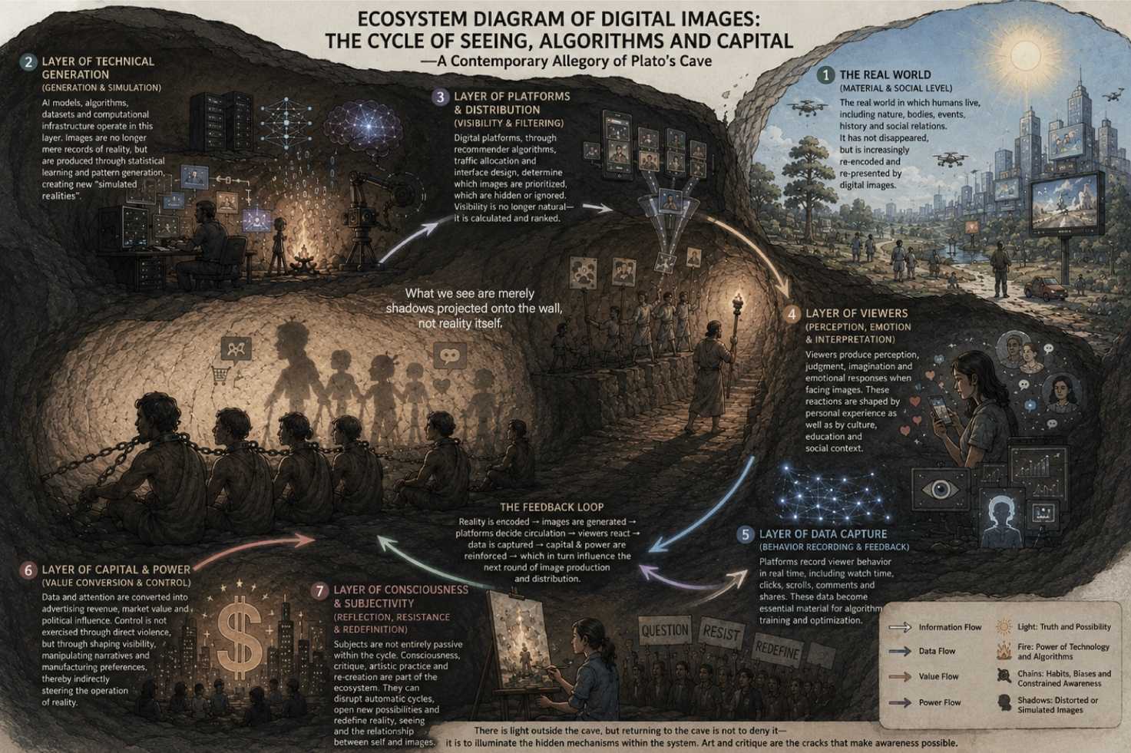
1. The Real World (Material and Social Dimension)
The first layer is the real world, namely the material and social environment in which human beings actually live. It includes nature, the body, space, events, history, culture, and social relationships. Reality has not disappeared with the development of digital technology, but it is increasingly recorded, encoded, classified, and represented through digital media.
There is a particular referential relationship between traditional photography and reality. Photography usually requires a real-world object to exist first, which is then transformed into an image through light and the photographic apparatus. A photograph, therefore, has not only functioned as a form of visual representation, but has also been understood as a trace of something that once existed in reality.
However, artificial intelligence-generated technologies are changing this relationship. A person, a building, or even a scene that has never taken place can now first appear in the form of an image without any corresponding real-world object. The image is therefore no longer merely the result of reality; it can also become the starting point for imagining and constructing reality.
Therefore, this research does not understand reality and the virtual simply as a binary opposition. Instead, it focuses on how reality continuously enters digital systems and how it is subsequently reorganised through those systems.
2. The Technological Generation Layer (Generation and Simulation)
AI models, algorithms, datasets, and computational infrastructures operate within this layer. The logic of image production has undergone a significant transformation. Traditional forms of image-making generally depend upon the existence of a real-world object, whereas generative artificial intelligence can learn statistical patterns from large amounts of visual data and subsequently generate a visual object that does not exist in reality.
The relationship between the image and reality therefore begins to shift from recording towards generation. This is also a key reason why this research moves from photography towards the study of AI-generated imagery. When an image with no corresponding object in reality can nevertheless produce real emotions, memories, and judgements, the question is no longer simply, “Is this image real or fake?” Rather, it becomes: does an image still require a real-world referent in order to produce effects in reality?
In this sense, AI-generated imagery not only changes the way visual images are produced, but also begins to challenge our understanding of the authenticity of images and of reality itself.
3. The Platform and Distribution Layer (Visibility and Selection)
The generation of an image does not mean that it can naturally enter the public field of vision. On digital platforms, the visibility of content is influenced by multiple factors, including recommendation algorithms, search rankings, traffic mechanisms, and interface design. Platforms are therefore not merely the technical infrastructure through which images circulate; they are also important structures of power that organise visibility.
What can be seen, what is hidden, and what is repeatedly recommended are not entirely random processes. Visibility therefore becomes a resource that is calculated and distributed.
This also establishes a more direct relationship between viewing and power. Power does not necessarily operate by prohibiting people from viewing certain kinds of content. It can also influence viewers by continuously increasing the frequency with which certain content appears before them. In other words, platforms do not only determine what we cannot see; they increasingly participate in determining what we continue to see. When certain images repeatedly enter our field of vision, they may gradually acquire a sense of reality that exceeds their own content.
4. The Viewer Layer (Perception, Emotion, and Interpretation)
Viewing is not a purely visual act, but a complex process involving perception, memory, emotion, judgement, and cultural experience. When viewers encounter an image, they bring their own experiences into it and assign personal meanings to what they see. This is also where the complexity of AI-generated imagery emerges.
Even when viewers know that a person does not actually exist, they may still feel sympathy towards that person. Even when they know that a particular scene has never taken place, they may still experience a sense of familiarity towards it. This demonstrates that the fictional nature of an image does not automatically invalidate the reality of the viewing experience. Therefore, this research is more concerned with how images produce consequences in reality than simply with whether an image has a referential object in the real world.
The emotional response of the viewer consequently becomes an important component of this ecosystem. It is through the act of viewing that an image begins to enter human consciousness, behaviour, and social relationships.
5. The Data Capture Layer (Behavioural Recording and Feedback)
Digital platforms have made it possible, for the first time, for viewing behaviour to be recorded with a high degree of precision. Actions such as time spent viewing, clicking, scrolling, commenting, sharing, and repeated viewing can all be transformed into calculable data.
Here, an action that originally possesses subjective meaning simultaneously acquires another form of systemic meaning. Viewing is therefore no longer simply an act of consuming content; it also becomes an act of producing data. This data is subsequently fed back into algorithms to optimise recommendations and content distribution, creating a cycle of: viewing → data → analysis → recommendation → re-viewing. This cycle enables technological systems to continuously learn from human behaviour, while at the same time making human behaviour increasingly influenced by feedback from the technological environment.
6. The Capital and Power Layer (Value Conversion and Control)
Data and attention have become important resources within the digital ecosystem because they can be further transformed into economic value and social influence. Viewing behaviour can generate advertising value, user preferences can be used for consumption prediction, and data can become an important resource through which platforms optimise their business models.
Images, attention, and behaviour therefore form a new chain of value conversion. Within this process, power is also no longer expressed primarily through direct commands or coercion. Instead, it increasingly operates through environments, interfaces, recommendation mechanisms, and the distribution of visibility. Individuals still possess choices, but the environment in which those choices take place has already been pre-organised by technology and platforms.
This gives Michel Foucault’s discussion of disciplinary power a new digital context. The subject does not necessarily need to be continuously commanded, because the system can gradually teach the subject to adjust their behaviour through continuous feedback. External control therefore begins to transform into internal self-regulation.
7. The Consciousness and Subjectivity Layer (Reflection, Resistance, and Redefinition)
If the first six layers form a continuously automated cycle, then the subject’s reflection, critique, and artistic practice may become important points at which this cycle can be disrupted. Yet there is an unavoidable contradiction here: art itself does not naturally exist outside structures of power.
When I use images, sound, space, and digital technologies to organise the viewer’s path of looking, I am also determining what the viewer sees, how they move, and where they stop. I therefore cannot simply place myself outside the system and position myself as a completely objective observer.
I once tried to search for a subject hidden behind the screen, attempting to understand who exactly was deciding what we see. But through the research, I gradually came to realise that there may not be a single person there. What actually produces these effects is a system collectively constituted by algorithms, platforms, data, capital, and human behaviour.
This ecosystem diagram is not intended to identify an ultimate controller. Rather, it attempts to reveal how these dispersed forces connect with one another and collectively shape our ways of viewing and our subjectivity. What artistic practice can intervene in is precisely the visibility of these relationships.
Art may not necessarily be able to lead us out of Plato’s cave, nor can it necessarily tell us what absolute reality is. But it can make us pause for a moment—to see how images are produced, how viewing is organised, and how we ourselves participate in these processes.
The world we see has already passed through countless processes of generation, selection, calculation, and feedback. And when we begin to watch ourselves watching, this ecosystem that has remained hidden behind the window may, for the first time, become visible.

Chapter Five：You Stopped for Seven Seconds
I have been thinking for a long time about what, exactly, a viewer is looking at when they enter my work.
They may not know that they are entering a system composed of algorithms, images, sound, space, and data. They simply see an image, hear a piece of sound, walk a few steps forward, and then stop. Perhaps they become interested in a particular image, or perhaps they stop because of a certain colour, a face, or a familiar scene. Seven seconds, ten seconds, or longer. For the viewer, this may be nothing more than an ordinary act of looking. For me, however, that moment of stopping has already become part of the work.
In the past, I tended to understand looking as a relatively active behaviour. The photographer chooses what to photograph, the viewer chooses what to look at, and the image, as a medium between the two, seems simply to carry information from one side to the other. But once looking enters the digital environment, this relationship becomes more complicated. We believe that we are choosing the images we see, when in fact the appearance of those images has already been shaped by a process of selection. Platforms determine how they are arranged, algorithms determine to whom they appear, while our own pauses, clicks, and swipes in turn become the basis for the next round of calculation. Looking is no longer simply a psychological activity taking place within the subject; it is increasingly becoming a behaviour that can be recorded, quantified, and fed back into the system.
For this reason, in my creative practice I have begun to consciously incorporate the viewer’s process of looking into the work, rather than treating the viewer simply as a recipient who appears after the work has been completed. I want the work to create a subtle sense of uncertainty. When viewers first enter the space, they may believe that they possess the freedom to choose what to look at, where to go, and how long to stay. But as their viewing continues, they gradually discover that their choices are being responded to by the work, and that these responses quietly alter what they are able to see next. The relationship of looking is therefore reversed. The viewer is no longer simply the person who looks at the work; they also become someone who is observed, recorded, and predicted by it.
For me, this design is not intended simply to reproduce the interactive mechanisms of digital platforms, nor is it designed merely to create the theatrical sensation of being watched. What matters is allowing a relationship that is normally invisible to become something that can be experienced through the body. The disciplinary power discussed by Foucault does not necessarily require the continuous imposition of external commands. When subjects know that they may be being watched, they may begin to adjust their own behaviour. Power in the digital environment has undergone a similar transformation: it does not always need to tell us what we should do. Instead, through recommendation, feedback, reward, and the distribution of visibility, it makes certain behaviours appear more natural and more worth repeating. Within this system, people are not simply forced to comply. On the contrary, they often participate in the mechanism through what appears to be voluntary choice.
This is also where I encounter the greatest contradiction in designing the work. I want the viewer to become aware that they are being guided, yet I must use guidance in order for this relationship to become perceptible. If I completely remove the work’s control over the viewer, the system may lose its structure, and the viewer may never become aware of what they are experiencing. But if I design the viewing path too extensively, the work simply becomes another closed structure of power. Art therefore encounters an ethical question that cannot easily be resolved: in order to reveal control, must I first exercise a form of control myself?
I have not tried to eliminate this contradiction. Instead, I want to preserve it and allow it to become a tension within the structure of the work. I have increasingly realised that art does not possess a naturally pure position outside the system. When I decide where an image should appear, when a particular sound should emerge, or which path the viewer should take through the space, I am already participating in the distribution of attention. Even if my intention is to critique algorithms, I am still organising the act of looking through another form of structure. The work therefore does not stand outside the system and pass judgement upon it. Instead, it creates, from within the system, a space in which the viewer can become aware of the system itself.
For this reason, I have also begun to reconsider the meaning of audience feedback within my research. If I simply record how many seconds a viewer remains in one place or which route they take, I can easily reproduce the logic of the platform: transforming human behaviour into data and then using that data to prove a predetermined conclusion. What truly interests me is not why a viewer stayed for seven seconds, but what happened during those seven seconds. Were they attracted by the image, or were they searching for meaning? Did they realise that they were being guided? When they discovered that the image might not actually exist, did their emotional response change? And when they realised that they themselves were becoming part of a data system, would they continue to look in the same way?
Clearly, these questions cannot be fully answered through quantitative data alone. They involve the viewer’s experience, memory, emotions, bodily sensations, and interpretation of the work. I have therefore begun to understand audience responses as qualitative research material rather than simply behavioural data. Observations within the work, records of the creative process, audience feedback, and the changes in my own judgements throughout the practice together constitute part of the knowledge produced by the research. The artwork is no longer simply a medium through which the final findings of research are displayed. It becomes a research site in which questions can be raised, contradictions can be produced, and problems can continue to unfold.
Here, I also return to my original question concerning the reality of images.
If an AI-generated image can make someone stop for seven seconds, then those seven seconds are real. The person within the image may never have existed, and the scene may never have taken place, yet the viewer’s attention has genuinely occurred, their emotions have genuinely occurred, their memories may have been activated, and they may even take further action as a result. Whether the image corresponds to something in the physical world seems no longer sufficient to explain what it does within reality.
This has led me to question whether reality was ever simply a correspondence between an image and the world. Perhaps reality can also emerge through relationships—between an image and a viewer, between memory and imagination, between technology and the body, and between looking and power.
Ultimately, I do not want the viewer to leave the work with a clear answer. I do not even want them simply to conclude that AI is false or that algorithms are controlling us. If the work can only tell the viewer an answer that I have already decided upon, then it is, in fact, still deciding for them how reality should be understood.
What I hope instead is that, when they leave, they experience a moment of hesitation about their own act of looking. Perhaps the next time they encounter an unfamiliar face on a screen, they will pause and ask themselves, Why do I believe this face? Perhaps, as they continue scrolling, they will suddenly wonder how many of the choices that seemed to come from themselves were actually their own.
For me, this brief hesitation is the most important space created by the work. It is neither an answer nor a method of escaping the system. It is a moment in which automated looking is temporarily interrupted. In that moment, the viewer no longer simply sees the image; they begin to see how they are looking at the image.
And perhaps this is where I understand art to be situated within this ecosystem: not standing outside the cave and telling those inside what is real, but lighting a small beam of light within the cave, allowing relationships that were previously imperceptible to become visible, if only for a moment. Only when we begin to watch ourselves watching can the relationship between subject and technology begin, for the first time, to open itself up again.

Chapter Six：To a Stranger I Have Yet to Meet
Dear Stranger,
If you are reading this letter, perhaps you do not know why I have spent so much time studying images. You might think that images are simply things we encounter every day: a photograph on a phone screen, a short video on social media, a person in an advertisement, or a scene generated by artificial intelligence that looks almost indistinguishable from reality. We look at them and then continue scrolling. They have become so ordinary that we rarely stop to ask a seemingly simple question: Why, exactly, do we believe what we see before us?
I was not always aware of how complicated this question could be. When I was studying photography, I believed that there was a relatively stable relationship between images and reality. Photography seemed convincing because it appeared to record a moment that had once actually taken place. A photograph therefore not only recorded reality; it also preserved evidence that reality had once existed. Then artificial intelligence began to change this relationship.
Today, a face that looks completely real may belong to someone who was never born. A city may contain streets that have never existed. More importantly, even when we know that an image is fictional, it can still produce genuine emotions, memories, and judgements within us. What concerns me, therefore, is no longer simply the distinction between whether an image is real or false. I am more interested in whether our understanding of reality itself is changing when things that do not exist can nevertheless produce real consequences.
My research cannot therefore simply position itself in opposition to technology. Technology has already entered our lives, our bodies, and our cognition, while at the same time becoming a tool through which I conduct my own artistic practice. I use it to create images, organise space, and construct relationships of looking. At the same time, I have become aware that my own practice sometimes employs mechanisms similar to those of the very systems I seek to critique. This means that I cannot place myself in a position of complete innocence. I am also part of the system. Perhaps this is precisely where I find the significance of this research.
I do not know whether this research will ultimately be able to answer the question of what is real. But I have come to believe that the value of research does not necessarily lie in arriving at a definitive answer. Sometimes, what a research project leaves behind is simply the ability to force us to look again at things that have become so familiar that we no longer notice them.
If one day you stand in front of my work, I do not want you to reject it simply because I tell you that it is fictional. I would rather that you stay for a moment. Then ask yourself: What is actually happening here—the events within the image, or what is happening between you and the image? If you can remain with this question for a little while, perhaps this research will already have found its reason for existing.
Yours sincerely,
A researcher who is still inside the cave
Chapter Seven：The Light Is Still On
At the beginning, I thought this research was about searching for an answer.
I wanted to know whether images were real, and how we should understand photography, memory, and existence once artificial intelligence became capable of generating a reality that had never existed. I also tried to place myself in a higher position, from which I could observe the relationships between humans, technology, capital, algorithms, and power—as if, by standing far enough away, I could somehow see the entire system clearly.
But by this point in the research, I have realised that I never truly stepped outside that system. I create using cameras, artificial intelligence, and networks, while also using them to look at the world. I study how algorithms shape the act of looking, yet I cannot avoid the fact that my own way of looking is shaped by the algorithmic environment as well. I try to examine how digital capitalism appropriates attention, while my own work must also compete for the viewer’s attention. Even when I try to make the viewer aware that they are being watched, I am still arranging their act of looking.
This contradiction has changed the way I understand research. I no longer believe that the task of research is to stand outside its object and provide a completely objective explanation of it. In practice-based artistic research, the researcher is themselves part of the relationship. My creative decisions, experiences of looking, ethical judgements, and the ongoing feedback between the work and its viewers all participate in the formation of knowledge. The artwork is therefore not simply the outcome of the research; it is also a site in which research takes place.
This has also changed my attitude towards technology. I no longer understand technology simply as a force that controls human beings, nor do I believe that rejecting technology necessarily means achieving freedom. Technology can become a tool of discipline, prediction, and capital accumulation, but it can also become a medium through which we observe and reconsider these mechanisms. The question is not whether technology is ultimately good or bad, but how we enter into relationships with technology, and whether we are still able to recognise how those relationships are shaping us.
My understanding of reality has changed in the same way.
I once wanted to find a way to prove that reality was real. But now, it seems that this may not be something art can accomplish. Reality is therefore no longer simply a correspondence between an image and an object in the world. It also exists within the relationships continually formed between images, bodies, memories, emotions, technology, and society. I am therefore more willing to understand this research as a process of relearning how to look. Those seemingly insignificant moments of stopping, clicking, and making judgements are not isolated behaviours. They are connected to larger structures of data, capital, and power. And perhaps what art can do is not lead us out of the cave. Perhaps it is more like lighting a lamp inside it.
I still do not know whether this world is truly real, but I am no longer obsessed with proving it.
Perhaps the research has not ultimately led me out of the cave. Instead, it has made me realise that the cave itself is part of the life we inhabit.
And the light is still on.

