Dementia Care UWTSD
helping families face dementia

What is dementia?



What is dementia?

The term "dementia" serves as a catch-all for a variety of progressive brain diseases.
Memory loss is simply one aspect of dementia. Additionally, it may influence how you act, speak, think, and feel. It's also critical to keep in mind that dementia is not a normal aspect of getting older.
Dementia is a syndrome (a group of related symptoms) associated with an ongoing decline of brain functioning. There are many different causes of dementia, and many different types. (NHS, 2022)
Who gets dementia?
Women are also more likely than men to get dementia. There are currently around 900,000 people in the UK living with dementia. It mainly affects people over the age of 65. The likelihood of developing dementia increases significantly with age. One in 14 people aged over 65 has dementia. This rises to 1 in 6 for people aged over 80. (Alzheimer’s society,2022)
Symptoms of dementia
Each person will experience dementia differently, no matter what kind of dementia is identified, or which area of the brain is impacted.
Dementia signs and symptoms can include Memory problems
You might observe your senior loved one becoming more forgetful over time. How can memory loss be distinguished from dementia?
The different kinds of memory loss, it’s helpful to go over risk factors. The biggest risk factor is age — all older adults are at risk of developing memory issues (including dementia) Cedar Creek (2022)

Other factors include:
- Genetics
- Head trauma
- High cholesterol
- High blood pressure
- Down syndrome
Communication
Dementia patients can repeat themselves or struggle to find the correct words. Reading and writing could become difficult.
There are two main ways that dementia can affect someone’s ability to communicate- it can interfere with their ability to get their point across, or it can interfere with their ability to process what others are saying. (DSDC, no date)
Cognitive ability, i.e., processing information
Stage 1:
People who are suffering from dementia may struggle to focus, which might affect their short-term memory.
Dementia can also be classified as the normal functioning stage. At this stage of dementia development, a patient generally does not exhibit any significant memory or cognitive impairment problems. Stages 1-3 of dementia progression are generally known as "pre-dementia" stages. (Dementia.org, 2022)
Stage 2: Age-Associated Memory Impairment
- Forgetting where one has placed an object
Stage 3: Mild Cognitive Impairment
- Getting lost easily, forgetting names

Types of dementia
Alzheimer’s
Alzheimer's is caused by the destruction of the brain cells. The disease clinically presents with a slow progression of cognitive and behavioural impairment. Approximately 50 million people across the globe suffer from the most common manifestation of the disease—dementia (Uwishema et al., 2022)
Lewy body dementia
Lewy body is progressive dementia that results from protein deposits in nerve cells of the brain.
Dementia with Lewy bodies usually occurs in people with no family history of the condition, although there have been very rare cases that seem to run in families. (NHS ,2022)
Subcortical vascular dementia
Small vessel disease causes vascular dementia, which develops slowly and steadily over time. The "subcortex" of the brain is where most of the damage takes place.
Subcortical vascular dementia is thought to be the most common type of vascular dementia. It is caused by diseases of the very small blood vessels that lie deep in the brain (known as ‘small vessel disease). (Alzheimer’s society, 2022).
Causes
Alzheimer's disease is characterized by memory loss. Most clinicians agree that there are four stages of the disease very mild, mild, moderate, and severe each with its own cognitive, functional and behavioural issues. Budson & Solomon (2016)
A Lewy body is caused by clumps of protein (called Lewy bodies) gathering inside brain cells. These Lewy bodies can build up in many parts of the brain but particularly in the areas responsible for thought, movement, visual perception, and regulating sleep and alertness. dementia Compared to other varieties of dementia, memory loss is frequently less common, but people may be more susceptible to mood and behaviour abnormalities like apathy, anxiety, sadness, delusions, and paranoia. (Dementia UK, 2022)
Subcortical vascular dementia
Although subcortical vascular dementia is a more precise diagnosis, most individuals have little understanding of it. However, you may better grasp what it is, what to anticipate, and what you can do about it by studying more about it.
Subcortical vascular dementia is defined as a small vessel disease that's a type of vascular dementia. Vascular dementia is a common form of dementia. It happens when the supply of blood to the brain is diminished. A series of small strokes can cause this. (Better help ,2022)

Getting a diagnosis
It is crucial to see a doctor as soon as possible if someone is displaying symptoms of dementia. Some illnesses, which affect a person's memory, focus, or behaviour, may have the appearance of dementia but are treatable if caught early.
What to expect from a G.P about dementia?
A GP will inquire about your symptoms as well as other aspects of your health. They will also ask whether you are having difficulty managing daily activities such as:
- cleaning and dressing (personal care)
- cooking and shopping
If possible, please bring someone who knows you well to your GP appointment so they can describe any changes or problems they've noticed. If you have trouble remembering what was said at the appointment, they may be able to assist you with extra support

Preventions
- Stay physically fit
- Reduce smoking
- Stay Social
- Keep on top of your mental health
- Diet superfoods
Any exercise is better than none, whether it be a few walks per week, a low-impact exercise class, or anything else that gets you moving such as a good weeding session in the garden. (Age space, 2021)
Treatments
Dementia currently has no known cure. However, there are medications and other treatments that can ease the symptoms of dementia. Cognitive stimulation therapy
Cognitive stimulation therapy (CST) involves taking part in group activities and exercises designed to improve:
- memory
- problem-solving skills
- language ability (NHS, 2022)

Activities
- dance, tai chi, yoga, swimming or joining a walking group to help keep you active and sociable – look out for local dementia-friendly swimming, gym and walking sessions
- reminiscence work – share your life experiences and stories from the past with photos, objects, video and music clips, either as a book or on a tablet or other digital device (NHS, 2021)

Interventions
Pharmacological and Non-Pharmacological Interventions

- Both pharmaceutical and non-pharmacological interventions can be utilised to care for, support, and treat dementia patients. (drugs) and non-pharmacological. The latter includes both environmental and behavioural modification. The section to follow will describe in broad terms these two types of interventions. (DSIDC, 2022)

Financial provisions
- A caregiver may speak with the person's doctor and attorney as necessary. Other parties can also be given authorization in advance, including Medicare, a credit card company, a bank, or a financial counsellor.

A durable power of attorney for finances names someone to make financial decisions when the person with Alzheimer's or related dementia no longer can. It can help avoid court actions that may take away control of financial affairs. (NIH, 2022)

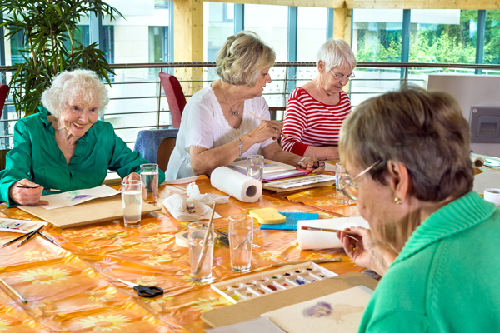
Sources of support
Dementia UK leaflet on Getting a diagnosis of dementia
dementiauk.org/getting-a-diagnosis-of-dementia
Dementia UK leaflet on the Emotional impact of a diagnosis
dementiauk.org/emotional impact
Dementia UK leaflet on Understanding Lewy body dementia
dementiauk.org/dementia-with-Lewy-bodies
Dementia UK resources on Sources of support and advice

dementiauk.org/sources-of-support-and-advice

The information in this booklet is written and reviewed by dementia UWTSD. We are always looking to improve our resources, to provide the most relevant support for families living with dementia. If you have feedback about any of our leaflets, please email UWTSD.COM For more information on how to support Dementia UWSTD, please visit dementia UWSTD/donate or call 0400 990 5500. © Dementia Care UWSTD 2022

