STUDENT JOURNAL

Sustainability within the Hotel Industry

Name: Corina Maria Danila
Student ID Number: 2118573
Module Title: Operating Hotel Facilities BMIH4006
Lecturer: Kathryn Roberts

Table of Contents

Introduction 3
Sustainability in Hotel Industry 3
Learning 3
Application of Learning and Skills Developed 5
Conclusion 5
References 6

Introduction
In this reflective report, I will be discussing my learning experience from the module along with the skills which I have developed that will help me to become a better member of the hospitality industry. My journal will be based on the topic of sustainability in the hotel industry.

Sustainability in the Hotel Industry
As per Calisto et al. (2021, p. 1), environment sustainability is considered to be an effective practice of enhancing hotel’s efficiency as well as reduce cost which makes sustainability a win-win practice for hotels. I think that this is very apt since the hotel industry associates with a lot of people and for this reason, it is necessary for it to be sustainable since consumption of natural resources is done on a large scale by hotels. With the help of journals and module material, I have learnt that sustainability is a fundamental practice which should be adopted by the hotel industry and its relevant sectors for better service provision. I have been able to learn various issues that are relevant to the sustainability aspect of the hospitality industry. Most of the hotels are undertaking superficial sustainability practices just for the sake of it. They consider sustainability steps such as foregoing plastic to be an action that costs a lot of money. I think, however, the hotels are not able to recognise the importance of sustainability. Hospitality industry including tourism and hotels are known to consume a lot of cultural and natural resources of nations. In my opinion, this makes the hotel industry more liable to be sustainable so that the further generations can also be privy to the natural beauty of countries (Han, 2021, p. 1021).

Learning
I have learnt about the pillars and principles of sustainability during the module. I have recognised environment, economy, and society to be the basic pillars that makes a hotel sustainable. In other words, these supports will transform into rocks of sustainability which are planet, profit and people respectively.
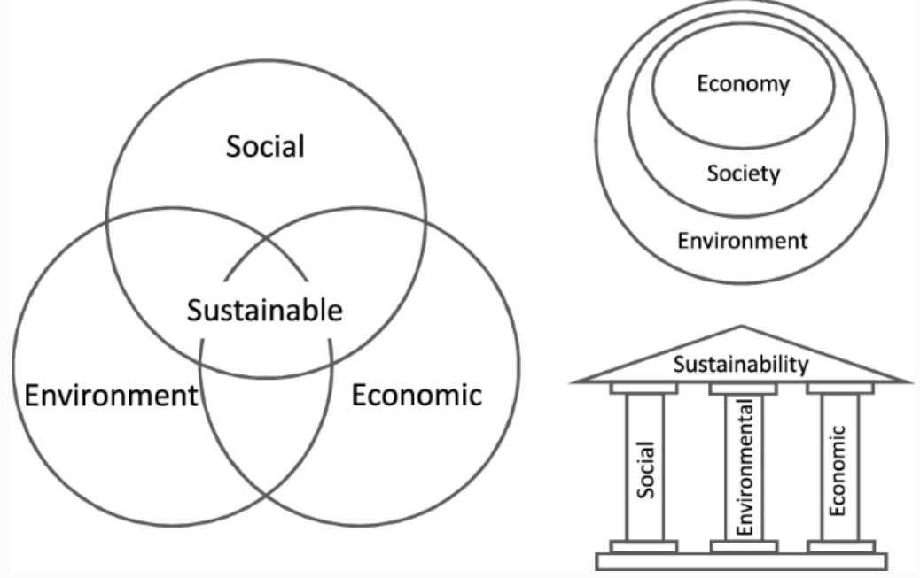
Figure 1 Pillars of sustainability
Source: (Purvis et al. 2019, p. 682)

I feel that hotels need to ensure that they are following these principles so that the hotel businesses can continue for long and serve customers along with profiting the business itself. With the help of my learning, I have identified various benefits of hotels becoming sustainable which includes:
- Lower cost
- Enhanced image of the hotels in the industry
- Positive impact on customers’ decisions (Welfle and Röder, 2022, p. 493)
- Governmental support
- Stakeholder engagement is improved
- Better profitability because of better recognition and support from stakeholders.
These benefits are enjoyed by any organisation that is following in the footsteps of sustainable operations. One of the most interesting aspects for me during my learning was CSR which stands for corporate social responsibility (Latapí Agudelo et al. 2019, p.1). I have found this concept to be a step of companies in the direction of their responsibility towards the environment. With my understanding, I can summarise this concept as the self-regulatory step of hotels and other companies that allow them to perform philanthropy and charitable actions for the benefit of people and planet overall.

Application of Learning and Skills Developed
With the learning developed, I will ensure that I add my best to the hotel industry. Some of the skills I have developed until now include communication, creativity, critical thinking, management, and problem solving. By having a creative mind for problem solving, I will develop business strategies that do not harm anyone; rather, enhances sustainability. I will make decisions after proper consideration of all factors involved and weighing them for their advantages and disadvantages, showcasing critical thinking. Most importantly, I will maintain effective communication with all my peers, managers, and other stakeholders. Through this communication, all relevant stakeholder of my business will be on the same page that will allow avoiding any problems arising (Lawson et al. 2019). During one of my group projects, I have faced an issue of miscommunication that led to a minor conflict which got later resolved with proper communication. This lesson helped me in realising the importance of communication which I will apply in my workplace to avoid problems (Khamis and Wahi, 2021, p.355). With my improved knowledge regarding sustainability, I will also make sure that I manage my business in a way that the operations are sustainable and contribute to the greater good of the people as well as the planet. With my management skills, I will develop business plans that ensure that I use resources in a way which gives back to the environment along with my own profit.

Conclusion
With this reflective journal, I have shared my learning from the module with a discussion of sustainability in hotels, and the skills built and their application in my workplace in future.

References
Calisto, M.D.L., Umbelino, J., Gonçalves, A. and Viegas, C. (2021) ‘Environmental Sustainability Strategies for Smaller Companies in the Hotel Industry: Doing the Right Thing or Doing Things Right?’, Sustainability, 13(18), p. 1-19. https://doi.org/ 10.3390/su131810380
Cozzio, C., Bullini Orlandi, L. and Zardini, A. (2018) ‘Food sustainability as a strategic value driver in the hotel industry’, Sustainability, 10(10), p.3404. https://www.mdpi.com/343578
Han, H. (2021) ‘Consumer behavior and environmental sustainability in tourism and hospitality: A review of theories, concepts, and latest research’, Journal of Sustainable Tourism, 29(7), pp.1021-1042. https://www.tandfonline.com/doi/abs/10.1080/09669582.2021.1903019
Khamis, N. and Wahi, W. (2021) ‘Enhancing business communication skills: An action research’, International Journal of Asian Social Science, 11(7), pp.355-364. https://archive.aessweb.com/index.php/5007/article/view/3264
Latapí Agudelo, M.A., Jóhannsdóttir, L. and Davídsdóttir, B. (2019) ‘A literature review of the history and evolution of corporate social responsibility’, International Journal of Corporate Social Responsibility, 4(1), pp.1-23. https://jcsr.springeropen.com/articles/10.1186/s40991-018-0039-y?uc=racialjustice
Lawson, C., Gill, R., Feekery, A. and Witsel, M. (2019) Communication skills for business professionals. Cambridge University Press. https://books.google.com/books?hl=en&lr=&id=fIOWDwAAQBAJ&oi=fnd&pg=PR12&dq=communication+skills,+business&ots=oahwLIpM4E&sig=LQylps-PzVsNadcF3eLZgCiHeYo
Purvis, B., Mao, Y. and Robinson, D. (2019) ‘Three pillars of sustainability: in search of conceptual origins’, Sustainability science, 14(3), pp.681-695. https://link.springer.com/article/10.1007/s11625-018-0627-5
Welfle, A. and Röder, M. (2022) ‘Mapping the sustainability of bioenergy to maximise benefits, mitigate risks and drive progress toward the Sustainable Development Goals’, Renewable energy, 191, pp.493-509. https://doi.org/10.1016/j.renene.2022.03.150

