DS 1 Assignment

My Screenshots/Photos

Screenshot/Photo 1

This screenshot shows outlook, which I use every day to check important information and emails from my university.

Screenshot/Photo 2

WhatsApp is one of my favourite apps because it helps me stay in touch with my family and friends.

Screenshot/Photo 3
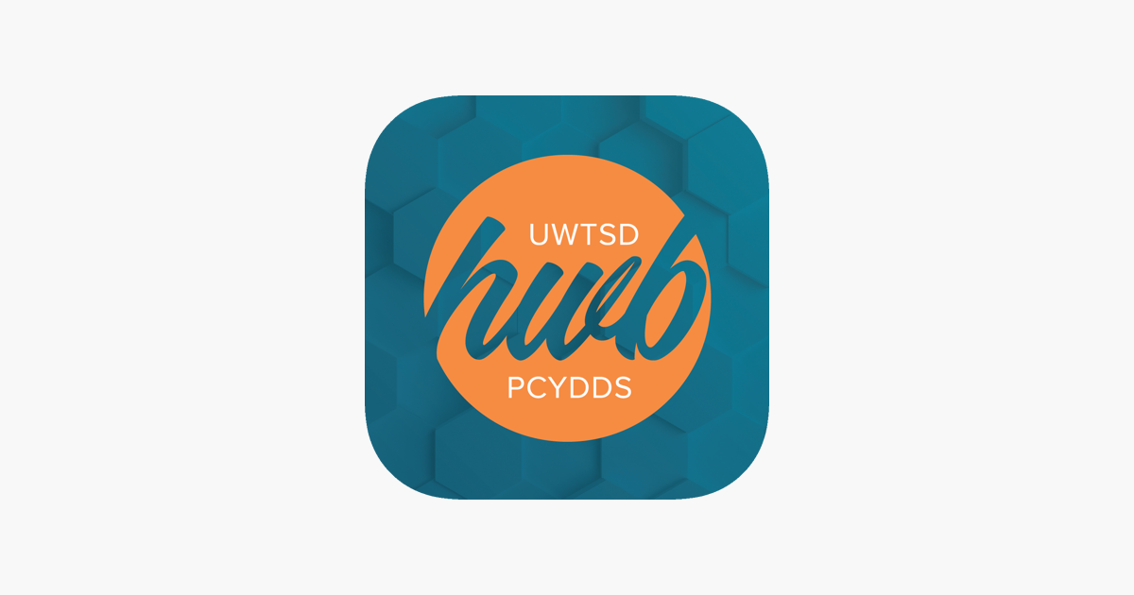
This screenshot shows Hwb, which helps me manage my university work. I check my assignments, class materials and lesson slides there.
Screenshot/Photo 4

RMP by Weduc helps me stay informed about the school my son attends. I receive important information such as school holidays, vaccination dates and other school updates.

Screenshot/Photo 5

Lloyds Bank helps me manage my money online. I use it to check my balance and transactions.

Screenshot/Photo 6

Google Maps helps me find places and plan my journeys. I use it to get directions when I need to travel somewhere.

And Short Reflection
I use digital tools very often for my university, my family and personal life. I feel confident when using apps that I am already familiar with. However, when I use a new app, I often feel stressed because I do not know how it works. I often use digital tools because they are essential in many aspects of our daily lives. I think digital tools are very important for everyone because they allow us to carry out online transactions and completely different tasks from home. This helps us save time and manage our daily responsibilities without having to leave the house. I hope this module will help me become more confident with technology and gain new knowledge and skills. Digital tools are valuable to me because they help me communicate with my family and friends in different parts of the world. My digital life is interesting and enjoyable because I learn new things every day. Digital tools help me stay informed about what my son is doing at school and learn new skills through my university apps.

