Marketing Essentials
Student Name:Arrafat B.Mamadou
Student ID:2239462
Lecturers Name:Gayathri
Date:11.06.2023

Table of Contents
Introduction 3
Situation analysis 4
5 'C's 4
Objectives 5
Strategy 6
Tactics 6
Action 8
Control 9
Conclusion 9
References 10
Appendix 12

Introduction
Marketing plan is basically an advertising strategy which is used by business organizations for selling their products and services in the market (McDonald, 2007). A marketing plan will be prepared in this report for Hilton Chicago, a hotel of Hilton Hotel brand which is located in Chicago, United States. This hotel is aimed at offering new services to the customers for which it needs a marketing plan which will be helping the hotel in making the new services accepted by the customers. The plan will be analysing 5C’s, marketing mix, communication plan and ansoff matrix for preparing a detailed marketing plan.

Situation analysis

5 'C's
Company: Hilton Hotel has lots of strengths such as high brand recognition, high employee retention, technological innovation, good reputation in market and so on (Reidhead, 2020). But along with the strengths there are also some weaknesses including limited market share and the negative impact of global market policies. Higher potential in emerging market, digitalization and innovation of customer services are the opportunity of the hotel that can contribute in boosting the profitability of the hotel. Hilton hotel also faces threats including stagnated growth, competitive pricing, entry of new brands in market and political and economic turbulence.
Customers: Hilton hotels segment the market based on demographic segmentation. It generally targets the upper class people who has high level of income and are middle and senior aged professionals. The customers of Hilton Hotels value multiculturalism.
Competitors: Hyatt, Marriott, IHG, Loews Hotels and Holiday Inn are the top competitors of Hilton Hotels and resort which are engaged in fierce competition with the brand (Kopuz and Bal, 2023). The services of Hilton Hotel are differentiated on the basis of quality to maintain the highest level of standards. IT systems have been integrated into multiple aspects of service provision. Hilton Hotels have gained competitive advantages through the digital hospitality services.
Collaborators: As of 2020, Hilton has become the official title sponsor and an exclusive global hotel partner of BringMe through partnership. Before that, Hilton has collaborated with BuzzFeed for making planning and booking quicker and easier than before.
Climate: The Russian Ukraine war has significant impact on the political environment of hospitality industry. This has also impacted the overall economy of the world. The need and preferences of the customers have also changed. The advanced technology has positive impact on the hospitality industry.

Marketing mix
- Products: Hilton hotel provides luxury hotel services in diverse geographical area (Reidhead, 2020).
- Prices: There is a premium pricing strategy followed by the hotel.
- Places: Hilton has its hotels in different geographical areas of the world.
- Promotion: The hotel promotes the brand through digital marketing.

Objectives
The SMART objectives of the marketing plan for Hilton Chicago will be provided in the below.
- Specific: Identifying a marketing opportunity and creating a communication plan for Hilton Chicago are the specific objectives of Hilton Chicago.
- Measurable: Increasing productivity through effective communication and increasing profitability through utilizing marketing opportunity.
- Achievable: by ensuring efficiency and effectiveness of the planning the objectives can be achieved.
- Relevant: The identification of marketing opportunity and creation of communication plan are relatable with the increase of productivity and profitability.
- Time-bound: The objectives should be gained within six months.

Strategy
Hilton Chicago is focused on building customer loyalty by serving better quality services (Yu et al., 2021). It tries best for delighting the customers and for anticipating their ever-changing behaviour. Hilton also ensures that the team members are contributing to their level best for aligning their performance with the objectives.
As per Ansoff matrix there are four different strategies for business organizations to follow. Such as
- Market penetration: Offering the current products and services in the current market.
- Market development: Offering the current products and services in the new market.
- Product development: Offering new products and services in the current market
- Diversification: Offering completely new products and services in the completely new market.
Hilton Chicago will be selecting the product development strategy for offering new services to the existing customers and potential customers. It will help the hotel in utilizing the marketing opportunity to market the new services.
The products of marketing mix need to be changed for implementing the product development strategy of Ansoff matrix. It will need to include new services for attracting more customers in the current market segment.

Tactics
Hilton Chicago will be using the communication mix for communicating with the customers to inform them about the launching of new services. The communication mix will be advertising the new products to the current market. It will also be conducting sales promotion for persuading the potential customers.
- Advertising: A set of particular advertising and promotional strategy will be used for communicating the marketing message to the customers. It will include advertisement in newspapers as well as magazines in the top level professionals including Financial times, Fortune, Forbes and so on, advertisement on TV, radio, PPC etc.
- Direct marketing: Digital media such as different social media are better option for communicating with customers all over the world at any moment (Tanjung et al., 2021). Emails, messages, phone calls etc. can also be used for direct marketing.
- Sales promotion: Hilton Chicago can use different forms of sales promotion such as loyalty programs through offering discounted prices, late check-out, free internet access, digital check-in and others as well. It can also be providing sales promotion to the regular customers who achieved a membership card. There are also the options of discount vouchers which can be made available in the official website as well as in the discount websites.
Currently Hilton is using lots of social media such as Facebook, Twitter, Instagram, LinkedIn, Youtube for interacting with the customers all of the world (Rockett and Yokoyama, 2019). Customers can know any updates in services by following the hotel company on their social media accounts. Hilton Chicago should be broadcasting live on the social media for replying the customer’s comments instantly through live which will engage the customers more with the hotel and will make them believe in the service by virtually witnessing the services. The hotel should minimize the current issues by developing its services and communicating with the customers.

Action
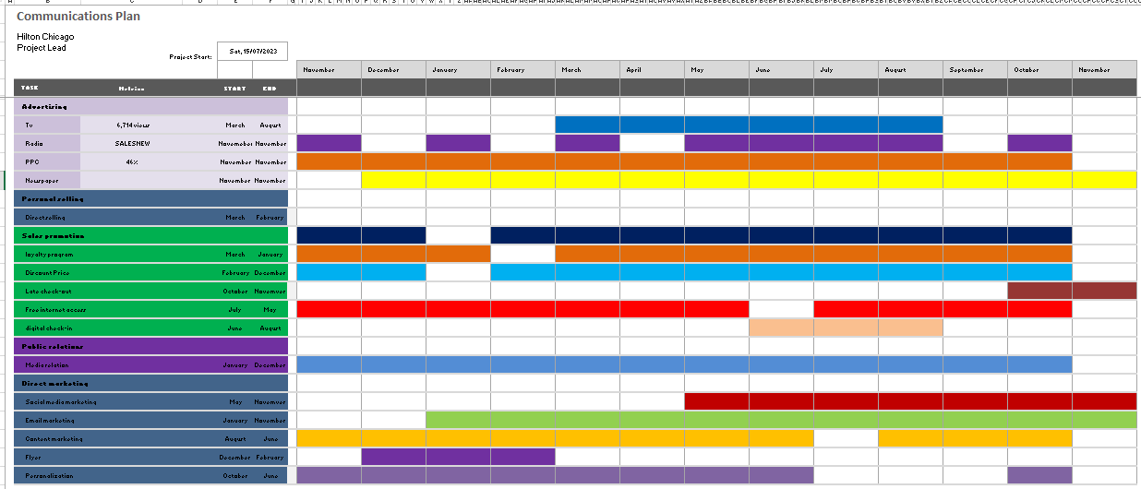
The marketing channels of Hilton Chicago will be including advertising, personal selling, sales promotion, public relation and direct marketing which will be continuously operated for marketing the new products towards the customers so that they can be aware of the new services of Hilton Chicago and can come for availing the services. The continuous operations of all of the marketing channels will be helping the hotel in being one of the trendy hotels in town.

Control
The effectiveness of the marketing plan will be seen in the progress of acceptance of the new services and the increase in customer engagement. The more the customer will be engaged with the hotel and will be taking the new services the more the effectiveness of the marketing plan will be ensured. The achievement of the objectives of the marketing plan will help in evaluating the KPI’s. The relevance of the actual performance with the expected performance will ensure that the marketing plan is being successful. It will also represent the positive attitude of the customers towards the brand and will help in increasing the profitability of the hotel.

Conclusion
The marketing plan of Hilton Chicago hotel need to be executed accordingly to have positive outcome. It is of serious concern that marketing plan needs modification with the change of market trend and customer’s perspectives. Hilton Chicago will need to collect market insights for having all of the updates about the market and what is going on in the market so that it can keep the plan up-to-date and effective as well. The marketers also need to be very careful in executing the plan so that no serious mistakes occurs and everything goes as planned.

References
- Azhar, M.E., Jufrizen, J., Prayogi, M.A. and Sari, M., 2019. The role of marketing mix and service quality on tourist satisfaction and loyalty at Samosir. Independent Journal of Management & Production, 10(5), pp.1662-1678.
- Choi, J.A. and Lim, K., 2020. Identifying machine learning techniques for classification of target advertising. ICT Express, 6(3), pp.175-180.
- Gilligan, C. and Wilson, R.M., 2009. Strategic marketing planning. Routledge.
- Kessler, C.S., Kalapurayil, P.S., Yudkowsky, R. and Schwartz, A., 2012. Validity evidence for a new checklist evaluating consultations, the 5Cs model. Academic Medicine, 87(10), pp.1408-1412.
- Kopuz, A.D. and Bal, A., 2023. The conservation of modern architectural heritage buildings in Turkey: İstanbul Hilton and İstanbul Çınar Hotel as a case study. Ain Shams Engineering Journal, 14(4), p.101918.
- Kurniawan, D., Iswahyudin, M.D. and Suciati, T.R., 2020. SWOT Analysis and Ansoff Matrix in Creative Food Industry Business Development: A Study on Creative Food Business “Komala”. Open Access Indonesia Journal of Social Sciences, 3(2), pp.128-136.
- Lahtinen, V., Dietrich, T. and Rundle-Thiele, S., 2020. Long live the marketing mix. Testing the effectiveness of the commercial marketing mix in a social marketing context. Journal of Social Marketing, 10(3), pp.357-375.
- McDonald, M., 2007. Marketing plans: how to prepare them, how to use them. Butterworth-Heinemann.
- Qin, X. and Jiang, Z., 2019. The impact of AI on the advertising process: The Chinese experience. Journal of Advertising, 48(4), pp.338-346.
- Raji, R.A., Rashid, S. and Ishak, S., 2019. The mediating effect of brand image on the relationships between social media advertising content, sales promotion content and behaviuoral intention. Journal of Research in Interactive Marketing.
- Reidhead, C., 2020. Impact of organizational culture on employee satisfaction: A case of Hilton hotel, United Kingdom. Journal of Economics and Business, 3(1).
- Rockett, G. and Yokoyama, M., 2019. A novel approach to inclusion and outreach to be tested at the Hilton Chicago O’Hare Airport hotel. Journal of Airport Management, 13(3), pp.238-244.
- Subotić, M., Vulić, M., Ristić, B., Popović Šević, N., Šević, A. and Ilić, M., 2021. Evaluating the impact of 5Cs model factors and marketing mix analysis: A case study. In 37th IBIMA conference proceedings.
- Tanjung, I.S., Tanjung, H. and Wibowo, Y.S., 2021. Development of Tourism Communication Model Based on Local Wisdom in Padangsidimpuan. Budapest International Research and Critics Institute (BIRCI-Journal): Humanities and Social Sciences, 4(4), pp.9877-9885.
- Westwood, J., 2010. How to write a marketing plan (Vol. 36). Kogan Page Publishers.
- Yu, J., Kang, B.N. and Kim, H.S., 2021. A comparative study between Hilton hotels in South Korea and USA through user-generated content analytics. Culinary Science & Hospitality Research, 27(12), pp.200-213.

Appendix


