International Meetings Management for the Hotel Industry
BMIH6007

Assignment 1: Feasibility Plan for an International Meeting

Event Theme: Equality, Diversity and Inclusion within Industry
Mother and Baby

Student Name: Selina Akhter Seema
Student ID: 2225106
Lecturer Name: Christopher Wilkin

AI Acknowledgement
I confirm that I have not used any AI tools in the research and creation of this assignment. I confirm that I have not presented any AI generated materials as my own work. I confirm I have copies of my drafts, notes, and other resources I used, which I may be asked to provide in evidence.

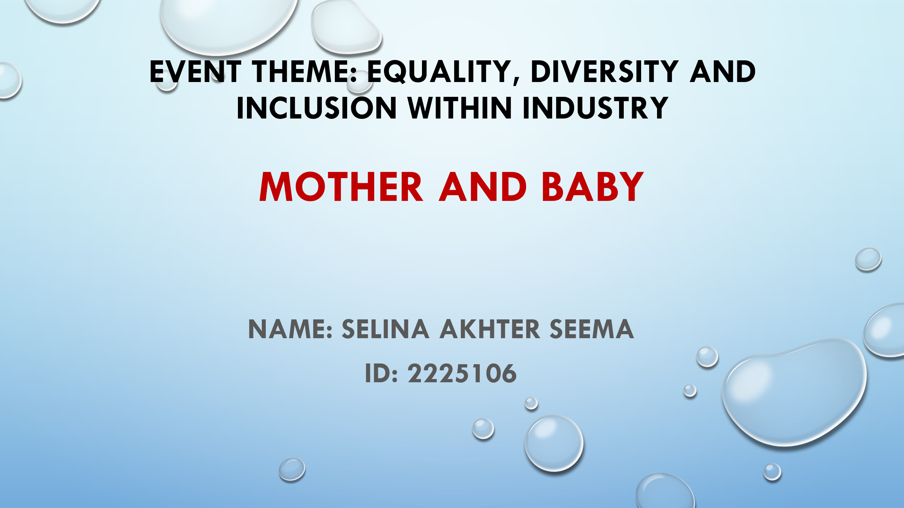

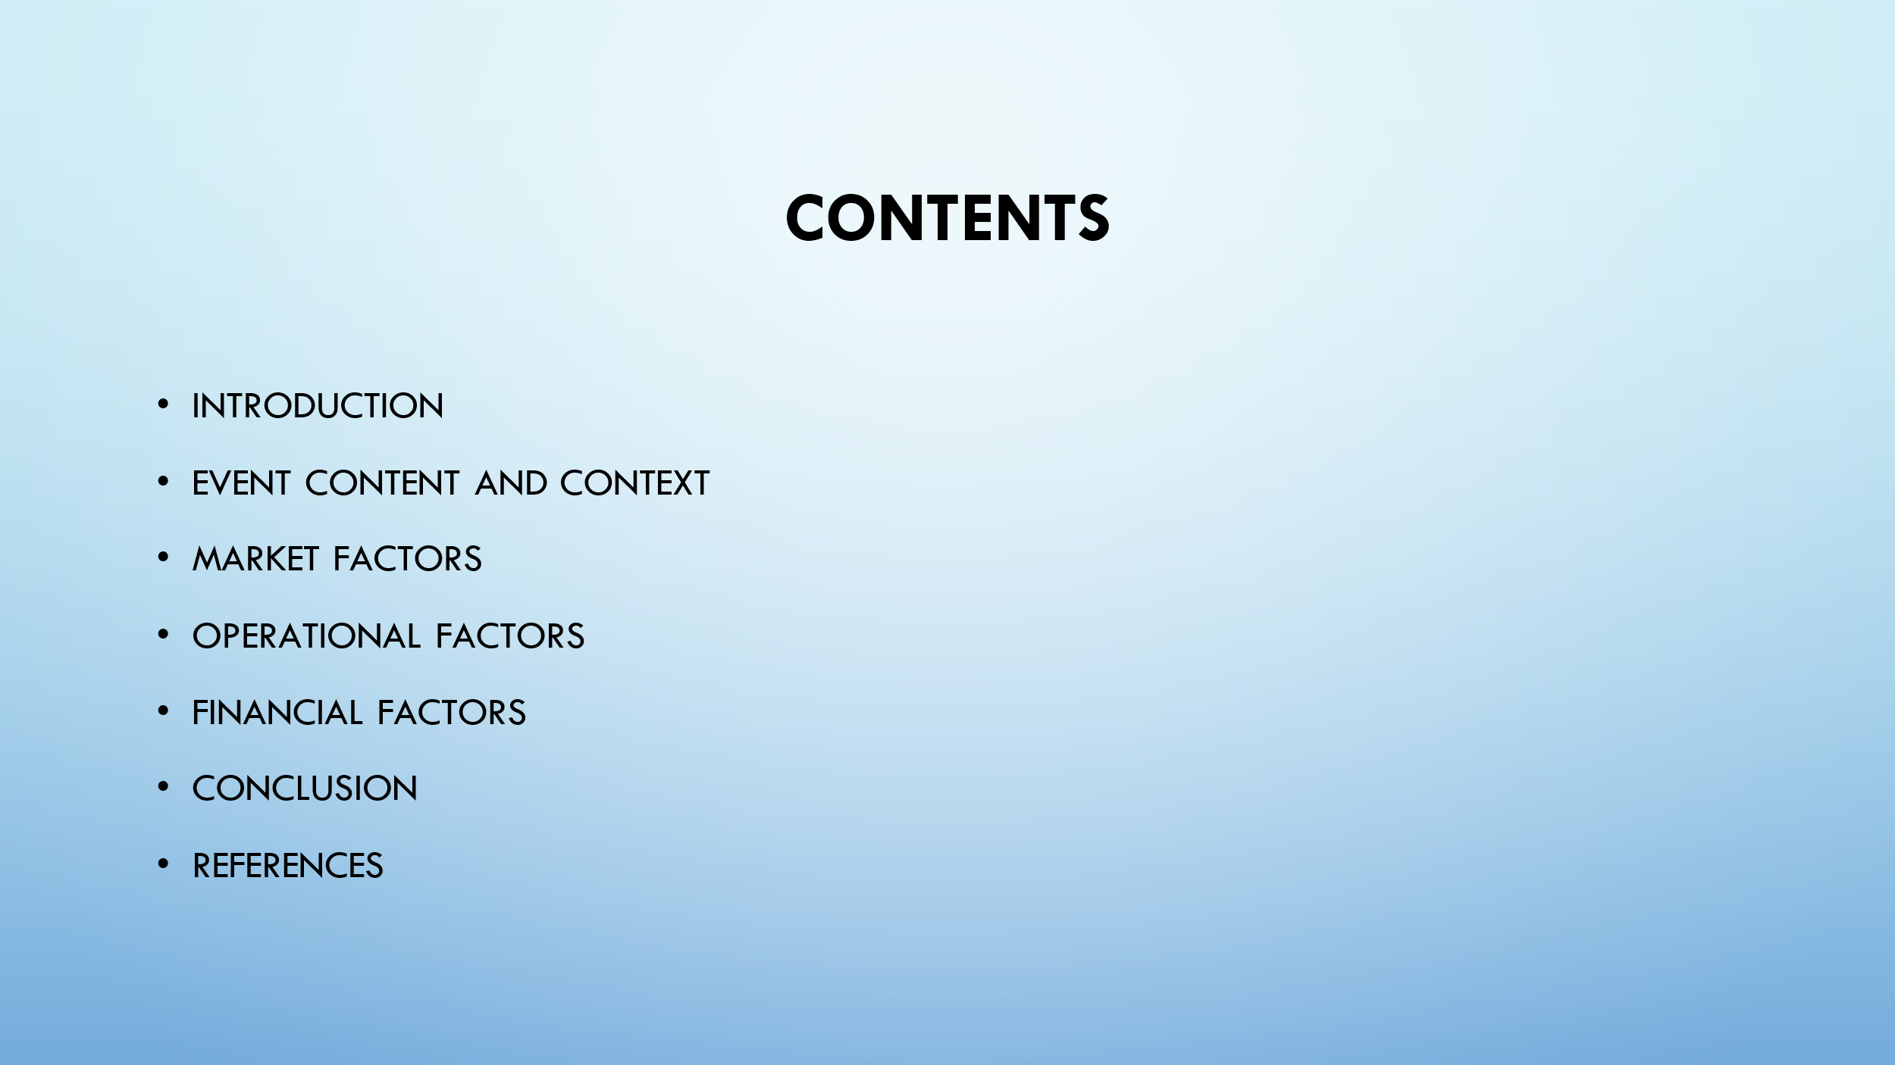

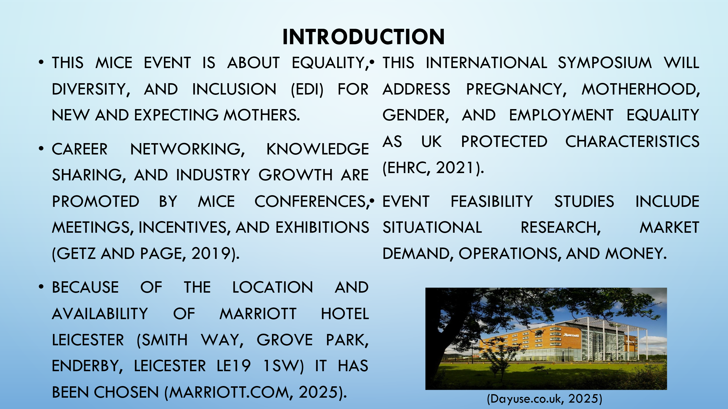

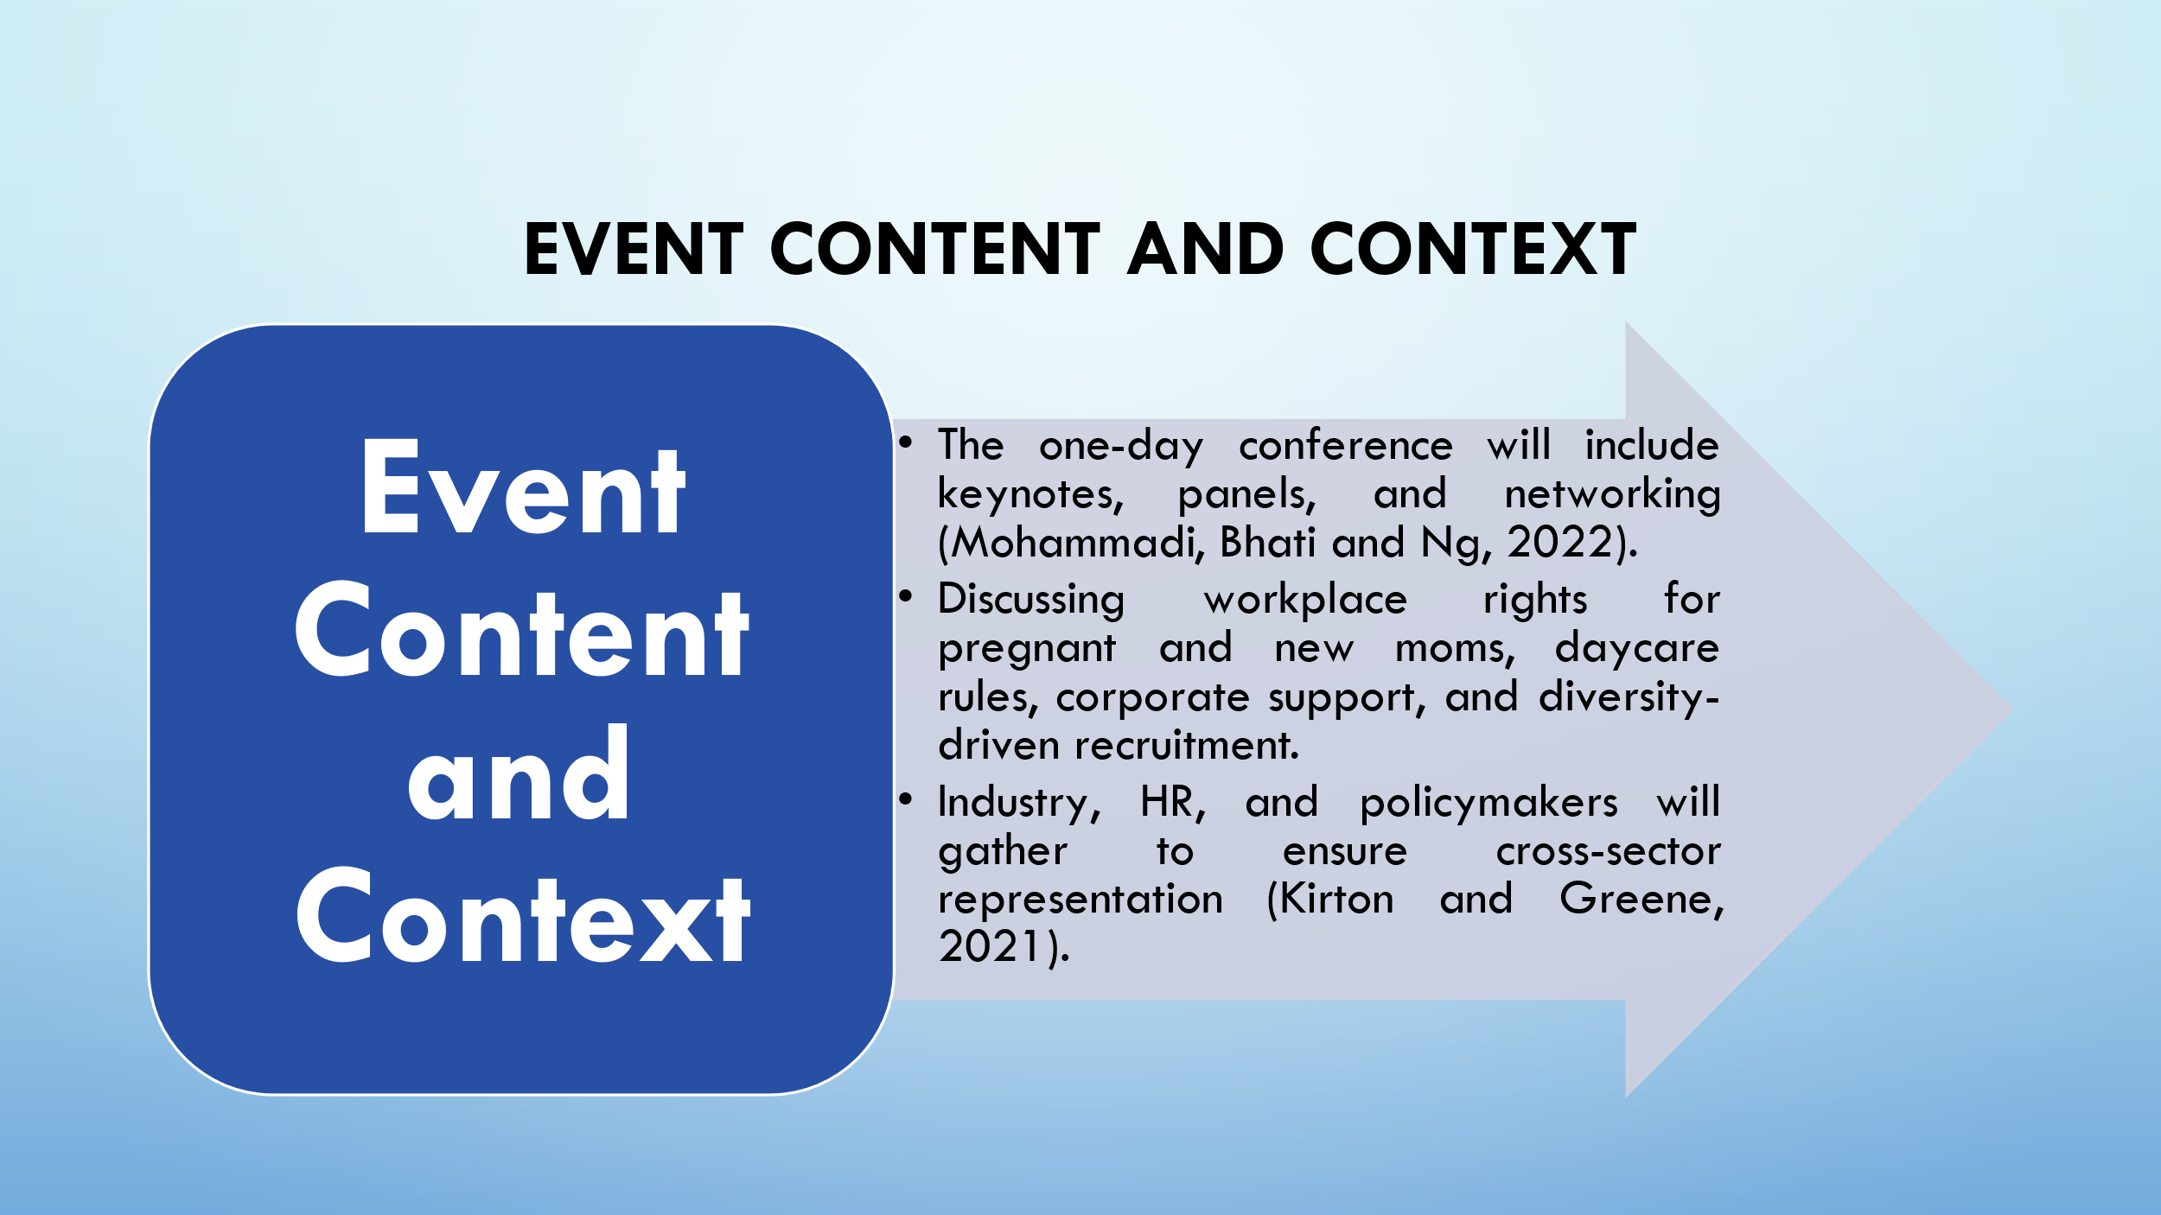

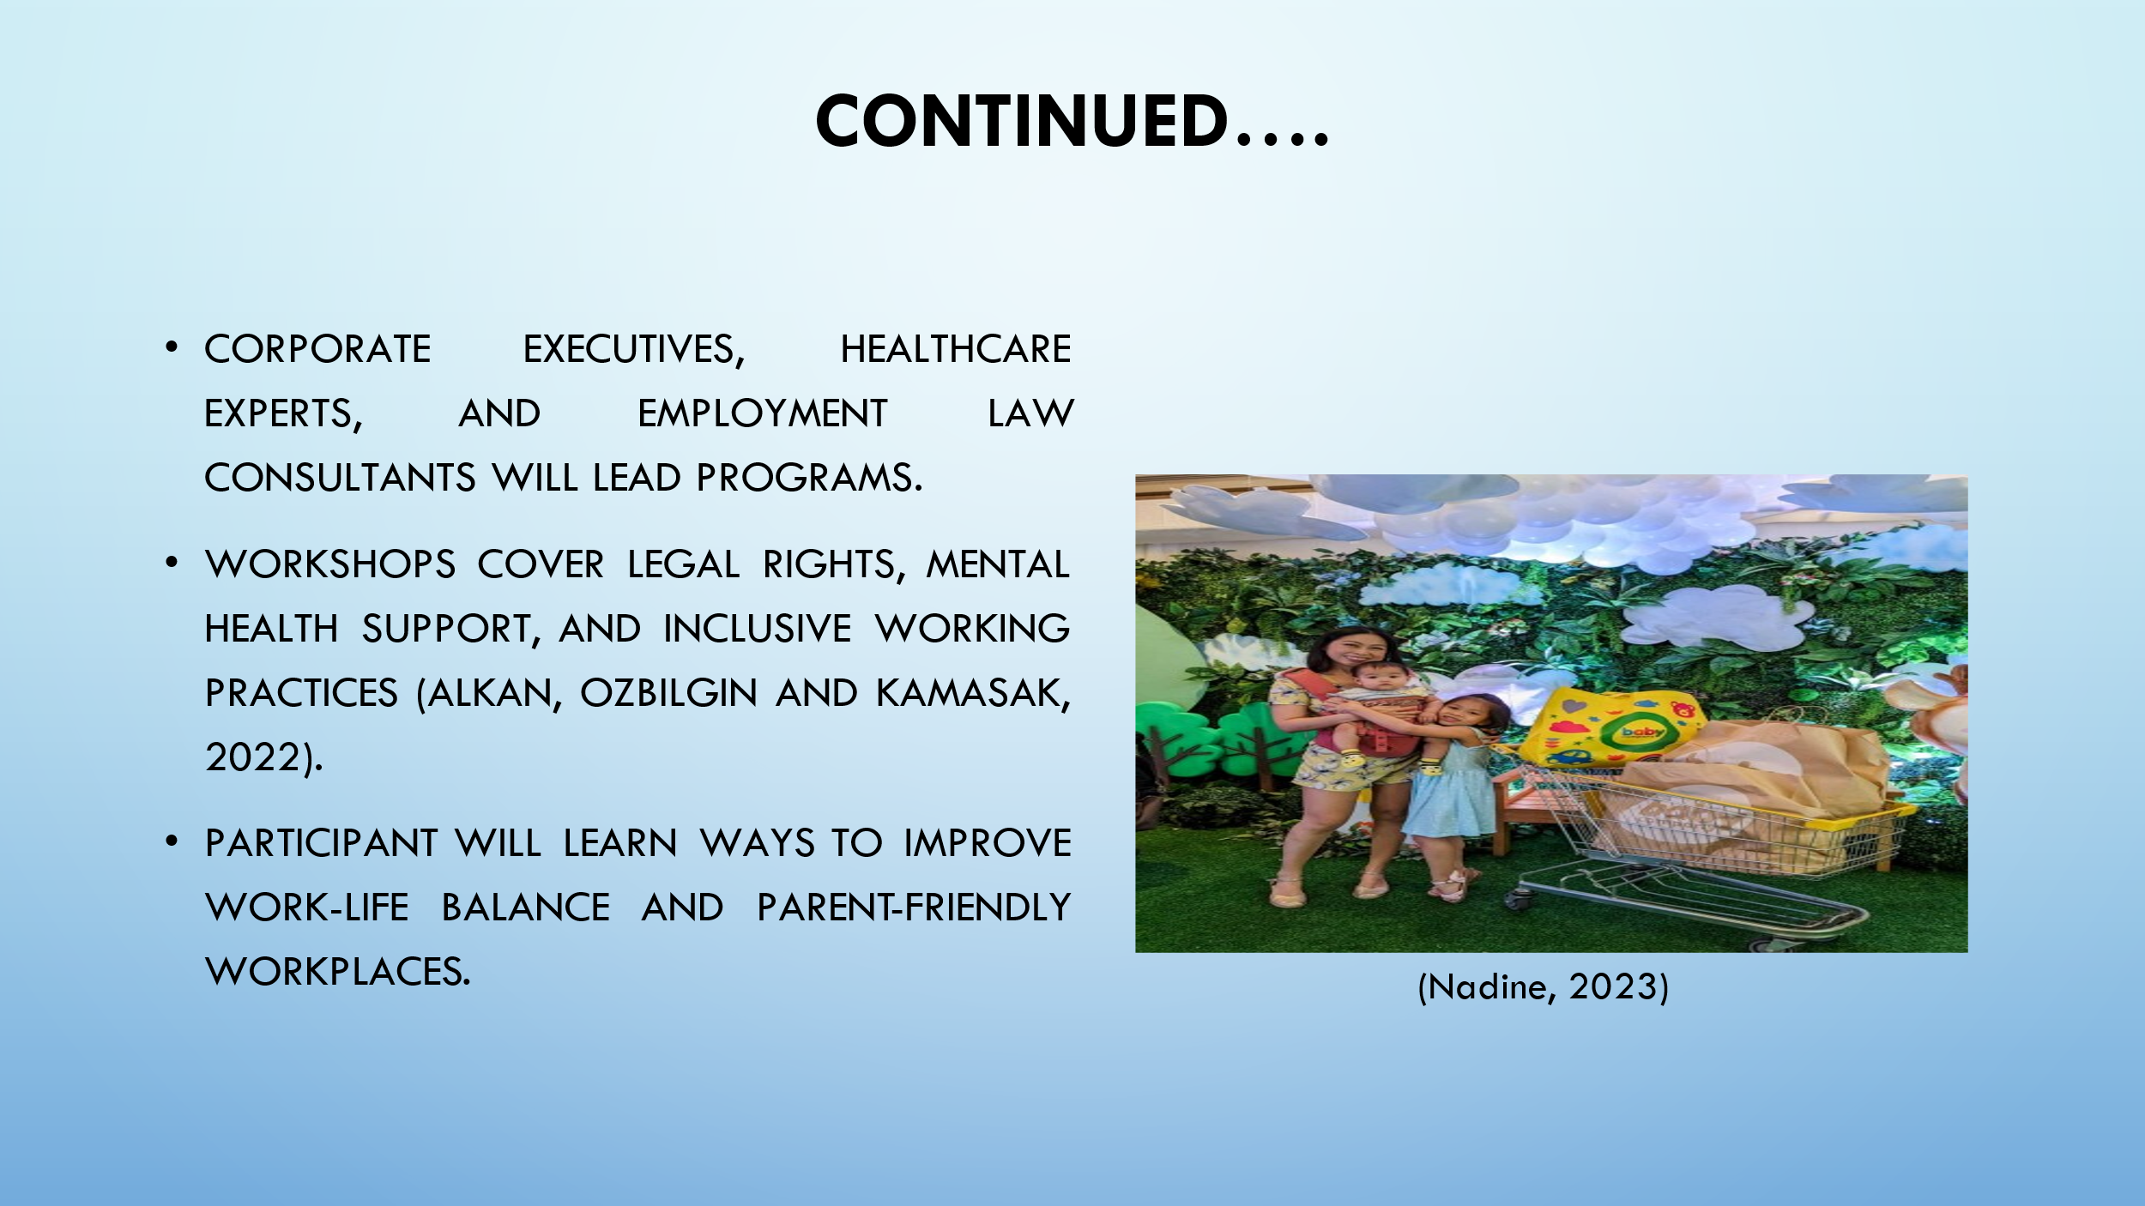

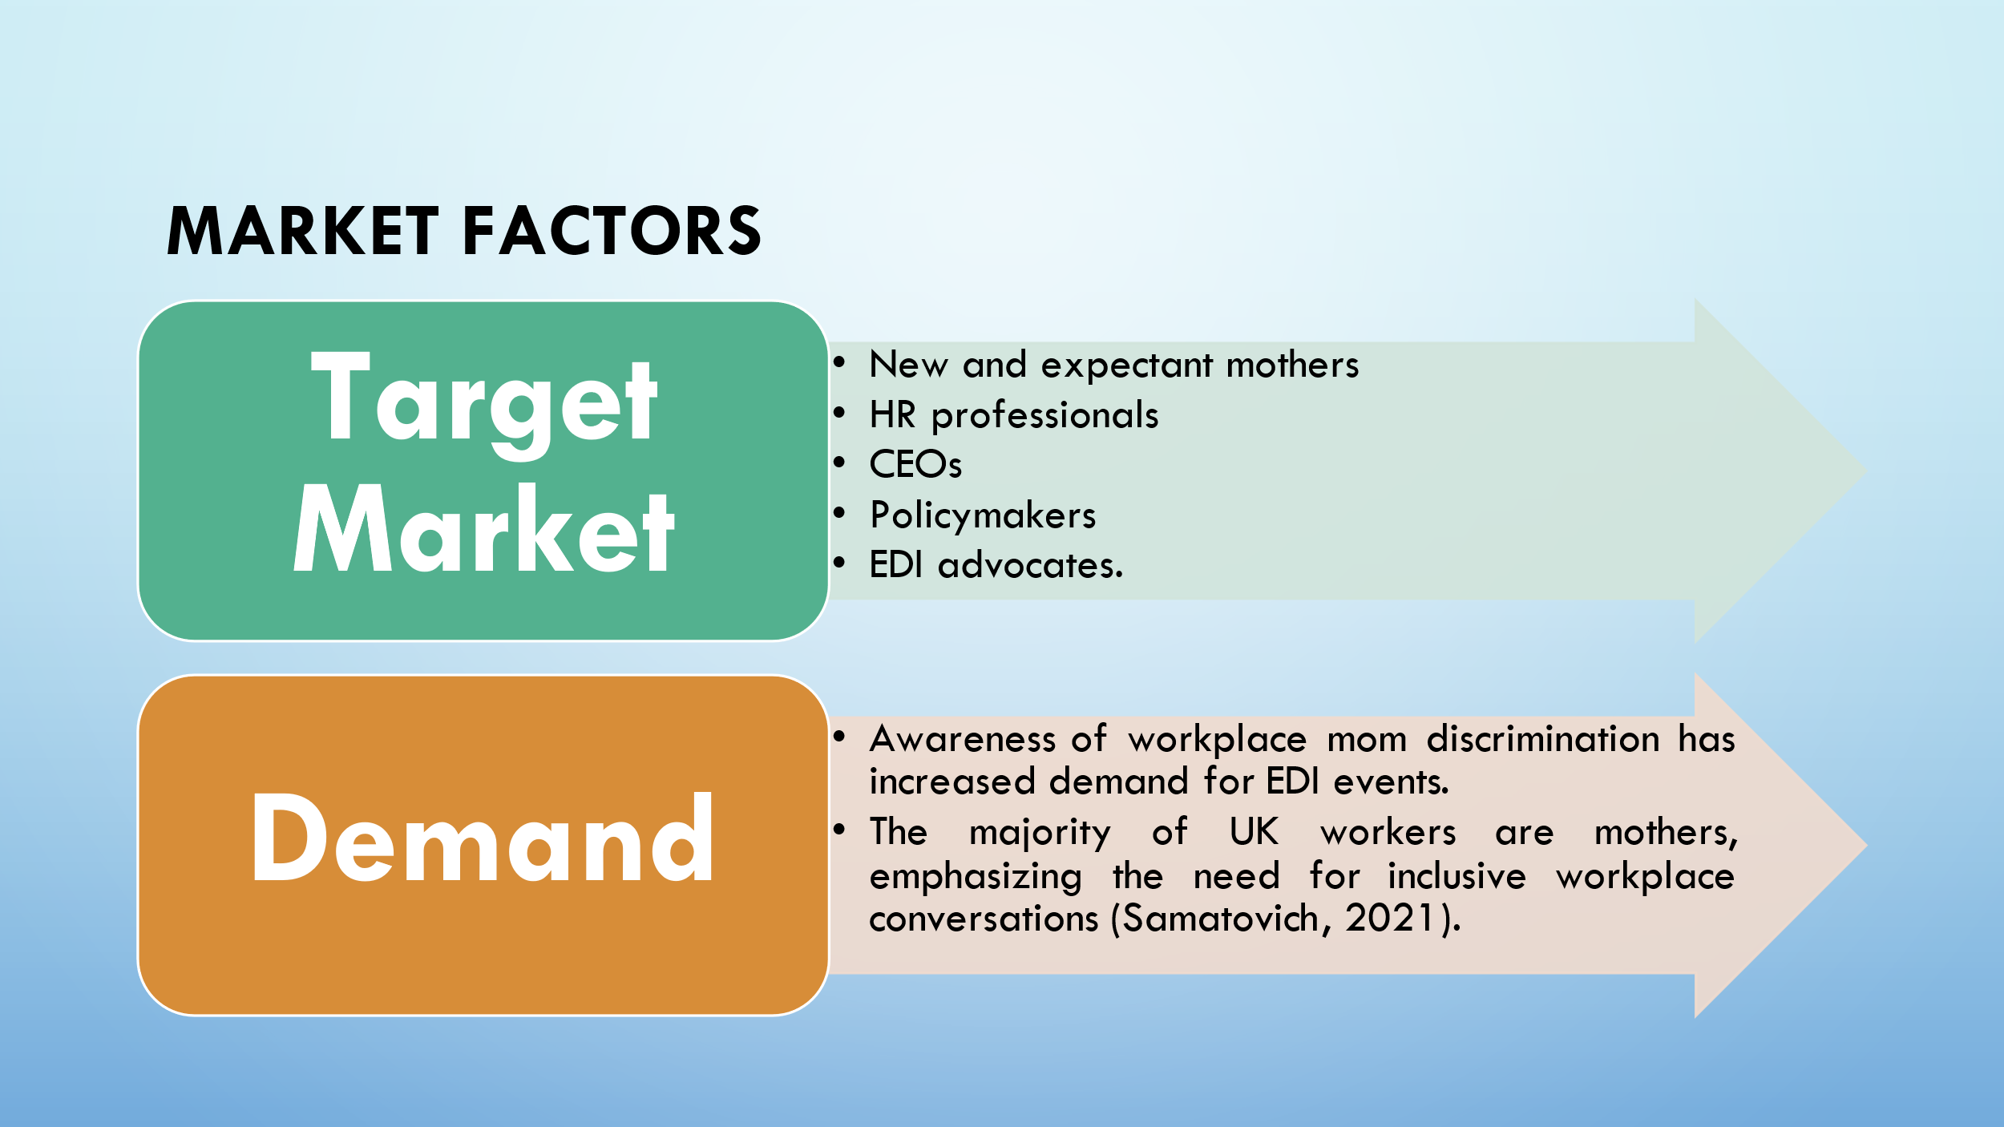

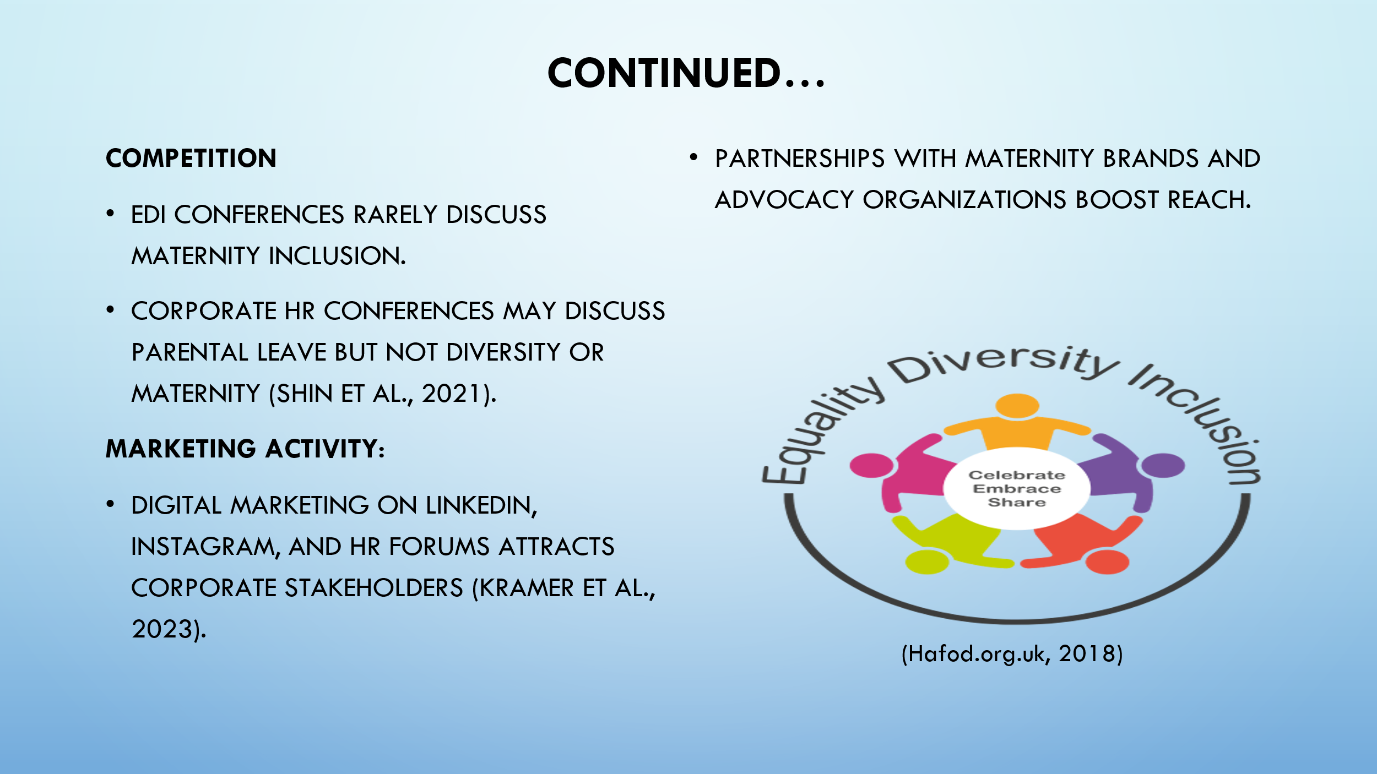

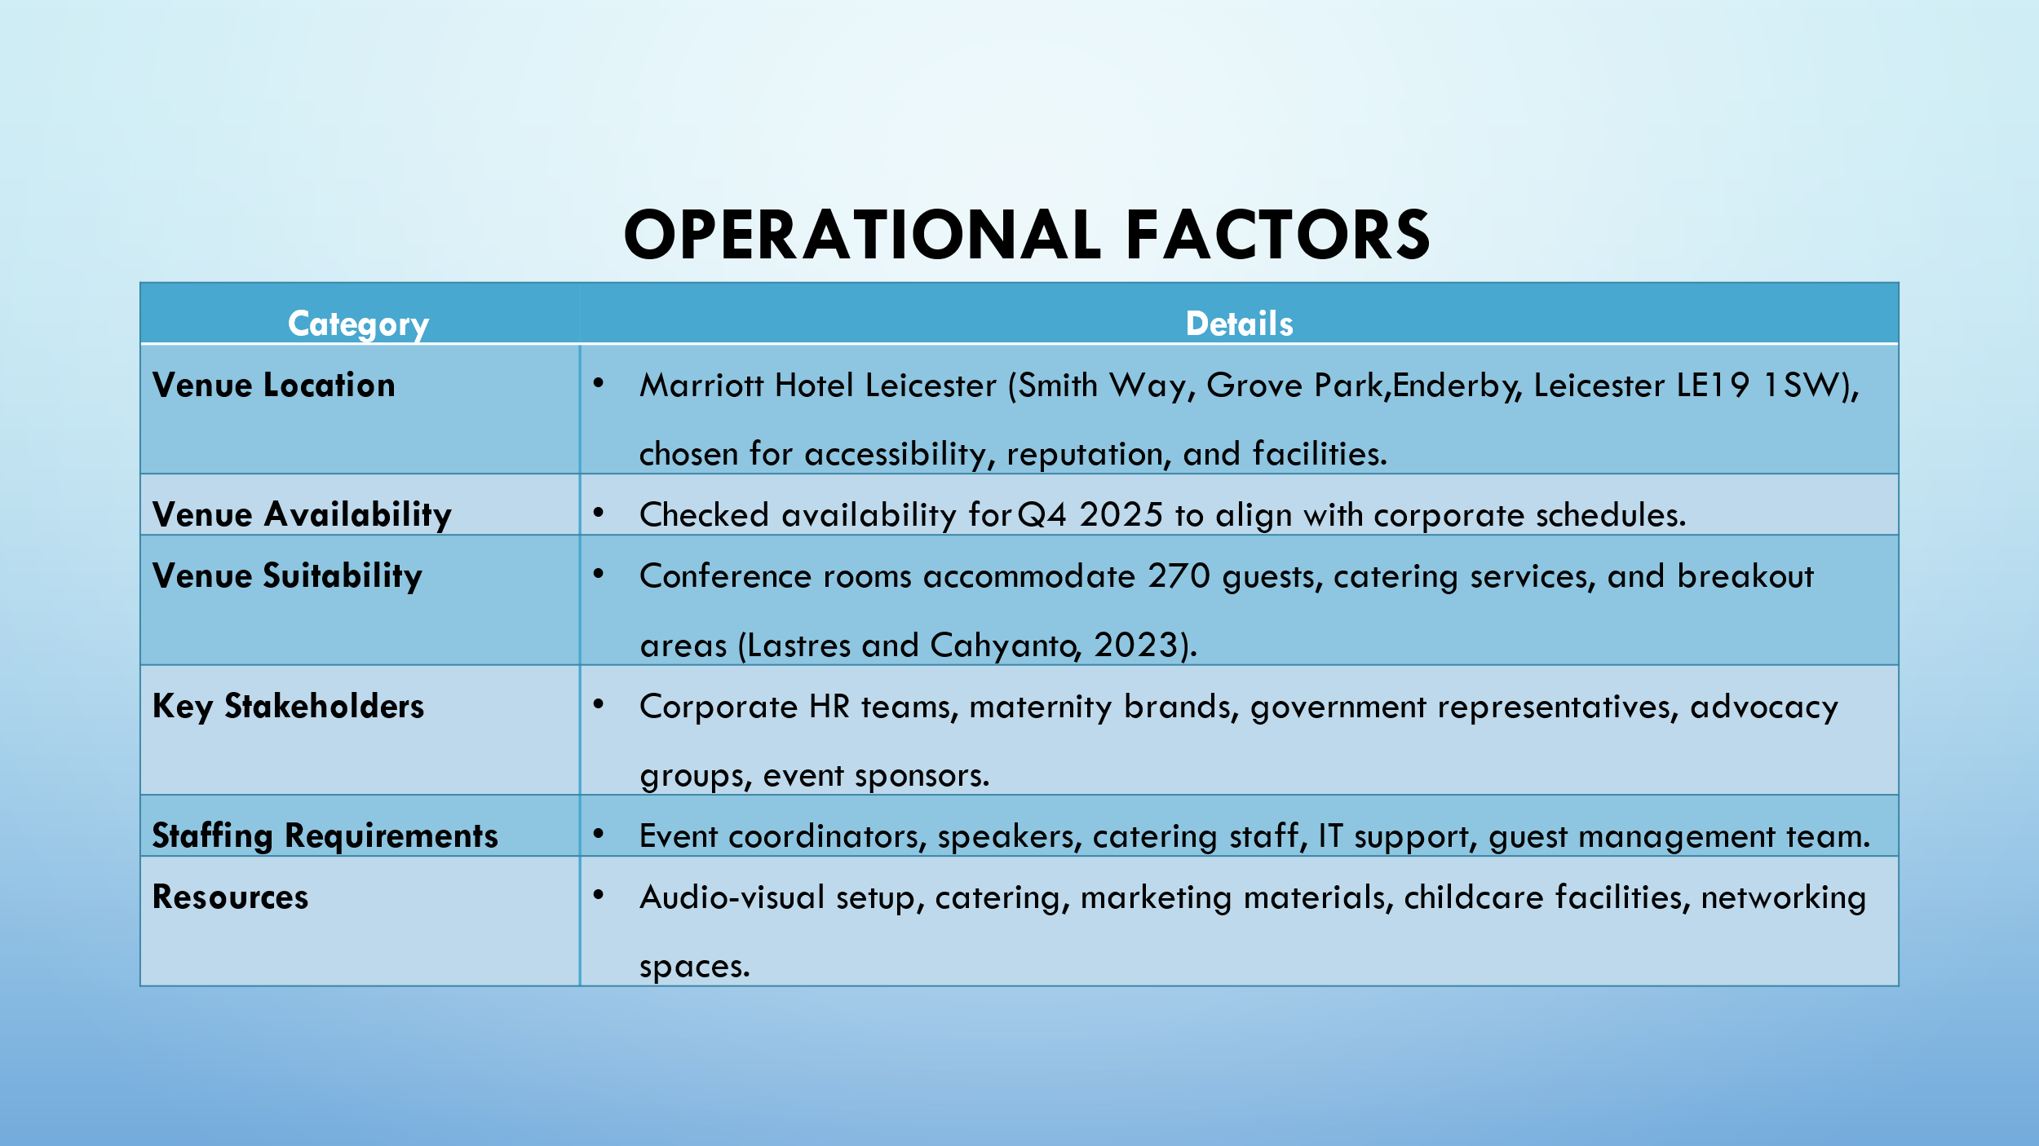

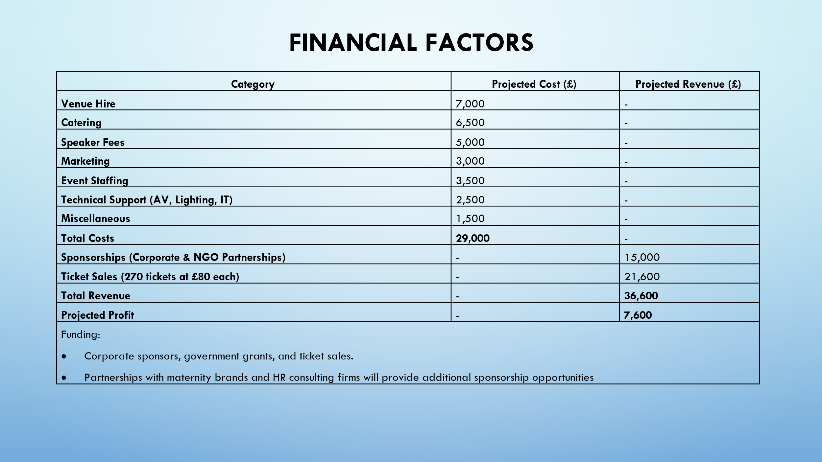

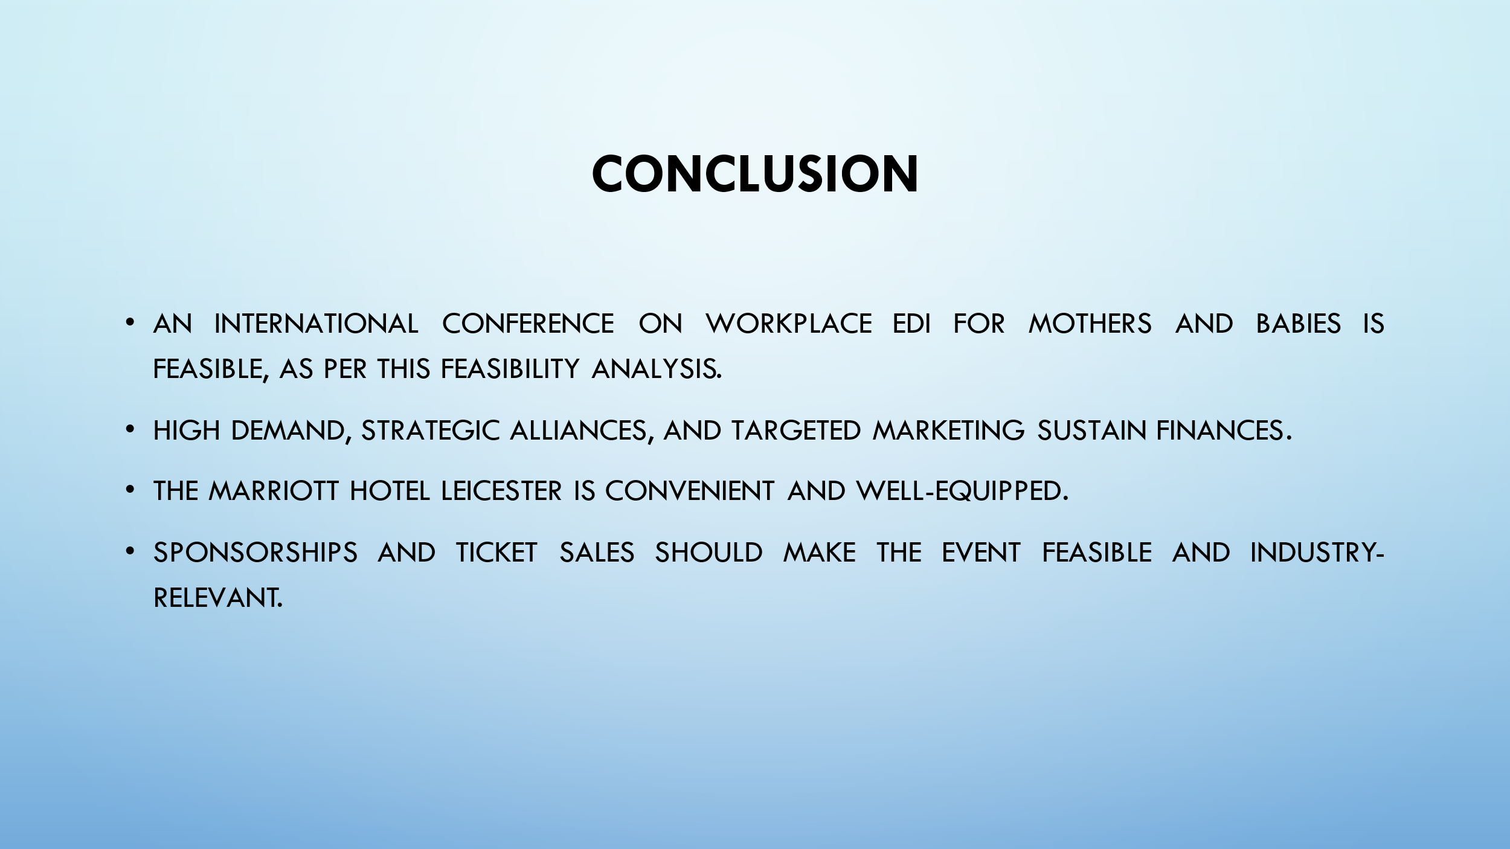

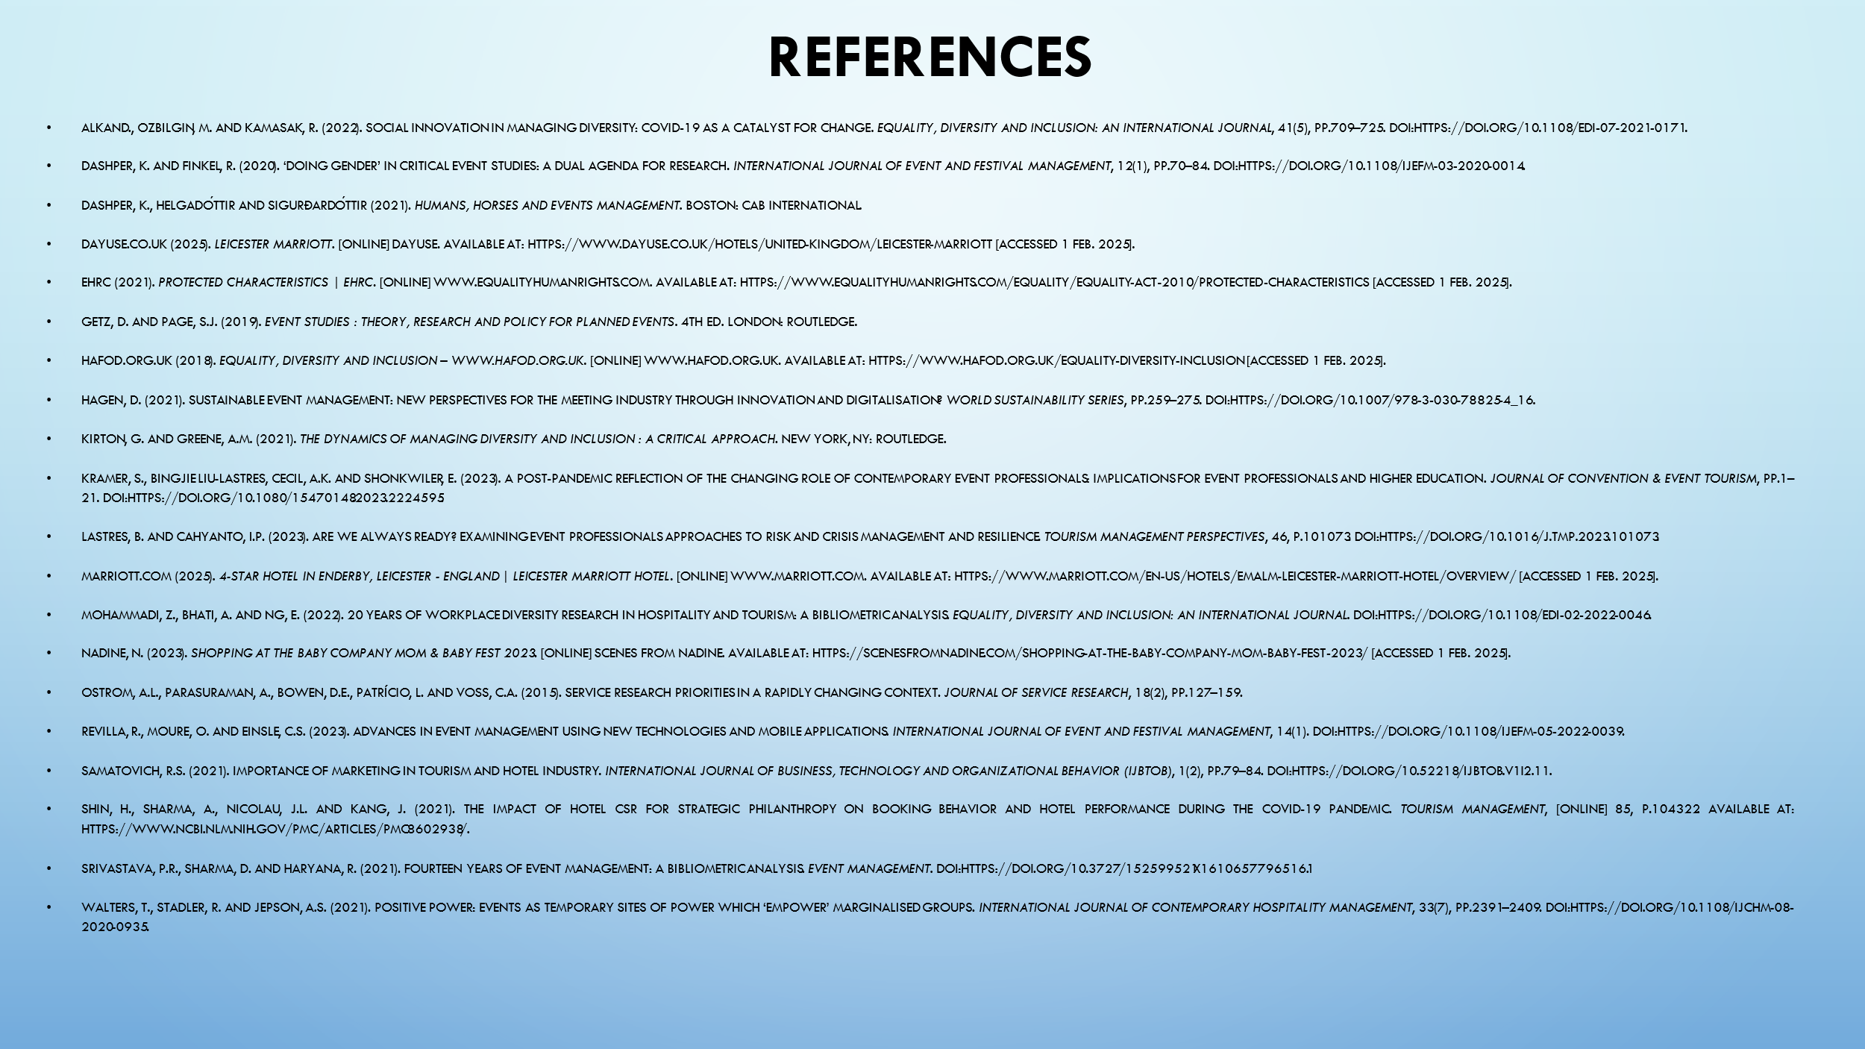

References:
- AlkanD., Ozbilgin, M. and Kamasak, R. (2022). Social Innovation in Managing diversity: COVID-19 as a Catalyst for Change. Equality, Diversity and Inclusion: An International Journal, 41(5), pp.709–725. doi:https://doi.org/10.1108/edi-07-2021-0171.
- Dashper, K. and Finkel, R. (2020). ‘Doing gender’ in critical event studies: a dual agenda for research. International Journal of Event and Festival Management, 12(1), pp.70–84. doi:https://doi.org/10.1108/ijefm-03-2020-0014.
- Dashper, K., Helgadóttir and Sigurðardóttir (2021). Humans, horses and events management. Boston: Cab International.
- Dayuse.co.uk (2025). Leicester Marriott. [online] Dayuse. Available at: https://www.dayuse.co.uk/hotels/united-kingdom/leicester-marriott [Accessed 1 Feb. 2025].
- EHRC (2021). Protected Characteristics | EHRC. [online] www.equalityhumanrights.com. Available at: https://www.equalityhumanrights.com/equality/equality-act-2010/protected-characteristics [Accessed 1 Feb. 2025].
- Getz, D. and Page, S.J. (2019). Event Studies : theory, Research and Policy for Planned Events. 4th ed. London: Routledge.
- Hafod.org.uk (2018). Equality, diversity and inclusion – www.hafod.org.uk. [online] www.hafod.org.uk. Available at: https://www.hafod.org.uk/equality-diversity-inclusion [Accessed 1 Feb. 2025].
- Hagen, D. (2021). Sustainable Event Management: New Perspectives for the Meeting Industry Through Innovation and Digitalisation? World Sustainability Series, pp.259–275. doi:https://doi.org/10.1007/978-3-030-78825-4_16.
- Kirton, G. and Greene, A.M. (2021). The dynamics of managing diversity and inclusion : a critical approach. New York, Ny: Routledge.
- Kramer, S., Bingjie Liu-Lastres, Cecil, A.K. and Shonkwiler, E. (2023). A post-pandemic reflection of the changing role of contemporary event professionals: Implications for event professionals and higher education. Journal of Convention & Event Tourism, pp.1–21. doi:https://doi.org/10.1080/15470148.2023.2224595.
- Lastres, B. and Cahyanto, I.P. (2023). Are we always ready? Examining event professionals approaches to risk and crisis management and resilience. Tourism Management Perspectives, 46, p.101073. doi:https://doi.org/10.1016/j.tmp.2023.101073.
- Marriott.com (2025). 4-Star Hotel in Enderby, Leicester - England | Leicester Marriott Hotel. [online] www.marriott.com. Available at: https://www.marriott.com/en-us/hotels/emalm-leicester-marriott-hotel/overview/ [Accessed 1 Feb. 2025].
- Mohammadi, Z., Bhati, A. and Ng, E. (2022). 20 years of workplace diversity research in hospitality and tourism: a bibliometric analysis. Equality, Diversity and Inclusion: An International Journal. doi:https://doi.org/10.1108/edi-02-2022-0046.
- Nadine, N. (2023). Shopping at the Baby Company Mom & Baby Fest 2023. [online] Scenes From Nadine. Available at: https://scenesfromnadine.com/shopping-at-the-baby-company-mom-baby-fest-2023/ [Accessed 1 Feb. 2025].
- Ostrom, A.L., Parasuraman, A., Bowen, D.E., Patrício, L. and Voss, C.A. (2015). Service Research Priorities in a Rapidly Changing Context. Journal of Service Research, 18(2), pp.127–159.
- Revilla, R., Moure, O. and Einsle, C.S. (2023). Advances in event management using new technologies and mobile applications. International Journal of Event and Festival Management, 14(1). doi:https://doi.org/10.1108/ijefm-05-2022-0039.
- Samatovich, R.S. (2021). Importance of Marketing in Tourism and Hotel Industry. International Journal of Business, Technology and Organizational Behavior (IJBTOB), 1(2), pp.79–84. doi:https://doi.org/10.52218/ijbtob.v1i2.11.
- Shin, H., Sharma, A., Nicolau, J.L. and Kang, J. (2021). The impact of hotel CSR for strategic philanthropy on booking behavior and hotel performance during the COVID-19 pandemic. Tourism Management, [online] 85, p.104322. Available at: https://www.ncbi.nlm.nih.gov/pmc/articles/PMC8602938/.
- Srivastava, P.R., Sharma, D. and Haryana, R. (2021). Fourteen Years of Event Management: A Bibliometric Analysis. Event Management. doi:https://doi.org/10.3727/152599521x16106577965161.
- Walters, T., Stadler, R. and Jepson, A.S. (2021). Positive power: events as temporary sites of power which ‘empower’ marginalised groups. International Journal of Contemporary Hospitality Management, 33(7), pp.2391–2409. doi:https://doi.org/10.1108/ijchm-08-2020-0935.

