

FRESHFUEL MEAL PREP

Business Plan
Module: LC LM4006 – Enterprise & Entrepreneurship
University: University of Wales Trinity Saint David
Student name: Elisei Constantin
Lecturer’s name: BOHDAN KOVALOV
Assignment: Business Plan
Submission date: Monday 26th October

Executive Summary
FreshFuel Meal Prep is a proposed startup in Swansea, Wales, selling affordable, nutritious and convenient ready-made meals. It will target university students, working professionals and gym users who have limited time to cook. Customers will order through social media or a website, with collection and local delivery available. FreshFuel will offer individual meals, weekly packages and vegetarian options. Its priorities will be quality, convenience, affordability and reducing food waste. The proposed startup funding is £8,000.

Table of Contents
- Overview of the Business Idea
- Market Research
- Marketing Communications
- Financial Plan
- Reference List

1. Overview of the Business Idea
FreshFuel Meal Prep is a proposed food business in Swansea, Wales, selling freshly prepared meals to customers who want convenient alternatives to fast food and expensive restaurant meals. The menu will include chicken and rice, pasta with vegetables, vegetarian curry and balanced protein bowls. Customers can buy individual meals or discounted weekly packages. Menus will change regularly to provide variety and encourage repeat purchases.
The business will target university students, working professionals and gym users who have busy schedules and limited time to cook. Students may have limited cooking facilities, while workers may want a convenient dinner after work. FreshFuel will offer pre-portioned meals that can be refrigerated and reheated safely. Ingredient and allergen information will be available to help customers make informed choices.
FreshFuel will initially operate from a suitable commercial kitchen rather than opening a restaurant. Customers will order through social media or a simple website and collect meals or use local delivery. This approach should keep initial premises and staffing costs lower. The business will begin with a small menu and limited delivery area, then expand if demand supports growth.financial records. If sales grow, FreshFuel could employ kitchen or delivery staff and consider changing its legal structure.
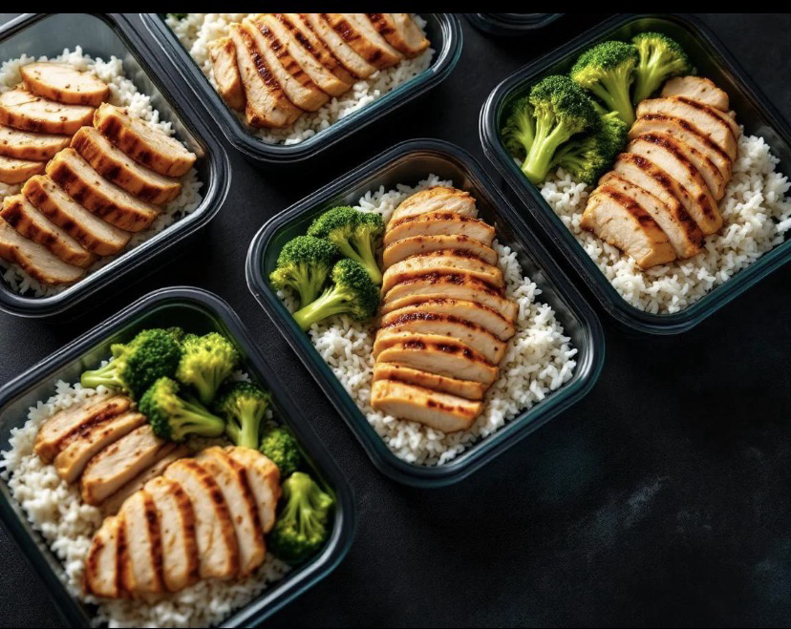
Sustainability will be part of the business model. FreshFuel will plan purchases around confirmed orders, forecast demand and use ingredients efficiently to reduce food waste. Packaging will be chosen with food safety and recyclability in mind. The business will separate recyclable materials and follow Welsh workplace recycling rules (Welsh Government, 2026). Where suitable, discounted surplus meals could reduce waste, provided food safety is maintained. FreshFuel aims to build a reputation for good value, consistent quality and reliable service.

2. Market Research

Target Market and Competition
The main target market is people aged approximately 18–35 who live, study or work in Swansea. This includes university students, young professionals and fitness-conscious customers. A secondary market includes busy families and older workers. These groups may value convenience and predictable prices, but their priorities will differ: some focus on price, while others care more about taste, portion size, ingredients or dietary choices.
FreshFuel will compete with supermarket ready meals, takeaway restaurants, food-delivery platforms and meal-preparation businesses. Supermarkets can offer low prices and broad availability. Takeaways provide variety and convenience, while meal-kit services allow customers to cook at home but still require preparation time. FreshFuel will need to show why its service is worth choosing over these alternatives.
The business will differentiate itself through local collection and delivery, weekly bundles, clear ingredient information and a menu shaped by customer feedback. It will not necessarily be the cheapest option; instead, it will aim to provide good value through convenient ordering, reliable portions and consistent quality. Before launch, the owner should survey potential customers and compare competitors’ prices, menus, delivery fees and reviews. A small trial menu will help test whether customers will pay the proposed prices.

PESTEL Analysis
Political factors: Policies supporting small businesses, training and local economic activity may create opportunities. However, changes in government policy or business support could affect costs. The owner should monitor relevant guidance and available support schemes.
Economic factors: Food prices, energy bills, kitchen rental and delivery costs could reduce profit margins. Customers may become more price-sensitive when household budgets are under pressure. FreshFuel will compare suppliers, monitor ingredient costs and offer bundles at clear prices. Prices must cover costs without becoming unaffordable for the target market.
Social factors: Busy lifestyles and interest in balanced eating may support demand for convenient meals. However, customers have different cultural preferences, dietary needs and allergies. FreshFuel will offer vegetarian choices, provide accurate ingredient and allergen information, and ask customers which meals they want. Feedback will help the business adjust its menu.
Technological factors: Social media, online ordering, digital payments and spreadsheets can help FreshFuel reach customers and manage orders. These tools are accessible to a small startup, but technical problems, payment fees or mishandling customer data could cause difficulties. The business will use secure systems and keep order records organised.
Environmental factors: Food waste and excessive packaging can harm the environment and increase costs. FreshFuel will plan purchases carefully, prepare meals according to demand and separate recyclable materials. Welsh workplace recycling rules require businesses to separate specified materials, with food waste separation applying to premises producing more than 5kg in a seven-day period (Welsh Government, 2026). Reducing waste can also improve efficiency and protect profits.
Legal factors: FreshFuel must follow food hygiene and safety rules, tax requirements, consumer protection and data protection legislation. A food business must register with its local authority at least 28 days before trading (Food Standards Agency, n.d.). The owner must check kitchen suitability, safe storage and temperature controls, allergen information, insurance and delivery arrangements. Legal compliance is essential to protect customers and the business’s reputation.
Overall, the market presents an opportunity, but demand should not be assumed. Customer surveys, competitor comparisons and a small launch will help FreshFuel test the idea before investing further.

3. Marketing Communications
FreshFuel will use digital marketing, introductory promotions and local partnerships to attract customers. Its main objectives are to build awareness, generate initial orders and encourage repeat purchases.
Social media: Instagram, TikTok and Facebook will show meal photographs, weekly menus, preparation videos and customer reviews. Posts will include prices, collection details and ordering instructions. Regular content can help customers recognise the brand and understand what makes it different. Photos and claims should accurately represent the meals being sold.
Promotional offers: During launch, FreshFuel could offer a discount on a first order or a lower price for a weekly bundle. A referral scheme could reward existing customers who introduce a new paying customer. Offers will be reviewed to make sure they lead to repeat purchases and do not reduce profit excessively.
Market segmentation: Students will be offered affordable bundles, professionals will be targeted with convenient weekday lunches and dinners, and gym users will be offered meals with clear nutritional information. Vegetarian options will support customers who do not eat meat. Different messages and offers will be used for each group rather than relying on one general advertisement.
Partnerships: FreshFuel will approach local gyms, student societies and suitable workplaces about promotions. A gym might share a discount code with members, while a student society could advertise a meal package. Permission will be obtained before promoting the business on university premises or using another organisation’s branding.
Customer retention: Weekly menus, dependable collection times and responsive customer service will encourage repeat orders. Customers will be invited to provide feedback about taste, portion size and price. Consistent quality and transparent communication will be important for building trust.
Marketing performance will be measured through weekly sales, repeat orders, website visits, social media engagement and the cost of attracting each customer. The owner will focus on methods that generate actual orders rather than online attention alone. This will help FreshFuel use its limited marketing budget effectively.

4. Financial Plan
FreshFuel will require an estimated £8,000 in startup funding. This is a planning estimate, not a supplier quotation. The proposed funding is £5,000 from the owner’s savings and a £3,000 startup loan, subject to approval. The owner should compare interest rates and repayment conditions before borrowing
Expense | Estimated cost
Kitchen equipment and utensils | £1,500
Initial ingredients | £800
Food packaging and labels | £300
Website and ordering setup | £400
Launch marketing | £300
Kitchen deposit and initial rental | £900
Insurance, training and compliance | £400
First-month utilities and transport | £400
Working capital reserve | £3,000
Total | £8,000

These figures must be checked against actual quotations. The working capital reserve will help cover unexpected costs and early operating shortfalls. Registration with the local authority as a food business is free, but premises, equipment, training, insurance and other compliance costs may apply.
The proposed average selling price is £6.50 per meal. If FreshFuel sells 600 meals in its first month, revenue would be £3,900. Assuming ingredients and packaging cost £2.60 per meal, direct costs would total £1,560, leaving £2,340 to contribute towards rent, utilities, delivery, marketing and other overheads.
If other monthly operating costs total £1,800, an estimated £540 would remain before tax, loan repayments and any owner’s salary. This is an illustrative scenario, not a guaranteed profit forecast. Actual results will depend on sales, food prices, kitchen costs and delivery demand. The owner should prepare a cash-flow forecast and calculate break-even sales before launch.
Financial performance will be reviewed monthly by comparing actual sales and expenses with the budget. If sales are lower than expected, FreshFuel could reduce the number of menu items, adjust purchasing quantities or focus marketing on its most popular meals. If demand is stronger, the owner could reinvest profits in equipment or staff. Careful monitoring will help the business avoid unnecessary spending and plan for sustainable growth.
In conclusion, FreshFuel Meal Prep could serve customers looking for convenient, affordable meals in Swansea. Its success will depend on food quality, effective marketing, cost control and evidence of genuine demand. Starting with a limited menu and testing demand before expanding will help reduce financial risk.

5. Reference List
Food Standards Agency (n.d.) Food business registration. Available at: https://www.gov.uk/guidance/food-business-registration (Accessed: 21 October 2026).
UK Government (n.d.) Set up as a sole trader. Available at: https://www.gov.uk/set-up-self-employed (Accessed: 21 October 2026).
Welsh Government (2026) Workplace recycling: guidance for workplaces. Available at: https://www.gov.wales/workplace-recycling-guidance-workplaces (Accessed: 21 October 2026).
Welsh Government (2024) Workplace recycling regulations: a guide for small and medium sized businesses and enterprises. Available at: https://www.gov.wales/workplace-recycling-regulations-guide-small-and-medium-sized-businesses-and-enterprises-smes (Accessed: 21 October 2026).

