WEEK 2 (week beginning October 9)

Forging a New Republic: From Colony to Constitution
In Focus: What is an American?
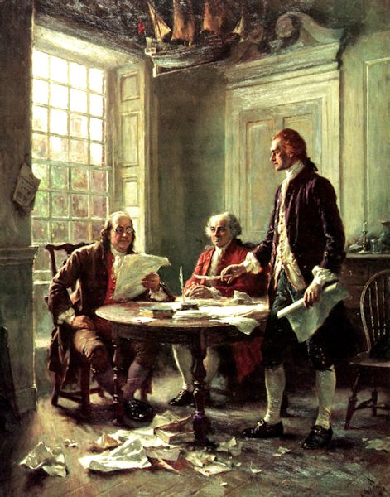
Jean Leon Gerome Ferris, Declaration of Independence (1932).
Part of The Pageant of a Nation series (see: http://xoax.net/art/ref/pageant_of_a_nation/)

This week focuses on the establishment of the United States. We examine the causes and consequences of the American Revolutionary War, plus the content of and arguments surrounding the Declaration of Independence and the US Constitution. In the process, we will focus on the influence of Enlightenment ideals on the American ‘founding fathers,’ and the ferment of different ideas about Democracy and Republicanism. We shall also discuss the emergence of a distinctively ‘American’ identity through a reading of J Hector St John de Crèvecœur’s ‘Letters from an American Farmer.'

- Reading and preparation:
Required reading:
- J Hector St John de Crèvecœur, ‘What is an American?’ in Letters from an American Farmer, originally published 1782
- The Declaration of Independence (pay particular attention for the lecture)
- The US Constitution
- The US Bill of Rights (Amendments 1–10 of the Constitution).

Recommended background reading:
- George B, Tindall and David Emory Shi, America: A Narrative History (New York: WW Norton & Co, 2010), chapters 6–8
- Eric Foner, Give Me Liberty! An American History (New York: WW Norton & Co, 2014), chapters 6–7

- Background information
On Crèvecœur, ‘What is an American?’ in Letters from an American Farmer, originally published 1782
Published during the American War of Independence, Letters from an American Farmer chronicles the fictional correspondence of James, the titular ‘American Farmer,’ as imagined by J. Hector St. John de Crèvecœur (1735-1813), a French author who was resident in North America from 1759 to 1778, and 1783 until shortly before his death. The letter ‘What is an American?’ is notable for demonstrating how the settler mentality had modified over the two centuries since Harriot’s initial explorations. In it, a nascent national identity is discernible – one which is recognisably distinct from earlier European or colonial attachments.
For further information, consult the Heath Anthology biography of Crèvecœur: http://college.cengage.com/english/lauter/heath/4e/students/author_pages/eighteenth/stjohndecrevecoeur_jh.html.

- Questions to consider:
Crèvecœur, ‘What is an American?’
- How does Crèvecœur describe what an American ‘is’?
- How are the new and old worlds differentiated?
- How might this text be viewed as a contributor to American national mythology?
- How are the attitudes detailed by Crèvecœur different to those in the earlier-dated sources?
- Conversely, in what ways can the content of Letters from an American Farmer be seen as a continuation of ideas established by Harriot, Bradford and Winthrop?

Declaration of Independence
- According to the opening paragraph, what is the goal of the writers? Why are they writing the declaration?

- What rights do the writers claim that they have as individuals and citizens in the declaration?

- What rights and powers does the declaration claim for the thirteen independent united states?

- How does the declaration define the purpose and function of government?

- Who is “He” that the colonists refer to in the document?

- Numerous grievances are listed in the declaration: can you summarise these into 3–6 key points?

- Are any of the signatories’ names recognisable to you, and if so why?

