

An analysis of Network Forensic tools

by
Christopher Morris

Supervisor: Carlene Campbell
Second Marker: TBD

Project submitted as part of the requirements for the award of MSc Computer Networks and Cybersecurity

December 2020

DECLARATION

I, Christopher Morris, declare that I am the sole author of this Project; that all references cited have been consulted; that I have conducted all work of which this is a record, and that the finished work lies within the prescribed word limits.

This work has not previously been accepted as part of any other degree submission.

Signed: c.morris
Date: 22/12/20

FORM OF CONSENT
I, Christopher Morris, hereby consent that my Project, submitted in candidature for the MSC Computer Networks and Cybersecurity degree, if successful, may be made available for inter-library loan or photocopying (subject to the law of copyright), and that the title and abstract may be made available to outside organisations.

Signed: c.morris
Date: 22/12/20

Abstract

Contents page
Contents
Abstract 3
Contents page 4
Chapter 1 – Introduction 7
1.1 Overview 7
1.2 Aim 7
1.3 Objectives 7
1.4 Project layout 7
Chapter 2 – Research and Review of Literature 9
2.1 Introduction 9
2.2 Research 9
2.2.1 Current background knowledge 9
2.2.2 Understanding of current processes 9
2.2.3 Criteria for an effective tool 10
2.3 Literature review 11
2.3.1 NF Analysis 11
2.3.2 Current tools 12
2.3.3 Background knowledge 14
2.3.4 Summary 15
Chapter 3 – Methodology 16
3.1 Chosen approach 16
3.2 Options discounted 16
3.3 Ethical considerations 17
3.4 Other factors 17
Chapter 4 – Design and Implementation 18
4.1 Introduction 18
4.2 Pre-task predictions 18
4.3 Considered limitations 18
4.4 Design Overview 18
4.4.1 Blueprint 18
4.5 Background of chosen tools 22
4.6 Implementation overview 23
4.6.1 Implementation process 23
4.7 Summary 27
Chapter 5 – Experiments and Results Discussion 28
5.1 Performance results 28
5.1.1 PRTG Monitor 28
5.1.2 SmartSniffer 29
5.1.3 Wireshark 30
5.1.4 Performance summary 31
5.2 Security results 31
5.2.1 PRTG Monitor 31
5.2.2 SmartSniffer 32
5.2.4 Security summary 32
5.2.3 Wireshark 33
5.3 Overall standings 33
5.4 Discussion of results 34
5.5 Chapter summary 34
Chapter 6 – Conclusions and Recommendations for future work 35
6.1 Chapter introduction 35
6.2 Conclusion 35
6.3 Recommendations for future work 36
Chapter 7 – Evaluation & Reflection 37
7.1 Evaluation 37
7.1.1 Project objectives 37
7.1.2 Project plan 37
7.2 Reflection 37
7.3. Conclusion 37
Chapter 8 – References and Bibliography 39
8.1 References 39
8.2 Bibliography 41
Appendix 1 42
Appendix 2 43

List of Figures
Figure 1: Research Onion Model 16
Figure 2: PRTG login 23
Figure 3: PRTG menu options 24
Figure 4: SmartSniffer interfaces 24
Figure 5: SmartSniffer loadup and headings 24
Figure 6: Wireshark interfaces 25
Figure 7: Wireshark startup/stop button 25
Figure 8: Wireshark headings 25
Figure 9: PRTG performance features 28
Figure 10: PRTG exporting 28
Figure 11: SmartSniffer performance features 29
Figure 12: SmartSniffer exporting 29
Figure 13: Wireshark performance analysis 30
Figure 14: Wireshark exporting 30
Figure 15: PRTG security features 31
Figure 16: PRTG malware check 31
Figure 17: SmartSniffer security features 32
Figure 18: SmartSniffer malware check 32
Figure 19: Wireshark security features 33
Figure 20: Wireshark malware check 33

List of Tables
Table 1: List of considered performance/security tools 15
Table 2: Overall scoring system for effectiveness 19
Table 3: Scoring classification 19
Table 4: Shortlist of final tools 20
Table 5: Factors considered during experiments 21
Table 6: Overall scoring system for performance 21
Table 7: Overall scoring system for security 22
Table 8: Final scores 33
Table 9: Chapter durations 43

Chapter 1 – Introduction

1.1 Overview
This project analyses Digital Forensics (tools which aim to improve the security of a device by simplifying areas such as device storage and recovering data that will prove important as evidence, such as alibis), experimenting with a minimum of three tools in the area of Network Forensics (tracing network statistics to discover potential threats).

Each tool was scored out of at least 10 based on how effective they were. A blueprint outlined the experiment process, which was repeated for each tool to ensure consistency. A series of sub-questions was formed for each tool to complete. Each tool chosen was cost-free, to keep analysis on a level-playing field. The scores determined how effective a tool is overall.

The project was worth doing because there became a gap in current literature for it, which increases the chances of it contributing new knowledge to the field. It is unpopular within the general area of Digital Forensics, meaning it could capitalise of the area’s growing popularity, while being even more likely to stand out by focusing on one specific area.

Having a scoring system in place also added variety and helped the project stand out. It was also an area of interest, inspired by a previous task where a wide variety of Digital Forensic tools were applied. It was therefore figured to be wise to return to this topic area.

1.2 Aim
The aim of the project was to assess what determines an effective Digital Forensics tool. This leads to the main research question:
“What defines an effective Network Forensic tool?”

1.3 Objectives
To answer the main research question, five objectives were identified:
• Conduct literature review to demonstrate understanding.
• Define the criteria that the Digital Forensic tools will be measured against in terms of effectiveness.
• Establish each tool’s requirements via implementation and instructions.
• Critically analyse and evaluate tools via experimentation and score each tool out of a required value depending on the implementation devised.
• Based on results, make any future recommendations and document who benefits from the project.

These objectives were met through primary research in the form of experimentation and secondary via a literature review and analysis after the experimentation. These objectives were relevant because they linked with each other and ensured a measurable outcome was reached. The project was managed through meetings with the supervisor and including a project plan (which details target dates for tasks). A test run of experimentation ensured that the experiments were achievable.

1.4 Project layout
The project was laid out in the following manner: an introduction detailing the task and any background information, literature review discussing which criteria the results should be analysed against, a justification of the methods employed, data results of the experimentation, an overall analysis, a conclusion, any recommendations and further research followed by references, a bibliography and appendixes.

Chapter 2 – Research and Review of Literature

2.1 Introduction
As per the first objective listed, a literature review was required to gain understanding of current research and select papers to measure results against. This section was split into two parts: first a “research” section to detail background knowledge, and then the literature review section analysing current research on the topic and which papers to most closely refer to once results have been formed.

2.2 Research

2.2.1 Current background knowledge
Digital Forensics is a branch of cybersecurity that assists with the recovery of data, so that it can be used as evidence. It is a popular trend within the field of cybersecurity due to simplifying the process of recovering and maintaining important data.
They are mainly software and can be split into several categories. Example areas previously covered include Disk Analysis (e.g. WinDirStat), File Analysis (e.g. Shadow Explorer), File Signature (e.g. Stellar Phoenix), and Internet Analysis (e.g. Xplico). The output of results is determinant on the purpose of it (e.g. Disk Analysis showing the amount of storage by separating them in blocks and where data is most spent).
An example Digital Forensic model is by Kohn in 2013. [1] Essentially, the objective is to recover any data that is needed as evidence (e.g. document proving that someone attended a meeting) so that it can be collected, identified, organised, and reviewed ready for purpose. These tend to be popular headings within Digital Forensic models since they are simple and common language.
In terms of UK law, it is necessary to abide by regulations from the British Computer Society, such as the Computer Misuse Act of 1990 to prevent unlawful access to a device. The main process of retrieving evidence is split into three main stages: Recovery (the initial retrieval of targeted data), Interpretation (the analysis of data), and Presentation (the summary of the findings). [2]
In this instance, the category of Digital Forensics chosen is Network Forensics (e.g. Wireshark), which examines network traffic (such as protocols used and amount of storage) and stores them into bytes of data named network “packets”. Network forensics can be used to track data such as recent users of a device and can retain data for future reference (since data will be lost as it constantly adapts and updates to reflect current data).
According to Garfinkel [3], there are two main groups that Network Forensic tools are divided by: either “catch-it-as-you can” (where all traffic is displayed regardless of how complex it is), or “stop, look, and listen” (where only network traffic deemed important is displayed). Both have their benefits and drawbacks (“catch-it-as-you-can requiring more storage but being able to pinpoint more data and vice versa for “stop, look, and listen”), and lend themselves to a tool depending on said tool’s primary purpose (e.g. to provide a full picture of a network’s infrastructure or list all important facts as instructed to by the user).

2.2.2 Understanding of current processes
Shaaban and Abdelbaki [4] are Egyptians who published a paper in 2018 via the Procedia Computer Science. They look primarily at Memory and Timeline Analysis. Their conclusion is that the best technique depends on scenario e.g. (a quick analysis in the case of an emergency).
The benefits of this paper include how specific it is, not focusing on one single aspect of Digital Forensics. It also has the most amount of references within this objective and considers how quick different varieties of Forensics are in retrieving data. Timeline Analysis particularly was identified as a promising area to investigate. However, its drawbacks encompass being the shortest chosen paper within this objective, at five pages long.
Next is Mushtaque in 2015 [5], based in Pakistan and available in the Journal of Information Systems and Technology Management. He looks at how Digital Forensics has evolved over time, particularly investigation models and analysis of data as demand for cybersecurity grows. The conclusion is that the right measures must be taken to retrieve enough evidence.
This paper’s strong points are, for example, displaying a high amount of statistics and the origins of digital forensics. It may be an idea to look for statistics in the UK to emphasise how important having a Digital Forensic plan is.
On the contrary, its weak points are that it is the least recent of all chosen papers and has the lowest amount of references. It may be ideal to use this paper against Narwal’s paper to get a clear picture of how Digital Forensics has evolved over time.
This is followed by Narwal in 2020 [6], located in India and firstly available in the International Conference on Emerging Technology in Electrical and Electronics. It is a walkthrough on how Digital Forensics works, including models and example tools against a set of criteria such as being able to detect threats (for memory tools). Overall point is that these tools will prove vital against cyberattacks as cybersecurity continues to grow with the effect of more weaknesses being identified.
One positive aspect of this paper is how recent it is, being released in the same year as this project and being the most recent of all the papers chosen. It also has the highest amount of references within this objective, at 58, and covers a wide range of digital forensics. On the other hand, many of the references are web links rather than other journals, meaning more outside research is needed.

2.2.3 Criteria for an effective tool
Horsman published a paper in 2018 [7], based in the UK Science and Justice department. This looks at the process and implication of Digital Forensic tools, namely how vigorous they are in areas such as reporting errors. The conclusion is that the area benefits from growth, but accountability needs to be made clear to avoid blame being placed wrongly.
The benefits of this paper are it being UK-based, allowing for easy reference of the most popular tools or legal standards. One example limitation, though, is how descriptive it is, especially how this task will be inferential.
Next is Dimpe and Kogeda in 2017 [8], from the US World Congress on Engineering and Computer Science. They look at the requirements and phases of Digital Forensic tools (e.g. Chain of Custody). The overall point is that tools need to be checked to avoid becoming unreliable. This ties in with Horsman’s [7] conclusion that repercussions can come if data is unavailable.
The usefulness of this paper comes from how in-depth it describes the process of retrieving data. It leads to several categories that can serve as criteria in this task, such as how well a tool preserves its data. The considered drawbacks are how complex the language is.
Lastly, Marshall and Paige published a UK paper in 2018 [9], via the Digital Investigation Journal. This examines how Digital Forensic tools integrate with the methods. Main point is that tools can be more effective if they are tested and engaged with.
The main positive aspects here are it being the longest paper within this area, at 21 pages long, and it being documented within the UK, meaning the legal procedures and standards will have a greater connection to this task. The negative factors include it having the lowest quantity of references (17).

2.3 Literature review
Added to the knowledge establishing the full picture, three papers will be primarily focused on to compare the task findings to (ideally investigating different elements of Network Forensics to reach as wide an audience as possible).

2.3.1 NF Analysis
The paper that was chosen to receive the most reference in this area was by Lopez-Araiza and Cankaya [10] in 2017 in the United States Journal of Medical – Clinical Research & Review. This paper examines several Network Forensic Security tools, namely: Fail2ban, HoneyDrive3, Netdata, and Nmap. Each tool was tested against seven sets of criteria and is given a score out of seven based on how many it can accomplish (in this case, being able to perform several actions associated with network security).

All four tools were capable of logging (listing events that have transpired), only Fail2ban could perform an Automated Threat Response (collecting data automatically through scans instead of manually), everything except HoneyDrive3 could actively monitor progress, only HoneyDrive3 could outright prevent a security attack, Fail2ban and Netdata were the only tools which could both detect malicious activity and report it, and only Nmap had the ability to perform security audits (an analysis of current protection measures).

The conclusion was that each of the four tools are least component in in performing network forensics, though Fail2ban was considered the best-performing by meeting 5 out of 7 and HoneyDrive3 ranked the lowest by only performing 2 out of 7.

This paper is important because it is similar to the intended layout of this task and includes several important factors in network forensics that must therefore be considered for this task. What is useful is that several tools are brought about which were previously unknown, which provides inspiration for tools as well as criteria. This paper is also the most recent of the chosen literature review.
It also has a similar criteria system via listing off what a tool can and cannot do, though this task’s scoring system will instead use knowledge of a tool’s capabilities to score it rather than solely listing them. For this task interest is especially shown in HoneyDrive3 since it ranks the lowest, hence it will be shortlisted as a potential choice to potentially examine whether its low score is justified. [11] Nmap was also covered in a previous task, meaning it can also be shortlisted due to renewed interest. [12]

One disadvantage, however, is how little references are included (4 journals plus 7 links to the website links of the tools), meaning it lacks links to related work. Also, the four tools analysed are the only tools mentioned. This provides the inspiration for this task to create a shortlist of tools during the selection process along with justification as to why or why not they are selected for experimentation.

2.3.1.1 Other papers
Alternatives to Lopez-Araiza and Cankaya’s paper [10] include Rodrigues et al. [13] and Kurniawan and Riadi [14].

Rodrigues et al’s journal [13] was documented in 2017 in Switzerland and examines Network Forensic traffic, namely how malicious traffic can have an impact on network packets within honeynets (networks set up for vulnerability testing). The overall takeaway is that Honeynets can make spotting weak areas of a network easier via DPI (Deep Packet Inspection).

While not as specific as Lopez-Araiza and Cankaya’s paper [10], it gives examples of how the experiments can be expressed as quantitative data (e.g. ranking data from how many packets of data they collect).

Kurniawan and Riadi’s study [14] in 2018 takes a closer look at how efficiently Cerber Ransomware (a malicious attack that locks off a user’s files is detected and demands payments) can be detected within Network Forensics. The key advisement is for users to update their security on a constant basis as human error is listed as the most common gateway for ransomware attacks to occur.

While malware is not the main focus of this task (hence it being less of a focus than Lopez-Araiza and Cankaya’s paper [10]), it lists Network Forensics more frequently than Rodrigues et all’s paper [13] and lists the key obstacles, making it an important paper to consider.

2.3.2 Current tools
The top-priority paper from this category is a book by Jaswal [15], which is over 300 pages long, released in 2019 and published in the Computer and Information Security Handbook, and describing the key elements of Network Forensics along with examples of experiments.

There are three sections and ten chapters total: obtaining evidence (technical requirements and how to retrieve data), main concepts (DPI, analysis of Statistical Flow, and tunnelling/encryption), and the overall process (investigating malware, investigating command-and-control servers, investigating data logs, forensics in Wide Local Area Networks, and Automatic Evidence). The overall summary is that network forensics continues to evolve over time and makes pinpoint exact data easier.

The most obvious positive to this reference, besides it being the longest chosen material, is it being the most recent of the main papers in each area, being only a year old. It also gave inspiration as to tools that could be found from own research, such as PRTG Monitor [16] (a network analyser which maps out infrastructure for organisations of any size) and SmartSniffer [17] (a network analyser which captures packets from a chosen interface at the discretion of the user).

2.3.2.1 Other papers
Alongside Jaswal [15], other notable papers in this area are by Saravanan et all [18] and S. and Z. Talukder [20].

Saravanan et all [18] in 2016 in India, published in the International Journal of Advanced Research Trends in Engineering and Technology and providing a general overview of Network Forensics, including a list of tools and its growing usage in other areas.

To summarise, the document examines why Network Forensics is an emerging trend (namely its ability to trace locations via data packets), before listing the most used tools. 26 are listed, categorised by whether they can perform specific tasks (filter data, create a log analysis, reassemble data into a readable format, form correlations, and/or view data within the Application Layer which handles communication).

The tools that captured attention included TCPDump [19] (a tool listed as only being able to filter data), Wireshark [20] (previously covered in a previous task and categorised as a filter tool), and FTK Forensic Toolkit (a bundle of tools aiming to encompass the entire network architecture of a device) [21]. All three tools were therefore added to the shortlist.

After also listing the role of Network Forensics in current infrastructure such as wireless networks (being able to extract data and form patters via data mining) and emerging trends such as social media (to connect users together securely), the conclusion is that forensic tools need to be updated to counter smarter attacks by hackers and network forensics will prove important in helping to track where an attack has occurred.

This paper is important due to the high number of tools it provides and in turn the most perspective as to the potential difficulties, making it the most balanced paper in terms of weighing up the benefits and drawbacks. However, it was not chosen as a main paper due to being the most outdated of the chosen references and being less specific, merely describing the available tools instead of performing experiments analysing them. Thus, it requires more verification than the other papers in terms of its findings and listed tools are more likely to be updated or replaced, hence why Jaswal’s paper [15] is at the forefront of this area.

S. and Z. Talukder [22], meanwhile, document a paper surveying current data on malware analysis in the United States in 2020, mainly statistics such as the amount of malware detected per year and the most prominent tools to combat it. While ultimately not chosen as the main paper in this area due to specialising in malware forensics rather than network forensics, it contains a high amount of references that was deemed to potentially be important later and is a recent paper. Malware is an important factor in network forensics, hence why at least having this paper in mind is important.

2.3.3 Background knowledge
Kaur et all [23] are considered to have published the most beneficial in this area, documenting a literature review in India in 2016 encompassing both background knowledge and advantages and drawbacks of certain tools, including Autopsy and Wireshark.

The main takeaways from this paper are that each tool has its benefits and drawbacks, and as cybersecurity continues to expand, so will the tools to ensure data can be protected and needs can be met. Despite being the oldest of the chosen three key papers and being more of an actual literature review instead of including experiments, the core objective is the same as this paper (to analyse Digital, or in this case, Network Forensic tools), making it wise to have this paper to refer to.

2.3.3.1 Other papers
The other two papers closely examined were by Shrivastava et all [24] and Shrivastava solely [25].

Shrivastava et all [24] in 2016 in India, published in the International Conference on Computing for Sustainable Global Development and examining the potential future of Network Forensics, comparing the blueprint models and the benefits/drawbacks of common network protection measures such as firewalls and intrusion systems.

The paper begins by listing the frameworks created for network forensics, and highlights which stages are proactive (aiming to prevent threats before they occur) or reactive (putting protection in after an attack). Stages such as incident response are proactive since it aims to immediately locate the source, while stages such as analysis are reactive since it relies collection of data first. Certain models omit certain stages, namely analysis (likely because one is being carried out regardless).

Each stage is then examined in detail before attacks and security is listed. The common risks include Trojan Horses (postal of intentionally malicious data) and Denial of Service attack (flooding a device with useless data to overload it). On the contrary, the three protection measures described are Firewalls (controlling what data can enter and leave a device), Honeypots (replica systems designed to lure attackers and gain data on them), and Intrusion Detection Systems (a system designed to track malicious activity). Each defence comes it with benefits and disadvantages.

It surmises that network forensics is the platform for the other types of forensics to arise due to allowing them to interact and share data (e.g. connecting cloud services), which strengthens the need for it to retrieve evidence in a reliable manner.

This paper was listing in this section due to its high amount of references and background knowledge that can be followed up on. To counteract the benefits, it lists no experimentation and instead documents the developments of network forensics. It is also a short paper at 5 pages.

Shrivastava [25] released a literature review of Network Forensics in 2016 in India. This paper lists examples of peer-reviewed research papers within the field and their type, e.g. referring to papers which examine common attacks on networks including phishing (posing as a popular organisation to trick users into revealing personal data). The conclusion is that understanding the process is important to help adapt to customer needs and help Network Forensics grow.

This paper is at least important in that it pinpoints the key authors and example areas to investigate. However, the references included fall past the last five years, the limit to all references included within this task.

2.3.4 Summary
In conclusion, Lopez-Araiza and Cankaya’s paper [10] was chosen as a guideline for the intended layout, Jaswal [15] was important as it provided a list of tools and possible tests, whereas Kaur et al [23] includes the necessary background knowledge. Choosing to focus on three papers with different aims and conclusions will allow this task to access a wide variety of knowledge as a base, while having elements such a scoring system based on effectiveness rather than functionality to differentiate it from current material.

Based on the tools identified within the literature review, a comprehensive list of tools was devised and taken forward (as shown below in Table 1), based primarily on Jaswal’s paper [15].

Table 1: List of considered performance/security tools
Name of tool | Shortlisted (yes/no), and if not, why not?
FTK Forensic Toolkit | Yes
HoneyDrive3 | Yes
Nmap | Yes
PRTG Monitor | Yes
SmartSniffer | Yes
TCPDump | No, due to being similar to Nmap and choosing the former between them
Wireshark | Yes

Chapter 3 – Methodology
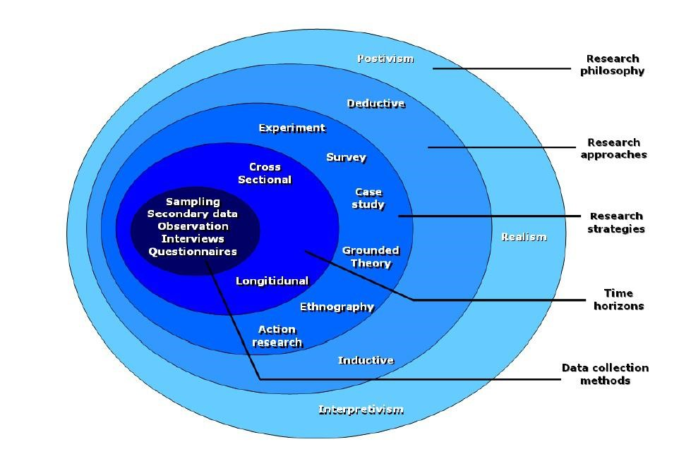
Figure 1: Research Onion Model [24]
There are five main research techniques that were considered to help complete this task, hence the need for this section; the one that was chosen was Experiment.

3.1 Chosen approach
Experiment was chosen as the most appropriate approach because it was deemed to help best answer and demonstrate what goes into an effective Network Forensic tool, via evaluating current tools. It ensured an equal balance of primary and secondary research, requiring hands-on testing with tools and then comparing findings to research literature to determine a score in each set of criteria and list results efficiently via tables.
It also ensured consistency, as findings were compared to present data and each tool was measured under the same criteria and easily be scaled up or down based on time allowance (while considering the disadvantage that too much altering of criteria can lead to lack of clarity). Each chosen tool underwent the same tests to ensure fairness and help keep to the timeframe by completing experiments efficiently. [25]
There are also two main types of types of research, qualitative and quantitative. [26] The project will include mostly quantitative data. Data was also deductive (testing expected outcomes) rather than inductive (creating outcomes after conducting findings), as well as positive (more focused on logical research) rather than interpretative (more focused on human interaction), and Inferential (comparing against existing data to discover patterns) rather than Descriptive (focusing on the averages of data). [27]
There were secondary questions to help answer the main question as to what goes into an effective Network Forensic tool. This allowed for easy repetition throughout and more specific deliverables. The scoring system to ensure validity was formed in the design section. The task was completed from home due to requiring the download of software, which proved safer being done away from home to ensure that access was always available and not providing any risks to university devices. It also had the benefit of following the guidelines set out after the outbreak of COVID-19, as working from home will significantly reduce the risk of contracting or spreading the virus.

3.2 Options discounted
Following the Research Onion model [24], methods are split according to their output of data. At the top of the model are methods which deal in strategies and use data to discover facts (Experiments and Surveys), while at the bottom are methods which deal in human behaviour and essentially examine the why of a situation (Action Research and Ethnography). Anything that shares elements of both is based in the middle (Case Study and Grounded theory). This task will involve analysis by testing concrete data, meaning it will utilise the upper layers of the model.
Ethnography was immediately ruled out as it involves research into cultures and traditions, which is related to environments rather than the intention of analysis of software. Similarly, Action Research (the process of ironing out identified problems) was ruled out due to not knowing issues from the start and needing testing to identify them. Grounded Theory (the concept of gathering data to construct a new hypothesis) was not seriously considered due to the intention being to begin with predictions and then see how well they hold up. Lastly, Surveys (using questionnaires to gain an understanding of opinions) was deemed ineffective due to feeling that the topic area would be too complex and lacking coverage to gather effective opinions. [28]
What these four methods have in common are that they specialise in qualitative research (examining personal feedback) rather than quantitative (examining measured data) [25], and this task will include mostly quantitative data, hence why they will not work efficiently. The two most quantitative methods left are Case Study (analysing past research) and Experiment (forming tests to analyse predictions). Experiment was ultimately chosen over Case Study due to the objective being to create deductive data via a critical analysis and being most common within the course of study.
To summarise, Action Research, Grounded Theory, and Survey were all deemed inappropriate due to not lending themselves well to the proposed objectives and specialising in qualitative rather than quantitative research. Experiment became the chosen research approach due to wanting to expand current opinions on computer forensics and examine how effective current tools are to complete the desired objectives.

3.3 Ethical considerations
Ethical risk for the project was deemed to be low due to dealing with equipment rather than people, though care was still taken to abide with university regulations and not download any software that could put the author at risk of loss of data due to threats such as viruses. To mitigate this risk and ensure no data is compromised, all software was extensively checked by an anti-virus and user reviews to ensure they were safe to use. The completion and submission of an ethics form before commencing the project ensured that ethics approval was obtained.

3.4 Other factors
All software chosen was cost-free to ensure a level-playing field and that no tool is given an advantage (having extra features, for instance). Reliability will be measured by comparing each tool to a set of criteria, while Validity will be achieved via then ranking each tool from most to least effective based on how much they score overall out of the highest overall amount determined by the implementation (at least 10). This strengthened the need for supervisor meetings, to ensure that work remained on track in terms of target dates and objectives.

Chapter 4 – Design and Implementation

4.1 Introduction
An experiment structure and scoring system was then laid out with appropriate rationale, following on from the two previous chapters (mainly the tools that were considered for experimentation during the literature review via Table 1 in Chapter 2). A structure was necessary to highlight whether all tools followed the same path and how, via listing criteria and instructions.

The main required elements for this project were:

- 2 PCs to perform experiments twice and ensure reliability (in this case, one PC and one laptop)
- Internet access to download chosen tools (in this case, Google Chrome)
- Network access to extract enough data during experiments (in this case, wi-fi via TalkTalk router)
- Enough device storage to download chosen tools (in this case, having 306 MB to download PRTG Monitor, 233 MB to download SmartSniffer, and 59 MB to download Wireshark)

4.2 Pre-task predictions
The expected outcome was that all tools will be deemed at least “effective” (at least 6/10) according to the scoring scale defined throughout the implementation, though certain tools were expected to score higher in at least certain areas (PRTG Monitor was predicted to highest in terms of security due to having the highest amount of tabs and therefore features, while Wireshark was predicted to have the best overall performance due to literature review praising its speed and user features) and this task was aimed to help pinpoint where the biggest benefits are and in which areas.

4.3 Considered limitations
The most obvious risk to this task was identified as downloading software that turned out to be malicious and damaged the performance of the author’s device as well as potentially pose a risk to the university (e.g. accessing details and access to accounts to infiltrate university websites). The main countermeasure was the device’s anti-virus, which provided a security scan to ensure they were safe for download before usage.

The outbreak pandemic of COVID-19 has also had an impact on the task, meaning it was required to be completed from home. While completing the task from home was intended from the start, this required all supervisor meetings to be completed electronically. This in turn meant that access to university devices was restricted in the case of an emergency, making it instrumental to save work regularly and in several locations.

4.4 Design Overview

4.4.1 Blueprint
Every question was repeated (once on two devices) to ensure that data is reliable, and each tool was marked with a colour for each question after findings are collected. This was meant to show how well it performed in that area and influenced its overall score as well as ensuring validity. The interface chosen for testing was the wi-fi of the author, due to determining that it could capture the highest amount of data.

The scoring system was constructed as follows:
Table 2: Overall scoring system for effectiveness
Colour | Description | Score
 | Performing a task to an excellent standard | 5 points
 | Performing a task to a great standard | 4 points
 | Performing a task to a good standard | 3 points
 | Performing a task to a mediocre standard | 2 points
 | Performing a task to a poor standard | 1 point
 | Performing a task to a non-existent standard | 0 points

The rationale of choosing this points-system was to keep the tools relatively close together and the scoring system simple.

A poor standard was defined as barely including elements of the question or outright failing to answer it. A mediocre standard was defined as having more than the bare minimum but likely having more flaws than positives while a good standard meant roughly having an equal amount of benefits and drawbacks, therefore meaning that a great standard meant answering the question with more benefits and an excellent standard meant having several advantages and little to no drawbacks.

The results formed a table encompassing the tools and experiment questions, with each tool being assigned a colour for each experiment category and resultantly assigned the allocated points. The maximum number of points a tool could achieve was 10, due to being able to score a maximum of five points within two chosen categories. The scoring scale was as followed:

Table 3: Scoring classification
Overall score | Classification
0-2 | Ineffective tool
3-5 | Somewhat effective tool
6-8 | Effective tool
9-10 | Vastly effective tool

Each score was also assigned a grade to help separate tools in case they categorised into the same classification range (e.g. two being deemed “effective”):

- 0 = U
- 1 = G
- 2 = F
- 3 = E
- 4 = D
- 5 = C
- 6 = C+
- 7 = B
- 8 = B+
- 9 = A
- 10 = A+
Table 4: Shortlist of final tools
Tool | Ultimately chosen for experiments, and why/why not
FTK Forensic Toolkit | No; Originally chosen in top three but then discarded due to security concerns
HoneyDrive3 | Chosen as reserve tool; Will be covered if time allows due to interest in low placement [10], but not priority due to chosen tools being less covered
Nmap | No, due wanting to cover other, less referenced tools
PRTG Monitor | Yes, due to desire to pick tools not covered in literature review
SmartSniffer | Yes, due to interest in its relatively lower coverage in literature review
Wireshark | Yes, due to popularity and personal experience

Both SmartSniffer and Wireshark were chosen for experimentation from the offset due to the rationale outlined, and both downloaded safely without issue. FTK Forensic Toolkit was originally chosen but then discarded due to extensive programs being added in the process and therefore concerns that it could compromise personal and therefore university data. SmartSniffer was therefore ultimately chosen as the final tool.

Tools were measured in two categories: performance and security. Performance is the capabilities of a tool, examining what features it provides. Security is the extent of which a tool protects data, both offensively against outside sources and defensively to protect user data. Each tool was considered individually to keep things fair, since each tool differs in its usage and therefore attempting to measure tools together would produce ineffective results.

A series of factors determined the amount of points scored in both areas, as shown in Table 5:

Table 5: Factors considered during experiments
Performance | Security
- Features in place to increase performance  - Options to export data | - Features in place to ensure security  - Ability to detect malware such as trojan horses, viruses, and worms

The factors considered were based upon personal knowledge and popular topics within literature review [10] [15] [23], aiming to cover as wide a range as possible. Reasoning was applied after listing the capabilities of each tool to give it a score in each area. If two or more tools end up tied overall in score, opinion will be applied as to which will be more highly recommended.

Identifying performance features was important to establish what each tool considered fundamental in its design and to help look for what areas were omitted. Likewise, these performance boosters were associated with security risks, hence why looking for how each tool protected data was important.

Exports of data were important so that data could be taken forward for further investigation and saved for future reference. Finally, malware was mentioned throughout the literature review as a common security risks to networks, hence why each tool was tested to see if it could identify it.

The following criteria in Tables 6 and 7 was laid out as rough guidelines to influence the final standings, according to the ideas presented earlier in Table 2:

Table 6: Overall scoring system for performance
Result | Green (5 points) | Yellow (4 points) | Blue (3 points) | Orange (2 points) | Red (1 point)
Description | More than three performance features with little to no flaws and several export options | At least three performance features with minor flaws and more than one export option | At least two performance features with minor flaws and at least one export option | At least two performance features with no severe flaws and at least one export option | Two or fewer performance features with flaws and limited or no export options

Table 7: Overall scoring system for security
Result | Green (5 points) | Yellow (4 points) | Blue (3 points) | Orange (2 points) | Red (1 point)
Description | More than three security features with little to no flaws and ability to detect malicious activity | At least three security features with minor flaws and ability to detect malicious activity | At least two security features with minor flaws and ability to detect malicious activity | At least two security features with no severe flaws and at least ability to detect malicious activity through external means | Two or fewer security features with flaws and at least ability to detect malicious activity through external means

In both areas, failure to meet at least the criteria for Red will result in a tool receiving 0 points for said category.

4.5 Background of chosen tools
PRTG Monitor is a Network Forensic tool created in 2001 by Paessler to fill demand for a performance monitoring tool. [16] It prides itself in delivering data in visual format such as pie charts and diagrams [31], specialising in publishing findings on all infrastructure that a device possesses without need for large downloads, while being easily scalable to be run on devices regardless of the size of the required organisation. This tool was chosen to have at least one “catch-it-as-you-can” tool experimented, and one that is less common within current research.

SmartSniffer is a Network Forensic tool designed to assist with capturing network data in an encapsulated (according to the TCP/IP model) format. [17] [32] Its primary function is to capture packets on a “stop, look, and listen” basis, capturing only when the user enables capture and displaying only the important information such as the addresses of both client and server. SmartSniffer is again not popular within current research according to the literature review, and having it be like another chosen tool (Wireshark) allows for simple comparison between them.

Wireshark is a Network Forensic tool, created in 1998 under the name Ethereal and established to be a cross-platform tool. Like SmartSniffer, it seizes network traffic in an encapsulated TCP/IP model format. [19] [33] Its other main selling points are its statement of being the world’s most popular network forensic analyser by using the “stop, look, and listen” format to list data quickly and concisely. While being a popular tool in comparison to the other two and therefore being less likely to contribute new data to the task, having it be experimented will help pinpoint where its popularity manifests (hence its selection).

4.6 Implementation overview
PRTG Monitor provides a license key specific to whether a free or paid version has been downloaded (in this case, free). Login was then provided to lock access to the device in question and the tool began collecting and categorizing data according to the level of risk. The login name and password were assigned as “prtgadmin” by default but was later changed to limit access and protect data.

SmartSniffer and Wireshark, meanwhile, were opened by listing the available interfaces of a device (e.g. Ethernet and Wi-Fi) and instructing one to be chosen. They then immediately began listing data packets until stopped by the user (detailed but concise information displaying how data has travelled across an interface, such as which IP addresses it has used as start and end points, any protocols, and any other information such as the function e.g. serving as an acknowledgement between two address to confirm that data has transferred successfully).

There were no issues during implementation aside from Wireshark being initially unable to detect interfaces and therefore unable to extract data from either device. The solution was to also download WinPcap (a supporting tool of 894 KB that allows tools such as Wireshark to detect home interfaces and update data as it emerges).

4.6.1 Implementation process
While each tool was chosen to be measured in the same areas and ideally include similar pathways into listing what measures were available, the exact procedure differed according to the setup of each tool, hence the need for step-by-step instructions.

4.6.1.1 Performance

4.6.1.1.1 Performance features
PRTG Monitor
Step 1: Load PRTG Monitor
Step 2: Login after being directed

Figure 2: PRTG login
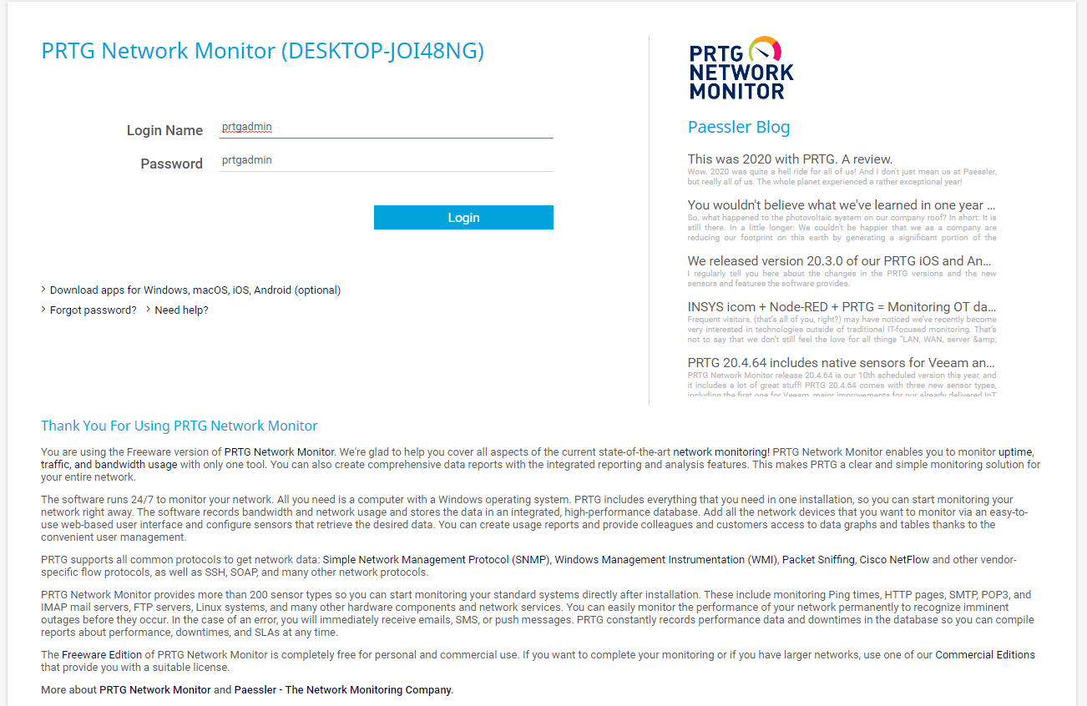

Step 3: Investigate the options available under the “libraries”, “sensors”, “maps”, and “reports” headings, looking for any features that increase performance such as increasing speed or hiding redundant columns

Figure 3: PRTG menu options
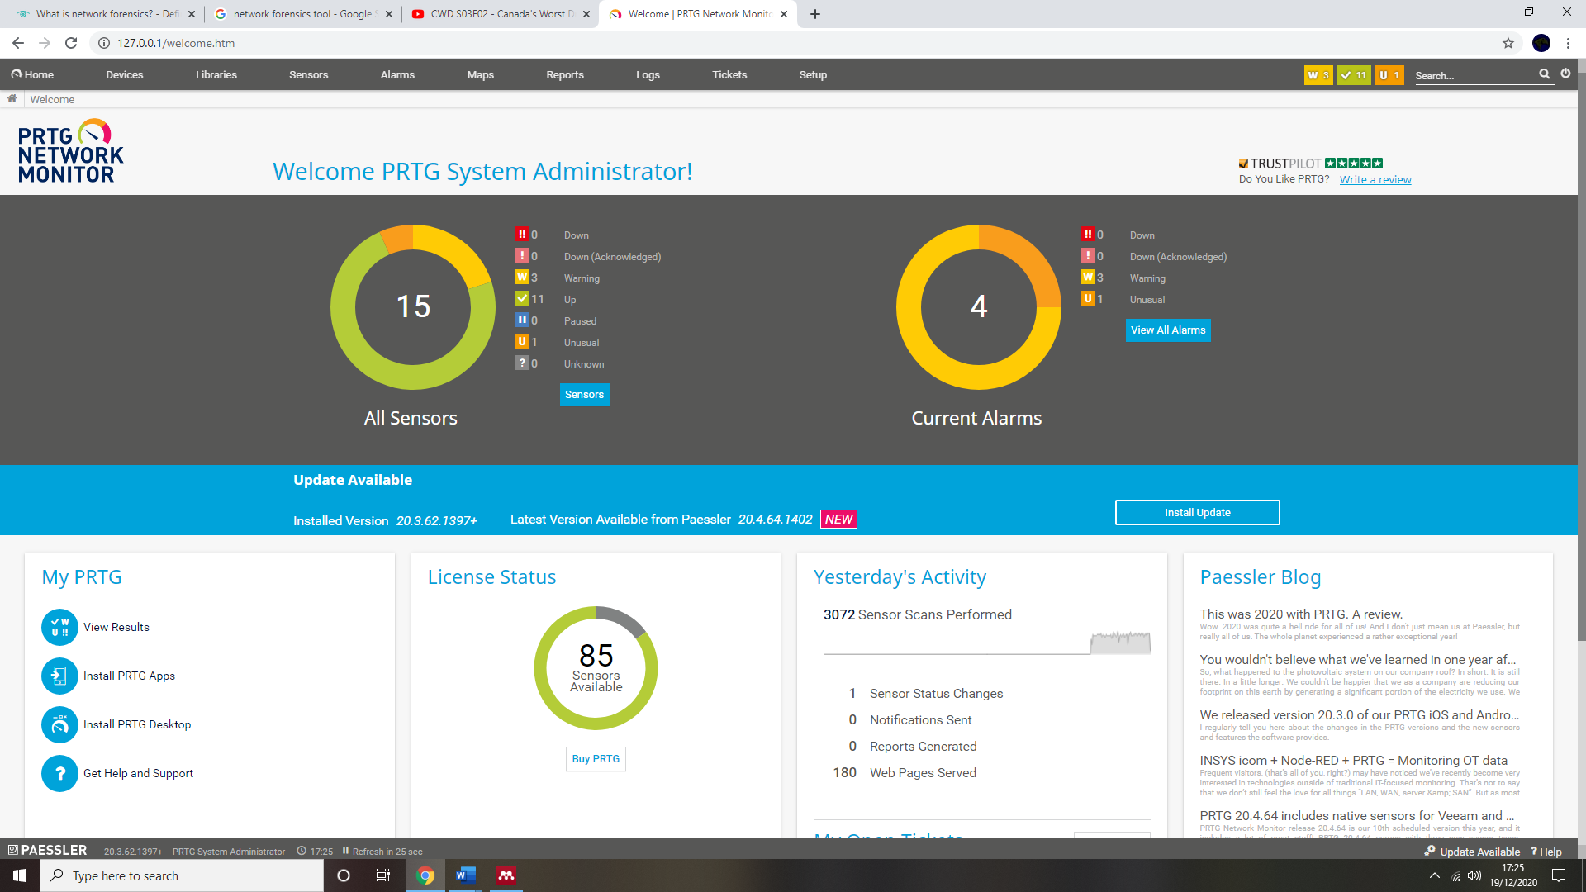

SmartSniffer
Step 1: Load SmartSniffer
Step 2: Select the “Capture Options” under the “options” heading, and select the wi-fi interface

Figure 4: SmartSniffer interfaces
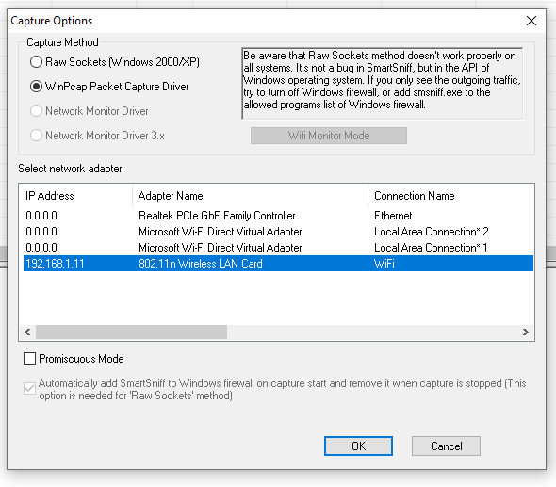
Step 3: Investigate the options available under the “view” and “options” headings, looking for any features that increase performance such as increasing speed or hiding redundant columns

Figure 5: SmartSniffer loadup and headings


Wireshark
Step 1: Load Wireshark
Step 2: Select the wi-fi interface

Figure 6: Wireshark interfaces
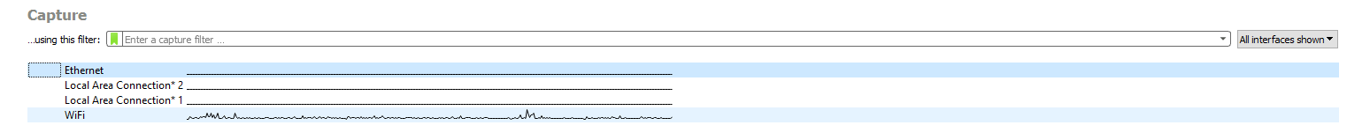
Step 3: Stop the listing of data packets by clicking the “stop” button”

Figure 7: Wireshark startup/stop button
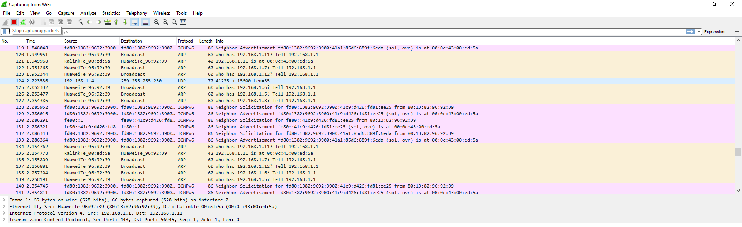
Step 4: Investigate the options available under every tab, looking for any features that increase performance such as increasing speed or hiding redundant columns

Figure 8: Wireshark headings
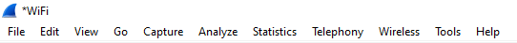

4.6.1.1.2 Exporting data packets
PRTG Monitor
Step 1: Load PRTG Monitor
Step 2: Login after being directed
Step 3: Access the “setup” tab and select live data to display current data
Step 4: Explore the options available for exporting data

SmartSniffer
Step 1: Load SmartSniffer
Step 2: Select the “Capture Options” under the “options” heading, and select the wi-fi interface
Step 3: Select the “file” tab and explore any of the “export” options listed

Wireshark
Step 1: Load Wireshark
Step 2: Select the wi-fi interface
Step 3: Stop the listing of packets by selecting the “stop” button”
Step 4: Select the “file” tab and explore any of the “export” options listed

4.6.1.2 Security

4.6.1.2.1 Security features
PRTG Monitor
Step 1: Load PRTG Monitor
Step 2: Login after being directed
Step 3: After system scan initiated by PRTG, two circles will form on the startup screen displaying security status; explore the features that are described within these circles

SmartSniffer
Step 1: Load SmartSniffer
Step 2: Select the “Capture Options” under the “options” heading, and select the wi-fi interface
Step 3: Search for any options pertaining to increasing security, such as controlling network traffic, in the “tools” heading in particular

Wireshark
Step 1: Load Wireshark
Step 2: Select the wi-fi interface
Step 3: Stop the listing of packets by selecting the “stop” button”
Step 4: Search for any options pertaining to increasing security, such as controlling network traffic, in the “tools” heading in particular

4.6.1.2.2 Malware identification
PRTG Monitor
Step 1: Load PRTG Monitor
Step 2: Login after being directed
Step 3: Explore the options available under the “alarms” tab, looking for anything that identifies risk of malware

SmartSniffer
Step 1: Load SmartSniffer
Step 2: Select the “Capture Options” under the “options” heading, and select the wi-fi interface
Step 3: Search for any options pertaining to detecting malware
Step 4: If no options are available from Step 3, exporting the findings as a web file via “Save Configuration to File” (found in “File” tab) and run on an online malware checker

Wireshark
Step 1: Load Wireshark
Step 2: Select the wi-fi interface
Step 3: Stop the listing of packets by selecting the “stop” button”
Step 4: Search for any options pertaining to detecting malware
Step 5: If no options are available from Step 4, exporting the findings as a web file via “Save As” (found in “file” tab”) and run on an online malware checker

4.7 Summary
Overall, three tools were taken forward for experimentation in two key areas, both worth four points maximum. Performance and security were identified as the core factors in determining effectiveness and reaching as many functions of a Network Forensic tool as possible and helping pinpoint how effective current tools are.

Chapter 5 – Experiments and Results Discussion

5.1 Performance results

5.1.1 PRTG Monitor

5.1.1.1 Performance features
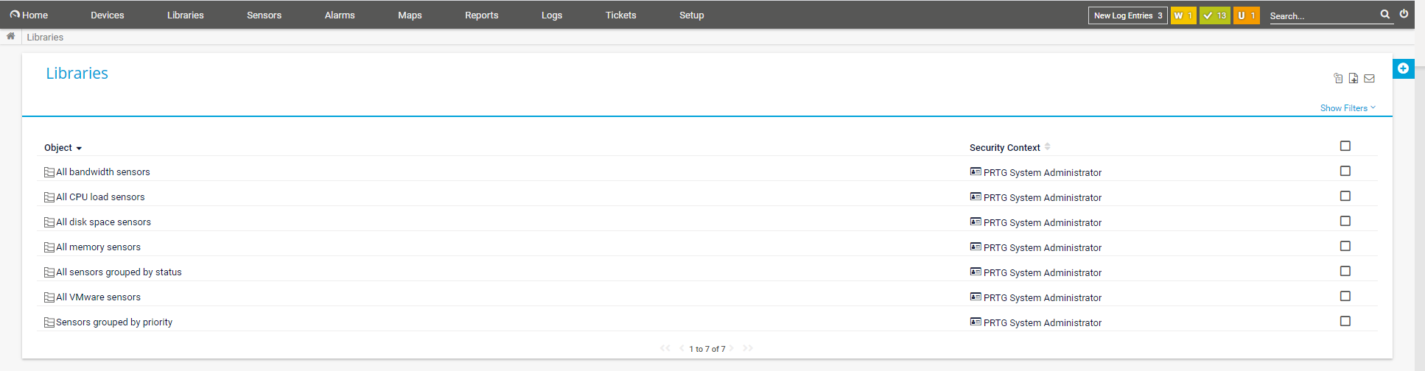
Figure 9: PRTG performance features
PRTG Monitor’s main features to improve and maintain performance include adding sensors such as CPU’s in the “sensors” section, a summary of network usage in the “reports” section, and ranking sensors by their impact on performance in the “sensors” section. Figure 9 demonstrates all sensors identified by PRTG, via the “libraries” section.

5.1.1.2 Exporting data packets

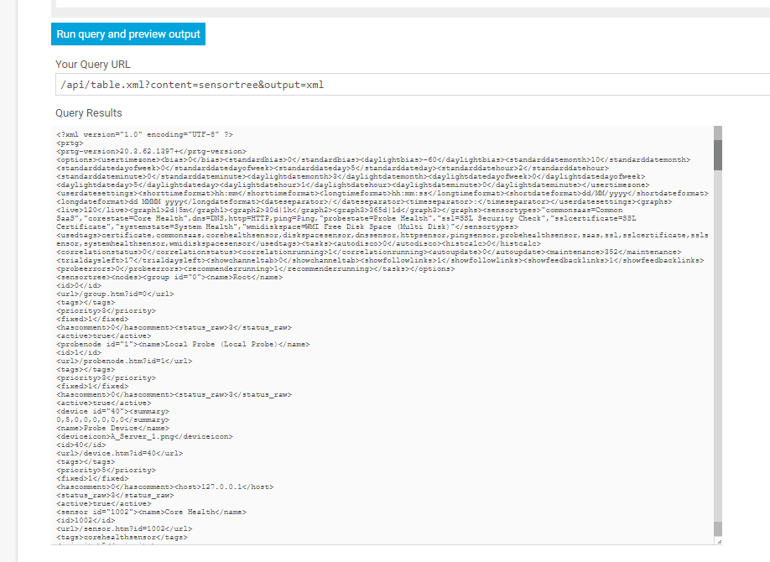
Figure 10: PRTG exporting
As Figure 10 shows, PRTG Monitor allows for exporting data solely via running queries in XML (Extensible Markup Language), which requires a URL. XML is pure text (which allows for simple exports). However, this results in PRTG being unable to export raw user data.

5.1.2 SmartSniffer

5.1.2.1 Performance features
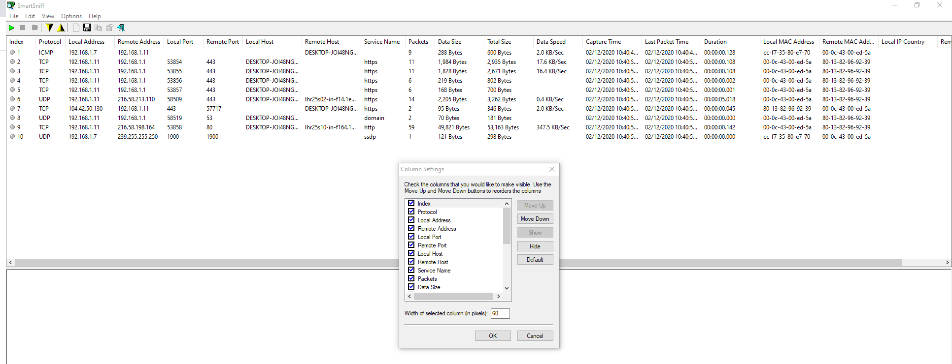
Figure 11: SmartSniffer performance features
SmartSniffer’s main performance features include display options such as protocols to list and the ability to enter promiscuous mode (rewiring network traffic to the CPU to allow each packet to be described in greater detail than basic description, as displayed in Figure 11), filter options such as showing gridlines and choosing which columns remain, and more advanced options such as enabling Summary Mode (allowing IP addresses to be viewed without them needing a separate line for each connection to make captures quicker).

5.1.2.2 Exporting data packets
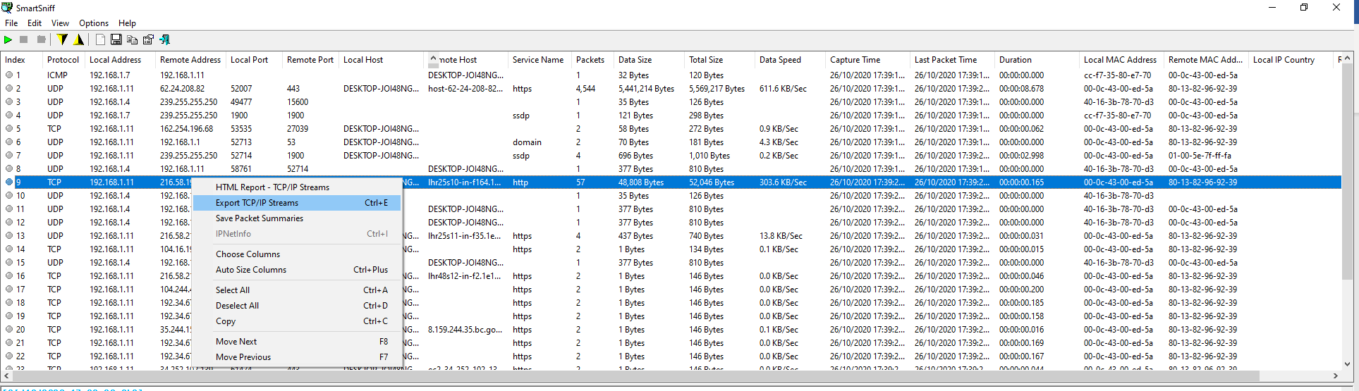
Figure 12: SmartSniffer exporting
Figure 12 proves that the options for exporting data via SmartSniffer are either saving an overall session as an HTML (HyperText Markup Language, commonly used to display webpages) file or exporting TCP/IP streams (a record of exchanges between the client and server networks using letters and numbers as unique identifiers.)

5.1.3 Wireshark

5.1.3.1 Performance features
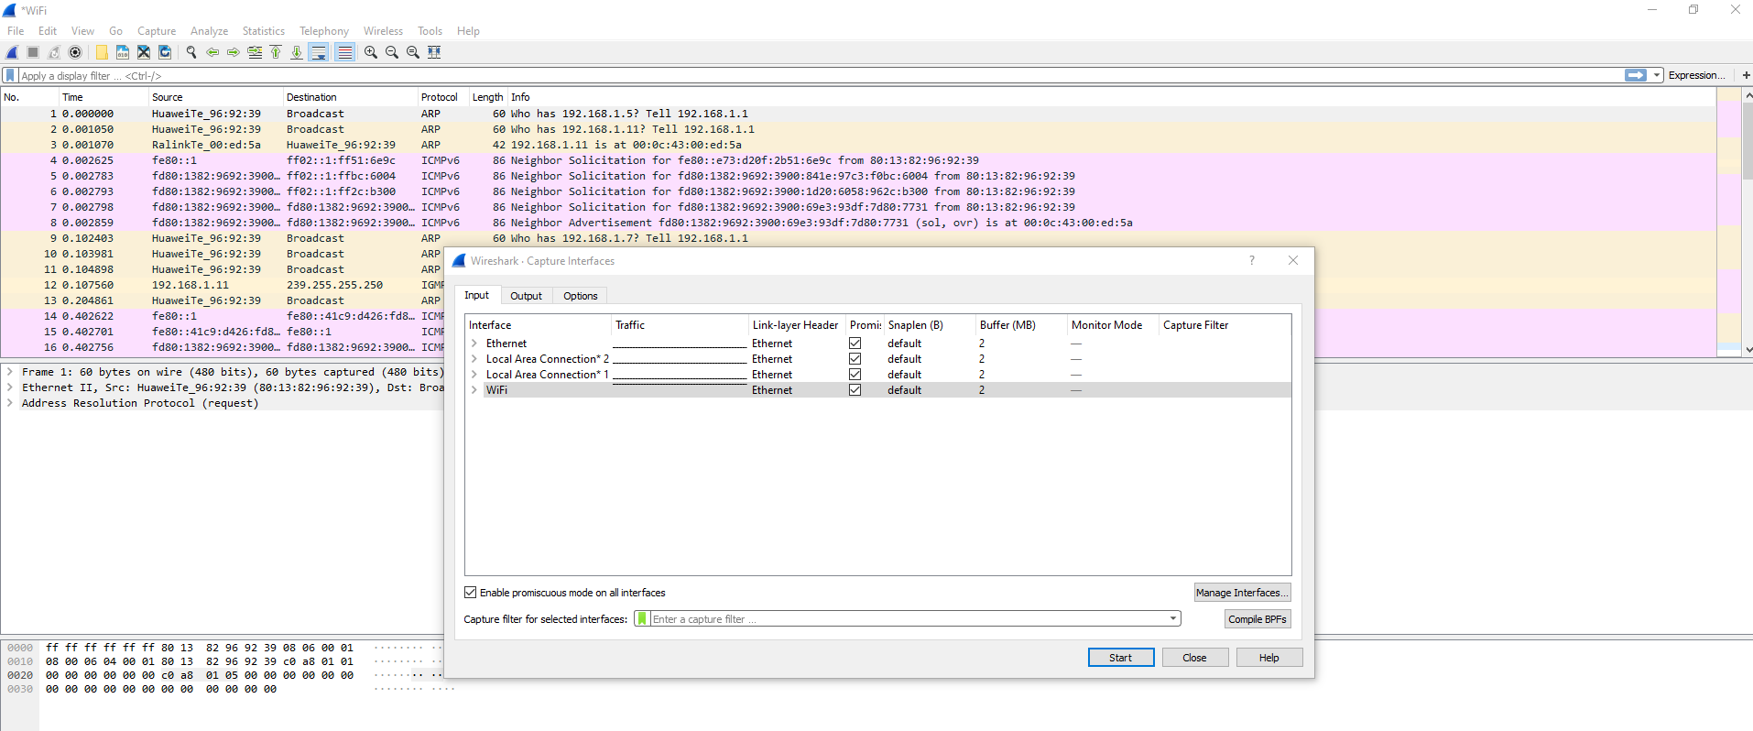
Figure 13: Wireshark performance analysis
The performance measures available on Wireshark include display options such as updating packets automatically or manually, displaying filters so data categories are made clear, and name resolution (being able to determine names of any networks found, as shown in Figure 13). There are also optimisation options such as turning off colour rules to save time and expanding the size of buffers. Statistics are provided for each category (e.g. wireless traffic for Wide Local Area Networks in the “wireless” section and exchanges between packets in the “statistics” section), making Wireshark overall effective in terms of performance.

5.1.3.2 Exporting data packets

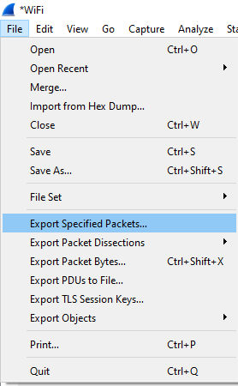

Figure 14: Wireshark exporting
Figure 14 determines that Wireshark can export packets in multiple manners, namely: a range of packets as a saved file (specified packets) that can be returned to later, exporting packets as a text file, retain a record of the packet by exporting that as bytes of data, representing data as layers of the OSI network model, exporting encryption keys, or a simple export into file types such as HTTP (Hypertext Transfer Protocol, commonly used in webpages).

5.1.4 Performance summary
Overall, for this category, Wireshark is marked yellow and highest among the three tools for its wide amount of performance features and having the most amount of export options (six compared to PRTG’s one and SmartSniffer’s two). PRTG is marked blue for having several features and ranking performance among sensors but being more descriptive and less hands-on, especially in comparison to Wireshark. SmartSniffer is also marked blue for having relatively fewer and less effective performance features, but enough of a wide variety and being effective enough for a user to work with.

5.2 Security results

5.2.1 PRTG Monitor

5.2.1.1 Security features
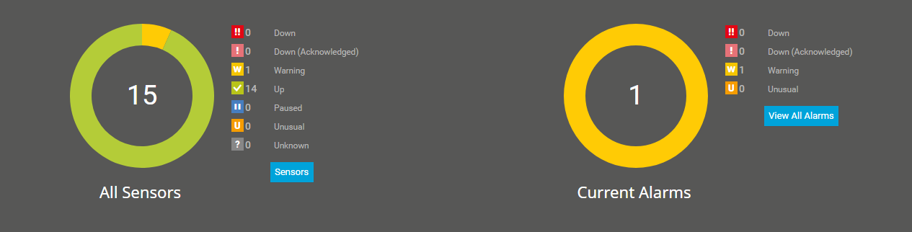
Figure 15: PRTG security features
As shown in Figure 15, PRTG scans data and divides findings into several areas: “down” (for sensors that have been powered off), “paused” (sensors that have been temporarily stopped), “unusual” (for when data is differing from previous findings), “up” (for active sensors), and “warning” (for areas that could pose a security risk). Sensors are described based on their status and performance

5.2.1.2 Malware identification
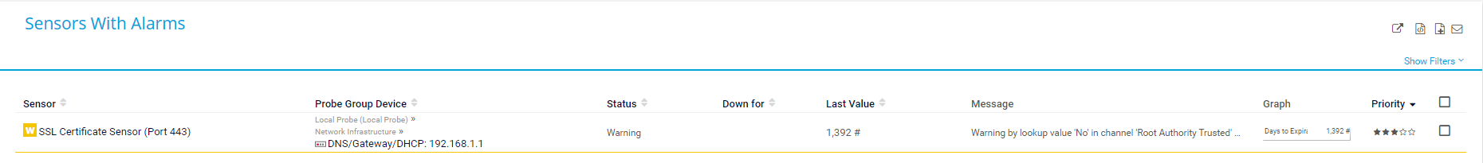
Figure 16: PRTG malware check
While PRTG can identify suspicious activity, it also has other flags rather than just “unusual”, making it a personal recommended tool in terms of spotting malware and other potential dangers. In this case, the important categories are unusual and warning. PRTG will list the identified risk with a message and a solution, as displayed via Figure 16.

5.2.2 SmartSniffer

5.2.2.1 Security features
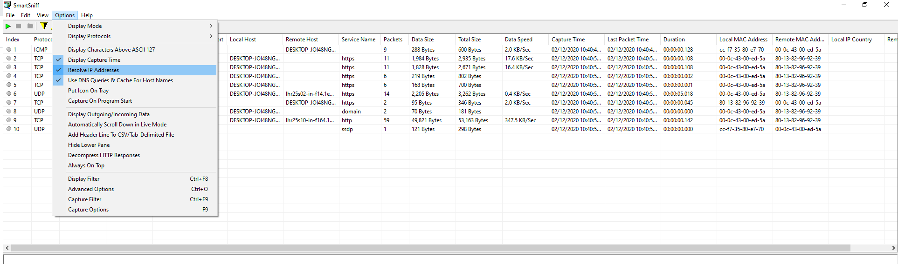
Figure17: SmartSniffer security features
Security options are in short supply on SmartSniffer apart from the aforementioned promiscuous mode being able to restrict data and options to hide IP addresses, protocols, or columns (as Figure 17 shows).

5.2.2.2 Malware identification
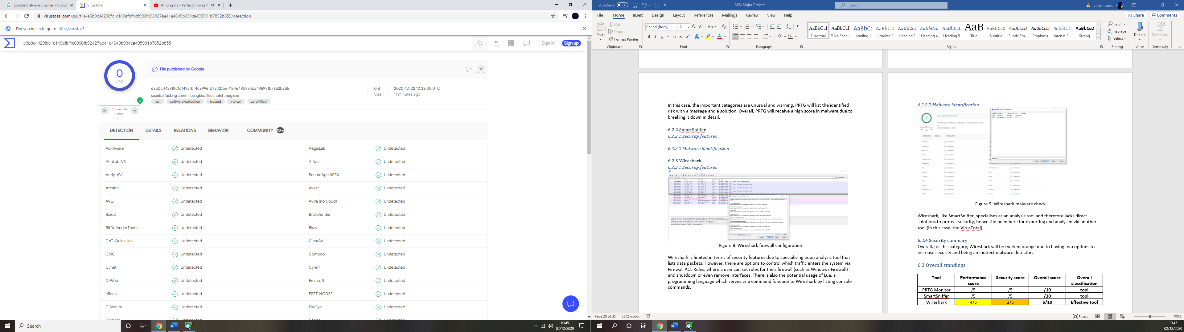
Figure 18: SmartSniffer malware check
SmartSniffer has no direct measures of checking malware due to specialising as an analysis tool, but has an indirect pathway of exporting a configuration file to be analysed via another tool (in this case, VirusTotal was used via Figure 18).

5.2.4 Security summary
Overall, for this category, PRTG is marked green and the highest overall due to how in-depth it breaks down security and detects risks. Wireshark is marked orange, despite being an indirect malware detector, due to having two options to increase security, one of which can especially tighten security. SmartSniffer is marked red for having limited options on its merit and comparatively less than Wireshark.

5.2.3 Wireshark

5.2.3.1 Security features
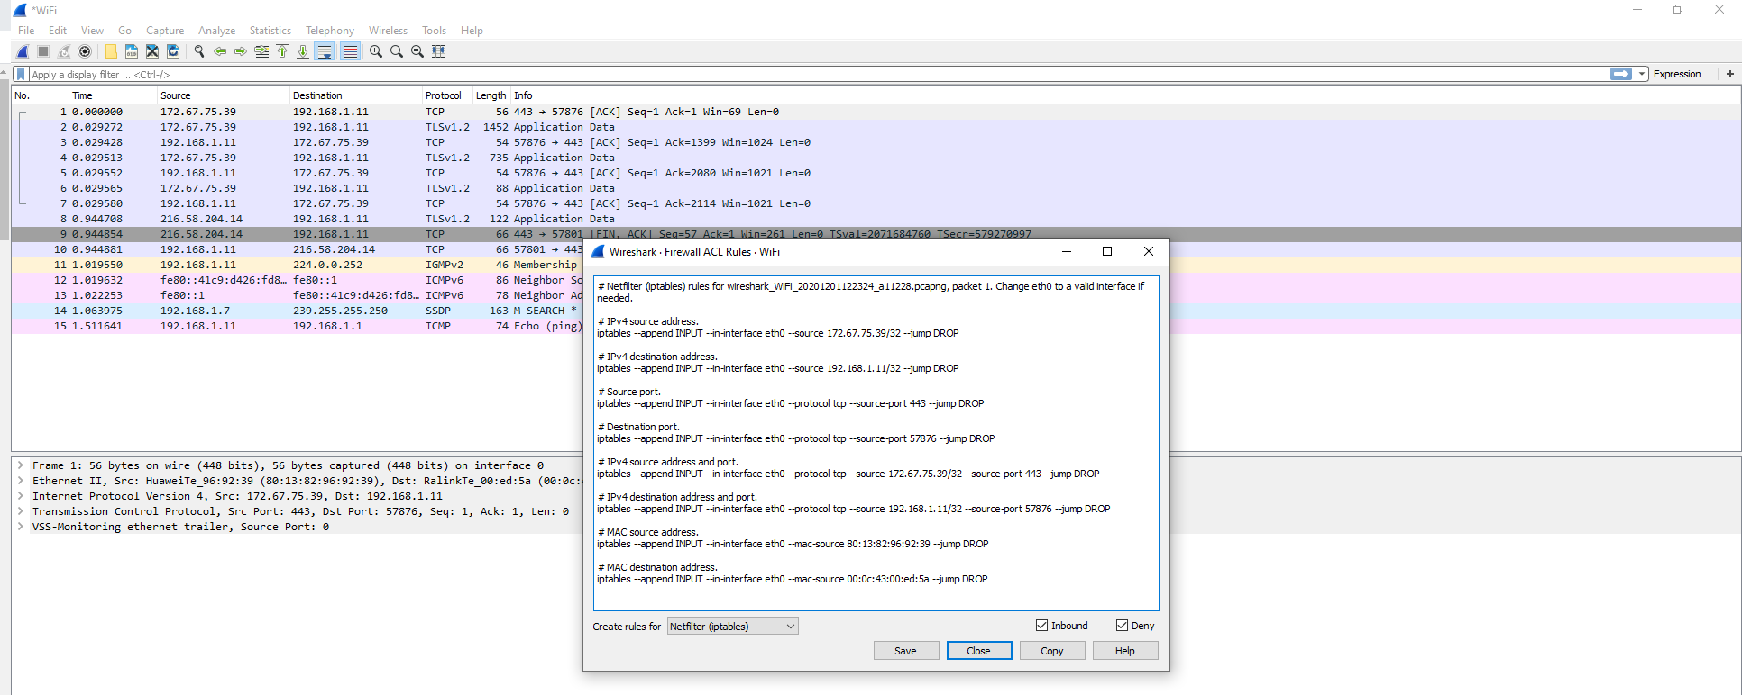
Figure 19: Wireshark security features
Wireshark is limited in terms of security features. However, there are options to control which traffic enters the system via Firewall ACL Rules (as displayed in Figure 19), where a user can set rules for their firewall (such as Windows Firewall) and shutdown or even remove interfaces. There is also the potential usage of Lua, a programming language which serves as a command function to Wireshark by listing console commands.

5.2.3.2 Malware identification
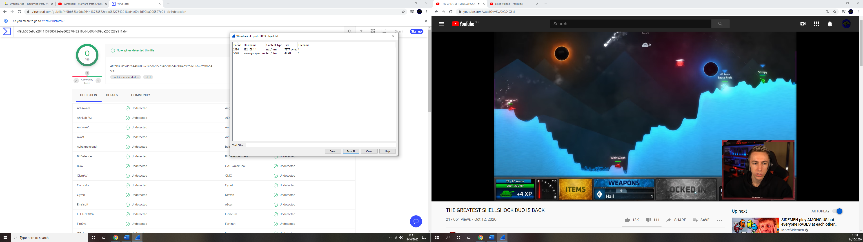

Figure 20: Wireshark malware check
Wireshark, like SmartSniffer, specialises as an analysis tool and therefore lacks direct solutions to protect security, hence the need here for exporting and analysed via another tool (in this case, VirusTotal was used via Figure 20, similar to Figure 18).

5.3 Overall standings
Table 8: Final scores
Tool | Performance score | Security score | Overall score | Overall classification | Overall grade
PRTG Monitor | 3/5 | 5/5 | 8/10 | Effective tool | B+
Wireshark | 4/5 | 2/5 | 6/10 | Effective tool | C+
SmartSniffer | 3/5 | 1/5 | 4/10 | Somewhat effective tool | D

5.4 Discussion of results
Overall, according to Table 8, PRTG Monitor was deemed the most effective tool, mainly due to its robust security. Wireshark finished second due to its solid performance in spite of mediocre security, while SmartSniffer was determined the least effective of the three largely due to its limited security features. The prediction that all three tools would finish under the “effective tool” classification was made incorrectly, as SmartSniffer was determined “somewhat effective”.

While the positions finished as expected, the exact scoring turned out to be surprising, with each possible scoring colour being used at least once (ensuring a wide variety of results). Having grades in place helped separate PRTG and Wireshark since both finished within the “effective tool” classification. While PRTG Monitor was correctly predicted to have the most effective security, placing Wireshark and SmartSniffer much lower in comparison was not expected (especially regarding detecting malware). Likewise, seeing Wireshark encompass the most effective performance was expected but each tool received at least a “blue” score in the area, ensuring a non-expected consistency throughout this category.

Compared to the chosen literature review [10] [15] [23], these results set a precedent in that they cannot be directly compared due to the results attempting to be unique.

The format is similar to Lopez-Araiza and Cankaya’s paper [10] in terms of marking what each tool is capable of but gives a score with justification instead of a bulleted list. It covers a lower number of tools and none of the tools analysed by Lopez-Araiza and Cankaya, but is longer overall, includes more references, and attempts to break analysis down by dividing experiments into categories, which ideally assists with it making a breakthrough.

Compared to Jaswal [15], this project deals with roughly the same number of tools (and shares a common analysis of Wireshark). While being less technical (targeted as an improvement in future), the results in this task attempt to be more specific via the scoring system and more test-heavy rather than specialising in instructions.

Lastly, when measured against Kaur et all [23], this paper displays the benefits of tools (including a mutual tool, Wireshark) while still attempting to include the required background knowledge, which this paper [23] provided inspiration for.

5.5 Chapter summary
Following on the literature review, the desire was to choose tools that were less common within current research, to ensure that the project reached different conclusions and became of a higher benefit to those such as Digital Forensic investigators due to specialising in said area and creating an uncommon experiment format, and those working or at least interested in the field of Cybersecurity as the project experiments in key areas (Performance and Security). The main objectives to analyse the effectiveness of chosen Network Forensic tools was met to the best possible ability and inspiration/differences from the literature review were discussed.

Chapter 6 – Conclusions and Recommendations for future work

6.1 Chapter introduction
A conclusion is required to determine how well the project has achieved its desired objectives, as well as potential areas to investigate in future.

There were five main objectives to the project and four prior chapters to help answer them beside the introduction; a literature review to list current research, defining effectiveness through the literature review, methodology and design, listing each tool’s requirements via implementation; overall analysis via experimentation; and this section.

6.2 Conclusion
To recap, the five main objectives were as followed:
• Conduct literature review to demonstrate understanding.
• Define the criteria that the Digital Forensic tools will be measured against in terms of effectiveness.
• Establish each tool’s requirements via implementation and instructions.
• Critically analyse and evaluate tools via experimentation and score each tool out of a required value depending on the implementation devised.
• Based on results, make any future recommendations and document who benefits from the project.

Overall, these objectives were important in both answering the main project question and establishing a stable procedure, and were answered to the best possible ability. The literature review, despite initially proving difficult due to having to narrow the scope down (from three areas of Digital Forensics to one because of time constraints and manageability) and therefore limiting the number of papers to choose and critically analyse, proved simple after selecting Network Forensics as the sole topic area and helped define the main term of “effectiveness” by providing inspiration for the chosen criteria.

Defining each tool’s requirements in the implementation was straightforward as they were all PC-based and safely downloaded. Devising the design was the most difficult area of the task from a personal perspective but was eventually condensed into two key areas, and the scoring system was important in helping the task stand out and pinpoint effectiveness. As a result, the experiments were simple to complete with the assistance of the lab process section.

The results turned out to be a surprise; while the overall ranking turned out as expected, the exact scoring in the two key areas differed from initial expectations (SmartSniffer and Wireshark not having more security features and every tool scoring at least 3/5 performance-wise). The three tools were analysed in as much detail as possible in two important areas with the aim of contributing new data, which was ideally strengthened by having a wide variety of scores (8/10, 6/10, and 4/10) with justification.

Each of the five scoring colours outlined in the implementation was applied to the overall standings, maximising its potential usage as well as helping the results vary. Having data stand out, choosing tools less commonly explored, and creating as unique a blueprint as possible will ideally help this task be of as high a benefit as possible to those interested or working in the fields of cybersecurity and/or digital forensics.

6.3 Recommendations for future work
In future, options could be taken that are not hindered by the impact of Covid-19, such as experimenting with a higher quantity of tools and being able to make usage of university equipment. Also, while PRTG Monitor turned out to finish first overall regardless, consideration as given to the fact that the free version was used. For a similar project, all software could be paid for to demonstrate benefits that are not present in the free versions (similar to how all tools were free for this task to ensure a level-playing field). Lastly, an attempt could be made to choose only tools that are similar in design (like SmartSniffer and Wireshark were during this task) to help draw out more sub-questions, analyse a higher number of tools, and limit the time spent doing implementation (considered a limitation during this project).

Chapter 7 – Evaluation & Reflection

7.1 Evaluation

7.1.1 Project objectives
Originally, the plan was to experiment within three Digital Forensic areas and six tools but was reduced to one area and three tools due to time constraints and lack of overall knowledge. Scaling the task down allowed for simple completion of the five main objectives (literature review in Chapter 2, establishing the criteria for effectiveness in Chapters 2 and 4, implementation in Chapter 4, critical analysis in Chapter 5, and conclusion and recommendations for further work in Chapter 6).

7.1.2 Project plan
Originally the project was intended to be completed in the summer of 2020 but was extended to winter due to the outbreak of COVID-19 and was marked for completion in November 2020. A further extension was then agreed with the supervisor due to personal circumstances (being classed as a disabled student), until the 31st of December. As shown in Appendix 2, the project began on the 1st of July 2020 and concluded on the 22nd of December 2020.

The introduction was simple and completed in a week. The literature review was recurring throughout the project to build on current research. The original aim was to complete the methodology and design planning by October. Experimentation would then last until the beginning of November and finally conclusions and a reflection would be carried out until the deadline at the end of November. As the deadline was extended, more time was given to the experiment and implementation sections. Experimentation was completed at the beginning of December, a month which was spent concluding, evaluating, and expanding each section.

Overall, despite the plan needing constant adjusting to due to COVID-19 and personal circumstances, the task was completed in advanced of the ultimate deadline (December 31st). Barring the literature review (which was necessary throughout the task to ensure all relevant research had been considered), the section that took the longest to complete was the Design & Implementation (at over three months, longer than the experiments themselves) due to having the narrow down the scope of the task from three areas of Digital Forensics to one and ensure that tools could be experimented in the same area, though attempting to complete this section earlier in future has been noted as an area to improve on.

7.2 Reflection
What this task performed well in was devising a blueprint which was unique in design and choosing tools which are less common. It also took sufficient inspiration from current research to examine what to include and what to tweak. This ensured knowledge in terms of results was unique and reached as wide an audience as possible. Of the three papers chosen for further examination, the most recent one is Jaswal [15] in 2019, giving this project an advantage in terms of contributing new work. Despite the design itself needing longer to complete than any other section, all tools were successfully kept on an equal level and could be tested in all the same areas.

The drawbacks of this task were spending more time completing the implementation than any other section, which had a knock-on effect on the experimentation, the key focus of the project, and could therefore negatively affect it if tweaked too much. Attempting to spend less time in this section in future will ensure that the experiments themselves take priority, and that a higher number of tools can be analysed. Also, despite the results aiming to set a precedent and be unique, attempting to follow data from the literature review in future will help draw more similarities and differences.

7.3. Conclusion
Overall, the project was completed to the best possible ability, though it is clear where, in future, improvements can be made. This project was important in terms of both developing unique data and for personal reasons such as timing and to help with regards to employability by attempting to develop unique data within this topic area.

Chapter 8 – References and Bibliography

8.1. References
[1] M. D. Kohn, “Integrated Digital Forensic Process Model,” no. November, 2012.
[2] The Parliamentary Office of Science and Technology, “Digital Forensics and Cyber Crime,” vol. 157, no. 520, pp. 103–114, 2015.
[3] S. Garfinkel, “Network Forensics: Tapping the Internet,” Inf. Secur., pp. 1–6, 2002.
[4] A. Shaaban and N. Adelaki, “Comparison study of digital forensics analysis techniques,” Procedia Comput. Sci., vol. 141, pp. 545–551, 2018.
[5] K. Mushtaque, “Digital Forensic Investigation Models, an Evolution study,” J. Inf. Syst. Technol. Manag., vol. 12, no. 2, pp. 233–244, 2015.
[6] B. Narwal, “A Walkthrough of Digital Forensics and its Tools,” no. March, 2020.
[7] G. Horsman, “‘I couldn’t find it your honour, it mustn’t be there!’ – Tool errors, tool limitations and user error in digital forensics,” Sci. Justice, vol. 58, no. 6, pp. 433–440, 2018.
[8] P. M. Dimpe and O. P. Kogeda, “Impact of using unreliable digital forensic tools,” Lect. Notes Eng. Comput. Sci., vol. 1, pp. 118–125, 2017.
[9] A. M. Marshall and R. Paige, “Requirements in digital forensics method definition: Observations from a UK study,” Digit. Investig., vol. 27, no. June, pp. 23–29, 2018.
[10] C. Lopez-Araiza and E. C. Cankaya, “A Comprehensive Analysis of Security Tools for Network Forensics,” J. Med. - Clin. Res. Rev., vol. 1, no. 3, pp. 1–9, 2017.
[11] M. A. Lugo, “Honeypots as Computer Forensics Tool,” 2015.
[12] A. Orebaugh and B. Pinkard, “Introducing Nmap,” Nmap Enterp., pp. 33–62, 2008.
[13] G. A. P. Rodrigues et al., “Cybersecurity and network forensics: Analysis of malicious traffic towards a honeynet with deep packet inspection,” Appl. Sci., vol. 7, no. 10, pp. 1–29, 2017.
[14] A. Kurniawan and I. Riadi, “Detection and Analysis Cerber Ransomware Based on Network Forensics Behavior,” Int. J. Netw. Secur., vol. 20, no. 5, pp. 998–1004, 2018.
[15] N. Jaswal, Hands-On Network Forensics. 2019.
[16] M. Chauhan, Ubuntu Using Hacking. 2017.
[17] S. S. Patil, P. D. Kapgate, and P. P. S. Prasad, “Effective Concept for Detection of Web Based Attacks Using ID3 Algorithm,” vol. 3, no. 5, pp. 321–330, 2014.
[18] P. Saravanan, T. Prabakeran, and V. Indumathi, “Network forensics: An analysis of techniques, tools, and trends,” Int. J. Adv. Res. Trends Eng. Technol., vol. 45, no. 12, pp. 36–43, 2016.
[19] I. M. Spring, “Introduction to Passive Network Traffic Monitoring,” 2015.
[20] H. Iqbal and S. Naaz, “Wireshark as a Tool for Detection of Various LAN Attacks,” Int. J. Comput. Sci. Eng., vol. 7, no. 5, pp. 833–837, 2019.
[21] N. Champagne et al., “Forensic Tool Comparison,” Lcdi, no. 802, 2016.
[22] S. Talukder and Z. Talukder, “A Survey on Malware Detection and Analysis Tools,” Int. J. Netw. Secur. Its Appl., vol. 12, no. 2, pp. 37–57, 2020.
[23] M. Kaur, N. Kaur, and S. Khurana, “A Literature review on Cyber Forensic and its Analysis tools,” Ijarcce, vol. 5, no. 1, pp. 23–28, 2016.
[24] G. Shrivastava, K. Sharma, and R. Kumari, “Network forensics: Today and Tomorrow,” Int. Conf. Comput. Sustain. Glob. Dev., pp. 2234–2238, 2016.
[25] G. Shrivastava, “Network forensics: Methodical literature review,” Proc. 10th INDIACom; 2016 3rd Int. Conf. Comput. Sustain. Glob. Dev. INDIACom 2016, pp. 2203–2208, 2016.
[26] N. Emmanuel, “Analysis of Saunders Research Onion,” 2019. Available: https://thesismind.com/analysis-of-saunders-research-onion/
[27] V. Mildner, “The SAGE Encyclopedia of Human Communication Sciences and Disorders Experimental Research,” SAGE Ref., pp. 728–732, 2019.
[28] H. H. Elkatawneh, “Comparing Qualitative and Quantitative Approaches,” SSRN Electron. J., no. February, 2016.
[29] I. Majeed, “Understanding Positivism in Social Research: a Research Paradigm of Inductive Logic of Inquiry,” Int. J. Res. Soc. Sci., vol. 9, no. 11, pp. 118–25, 2019.
[30] K. Elmusharaf, “4) Qualitative Research Approaches,” no. Training Course in Sexual and Reproductive Health Research, 2015.
[31] Paessler, “PRTG Monitor >> All-In-One Network Monitoring Software.” Available: https://www.paessler.com/prtg
[32] Techspot, “SmartSniff 2.29.” Available: https://www.techspot.com/downloads/6483-smartsniff.html
[33] Wireshark, “Wireshark. Download.” Available: https://www.wireshark.org/download.html

8.2. Bibliography

[1] G. Gogolin, “Digital Forensics Explained,” Digit. Forensics Explain., vol. 0, 2012.

[2] A. Sivaprasad and S. Jangale, “A complete study on tools & techniques for digital forensic analysis,” 2012 Int. Conf. Comput. Electron. Electr. Technol. ICCEET 2012, pp. 881–886, 2012.

[3] A. G. Furuseth, “Digital Forensics: Methods and tools for retrieval and analysis of security credentials and hidden data.,” 2005.

[4] W. Mazurczyk, L. Caviglione, and S. Wendzel, “Recent Advancements in Digital Forensics,” IEEE Secur. Priv., vol. 15, no. 6, pp. 10–11, 2017.

[5] F. Cohen, J. Lowrie, C. Preston, G. Peterson, and S. Shenoi, Advances in Digital Forensics VII, vol. 361. 2011.

Appendix 1

Logbook (Supervisor meetings)

16th July
Tweak intro, how does work constitute an experiment? Place work from methodology into intro for it to be clearer. Chose at least two papers to dissect for lit review; will find models to base work off. Put everything else into sub-headings. Cross-reference; chose papers from timeframe.

30th July
Intro much better. Use research onion to expand methodology. Construct blueprint for experiments and add in Gantt chart. Include a more recent paper (from about 2018) and say what their investigation is lacking and how mine differs and contributes new knowledge.

3rd September
One size does not fit all; return to lit review and categorize tools so more sub-questions can be formed. Do not be in hurry to arrange meetings unless work significantly changed.

30th September
Devise a blueprint for each question via step-by-step instructions and break down scoring system to make implementation simpler and longer.

28th October
Extension to deadline agreed (31st December). Expand implementation to include basic equipment and follow comments on draft provided by supervisor (namely specifying experiments).

2nd December
Implementation layout significantly improved. Text aligned and plans to buff up each section before submission.

Appendix 2

Chapter start and end dates

Table 9: Chapter durations
Chapter | Start date | End date | Duration
Introduction | 1st July 2020 | 8th July 2020 | 7 days
Research and Review of Literature | 1st July 2020 | 22nd December 2020 | 5 months and 20 days
Methodology | 1st July 2020 | 26th August 2020 | 1 month and 25 days
Design & Implementation | 9th August 2020 | 25th November 2020 | 3 months and 16 days
Experiments and Results | 29th September 2020 | 2nd December 2020 | 2 months and 3 days
Conclusion | 2nd December 2020 | 14th December 2020 | 12 days
Evaluation & Reflection | 2nd December 2020 | 22nd December 2020 | 20 days

