How useful are manifestoes to designers and/or design groups?
Student number: 1801066
Course title: BA Set Design
Tutor: Julia Lockheart
Word count: 2586

How useful are manifestoes to designers and/or design groups?
Manifestoes, defined as, “A declaration of the intentions, motives and views” (Cambridge dictionary, 2019) can only limit the true possibilities of what a designer can produce. Thus, bringing me to my thesis that manifestoes pose a negative impact on designers and hold no good use towards them or what they create. Exploring this concept will be how I am going to base the research in my writing, as well as providing arguments against my thesis statement, later in the essay, to contradict my views. Summarising my findings in the conclusion will be how I tie my final thoughts together and decide whether I still believe in my thesis. Bringing my own experiences and professionalism into this will also help me with putting the concept of manifestoes into a context that I relate closely to – framing my beliefs into a subject area that I care about and have knowledge on. Answering the question allows me to introduce theorists who I have been recently educated with such as John Wood, Bernard Tschumi, Andrew Gallix, Egon Guba and John Kolko since their work and/or quotes have inspired my thinking process and resonated well with the ideas that are already starting to form.
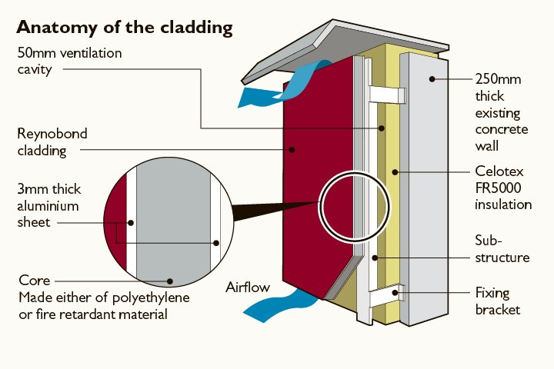
Manifestoes are essentially paradigms created to help infiltrate the public with new ideas and promises. Typical political manifestoes, created in the run up to an election, are the perfect example of this. The parties list their beliefs and what they would like to achieve or change when they are in power; most of what they mention appears to be too good to be true. For example, in the 2019 elections the Tories and Labour parties are both vowing to improve the NHS by spending billions, however, “Mr Hopson, the health trust leader, responded to this by urging parties not to make ‘empty promises’ or ‘unrealistic expectations.’” (BBC news, 2019). Although this is not relating directly to design, it shows how manifestoes have a negative impact. Also, the documents are not legally strict, therefore, those who impose them face no serious consequence if the points are not followed truthfully. As a result, the dictators try to win over people by emphasising what they would like to do when they are in power (even if they know they cannot or will not achieve it) and constantly reusing this tactic since “we are trapped in a paradigm of paradigms” (John Wood, 2019) and the likelihood of this epidemic – of lies – becoming a paradigm shift and changing would be very slim. This translates into the design world by showing that a designer could follow a cynical manifesto and be accustomed to creating dishonest pieces of work by the fundamental basis that everything is constructed from perfidious truths. Politics has taught me that insincerity is acceptable. So, what stops designers from following suit?
Furthermore, bad design due to following substandard rules can be shown from the Grenfell Tower disaster. The lack of building regulations, during the 1970s, linked to the number of stairways that had to be in a high rise building and it not being a legal requirement to add sprinklers, meant that when Grenfell tower was constructed they were able to skip out these details. Moreover, the 10 columns spaced evenly across each face of the tower were a peculiar design, they did not allow the cladding to sit tightly against them. Consequently, this created an air gap which became an inevitable route for fire to spread (see figure one for a visual explanation of where the 50mm void was – the main catalyst for how the fire developed faster vertically than it did horizontally). Evidently, all these factors contributed to the building being engulfed in flames so quickly. This horrific event points out how design regulations (which are a form of manifesto) must be insightful, well written and hold as much truth as possible or they are in no way useful to a designer – insufficient statements can hinder the final product, resulting in appalling events that could cause injuries and/or death.
Figure 1.
Expanding on this, designers are very good at correcting mistakes, or learning from past experiences. So the quote, “after a period of reflection they will produce a tangible artefact as a visual representation of the reflection” (John Kolko, 2006) allows me to believe confidently that building regulations in the future will be harsher and those who are designing buildings will be able to note what negatively impacts the safety and work on how to utilise their improvements within the structure. Considering the precautions taken with new high-rise towers and checking over existing ones that were fabricated during the 70s, hopefully Grenfell will remain the worst result of following badly written rules and no others will see the same fate in the UK any time soon.
In addition, my research has led me to the El Paso shooter’s manifesto. Again, not specifically design orientated, however, it is a great example of how a manifesto can be extremely bad to follow. Upon researching this, I have discovered that a lot of other twisted killers have also used manifesto writing to state their intentions and beliefs, prior to committing murder. Patrick Crusius, who I am focusing on here, included his “political and economic reasons behind the attack, gear, expectations of what this response will generate” and “personal motivations and thoughts” (Crusius, 2019) I wanted to include this manifesto to demonstrate that people can use them in the wrong light and send out terrible messages that people will inevitably follow – other offenders since this attack in August 2019 have written manifestoes which have taken inspiration from Crusius’ writing; highlighting the dominance that manifestoes can have over easily manipulated people. Also, I had no idea that manifestoes could get so sinister or be used in such a negative light, thus opening my eyes more to how influential this form of rulemaking is. Designers are at risk of being exposed to unfavourable lists of directions as much as anyone else is – Grenfell tower being a prime example.
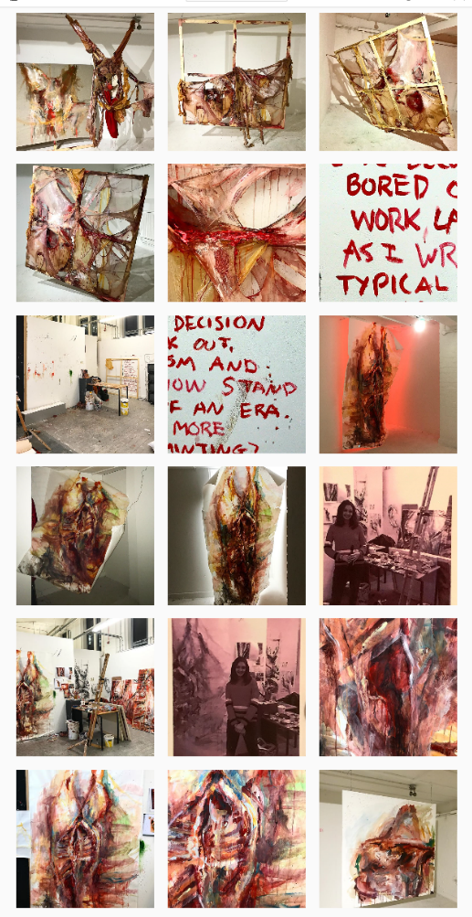
Moreover, during my introduction, I mentioned how I believe that manifestoes set limits due to the expectations of them almost being like laws. Therefore, I am now going to elaborate on my thesis and give more context towards why that is my opinion. Within the art and design disciplines, being given a boundary can become very tedious and almost appear as a metaphorical cage; having the freedom to express ourselves as much as we wish, is how some of the best pieces of work are created. For example, I am deeply intrigued by, the fine art student, Jess Parry’s work as she is constantly taking what she makes one step further and not allowing anything to restrict what her imagination envisions. Thus, presenting her with a beautiful portfolio of work which has taken the concept of flesh on a very inspiring journey (see figure 2 for a snippet of her most recent pieces, which began as a series of paintings and then transitioned into a hanging composition of latex). If Parry had been restricted by a list of commandments, I very much doubt her mind would have wondered upon such brilliant ideas. In some cases, I can see how being limited can be useful to a designer as there are so many different routes one can take when they are brainstorming, so giving restrictions can help speed up the thought process and designing or making can then begin immediately. But since manifestoes tend to be very carefully devised by whoever wishes to use it, “a masochistic relationship begins between the author and the text, for the manifesto-contract has been drafted by the very person who will suffer from the restrictions” (B. Tschumi, 1979), implying that it is possible to get sucked into the system of following the points within a manifesto, and it can have a negative effect on who is using it, due to being swamped in the need to complete or comply to the statements.
Figure 2
Typically, in design, manifestoes are a skeletal outline of methods and processes which almost acts as a to do list – but the intentions to follow it are more serious. Having a to do list helps a lot of designers have a clarity of their vision, clearly identifies their values, keeps their thoughts organised as well as keeping on top of everything. Therefore, contradicting my opinion in the last paragraph, manifestoes can become very useful for designers when written in a personal light that allows them to be free with what they include. This brings me to another statement that I made prior about how the documents are not legally binding. With my newfound knowledge, I now believe that the lack of legal force allows designers the freedom to be playful and have a peace of mind when creating the rules as they know that they may change them if they wish. Dieter Rams’ “The Ten Principles for Good Design” is a great example of how manifestoes can be incredibly useful to a designer. The list is easy to follow and doesn’t come across as forceful or persuasive; pictures are also included which gives the people viewing his manifesto visual satisfaction as well as genuine pleasure from finding a reliable source to help them with their work. It just states Ram’s views on what makes a good design, which he has then decided to share with the world. I especially like how he has included examples of work that he has made whilst following his principles, which makes his ideas seem candid and show how they can benefit the designing process. His ability to actually create work in response to his ten principles sets a perfect example for others who want to follow his statements or create their own – it is possible to propose an honest manifesto that is followed through fully and not just left as an empty promise. Also, it highlights how he is involved in his ideas and believes in them, rather than publishing them to brainwash the public into using them.
Looking at the concept of hauntology, manifestoes can become an object that reminds the creator of what there once was. It gives whoever wrote it a visual entity to look back on and see whether they have managed to follow what is stated. It would also highlight any failures linked to not pursuing their list as the ideas that have died out live on through the published text. Perhaps it hints at a completed process of thoughts which stand as a remembrance of what once was. A dead part of their old personality or “haunted by a nostalgia for all our lost futures” (Andrew Gallix, 2011) suggests how a designer could be taunted by a manifesto they were once subject to following. The reminder of a failed future could put a dampen on how their work progresses as they will always wonder what could have been if they stuck to the manifesto. Therefore, manifestoes could hold a nostalgic presence to a designer and become useful in the form of giving them inspiration from past experiences or just torment them by allowing them to review old processes and thoughts that they abandoned or never followed-through.
Within the film industry, following rules when filming can be very common. The Blair Witch Project (1999) being a film in which the directors – Daniel Myrick and Eduardo Sanchez – created requirements and had specific ideas in mind for how they wanted to capture the content. Some examples of what they did are: not adding any dialogue into the script (wanting the actors to improvise everything); stripping the actors of proper meals during the eight day shoot; and, not allowing the actors to break character at all during the days of filming – unless they used the safe word ‘taco’ for emergencies. Learning about how manifestoes can be used within film making is very inspiring and helping me to understand that giving a strict expression of what is needed or wanted can be very useful for short schedules (Blair Witch was filmed in eight days). I can now agree that, in some cases, sticking to a list of rules can work very well, because I think if the director had let some of the rules slip the movie would not have had the same effect. Wim Wenders, a German filmmaker, generated a fifty-point manifesto entitled the “50 golden rules of filmmaking” which shows a playful attempt at addressing his opinions on the rules of filmmaking. I really idolize his perspective because he even states within his list that “There are no rules” and “None of the above is necessarily correct” (Wenders) showing that he is completely open to the idea that his thoughts are not right for everyone, and no one has to follow them – it is just a list of his morals that he wanted to share with the world to see if they could come to some use. As the sincerity can be felt through his words, I think that his points are useful as they are playful and do not force his ideologies onto the public.
In conclusion, I have revised my thesis and now have a greater understanding of the positive impact manifestoes can hold and that they do hold a good use for designers if used carefully and under their own terms. Looking back on my original viewpoints on how manifestoes are paradigms, the negative light in which I was approaching the subject in can now be changed, since we as designers have the power to change the world as “paradigms are a human construction” (Guba, 1990), thus leaving us in charge of our worlds fate. If we alter the manipulative routes used to control people with manifestoes and create honest pieces of writing for ourselves or others to follow, the whole concept of manifestoes becomes useful. Not just to designers, but to everyone. Also, I am now able to answer the question, that I left at the end of the first paragraph, ‘so what stops designers from following suit?’ confidently as I believe that designers are stopped by their own will to provide decent work for the public because they love what they do and are in it more for the satisfaction of providing genuine products than the publicity and/or money. To conclude, my opinion on the usefulness of manifestoes to designers has shifted, and I now believe that designers have the ability to choose the route that they take with what they produce and whether a manifesto holds use to them depends on how they perceive truthful design. How they respond to it is their choice. If a designer does not allow the manifesto to take over their life, it can be a very useful tool in the creation of work.
My 10 design values:
- Having an open mind and allowing ideas to flow freely is a key skill to have when designing and making sets.
- Do not restrict yourself.
- Do not allow rules to take over the designing. Have a balance.
- Look back on old work to gain inspiration or for finding an area to base improvements.
- Be honest.
- Do not feel forced by or force others into doing things.
- Work in a way that inspires you best, do not do what others suggest if it does not suit your methodologies.
- Create what makes you happy.
- Be organised but ready for spontaneity.
- Enjoy what you are doing or change it until you do.

Bibliography
Books
Guba, E. (1990). The Paradigm dialog. California: sage publications, p.19.
Tschumi, B. (1979). Architectural manifestoes [of] Bernard Tschumi. London (34 Bedford Sq., W.C.1): Architectural Association.
Websites
BBC News. (2019). Don't use NHS as political weapon - health bosses. [online] Available at: https://www.bbc.co.uk/news/election-2019-50282333 [Accessed 4 Dec. 2019].
marsden, h. (2019). Unusual design of Grenfell Tower could be why fire was so severe, investigators say. [online] The Independent. Available at: https://www.independent.co.uk/news/uk/grenfell-tower-block-design-caused-fire-unusual-investigation-reports-combustible-cladding-unsafe-a7806951.html [Accessed 4 Dec. 2019].
crusius, p. (2019). Here's the El Paso Shooter's Full Manifesto: Read it Before You Believe the News. [online] Pulpit & Pen. Available at: https://pulpitandpen.org/2019/08/05/heres-the-el-paso-shooters-full-manifesto-read-it-before-you-believe-the-news/ [Accessed 8 Dec. 2019].
Video & Filmmaker magazine. (2013). 50 Golden Rules of Filmmaking as told by Wim Wenders - Video & Filmmaker magazine. [online] Available at: http://videoandfilmmaker.com/wp/index.php/news/50-golden-rules-filmmaking-told-wim-wenders/ [Accessed 8 Dec. 2019].
tschumi, b. (2019). [online] Unbuilt-archive.org. Available at: http://www.unbuilt-archive.org/wp-content/uploads/2019/03/1978_Tschumi_Architectural_Manifestos.pdf [Accessed 10 Dec. 2019].
Gallix, A. (2011). Hauntology: A not-so-new critical manifestation. [online] the Guardian. Available at: https://www.theguardian.com/books/booksblog/2011/jun/17/hauntology-critical [Accessed 3 Dec. 2019].
Wenders, W. (2013). 50 Golden Rules of Filmmaking as told by Wim Wenders - Video & Filmmaker magazine. [online] Video & Filmmaker magazine. Available at: http://videoandfilmmaker.com/wp/index.php/news/50-golden-rules-filmmaking-told-wim-wenders/ [Accessed 3 Dec. 2019].
DVD/video
manifesto. (2015). [DVD] Directed by j. rosefeldt. berlin.
blair witch project. (1999). [DVD] Directed by D. Myrick and E. Sanchez. USA: Haxan films.
Images
Figure 1. Image reference: https://i1.wp.com/voxpoliticalonline.com/wp-content/uploads/2017/06/170616-Grenfell-House-cladding.jpg 07/12/19
Figure 2. image reference: https://www.instagram.com/paintingsbyparry/ 10/12/19

