Name student: Mariana Cocos
Student Number: 2024061
Module Title: Assessment 2- Management Economics LCBB5003
Lecturer: Taye Osadiya

Management Economics

Table of Contents
1. Pfizer Inc business background 4
1.1 Introduction 4
1.2 Short historical background 4
1.3 Description of Industry of operation and company activities 4
1.4 Pfizer plc services and products 5
1.5 Business environment 5
1.6 Financial background 5
1.7 Summary 6
2. The analysis of demand and market equilibrium 6
2.1 Introduction 6
2.2 The analysis of factors 7
2.1.1 Price of substitutes 7
2.1.2 Price of complements 8
2.1.3 Consumer Income 9
2.1.4 Consumer tastes and preferences 10
2.1.5 Consumer expectations of price 10
2.1.6 Demographics 11
2.3 Summary 11
3. Price Elasticity of Demand 12
3.1 Introduction 12
3.2 Factors that affect price elasticity 12
3.2.1 Substitution Effects (Luxury or necessity) 12
3.2.2 Income Effects 13
3.3 Pricing Policy 14
3.4 Summary 14
4.Conclusion 14
Bibliography 16

Figure 1. Market Equilibrium (Pettinger, 2019) 6
Figure 2. Covid vaccine deliveries, prices per dose and revenue. Source; Airfinity forecasts 7
Figure 3. Price of Covid vaccine per dose. Source Bernstein Research 8
Figure 4. Complementary Goods. Source: (Sexton, 2015) 9
Figure 5. Inelastic Demand. Source; Hofstrand (2020) 13

Pfizer Inc business background

Introduction

Effective management economics can be an essential contributor to business success as the basis of the field is the study of economic patterns to maximise the efficiency of the business through economic intelligence, which refers to the production, distribution, and consumption of goods and other aspects of the economic system. This report aims to evaluate Pfizer Inc from an economic perspective critically. First, it will briefly analyse the Pfizer background. Secondly, the reports focus on analysing the demand and market equilibrium; third, the discussion is centred on the price elasticity of demand.

Short historical background
Pfizer, Inc is considered one of the most significant research projects based pharmaceutical and biomedical American companies. It was founded in 1849 by Charles Pfizer and Charles Erhart (Nolen, 2022) and has successfully operated. Pfizer Inc applies science and existing resources to provide solutions for health conditions by discovering, developing, and manufacturing biopharmaceutical products globally (Pfizer, Annual report, 2021. Since its inception, Pfizer has made important discoveries that helped many people, particularly during Covid-19. In addition, it is important to remark on the challenge Pfizer and other similar companies faced during the pandemic. According to Searly (2021), these companies faced challenges in producing a Covid-19 vaccine and meeting the high demand.

Description of Industry of operation and company activities
Pfizer is among the leading businesses in the biotechnology and pharmaceutical industry. The industries have rapidly advanced scientifically, which means employing laboratory techniques to produce biopharmaceutical products (Vitolo, 2021). The pharmaceutical industry has made significant contributions to health care (Scheher, 2000) and continues to do so through extensive research and the discovery of new drugs based on scientific knowledge. Pfizer’s activities of discovering, developing, and manufacturing are extended to the following areas: internal medicine, hospital, vaccines, inflammation, oncology, rare disease, and immunology (Pfizer, Inc, 2021).

Pfizer plc services and products
As Pfizer is a large corporation, it has multiple departments, each providing its products and services. Based on the Annual Report of Pfizer Inc (2020), the most prominent products from internal medicine are “Chantix”, “Champix” and “Eliquis”. From oncology, the essential products are “Lorbrena” and, “Braftovi”, “Sutent”. In terms of inflammation and immunology department, “Medrol” and “Vfend” are among the essential drugs (Pfizer Inc, 2020). From vaccines department the most important products are Pfizer-BioNTech Covid-19, Trumenba.

Business environment
Pfizer operates in the global market in biotechnology and pharmaceutical across America, Europe, Africa, and the Middle East (Global Data, 2022). Despite the company being among pharmaceutical giants, it has a competitive environment. Pfizer operates in an oligopoly market structure, and as suggested by Stanton (2016), the vaccine oligopoly is unlikely to be challenged.

Financial background
Pfizer is immensely profitable; it made nearly $37bn in the sale of covid vaccine alone (Kollewe, 2022). It has raised controversial views and criticism of Pfizer for withholding medical innovation from poorer countries. This report mainly focuses on the Pfizer vaccine for the Covid-19 virus. This product has been selected for analysis because it is one of the most revolutionised discoveries of the 21st century that made a significant impact on the industry and its enormous impact on society, particularly by saving lives worldwide and meeting enormous demands.

Summary
As discussed in this section, Pfizer is a giant in the pharmaceutical and biomedical industry and has made an outstanding contribution to health care, particularly in the vaccine department. Additionally, the company is highly profitable by succeeding in meeting demand worldwide. The demand/supply, including market equilibrium, is analysed in the next section.

The analysis of demand and market equilibrium

2.1 Introduction

The analysis of demand/ supply, including market equilibrium, has an essential role in the business. Demand can be defined as “the number of goods consumers are willing and able to buy at each price”, whereas supply is defined as “the number of goods or services a producer is willing to supply at each price” (Taylor, 2017). According to (Goodwin et al., 2020), the law of demand provides valuable information on potential future activities, particularly in terms of changes in demand that may generate price changes. This section analyses the factors influencing demand/supply and the market equilibrium concept in relation to Pfizer. The analysis points towards the need for Pfizer/BioNTech to consider the factors to be in a market equilibrium where the supply meets the demand (Figure 1. Market Equilibrium (Pettinger, 2019).
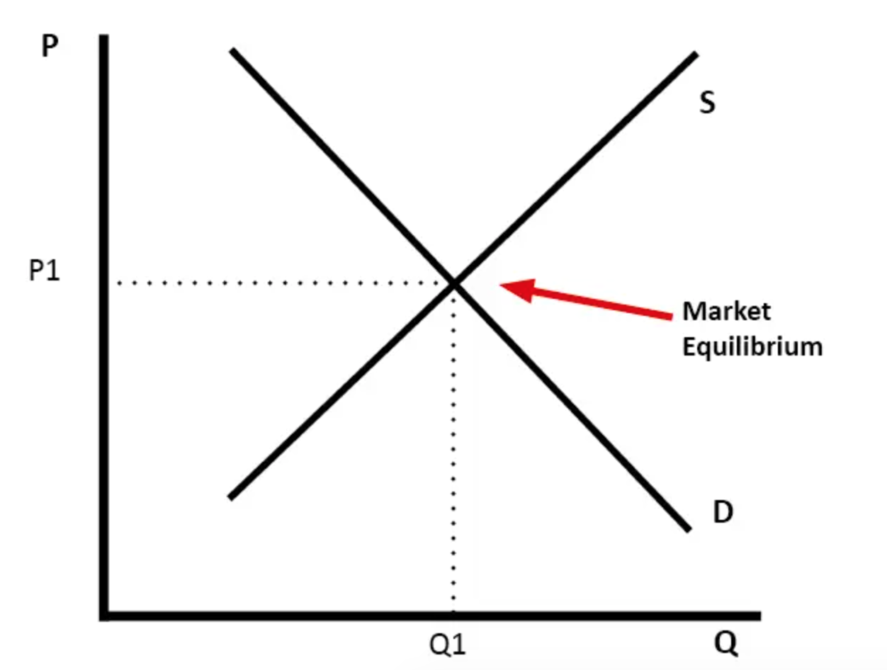
Figure 1. Market Equilibrium (Pettinger, 2019)

2.2 The analysis of factors

Various factors influence demand and supply; among these are the price of the products, their income, prices of related goods or services, consumer expectations, the volume of consumers in the market and many others. This section is centred on the Pfizer/BioNTech Covid vaccine analysis. The following factors are considered, the price of substitutes, the price of complements, the income of consumers, their preferences and expectation of price and the demographic.

Price of substitutes

As discussed previously, Pfizer operates in multiple markets worldwide. It aims to provide access to its products across countries with different income levels. It has registered high demand since first authorisation (Pfizer, 2020); however, the demand for Covid jabs has fallen (Smyth, 2022), and it is forecasted that the doses delivered will be reduced further and the price is expected to rise (See Figure 1. Covid vaccine deliveries, prices per dose and revenue. Source; Airfinity forecasts).

Covid vaccine deliveries, prices per dose and revenue
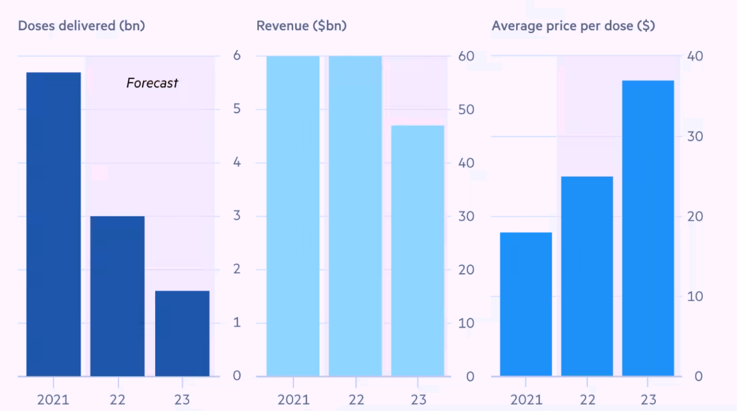
Figure 2. Covid vaccine deliveries, prices per dose and revenue. Source; Airfinity forecasts
Among the causes of lower demand can be changes in preferences, lower prices of substitutes. Based on World Health Organisation (2020) Pfizer/BioNTech vaccines substitutes are the Jenssen, Moderna, Sinopharm and Oxford AstraZeneca, thus there are few alternatives available that can triger compettition. In term of pricing, it varies from country to country and has not been fully disclosed. Neverthless, many countries still struged to aquire vaccines at an afordable price. Based on Birnbaum et al. (2020) Pfizer/BioNTech is selling at the highest price compared to other alternative companies. Additionally, the price is lower for E.U compared to U.S ( Figure 2. Price of Covid vaccine per dose. Source Bernstein Research).
Price per dose
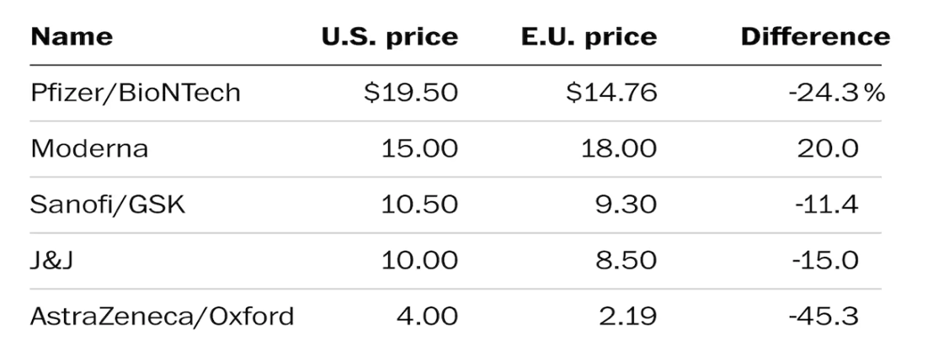
Figure 3. Price of Covid vaccine per dose. Source Bernstein Research
As discussed by Goodwin , et al.,( 2020) if the price increases that could generate lower demand and consumers may search for cheaper alternatives available on the market. Therefore, if the prices of Pfizer/ BioNTech will remain high while the demand decreases further and cheaper options are available it could shift the consumer choise towards more afordable vaccines.

    - Price of complements
Besides that, the demand being impacted by the price of substitutes can also be influenced by the price of complements. A complement can be defined as another product or service that adds value to each other (Boyce, 2021); therefore, it is usually purchased together. While analysing the price changes, it is essential to consider the prices of complements; if the price decrease for one product, the demand for the complementary product will also increase and vice versa (Figure (Sexton, 2015).
An example of relation between product and complement.
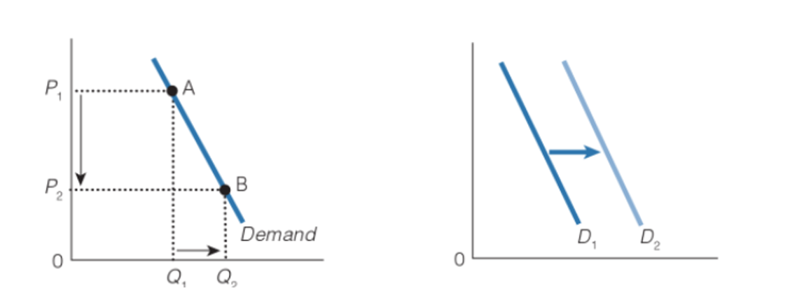
Figure 4. Complementary Goods. Source: (Sexton, 2015)
While Pfizer, along with other COVID-19 alternative vaccines, is critical to save people’s lives and end the pandemic, according to Global Healthcare Systems & Services and Pharmaceutical & Medical Products Practices (2021), the diagnostics, antibody medicines and other therapeutics are among essential complements. As projected in Figure 3. Complementary Goods. Source: (Sexton, 2015) (Sexton, 2015) a potential rise in the price of Covid Vaccine will impact the demand for complements, which would mean a downward shift in demand for antibody medicines and other therapeutics.

    - Consumer Income
Consumer income is another important factor that impacts demand. The Access to COVID-19 Tools Accelerator was launched to ensure product equitable and efficient distribution (Dodson, 2022). The governments were responsible for acquiring vaccines for the population, which would mean the vaccine distribution based on specific criteria. As the economy has been affected by the pandemic, consumers struggled to face challenges in terms of employment; however, the more significant challenge was to make these vaccines available to all people, including least developed countries. As the vaccine is a necessity, not a luxury product, the consumer income did not have a high impact; on the other hand, developed countries struggled could acquire the vaccines. There were issues with meeting the high demand, as these were distributed on a first-come, first-served basis. Weise (2022) condemned this strategy and implied that the focus should have been on saving the most lives.
    - Consumer tastes and preferences
Many factors can influence customers' tastes and preferences; for example, a preference for a particular vaccine because of branding would cause lower demand for others. A preference change will eventually cause a change in demand (Sivagnanam, 2010). Primarily the demand for Covid vaccines is driven by their efficiency. Even if consumers may have preferences for vaccines in the UK, they will offer vaccines suitable for people (NHS, 2022).

Consumer expectations of price

Consumer expectations of price refer to the economic outlook, which means that if consumers expect an improved economy, they may purchase more goods. Conversely, their willingness to buy goods or services may decline if they expect an economic decline. As discussed by (McEachern, 2010), if the consumers expect the price of the preferred product to fall, they may wait to purchase it at a lower price, and the demand falls; however, if the price is low, the demand increases. Curtin (2019), on the other hand, suggested that consumers make their decisions based on price data and expectations. In terms of Pfizer/BioNTech, governments hold the responsibility for procurement, and it is highly questionable whether, in this case, their decision to purchase is based on expectations of price. As shown in (Figure 1. Covid vaccine deliveries, prices per dose and revenue. Source: Airfinity forecasts), the prices are expected to rise in 2023, which would mean higher demand for 2020 compared to 2023.

Demographics

Another essential factor that influences demand is demographic changes. According to (Fernandes, 2020), a potential increase in mortality on a global level led to changes in demand. Similarly, Mester (2017) argued that a potential slowdown in population growth rates would impact long-run economic growth, including consumption. The Pfizer vaccine is expected to have at least a 1.7billion doses in 2023 (Erman & Mishra, 2021); nevertheless, the number is decreasing compared to 2021 and 2022; thus, the demand is also decreasing.

2.3 Summary

This section discussed the main factors that impact the demand for Pfizer/BioNTech, remarkably the price of substitutes, the price of complements, the income of consumers, their preferences and expectation of price and the demographic. The results show that potential changes in any factors mentioned earlier will contribute to a shift in demand.

Price Elasticity of Demand

Introduction

Price elasticity of demand refers to the measurement of changes in product quantity in relation to price. According to James (2021), a price increase will determine the quantity demanded to drop, which means the price is elastic. Price elasticity is affected by multiple factors: substitution, income, and pricing policy. This section describes how the Pfizer Covid vaccine is affected. It determines whether the price is more elastic or inelastic and discusses factors that determine price elasticity, including recommendations for pricing policy Pfizer could employ.

Factors that affect price elasticity

The factors that impact the price elasticity of demand include the need for the product, the availability of substitute goods, the income effects, time under consideration, perishability, production technique and many others. This analysis particularly focuses on substitution effects and income concerning Pfizer vaccine.

3.2.1 Substitution Effects (Luxury or necessity)

The substitution effect is the decline in sales for a product or service, which can be related to buyers swapping to cheaper options, particularly when the price rises, or their income does not change (Boyle& Schmitt, 2022).
As of December 08, 2022, a total of 6,652,850 people died from the (Worldometer, 2022); therefore, to prevent people from dying, Covid jabs are a necessity. Consumers also perceive the vaccine to be a necessity. On the other hand, it is essential to mention that a small share of people worldwide is hesitantly against Covid vaccines in general. According to al-Gharbi (2022), people are questioning how safe and effective the vaccines are, considering it has developed rapidly. Also, there are uncertainties concerning long-term side effects.
Even though controversial views about Covid-19 vaccines remain a necessity that would mean the item is inelastic, the demand may slightly change because of the shift in price (Figure 5. Inelastic Demand. Source; Hofstrand (2020).
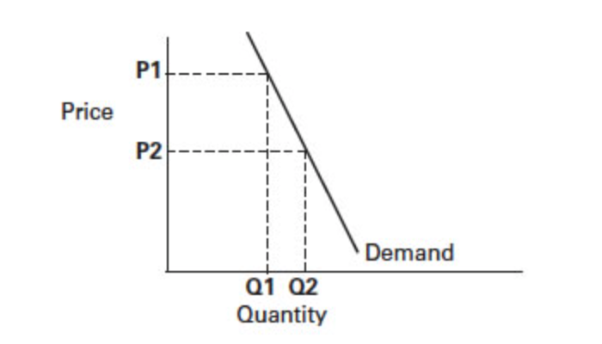
Figure 5. Inelastic Demand. Source; Hofstrand (2020)

3.2.2 Income Effects

Income effects mean that if the price goes down for a good the purchasing power would increase for consumers allowing them to purchase more. As discussed by Estevez (2022) as income rises the demand for them also increases.
The purchase of vaccines could represent a small portion of consumer’s income however, these are not purchased by individuals but are acquired by government to provide free of charge for population. For example, United Kingdom spent overall £600m on Pfizer jabs (Brooks, 2021).
Richer countries would prioritise the jabs based on their efficiency whereas developing countries may prefer cheaper options for vaccines, a more affordable. The demand is rather inelastic as it is not highly influenced by income changes particularly if referring to more developed countries. However, a more detailed analysis can be useful to have a better understanding of the elasticity of demand for vaccines in developed and developing countries.

Pricing Policy

Setting an effective and equitable pricing policy is crucial for the company's reputation and success. The pricing policy must be strongly aligned with company goals, market analysis, demand and supply, manufacturing capacity and other aspects. As the demand for the Pfizer vaccine is expected to drop in 2023, thus a high price or even increasing the price for vaccines will allow the company to keep its profit high. Pfizer and other similar companies adopted a flexible pricing strategy which means the prices vary; for example, the price is higher for America and lower for Europe; this creates controversies, and a well-established pricing strategy must be in place to motivate these choices. It is fundamental to ensure transparency why the price is differentiated and how this can contribute to a more equitable distribution of vaccines to avoid potential damage to the company's global reputation.

Summary

To summarise, this section discussed the price elasticity of demand in relation to Pfizer Covid vaccine. The product is a necessity; therefore, the price is inelastic, potential changes in price could cause a small shift in demand. As most of the buyers prioritise the efficiency of vaccines, a cheaper price of substitutes has little impact on Pfizer vaccine demand.

4.Conclusion

Pfizer is a giant in the pharmaceutical and biomedical industry and has made a significant contribution to health care. This report aimed to analyse the demand/supply, market equilibrium and price elasticity of demand for the Pfizer/BioNTech vaccine.
In terms of factors that impact demand, remarkably the price of substitutes, the price of complements, the income of consumers, their preferences and expectation of price and the demographic, the analysis shows that potential changes in any factors mentioned earlier will contribute to a shift in demand. As the vaccine is a necessity, not a luxury, the price is inelastic, and potential price changes could cause a slight shift in demand. As most of the buyers prioritise the efficiency of vaccines, a lower price of substitutes has little impact on Pfizer vaccine demand. Pfizer maintains a flexible price policing, which is somewhat effective; however, there is a lack of reasons behind it. To increase efficiency, it is recommended to contribute to a more equitable distribution of vaccines and provide vaccines at a lower price for developing countries.

Bibliography
- al-Gharbi, M., 2022. Why don’t some people want to get the vaccine? Here’s why. [Online]
Available at: https://www.theguardian.com/commentisfree/2022/feb/15/this-is-why-some-people-dont-want-to-get-the-covid-vaccine
[Accessed 8 December 2022].
- Armstrong , D. & Randall, T., 2020. U.S. Ranks Behind EU, Australia, U.K. in Vaccine Buys But Says It Will Meet Goal. Bloomberg.
- Boyce, P., 2021. Complementary Goods Definition. [Online]
Available at: boycewire.com
[Accessed 24 August 2021].
- Boyle, M. J. & Schmitt, K. R., 2022. Substitution Effect. [Online]
Available at: https://www.investopedia.com/terms/s/substitution-effect.asp#:~:text=Key%20Takeaways-,The%20substitution%20effect%20is%20the%20decrease%20in%20sales%20for%20a,substitution%20effect%20generally%20kicks%20in.
[Accessed 8 December 2022].
- Brooks, M., 2021. How much is the UK spending on Covid vaccines? Cost of Moderna, Oxford-AstraZeneca and Pfizer-BioNtech jabs. [Online]
Available at: nationwide.com
- Curtin, R.T ., 2019. Consumer Expectations: Micro Foundations and Macro Impact.. United Kingdom: Cambridge University Press.
- Dodson, K., 2022. Key takeaways from the Act-Accelerator: A fisrt-of-its-kind Platform for sharing pandemic countermeasures. [Online]
Available at: https://unfoundation.org/blog/post/key-takeaways-from-act-accelerator-platform-for-sharing-pandemic-countermeasures/?gclid=Cj0KCQiAkMGcBhCSARIsAIW6d0DOXWbyPOA-hFy-hJH1dOLZtm5649xz2L7o6ETvUWAD66mEYps507saAh6wEALw_wcB
[Accessed 7 December 2022].
- Estevez, E., 2022. What Is the Income Effect? Its Meaning and Example. [Online]
Available at: https://www.investopedia.com/terms/i/incomeeffect.asp
[Accessed 8 December 2022].
- Fernandes, N., 2020. Economic effects of coronavirus outbreak (COVID-19) on the world economy. IESE Business School, pp. 1-33.
- Global Data , 2022. Pfizer Inc: Overview. [Online]
Available at: https://www.globaldata.com/company-profile/pfizer-inc/#:~:text=The%20company%20provides%20its%20products,in%20New%20York%2C%20the%20US.
[Accessed 6 December 2022].
- Global Healthcare Systems & Services and Pharmaceutical & Medical Products, 2021. How accessible and effective will COVID-19 vaccines be?. [Online]
Available at: https://www.mckinsey.com/industries/life-sciences/our-insights/on-pins-and-needles-will-covid-19-vaccines-save-the-world
[Accessed 7 December 2022].
- Goodwin , N., Harris, J. M. & Nelson , J., 2020. Demand, Supply and Market Equilibrium. In: Principles of Economics in Context. s.l.:Routledge, pp. 95-129.
- Hofstrand, D., 2020. Elasticity of Demand. [Online]
Available at: https://www.extension.iastate.edu/agdm/wholefarm/html/c5-207.html
[Accessed 8 December 2022].
- James, M., 2021. Price Elasticity of Demand. Investopedia .
- Mancini, D. P. & Kuchler, H., 2021. Pfizer and Moderna raise EU Covid vaccine prices. Financial Times .
- McEachern, W. A., 2010. Economics; A conteporary Introduction. 7th ed. Thomson South-Western.
- Michael Birnbaum, C. R. a. Q. A., 2020. Europe is paying less than U.S. for many coronavirus vaccines. [Online]
Available at: https://www.washingtonpost.com/world/eu-coronavirus-vaccines-cheaper-than-united-states/2020/12/18/06677e34-4139-11eb-b58b-1623f6267960_story.html
[Accessed 7 December 2022].
- Erman, M. M., 2021. Pfizer expects 2021, 2022 COVID-19 vaccine sales to total at least $65 bln. [Online]
Available at: https://www.reuters.com/business/healthcare-pharmaceuticals/pfizer-raises-covid-19-vaccine-sales-forecast-36-billion-2021-11-02/
[Accessed 8 December 2022].
- Mikulic, M., 2021. Pfizer - Statistics & Facts. [Online]
Available at: statista.com
[Accessed 24 August 2021].
- NHS, 2022. Coronavirus (COVID-19) vaccine. [Online]
Available at: https://www.nhs.uk/conditions/coronavirus-covid-19/coronavirus-vaccination/coronavirus-vaccine/
[Accessed 7 December 2022].
- Nolen, J. L., 2022. Pfizer, Inc. [Online]
Available at: https://www.britannica.com/topic/Pfizer-Inc
[Accessed 6 December 2022].
- Pettinger, T., 2019. Market equilibrium. [Online]
Available at: https://www.economicshelp.org/microessays/equilibrium/market-equilibrium/
[Accessed 8 December 2022].
- Pfizer , 2020. Pfizer and BioNTech Celebrate Historic First Authorization in the U.S. of Vaccine to Prevent COVID-19. [Online]
Available at: https://www.pfizer.com/news/press-release/press-release-detail/pfizer-and-biontech-celebrate-historic-first-authorization
[Accessed 7 December 2022].
- Pfizer Inc, 2020. United states Securities and Exchange commision, Washington: investor.pfiser.com.
- Pfizer, Inc , 2021. Pfizer Inc, Annual Report , Washington : https://www.annualreports.com/HostedData/AnnualReports/PDF/NYSE_PFE_2021.pdf.
- Riley, G., 2016. Factors affecting Price Elasticity of Demand. [Online]
Available at: https://www.youtube.com/watch?v=9fZXWr7wXUM&t=9s
- Scherer, F. M., 2000. The Pharmaceutical Indutry . In: A. C. a. J. N. E. S. B. V. A, ed. Handbook of Health Economics. s.l.:Harvard University .
- Searly, A., 2021. Manufacturing moonshot: How Pfizer makes its millions of Covid-19 vaccine doses. [Online]
Available at: https://edition.cnn.com/2021/03/31/health/pfizer-vaccine-manufacturing/index.html
[Accessed 6 December 2022].
- Sexton, R.L ., 2015. Exploring Macroeconomics. United States: Cengage Learning.
- Sivagnanam, S., 2010. Business Economics. India: McGraw-Hill Education.
- Smyth, J., 2022. Vaccine makers face revenue slump as demand falls for Covid jabs. [Online]
Available at: https://www.ft.com/content/e4cea6be-2e96-4458-a441-56fa79c7203e
[Accessed 7 December 2022].
- Stanton, D., 2016. Breaking the Big Four: vaccine oligapoly unlikely to be challenged, analyst. [Online]
Available at: https://www.biopharma-reporter.com/Article/2016/12/02/GSK-Sanofi-Merck-Pfizer-vaccine-oligopoly-unlikely-to-be-challenged
[Accessed 6 December 2022].
- Taylor, T ., 2017. Principles of Economics 2e. United States: OpenStax.
- Vitolo, M., 2021. Fundamentals of Biotechnology. In: M. V. P. F. L. Adalberto Pessoa, ed. Pharmaceutical Biotechnology: A Focus on Industrial Application. . United States: CRC Press.
- Weise, E., 2022. Report: Coronavirus vaccine shouldn't be first-come, first-served. [Online]
Available at: https://eu.usatoday.com/story/news/2020/09/01/clovid-vaccine-shouldnt-first-come-first-served-says-science-committee/5681998002/
[Accessed 8 December 2022].
- World Health Organisation, 2020. Coronavirus disease (COVID-19): Vaccines. [Online]
Available at: who.int
[Accessed 19 August 2021].
- Worldometer, 2022. Coronavirus Death Toll. [Online]
Available at: https://www.worldometers.info/coronavirus/coronavirus-death-toll/
[Accessed 8 December 2022].

