

Accounting

Student name: | Ilie Sbircea
Student number | 2414596
Module: | Finance for Business
Module code: | BMBM4003D
Lecturer: | Manjit Biant
Assignment Title: | Accounting
Submission deadline: | 15/5/26

Task 1

Sales invoices and sales credit notes have been received and partially entered in the day books, as shown below.
Complete the entries in the sales day book and the sales returns day book by:
        - inserting the appropriate figures to complete the entries
        - entering totals for 30 July

Sales day book

Date 2026 | Details | Invoice number | Total  £ | VAT  £ | Net  £ | Sales type 1 £ | Sales type 2 £
30 Jul | Silver Gifts | 1250 | 900 | 150 | 750 | 400 | 350
30 Jul | Special Crafts | 1251 | 1464 | 244 | 1220 | / | 1,220
30 Jul | Pan Trading | 1252 | 3168 | 528 | 2,640 | 2,640 | /
30 Jul | Harlam Lights | 1253 | 2,304 | 384 | 1920 | 820 | 1,100
 | Totals |  | 7836 | 1306 | 6530 | 3860 | 2670

Sales returns day book

Date 20-4 | Details | Credit note number | Total  £ | VAT  £ | Net  £ | Sales type 1 £ | Sales type 2 £
30 Jun | Metal Supplies | 251 | 78 | 13 | 65 | / | 65
30 Jun | Pearls | 252 | 162 | 27 | 135 | 135 | /
 | Totals |  | 240 | 40 | 200 | 135 | 65

      - A supply of art paper has been delivered to Deven Supplies by ExeterStore Ltd. The purchase order sent from Deven Supplies and the invoice from ExeterStore Ltd are shown below.
Deven Supplies
29 Constitution Street Mereford, MR11 4GT

Purchase Order No. ST1872 To: ExterStore Ltd

Date: 9 July 2026

Please supply 200 packs of A3 Art paper product code 6543 Purchase price: £5 per pack, plus VAT
Discount: less 25% trade discount, as agreed.

Terms: 30 days net
£800.00
£160.00
£960.00
Packs A3 Art paper Ref 6543 @ £5.00 per pack less trade discount VAT @ 20%
Total
200
12 July 2026
Order ref: ST1872
Invoice No. 2353
Deven Supplies
29 Constitution Street
Mereford, MR11 4GT
ExeterStore Ltd
Unit 16 Varsity Estate, Spirefield SP6 3DF
VAT Registration No. 118 3822 50
INVOICE

Check the invoice against the purchase order and answer the following questions.

Has the correct purchase price of the paper been charged? Yes or No? | Yes
Has the correct discount been applied? Yes or No? | Yes
What would be the VAT amount charged if the invoice was correct? | 160
What would be the total amount charged if the invoice was correct? | 960
Task 2

Swansea Motor Spares is a small business selling spare parts for motor vehicles run by a sole trader in Swansea. The trial balance as at 31st August 2026 is shown below.

SWANSEA MOTOR SPARES

Trial balance as at 31st August 2026

DEBIT CREDIT

£ £

Advertising 12,000
Capital 270,000
Cash 21,000
Drawings 36,000
Electricity 6,000
Fixed assets at cost 80,000
Fixed assets accumulated depreciation (01.09.25) 16,000
Insurance 12,000
Purchases 420,000
Rent and rates 26,000
Salaries 125,000
Sales 560,000
Stationery 10,000
Stock at 01.09.25 140,000
Telephone 4,000
Trade creditors 94,000
Vehicle running expenses 48,000

940,000 940,000

Closing stock at 31st August 2026 was valued at £168,000.

The depreciation charge for the year needs to be calculated using the straight line method over ten years.

You are required to prepare a comprehensive report to the owner of the business to clearly answer each of the following questions:

- Prepare a profit and loss account for the year to 31st August 2026 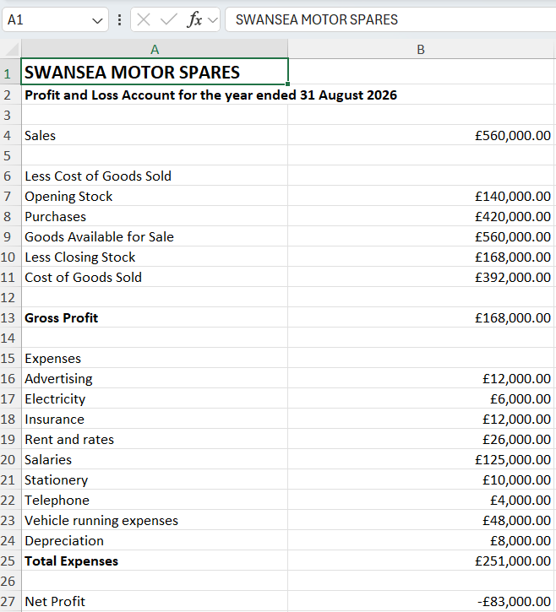

- Prepare a balance sheet as at 31st August 2026 in the correct format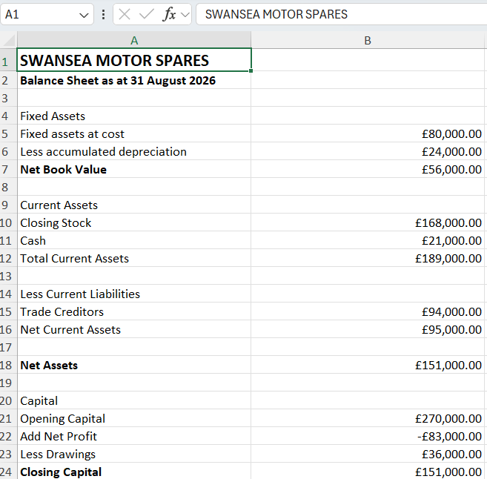

- The business is currently registered for VAT. A new member of staff has been employed to supervise the accounts department and has asked the following questions to which the owner has asked you for some advice:

  - Whether it is possible to, when to, and how to deregister for VAT

Swansea Motor Spares can deregister for VAT if the business expects its taxable turnover to fall below the HMRC deregistration threshold or if the business stops trading. The owner can apply online through the HMRC VAT account or by submitting form VAT7. Before deregistering, the owner should consider that VAT can no longer be charged to customers and VAT on purchases usually cannot be reclaimed. However, deregistration may allow the business to offer lower prices to customers.

  - The rate of VAT that needs to be charged on each of the products that the business sells
Most products sold by Swansea Motor Spares, such as spare parts, tyres, batteries, oils and accessories, are charged at the standard UK VAT rate of 20%. Some specialist products linked to disability equipment or exports may qualify for different VAT treatment, but this would depend on the circumstances. The business should ensure the correct VAT rate is applied to all invoices and accounting records.
  - Are there any alternatives to the system of quarterly VAT returns that the business currently uses
The business does not have to continue using quarterly VAT returns. HMRC also allows monthly VAT returns, annual accounting and the cash accounting scheme. Monthly returns may help cash flow if the business regularly reclaims VAT, while annual accounting reduces paperwork by requiring only one return each year. The cash accounting scheme allows VAT to be paid only when customers pay their invoices, which can improve cash flow for smaller businesses.

- Explain to the owner how the annual depreciation amount would be calculated using 15 years life and what difference this change would make to the profit of the business over the past three years.

The business currently depreciates fixed assets over 10 years using the straight-line method.
The depreciation formula is:
$$\text{Annual Depreciation}=\frac{\text{Cost of Asset}}{\text{Useful Life}}$$
Using a 10-year life, the annual depreciation is:
$$\frac{£80,000}{10}=£8,000$$
If the useful life changed to 15 years, the annual depreciation would become:
$$\frac{£80,000}{15}=£5,333.33$$
This means the yearly depreciation expense would reduce by approximately £2,667. As depreciation is an expense, the annual profit of the business would increase by the same amount. Over the last three years, profits would therefore have been approximately £8,000 higher in total.
A longer asset life increases reported profits and asset values, but the depreciation policy should always reflect the true expected life of the assets. A longer asset life increases reported profits and asset values, but the depreciation policy should always reflect the true expected life of the assets.

- In order to be able to hold more stock, the owner of the business has decided to refit his warehouse at a cost of £200,000. The owner of the business plans to raise the selling price of all of the spare parts by 10% in order to improve profitability. Explain the economic arguments for and against this strategy, paying particular attention to the possible effects of the decision on the level of sales that would be achieved.

The warehouse refit costing £200,000 would allow Swansea Motor Spares to hold more stock, which could increase sales by ensuring products are always available and allowing bulk buying discounts. This could improve profitability. However, it is a large cost and could reduce available cash or increase borrowing.
The 10% price increase would raise selling prices and could increase revenue if customers continue buying the same quantity. However, if customers are price-sensitive, demand may fall and sales could decrease. If demand is inelastic, sales revenue will increase. If demand is elastic, customers may switch to competitors, reducing revenue and profit.

- Clearly explain how the pricing strategy in (5) would affect the profitability of the business, assuming that the level of sales and the current business policies remained unchanged.
Current sales are £560,000. A 10% increase gives forecast sales of:
$$£560,000×1.10=£616,000$$
Increase in revenue:
$$£616,000-£560,000=£56,000$$
If all costs remain unchanged, profit improves by £56,000, making the business more profitable.

- Illustrate your answer to (6) by producing a forecast profit and loss account in the correct format for the year to 31st August 2028.
- 

