Continued assignment

Use of drones:
There are a number of applications of ramble innovation joining with progressed image data analytics that can be utilized within the horticulture industry. Based on specific extend necessities rambles can be prepared with a range of picture information sensors. This strategy has been broadly utilized for decades based on fawning- or plane-borne cameras, but the resolution of the coming about items has been inadequately to outline areas, absolutely, not to specify specific plants. Ramble innovation as a stage for picture information procurement has brought the NDVI mapping capabilities to a totally modern level of precision making it conceivable to monitor the condition of not as it were plants, but too particular parts of plants. There can also be a wireless sensor fit in fences that will notify or send a message to the farmer that if the fences are broken [8].

Conclusion:
WMSs have the potential to change over the security of cultivating within the provincial division of any nation. Joining WMSs with existing organizations to boot credibility with ensures of revolutionizing precision cultivating. Not at all, like other systems, WMSs are sketched out for specific applications [9].

Introduction:
The speculation behind the utility of open surveillance systems for wrongdoing expectation purposes is that potential transgressors will go without criminal development within the occasion that they know they are being watched and acknowledge they are at a more critical chance of dread. Video film announcing criminal development and recognizing offenders and witnesses may also offer assistance in examinations and arraignments, extending police and prosecutorial efficiency, benefitting wrongdoing casualties whose cases can be closed through the utilize of video demonstrate, and weakening a more critical number of guilty parties from committing future infringement [1]
System:
Remote security cameras are less requesting to present than wired electives. Wired cameras must interface to your home’s electrical system, so you’ll get to enrol a capable for the foundation. Inaccessible cameras depend on Wi-Fi or other frameworks. Take after the illuminating, and you will be able to set up and interface most cameras in less than thirty minutes [1].

Model:
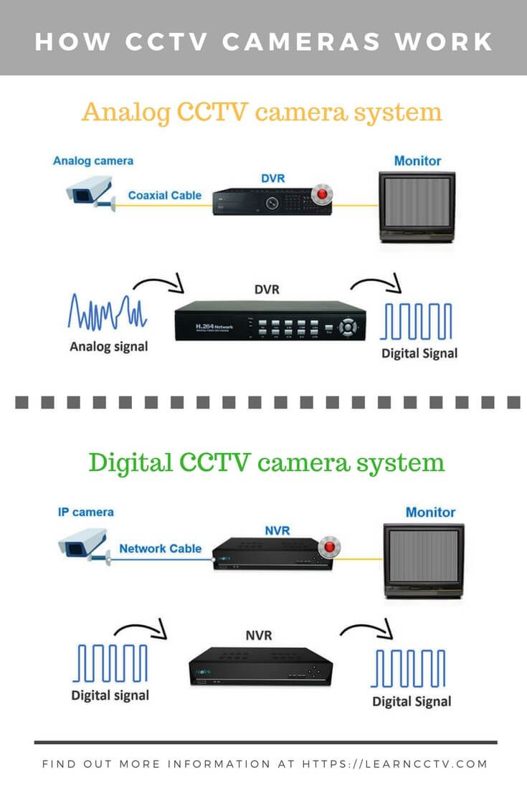

Working:
Blocked off cameras work by transmitting the camera's video through a radio (RF) transmitter. The video is sent to a recipient that's related to a built-in capacity contraption or through cloud capacity. Through your screen or beneficiary, you'll have a clear interface to encourage all your pictures or video clips. PoE security cameras get control and transmit data by implies of because it was one Ethernet cable. That's to say, all you've to have to be do is wire up the organize, and there's no need to find an electrical outlet for control movement [1].

Conclusion:
Farther security cameras are an exceptional extension to your residential security system, as they offer you 24/7 seeing get to your residential, no matter where inside the world you're. Farther cameras can be mounted/installed in ranges as of now blocked off to standard wired cameras. In development to the ease of utilizing and consolation of getting to, farther security camera grants clients to utilize the inaccessible broadband web to supply reliable video spouting over-internet. These checking frameworks ought to too be connected to the closest town [1].

