

Student name: Patience Edo
Student ID: 2220883
Programme: BSc (Hons) Health and Social Care
Module name: Independent Project
Module code: BMHP6020
Supervisor’s name: Konstantina Mari
Lecturer: Jolly Nwankwo
Element 2 Methodology poster.

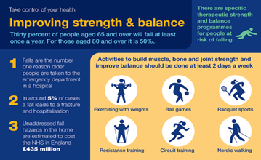  (UK Government, 2022) |  | Title: To Investigate the Effectiveness and Adoption of Fall-Prevention Technologies Among Older Adults in the UK (Yeoh Lui et al., 2024).  Study Aim:  To critically evaluate the effectiveness and adoption of fall-prevention technologies for older adults in the UK, and to develop a framework for their categorisation, implementation, and accessibility. |  | 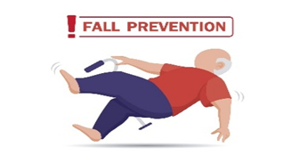  (Sowega Council on Aging, 2025)
Research Objectives:  - To define and categorise fall-prevention technologies currently used among older adults in the UK  - To evaluate their effectiveness in reducing falls and injuries.  - To explore barriers and facilitators influencing uptake, including digital exclusion, and user experience  - To provide evidence-based recommendations for development, implementation, and policy.  Research design:  Systematic Literature Review (SLR) following PRISMA principles  - Secondary research approach (2015-2025 UK-based studies)  - Quality assessed using CASP tool & PRISMA  - Constructivist-interpretivist paradigm, recognizing social context and meaning.  Quality Appraisal:  - All studies appraised by CASP were extracted (Haile, 2021).  - Triangulated quantitative and qualitative evidence.  - Pre-2015 theories used conceptually only (e.g. TAM, Diffusion of innovation).  Rationale  - Approximately 14 million adults aged 65 and older report sustaining a fall, with 37% of those falls resulting in injury-related hospital admissions (Kumar et al., 2025)  - 30% of adults aged 65+ and 50% aged 80+ fall at least once annually (Office for Health Improvement and Disparities (2025)  - Falls-related injuries cost the NHS over £2.3 billion per year (Aylesbury, Ccgs and Ahsn, n.d.).  - Digital innovation shows promise but remains under-adopted due to usability, cost, and digital exclusion (Gulline et al., 2025). |  |  |  | Analytical Framework  Thematic Analysis (Braun and Clarke, 2006, 2019):  - Familiarization  - Coding  - Searching for themes  - Reviewing themes  - Defining themes  Producing the report (Braun and Clarke, 2019). Analyse evidence, including identifying, evaluating, and summarising it. The thematic analysis method will be used to identify, analyse, and report patterns (themes) (Chawla and Wood, 2023).  Identified Themes  - Technology categorisation- Four main types identified: wearable, smart-home systems, telecare and mHealth apps, and AI-based monitoring.  - Effectiveness – Technologies reduced fall rate by 30-43% when applied in care settings  - Barriers and Facilitators- barriers: digital exclusion, cost, privacy. Facilitators: training, integration, support.  - Implementation and policy – need for NHS integration and a national evaluation framework.  Ethical considerations  - This secondary study involves no human participation, complied with GDPR (2018) and institutional ethics compliance and ethics standards (Creswell and Creswell, 2023)  - Theoretical frameworks predating 2015 are cited for conceptual interpretation only.  - Supervisor’s approval obtained from UWTSD.  Strengths  - UK-only scope, inclusion of grey literature, rigorous CASP appraisal.  Limitations  - Limited longitudinal evidence(12 months), variation in outcomes, some un-peer-reviewed sources.

Data sources
- Databases: PubMed, BMJ, BioMedCentral, ScienceDirect, ProQuest, PsycINFO, Google Scholar,
- Grey Literature: NHS England, The King’s Fund, Age UK, The Health Foundation.
- Keywords: Boolean terms: ‘’Technology OR digital’’ AND adults’’ AND ‘’fall prevention OR telehealth, , OR mHealth’’ AND ‘’UK OR United Kingdom’’. Older digital health technologies, including wearable sensors and smart-home systems.
Inclusion
- UK-based (2015-2025), adults aged 65+, digital fall-prevent technologies, written in the English language.
Exclusion Criteria
- Non-UK data, pre-2015 studies, non-digital or exercise-only interventions, non-English sources.
Data Extraction Process
- Variable: author, year, design, sample size, intervention, outcomes, barriers, facilitators, limitations.
- Data charted in Excel and coded thematically in NVivo

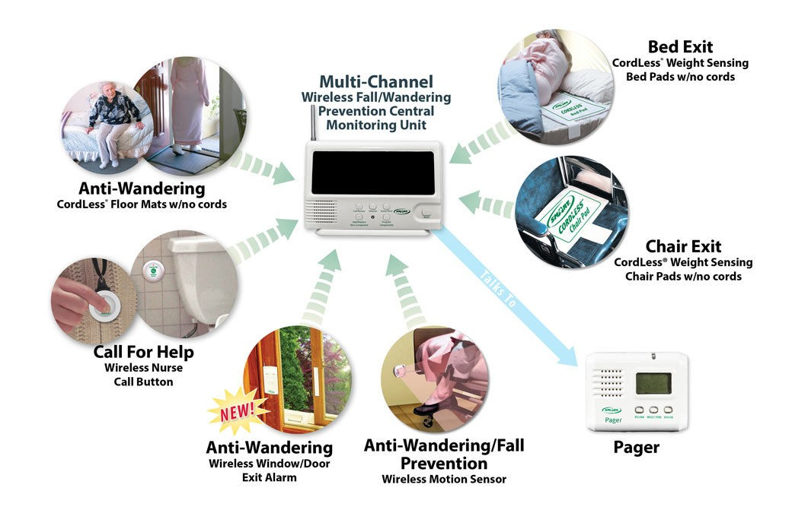(OMG Solutions, 2011).

References
Aylesbury, C., Ccgs, V. and Ahsn, O. (n.d.). NHS Aylesbury Vale Clinical Commissioning Group, NHS Chiltern Clinical Commissioning Group, Falls prevention: a case for change, Clinical Commissioning Director, Thames Valley Primary Care, Cardiac Lead for HF and AF. Available at: https://www.england.nhs.uk/south/wp-content/uploads/sites/6/2017/03/fall-prevention.pdf?utm_source (Accessed: 2 October 2025)
Braun, V. and Clarke, V. (2006). ‘Using Thematic Analysis in Psychology’, Qualitative Research in Psychology, 3(2), pp.77–101. doi: https://doi.org/10.1191/1478088706qp063oa.
Braun, V. and Clarke, V. (2019). ‘Reflecting on Reflexive Thematic Analysis’, Qualitative Research in Sport, Exercise and Health, 11(4), pp.589–597. doi: https://doi.org/10.1080/2159676X.2019.1628806.
Chawla, T. and Wood, J. (2023). Thematic analysis - an overview. Available at: https://www.sciencedirect.com/topics/social-sciences/thematic-analysis. (Accessed: 20 September 2025).
Creswell, J.W. and Creswell, J.D. (2023). Research Design: Qualitative, Quantitative, and Mixed Methods Approaches. Available at: https://uk.sagepub.com/en-gb/eur/research-design/book270550. (Accessed: 11 October 2025).
Gulline, H., Melder, A., Barker, A., Dickins, M., Smith, K. and Ayton, D. (2025). ‘Opportunities to Digitally Enable Falls Prevention in Older Adults’, The Gerontologist, 65(4). doi: https://doi.org/10.1093/geront/gnaf016.
Haile, Z.T. (2021). ‘Critical Appraisal Tools and Reporting Guidelines’, Journal of Human Lactation, 38(1), pp.21–27. doi: https://doi.org/10.1177/08903344211058374.
Kumar, S., Cruz, F., Yates, Z., Amin, Q., Awan, M.U., Lee, P., Kumar, S. and Elkbuli, A. (2025). ‘Falls Among Older Adults: An Exploration of Trends, Clinical Outcomes, Predisposing Risk Factors, and Intervention Strategies’, The American Journal of Surgery, 245, p.116385. do i:https://doi.org/10.1016/j.amjsurg.2025.116385.
Office for Health Improvement and Disparities (2025). Public Health Outcomes Framework: commentary. Available at: https://www.gov.uk/government/statistics/public-health-outcomes-framework-february-2025-data-update/public-health-outcomes-framework-commentary-february-2025?utm_source (Accessed: 18 September 2025).
OMG Solutions (2011) Wireless Fall Prevention Monitors. Available at: https://omg-solutions.com/about-us/ (Accessed: 16 October 2025).
Sowega Council on Aging (2025) Fall Prevention Month. Available at: https://sowegacoa.org/fall-prevention-month/ (Accessed: 27 June 2025).

UK Government (2022). Falls: Applying All Our Health. Available at: https://www.gov.uk/government/publications/falls-applying-all-our-health/falls-applying-all-our-health. (Accessed: 19 September 2025).
Yeoh Lui, C.X., Yang, N., Tang, A. and Tam, W.W.S. (2024). ‘Effectiveness Evaluation of Smart Home Technology in Preventing and Detecting Falls in Community and Residential Care Settings for Older Adults: A Systematic Review and Meta-Analysis', Journal of the American Medical Directors Association, 26(1), p.105347. doi: https://doi.org/10.1016/j.jamda.2024.105347.

