Name: Huma Ali
Student Number: 2437892
Module Code and Title: Introduction to Health and Social Care
Module Code: LCHS4003
Lecturer’s Name: Mumtaz Goolam
Assignment Title: Portfolio – 2 Tasks

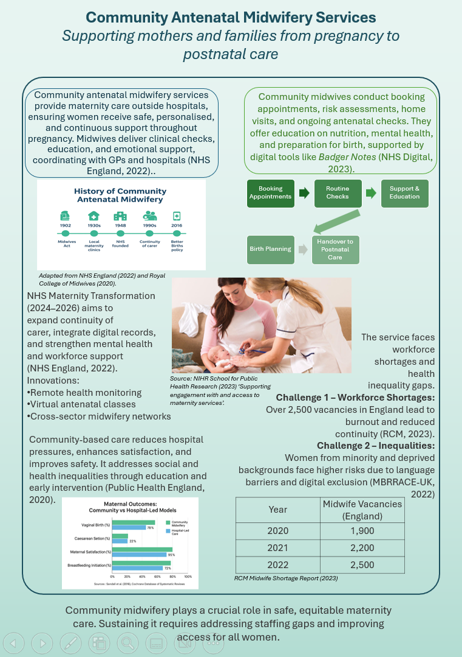

The Origins and Structure of the National Health Service (NHS)
Introduction
The National Health Service (NHS) remains one of the most defining features of British society. Established in 1948, it represents a promise that good healthcare should be available to everyone, regardless of wealth. This essay explores how the NHS emerged from the social and political context of post-war Britain and examines how its founding principles continue to shape and sometimes challenge its current structure and operation.
Historical Origins and Key Principles
The NHS was born out of a period of reconstruction following the Second World War. Britain’s economy was damaged, yet there was a collective determination to build a fairer society. Before the NHS, access to medical care depended largely on income or employment-based insurance. Many working-class families relied on voluntary hospitals or charity. The inequalities this produced became impossible to ignore during wartime, when a national effort revealed the importance of collective welfare.
The Beveridge Report (1942) played a crucial role by identifying “disease” as one of the five social evils that the state had a duty to overcome. The report inspired the creation of a universal welfare system that would provide security from “cradle to grave.” Building on this vision, Aneurin Bevan, the Labour Minister of Health, introduced the National Health Service Act (1946), which took effect on 5 July 1948.
Bevan’s vision rested on three fundamental principles: healthcare should be universal, comprehensive, and free at the point of delivery. These ideas were radical in a society still marked by class divisions and economic hardship. Bevan famously said the NHS would “lift the shadow from millions of homes.” Although doctors and politicians debated the practicality of nationalised healthcare, public support ensured the service’s success.
The Current Structure and Functioning of the NHS
Over the decades, the NHS has undergone continual reform. Initially managed centrally, it now operates under a devolved structure, with separate NHS organisations in England, Scotland, Wales, and Northern Ireland. In England, the Department of Health and Social Care (DHSC) oversees the system, while NHS England manages budgets and commissions services. Funding remains largely tax-based, reflecting its public service ethos.
Care is provided through a tiered structure: primary care (GPs, dentists, pharmacists), secondary care (hospitals and specialists), and community services. Recently, the development of Integrated Care Systems (ICSs) has aimed to improve coordination between health and social care providers. In theory, this approach should reduce inefficiencies and promote preventive care. However, in practice, integration has proved uneven across regions.
In my view, the NHS’s greatest strength remains its principle of equity, yet this is also where the strain shows most clearly. Growing demand, workforce shortages, and the rising costs of technology have created pressures that threaten sustainability. Long waiting times and staff burnout are now routine headlines. Critics argue that the introduction of private providers and market-style competition, particularly since the Health and Social Care Act 2012, risks fragmenting services and eroding Bevan’s original ideals. Supporters of reform counter that some competition can drive innovation and efficiency. Both views have merit, but the balance between public accountability and financial sustainability remains delicate.
Conclusion
The NHS was founded during a time of social optimism, built on ideals of fairness and solidarity. Its origins remind us that healthcare is not merely a service but a social contract. Although the NHS continues to face significant challenges, it still embodies a collective belief in equal access to care. To protect its future, policymakers must remain faithful to its founding values while finding realistic ways to adapt to modern pressures. In this sense, the NHS stands as both a proud legacy and a continuing responsibility for every generation.

References Poster:
Department of Health and Social Care (DHSC), 2021. Maternity Transformation Programme: Continuity of Carer Implementation Guidance. London: DHSC.
National Institute for Health and Care Excellence (NICE), 2021. Antenatal care: Quality standard [QS22]. Available at: https://www.nice.org.uk/guidance/qs22 (Accessed: 13 October 2025).
National Institute for Health and Care Research (NIHR) School for Public Health Research, 2023. Supporting engagement with and access to maternity services. Available at: https://sphr.nihr.ac.uk/research/supporting-engagement-with-and-access-to-maternity-services/ (Accessed: 19 October 2025).
NHS England, 2022. Better Births: Improving outcomes of maternity services in England – A Five Year Forward View for maternity care. London: NHS England.
Office for National Statistics (ONS), 2023. Birth characteristics in England and Wales: 2022. London: ONS.
Royal College of Midwives (RCM), 2020. The State of Maternity Services Report 2020. London: RCM.
Sandall, J., Soltani, H., Gates, S., Shennan, A. and Devane, D., 2016. ‘Midwife-led continuity models versus other models of care for childbearing women’, Cochrane Database of Systematic Reviews, Issue 4, Art. No.: CD004667. DOI: 10.1002/14651858.CD004667.pub5.

References Essay:
Beveridge, W., 1942. Social Insurance and Allied Services. London: HMSO.
Department of Health and Social Care, 2023. The NHS Long Term Plan. London: DHSC.
Ham, C., 2021. Health Policy in Britain. 8th ed. London: Palgrave Macmillan.
Klein, R., 2019. The New Politics of the NHS: From Creation to Reinvention. 8th ed. London: Routledge.
NHS England, 2024. The Structure of the NHS in England. Available at: https://www.england.nhs.uk/ (Accessed: 18 October 2025).
Webster, C., 2002. The National Health Service: A Political History. Oxford: Oxford University Press.

