DS 1 Template

My Screenshots/Photos
- Please add 4–6 screenshots or photos of your digital life.
- You can use your phone or laptop.
- For each screenshot, write one or two sentences explaining what it shows.

Screenshot/Photo 1

[I use Instagram to Fing friends, and I also browse it to discover and about making money write…

Screenshot/Photo 2

I use tik Tok for to watch people making jokes and to look at girls...

Screenshot/Photo 3
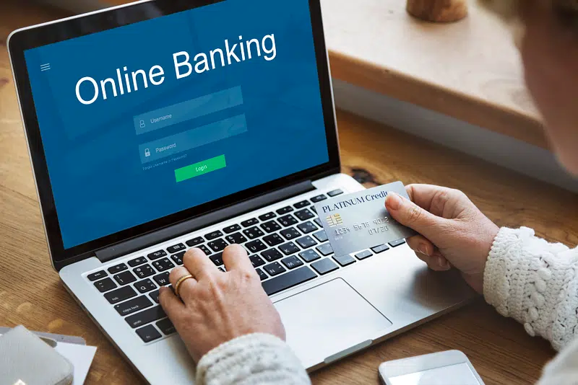
I use the app to send money to friends and family and to receive and make transfers.

Screenshot/Photo 4

[I
This Photo by Unknown Author is licensed under CC BY
I use email for important correspondence for work and for the kids' school…

Screenshot/Photo 5

WhatsApp this is a great technology to use I use it every day for work with colleagues for the school and much more.

Screenshot/Photo 6
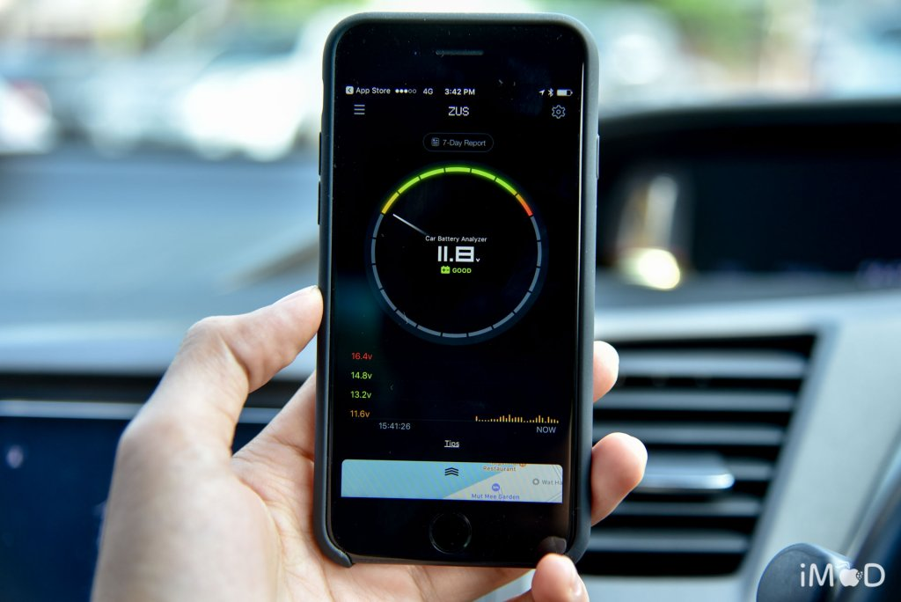
This app is good because you can pick up the car from wherever you want using just your phone ….

My Short Reflection
- Write 5–8 simple sentences about your digital life.
- You can use the sentence starters below if helpful.
Use all of these because they are very important to me, I feel safe when I use them sometimes, I get a bit annoyed when they don’t work but they are pretty good and very safe…
I use digital tools to learn new things and find information
I feel confident when I use digital tool to complete task
I sometimes feel nervous about using new digital tools
Digital skills are important for me because they help me in my studies work and everyday life
I hope this module will help me because more confident with technology

Sentence starters
- I use digital tools to …
- I feel confident when I …
- I want to improve …
- I often use these tools: …
- I sometimes feel nervous about …
- I hope this module will help me …
- Digital skills are important for me because …
You can write more if you want.

Submission Checklist
Before you submit, please check:
​​​ ☒ I added 4–6 screenshots
☒ I wrote short sentences for each screenshot
☒ I wrote my short reflection
☒ My work is my own
☒ My file opens correctly
​​☒ My file opens correctly

